Extraction and assessment of Rudbeckia hirta extracts’ larvicidal activity on lackey moth (Malacosoma neustria Testacea): toxicity, nutritional effects and enzyme activities

Yajun Wang ^{a, 1}, HUNG HAI PHAM ^{a, 1}, Weihu Ma ª, Kejiao Li ª, Guocai Zhang ^{a, *}, Jie Zhang ^{b, *}

ª School of Forestry, Northeast Forestry University, Harbin 150040, PR China
^{b} College of Life Science, Northeast Forestry University, Harbin 150040, PR China

Supplementary Information
Table S1. Acute toxicity rating scale (data from USFWS).
Relative Toxicity | Aquatic LC₅₀ (mg/L)
Super Toxic | 0.01-0.1
Highly Toxic | 0.1-1
Moderately Toxic | 1-10
Slightly Toxic | 10-100
Practically Nontoxic | 100-1000
Relatively Harmless | >1000
Extracted Ion Chromatogram 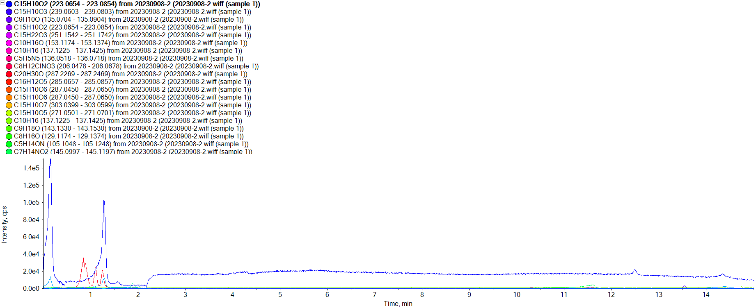
Fig. S1. Total ions flow chromatograms of ethanol extracts of R. hirta.

1 C15H10O3 (Mass/FragMass/RT/Isotope/Library/Formula/Ion Ratio)
Retention Time: 0.12 minutes  Precursor m/z : 239.0703  Fit (%) N/A RFit (%) N/A | Exp RT: 0.00 minutes  Analyte Name:  C15H10O3
 |  | Collision Energy = 35 ± 15 eV
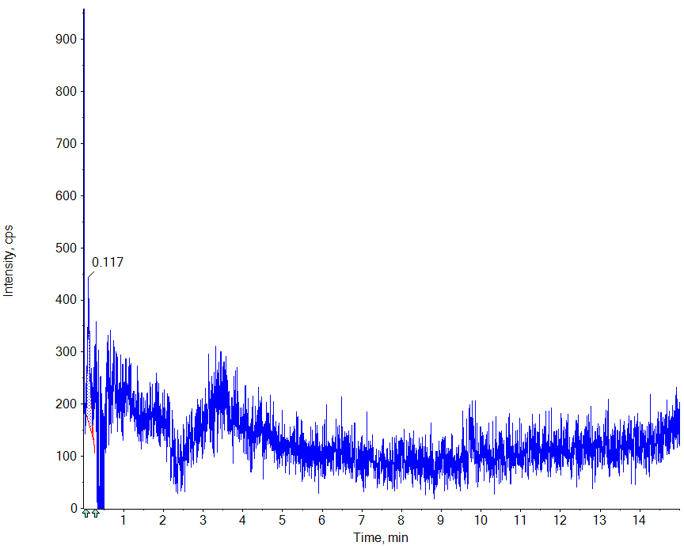 |  | Acquired / Library MSMS | 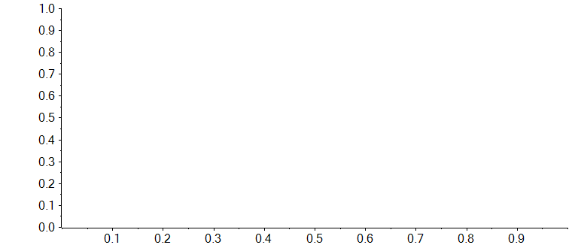
 |  | Acquired / Theoretical MS | 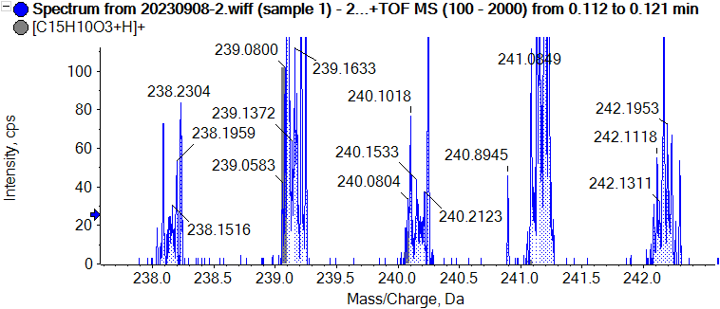

2 C15H10O2 (Mass/FragMass/RT/Isotope/Library/Formula/Ion Ratio)
Retention Time: 0.14 minutes  Precursor m/z : 223.0754  Fit (%) N/A RFit (%) N/A | Exp RT: 0.14 minutes  Analyte Name:  C15H10O2
 |  | Collision Energy = 35 ± 15 eV
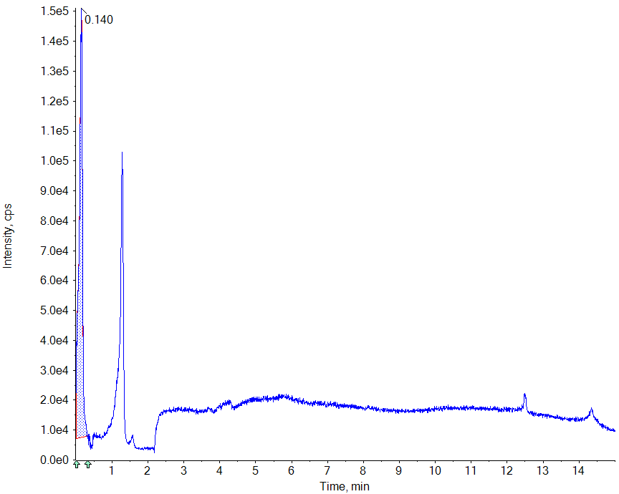 |  | Acquired / Library MSMS
 |  | Acquired / Theoretical MS | 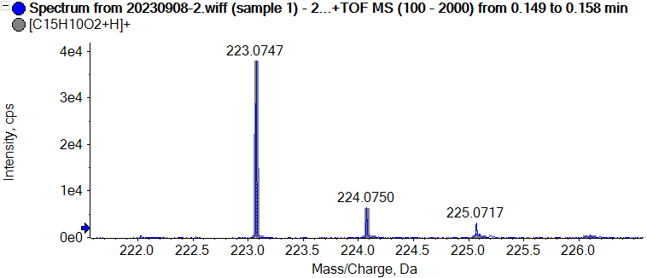

3 C16H18O9 (Mass/FragMass/RT/Isotope/Library/Formula/Ion Ratio)
Retention Time: 0.14 minutes  Precursor m/z : 355.1024  Fit (%) N/A RFit (%) N/A | Exp RT: 0.15 minutes  Analyte Name:  C16H18O9
 |  | Collision Energy = 35 ± 15 eV
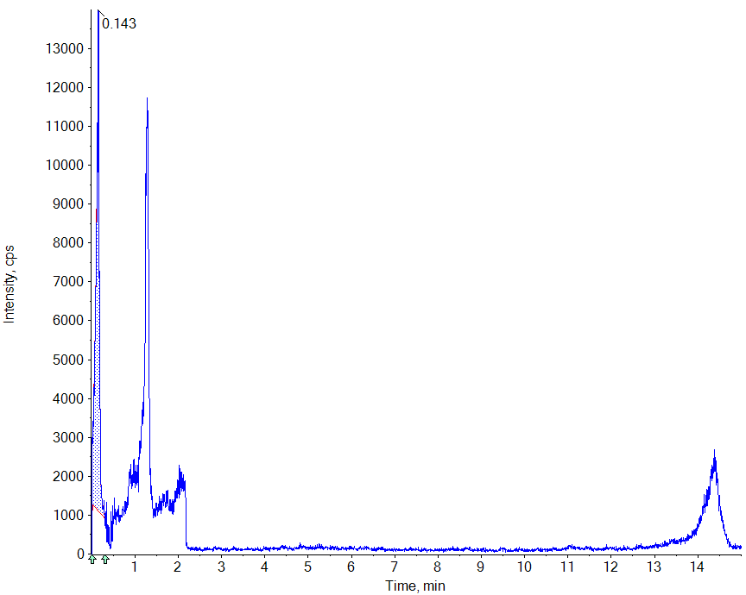 |  | Acquired / Library MSMS
 |  | Acquired / Theoretical MS | 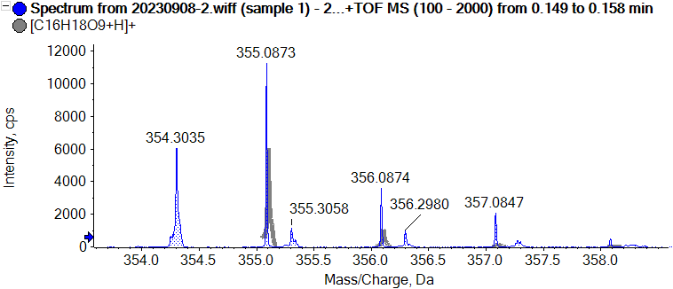

4 C10H18O (Mass/FragMass/RT/Isotope/Library/Formula/Ion Ratio)
Retention Time: 0.24 minutes  Precursor m/z : 155.1430  Fit (%) N/A RFit (%) N/A | Exp RT: 0.30 minutes  Analyte Name:  C10H18O
 |  | Collision Energy = 35 ± 15 eV
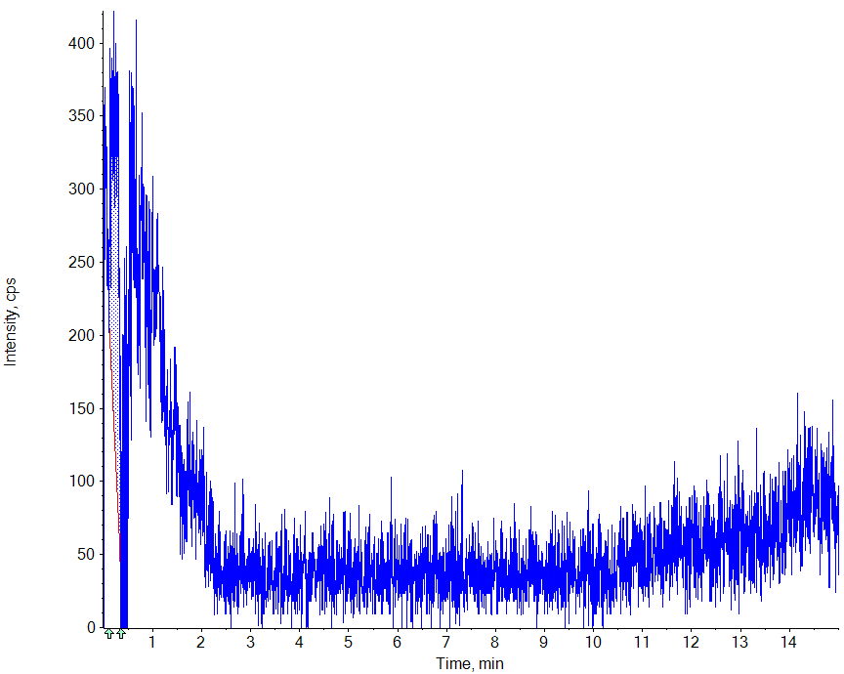 |  | Acquired / Library MSMS
 |  | Acquired / Theoretical MS | 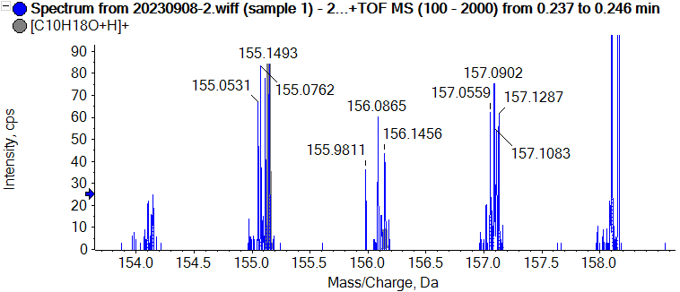

5 C15H22O3 (Mass/FragMass/RT/Isotope/Library/Formula/Ion Ratio)
Retention Time: 0.28 minutes  Precursor m/z : 251.1642  Fit (%) N/A RFit (%) N/A | Exp RT: 0.29 minutes  Analyte Name:  C15H22O3
 |  | Collision Energy = 35 ± 15 eV
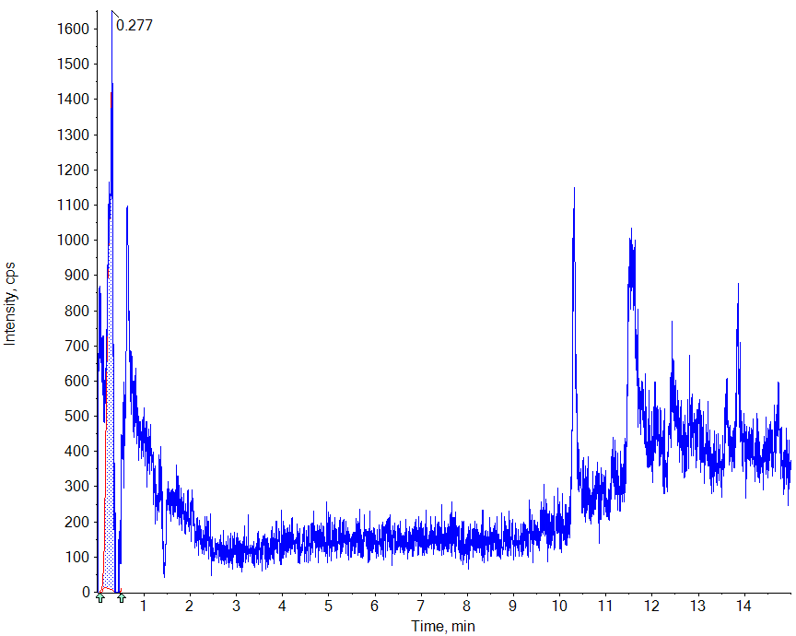 |  | Acquired / Library MSMS
 |  | Acquired / Theoretical MS | 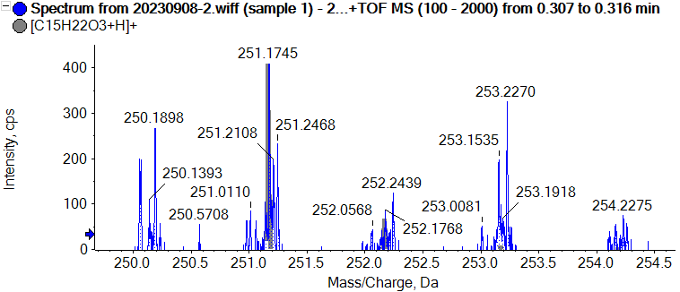

6 C4H10N4O2 (Mass/FragMass/RT/Isotope/Library/Formula/Ion Ratio)
Retention Time: 0.29 minutes  Precursor m/z : 147.0877  Fit (%) N/A RFit (%) N/A | Exp RT: 0.28 minutes  Analyte Name:  C4H10N4O2
 |  | Collision Energy = 35 ± 15 eV
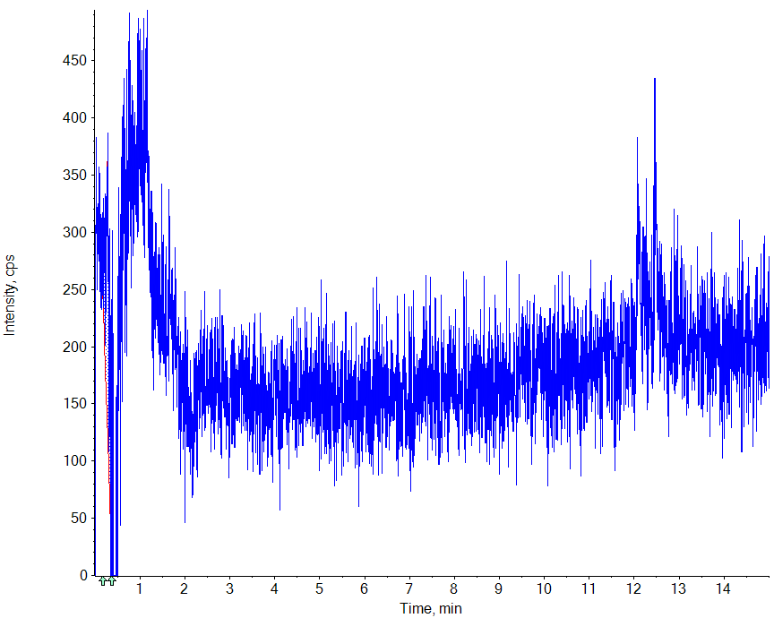 |  | Acquired / Library MSMS
 |  | Acquired / Theoretical MS | 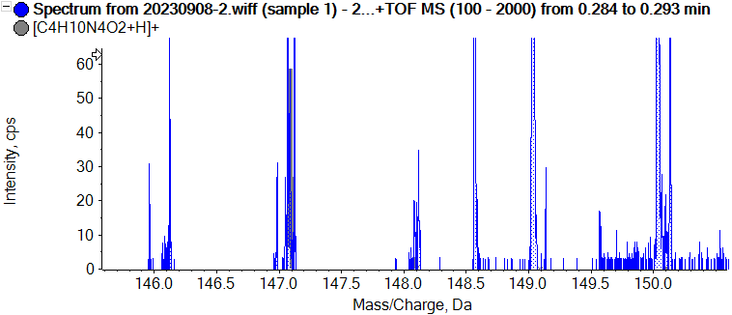

7 C10H16O (Mass/FragMass/RT/Isotope/Library/Formula/Ion Ratio)
Retention Time: 0.35 minutes  Precursor m/z : 153.1274  Fit (%) N/A RFit (%) N/A | Exp RT: 0.34 minutes  Analyte Name:  C10H16O
 |  | Collision Energy = 35 ± 15 eV
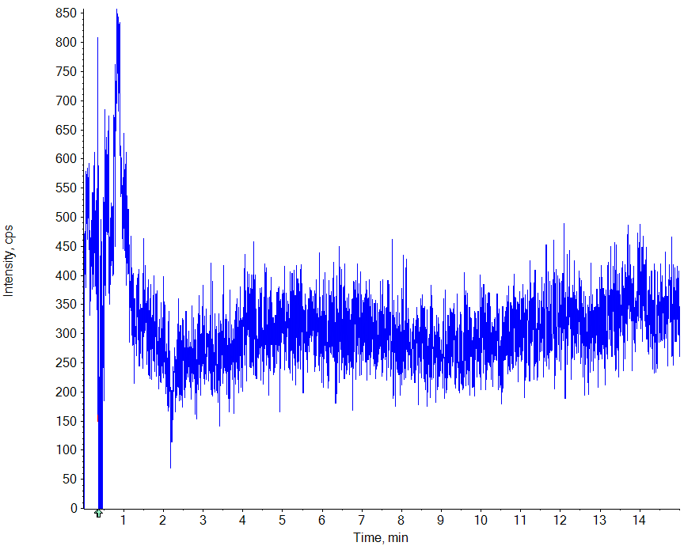 |  | Acquired / Library MSMS
 |  | Acquired / Theoretical MS | 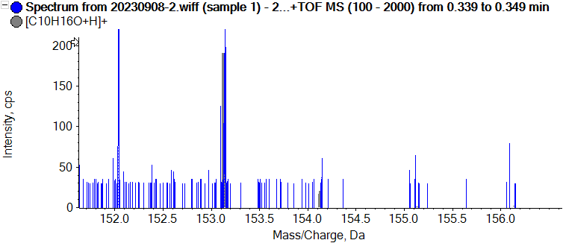

8 C15H10O7 (Mass/FragMass/RT/Isotope/Library/Formula/Ion Ratio)
Retention Time: 0.39 minutes  Precursor m/z : 303.0499  Fit (%) N/A RFit (%) N/A | Exp RT: 0.39 minutes  Analyte Name:  C15H10O7
 |  | Collision Energy = 35 ± 15 eV
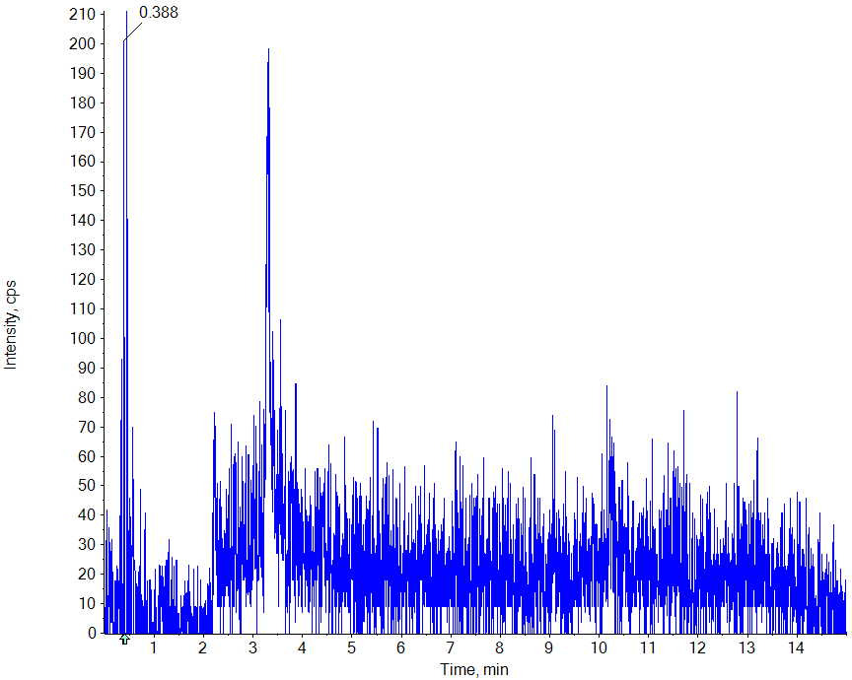 |  | Acquired / Library MSMS
 |  | Acquired / Theoretical MS | 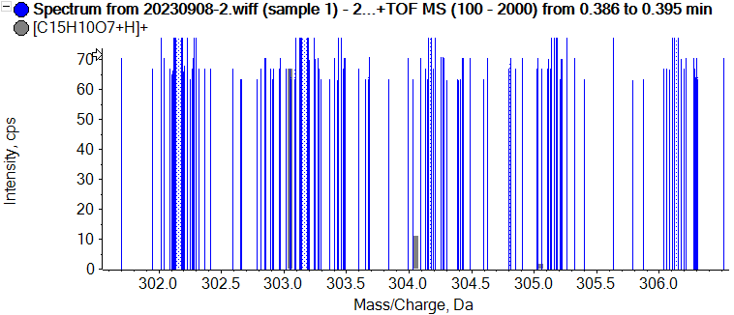

9 C8H12ClNO3 (Mass/FragMass/RT/Isotope/Library/Formula/Ion Ratio)
Retention Time: 0.46 minutes  Precursor m/z : 206.0578  Fit (%) N/A RFit (%) N/A | Exp RT: 0.46 minutes  Analyte Name:  C8H12ClNO3
 |  | Collision Energy = 35 ± 15 eV
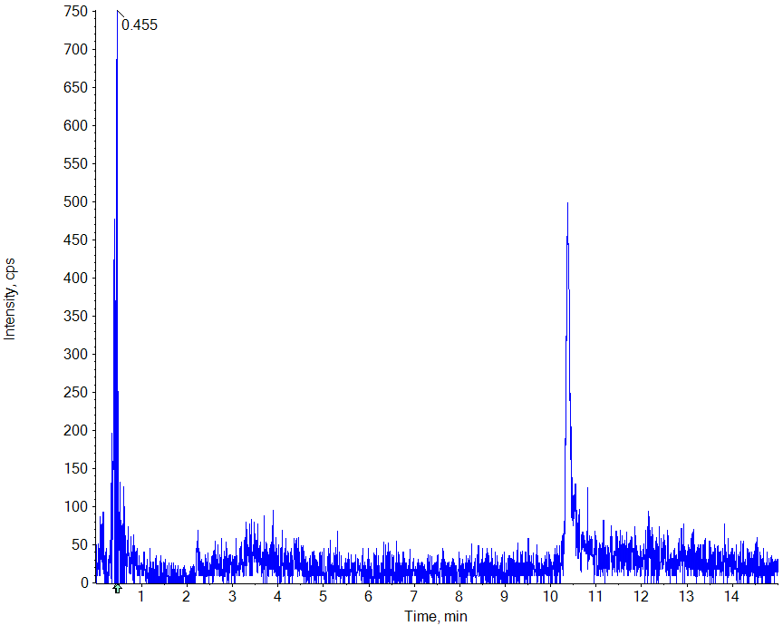 |  | Acquired / Library MSMS
 |  | Acquired / Theoretical MS | 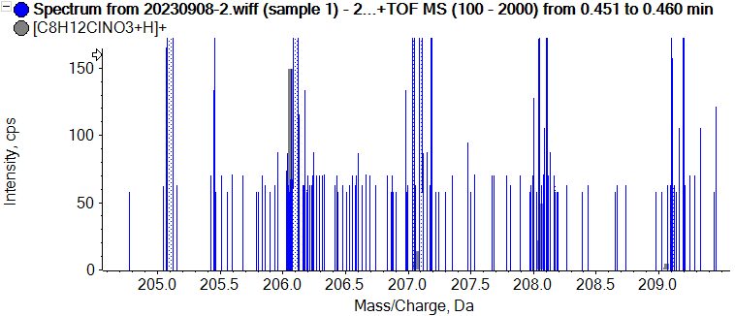

10 C10H16 (Mass/FragMass/RT/Isotope/Library/Formula/Ion Ratio)
Retention Time: 0.49 minutes  Precursor m/z : 137.1325  Fit (%) N/A RFit (%) N/A | Exp RT: 0.50 minutes  Analyte Name:  C10H16
 |  | Collision Energy = 35 ± 15 eV
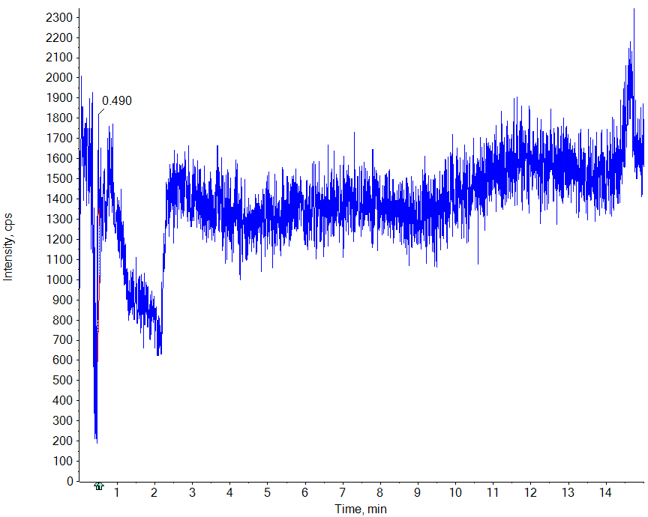 |  | Acquired / Library MSMS
 |  | Acquired / Theoretical MS | 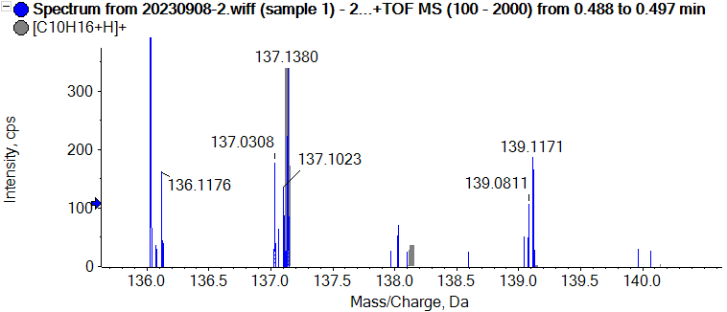

11 C8H16O (Mass/FragMass/RT/Isotope/Library/Formula/Ion Ratio)
Retention Time: 0.55 minutes  Precursor m/z : 129.1274  Fit (%) N/A RFit (%) N/A | Exp RT: 0.87 minutes  Analyte Name:  C8H16O
 |  | Collision Energy = 35 ± 15 eV
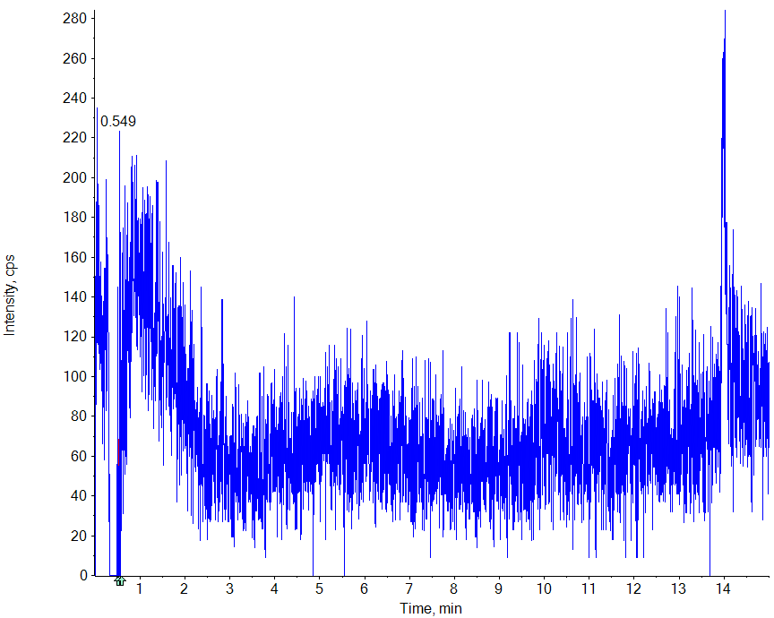 |  | Acquired / Library MSMS
 |  | Acquired / Theoretical MS | 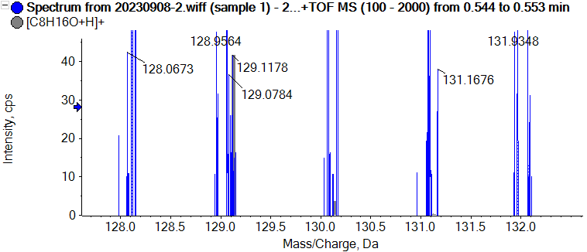

12 C20H30O (Mass/FragMass/RT/Isotope/Library/Formula/Ion Ratio)
Retention Time: 0.83 minutes  Precursor m/z : 287.2369  Fit (%) N/A RFit (%) N/A | Exp RT: 0.84 minutes  Analyte Name:  C20H30O
 |  | Collision Energy = 35 ± 15 eV
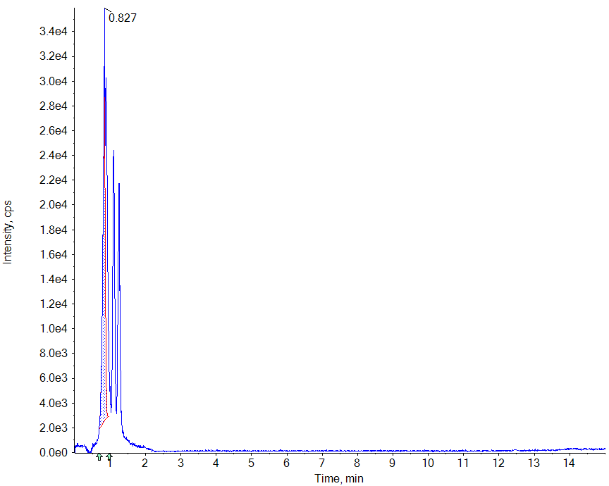 |  | Acquired / Library MSMS
 |  | Acquired / Theoretical MS | 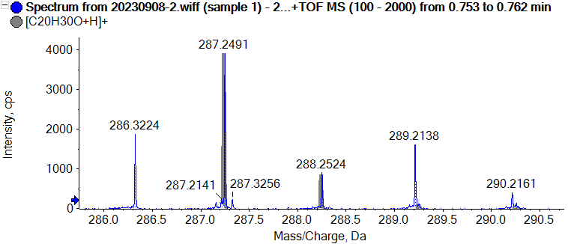

13 C16H12O6 (Mass/FragMass/RT/Isotope/Library/Formula/Ion Ratio)
Retention Time: 1.28 minutes  Precursor m/z : 301.0707  Fit (%) N/A RFit (%) N/A | Exp RT: 1.27 minutes  Analyte Name:  C16H12O6
 |  | Collision Energy = 35 ± 15 eV
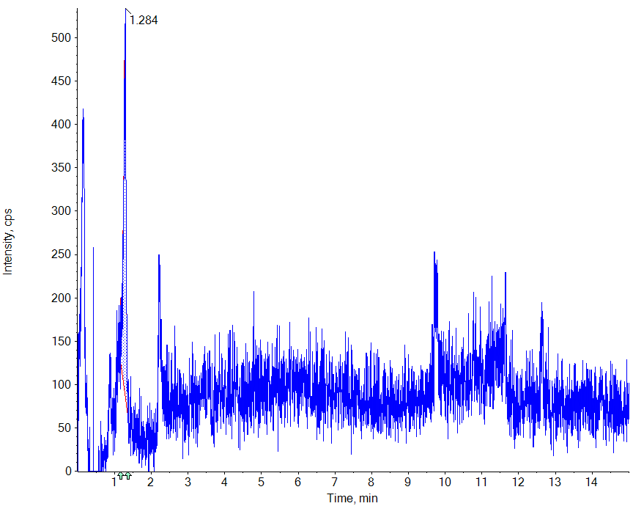 |  | Acquired / Library MSMS
 |  | Acquired / Theoretical MS | 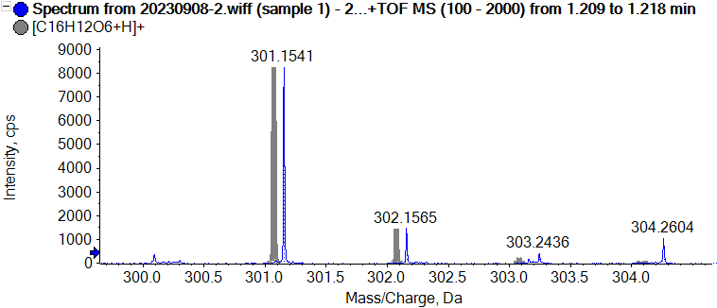

14 C16H12O5 (Mass/FragMass/RT/Isotope/Library/Formula/Ion Ratio)
Retention Time: 1.28 minutes  Precursor m/z : 285.0757  Fit (%) N/A RFit (%) N/A | Exp RT: 1.26 minutes  Analyte Name:  C16H12O5
 |  | Collision Energy = 35 ± 15 eV
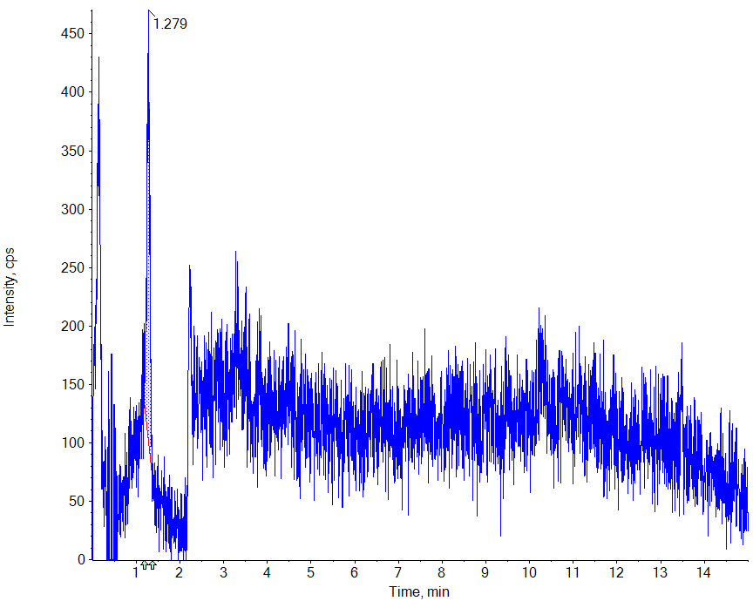 |  | Acquired / Library MSMS
 |  | Acquired / Theoretical MS | 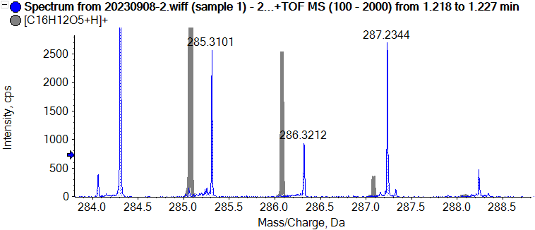

15 C10H14O (Mass/FragMass/RT/Isotope/Library/Formula/Ion Ratio)
Retention Time: 1.89 minutes  Precursor m/z : 151.1117  Fit (%) N/A RFit (%) N/A | Exp RT: 1.89 minutes  Analyte Name:  C10H14O
 |  | Collision Energy = 35 ± 15 eV
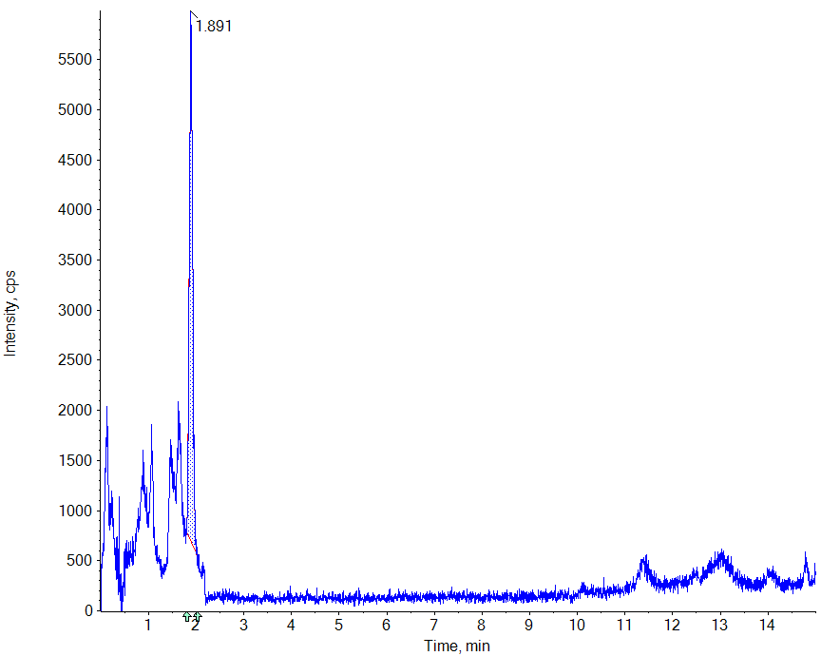 |  | Acquired / Library MSMS
 |  | Acquired / Theoretical MS | 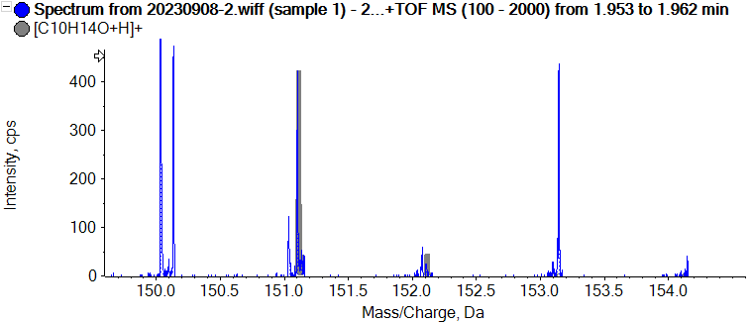

16 C5H14ON (Mass/FragMass/RT/Isotope/Library/Formula/Ion Ratio)
Retention Time: 2.19 minutes  Precursor m/z : 105.1148  Fit (%) N/A RFit (%) N/A | Exp RT: 2.23 minutes  Analyte Name:  C5H14ON
 |  | Collision Energy = 35 ± 15 eV
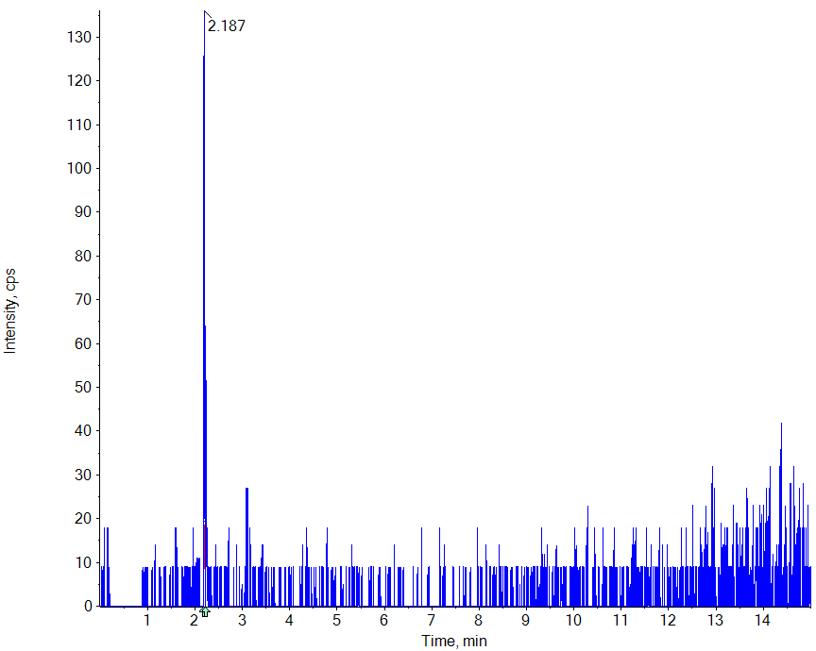 |  | Acquired / Library MSMS
 |  | Acquired / Theoretical MS | 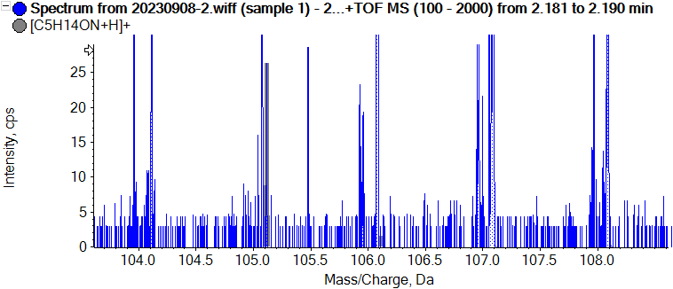

17 C5H5N5 (Mass/FragMass/RT/Isotope/Library/Formula/Ion Ratio)
Retention Time: 3.33 minutes  Precursor m/z : 136.0618  Fit (%) N/A RFit (%) N/A | Exp RT: 3.34 minutes  Analyte Name:  C5H5N5
 |  | Collision Energy = 35 ± 15 eV
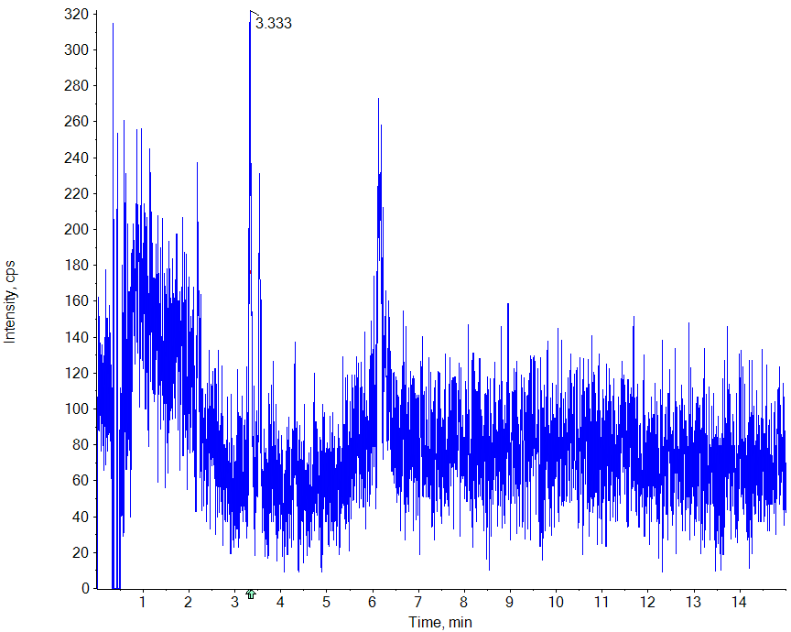 |  | Acquired / Library MSMS
 |  | Acquired / Theoretical MS | 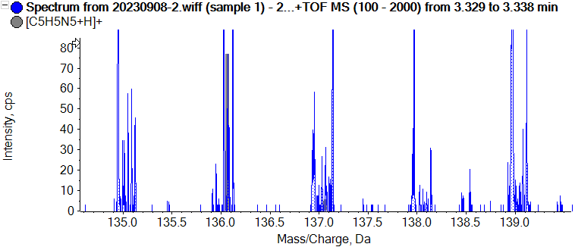

18 C15H10O6 (Mass/FragMass/RT/Isotope/Library/Formula/Ion Ratio)
Retention Time: 10.76 minutes  Precursor m/z : 287.0550  Fit (%) N/A RFit (%) N/A | Exp RT: 10.76 minutes  Analyte Name:  C15H10O6
 |  | Collision Energy = 35 ± 15 eV
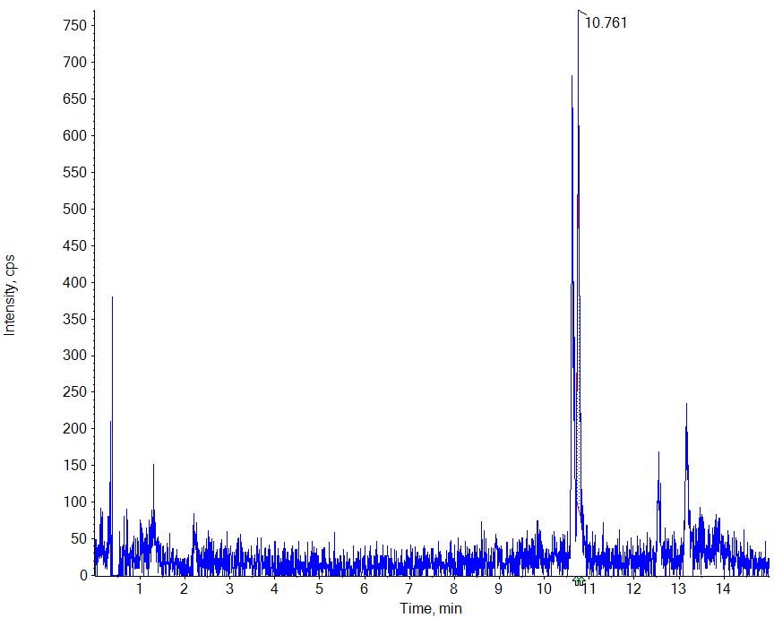 |  | Acquired / Library MSMS
 |  | Acquired / Theoretical MS | 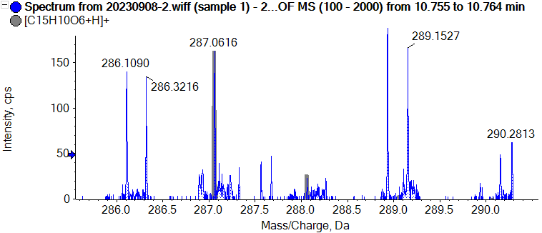

19 C7H14NO2 (Mass/FragMass/RT/Isotope/Library/Formula/Ion Ratio)
Retention Time: 11.56 minutes  Precursor m/z : 145.1097  Fit (%) N/A RFit (%) N/A | Exp RT: 11.59 minutes  Analyte Name:  C7H14NO2
 |  | Collision Energy = 35 ± 15 eV
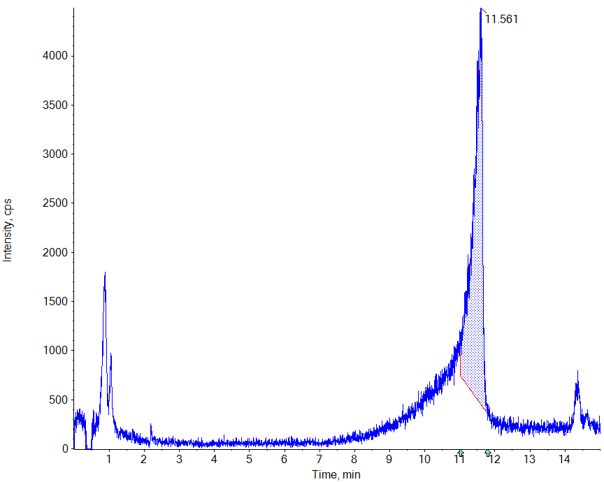 |  | Acquired / Library MSMS
 |  | Acquired / Theoretical MS | 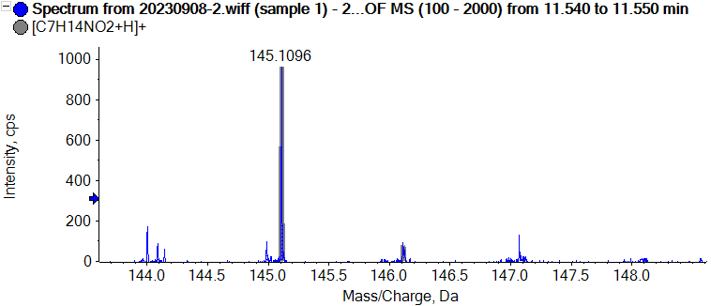

20 C15H10O5 (Mass/FragMass/RT/Isotope/Library/Formula/Ion Ratio)
Retention Time: 12.61 minutes  Precursor m/z : 271.0601  Fit (%) N/A RFit (%) N/A | Exp RT: 12.63 minutes  Analyte Name:  C15H10O5
 |  | Collision Energy = 35 ± 15 eV
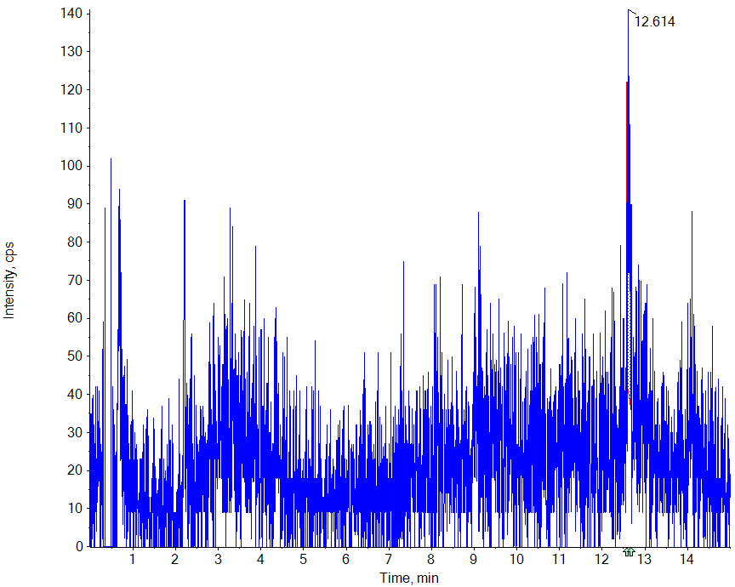 |  | Acquired / Library MSMS
 |  | Acquired / Theoretical MS | 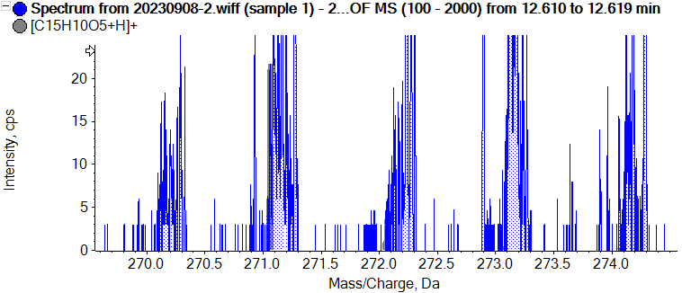

21 C9H10O (Mass/FragMass/RT/Isotope/Library/Formula/Ion Ratio)
Retention Time: 13.54 minutes  Precursor m/z : 135.0804  Fit (%) N/A RFit (%) N/A | Exp RT: 13.54 minutes  Analyte Name:  C9H10O
 |  | Collision Energy = 35 ± 15 eV
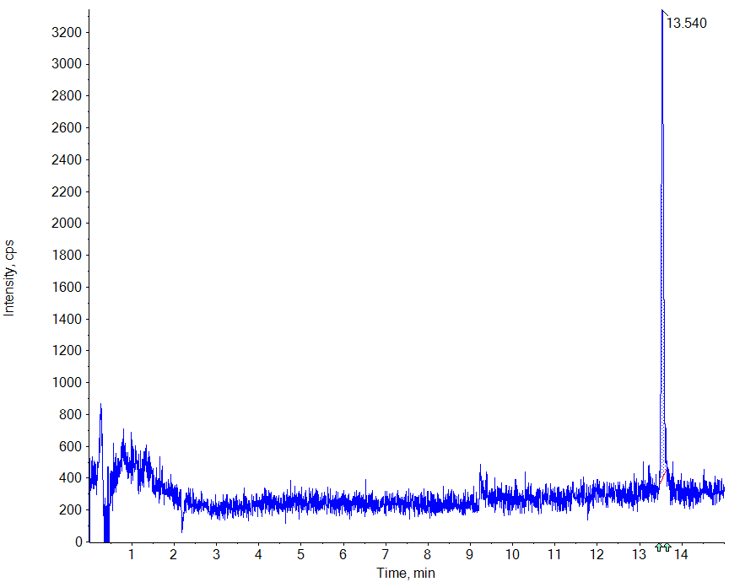 |  | Acquired / Library MSMS
 |  | Acquired / Theoretical MS | 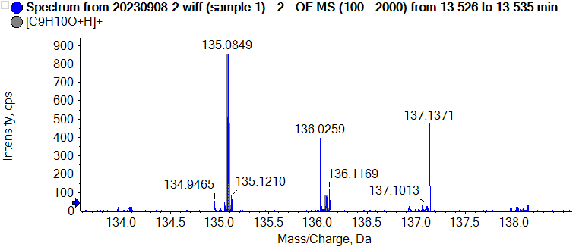

22 C24H22O14 (Mass/FragMass/RT/Isotope/Library/Formula/Ion Ratio)
Retention Time: 13.72 minutes  Precursor m/z : 535.1082  Fit (%) N/A RFit (%) N/A | Exp RT: 13.75 minutes  Analyte Name:  C24H22O14
 |  | Collision Energy = 35 ± 15 eV
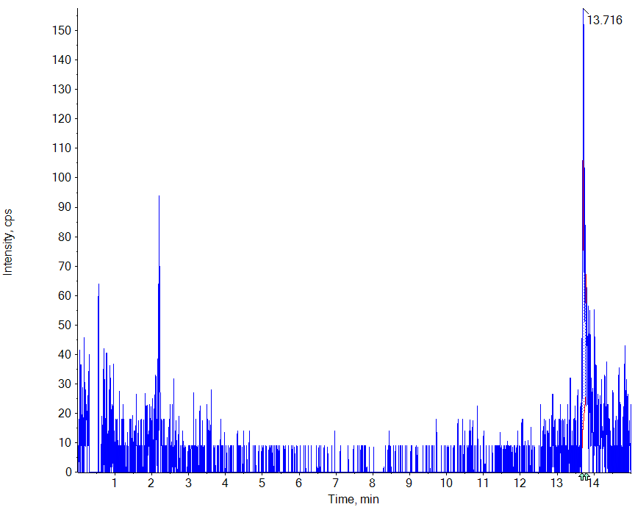 |  | Acquired / Library MSMS
 |  | Acquired / Theoretical MS | 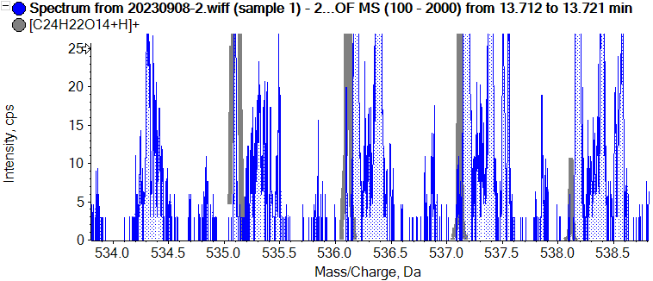
Fig. S2-23. Mass spectra of 22 compounds of ethanol extracts of R. hirta.

