SUPPORTING INFORMATION

Unveiling Piperazine-Quinoline Hybrids as Potential Multi-Target Directed Anti-Alzheimer’s Agents: In-silico Insights and Chemical Characterization
Afzal Nagani^{1,2}, Moksh Shah¹, Salman Patel¹, Harnisha Patel¹, Vruti Parikh¹, Ashish Patel³, Sagar Patel⁴, Kirti Patel⁵, Hardik Parmar⁵, Bhargav Bhimani⁶, M R Yadav^{2*}

¹Parul Institute of Pharmacy, Parul University, Vadodara.
²Research and Development Cell, Parul University, Vadodara.
³Ramanbhai Patel College of Pharmacy, Charusat University, Changa.
⁴Sunnybrook Research Institute, Sunnybrook Health Science Centre,
University of Toronto, Ontario, Canada
⁵Faculty of Pharmacy, The M.S University of Baroda
⁶Piramal Healthcare, Ahmedabad.

*Author for Correspondence
E-mail: mryadav11@yahoo.co.in

CONTENTS:
 | Table-1: ADME prediction of the synthesized compounds using SWISS ADME. | 11,12
 | IR Spectrum of 2-(4-(tert-Butoxycarbonyl)piperazin-1-yl)-2-phenylacetic acid (4). | 13
 | MS Spectrum of 2-(4-(tert-Butoxycarbonyl)piperazin-1-yl)-2-phenyl acetic acid (4). | 13
 | ¹H NMR of 2-(4-(tert-Butoxycarbonyl)piperazin-1-yl)-2-phenylacetic acid (4). | 14
 | IR Spectrum of 2-(4-(tert-Butoxycarbonyl)piperazin-1-yl)-2-(4- fluorophenyl)acetic acid (5). | 14
 | MS of 2-(4-(tert-Butoxycarbonyl)piperazin-1-yl)-2-(4 fluorophenyl) acetic acid (5) | 15
 | ¹H-NMR of 2-(4-(tert-Butoxycarbonyl)piperazin-1-yl)-2-(4- fluorophenyl)acetic acid (5). | 16
 | IR Spectrum of 2-(4-(tert-Butoxycarbonyl)piperazin-1-yl)-2-(4-methoxyphenyl)acetic acid (6). | 17
 | MS of 2-(4-(tert-Butoxycarbonyl)piperazin-1-yl)-2-(4-methoxyphenyl) acetic acid (6). | 18
 | ¹H NMR of 2-(4-(tert-Butoxycarbonyl)piperazin-1-yl)-2-(4-methoxy phenyl)acetic acid (6). | 19
 | IR Spectrum of tert-Butyl-4-(2-oxo-1-phenyl-2-(phenylamino)ethyl) piperazine-1-carboxylate (16). | 19
 | IR Spectrum of tert-Butyl-4-(2-oxo-1-phenyl-2-(o-tolylamino)ethyl) piperazine-1-carboxylate (17). | 20
 | IR Spectrum of tert-Butyl-4-(2-oxo-1-phenyl-2-(p-tolylamino)ethyl) piperazine-1-carboxylate (18). | 20
 | IR Spectrum of tert-Butyl-4-(2-((2-methoxyphenyl)amino)-2-oxo-1-phenylethyl)piperazine-1-carboxylate (19). | 21
 | IR Spectrum of tert-Butyl-4-(2-((4-methoxyphenyl)amino)-2-oxo-1-phenylethyl)piperazine-1-carboxylate (20). | 22
 | IR Spectrum of tert-Butyl-4-(2-((4-fluorophenyl)amino)-2-oxo-1-phenylethyl)piperazine-1-carboxylate (21). | 22
 | IR Spectrum of tert-Butyl-4-(2-((4-chlorophenyl)amino)-2-oxo-1-phenylethyl)piperazine-1-carboxylate (22). | 23
 | IR Spectrum of tert-Butyl-4-(2-((4-hydroxyphenyl)amino)-2-oxo-1-phenylethyl)piperazine-1-carboxylate (23). | 24
 | IR Spectrum of tert-Butyl-4-(2-(cyclohexylamino)-2-oxo-1-phenylethyl)piperazine-1-carboxylate (24). | 24
 | IR Spectrum of tert-Butyl-4-(1-(4-fluorophenyl)-2-oxo-2-(phenylamino)ethyl)piperazine-1-carboxylate (25). | 25
 | IR Spectrum of tert-Butyl-4-(1-(4-fluorophenyl)-2-oxo-2-(o-tolylamino) ethyl)piperazine-1-carboxylate (26). | 25
 | IR Spectrum of tert-Butyl-4-(1-(4-fluorophenyl)-2-oxo-2-(p-tolylamino)ethyl)piperazine-1-carboxylate (27). | 26
 | IR Spectrum of tert-Butyl-4-(1-(4-fluorophenyl)-2-((2-methoxyphenyl)amino)-2-oxoethyl)piperazine-1-carboxylate (28). | 27
 | IR Spectrum of tert-Butyl-4-(1-(4-fluorophenyl)-2-((4-methoxyphenyl) amino)-2-oxoethyl)piperazine-1-carboxylate (29). | 27
 | IR Spectrum of tert-Butyl-4-(1-(4-fluorophenyl)-2-((4-fluorophenyl)amino)-2-oxoethyl)piperazine-1-carboxylate (30). | 28
 | IR Spectrum of tert-Butyl-4-(2-((4-chlorophenyl)amino)-1-(4-fluorophenyl)-2-oxoethyl)piperazine-1-carboxylate (31). | 28
 | IR spectrum of tert-Butyl-4-(1-(4-fluorophenyl)-2-((4-hydroxyphenyl) amino)-2-oxoethyl)piperazine-1-carboxylate (32). | 29
 | IR Spectrum of tert-Butyl-4-(2-(cyclohexylamino)-1-(4-fluorophenyl)-2-oxoethyl)piperazine-1-carboxylate (33). | 30
 | IR Spectrum of tert-Butyl-4-(1-(4-methoxyphenyl)-2-oxo-2-(phenylamino)ethyl)piperazine-1-carboxylate (34). | 30
 | IR Spectrum of tert-Butyl-4-(1-(4-methoxyphenyl)-2-oxo-2-(o-tolylamino)ethyl)piperazine-1-carboxylate (35). | 31
 | IR Spectrum of tert-Butyl-4-(1-(4-methoxyphenyl)-2-oxo-2-(p-tolylamino)ethyl)piperazine-1-carboxylate (36). | 32
 | IR Spectrum of tert-Butyl-4-(1-(4-methoxyphenyl)-2-((2-methoxyphenyl)amino)-2-oxoethyl)piperazine-1-carboxylate (37). | 32
 | IR Spectrum of tert-Butyl-4-(1-(4-methoxyphenyl)-2-((4-methoxyphenyl)amino)-2-oxoethyl)piperazine-1-carboxylate (38). | 33
 | IR Spectrum of tert-Butyl-4-(2-((4-fluorophenyl)amino)-1-(4-methoxyphenyl)-2-oxoethyl)piperazine-1-carboxylate (39). | 34
 | IR Spectrum of tert-Butyl-4-(2-((4-chlorophenyl)amino)-1-(4-methoxyphenyl)-2-oxoethyl)piperazine-1-carboxylate (40). | 34
 | IR Spectrum of tert-Butyl-4-(2-((4-hydroxyphenyl)amino)-1-(4-methoxyphenyl)-2-oxoethyl)piperazine-1-carboxylate (41). | 35
 | IR Spectrum of tert-Butyl-4-(2-(cyclohexylamino)-1-(4-methoxyphenyl) -2-oxoethyl)piperazine-1-carboxylate (42). | 36
 | IR spectrum of 2-(4-((8-Hydroxyquinolin-5-yl)methyl)piperazin-1-yl)-N,2-diphenylacetamide (71). | 36
 | LCMS of 2-(4-((8-Hydroxyquinolin-5-yl)methyl)piperazin-1-yl)-N,2-diphenylacetamide (71). | 37
 | ¹H NMR of 2-(4-((8-Hydroxyquinolin-5-yl)methyl)piperazin-1-yl)-N,2-diphenylacetamide (71). | 38
 | IR Spectrum of 2-(4-((8-Hydroxyquinolin-5-yl)methyl)piperazin-1-yl)-2-phenyl-N-(o-tolyl)acetamide (72). | 39
 | MS of 2-(4-((8-Hydroxyquinolin-5-yl)methyl)piperazin-1-yl)-2-phenyl-N-(o-tolyl)acetamide (72). | 40
 | ¹H NMR of 2-(4-((8-Hydroxyquinolin-5-yl)methyl)piperazin-1-yl)-2-phenyl-N-(o-tolyl)acetamide (72). | 41
 | IR Spectrum of 2-(4-((8-Hydroxyquinolin-5-yl)methyl)piperazin-1-yl)-2-phenyl-N-(p-tolyl)acetamide (73). | 41
 | LCMS of 2-(4-((8-Hydroxyquinolin-5-yl)methyl)piperazin-1-yl)-2-phenyl-N-(p-tolyl)acetamide (73). | 42
 | ¹H NMR of 2-(4-((8-Hydroxyquinolin-5-yl)methyl)piperazin-1-yl)-2-phenyl-N-(p-tolyl)acetamide (73). | 42
 | IR Spectrum of 2-(4-((8-Hydroxyquinolin-5-yl)methyl)piperazin-1-yl)-N-(2-methoxyphenyl)-2-phenyl- acetamide (74). | 44
 | MS of 2-(4-((8-Hydroxyquinolin-5-yl)methyl)piperazin-1-yl)-N-(2-methoxyphenyl)-2-phenyl- acetamide (74). | 45
 | ¹H NMR of 2-(4-((8-Hydroxyquinolin-5-yl)methyl)piperazin-1-yl)-N-(2-methoxyphenyl)-2-phenyl- acetamide (74). | 46
 | IR Spectrum of 2-(4-((8-Hydroxyquinolin-5-yl)methyl)piperazin-1-yl)-N-(4-methoxyphenyl)-2-phenyl- acetamide (75). | 46
 | MS of 2-(4-((8-Hydroxyquinolin-5-yl)methyl)piperazin-1-yl)-N-(4-methoxyphenyl)-2-phenyl- acetamide (75). | 47
 | ¹H NMR of 2-(4-((8-Hydroxyquinolin-5-yl)methyl)piperazin-1-yl)-N-(4-methoxyphenyl)-2-phenyl- acetamide (75). | 48
 | IR Spectrum of N-(4-Fluorophenyl)-2-(4-((8-hydroxyquinolin-5-yl)methyl)piperazin-1-yl)-2-phenyl- acetamide (76). | 49
 | MS of N-(4-Fluorophenyl)-2-(4-((8-hydroxyquinolin-5-yl)methyl) piperazin-1-yl)-2-phenyl- acetamide (76). | 50
 | ¹H-NMR of N-(4-Fluorophenyl)-2-(4-((8-hydroxyquinolin-5-yl)methyl) piperazin-1-yl)-2-phenyl- acetamide (76). | 51
 | IR Spectrum of N-(4-Chlorophenyl)-2-(4-((8-hydroxyquinolin-5-yl) methyl)piperazin-1-yl)-2-phenyl- acetamide (77). | 52
 | MS of N-(4-Chlorophenyl)-2-(4-((8-hydroxyquinolin-5-yl)methyl) piperazin-1-yl)-2-phenyl- acetamide (77). | 53
 | ¹H NMR of N-(4-Chlorophenyl)-2-(4-((8-hydroxyquinolin-5-yl)methyl)piperazin-1-yl)-2-phenyl- acetamide (77). | 54
 | IR Spectrum of N-(4-Hydroxyphenyl)-2-(4-((8-hydroxyquinolin-5-yl) methyl)piperazin-1-yl)-2-phenyl- acetamide (78). | 54
 | MS of N-(4-Hydroxyphenyl)-2-(4-((8-hydroxyquinolin-5-yl)methyl) piperazin-1-yl)-2-phenyl- acetamide (78). | 55
 | ¹H NMR of N-(4-Hydroxyphenyl)-2-(4-((8-hydroxyquinolin-5-yl) methyl)piperazin-1-yl)-2-phenyl- acetamide (78). | 56
 | IR Spectrum of N-Cyclohexyl-2-(4-((8-hydroxyquinolin-5-yl) methyl)piperazin-1-yl)-2-phenylacetamide (79). | 56
 | MS of N-Cyclohexyl-2-(4-((8-hydroxyquinolin-5-yl)methyl)piperazin-1-yl)-2-phenylacetamide (79). | 57
 | ¹H-NMR of N-Cyclohexyl-2-(4-((8-hydroxyquinolin-5-yl)methyl) piperazin-1-yl)-2-phenylacetamide (79). | 58
 | ¹³C-NMR of N-Cyclohexyl-2-(4-((8-hydroxyquinolin-5-yl)methyl) piperazin-1-yl)-2-phenylacetamide (79). | 59
 | IR Spectrum of 2-(4-Fluorophenyl)-2-(4-((8-hydroxyquinolin-5-yl) methyl)piperazin-1-yl)-N-phenyl- acetamide (80). | 60
 | MS of 2-(4-Fluorophenyl)-2-(4-((8-hydroxyquinolin-5-yl)methyl) piperazin-1-yl)-N-phenyl- acetamide (80). | 61
 | ¹H-NMR of 2-(4-Fluorophenyl)-2-(4-((8-hydroxyquinolin-5-yl)methyl) piperazin-1-yl)-N-phenyl- acetamide (80). | 62
 | ¹³C-NMR of 2-(4-Fluorophenyl)-2-(4-((8-hydroxyquinolin-5-yl)methyl) piperazin-1-yl)-N-phenyl- acetamide (80) | 63
 | IR Spectrum of 2-(4-Fluorophenyl)-2-(4-((8-hydroxyquinolin-5-yl) methyl)piperazin-1-yl)-N-(o-tolyl)- acetamide (81). | 64
 | MS of 2-(4-Fluorophenyl)-2-(4-((8-hydroxyquinolin-5-yl)methyl)piperazin-1-yl)-N-(o-tolyl)- acetamide (81). | 65
 | ¹H-NMR of 2-(4-Fluorophenyl)-2-(4-((8-hydroxyquinolin-5-yl)methyl) piperazin-1-yl)-N-(o-tolyl)- acetamide (81). | 66
 | IR Spectrum of 2-(4-Fluorophenyl)-2-(4-((8-hydroxyquinolin-5-yl) methyl)piperazin-1-yl)-N-(p-tolyl)- acetamide (82). | 66
 | MS of 2-(4-Fluorophenyl)-2-(4-((8-hydroxyquinolin-5-yl)methyl) piperazin-1-yl)-N-(p-tolyl)- acetamide (82). | 67
 | ¹H-NMR of 2-(4-Fluorophenyl)-2-(4-((8-hydroxyquinolin-5-yl)methyl) piperazin-1-yl)-N-(p-tolyl)- acetamide (82). | 68
 | IR Spectrum of 2-(4-Fluorophenyl)-2-(4-((8-hydroxyquinolin-5-yl) methyl)piperazin-1-yl)-N-(2-methoxyphenyl)acetamide (83). | 68
 | LCMS of 2-(4-Fluorophenyl)-2-(4-((8-hydroxyquinolin-5-yl)methyl) piperazin-1-yl)-N-(2-methoxyphenyl)acetamide (83). | 69
 | ¹H-NMR of 2-(4-Fluorophenyl)-2-(4-((8-hydroxyquinolin-5-yl)methyl) piperazin-1-yl)-N-(2-methoxyphenyl)acetamide (83). | 70
 | IR Spectrum of 2-(4-Fluorophenyl)-2-(4-((8-hydroxyquinolin-5-yl) methyl)piperazin-1-yl)-N-(4-methoxyphenyl)acetamide (84). | 70
 | LCMS of 2-(4-Fluorophenyl)-2-(4-((8-hydroxyquinolin-5-yl)methyl) piperazin-1-yl)-N-(4-methoxyphenyl)acetamide (84). | 71
 | ¹H-NMR of 2-(4-Fluorophenyl)-2-(4-((8-hydroxyquinolin-5-yl)methyl) piperazin-1-yl)-N-(4-methoxyphenyl)acetamide (84). | 72
 | IR Spectrum of N,2-bis(4-Fluorophenyl)-2-(4-((8-hydroxyquinolin-5-yl)methyl)piperazin-1-yl)- acetamide (85). | 73
 | LCMS of N,2-bis(4-Fluorophenyl)-2-(4-((8-hydroxyquinolin-5-yl) methyl)piperazin-1-yl)- acetamide (85). | 74,75
 | ¹H-NMR of N,2-bis(4-Fluorophenyl)-2-(4-((8-hydroxyquinolin-5-yl) methyl)piperazin-1-yl)- acetamide (85). | 76
 | IR Spectrum of N-(4-Chlorophenyl)-2-(4-fluorophenyl)-2-(4-((8-hydroxyquinolin-5-yl)methyl)- piperazin-1-yl)acetamide (86). | 77
 | LCMS of N-(4-Chlorophenyl)-2-(4-fluorophenyl)-2-(4-((8-hydroxy- quinolin-5-yl)methyl)- piperazin-1-yl)acetamide (86). | 78
 | ¹H-NMR of N-(4-Chlorophenyl)-2-(4-fluorophenyl)-2-(4-((8-hydroxy- quinolin-5-yl)methyl)- piperazin-1-yl)acetamide (86). | 79
 | IR Spectrum of 2-(4-Fluorophenyl)-N-(4-hydroxyphenyl)-2-(4-((8-hydroxyquinolin-5-yl)methyl)- piperazin-1-yl)acetamide (87). | 80
 | MS of 2-(4-Fluorophenyl)-N-(4-hydroxyphenyl)-2-(4-((8-hydroxy- quinolin-5-yl)methyl)- piperazin-1-yl)acetamide (87). | 81
 | ¹H-NMR of 2-(4-Fluorophenyl)-N-(4-hydroxyphenyl)-2-(4-((8-hydroxy quinolin-5-yl)methyl)- piperazin-1-yl)acetamide (87). | 82
 | IR Spectrum of N-Cyclohexyl-2-(4-fluorophenyl)-2-(4-((8-hydroxy quinolin-5-yl)methyl)piperazin-1-yl)acetamide (88). | 82
 | MS of N-Cyclohexyl-2-(4-fluorophenyl)-2-(4-((8-hydroxyquinolin-5-yl) methyl)piperazin-1-yl)acetamide (88). | 83
 | ¹H-NMR of N-Cyclohexyl-2-(4-fluorophenyl)-2-(4-((8-hydroxyquinolin -5-yl)methyl)piperazin-1-yl)acetamide (88). | 84
 | IR Spectrum of 2-(4-((8-Hydroxyquinolin-5-yl)methyl)piperazin-1-yl)-2-(4-methoxyphenyl)-N-phenyl- acetamide (89). | 84
 | MS of 2-(4-((8-Hydroxyquinolin-5-yl)methyl)piperazin-1-yl)-2-(4-methoxyphenyl)-N-phenyl- acetamide (89). | 85
 | ¹H-NMR of 2-(4-((8-Hydroxyquinolin-5-yl)methyl)piperazin-1-yl)-2-(4-methoxyphenyl)-N-phenyl- acetamide (89). | 86
 | IR Spectrum of 2-(4-((8-Hydroxyquinolin-5-yl)methyl)piperazin-1-yl)-2-(4-methoxyphenyl)-N-(o-tolyl) acetamide (90). | 87
 | MS of 2-(4-((8-Hydroxyquinolin-5-yl)methyl)piperazin-1-yl)-2-(4-methoxyphenyl)-N-(o-tolyl) acetamide (90). | 88
 | ¹H-NMR of 2-(4-((8-Hydroxyquinolin-5-yl)methyl)piperazin-1-yl)-2-(4-methoxyphenyl)-N-(o-tolyl) acetamide (90). | 89
 | ¹³C-NMR of 2-(4-((8-Hydroxyquinolin-5-yl)methyl)piperazin-1-yl)-2-(4-methoxyphenyl)-N-(o-tolyl) acetamide (90). | 90
 | IR Spectrum of 2-(4-((8-Hydroxyquinolin-5-yl)methyl)piperazin-1-yl)-2-(4-methoxyphenyl)-N-(p-tolyl) acetamide (91). | 91
 | MS of 2-(4-((8-Hydroxyquinolin-5-yl)methyl)piperazin-1-yl)-2-(4-methoxyphenyl)-N-(p-tolyl) acetamide (91). | 92
 | 1H-NMR of 2-(4-((8-Hydroxyquinolin-5-yl)methyl)piperazin-1-yl)-2-(4-methoxyphenyl)-N-(p-tolyl) acetamide (91). | 93
 | IR Spectrum of 2-(4-((8-Hydroxyquinolin-5-yl)methyl)piperazin-1-yl)-N-(2-methoxyphenyl)-2-(4-methoxyphenyl)acetamide (92). | 94
 | MS of 2-(4-((8-Hydroxyquinolin-5-yl)methyl)piperazin-1-yl)-N-(2-methoxyphenyl)-2-(4-methoxyphenyl)acetamide (92). | 95
 | ¹H-NMR of 2-(4-((8-Hydroxyquinolin-5-yl)methyl)piperazin-1-yl)-N-(2-methoxyphenyl)-2-(4-methoxyphenyl)acetamide (92). | 96
 | IR Spectrum of 2-(4-((8-Hydroxyquinolin-5-yl)methyl)piperazin-1-yl)-N,2-bis(4-methoxyphenyl)- acetamide (93). | 97
 | MS of 2-(4-((8-Hydroxyquinolin-5-yl)methyl)piperazin-1-yl)-N,2-bis(4-methoxyphenyl)- acetamide (93). | 98
 | ¹H-NMR of 2-(4-((8-Hydroxyquinolin-5-yl)methyl)piperazin-1-yl)-N,2-bis(4-methoxyphenyl)- acetamide (93). | 99
 | IR Spectrum of N-(4-Fluorophenyl)-2-(4-((8-hydroxyquinolin-5-yl)methyl)piperazin-1-yl)-2-(4-methoxyphenyl)acetamide (94). | 100
 | MS of N-(4-Fluorophenyl)-2-(4-((8-hydroxyquinolin-5-yl)methyl) piperazin-1-yl)-2-(4-methoxyphenyl)acetamide (94). | 101
 | ¹H NMR of N-(4-Fluorophenyl)-2-(4-((8-hydroxyquinolin-5-yl)methyl)piperazin-1-yl)-2-(4-methoxyphenyl)acetamide (94). | 102
 | IR Spectrum of N-(4-Chlorophenyl)-2-(4-((8-hydroxyquinolin-5-yl) methyl)piperazin-1-yl)-2-(4-methoxyphenyl)acetamide (95). | 103
 | MS of N-(4-Chlorophenyl)-2-(4-((8-hydroxyquinolin-5-yl)methyl) piperazin-1-yl)-2-(4-methoxyphenyl)acetamide (95). | 104
 | ¹H-NMR of N-(4-Chlorophenyl)-2-(4-((8-hydroxyquinolin-5-yl)methyl) piperazin-1-yl)-2-(4-methoxyphenyl)acetamide (95). | 105
 | IR Spectrum of N-(4-Hydroxyphenyl)-2-(4-((8-hydroxyquinolin-5-yl) methyl)piperazin-1-yl)-2-(4-methoxyphenyl)acetamide (96). | 106
 | MS of N-(4-Hydroxyphenyl)-2-(4-((8-hydroxyquinolin-5-yl)methyl) piperazin-1-yl)-2-(4-methoxyphenyl)acetamide (96). | 107
 | ¹H-NMR of N-(4-Hydroxyphenyl)-2-(4-((8-hydroxyquinolin-5-yl) methyl)piperazin-1-yl)-2-(4-methoxyphenyl)acetamide (96). | 108
 | IR Spectrum of N-(4-Hydroxyphenyl)-2-(4-((8-hydroxyquinolin-5-yl) methyl)piperazin-1-yl)-2-(4-methoxyphenyl)acetamide (97). | 109
 | MS of N-(4-Hydroxyphenyl)-2-(4-((8-hydroxyquinolin-5-yl)methyl) piperazin-1-yl)-2-(4-methoxyphenyl)acetamide (97). | 110
 | ¹H-NMR of N-(4-Hydroxyphenyl)-2-(4-((8-hydroxyquinolin-5-yl) methyl)piperazin-1-yl)-2-(4-methoxyphenyl)acetamide (97). | 111
 | Result of Metal chelation Activity. | 112
 | Table-2: Metal Chelation Activity | 112
 | Graphs of metal chelation | 113-126

Table-1: ADME prediction of the synthesized compounds.
Compound | clogP | BBB permeation | Pgp substrate | Bioavailability score | GI absorption
71 | 3.40 | Yes | Yes | 0.55 | High
72 | 3.72 | Yes | Yes | 0.55 | High
73 | 3.77 | Yes | Yes | 0.55 | High
74 | 3.46 | No | Yes | 0.55 | High
75 | 3.40 | No | Yes | 0.55 | High
76 | 3.76 | Yes | Yes | 0.55 | High
77 | 3.97 | Yes | Yes | 0.55 | High
78 | 3.06 | No | Yes | 0.55 | High
79 | 3.56 | Yes | Yes | 0.55 | High
80 | 4.57 | Yes | Yes | 0.55 | High
81 | 4.88 | Yes | Yes | 0.55 | High
82 | 4.88 | Yes | Yes | 0.55 | High
83 | 4.58 | Yes | Yes | 0.55 | High
84 | 4.58 | Yes | Yes | 0.55 | High
85 | 4.79 | Yes | Yes | 0.55 | High
86 | 5.23 | Yes | Yes | 0.55 | High
87 | 4.2 | No | Yes | 0.55 | High
88 | 4.38 | Yes | Yes | 0.55 | High
89 | 4.4 | Yes | Yes | 0.55 | High
90 | 4.75 | Yes | Yes | 0.55 | High
91 | 4.75 | Yes | Yes | 0.55 | High
92 | 4.45 | No | Yes | 0.55 | High
93 | 4.45 | No | Yes | 0.55 | High
94 | 4.58 | Yes | Yes | 0.55 | High
95 | 5.1 | Yes | Yes | 0.55 | High
96 | 4.1 | No | Yes | 0.55 | High
97 | 4.25 | Yes | Yes | 0.55 | High

2-(4-(tert-Butoxycarbonyl)piperazin-1-yl)-2-phenylacetic acid (4)
IR Spectrum
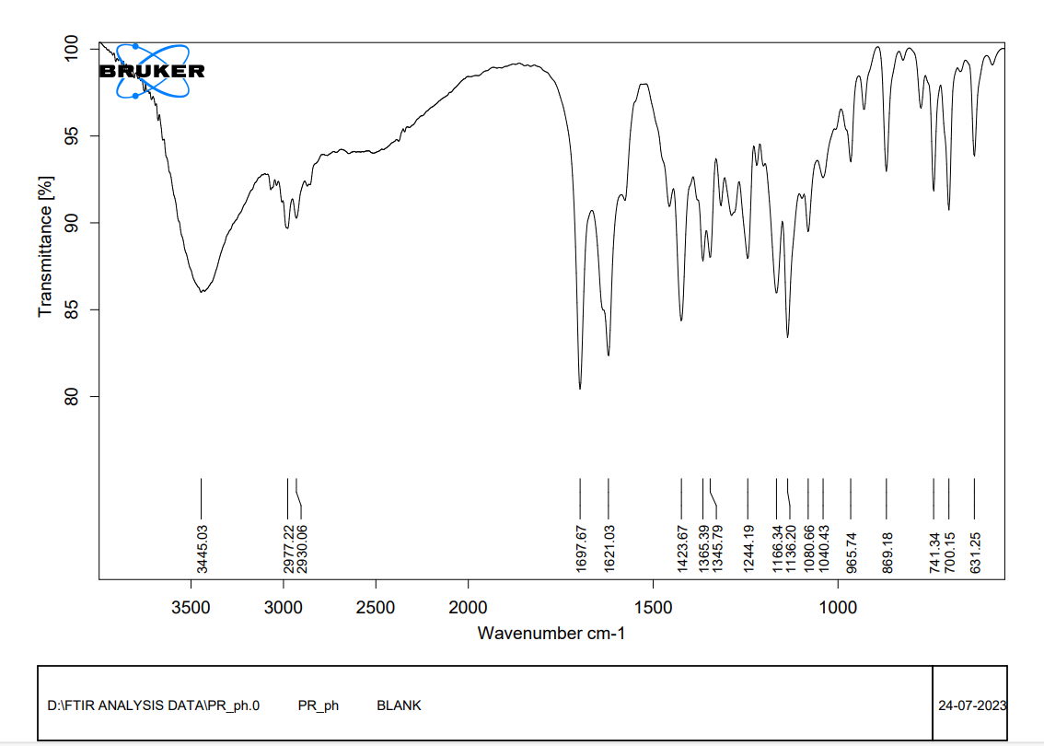

Mass Spectrum
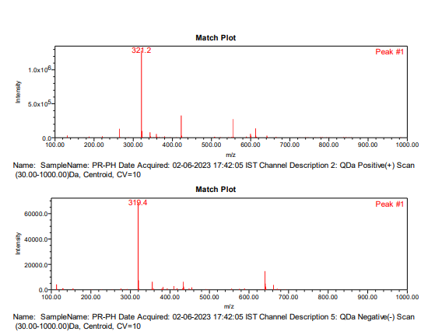
¹H NMR Spectrum
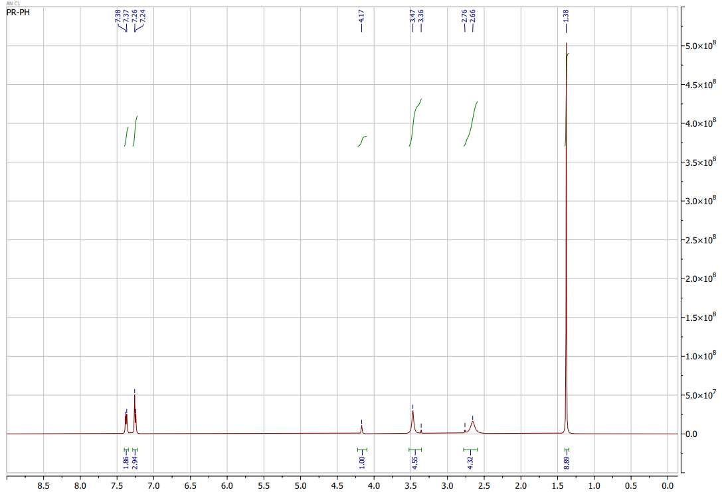
2-(4-(tert-Butoxycarbonyl)piperazin-1-yl)-2-(4 fluorophenyl)acetic acid (5)
IR Spectrum
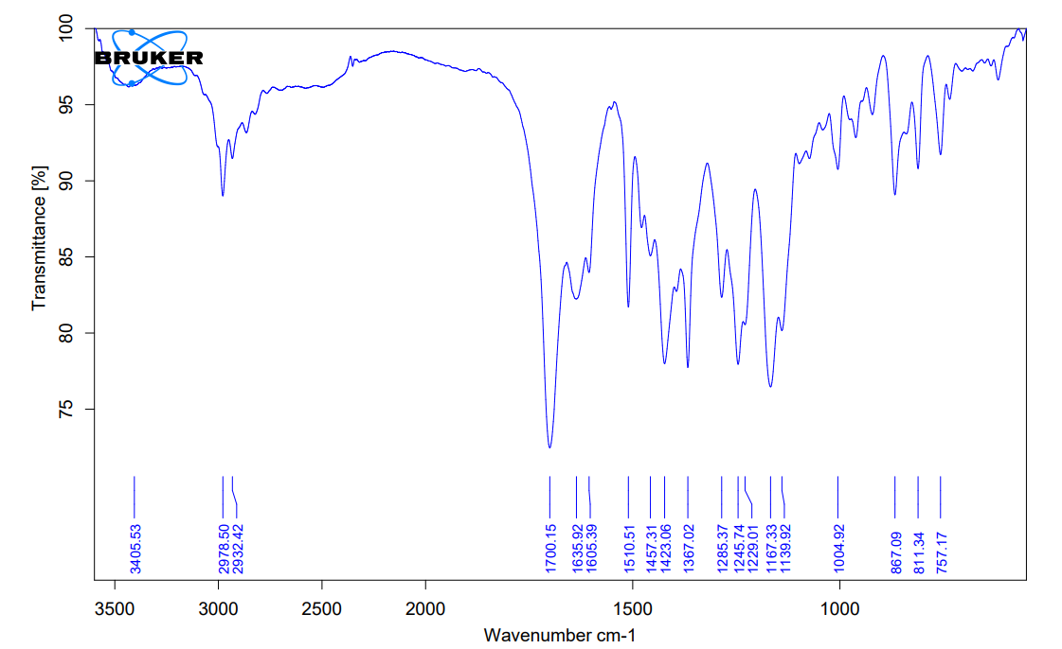
Mass Spectrum
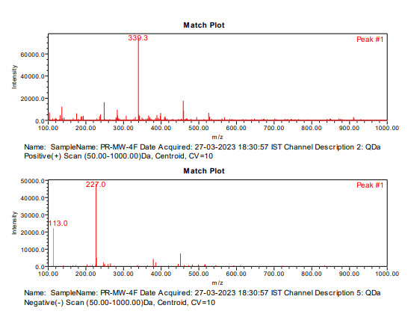

¹H NMR Spectrum
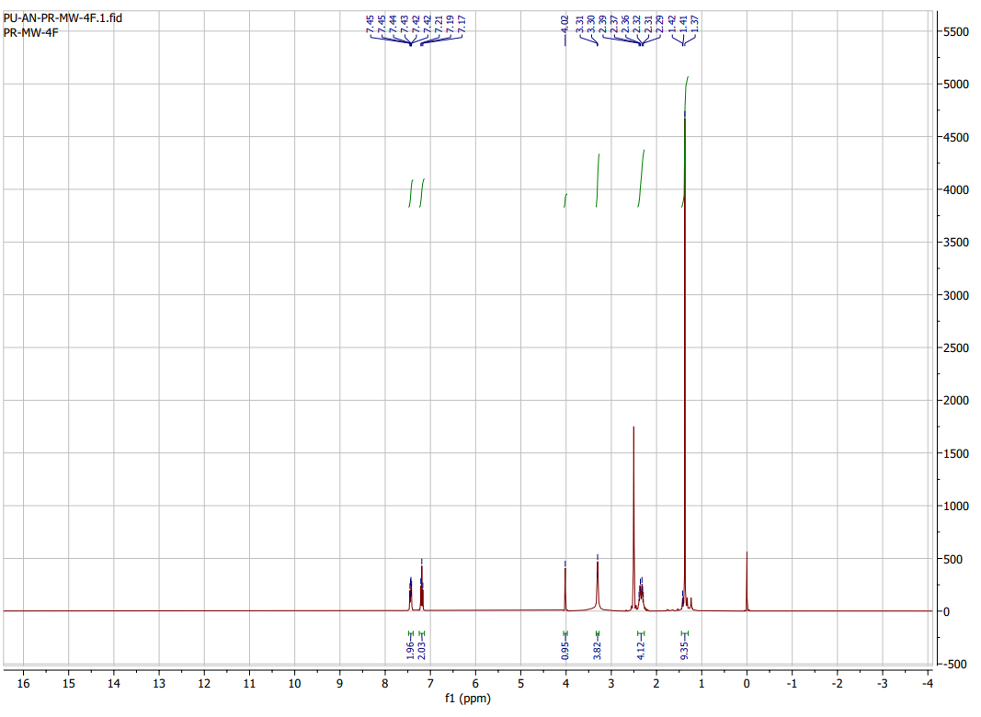

2-(4-(tert-Butoxycarbonyl)piperazin-1-yl)-2-(4-methoxyphenyl)acetic acid (6)
IR Spectrum
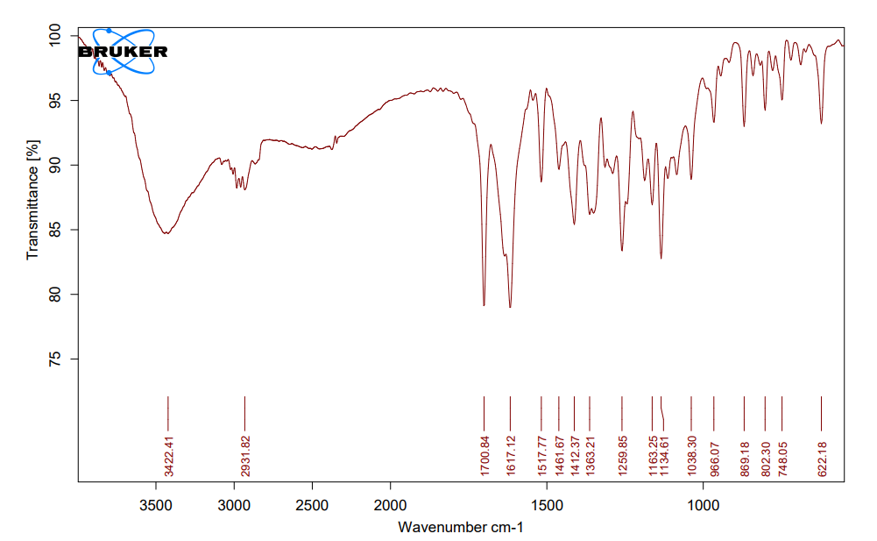

Mass Spectrum
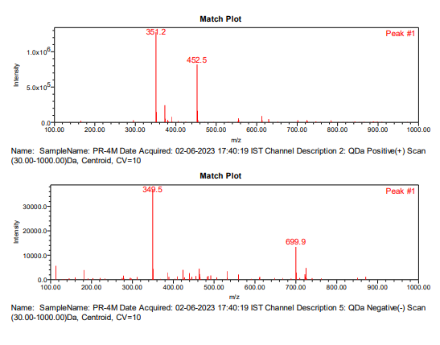

¹H NMR Spectrum
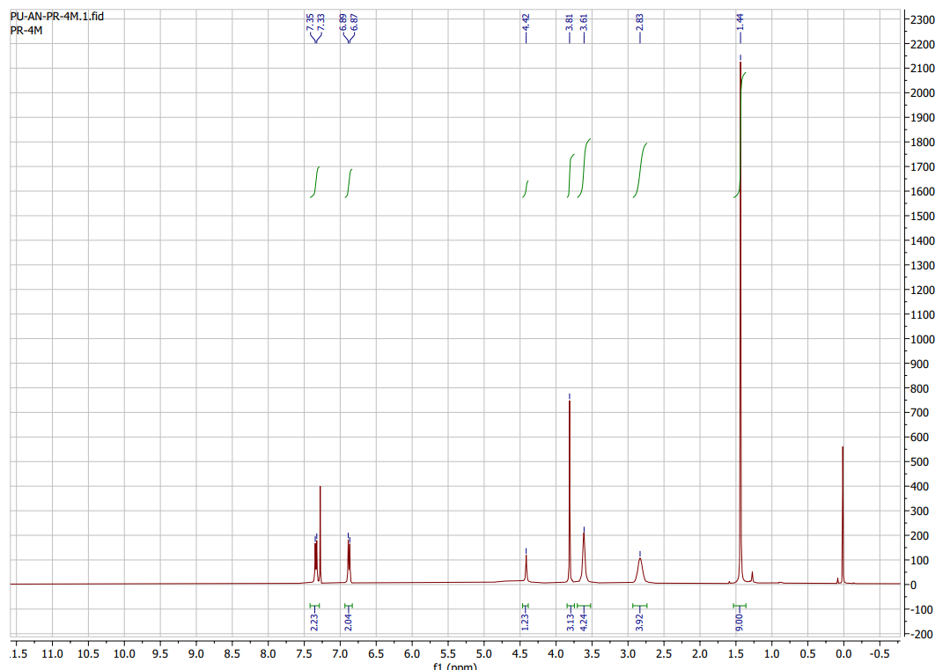
tert-Butyl-4-(2-oxo-1-phenyl-2-(phenylamino)ethyl)piperazine-1-carboxylate (16)
IR Spectrum
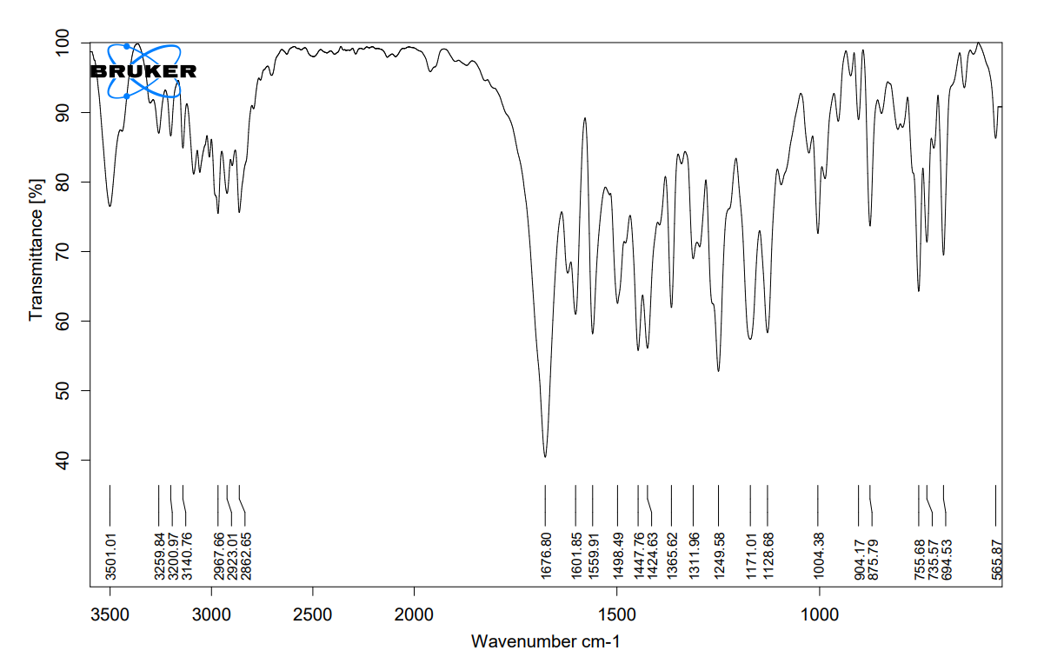
tert-Butyl-4-(2-oxo-1-phenyl-2-(o-tolylamino)ethyl)piperazine-1-carboxylate (17)
IR Spectrum
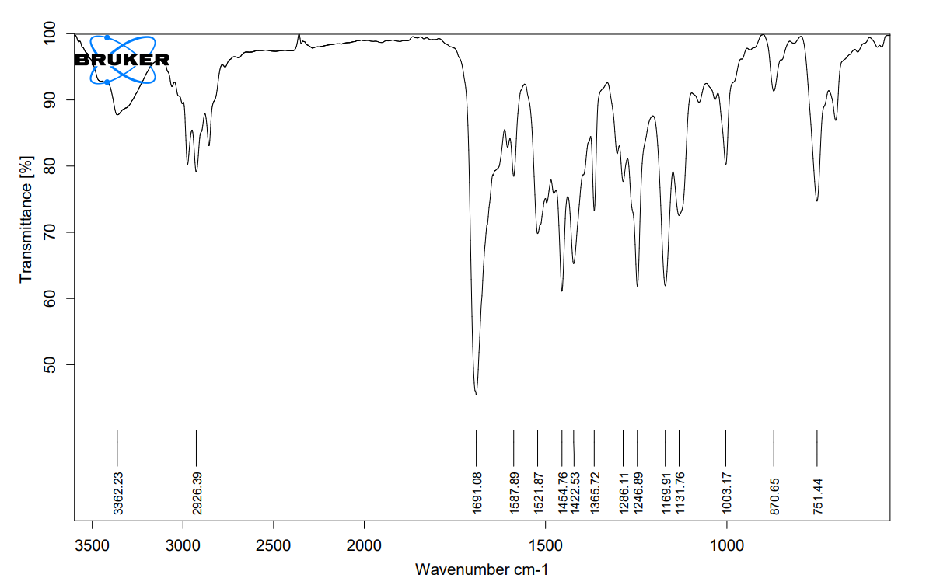
tert-Butyl-4-(2-oxo-1-phenyl-2-(p-tolylamino)ethyl)piperazine-1-carboxylate (18)
IR Spectrum
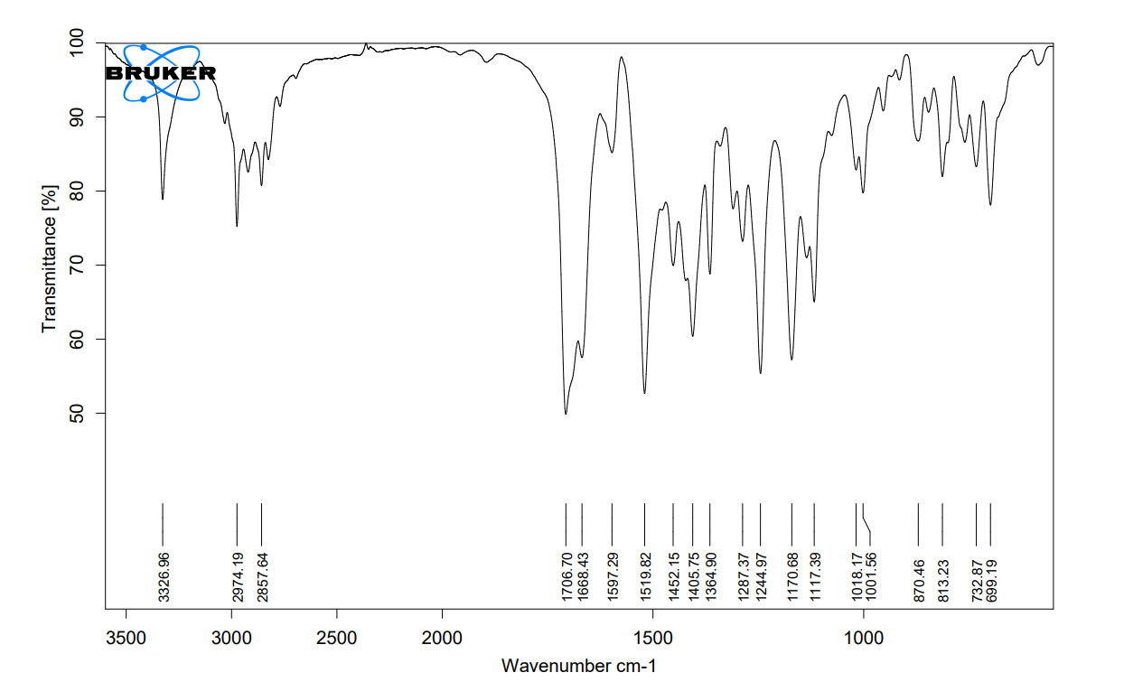
tert-Butyl-4-(2-((2-methoxyphenyl)amino)-2-oxo-1-phenylethyl)piperazine-1-carboxylate (19)
IR Spectrum
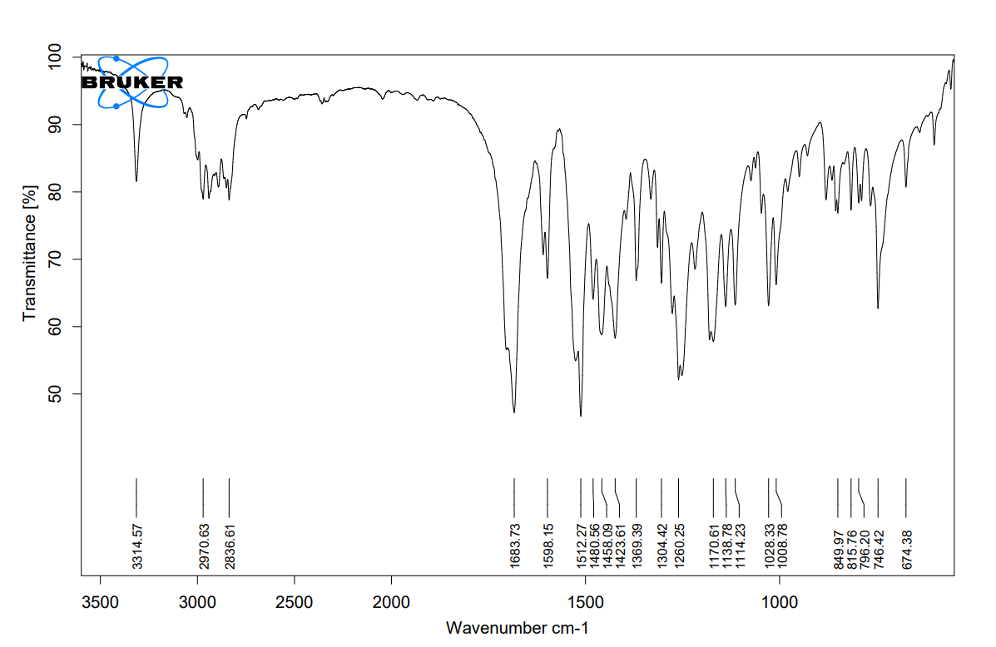
tert-Butyl-4-(2-((4-methoxyphenyl)amino)-2-oxo-1-phenylethyl)piperazine-1-carboxylate (20)
IR Spectrum
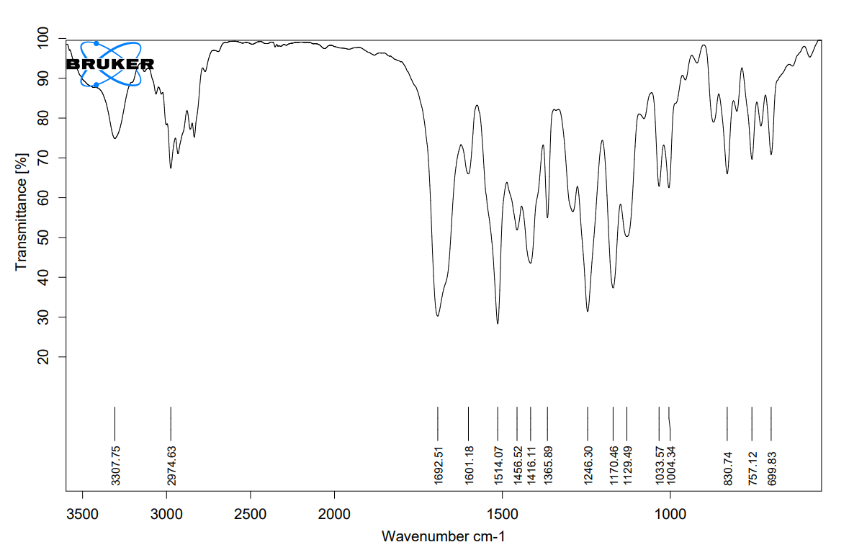
tert-Butyl-4-(2-((4-fluorophenyl)amino)-2-oxo-1-phenylethyl)piperazine-1-carboxylate (21)
IR Spectrum
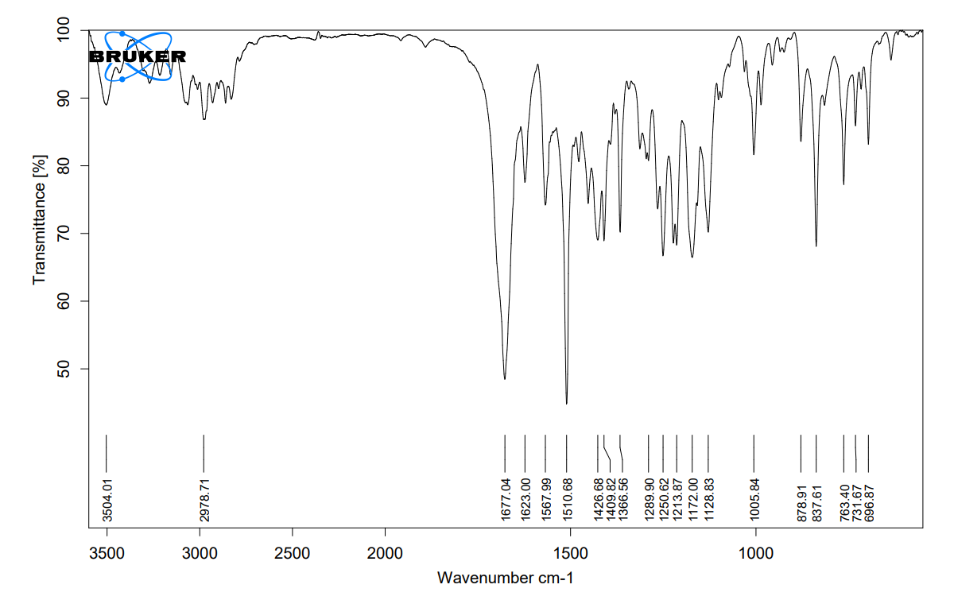
tert-Butyl-4-(2-((4-chlorophenyl)amino)-2-oxo-1-phenylethyl)piperazine-1-carboxylate (22)
IR Spectrum
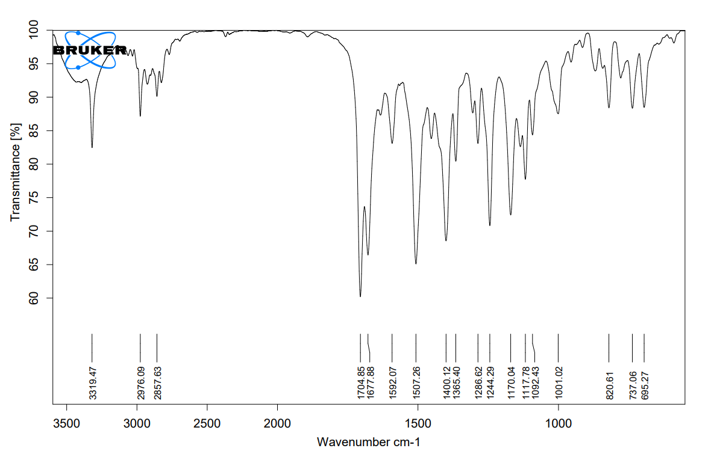
tert-Butyl-4-(2-((4-hydroxyphenyl)amino)-2-oxo-1-phenylethyl)piperazine-1-carboxylate (23)
IR Spectrum
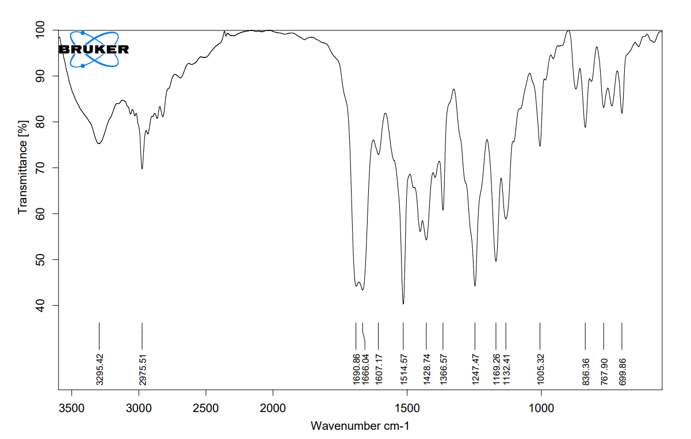
tert-Butyl-4-(2-(cyclohexylamino)-2-oxo-1-phenylethyl)piperazine-1-carboxylate (24)
IR Spectrum
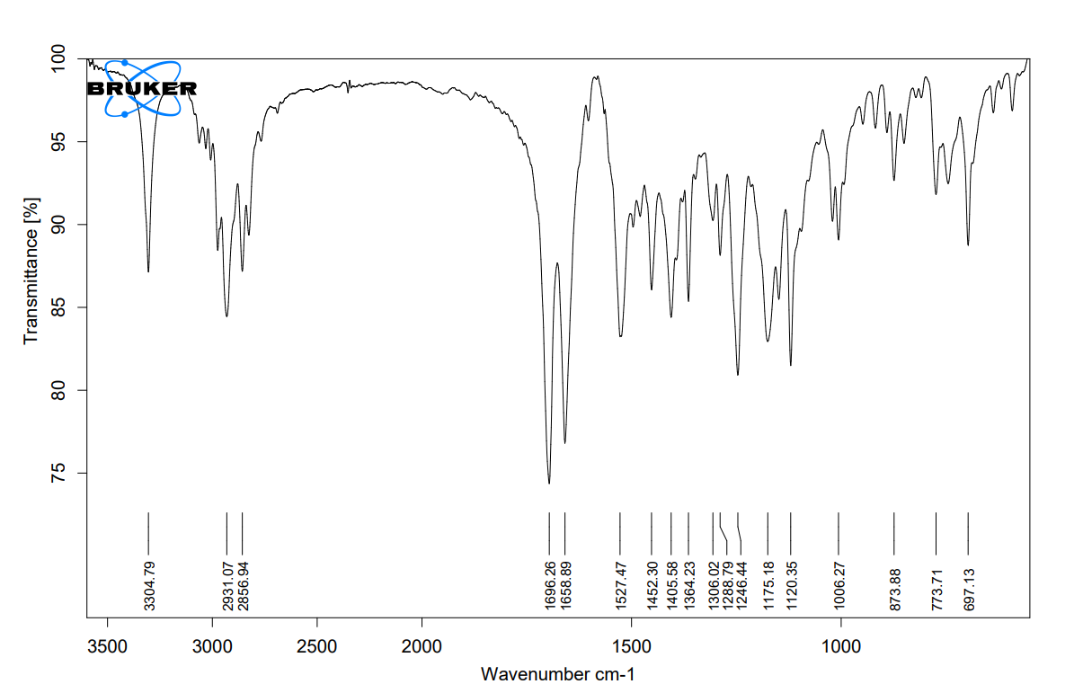
tert-Butyl-4-(1-(4-fluorophenyl)-2-oxo-2-(phenylamino)ethyl)piperazine-1-carboxylate (25)
IR Spectrum
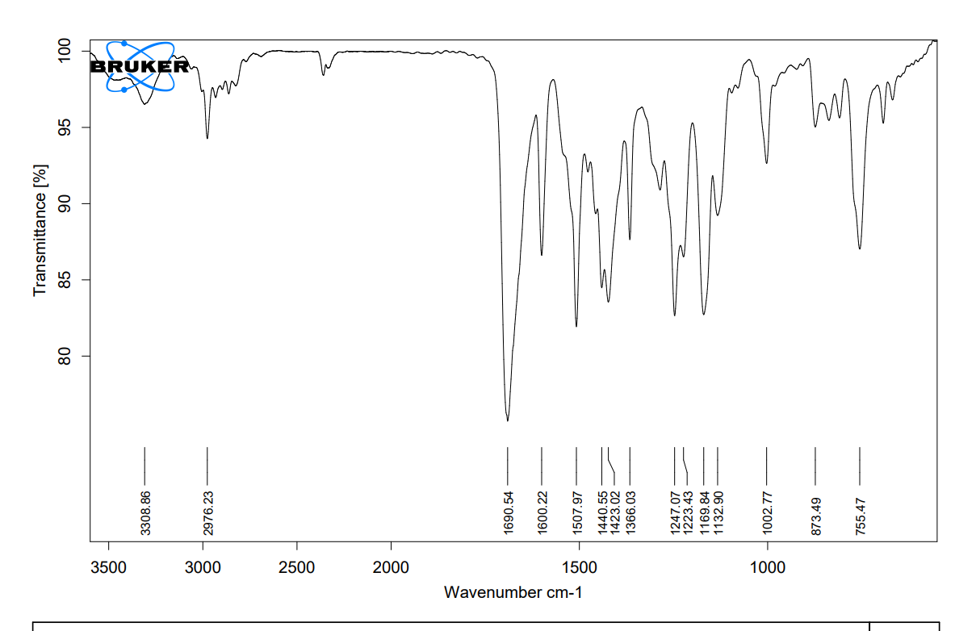
tert-Butyl-4-(1-(4-fluorophenyl)-2-oxo-2-(o-tolylamino)ethyl)piperazine-1-carboxylate (26)
IR Spectrum
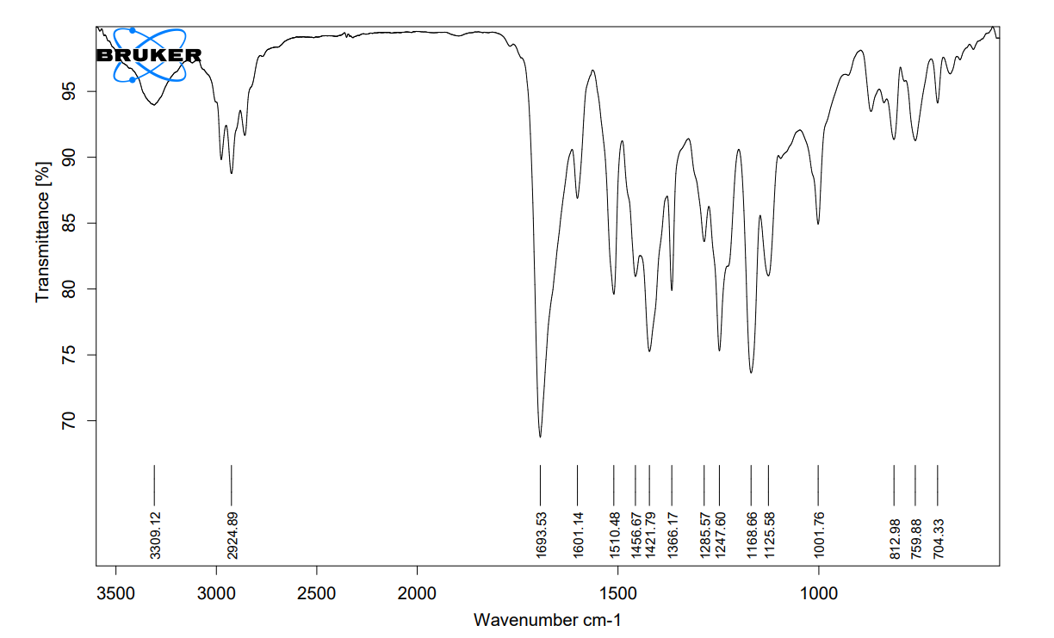
tert-Butyl-4-(1-(4-fluorophenyl)-2-oxo-2-(p-tolylamino)ethyl)piperazine-1-carboxylate (27)
IR Spectrum
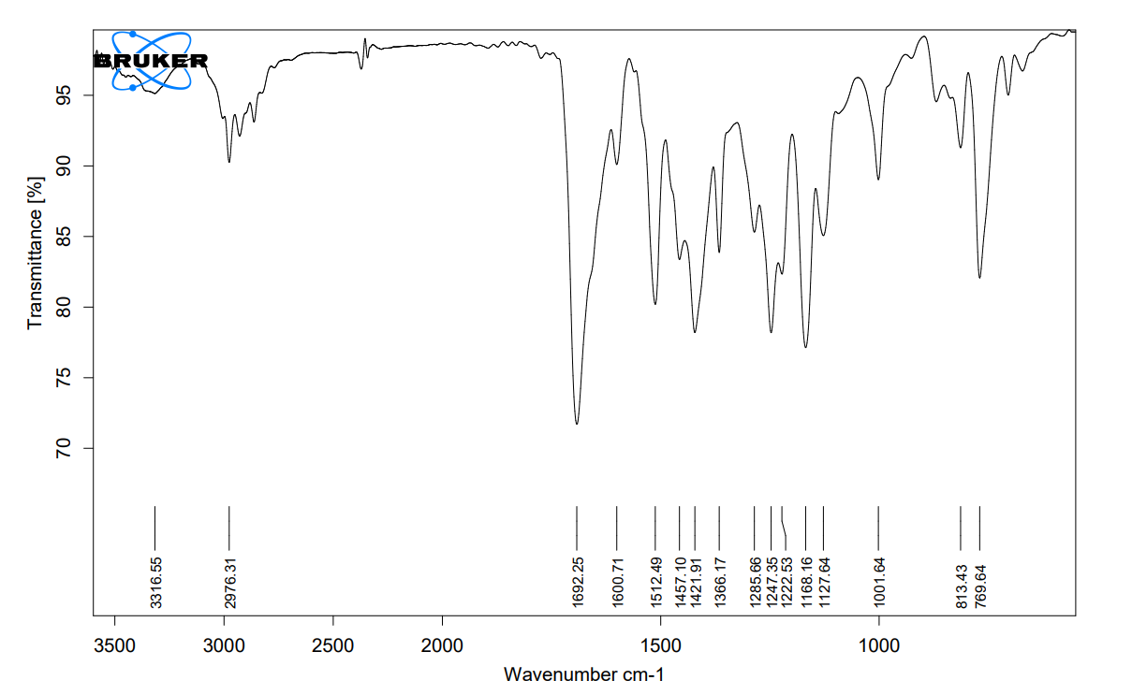
tert-Butyl-4-(1-(4-fluorophenyl)-2-((2-methoxyphenyl)amino)-2-oxoethyl)piperazine-1-carboxylate (28)
IR Spectrum
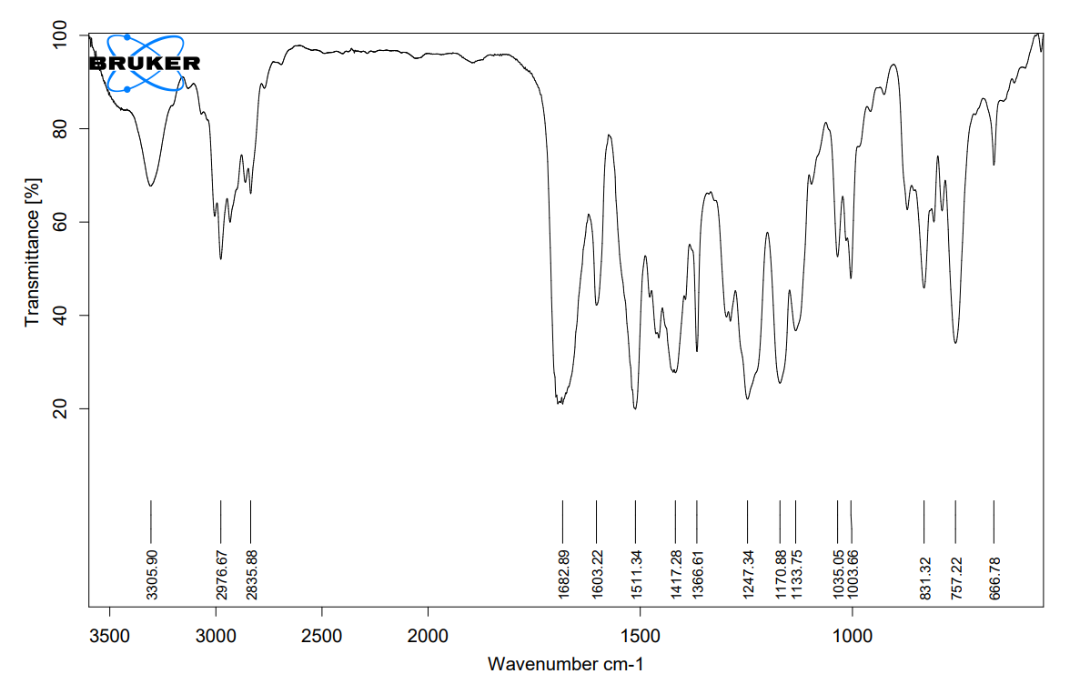
tert-Butyl-4-(1-(4-fluorophenyl)-2-((4-methoxyphenyl)amino)-2-oxoethyl)piperazine-1-carboxylate (29)
IR Spectrum
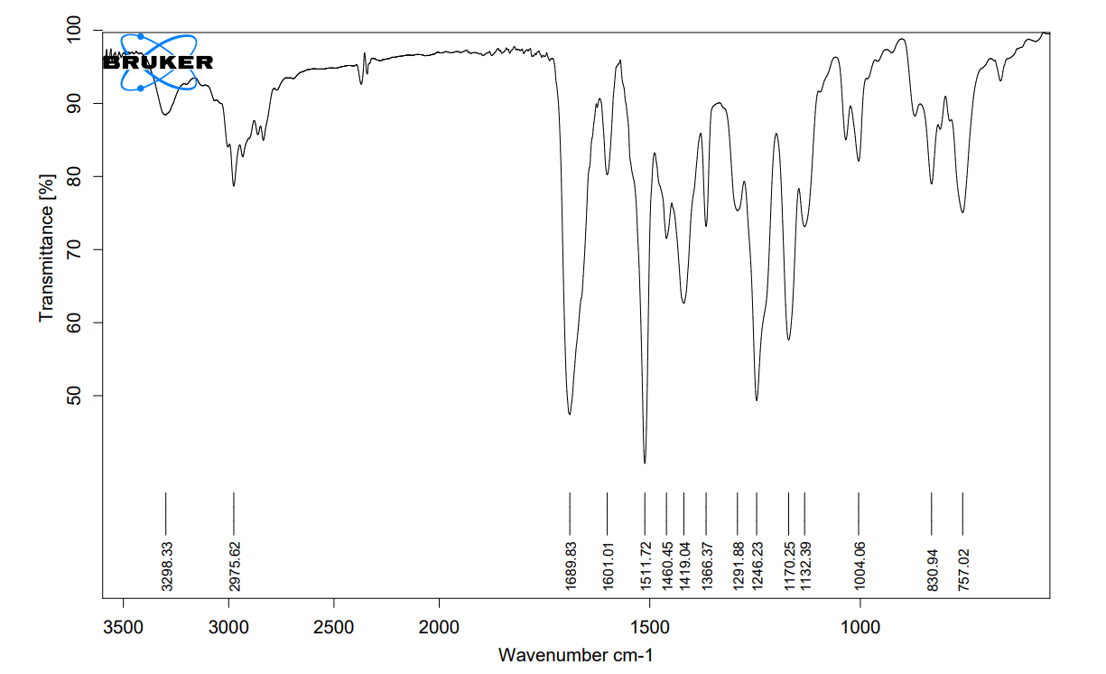
tert-Butyl-4-(1-(4-fluorophenyl)-2-((4-fluorophenyl)amino)-2-oxoethyl)piperazine-1-carboxylate (30)
IR Spectrum
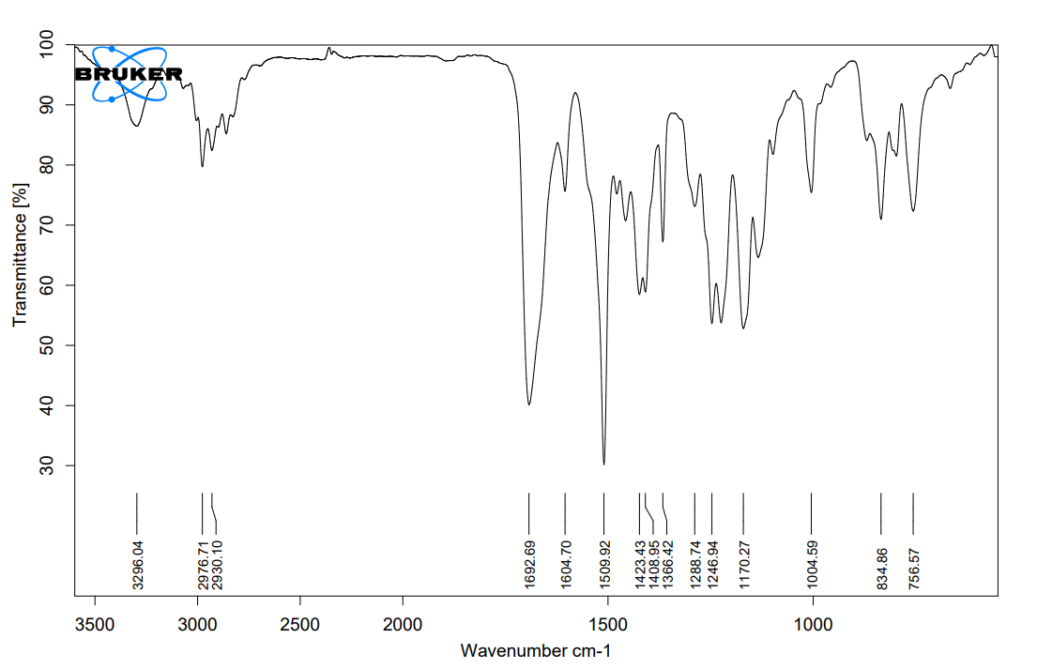
tert-Butyl-4-(2-((4-chlorophenyl)amino)-1-(4-fluorophenyl)-2-oxoethyl)piperazine-1-carboxylate (31)
IR Spectrum
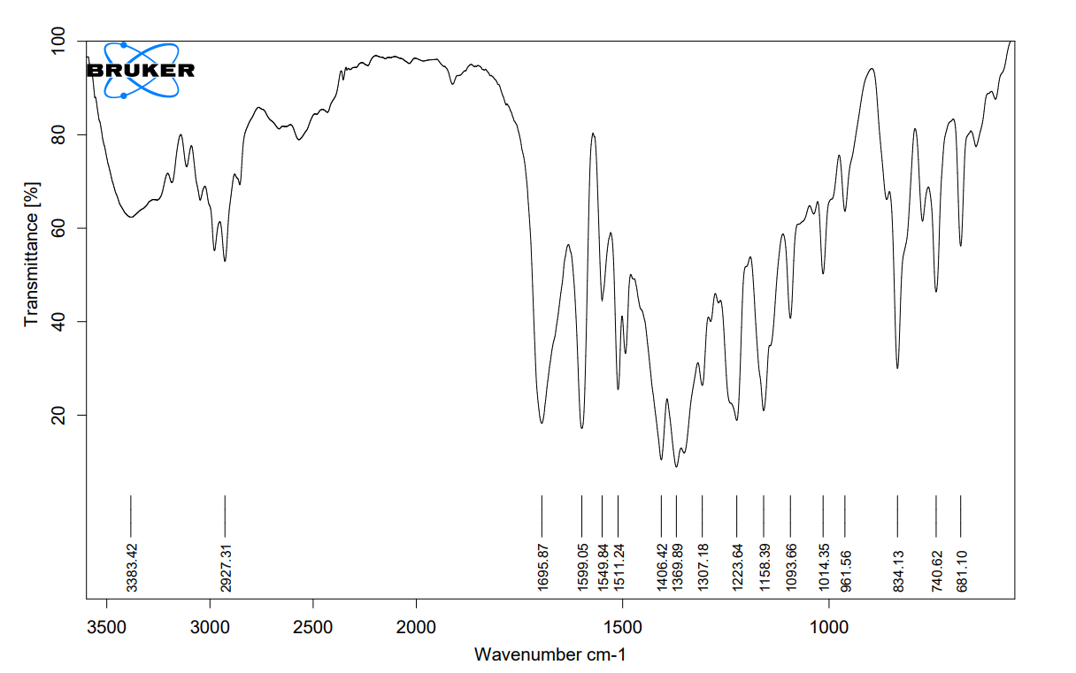
tert-Butyl-4-(1-(4-fluorophenyl)-2-((4-hydroxyphenyl)amino)-2-oxoethyl)piperazine-1-carboxylate (32)
IR Spectrum
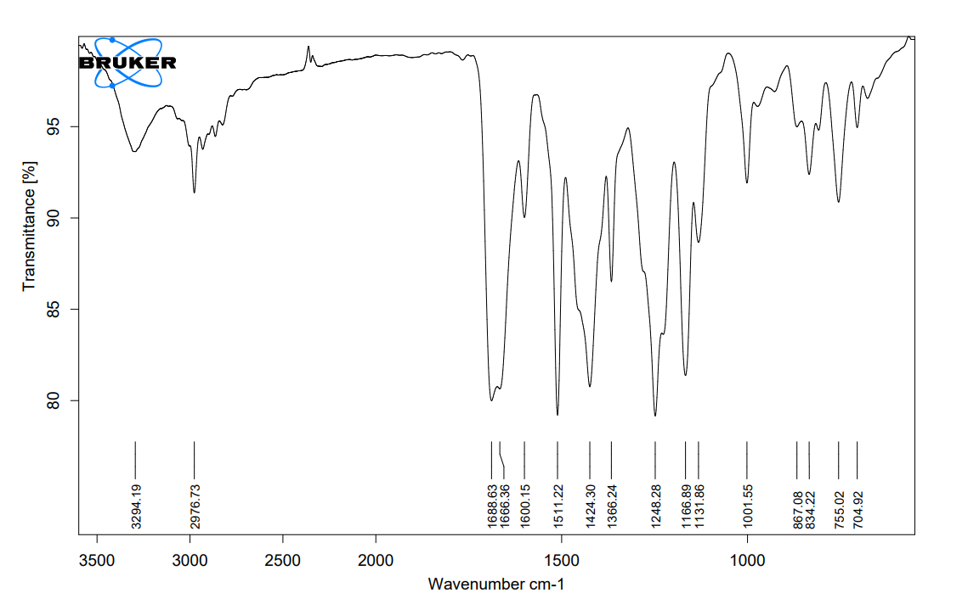
tert-Butyl-4-(2-(cyclohexylamino)-1-(4-fluorophenyl)-2-oxoethyl)piperazine-1-carboxylate (33)
IR Spectrum
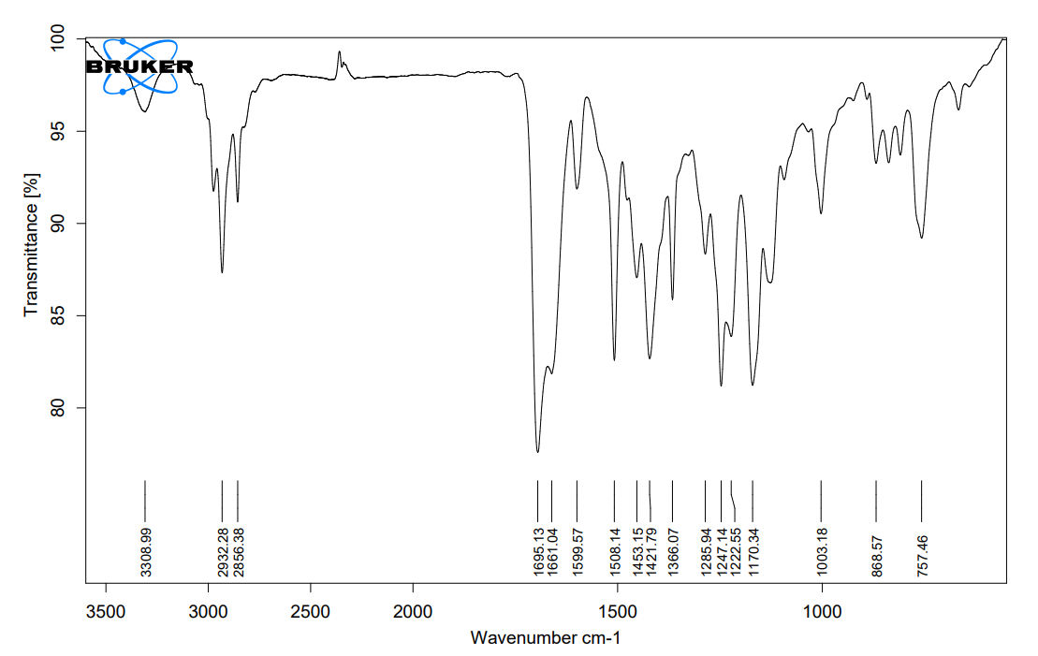
tert-Butyl-4-(1-(4-methoxyphenyl)-2-oxo-2-(phenylamino)ethyl)piperazine-1-carboxylate (34)
IR Spectrum
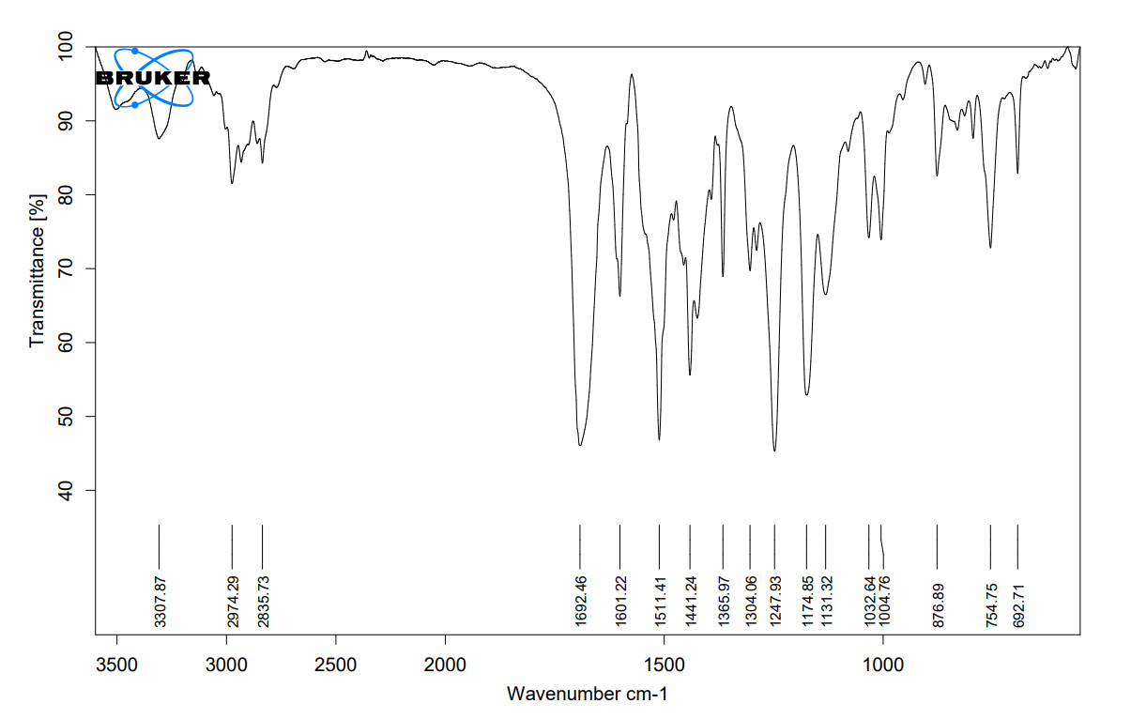
tert-Butyl-4-(1-(4-methoxyphenyl)-2-oxo-2-(o-tolylamino)ethyl)piperazine-1-carboxylate (35)
IR Spectrum
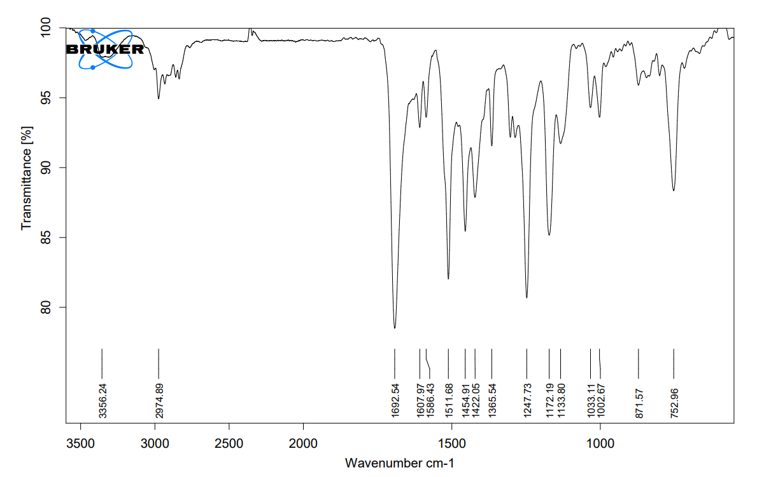
tert-Butyl-4-(1-(4-methoxyphenyl)-2-oxo-2-(p-tolylamino)ethyl)piperazine-1-carboxylate (36)
IR Spectrum
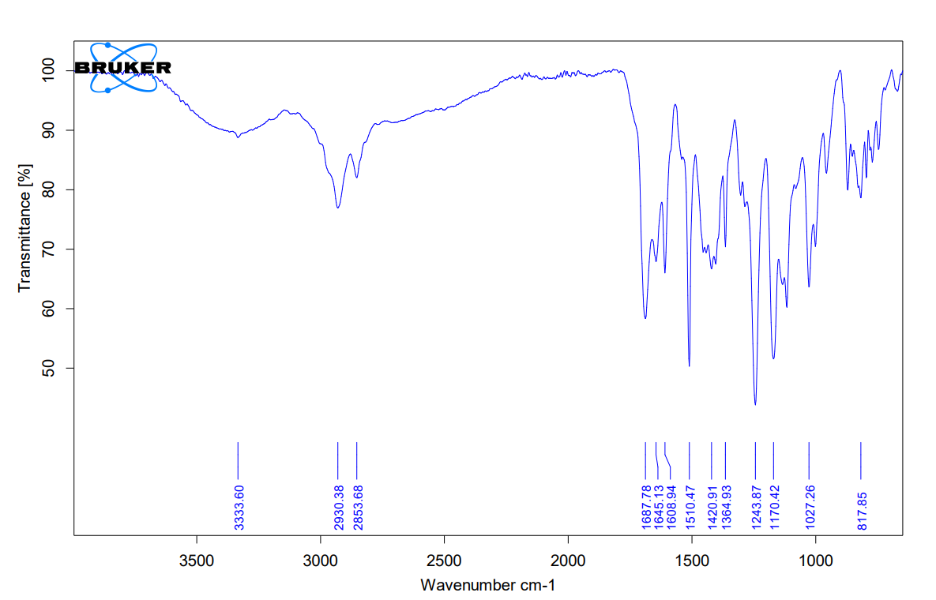
tert-Butyl-4-(1-(4-methoxyphenyl)-2-((2-methoxyphenyl)amino)-2-oxoethyl)piperazine-1-carboxylate (37)
IR Spectrum
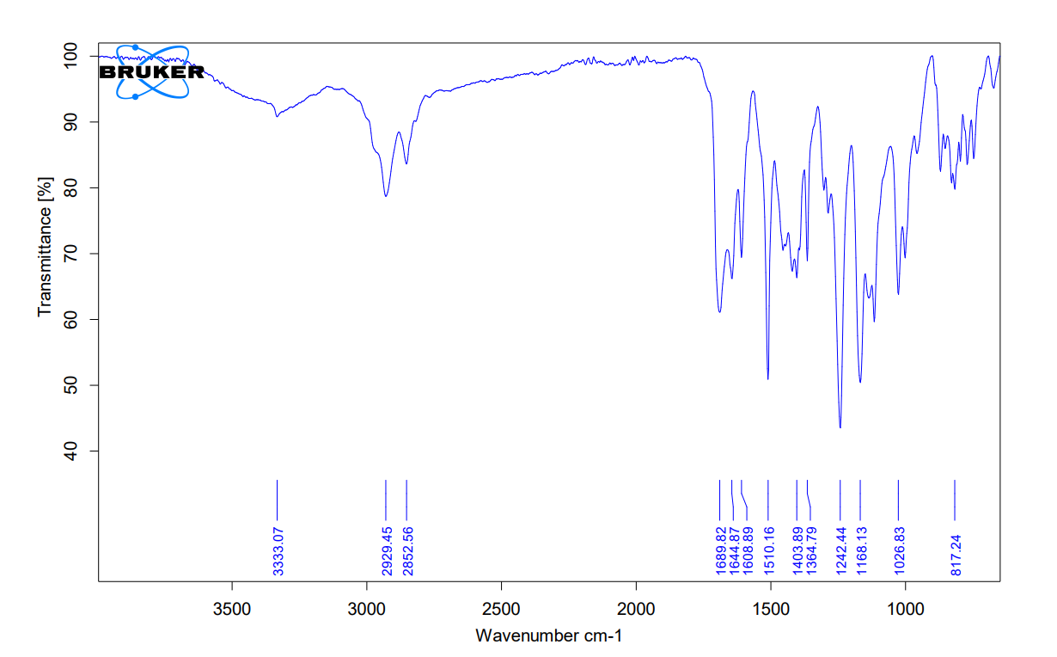
tert-Butyl-4-(1-(4-methoxyphenyl)-2-((4-methoxyphenyl)amino)-2-oxoethyl)piperazine-1-carboxylate (38)
IR Spectrum
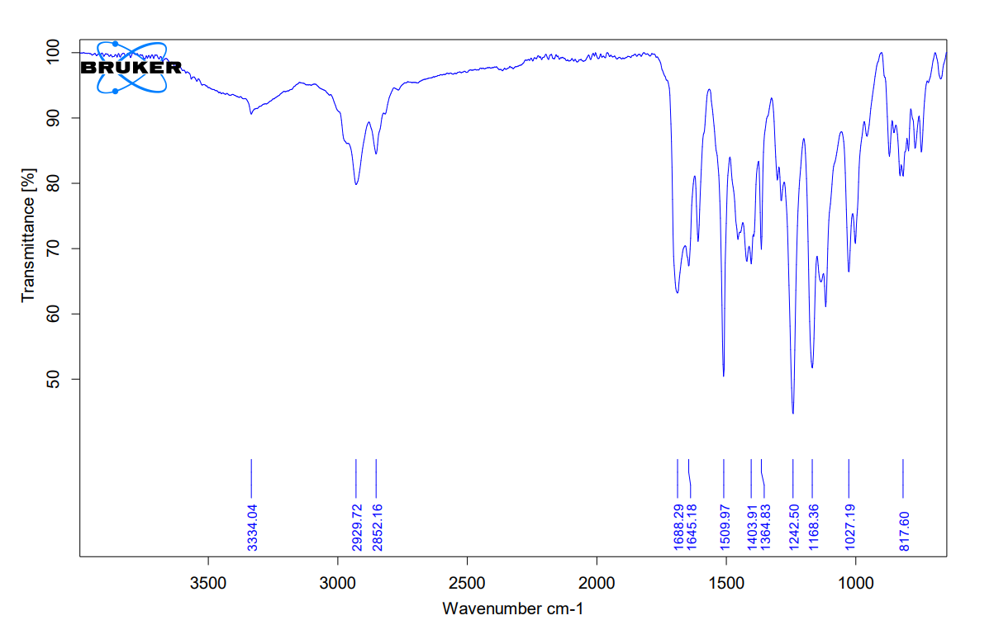
tert-Butyl-4-(2-((4-fluorophenyl)amino)-1-(4-methoxyphenyl)-2-oxoethyl)piperazine-1-carboxylate (39)
IR Spectrum
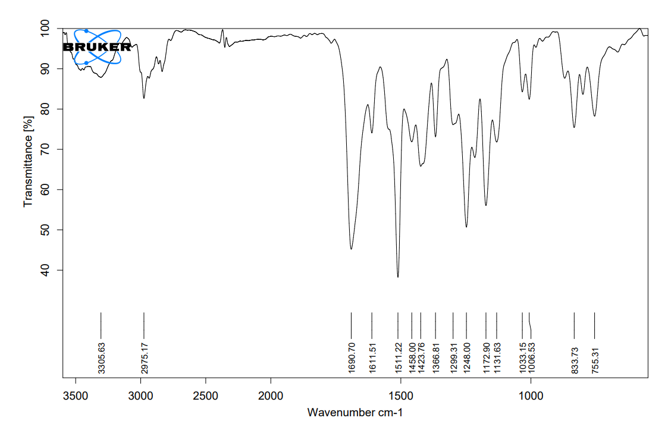
tert-Butyl-4-(2-((4-chlorophenyl)amino)-1-(4-methoxyphenyl)-2-oxoethyl)piperazine-1-carboxylate (40)
IR Spectrum
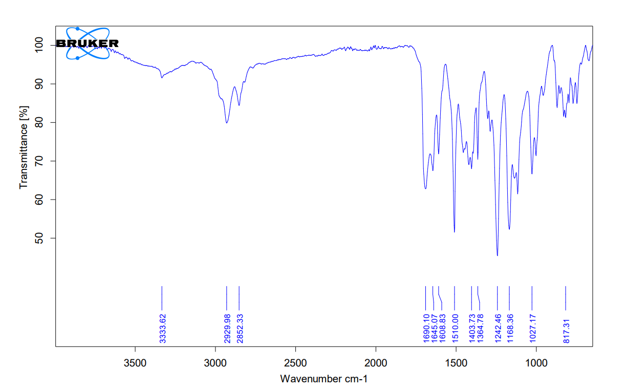
tert-Butyl-4-(2-((4-hydroxyphenyl)amino)-1-(4-methoxyphenyl)-2-oxoethyl)piperazine-1-carboxylate (41)
IR Spectrum
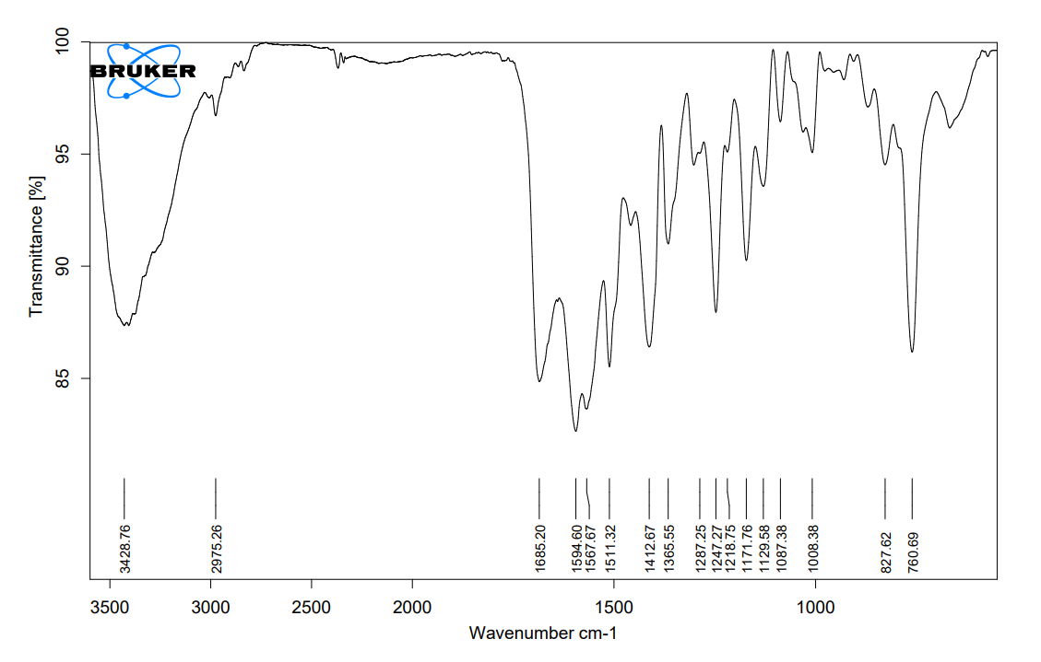
tert-Butyl-4-(2-(cyclohexylamino)-1-(4-methoxyphenyl)-2-oxoethyl)piperazine-1-carboxylate (42)
IR Spectrum
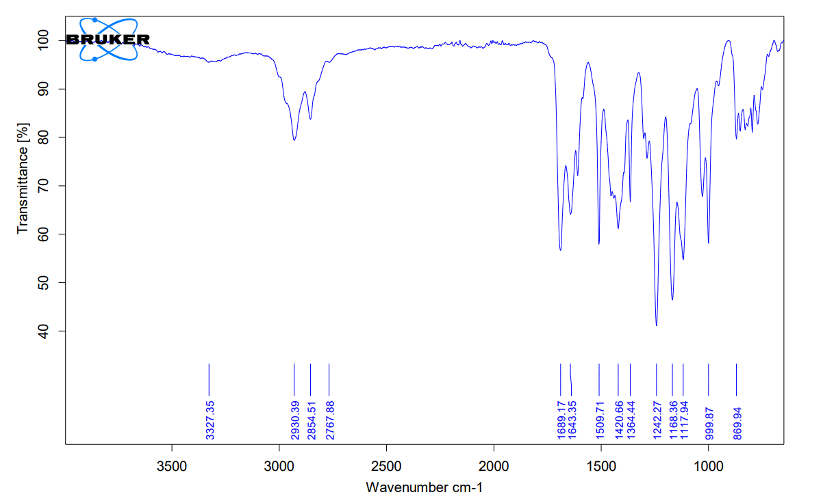
2-(4-((8-Hydroxyquinolin-5-yl)methyl)piperazin-1-yl)-N,2-diphenylacetamide (71)
IR Spectrum
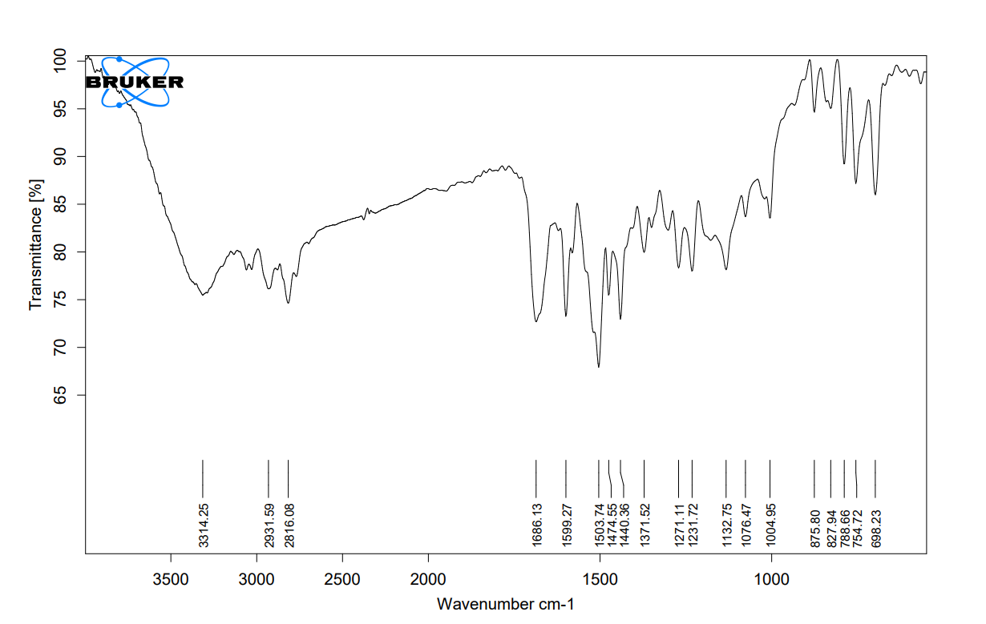
LCMS
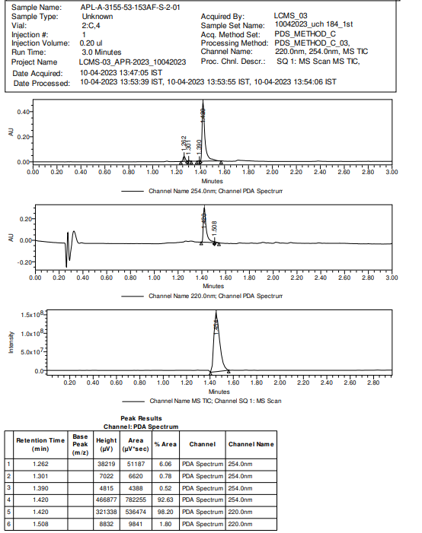
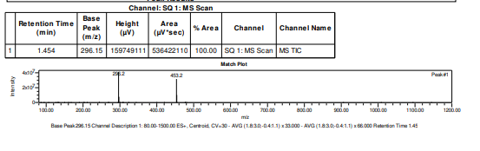
¹H NMR Spectrum
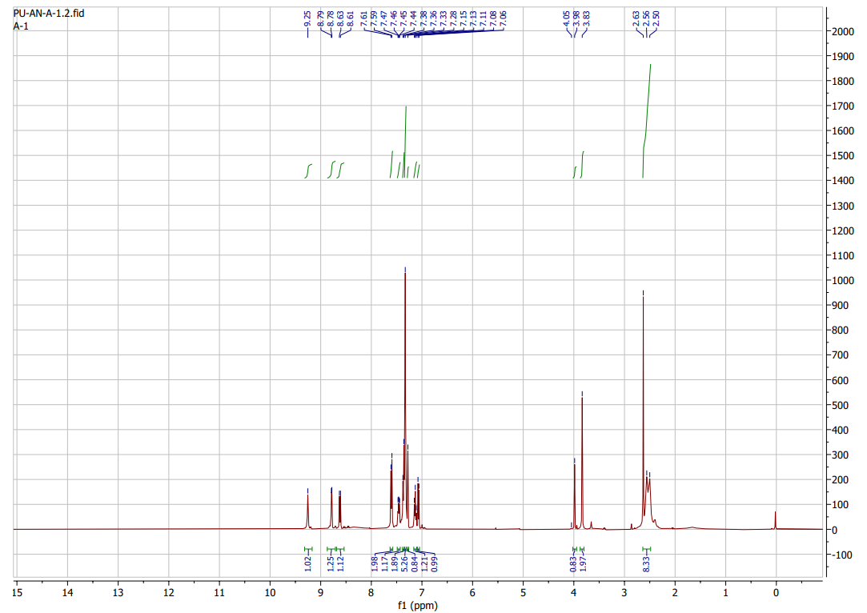
2-(4-((8-Hydroxyquinolin-5-yl)methyl)piperazin-1-yl)-2-phenyl-N-(o-tolyl)acetamide (72)
IR Spectrum
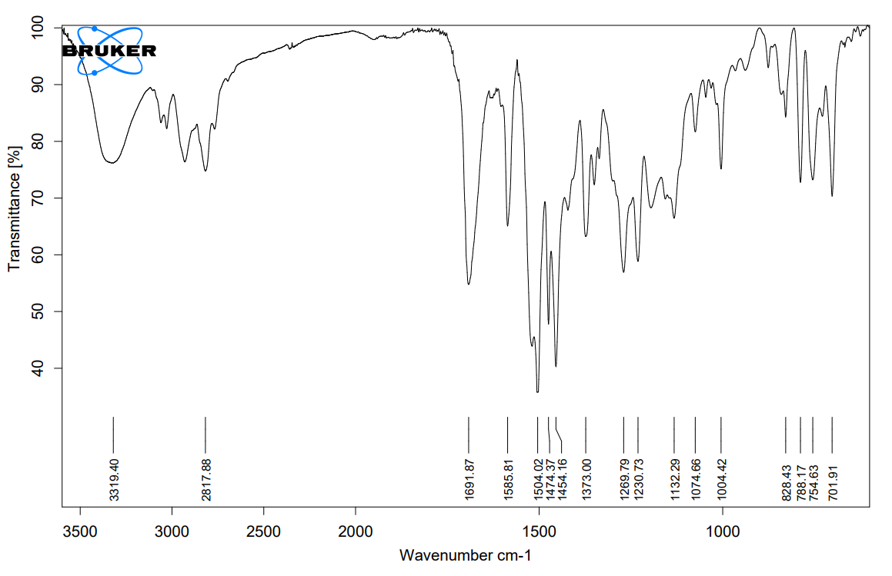
Mass Spectrum
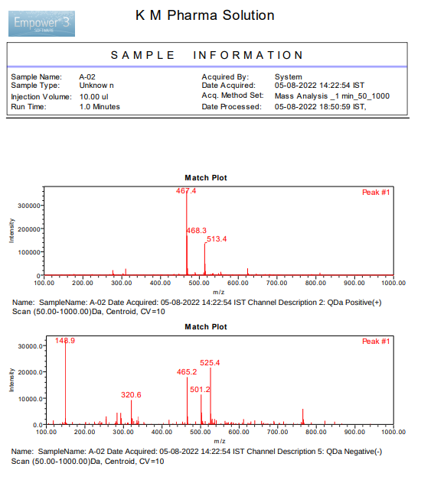
¹H NMR Spectrum
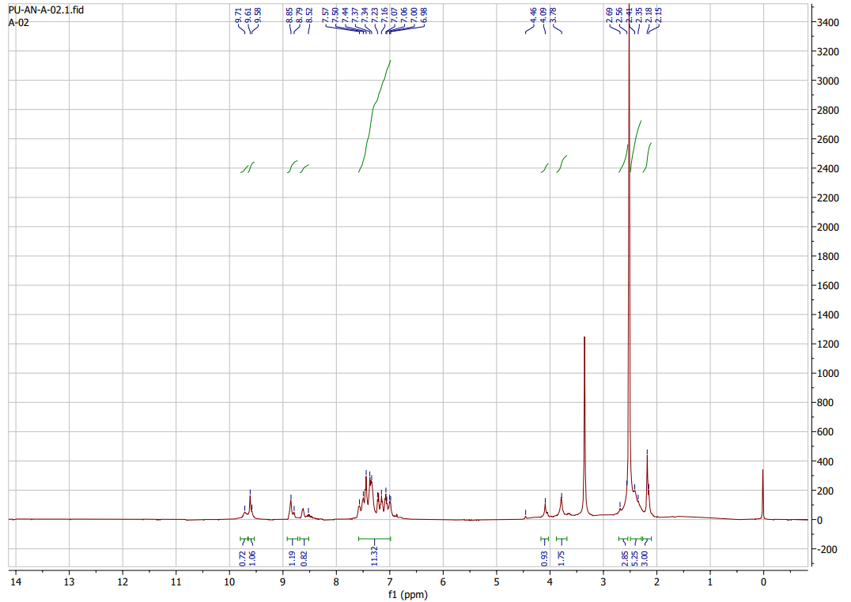
2-(4-((8-Hydroxyquinolin-5-yl)methyl)piperazin-1-yl)-2-phenyl-N-(p-tolyl)acetamide (73)
IR Spectrum
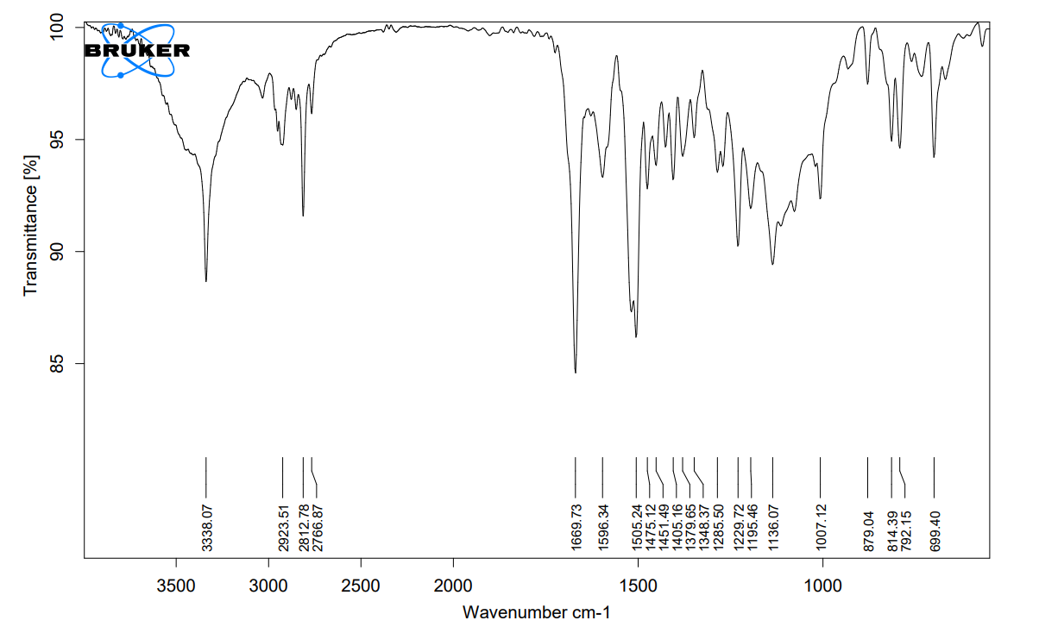
LCMS
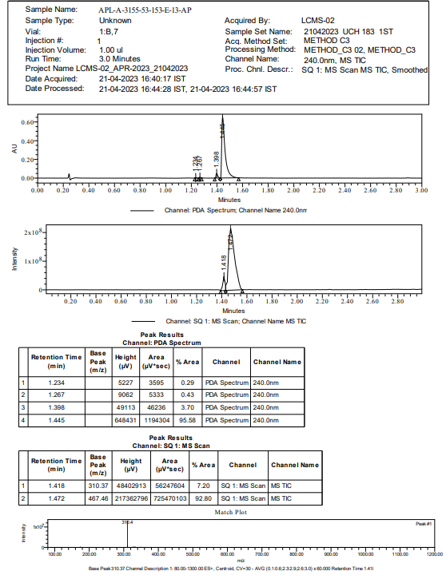
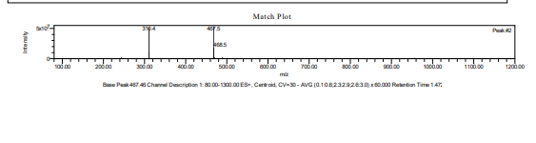
¹H NMR Spectrum
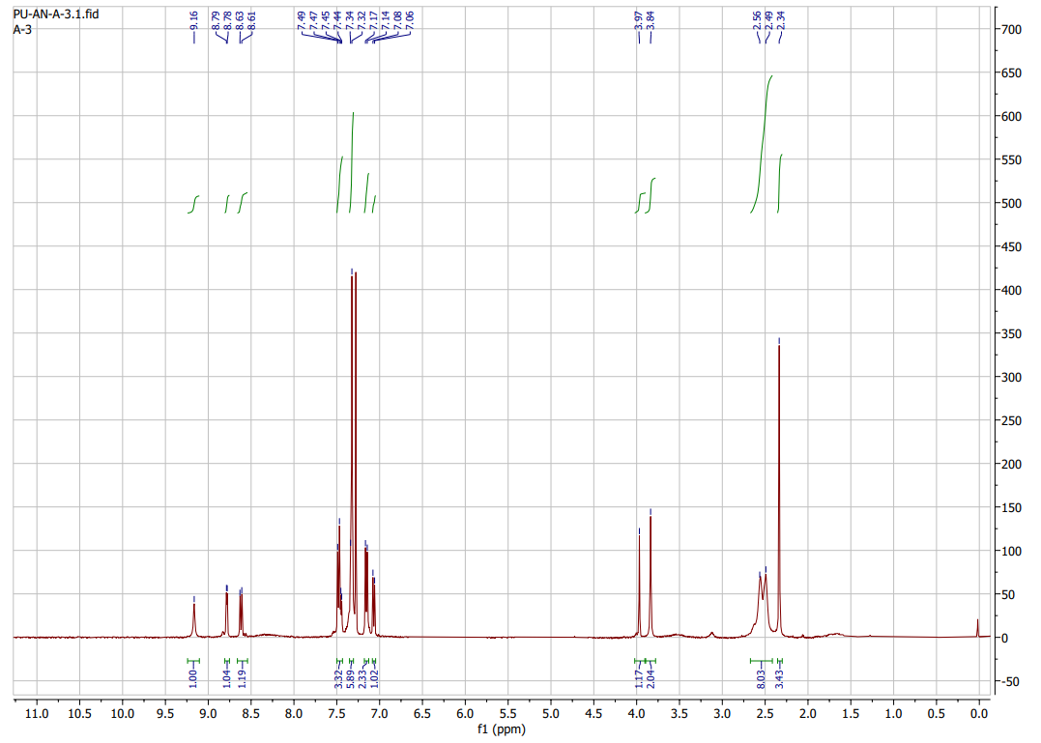
2-(4-((8-Hydroxyquinolin-5-yl)methyl)piperazin-1-yl)-N-(2-methoxyphenyl)-2-phenyl- acetamide (74)
IR Spectrum
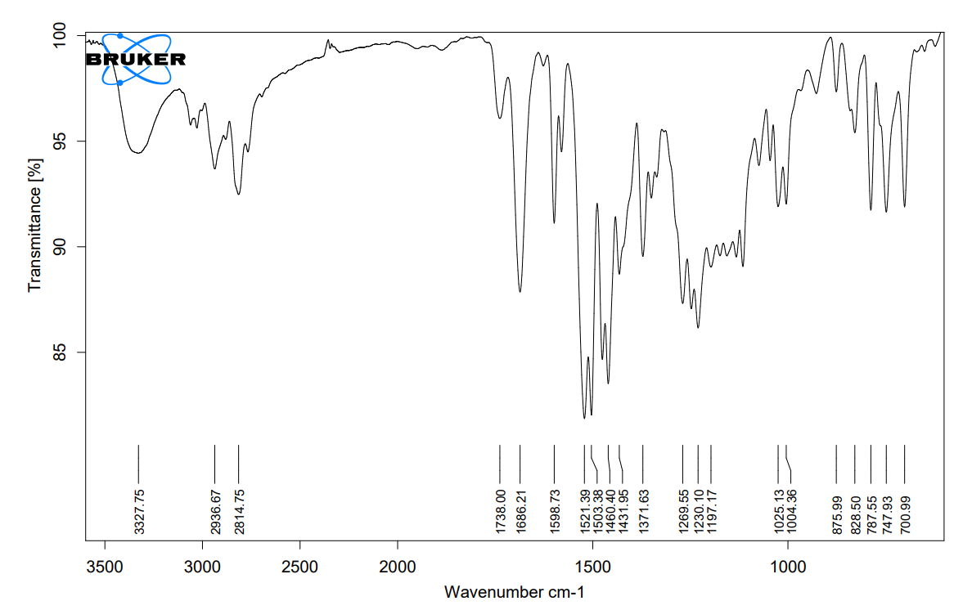
Mass Spectrum
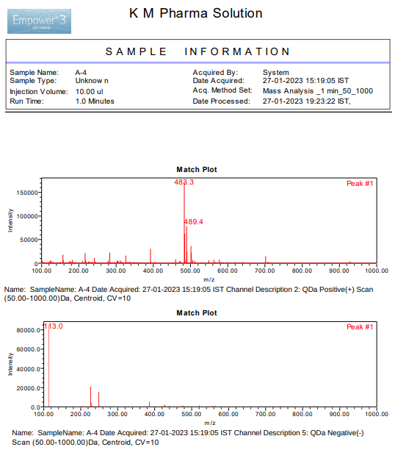
¹H NMR Spectrum
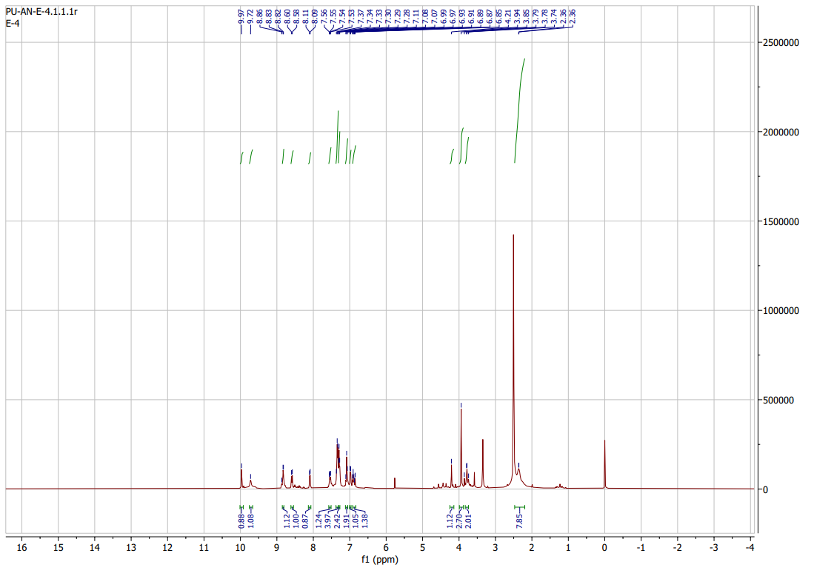
2-(4-((8-Hydroxyquinolin-5-yl)methyl)piperazin-1-yl)-N-(4-methoxyphenyl)-2-phenyl- acetamide (75)
IR Spectrum
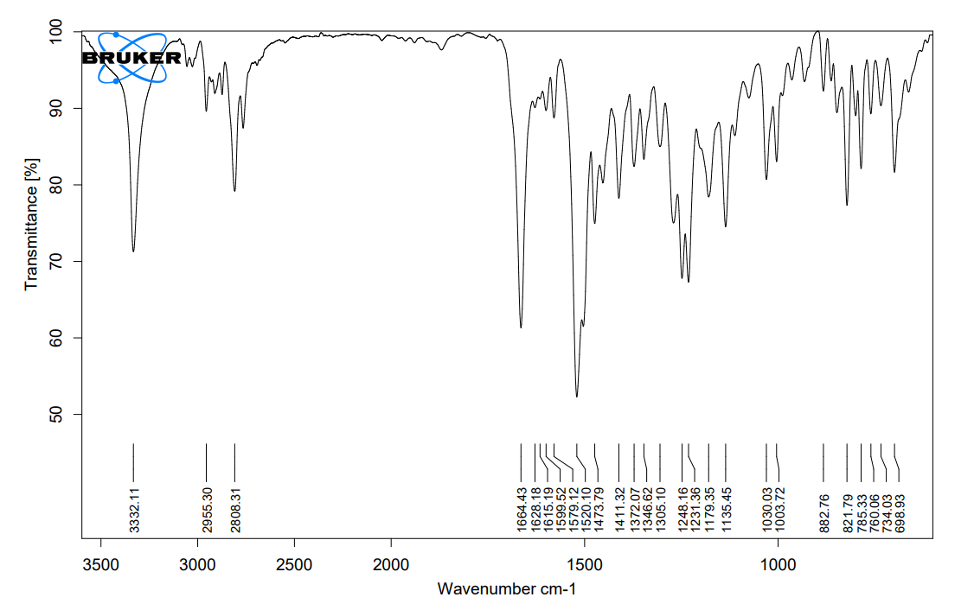
Mass Spectrum
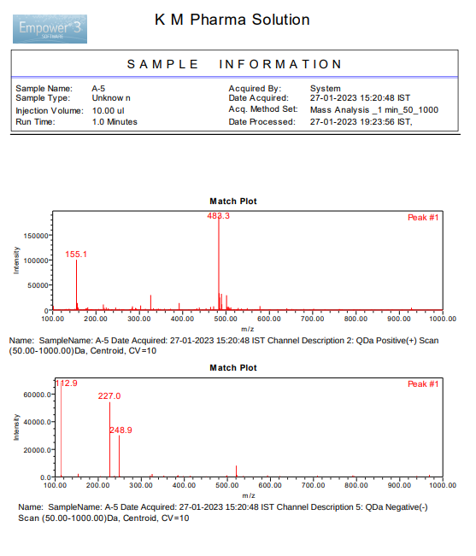
¹H NMR Spectrum
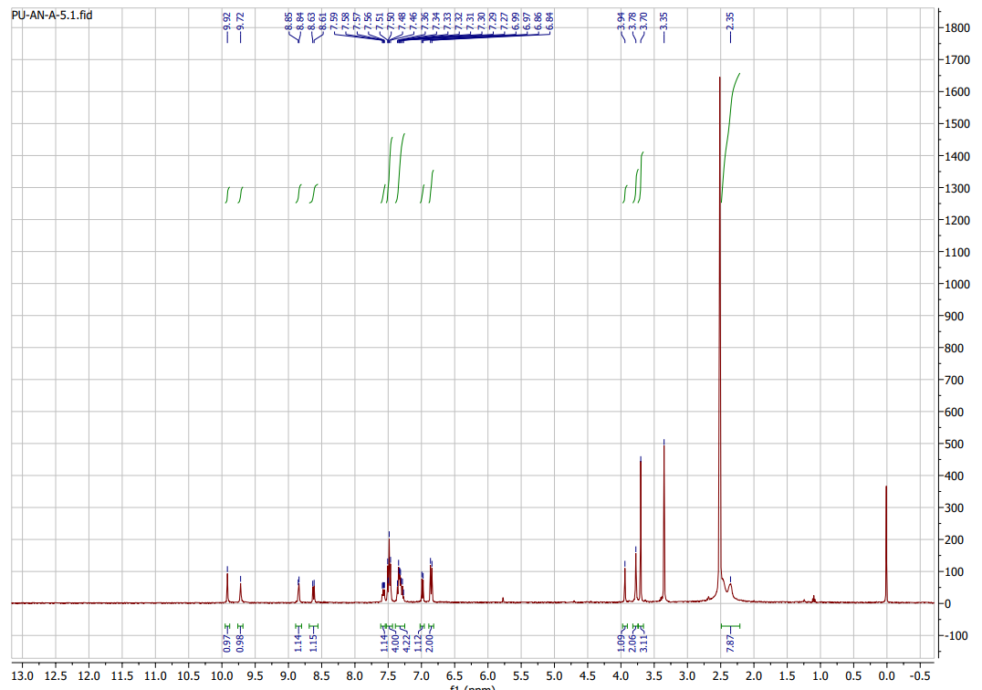
N-(4-Fluorophenyl)-2-(4-((8-hydroxyquinolin-5-yl)methyl)piperazin-1-yl)-2-phenyl- acetamide (76)
IR Spectrum
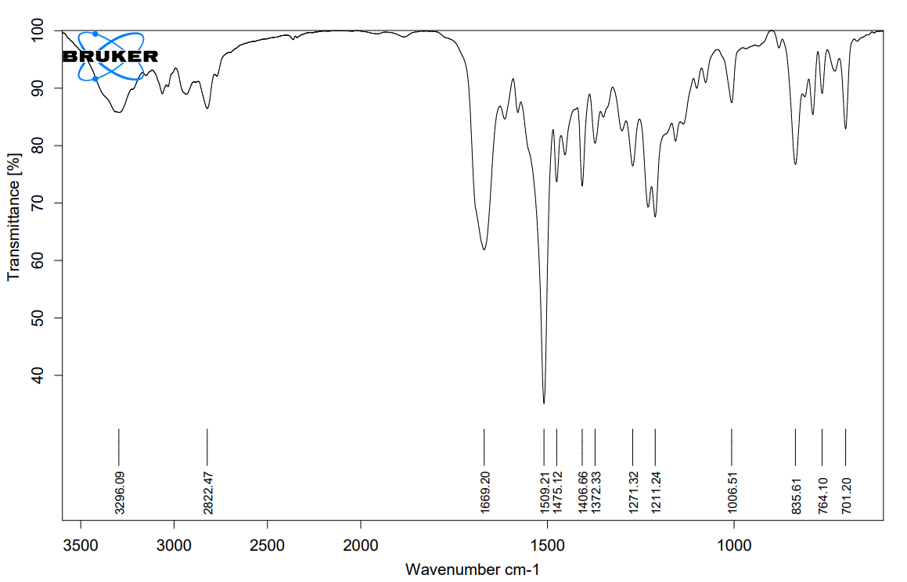
Mass Spectrum
¹H NMR Spectrum
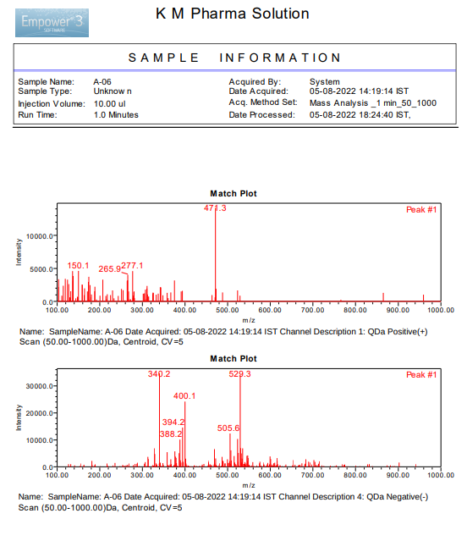
¹H NMR Spectrum
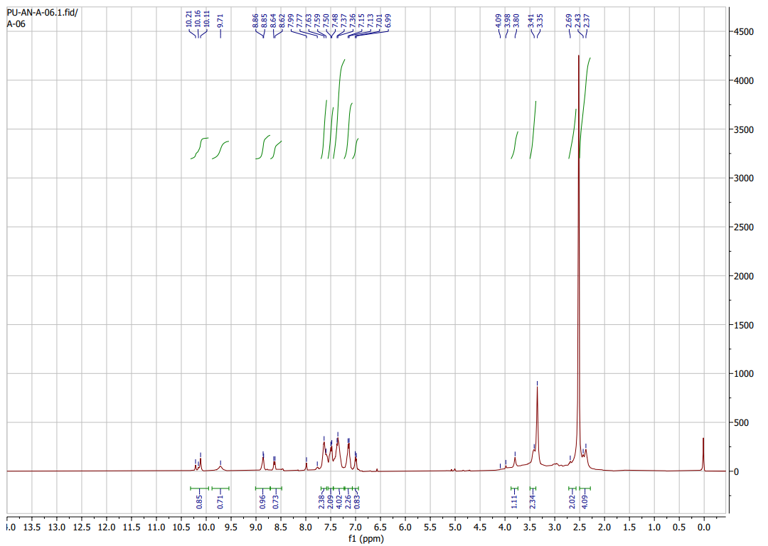
N-(4-Chlorophenyl)-2-(4-((8-hydroxyquinolin-5-yl)methyl)piperazin-1-yl)-2-phenyl- acetamide (77)
IR Spectrum
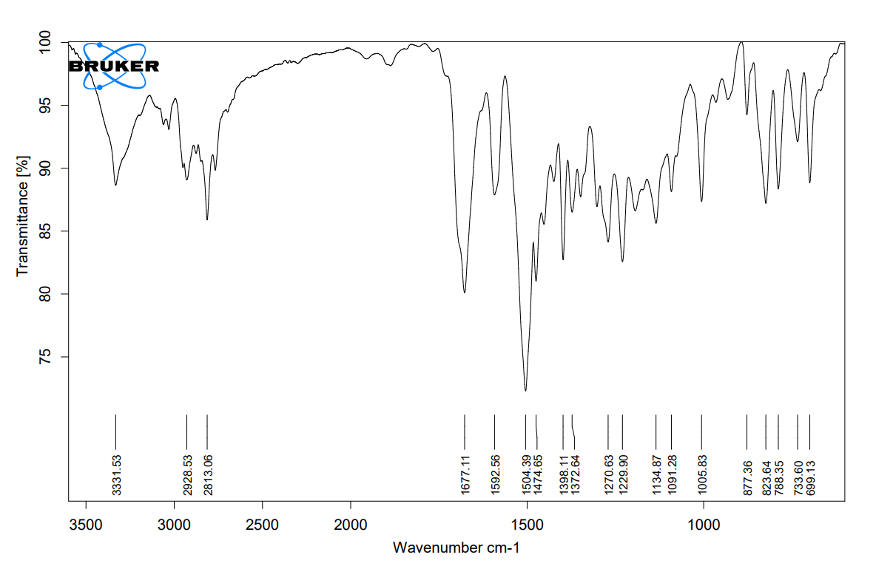
Mass Spectrum
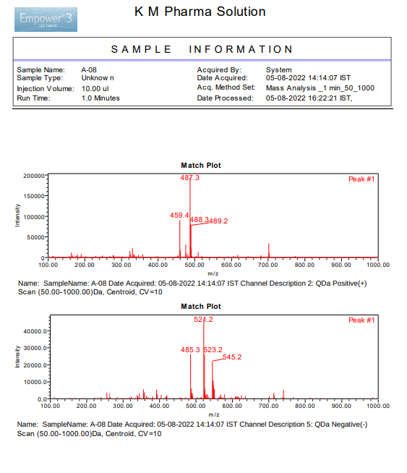
¹H NMR Spectrum
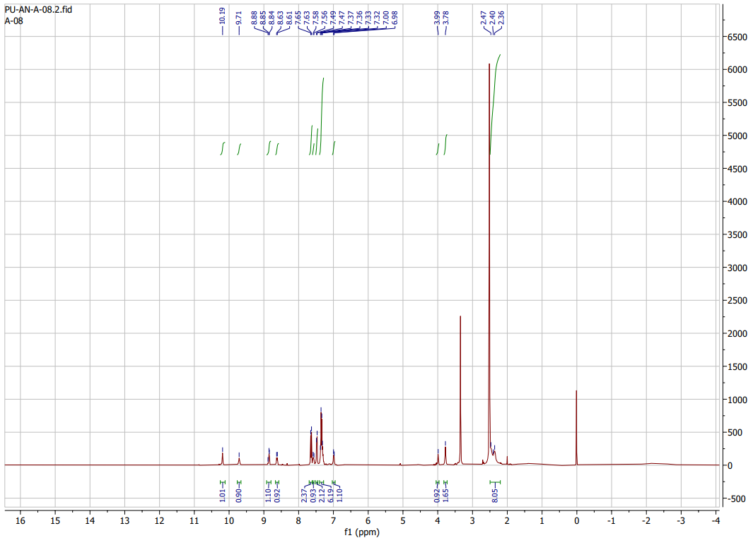
N-(4-Hydroxyphenyl)-2-(4-((8-hydroxyquinolin-5-yl)methyl)piperazin-1-yl)-2-phenyl- acetamide (78)
IR Spectrum
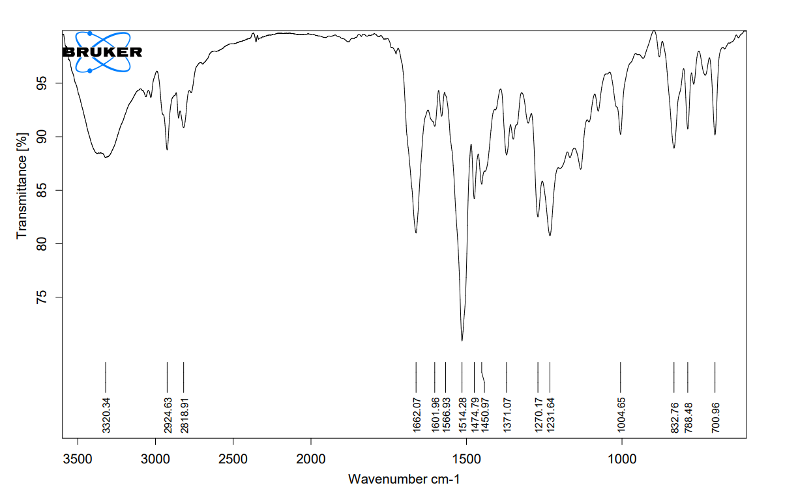
Mass Spectrum
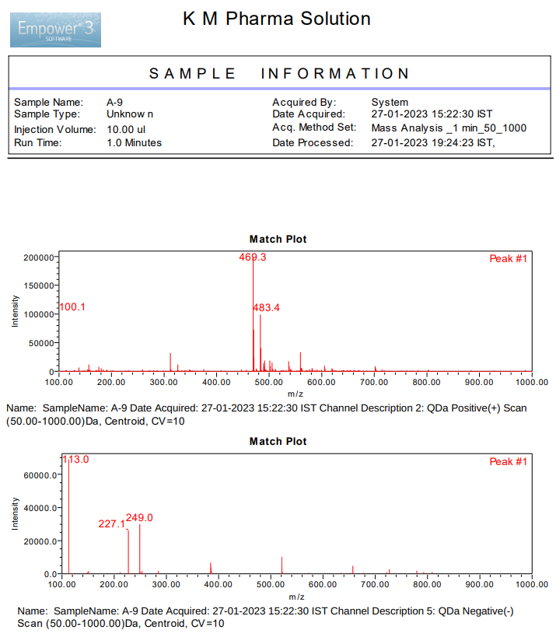
¹H NMR Spectrum
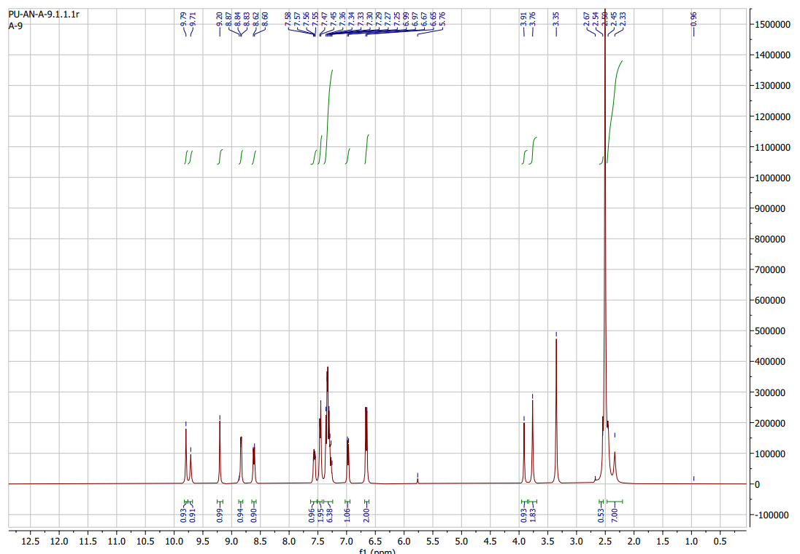
N-Cyclohexyl-2-(4-((8-hydroxyquinolin-5-yl)methyl)piperazin-1-yl)-2-phenylacetamide (79)
IR Spectrum
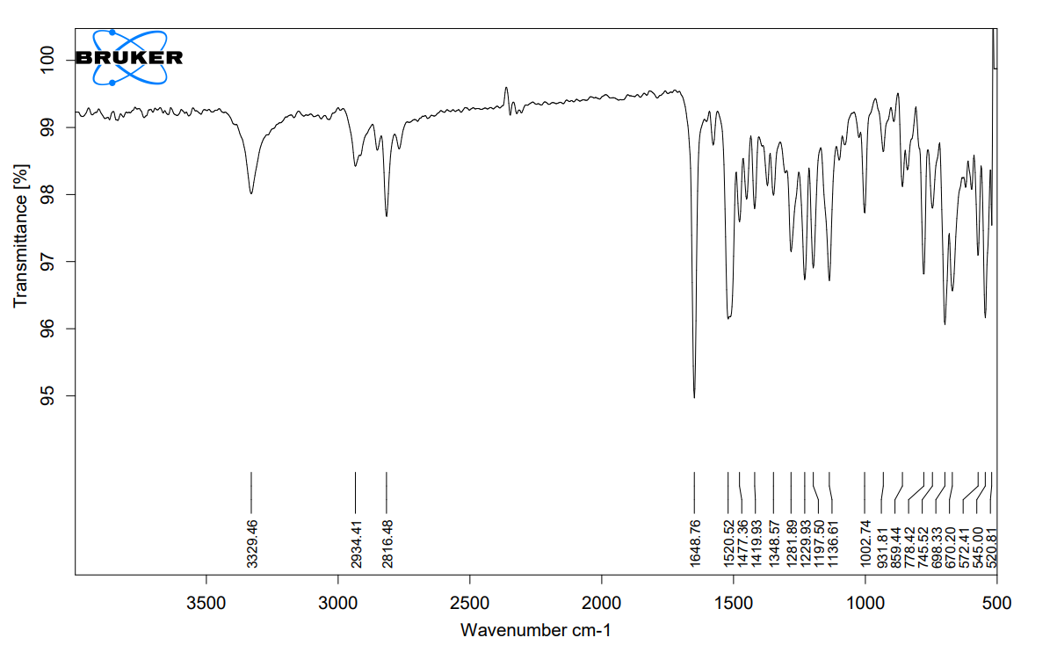
Mass Spectrum
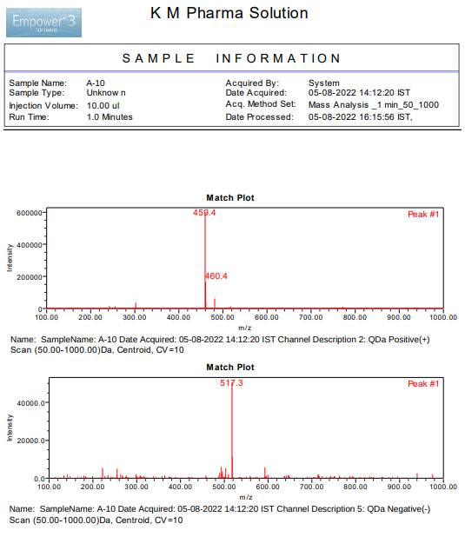

¹H NMR Spectrum
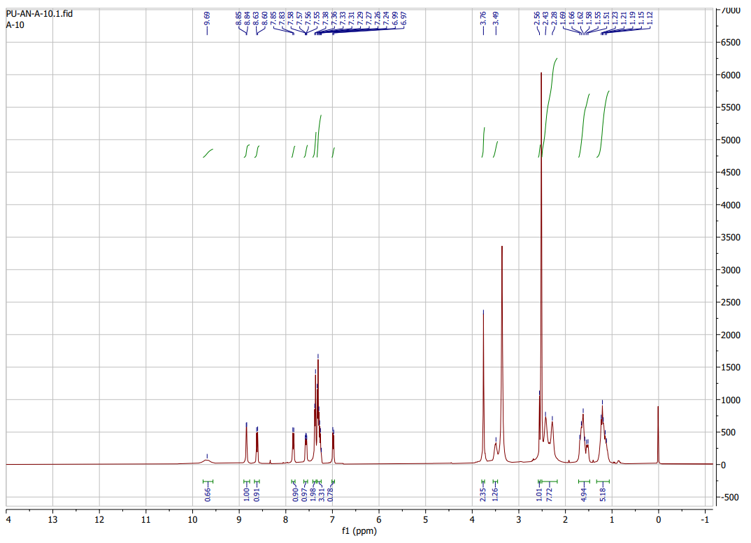
¹³C NMR Spectrum
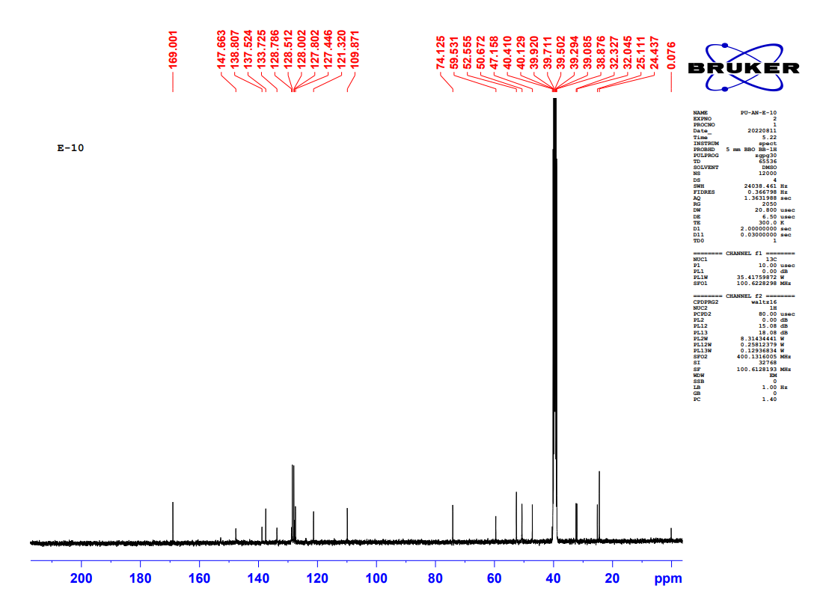
2-(4-Fluorophenyl)-2-(4-((8-hydroxyquinolin-5-yl)methyl)piperazin-1-yl)-N-phenyl- acetamide (80)
IR Spectrum
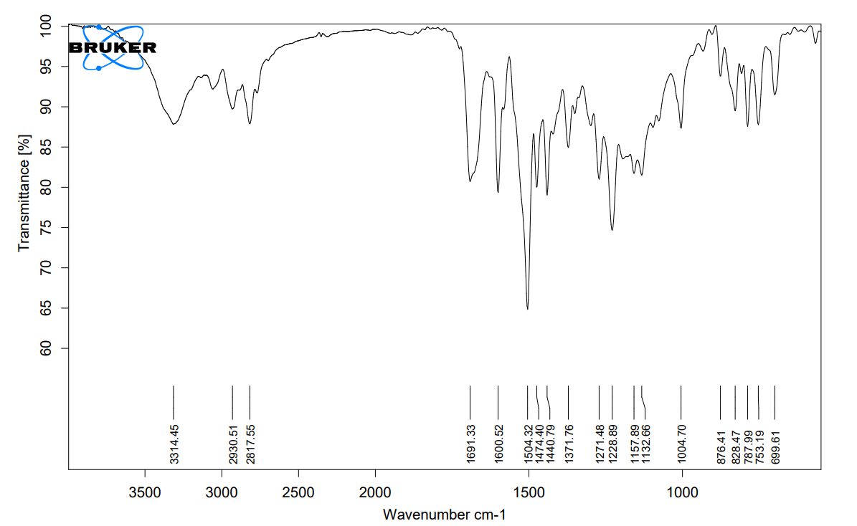
Mass Spectrum
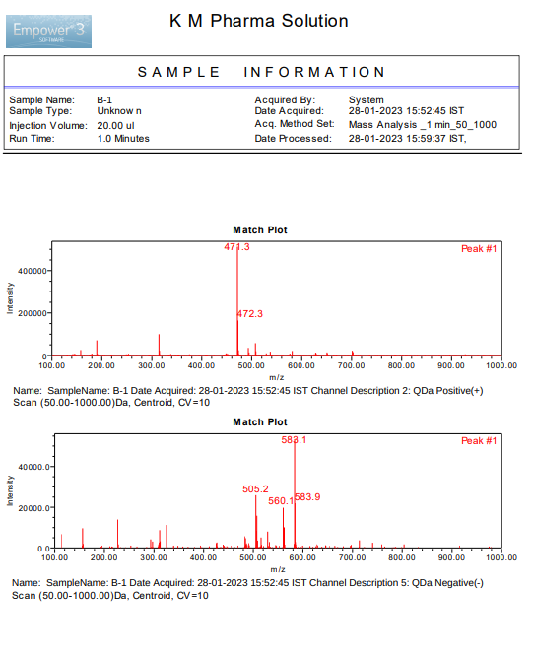
¹H NMR Spectrum
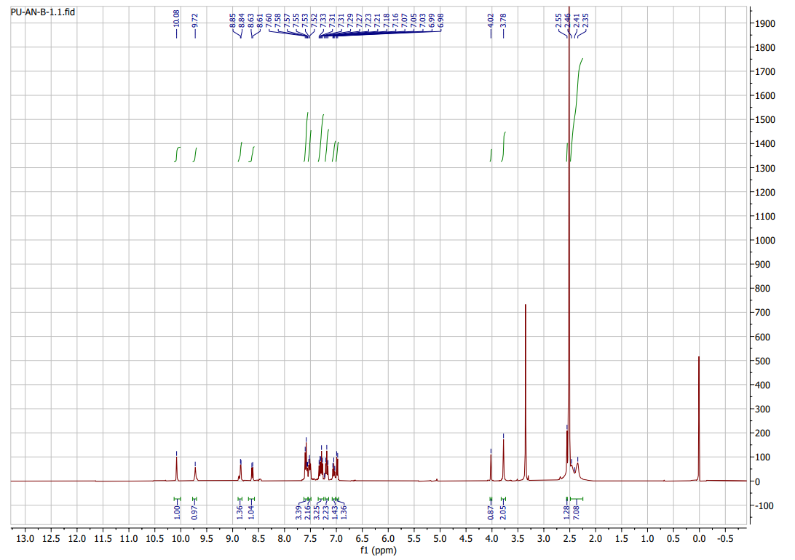

¹³C NMR Spectrum
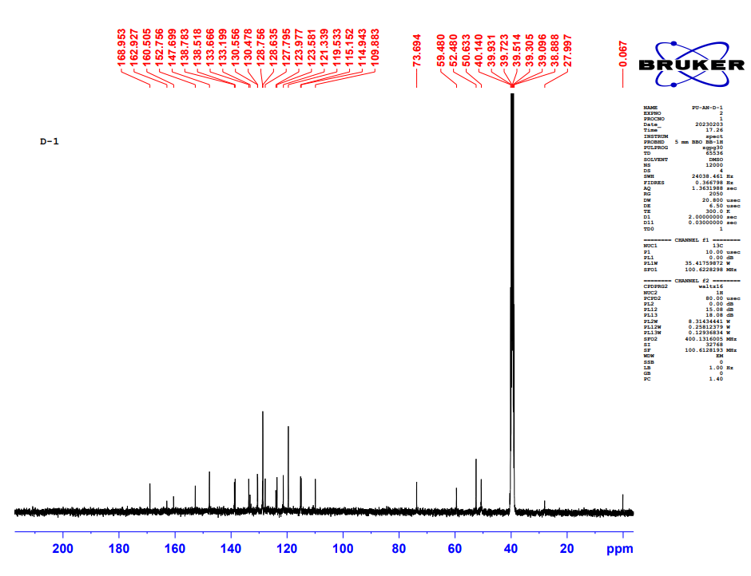

2-(4-Fluorophenyl)-2-(4-((8-hydroxyquinolin-5-yl)methyl)piperazin-1-yl)-N-(o-tolyl)- acetamide (81)
IR Spectrum
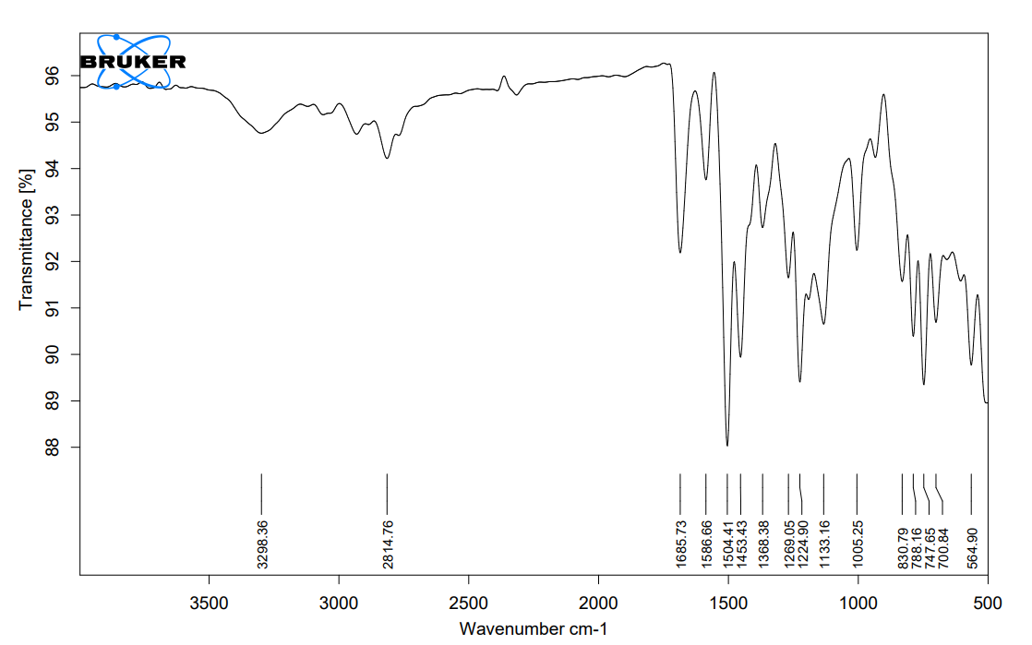
Mass Spectrum
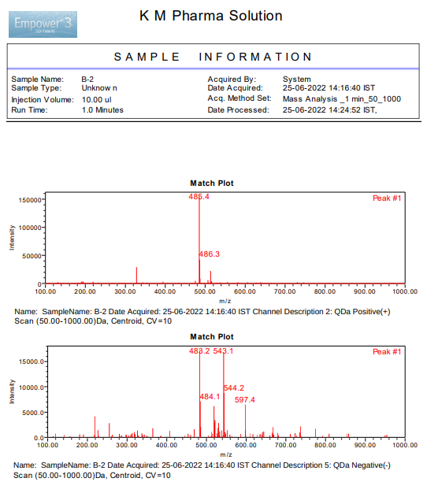
¹H NMR Spectrum
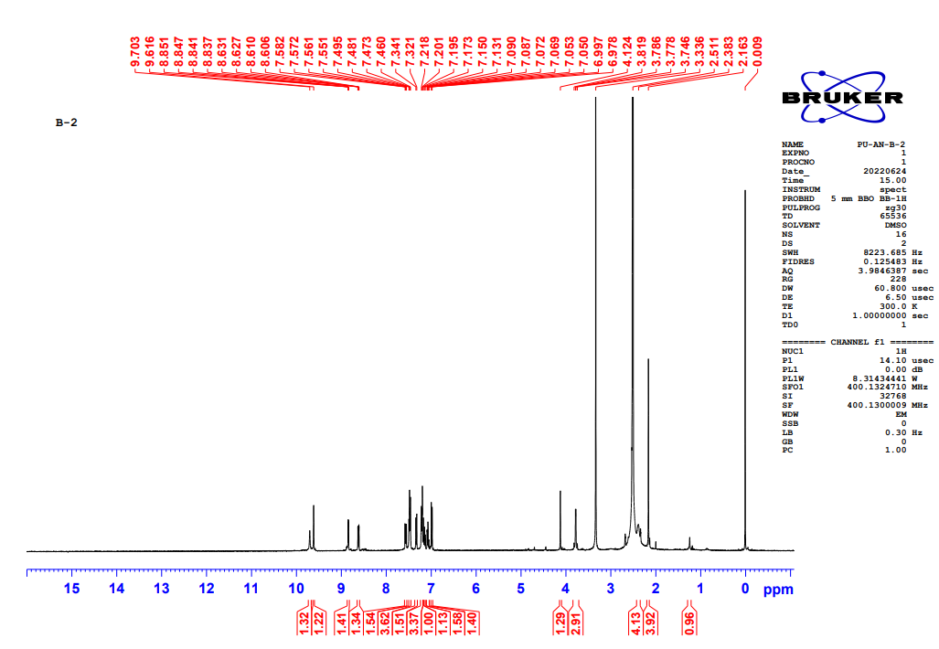
2-(4-Fluorophenyl)-2-(4-((8-hydroxyquinolin-5-yl)methyl)piperazin-1-yl)-N-(p-tolyl)- acetamide (82)
IR Spectrum
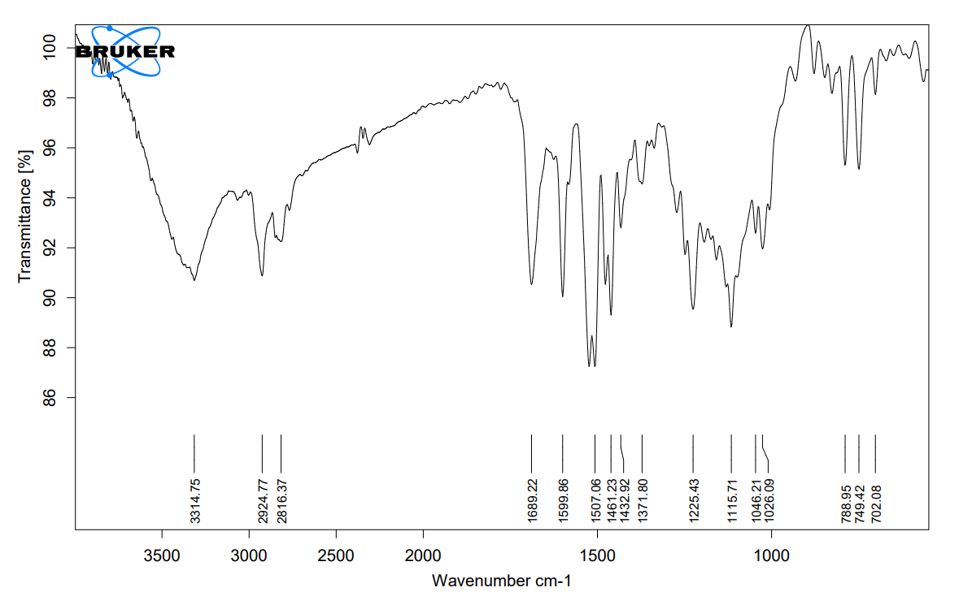
Mass Spectrum
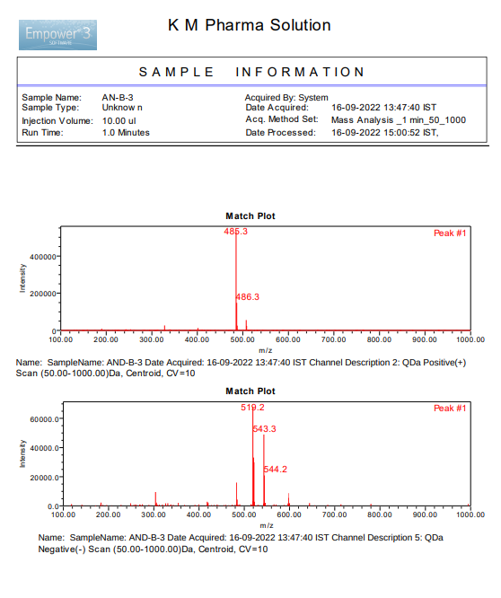
¹H NMR Spectrum
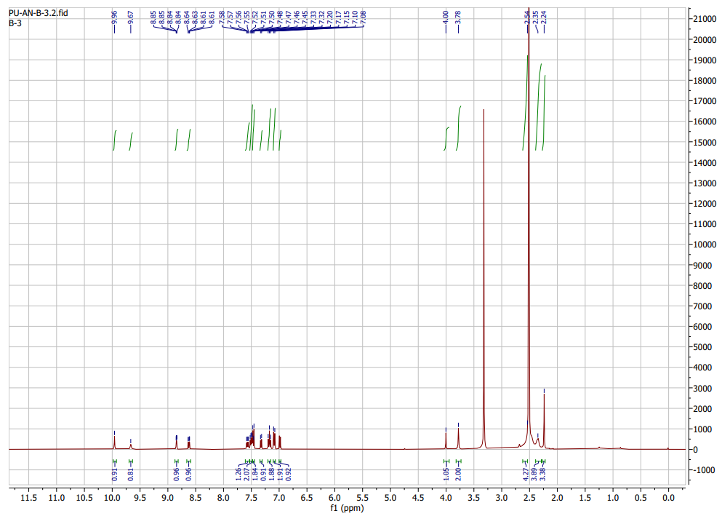
2-(4-Fluorophenyl)-2-(4-((8-hydroxyquinolin-5-yl)methyl)piperazin-1-yl)-N-(2-methoxyphenyl)acetamide (83)
IR Spectrum
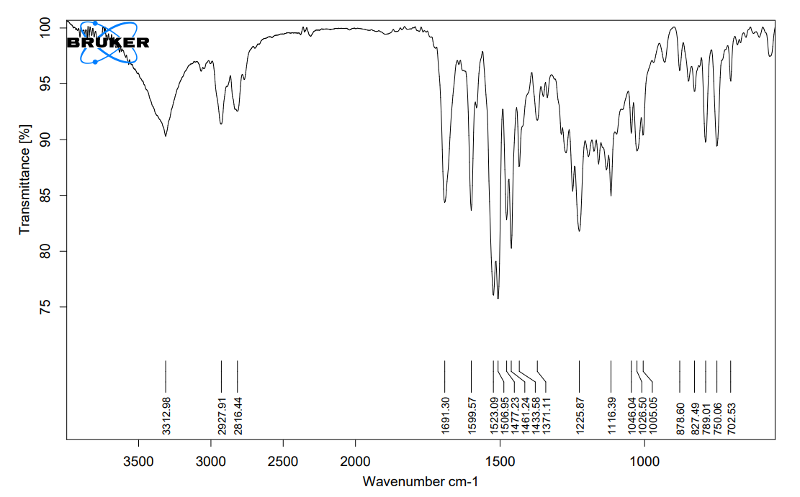
LCMS
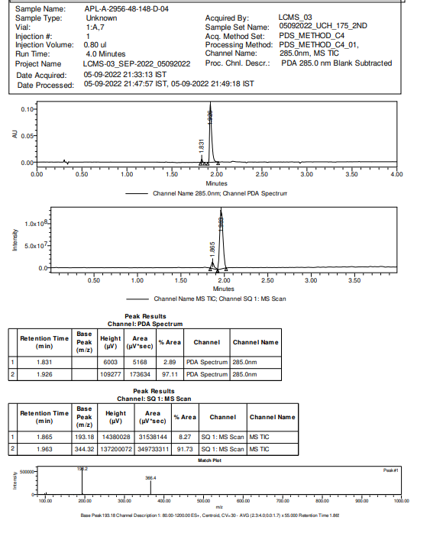
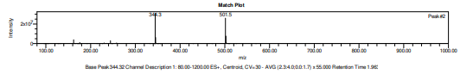
¹H NMR Spectrum
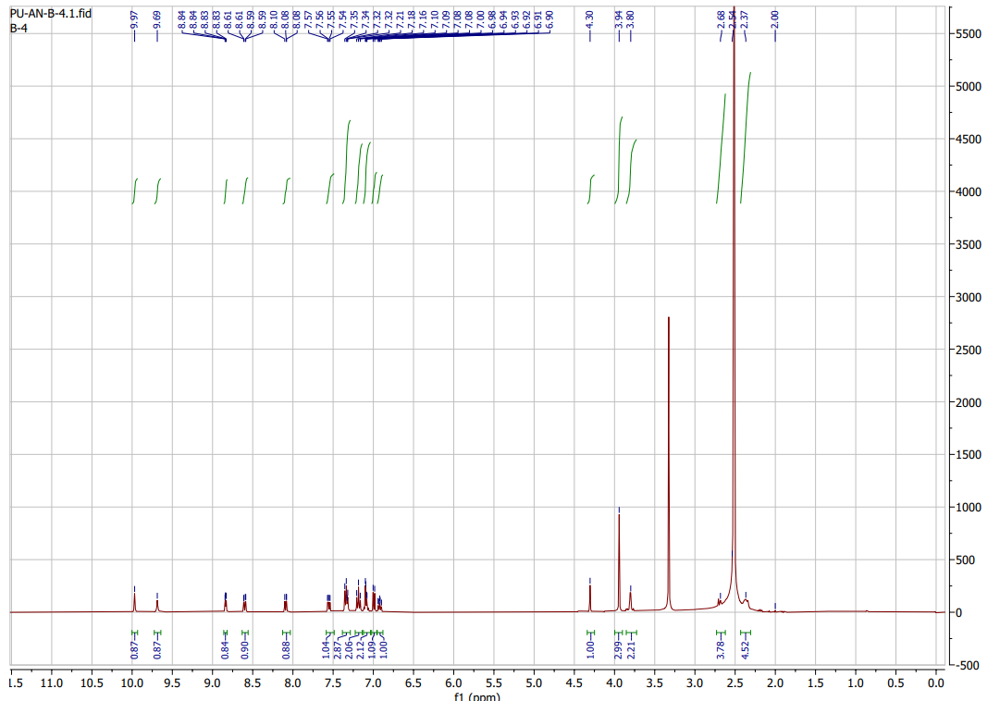
2-(4-Fluorophenyl)-2-(4-((8-hydroxyquinolin-5-yl)methyl)piperazin-1-yl)-N-(4-methoxyphenyl)acetamide (84)
IR Spectrum
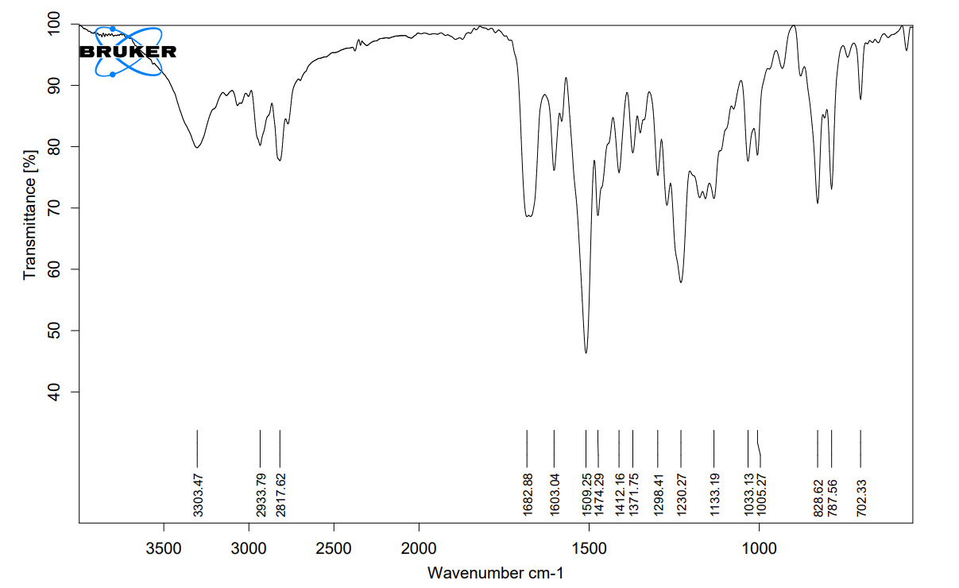
LCMS

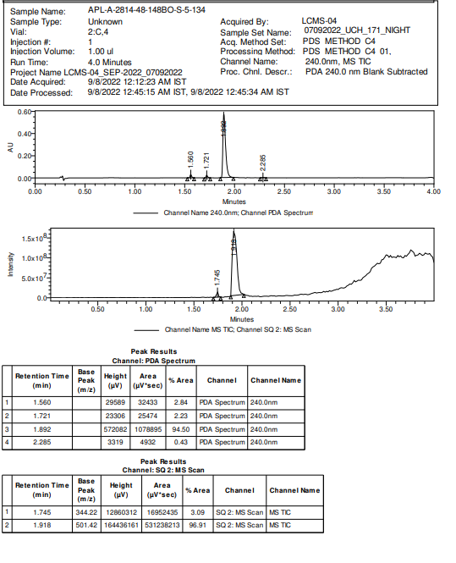
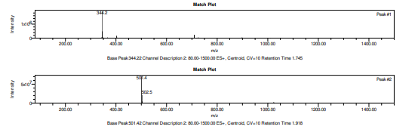
¹H NMR Spectrum
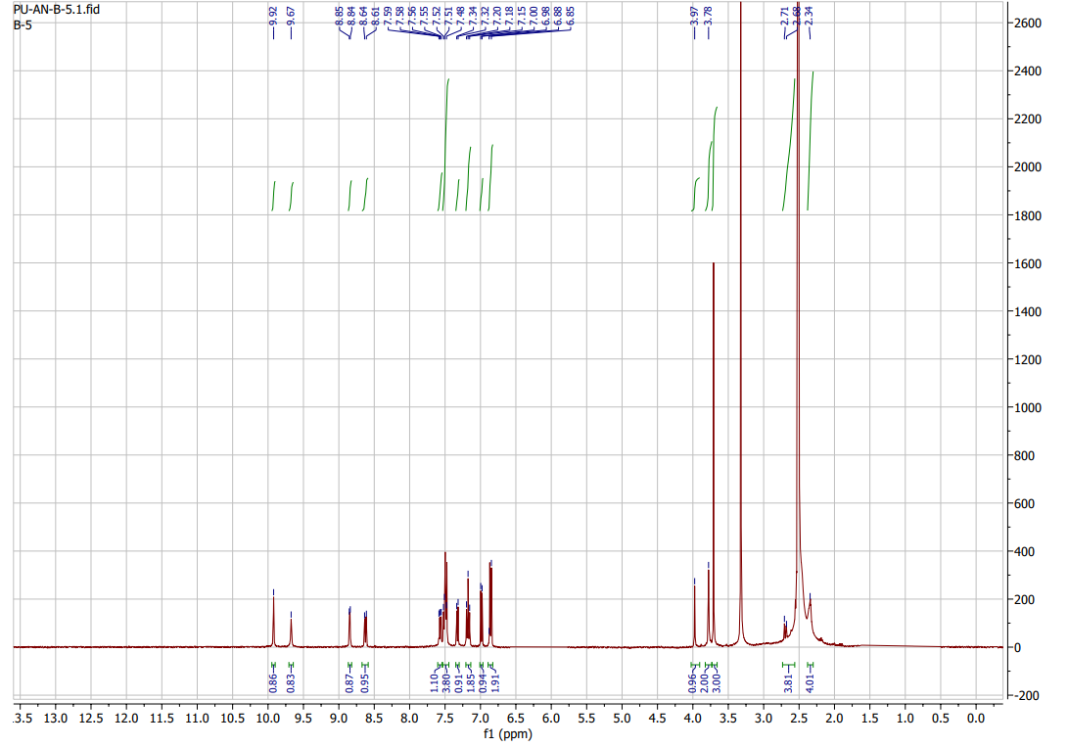
N,2-bis(4-Fluorophenyl)-2-(4-((8-hydroxyquinolin-5-yl)methyl)piperazin-1-yl)- acetamide (85)
IR Spectrum
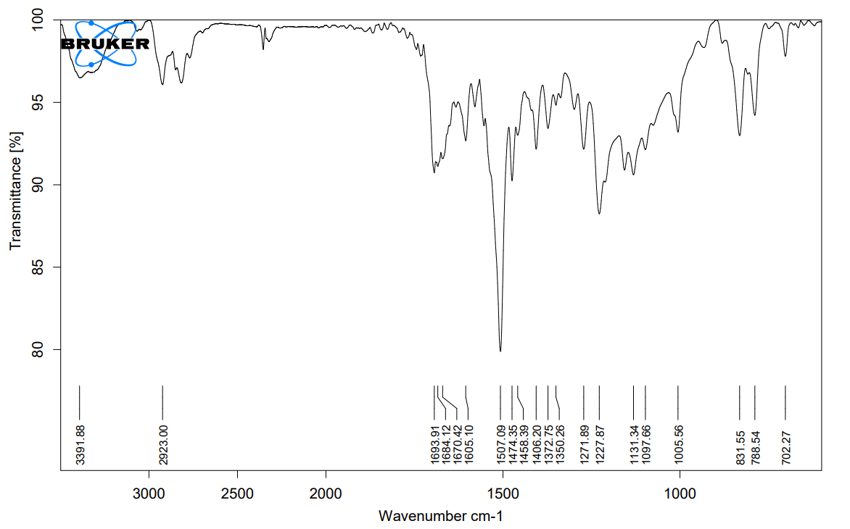
LCMS
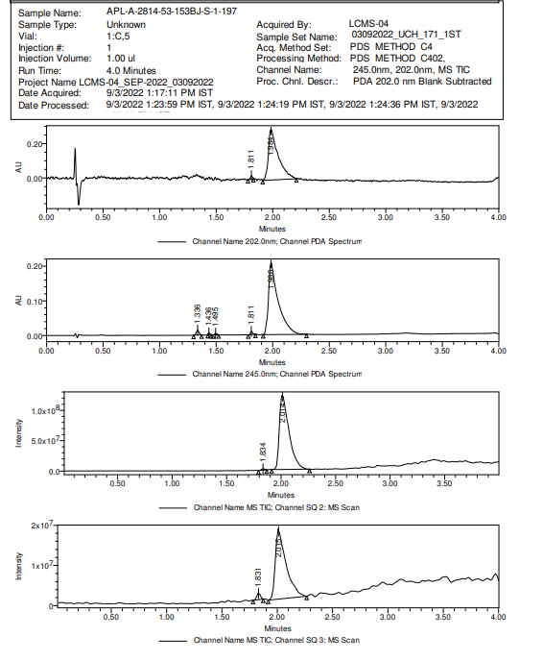
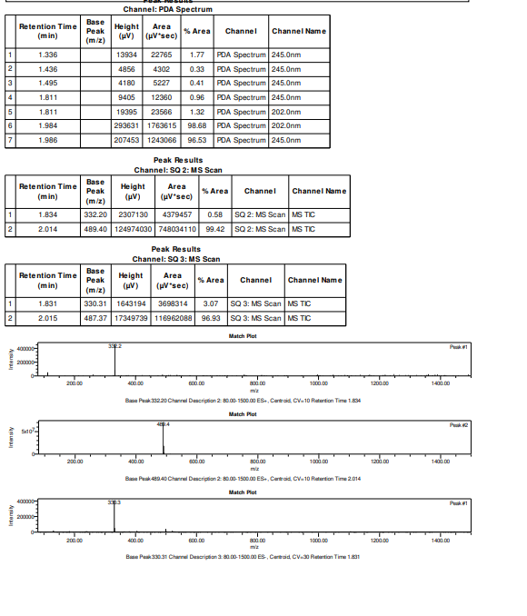
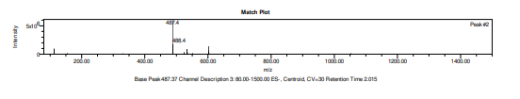
¹H NMR Spectrum
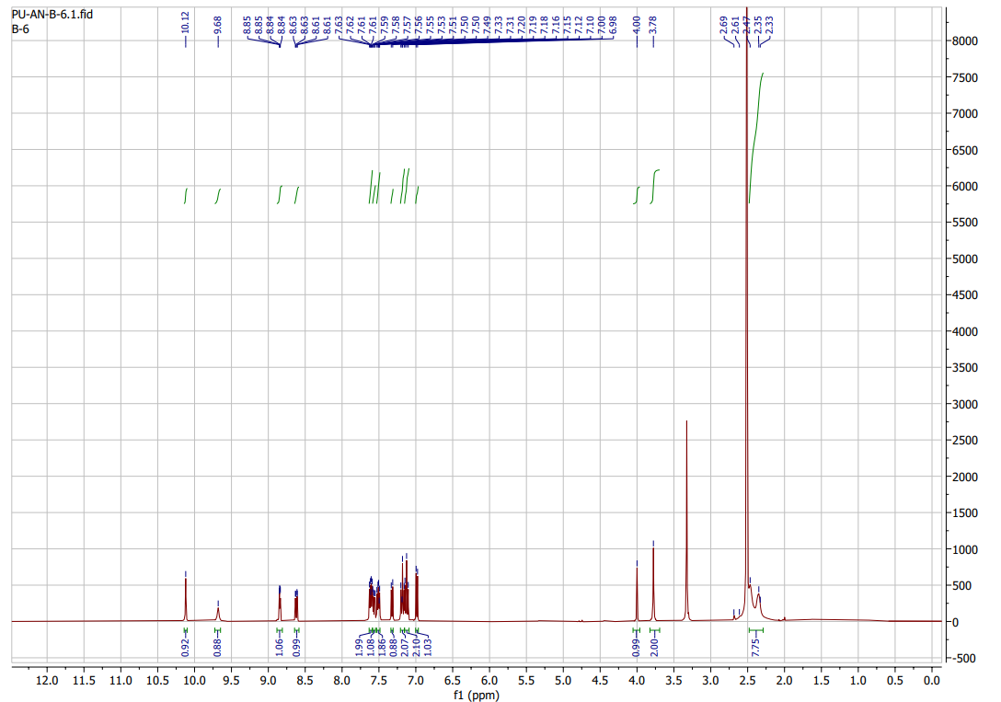
N-(4-Chlorophenyl)-2-(4-fluorophenyl)-2-(4-((8-hydroxyquinolin-5-yl)methyl)- piperazin-1-yl)acetamide (86)
IR Spectrum
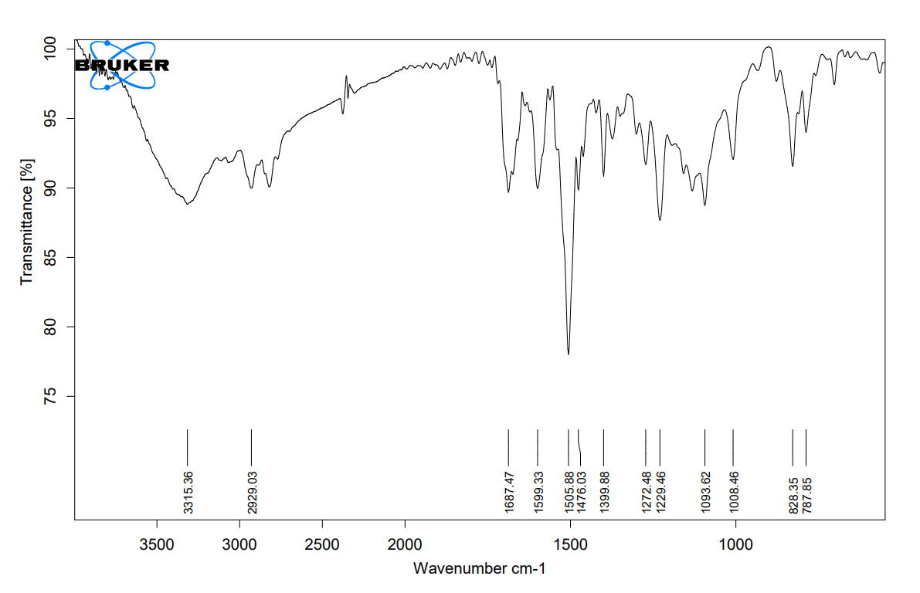
Mass Spectrum
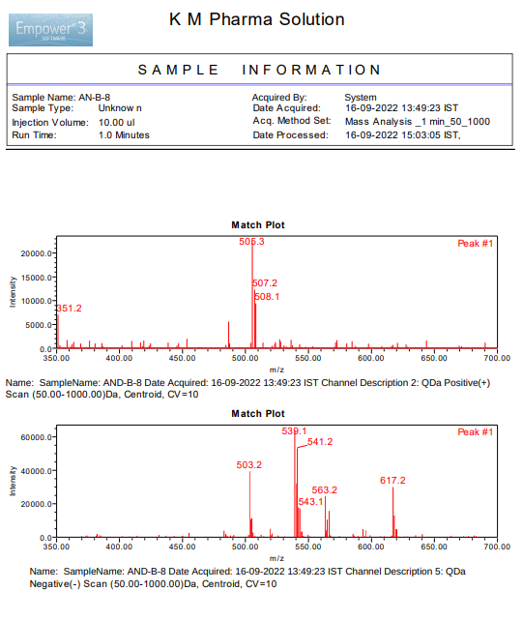
¹H NMR Spectrum
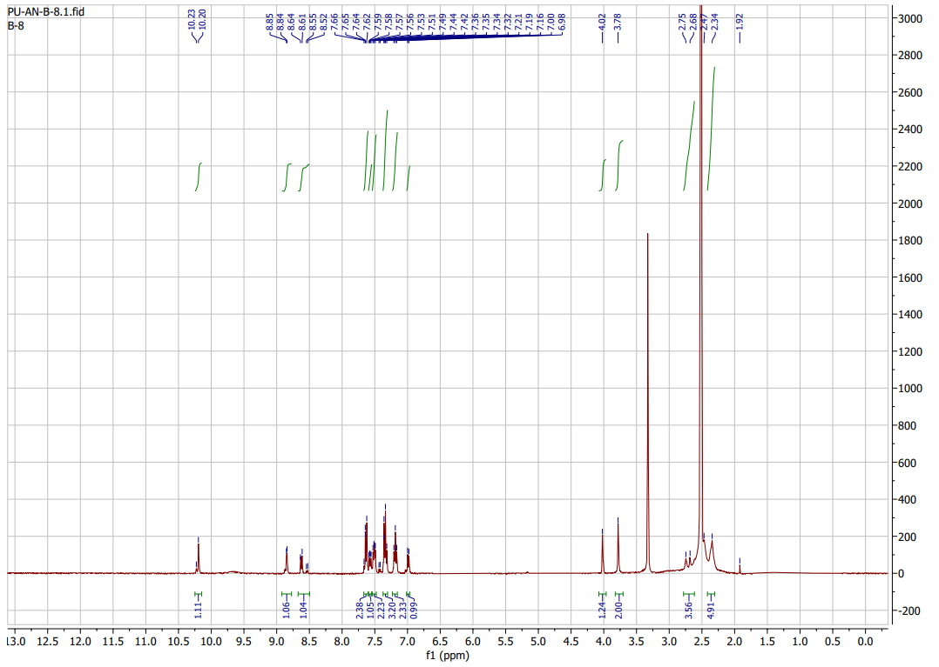
2-(4-Fluorophenyl)-N-(4-hydroxyphenyl)-2-(4-((8-hydroxyquinolin-5-yl)methyl)- piperazin-1-yl)acetamide (87)
IR Spectrum
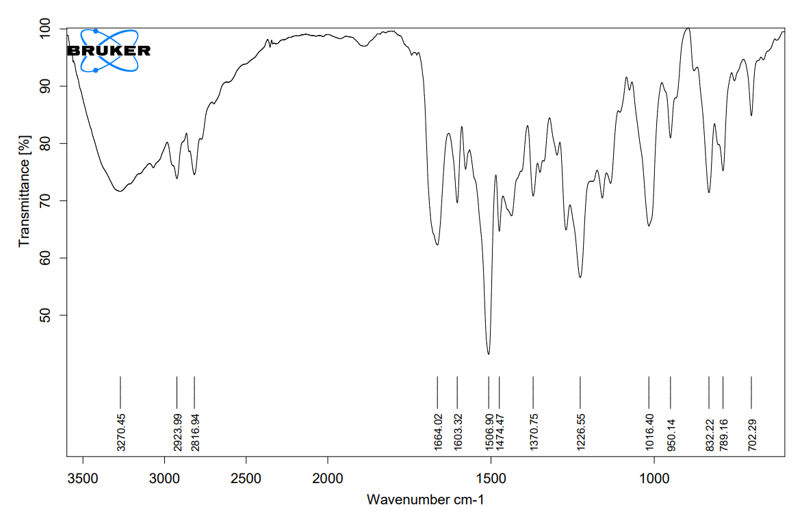
LCMS
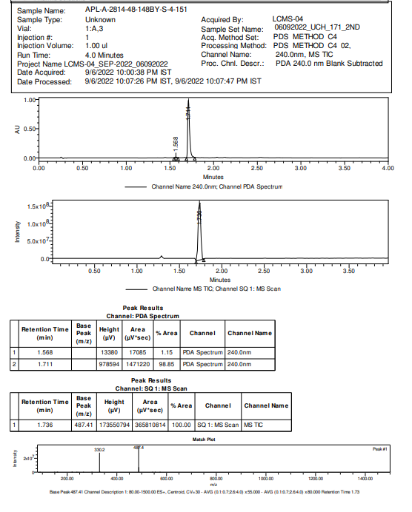
¹H NMR Spectrum
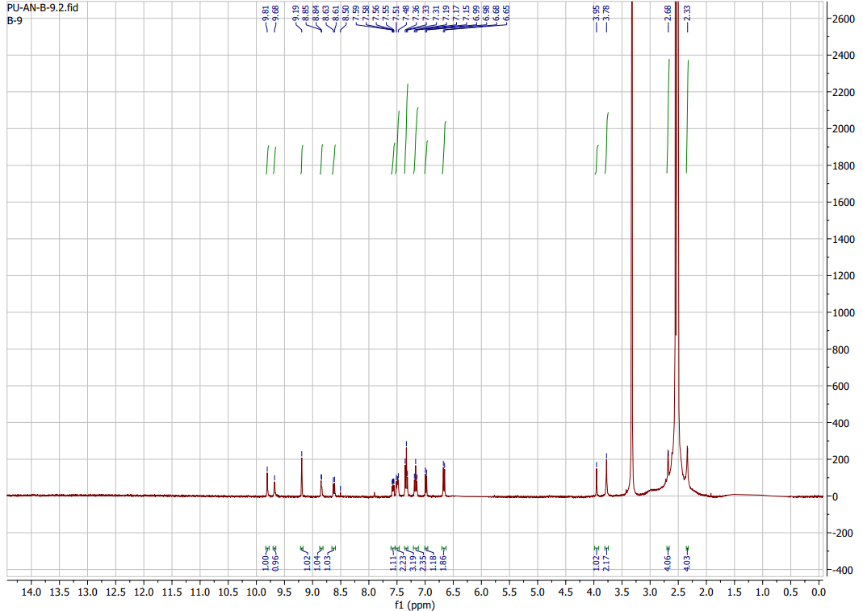
N-Cyclohexyl-2-(4-fluorophenyl)-2-(4-((8-hydroxyquinolin-5-yl)methyl)piperazin-1-yl)acetamide (88)
IR Spectrum
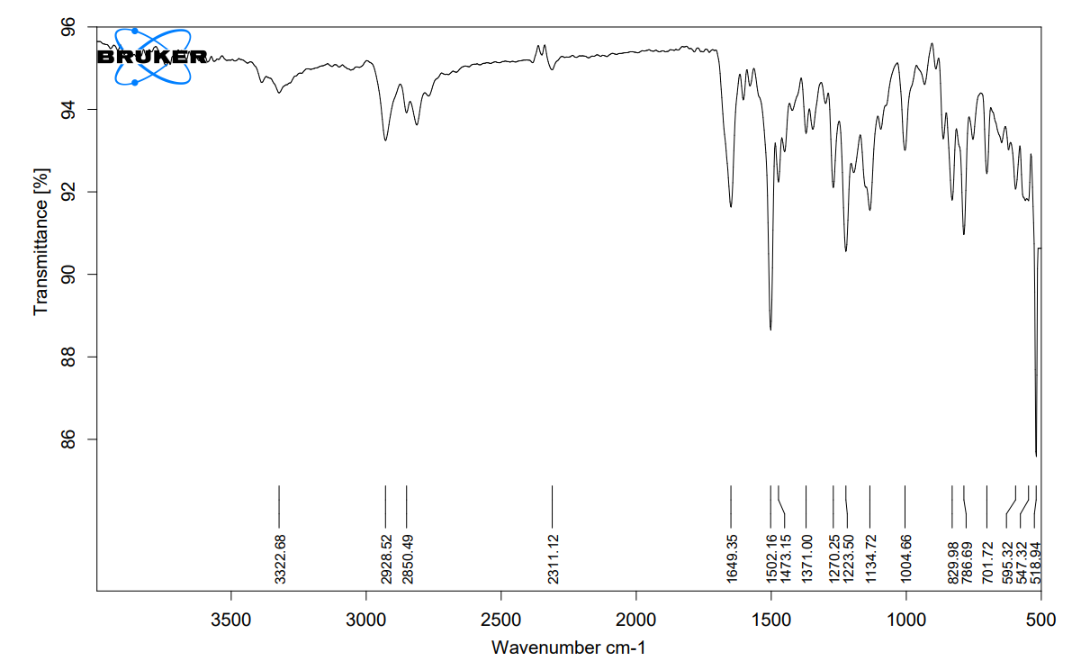
Mass Spectrum
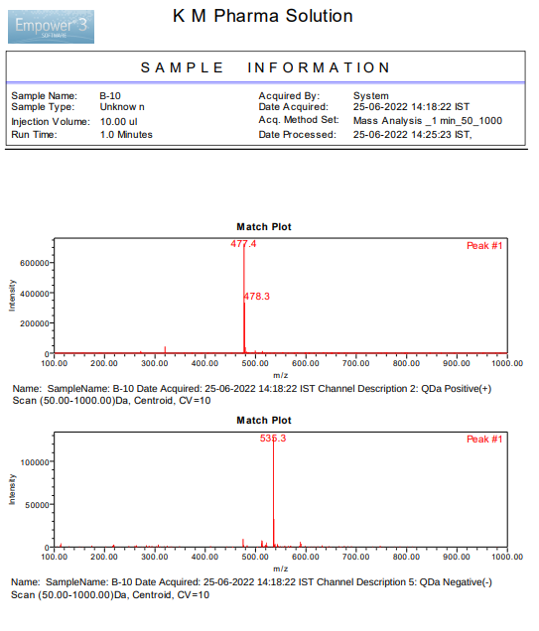
¹H NMR Spectrum
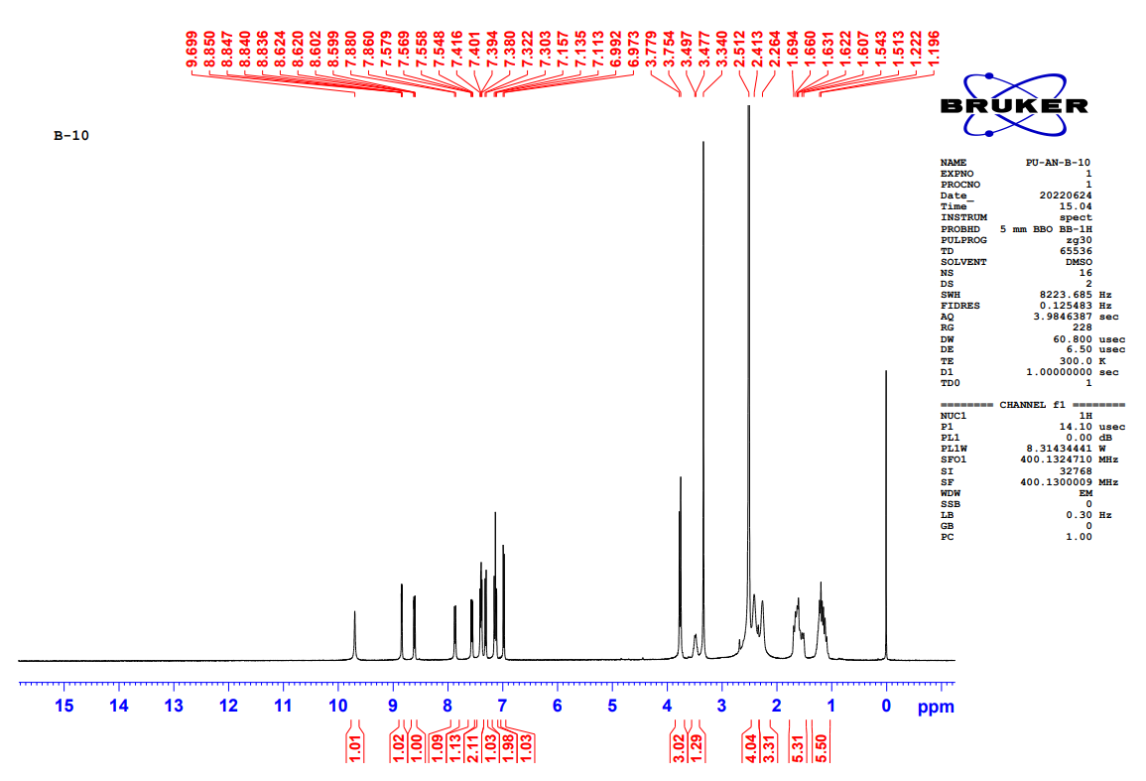
2-(4-((8-Hydroxyquinolin-5-yl)methyl)piperazin-1-yl)-2-(4-methoxyphenyl)-N-phenyl- acetamide (89)
IR Spectrum
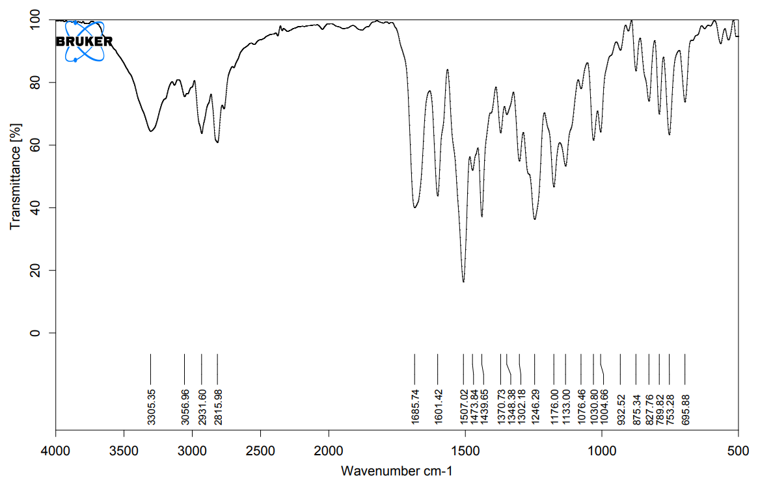
Mass Spectrum
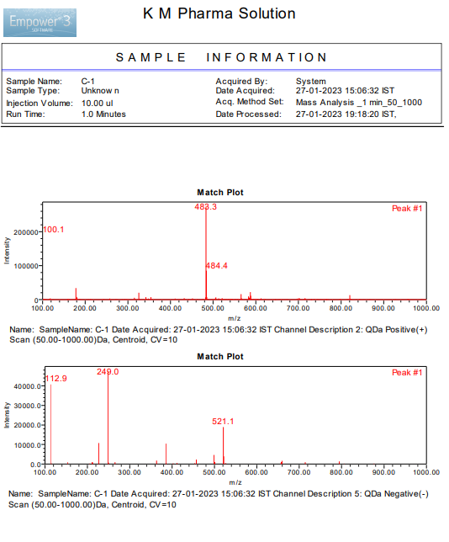
¹H NMR Spectrum
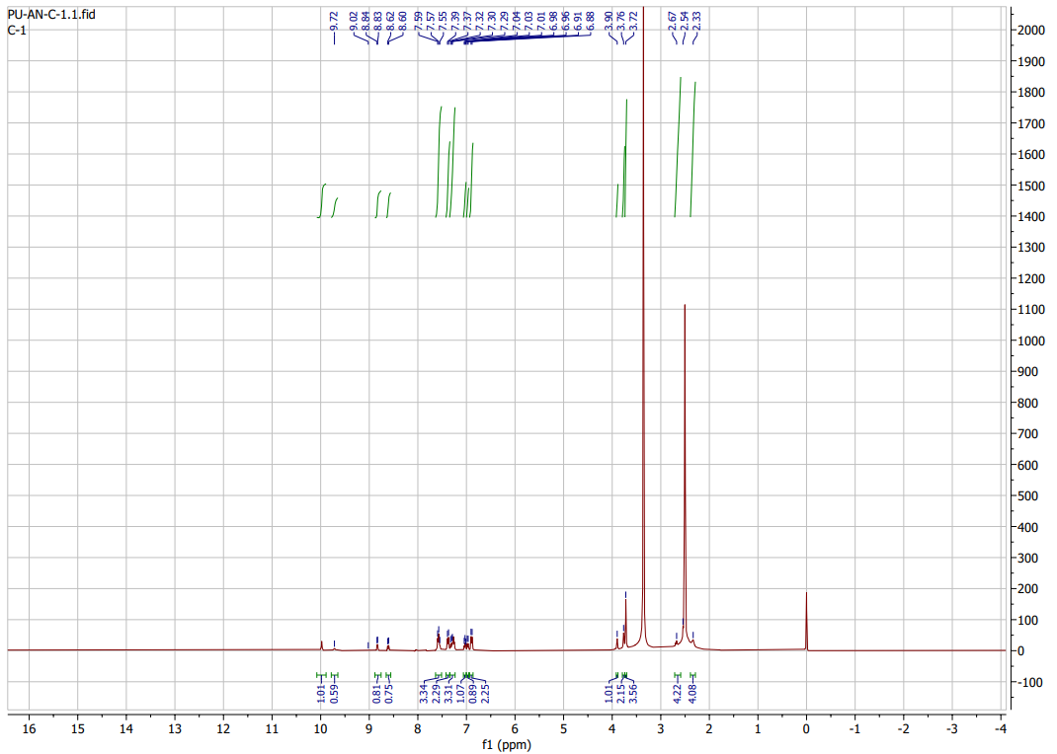
2-(4-((8-Hydroxyquinolin-5-yl)methyl)piperazin-1-yl)-2-(4-methoxyphenyl)-N-(o-tolyl) acetamide (90)
IR Spectrum
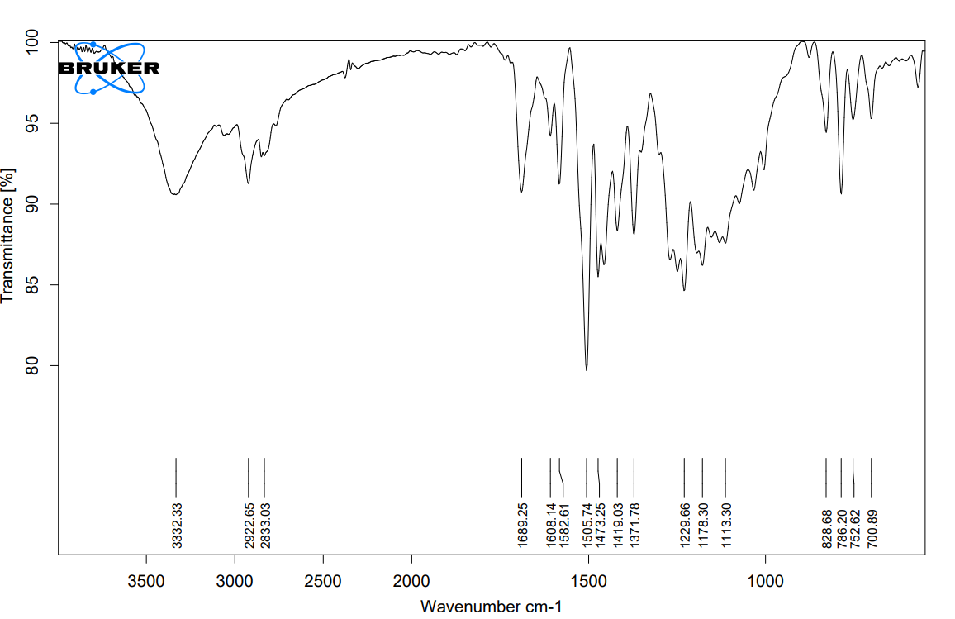
Mass Spectrum
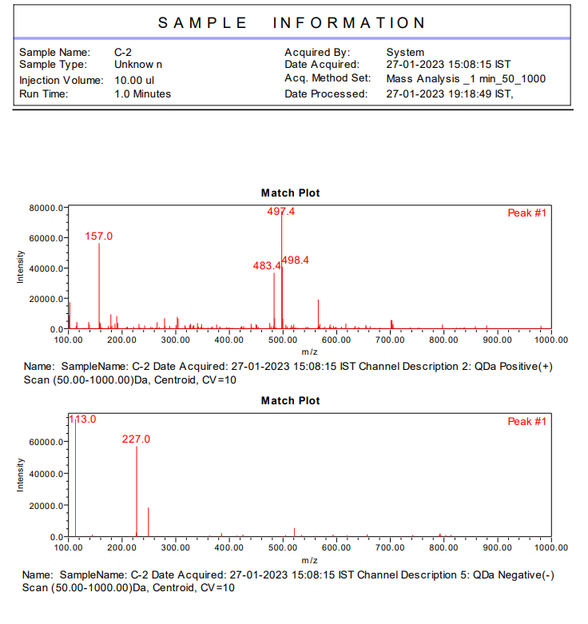
¹H NMR Spectrum
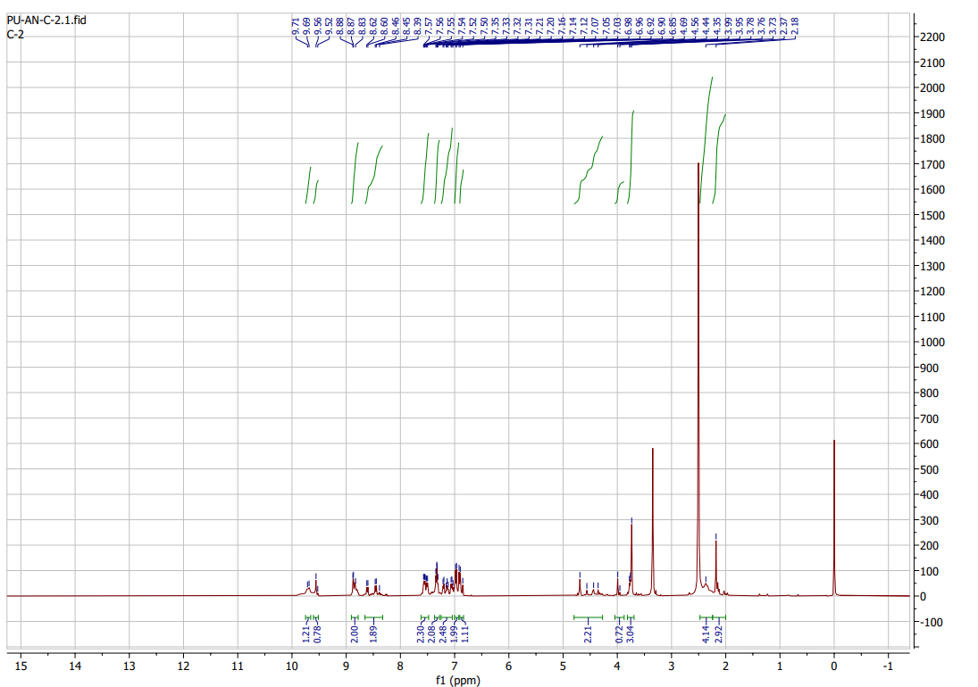
¹³C NMR Spectrum
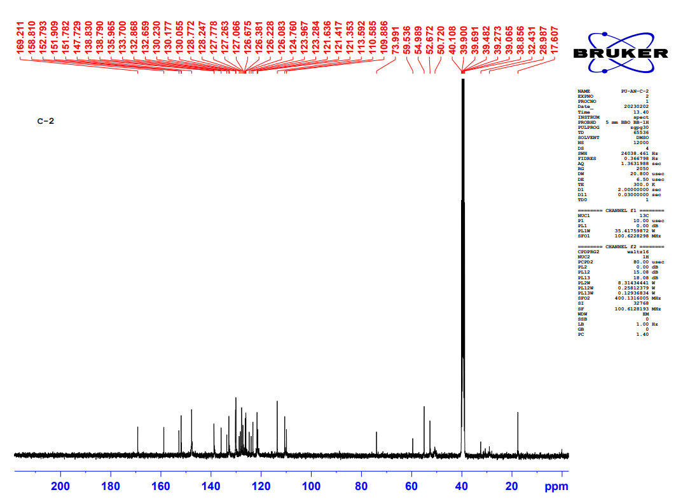
2-(4-((8-Hydroxyquinolin-5-yl)methyl)piperazin-1-yl)-2-(4-methoxyphenyl)-N-(p-tolyl) acetamide (91)
IR Spectrum
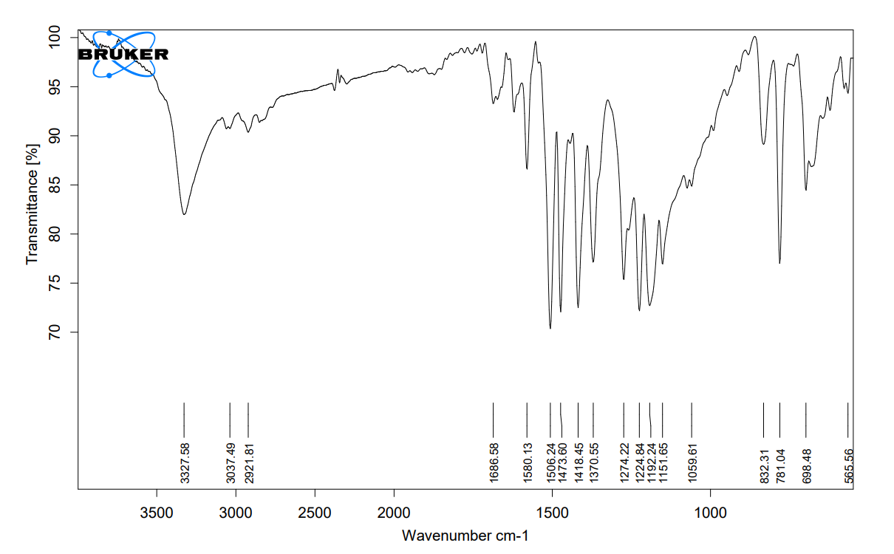
Mass Spectrum
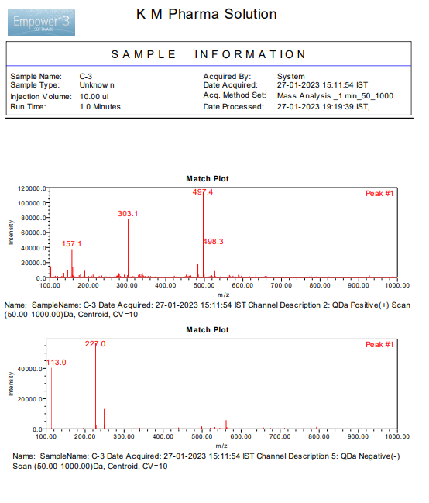
¹H NMR Spectrum
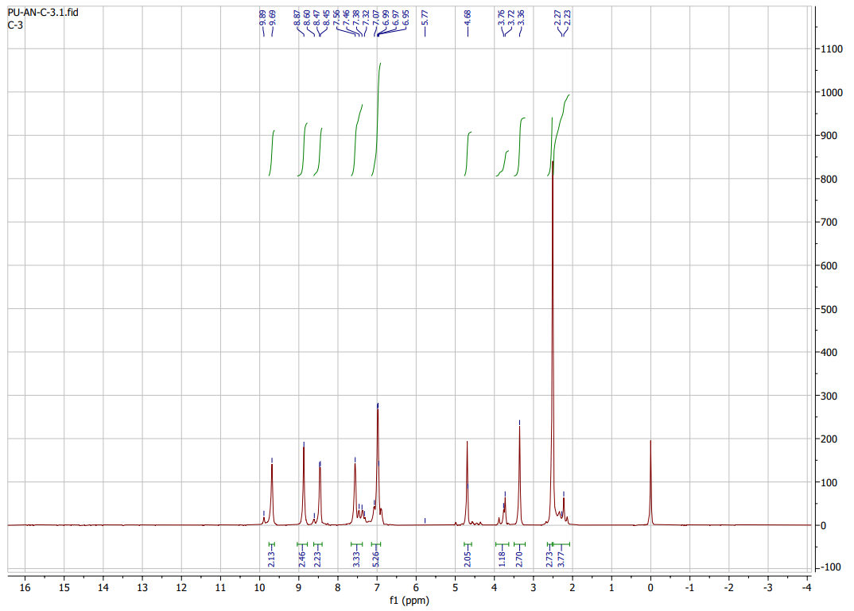
2-(4-((8-Hydroxyquinolin-5-yl)methyl)piperazin-1-yl)-N-(2-methoxyphenyl)-2-(4-methoxyphenyl)acetamide (92)
IR Spectrum
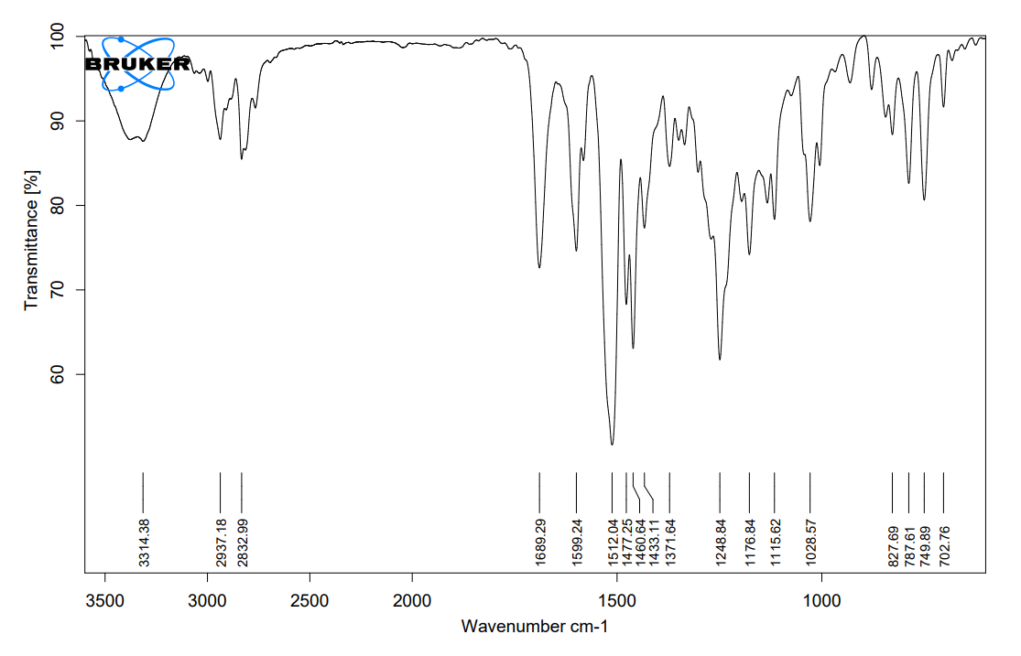
Mass Spectrum
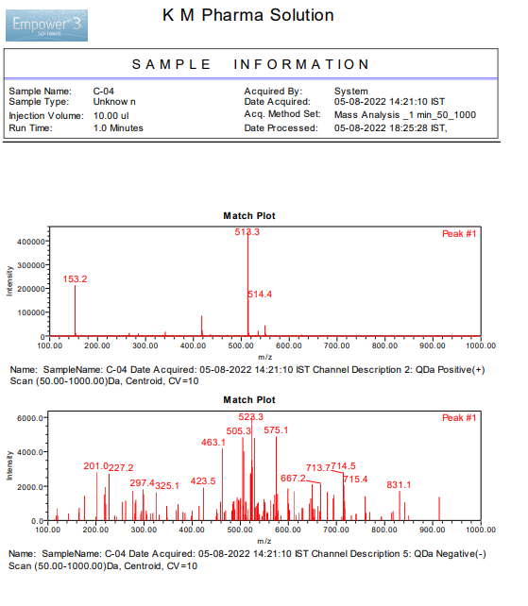
¹H NMR Spectrum
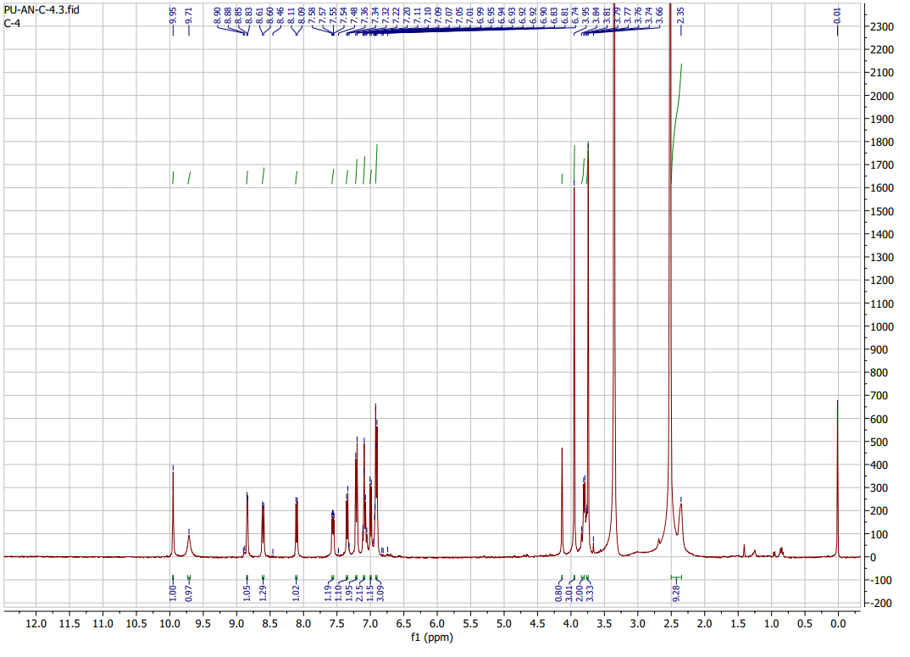
2-(4-((8-Hydroxyquinolin-5-yl)methyl)piperazin-1-yl)-N,2-bis(4-methoxyphenyl)- acetamide (93)
IR Spectrum

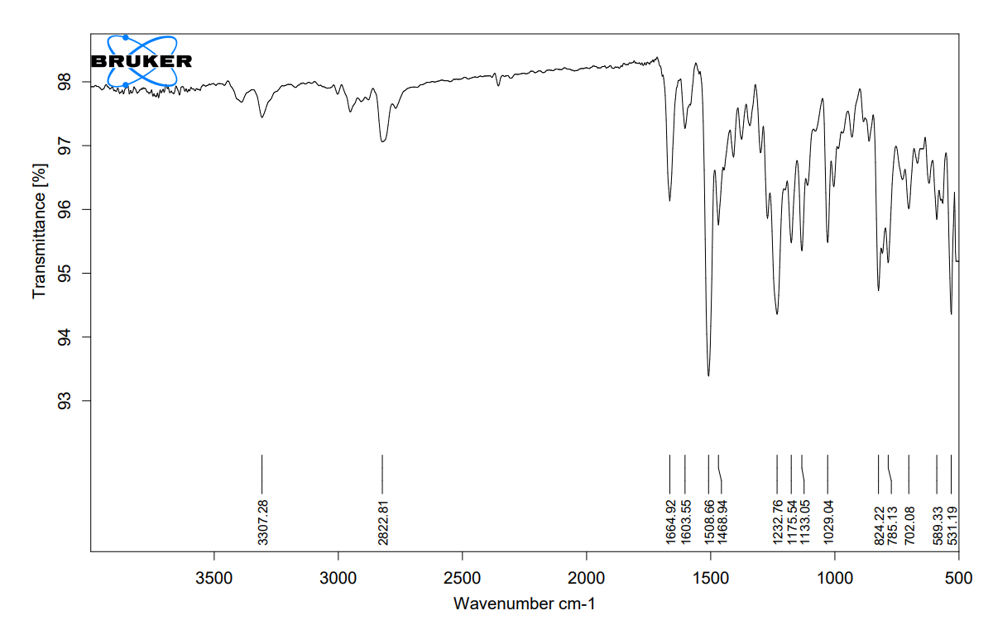
Mass Spectrum
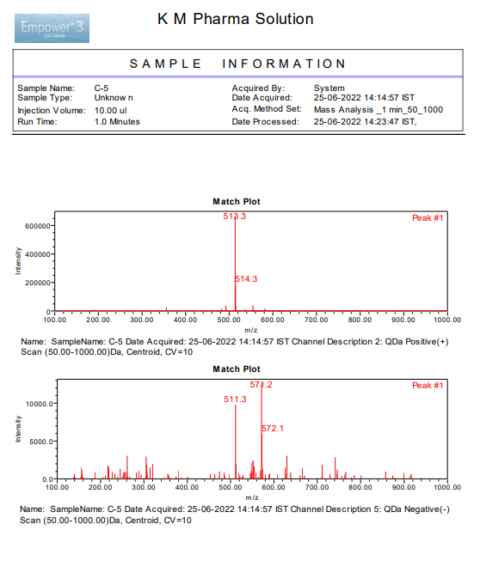
¹H NMR Spectrum
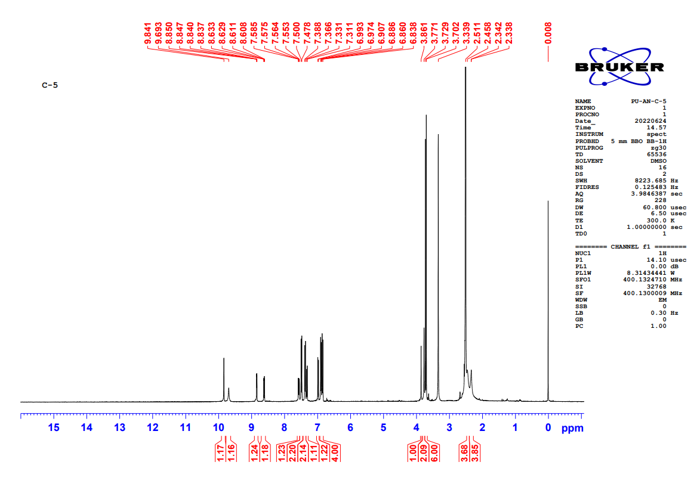
N-(4-Fluorophenyl)-2-(4-((8-hydroxyquinolin-5-yl)methyl)piperazin-1-yl)-2-(4-methoxyphenyl)acetamide (94)
IR Spectrum
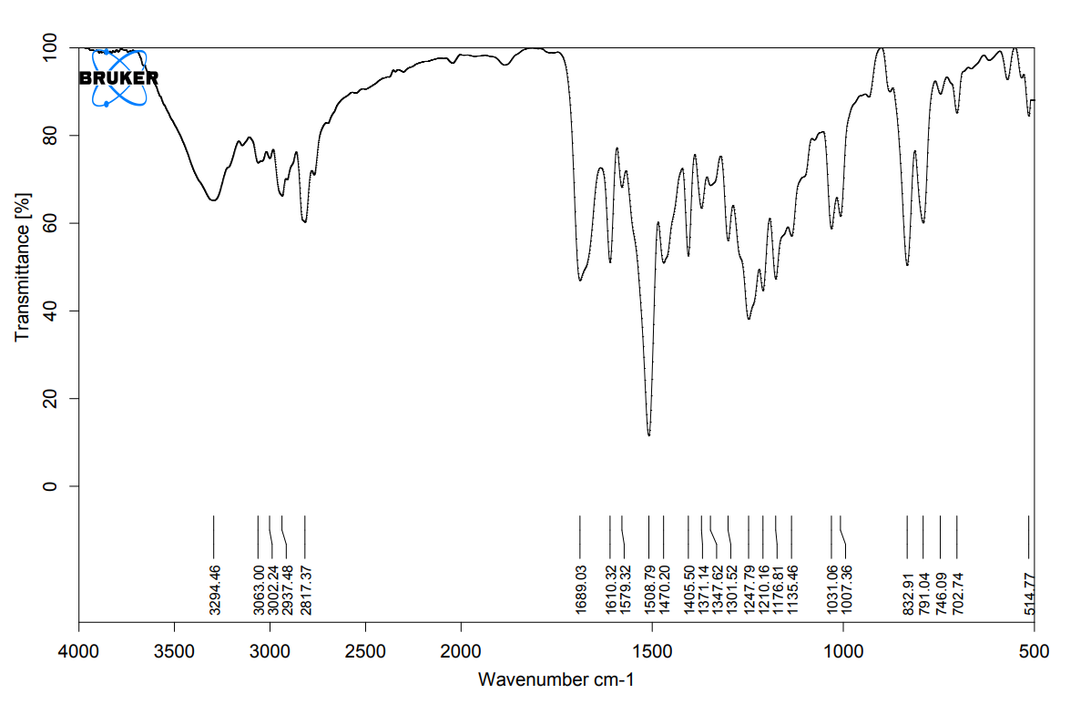
Mass Spectrum
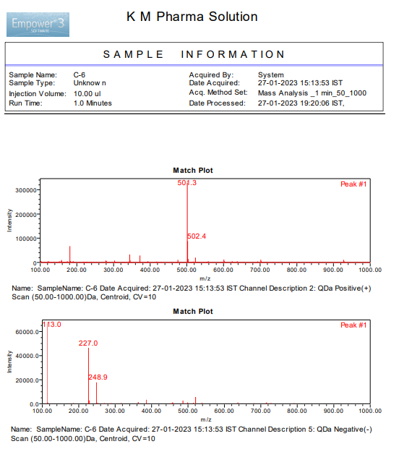
¹H NMR Spectrum
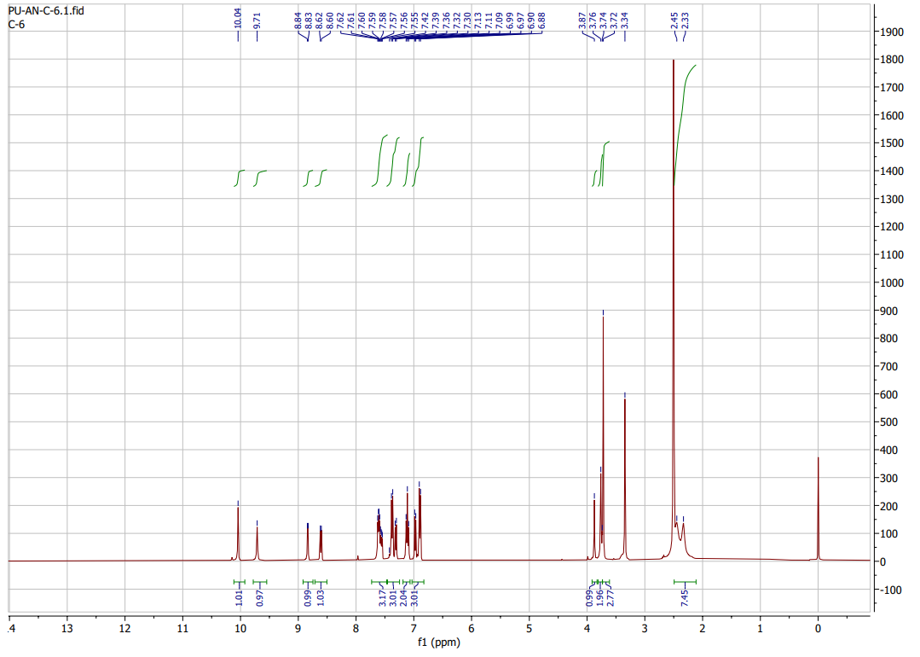
N-(4-Chlorophenyl)-2-(4-((8-hydroxyquinolin-5-yl)methyl)piperazin-1-yl)-2-(4-methoxyphenyl)acetamide (95)
IR Spectrum
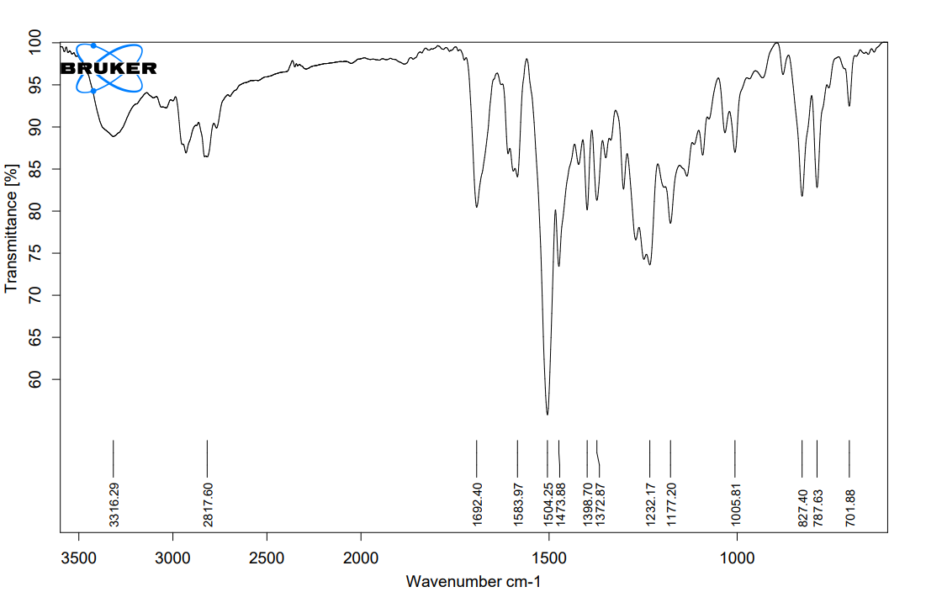
Mass Spectrum
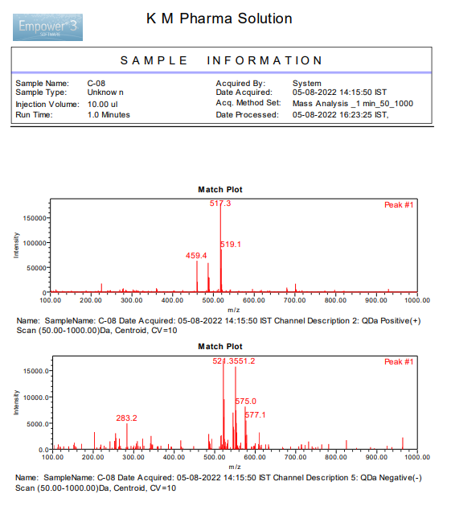
¹H NMR Spectrum
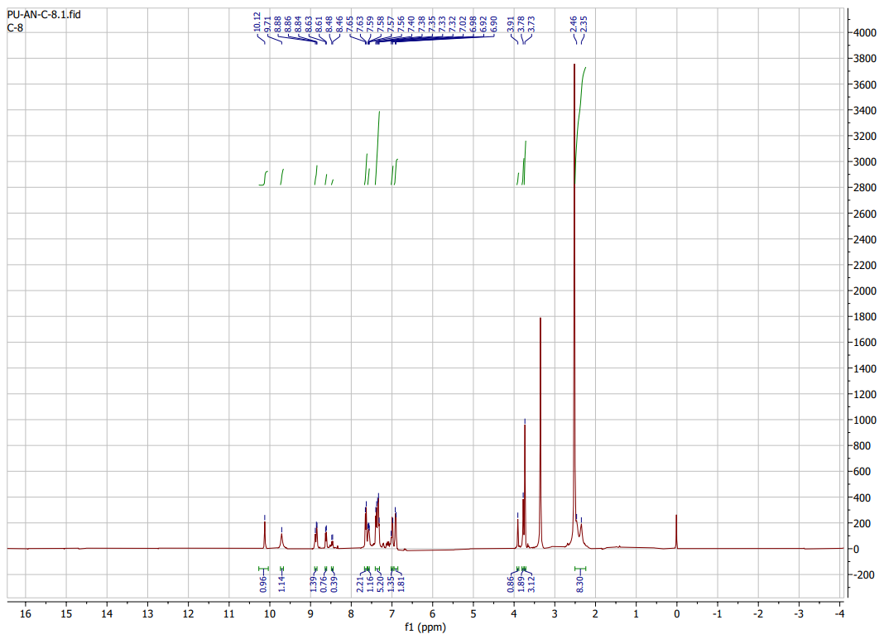
N-(4-Hydroxyphenyl)-2-(4-((8-hydroxyquinolin-5-yl)methyl)piperazin-1-yl)-2-(4-methoxyphenyl)acetamide (96)
IR Spectrum
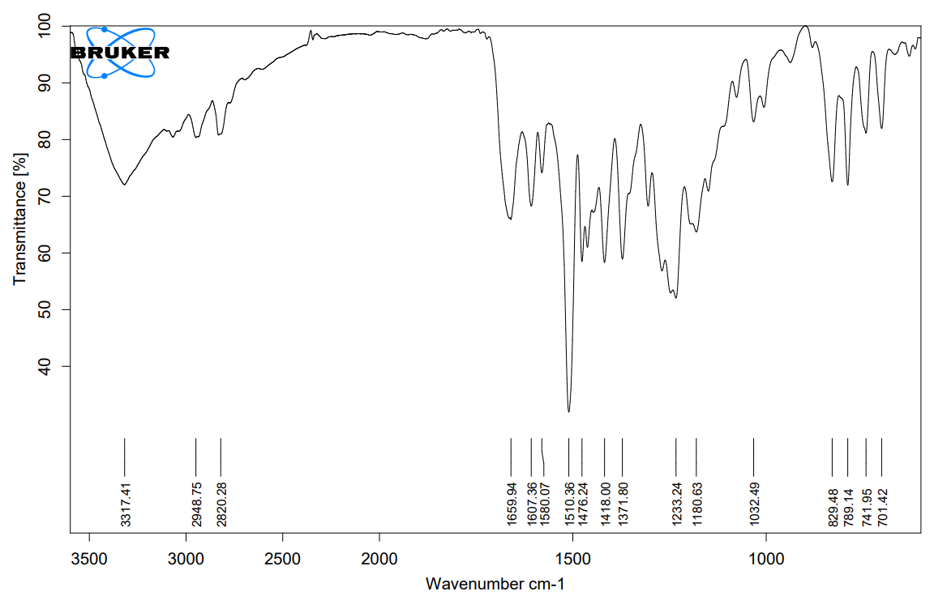
Mass Spectrum
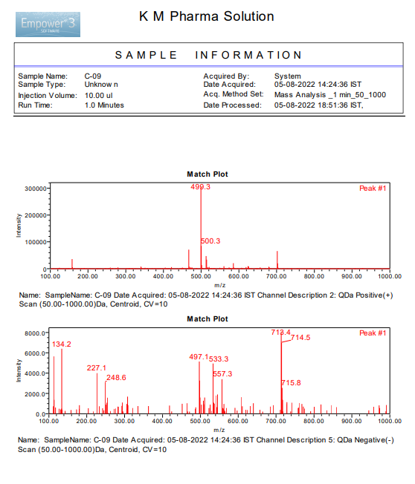
¹H NMR Spectrum
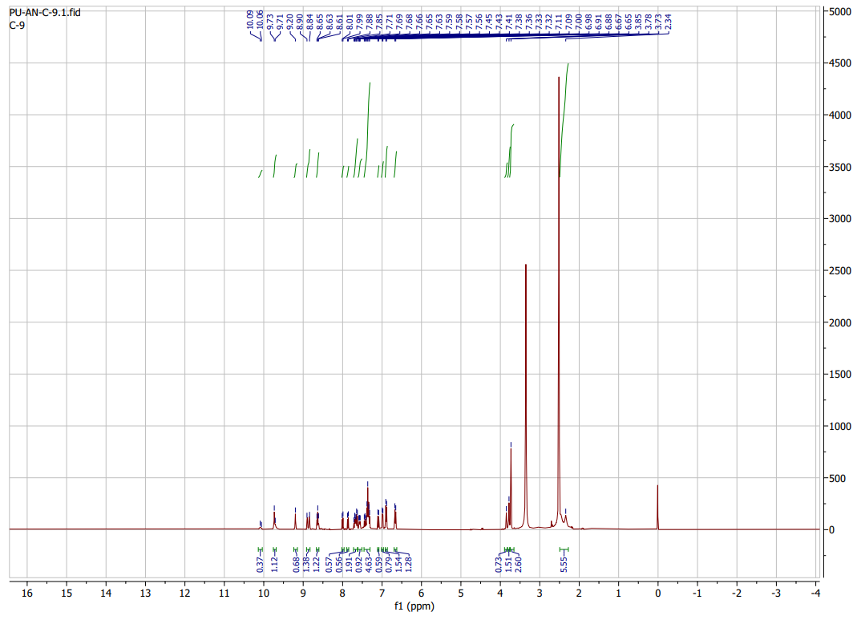
N-(4-Hydroxyphenyl)-2-(4-((8-hydroxyquinolin-5-yl)methyl)piperazin-1-yl)-2-(4-methoxyphenyl)acetamide (97)
IR Spectrum
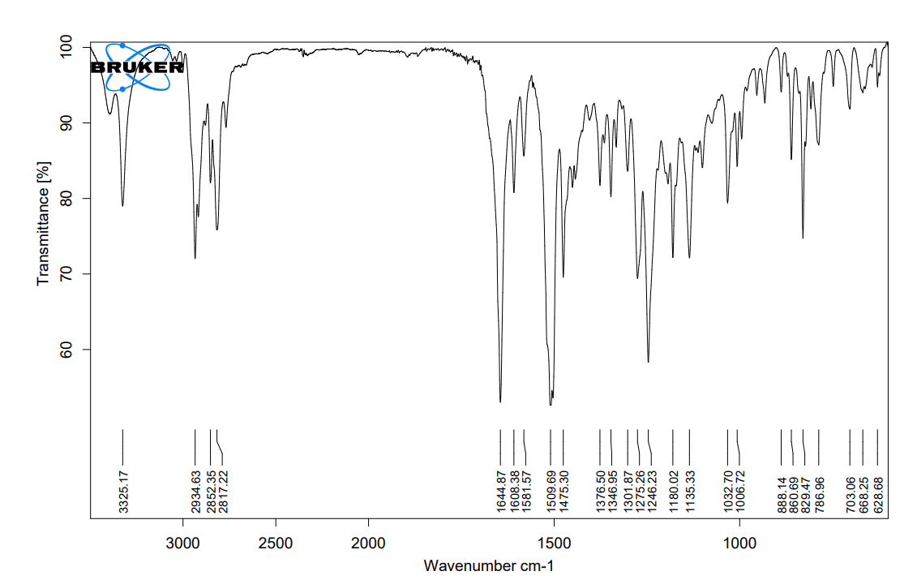
Mass Spectrum
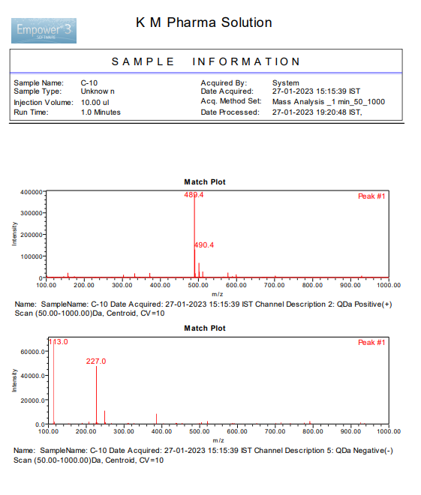
¹H NMR Spectrum
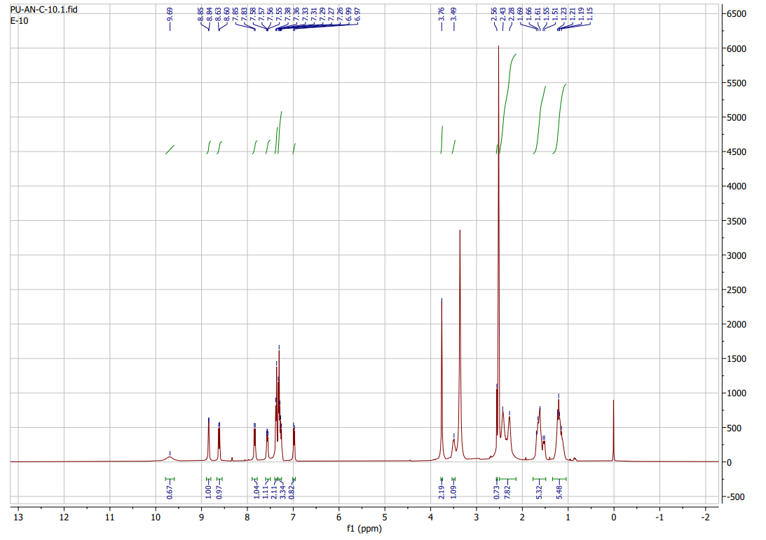

Metal Chelation Activity:
Table-2: Metal Chelation Activity
Compound ID | Compound  ƛ max (nm) | ƛ max (nm) with Fe⁺² | ƛ max (nm) with Fe⁺³ | ƛ max (nm) with Cu⁺² | ƛ max (nm) with Zn⁺² | ƛ max (nm) with Al⁺³
A1 | 243.4 | 252.6 | 252.4 | 257.2 | 258.2 | 255.8
A2 | 244.3 | 252.8 | 252.6 | 258.3 | 259.3 | 256.2
A3 | 243.6 | 251.8 | 251.6 | 257.8 | 258.8 | 255.6
A4 | 244.8 | 255.6 | 255.4 | 257.6 | 258.6 | 255.8
A5 | 246.6 | 254.2 | 253 | 258.1 | 257.1 | 256.2
A6 | 244.8 | 255.2 | 264.6 | 258.9 | 257.6 | 256.0
A7 | 244.2 | 252.6 | 252.4 | 258.2 | 257.6 | 256.2
A8 | 244.0 | 253.4 | 252.6 | 259.2 | 258.0 | 257.0
A9 | 243.0 | 252.3 | 252.6 | 258.2 | 258.4 | 257.2
B1 | 243.8 | 251.6 | 251.4 | 258.2 | 258.4 | 255.6
B2 | 243.2 | 252.0 | 252.0 | 259.2 | 259.2 | 255.6
B3 | 243.6 | 252.0 | 251.6 | 257.8 | 258.6 | 258.0
B4 | 243.2 | 251.2 | 250.8 | 258.0 | 258.4 | 256.8
B5 | 243.6 | 252.8 | 253.0 | 258.6 | 258.6 | 257.0
B6 | 243.4 | 252.2 | 250.6 | 257.6 | 259.4 | 257.2
B7 | 244.2 | 254.2 | 251.3 | 257.2 | 258.6 | 258.6
B8 | 245.4 | 256.4 | 252.1 | 258.2 | 258.2 | 256.6
B9 | 243.8 | 255.6 | 252.4 | 258.6 | 258.6 | 257.4
C1 | 243.6 | 249.4 | 250.2 | 257.4 | 256.4 | 254.2
C2 | 244.6 | 256.2 | 253.6 | 260.8 | 260.4 | 248.8
C3 | 244.8 | 255.8 | 252.4 | 259.6 | 259.4 | 256.6
C4 | 243.4 | 251.0 | 250.0 | 258.6 | 258.2 | 255.8
C5 | 243.6 | 262.2 | 253.0 | 260.8 | 257.8 | 248.8
C6 | 242.8 | 249.6 | 249.6 | 258.0 | 257.0 | 254.2
C7 | 243.2 | 255.2 | 253.6 | 259.6 | 259.2 | 254.2
C8 | 246.0 | 254.5 | 253.8 | 258.8 | 259.2 | 255.6
C9 | 242.0 | 252.4 | 250.2 | 260.0 | 259.6 | 257.2

Note: Color of the graph indicates metal ions as follows:
Black = Drug; Purple = Fe⁺²; Orange = Cu⁺²; Blue = Fe⁺³; Pink: Al⁺³

2-(4-((8-Hydroxyquinolin-5-yl)methyl)piperazin-1-yl)-N,2-diphenylacetamide (71)
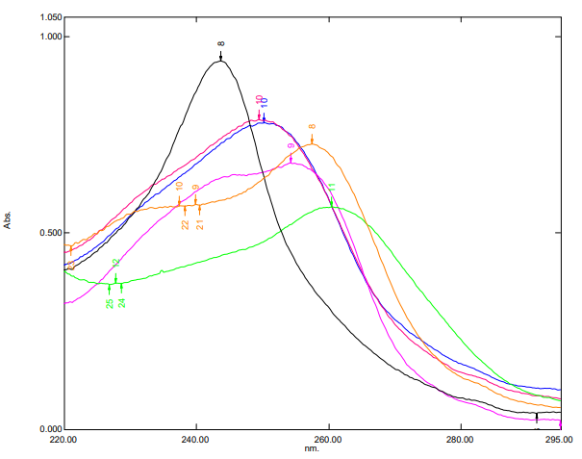
2-(4-((8-Hydroxyquinolin-5-yl)methyl)piperazin-1-yl)-2-phenyl-N-(o-tolyl)acetamide (72)
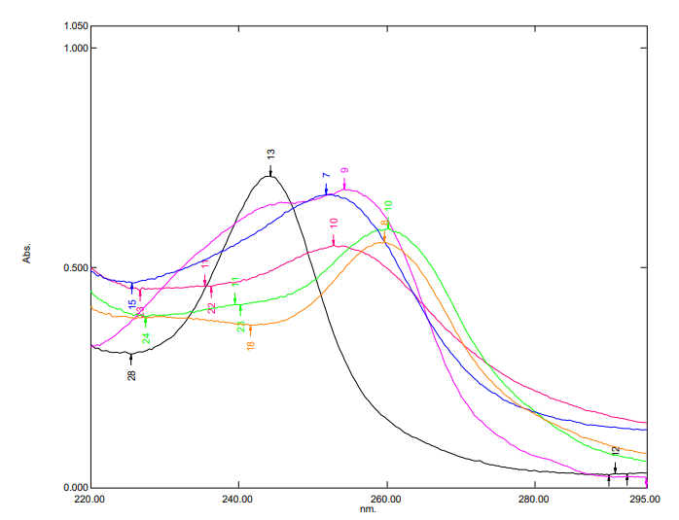
2-(4-((8-Hydroxyquinolin-5-yl)methyl)piperazin-1-yl)-2-phenyl-N-(p-tolyl)acetamide (73)
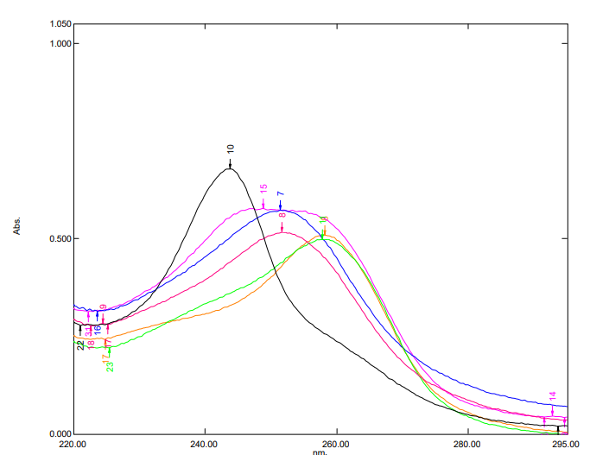
2-(4-((8-Hydroxyquinolin-5-yl)methyl)piperazin-1-yl)-N-(2-methoxyphenyl)-2-phenyl- acetamide (74)
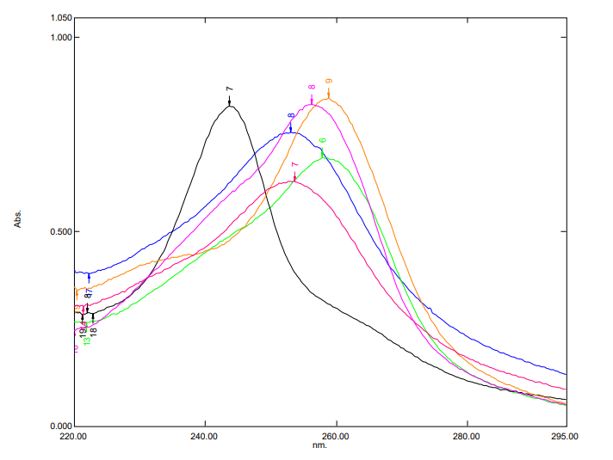
2-(4-((8-Hydroxyquinolin-5-yl)methyl)piperazin-1-yl)-N-(4-methoxyphenyl)-2-phenyl- acetamide (75)
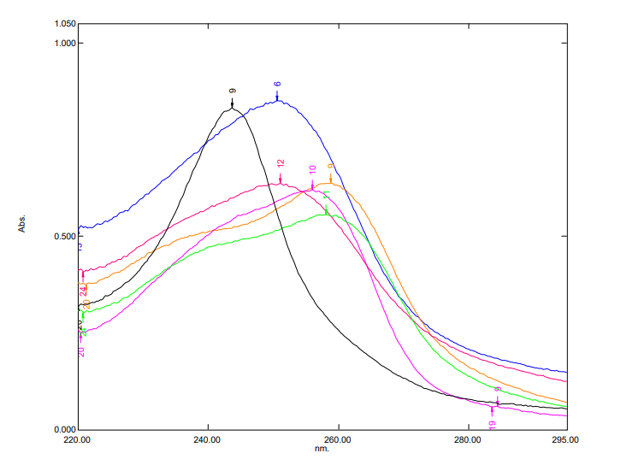
N-(4-Fluorophenyl)-2-(4-((8-hydroxyquinolin-5-yl)methyl)piperazin-1-yl)-2-phenyl- acetamide (76)
N-(4-Chlorophenyl)-2-(4-((8-hydroxyquinolin-5-yl)methyl)piperazin-1-yl)-2-phenyl- acetamide (77)
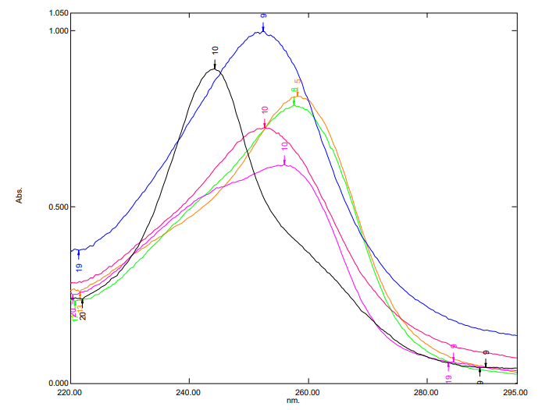
N-(4-Hydroxyphenyl)-2-(4-((8-hydroxyquinolin-5-yl)methyl)piperazin-1-yl)-2-phenyl- acetamide (78)
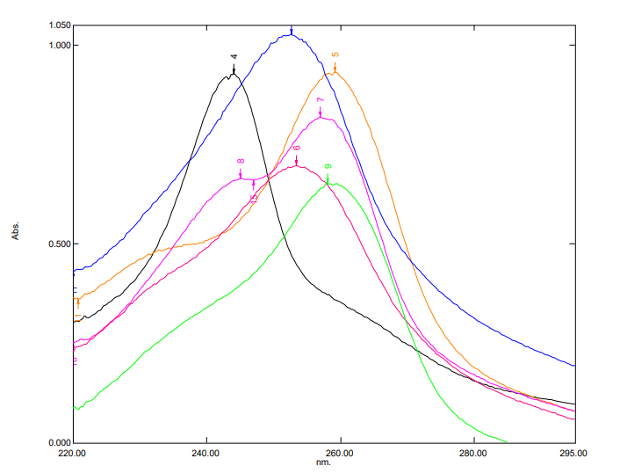
N-Cyclohexyl-2-(4-((8-hydroxyquinolin-5-yl)methyl)piperazin-1-yl)-2-phenylacetamide (79)
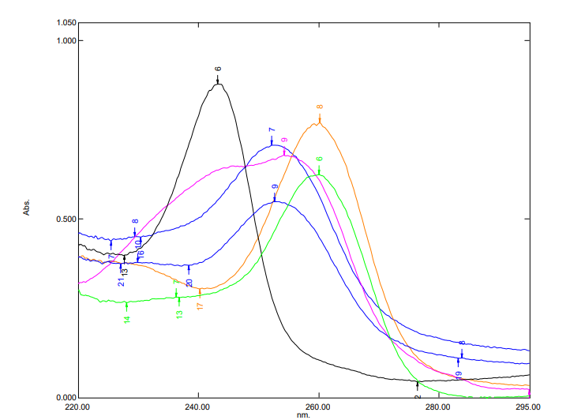
2-(4-Fluorophenyl)-2-(4-((8-hydroxyquinolin-5-yl)methyl)piperazin-1-yl)-N-phenyl- acetamide (80)
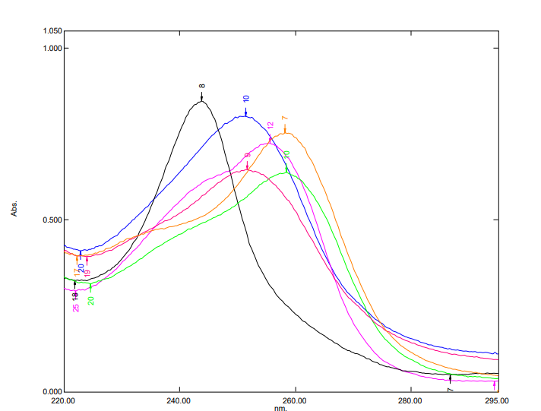
2-(4-Fluorophenyl)-2-(4-((8-hydroxyquinolin-5-yl)methyl)piperazin-1-yl)-N-(o-tolyl)- acetamide (81)
2-(4-Fluorophenyl)-2-(4-((8-hydroxyquinolin-5-yl)methyl)piperazin-1-yl)-N-(o-tolyl)- acetamide (81)
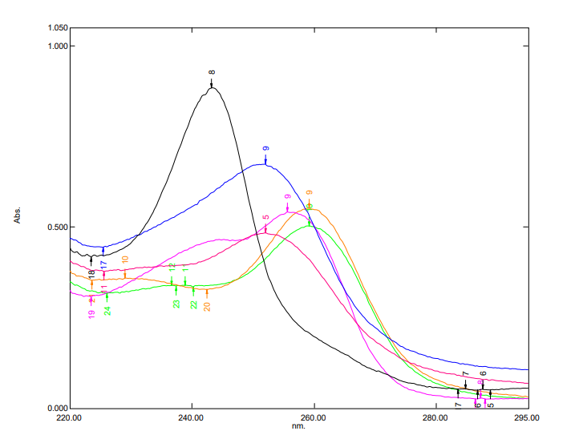
2-(4-Fluorophenyl)-2-(4-((8-hydroxyquinolin-5-yl)methyl)piperazin-1-yl)-N-(p-tolyl)- acetamide (82)
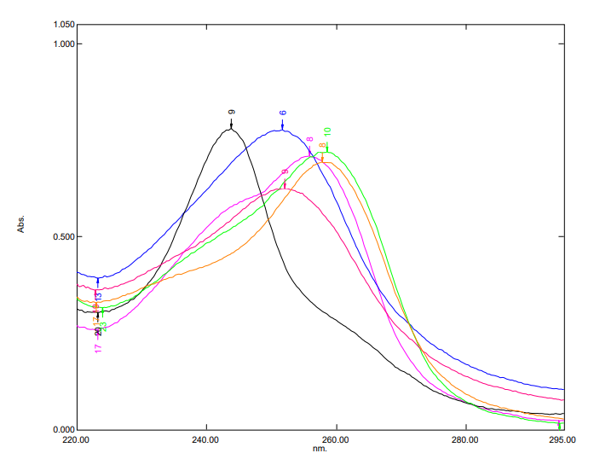
2-(4-Fluorophenyl)-2-(4-((8-hydroxyquinolin-5-yl)methyl)piperazin-1-yl)-N-(2-methoxyphenyl)acetamide (83)
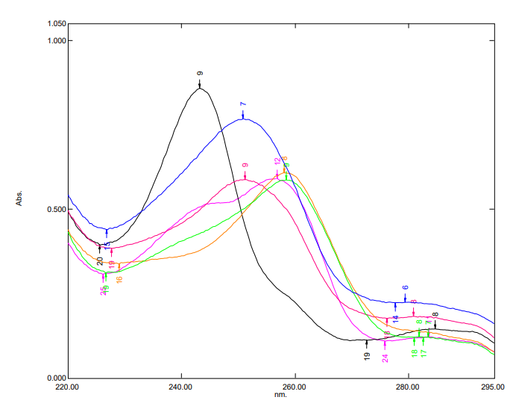
2-(4-Fluorophenyl)-2-(4-((8-hydroxyquinolin-5-yl)methyl)piperazin-1-yl)-N-(4-methoxyphenyl)acetamide (84)
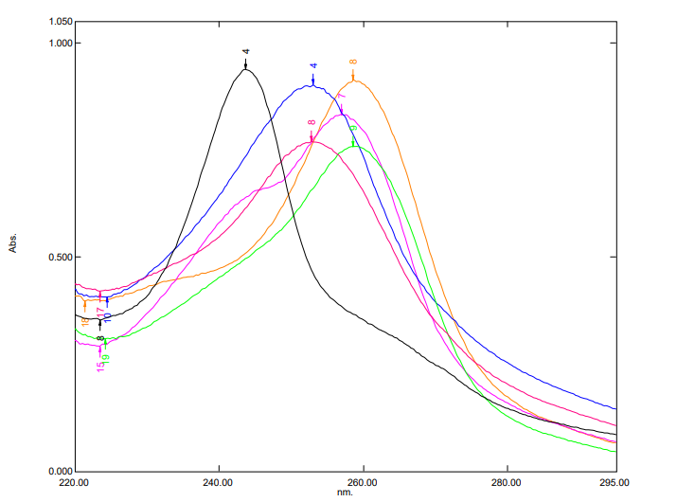
N,2-bis(4-Fluorophenyl)-2-(4-((8-hydroxyquinolin-5-yl)methyl)piperazin-1-yl)- acetamide (85)
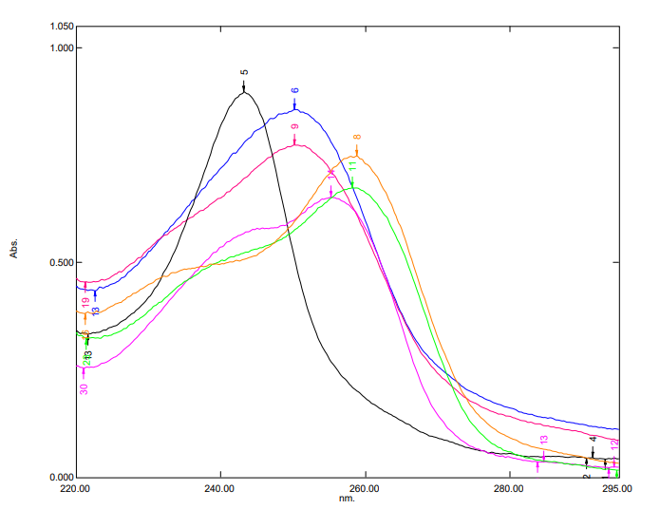
N-(4-Chlorophenyl)-2-(4-fluorophenyl)-2-(4-((8-hydroxyquinolin-5-yl)methyl)- piperazin-1-yl)acetamide (86)
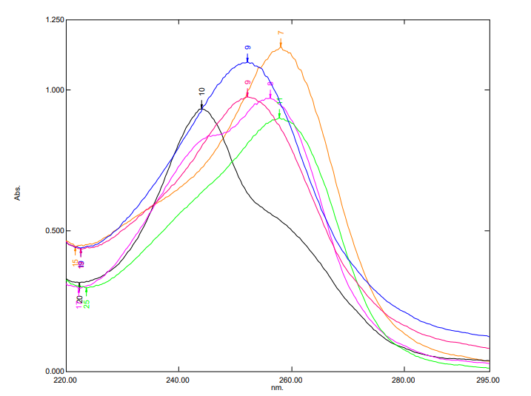
2-(4-Fluorophenyl)-N-(4-hydroxyphenyl)-2-(4-((8-hydroxyquinolin-5-yl)methyl)- piperazin-1-yl)acetamide (87)
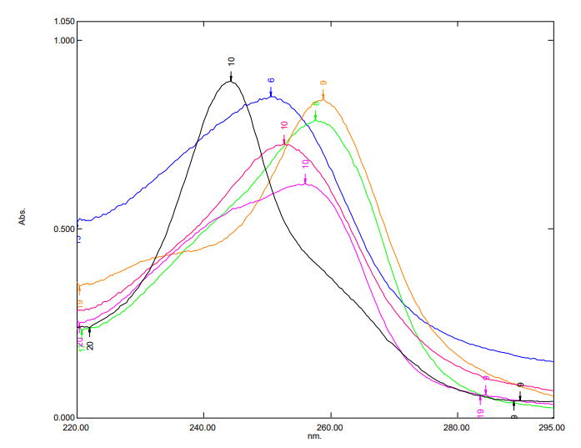
N-Cyclohexyl-2-(4-fluorophenyl)-2-(4-((8-hydroxyquinolin-5-yl)methyl)piperazin-1-yl)acetamide (88)
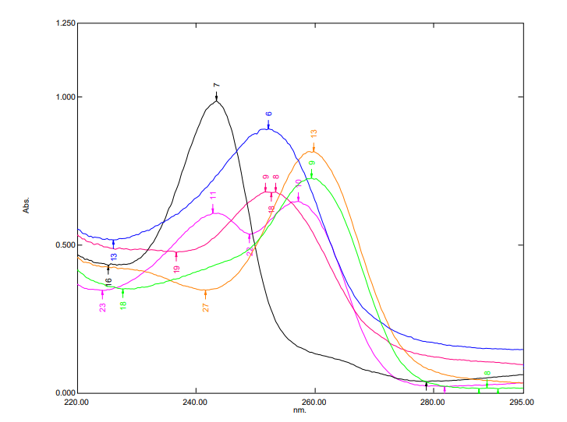
2-(4-((8-Hydroxyquinolin-5-yl)methyl)piperazin-1-yl)-2-(4-methoxyphenyl)-N-phenyl- acetamide (89)
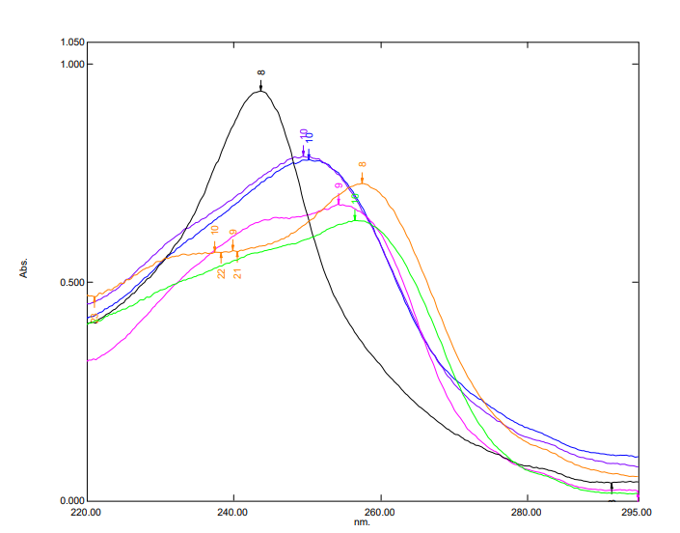
2-(4-((8-Hydroxyquinolin-5-yl)methyl)piperazin-1-yl)-2-(4-methoxyphenyl)-N-(o-tolyl) acetamide (90)
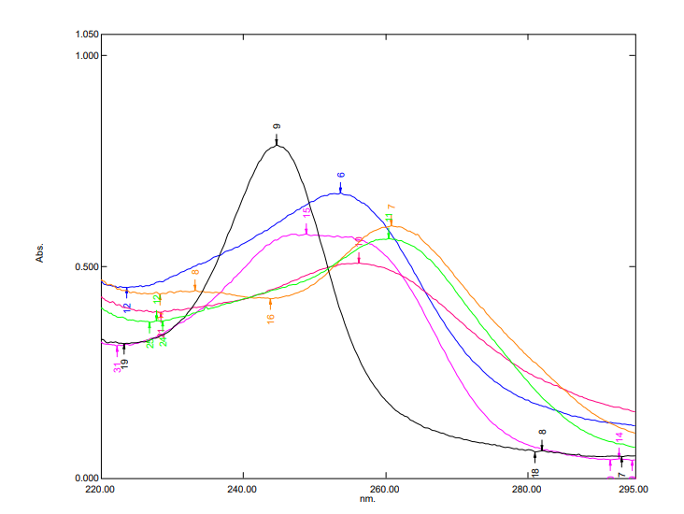
2-(4-((8-Hydroxyquinolin-5-yl)methyl)piperazin-1-yl)-2-(4-methoxyphenyl)-N-(p-tolyl) acetamide (91)
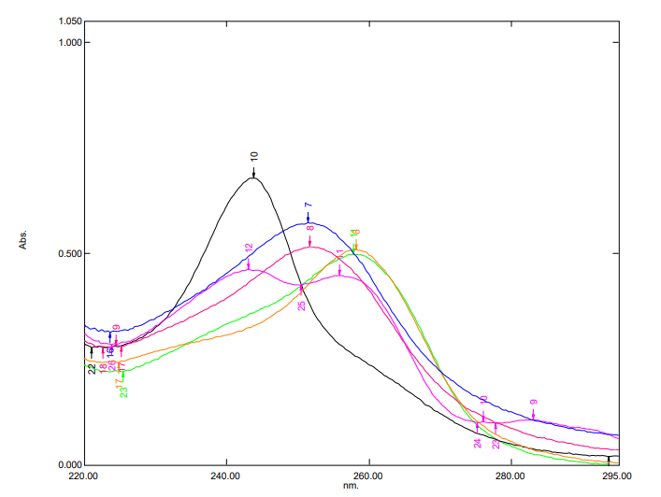
2-(4-((8-Hydroxyquinolin-5-yl)methyl)piperazin-1-yl)-N-(2-methoxyphenyl)-2-(4-methoxyphenyl)acetamide (92)
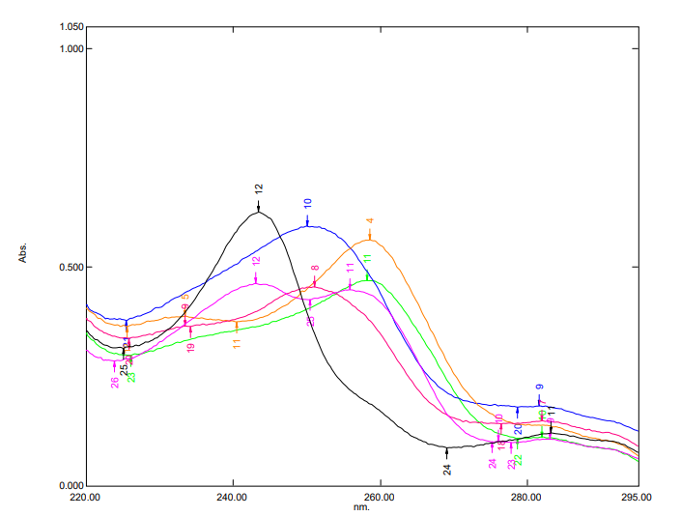
2-(4-((8-Hydroxyquinolin-5-yl)methyl)piperazin-1-yl)-N,2-bis(4-methoxyphenyl)- acetamide (93)
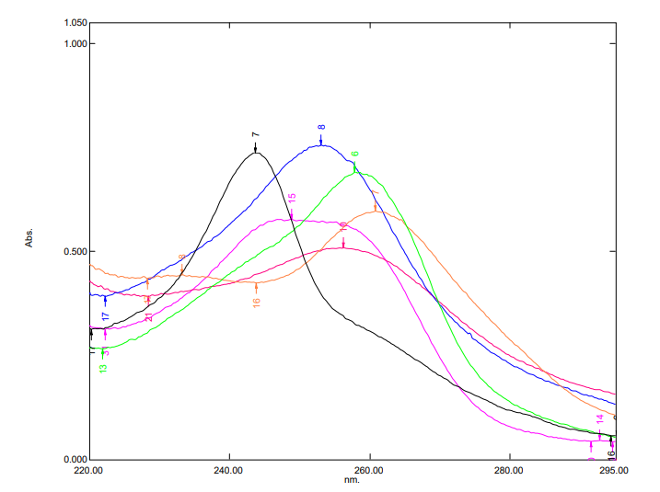
N-(4-Fluorophenyl)-2-(4-((8-hydroxyquinolin-5-yl)methyl)piperazin-1-yl)-2-(4-methoxyphenyl)acetamide (94)
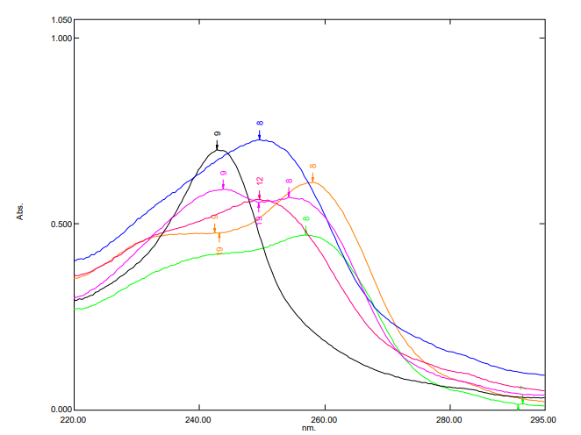
N-(4-Chlorophenyl)-2-(4-((8-hydroxyquinolin-5-yl)methyl)piperazin-1-yl)-2-(4-methoxyphenyl)acetamide (95)
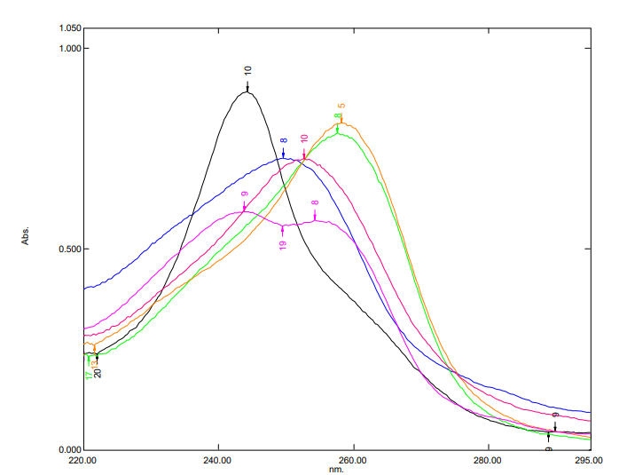
N-(4-Hydroxyphenyl)-2-(4-((8-hydroxyquinolin-5-yl)methyl)piperazin-1-yl)-2-(4-methoxyphenyl)acetamide (96)
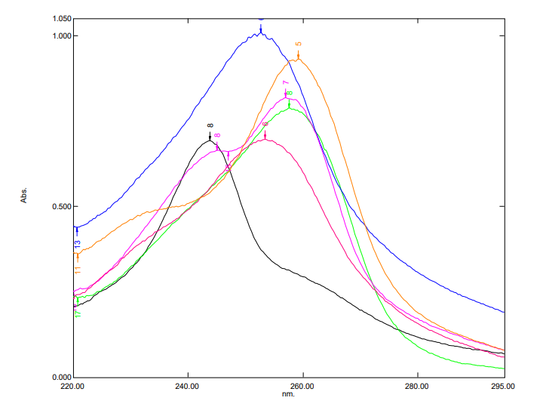
N-(4-Hydroxyphenyl)-2-(4-((8-hydroxyquinolin-5-yl)methyl)piperazin-1-yl)-2-(4-methoxyphenyl)acetamide (97)
