Table-4: Anti-AChE, anti-BuChE and metal chelating potential of the synthesized compounds.
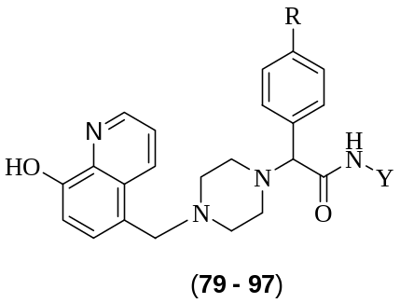
Comp. | R | Y | IC₅₀ Value (µM) |  | Metal Chelating tendency
Comp. | R | Y | hAChE | eqBuChE | Metal Chelating tendency
71 | -H | 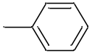 | 144.54 | 5.740 | Yes
72 | -H | 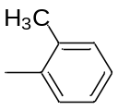 | 78.64 | 6.762 | Yes
73 | -H | 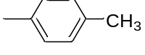 | 96.24 | 7.965 | Yes
74 | -H | 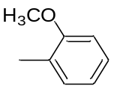 | 69.51 | 3.732 | Yes
75 | -H | 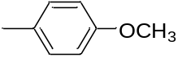 | 133.1 | 12.39 | Yes
76 | -H | 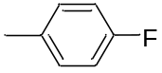 | 58.32 | 7.915 | Yes
77 | -H | 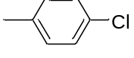 | 290 | 5.182 | Yes
78 | -H | 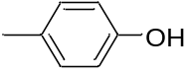 | 30.92 | 12.42 | Yes
79 | -H | 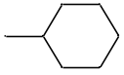 | 214.46 | 2.288 | Yes
80 | -F |  | 134.9 | 8.170 | Yes
81 | -F |  | 8.056 | 6.868 | Yes
82 | -F |  | 21.85 | 9.876 | Yes
83 | -F |  | 14.09 | 1.888 | Yes
84 | -F |  | 76.97 | 3.514 | Yes
85 | -F |  | 57.21 | 6.974 | Yes
86 | -F |  | 64.32 | 2.02 | Yes
87 | -F |  | 68.07 | 9.326 | Yes
88 | -F |  | 382.1 | 6.509 | Yes
89 | -OCH₃ |  | 25.58 | 5.940 | Yes
90 | -OCH₃ |  | 58.97 | 4.365 | Yes
91 | -OCH₃ |  | 132.2 | 10.95 | Yes
92 | -OCH₃ |  | 54.23 | 2.217 | Yes
93 | -OCH₃ |  | 76.43 | 4.953 | Yes
94 | -OCH₃ |  | 45.27 | 4.433 | Yes
95 | -OCH₃ |  | 3.013 | 3.144 | Yes
96 | -OCH₃ |  | 41.65 | 5.720 | Yes
97 | -OCH₃ |  | 146.3 | 8.368 | Yes
Donepezil |  |  | 0.054 | ND | ND
Tacrine |  |  | ND | 0.0047 | ND
ND = Not determined

