Journal name: Discover Nano
Supplementary Information

A novel transdermal drug delivery system: drug loaded ROS responsive ferrocene fibers for effective photoprotective and wound healing activity
Sangwoo Kim ^{a,b}, Yoon Kim ^{c}, Chaehyun Kim ^{a,d}, Won Il Choi ª, Byoung Soo Kim ª, Jinkee Hong ^{b}, Hoik Lee ^{c,*}, and Daekyung Sung ^{a,*}

ªCenter for Bio-Healthcare Materials, Bio-Convergence Materials R&D Division, Korea Institute of Ceramic Engineering and Technology, 202 Osongsaengmyeong 1-ro, Osong-eup, Heungdeok-gu, Cheongju,
^{b}Department of Chemical and Biomolecular Engineering, Yonsei University, 50 Yonsei-ro, Seodaemun-gu, Seoul 03722, Republic of Korea
^{c}Korea Institute of Industrial Technology (KITECH), 143 Hanggaulro, Sangnok-gu, Ansan-si, Gyeonggi-do 15588, Republic of Korea
^{d}Department of Applied Bioengineering, Research Institute for Convergence Science, Seoul National University, Seoul 08826, Republic of Korea

* Corresponding authors:
Hoik Lee (hoik@kitech.re.kr)
Daekyung Sung (dksung@kicet.re.kr)

S.K. and Y.K. contributed equally to this work.

1. Supplementary Figures and Tables

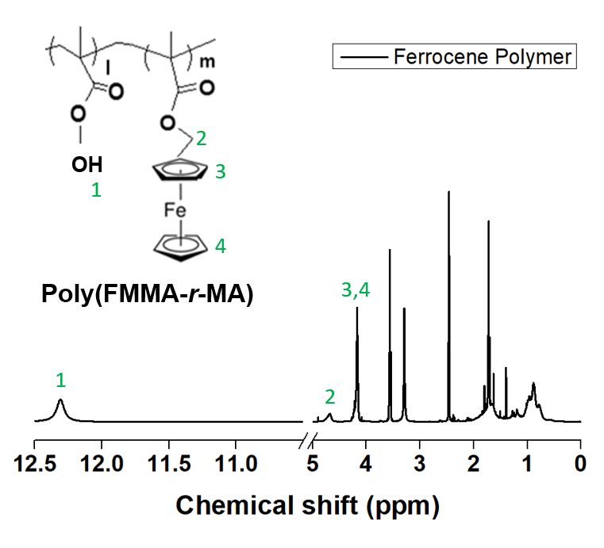
Figure S1. ¹H-NMR spectra of the synthesized ferrocene polymers with chemical structures and peak assignments. The proton chemical shifts are expressed in parts per million (ppm) as follows: δ = (1) 12.4 (br, 1H, COOH of MA), (2) 4.8 (br, 2H, CO₂-CH₂ of FMMA), (3,4) 4.4–4.1 (br, 9H of FMMA), 2.5 (DMSO‑d6), 2.0–1.7 (br, 15H), and 1.1–0.8 (br, 17H).

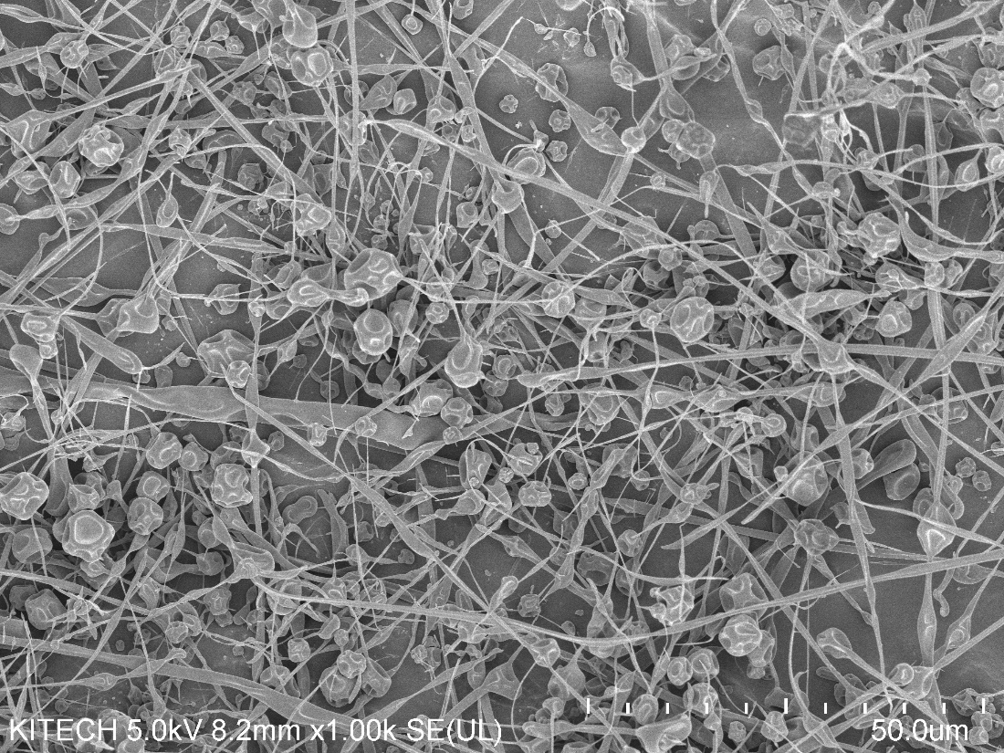
50 μm
Figure S2. Scanning electron microscopy image of the electrospun fiber with 43 w/v% of poly(FMMA-r-MA).

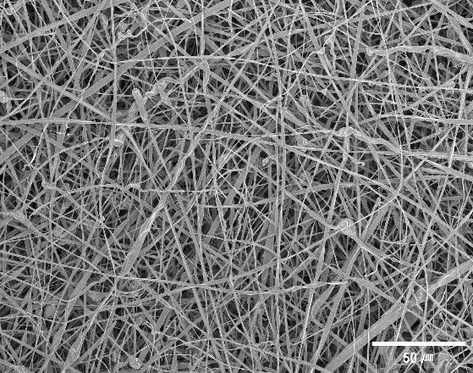
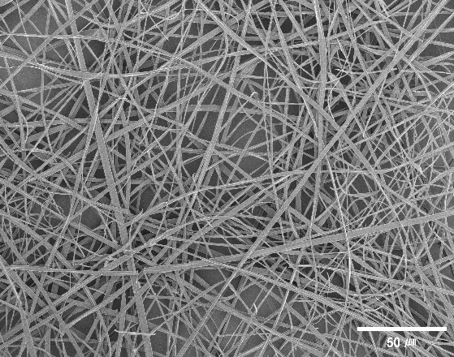
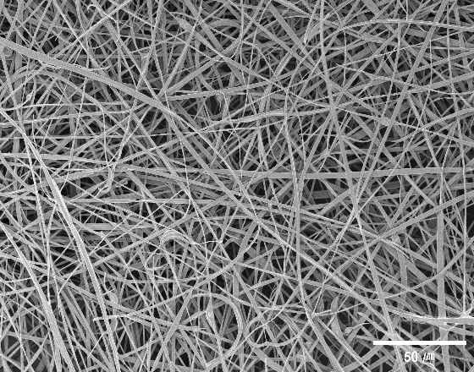
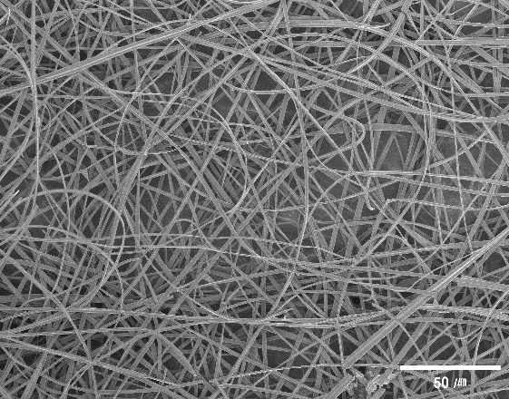
Figure S3. Scanning electron microscopy images of the electrospun fibers with (a) 0 wt%, (b) 20 wt%, (c) 45 wt%, and (d) 70 wt% AT relative to the poly(FMMA-r-MA) content.
(a)
(b)
(c)
(d)

Name | Monomer feed (mol%) |  | Polymer feed (mol%) |  | Conversion  (%) | M_{n}  (g/mol) | M_{w}  (g/mol) | D_{m}
Name | FMMA | MA | FMMA | MA | 99.77 | 3,217 | 5,150 | 1.601
Ferrocene polymer | 16.7 | 83.3 | 16.0 | 84.0

Table S1. Monomer feed and ferrocene polymer compositions along with average molecular weight and polydispersity index of the synthesized ferrocene polymers

