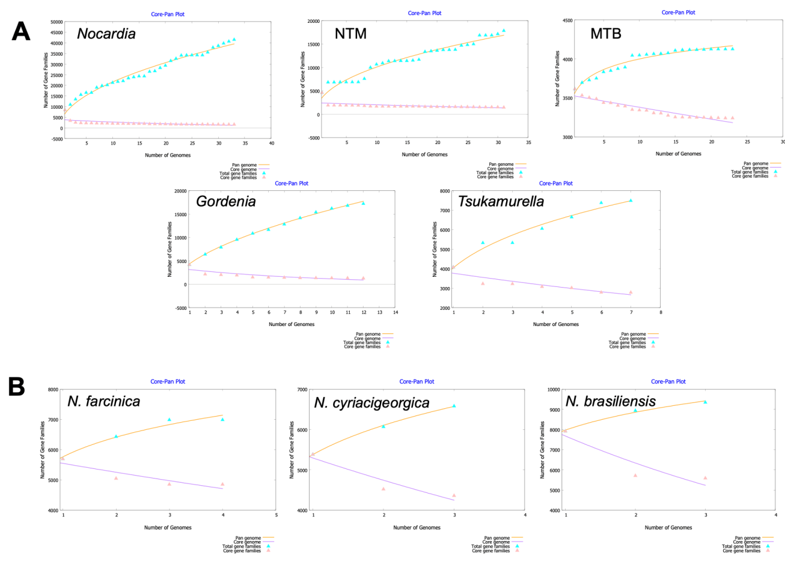
Figure. S1 Gene accumulation curves for the pan-genome. A. Gene accumulation curves of the pan-genome (orange) and core-genome (purple) of Nocardia、NTM、MTB、Gordonia and Tsukamurella. B. Gene accumulation curves of the pan-genome (orange) and core-genome (purple) of N. farcinica、N. cyriacigeorgica and N. brasiliensis.

