Can a Deep-Learning Markerless Motion-Capture System Outperform the Gold Standard Marker-Based System? Concurrent Validity, Test-Reliability, and Usability
—Supplementary Information

Authors
Kyungun Bae 1,3,+
Seyun Lee 2,+
Hyosang Kim 1
Yuncheol Ha 1
SeYoung Bak 1
Seunghyun Yoo *

Affiliations
1 Naver, health care lab, Seongnam, 13561, Republic of Korea
2 NaverCloud, Seongnam, 13561, Republic of Korea
3 Sports Movement Artificial-Intelligence Robotics Technology (SMART) Institute, Department of Physical Therapy,Yonsei University, Wonju, 26493, Republic of Korea
* Corresponding author email: neurorehab@yonsei.ac.kr
+these authors contributed equally to this work

This file includes:
- Further example of the time-series joint angles of the overhead squat from the Ergo and Qualisys.
- Further example of the Bland–Altman plot for assessing the peak joint angles for the Ergo and Qualisys.

1. Further example of the time-series joint angles of the overhead squat from the Ergo and Qualisys.

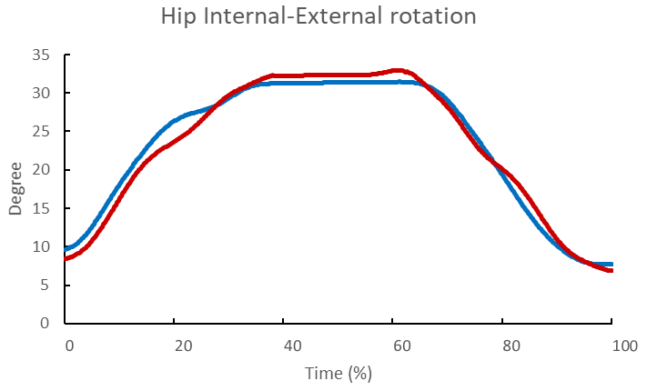
SI Figure1. The time-series joint angles of the overhead squat from the Ergo and Qualisys. Blue lines denote the
data obtained by the Ergo and red lines denote the data obtained by the Qualisys.

2.Further example of the Bland–Altman plot for assessing the peak joint angles for the Ergo and Qualisys.

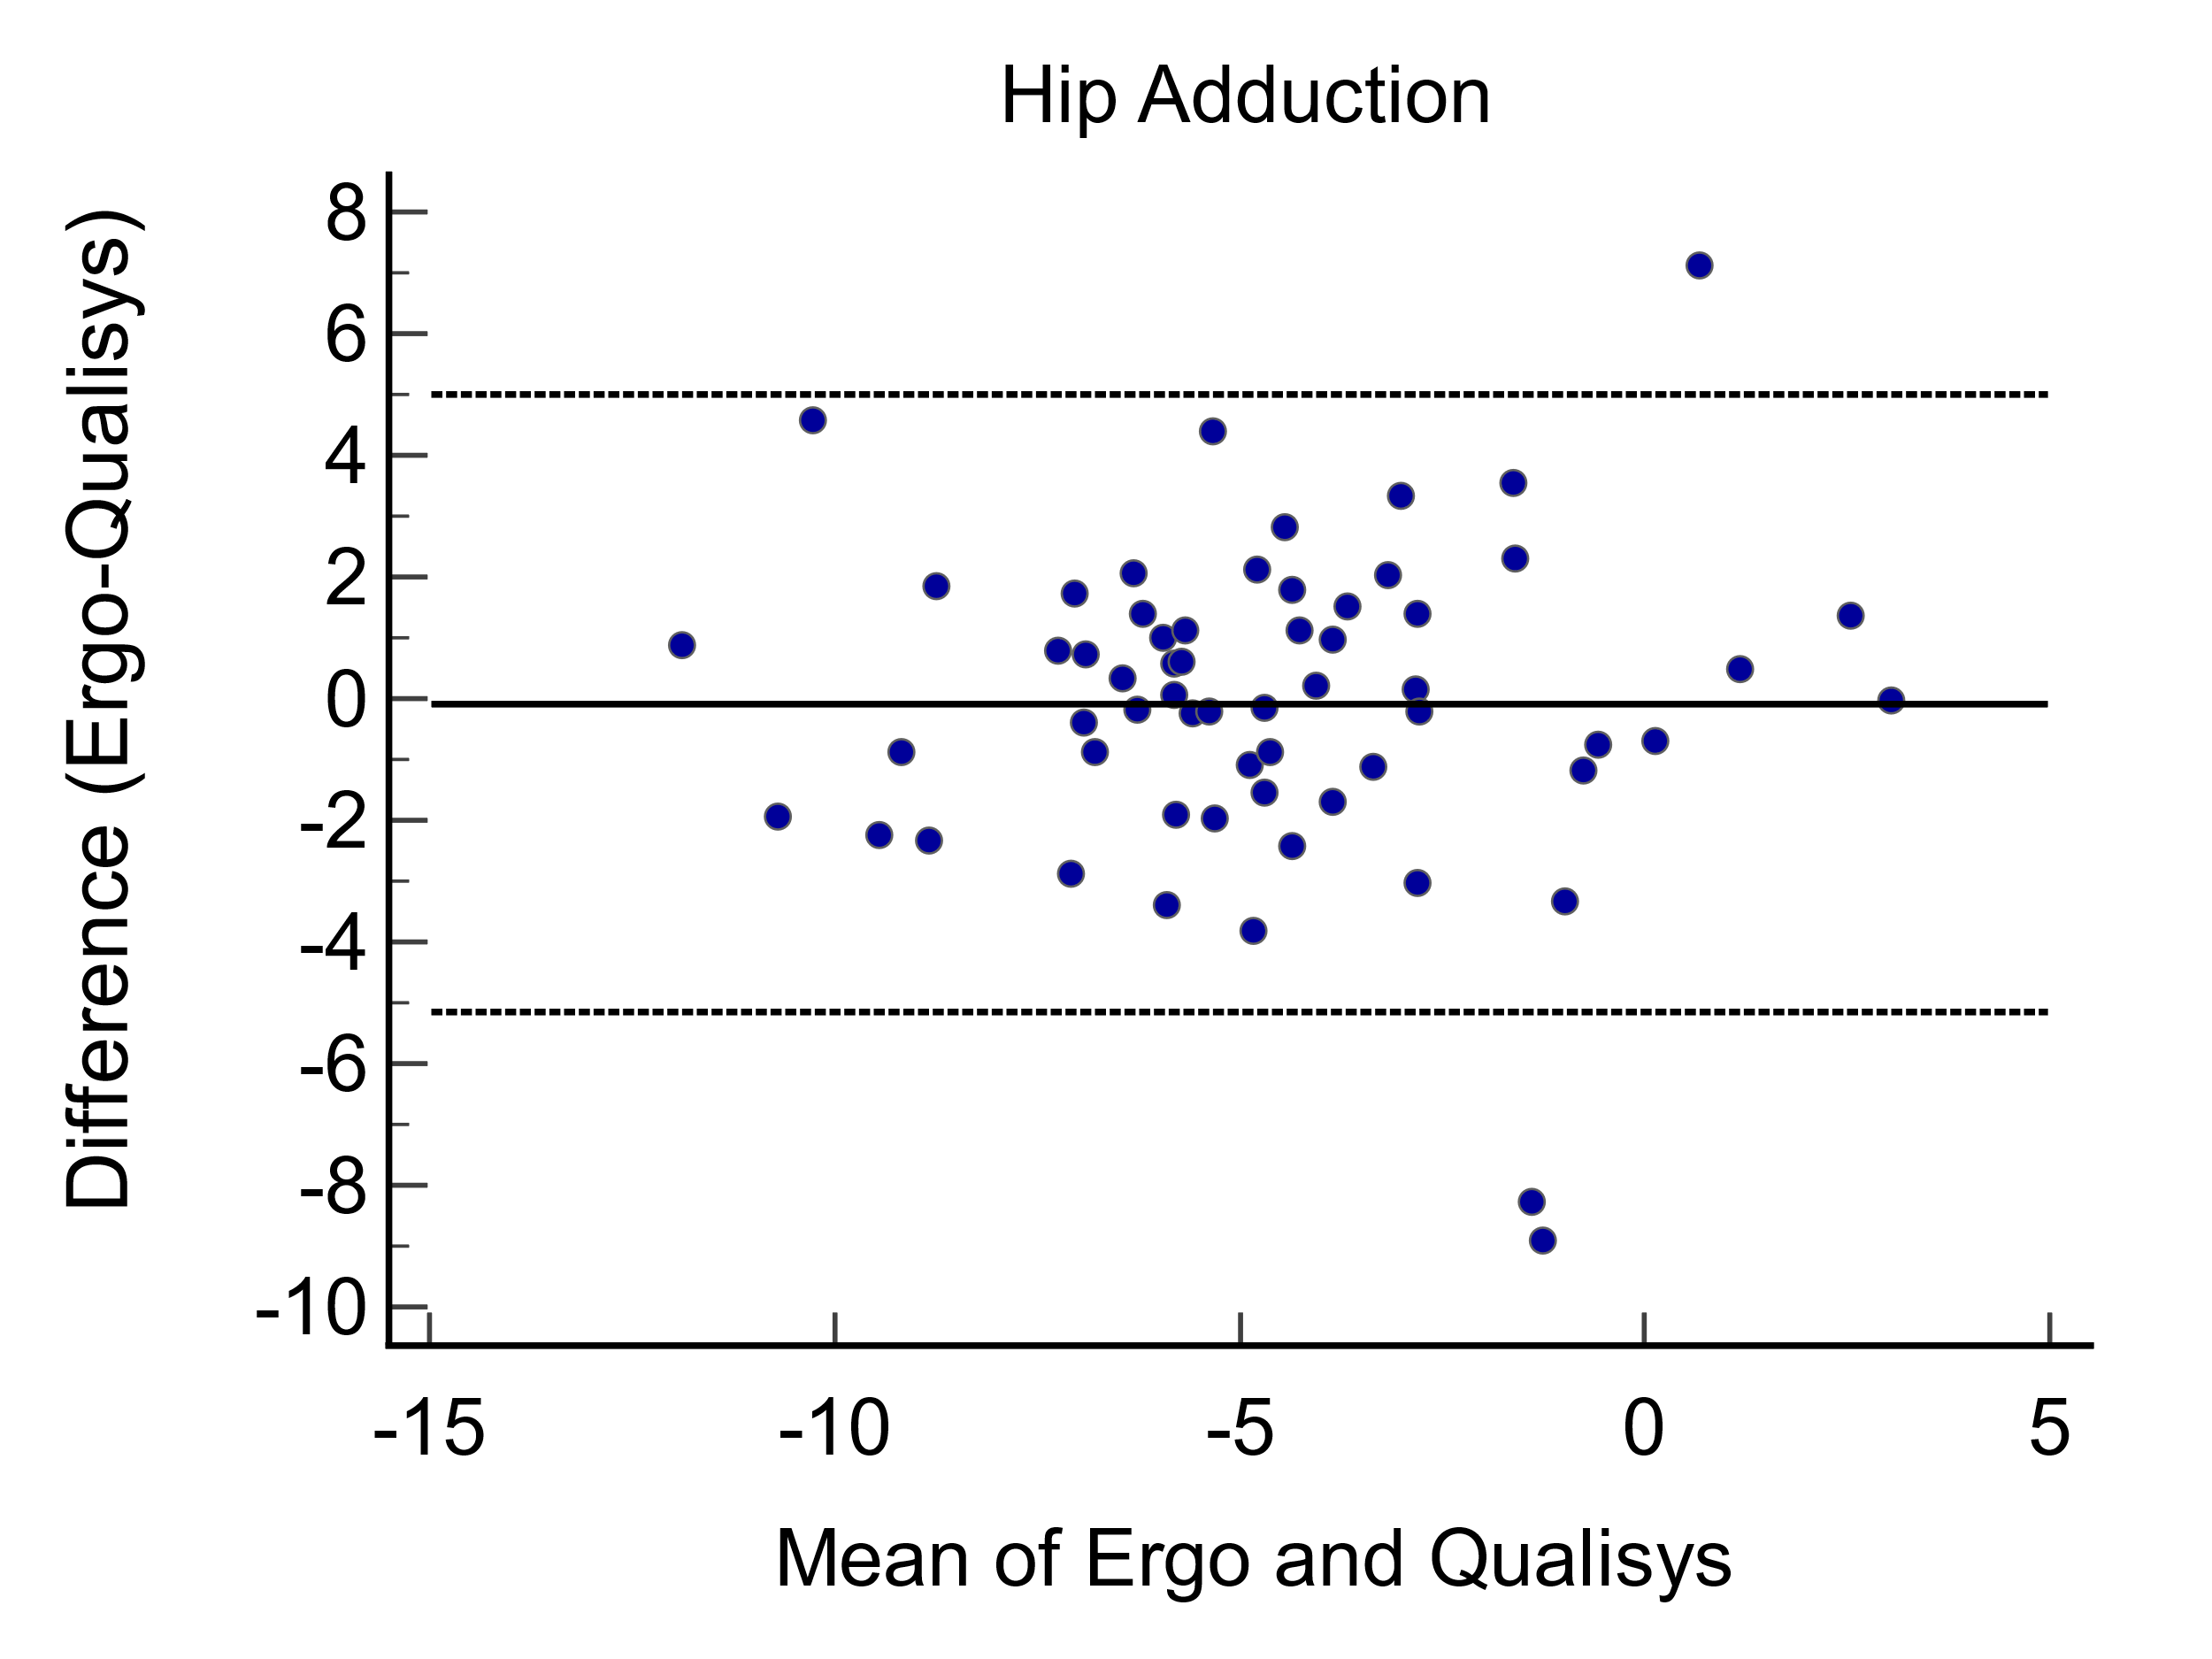
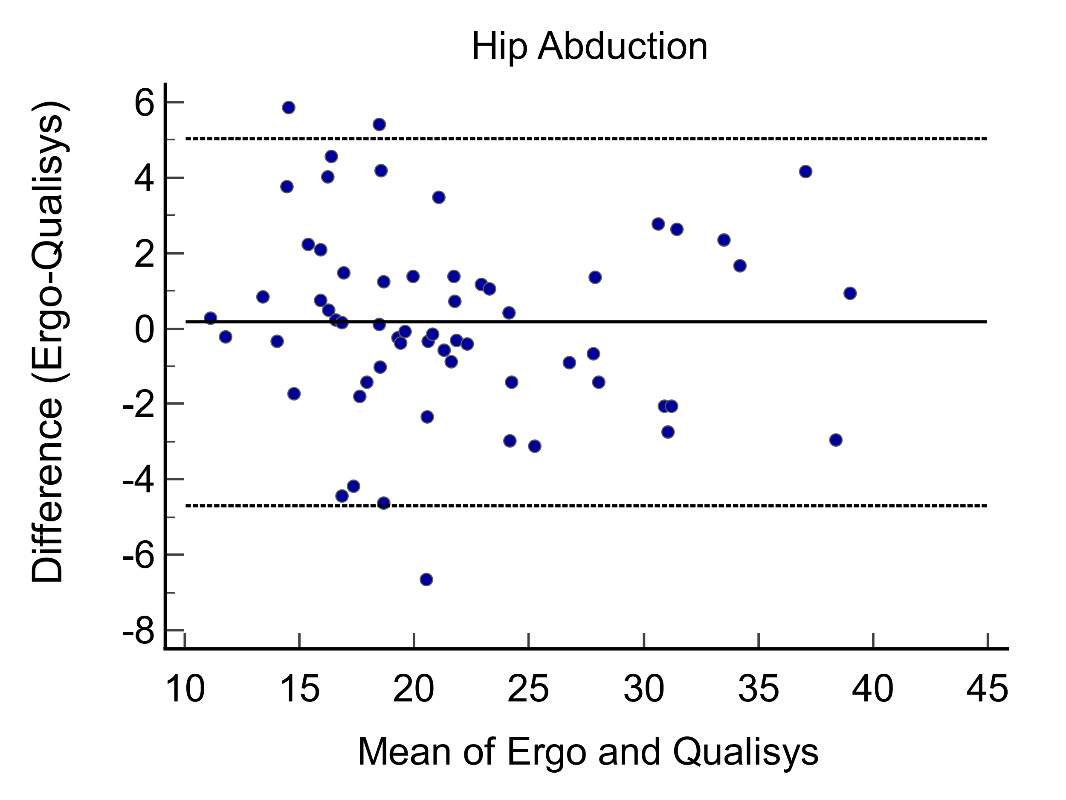
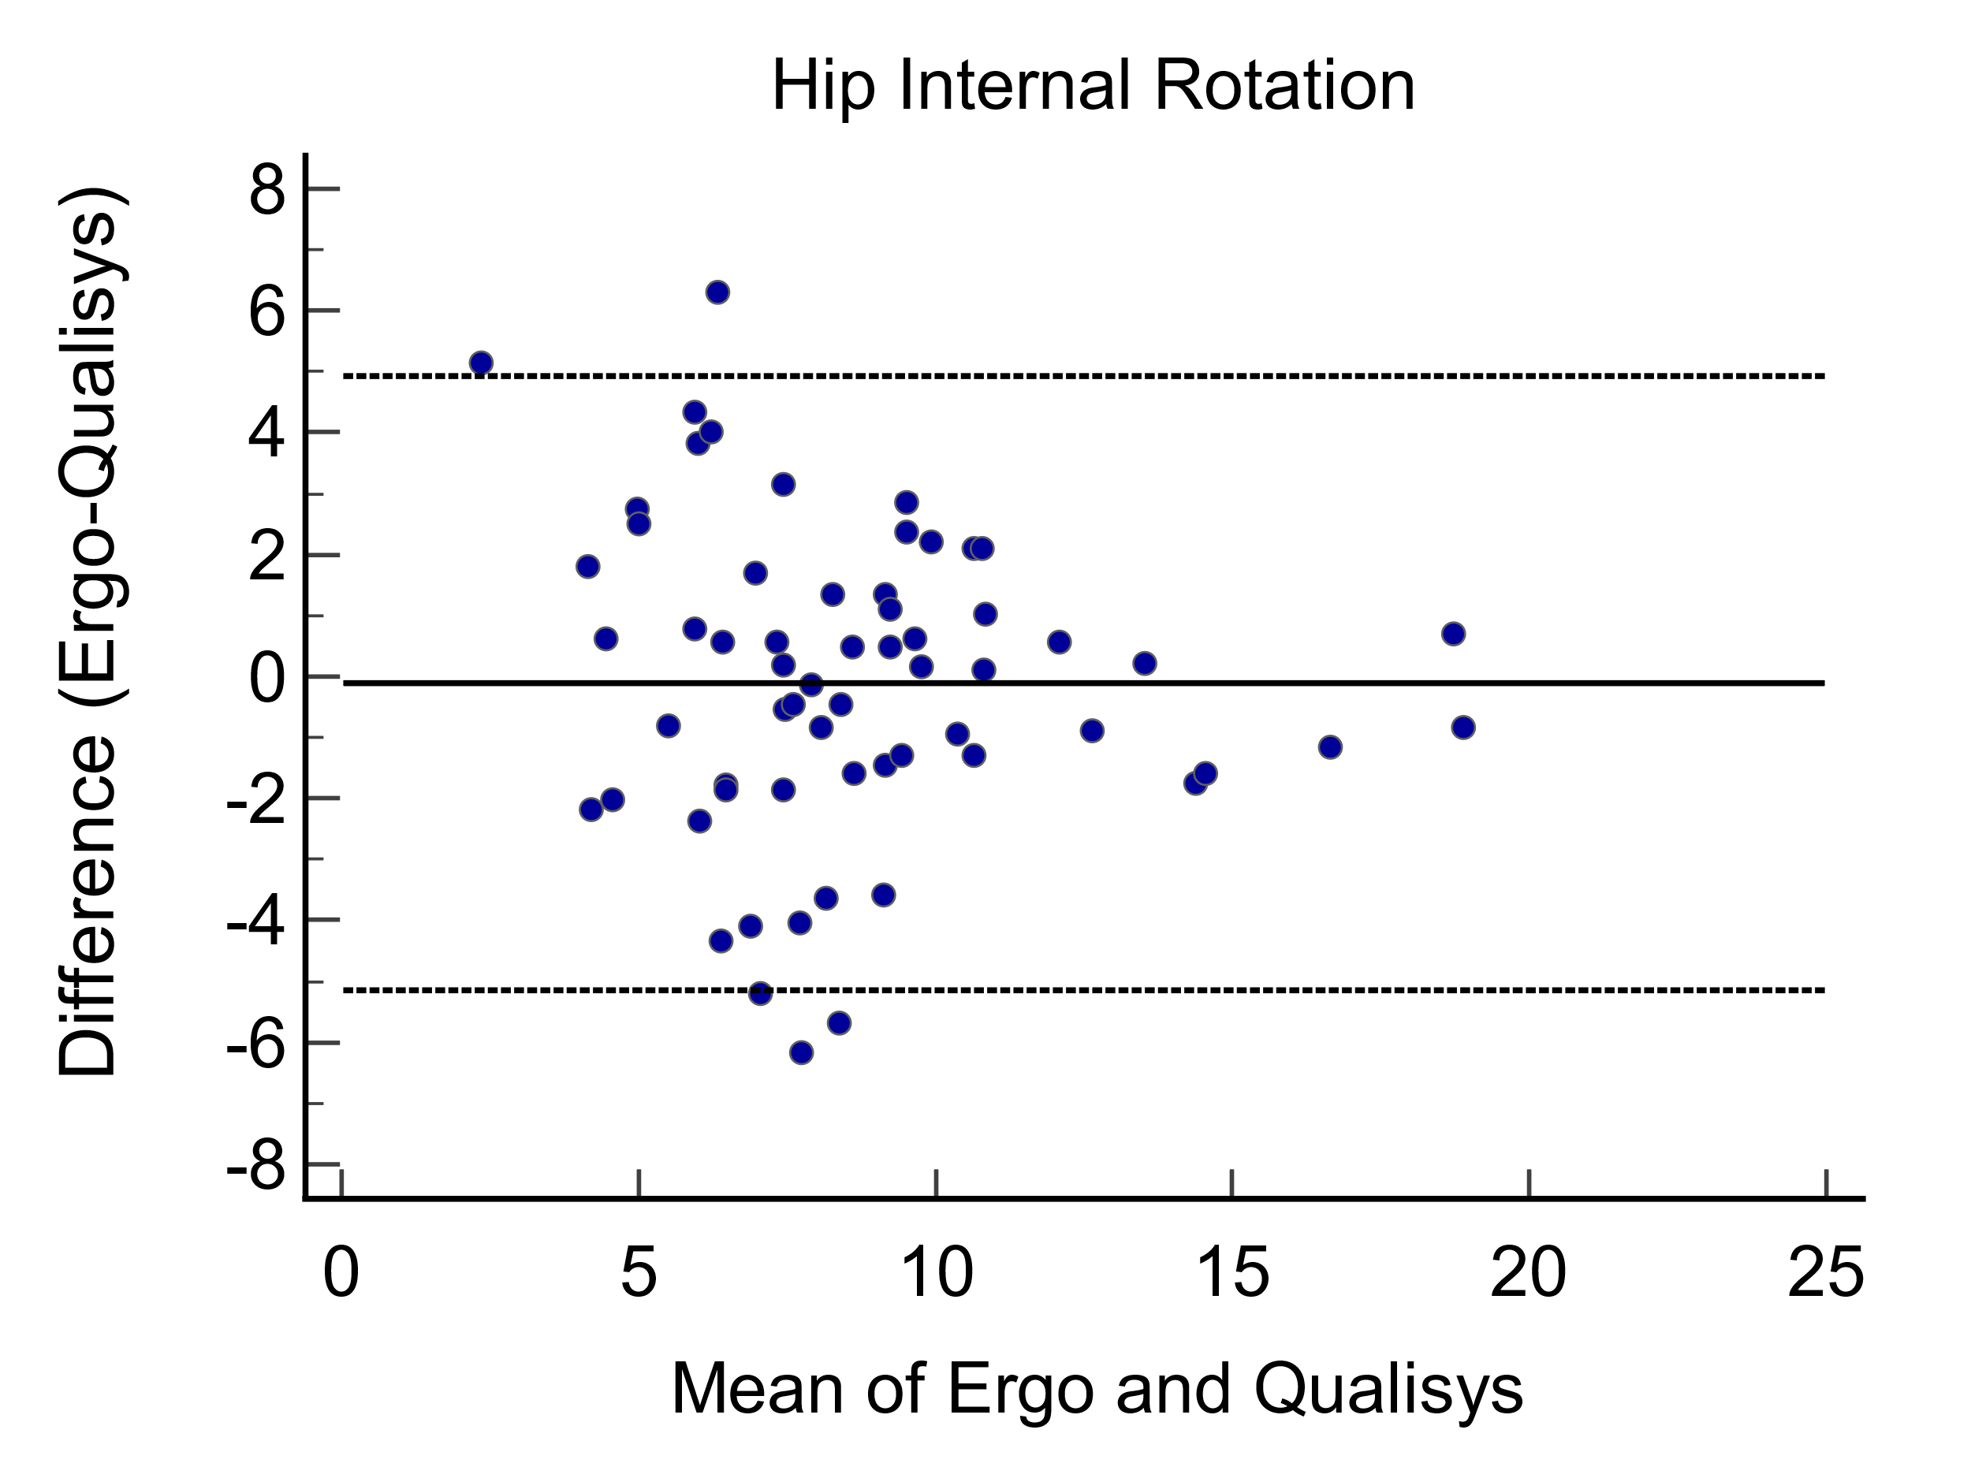
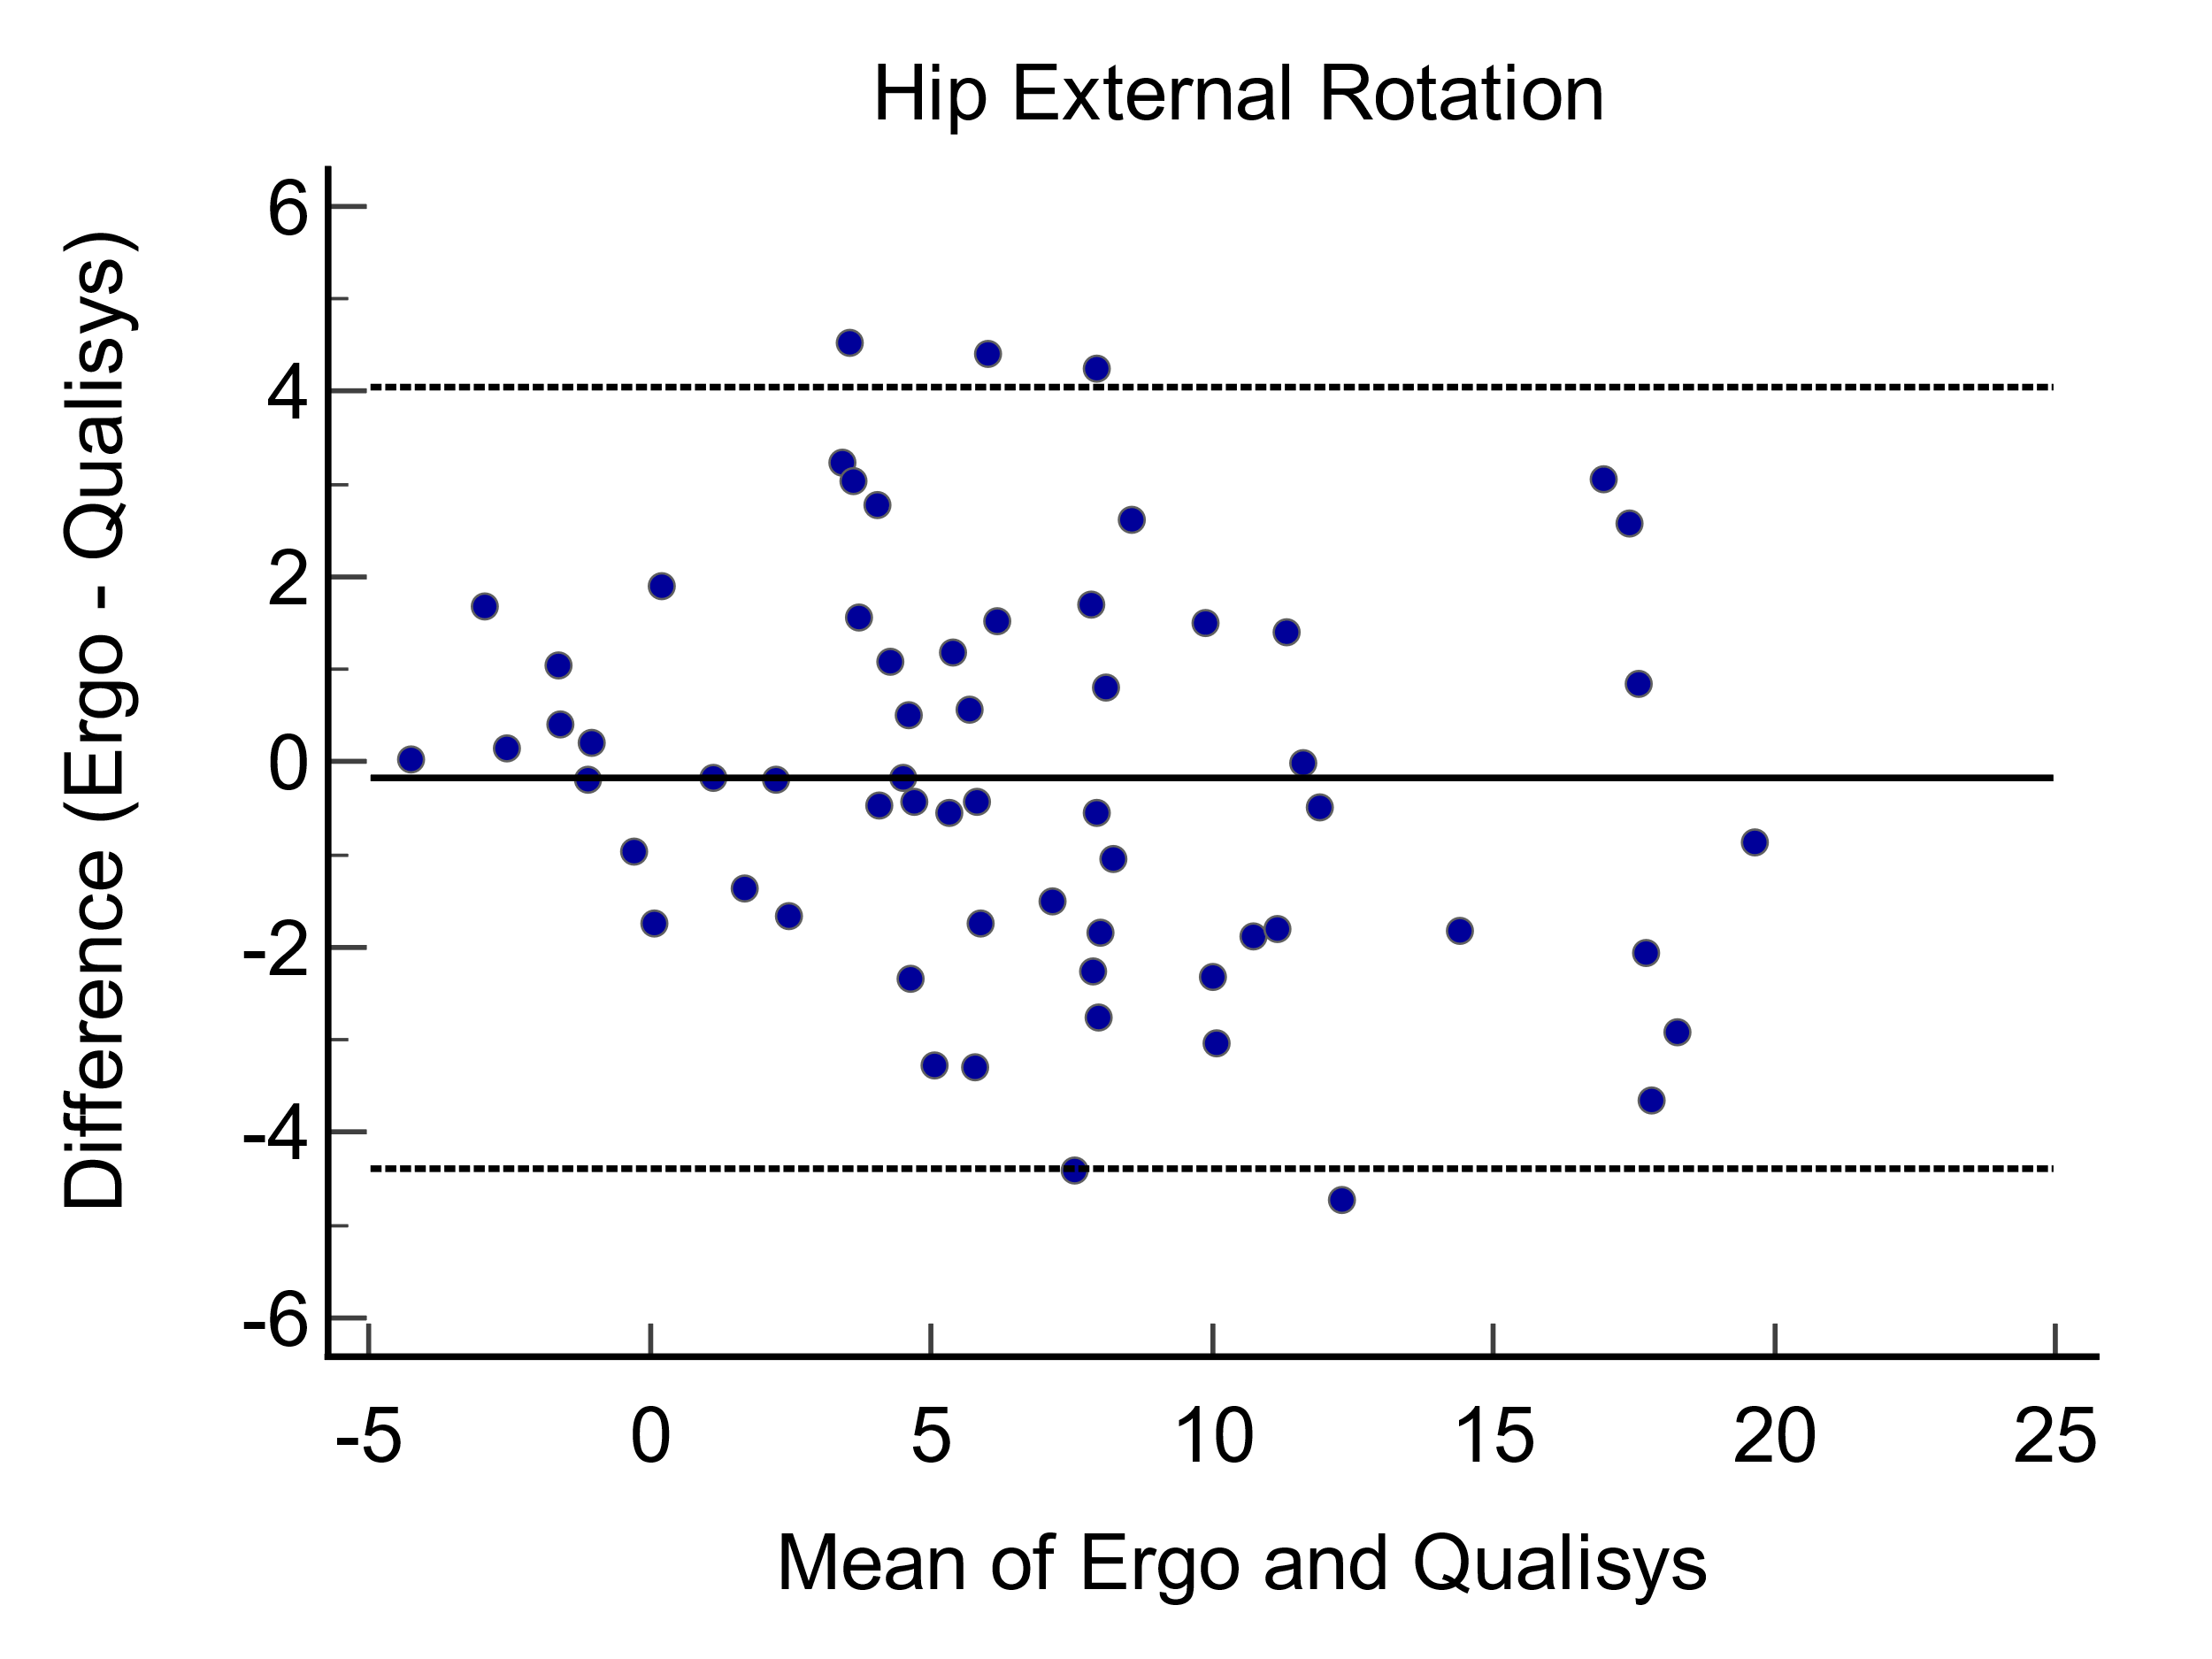

S1 Figure2. Bland–Altman agreement plot of the peak joint angles between the Ergo and the Qualisys measurements. The solid black line represents bias (mean difference) between measurement systems, and the gray dashed lines represent Bland-Altman upper and lower LoA. Means of two system values are plotted on the x-axis and the differences between the Ergo and Qualisys values are plotted on the y-axis.

