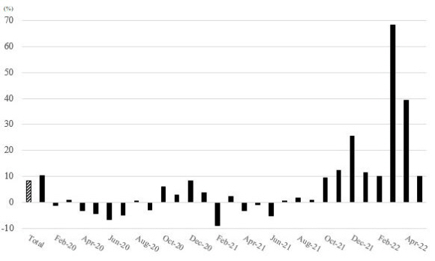Supplemental Table 1. The number of confirmed COVID-19 cases and deaths by age.
Age  Month | 60-69 |  |  | 70-79 |  |  | 80 or above
Age  Month | Confirm | Death | (%) | Confirm | Death | (%) | Confirm | Death | (%)
21-Jan | 2641 | 61 | 2.31 | 1241 | 135 | 10.88 | 903 | 302 | 33.44
21-Feb | 1756 | 17 | 0.97 | 802 | 47 | 5.86 | 451 | 107 | 23.73
21-Mar | 1963 | 15 | 0.76 | 824 | 45 | 5.46 | 376 | 60 | 15.96
21-Apr | 2791 | 15 | 0.54 | 1186 | 38 | 3.2 | 572 | 40 | 6.99
21-May | 2515 | 15 | 0.6 | 985 | 30 | 3.05 | 406 | 77 | 18.97
21-Jun | 1771 | 14 | 0.79 | 515 | 23 | 4.47 | 165 | 18 | 10.91
21-Jul | 2591 | 19 | 0.73 | 714 | 17 | 2.38 | 281 | 27 | 9.61
21-Aug | 4362 | 43 | 0.99 | 1363 | 37 | 2.71 | 630 | 56 | 8.89
21-Sep | 4985 | 47 | 0.94 | 1924 | 41 | 2.13 | 902 | 59 | 6.54
21-Oct | 6119 | 62 | 1.01 | 2748 | 96 | 3.49 | 1747 | 163 | 9.33
21-Nov | 15519 | 108 | 0.7 | 7764 | 201 | 2.59 | 4764 | 435 | 9.13
21-Dec | 33214 | 326 | 0.98 | 13587 | 535 | 3.94 | 6292 | 970 | 15.42
22-Jan | 13277 | 219 | 1.65 | 4744 | 357 | 7.53 | 3552 | 540 | 15.2
22-Feb | 176030 | 125 | 0.07 | 68473 | 281 | 0.41 | 45847 | 820 | 1.79
22-Mar | 998086 | 798 | 0.08 | 461955 | 1761 | 0.38 | 279780 | 5161 | 1.84
22-Apr | 468766 | 713 | 0.15 | 248954 | 1372 | 0.55 | 151168 | 4095 | 2.71
22-May | 91523 | 154 | 0.17 | 49260 | 298 | 0.6 | 29471 | 806 | 2.73
Age  Month | 30-39 |  |  | 40-49 |  |  | 50-59
Age  Month | Confirm | Death | (%) | Confirm | Death | (%) | Confirm | Death | (%)
21-Jan | 2192 | 3 | 0.14 | 2589 | 3 | 0.12 | 3278 | 16 | 0.49
21-Feb | 1737 | 0 | 0.00 | 1642 | 4 | 0.24 | 2021 | 7 | 0.35
21-Mar | 2128 | 1 | 0.05 | 2152 | 0 | 0.00 | 2319 | 5 | 0.22
21-Apr | 2593 | 0 | 0.00 | 3061 | 0 | 0.00 | 3552 | 4 | 0.11
21-May | 2836 | 1 | 0.04 | 3071 | 1 | 0.03 | 3254 | 7 | 0.22
21-Jun | 2780 | 0 | 0.00 | 3086 | 0 | 0.00 | 2938 | 4 | 0.14
21-Jul | 6970 | 2 | 0.03 | 7309 | 2 | 0.03 | 6812 | 8 | 0.12
21-Aug | 8923 | 2 | 0.02 | 8355 | 5 | 0.06 | 8240 | 44 | 0.53
21-Sep | 11266 | 7 | 0.06 | 10159 | 11 | 0.11 | 7223 | 29 | 0.40
21-Oct | 9015 | 6 | 0.07 | 7937 | 12 | 0.15 | 5822 | 27 | 0.46
21-Nov | 10214 | 1 | 0.01 | 9734 | 6 | 0.06 | 10344 | 23 | 0.22
21-Dec | 23263 | 9 | 0.04 | 24427 | 26 | 0.11 | 24357 | 71 | 0.29
22-Jan | 32903 | 9 | 0.03 | 33555 | 20 | 0.06 | 22356 | 45 | 0.20
22-Feb | 349016 | 6 | 0.00 | 369832 | 13 | 0.00 | 257619 | 52 | 0.02
22-Mar | 1463421 | 33 | 0.00 | 1533300 | 93 | 0.01 | 1201458 | 295 | 0.02
22-Apr | 601972 | 16 | 0.00 | 639882 | 83 | 0.01 | 546828 | 260 | 0.05
22-May | 122844 | 9 | 0.01 | 126962 | 36 | 0.03 | 114804 | 68 | 0.06
Age  Month | 0-9 |  |  | 10-19 |  |  | 20-29
Age  Month | Confirm | Death | (%) | Confirm | Death | (%) | Confirm | Death | (%)
21-Jan | 893 | 0 | 0.00 | 1433 | 0 | 0.00 | 2241 | 0 | 0.00
21-Feb | 638 | 0 | 0.00 | 828 | 0 | 0.00 | 1597 | 1 | 0.06
21-Mar | 749 | 0 | 0.00 | 979 | 0 | 0.00 | 1921 | 2 | 0.10
21-Apr | 912 | 0 | 0.00 | 1520 | 0 | 0.00 | 2732 | 0 | 0.00
21-May | 912 | 0 | 0.00 | 1469 | 0 | 0.00 | 2885 | 0 | 0.00
21-Jun | 959 | 0 | 0.00 | 1345 | 0 | 0.00 | 3062 | 0 | 0.00
21-Jul | 2479 | 0 | 0.00 | 4334 | 0 | 0.00 | 9894 | 2 | 0.02
21-Aug | 3422 | 0 | 0.00 | 5543 | 0 | 0.00 | 12238 | 3 | 0.02
21-Sep | 3879 | 0 | 0.00 | 5967 | 0 | 0.00 | 13563 | 2 | 0.01
21-Oct | 4209 | 0 | 0.00 | 6853 | 0 | 0.00 | 8961 | 2 | 0.02
21-Nov | 7210 | 1 | 0.01 | 9529 | 0 | 0.00 | 7452 | 0 | 0.00
21-Dec | 20793 | 2 | 0.01 | 19483 | 0 | 0.00 | 18192 | 0 | 0.00
22-Jan | 25564 | 0 | 0.00 | 35793 | 0 | 0.00 | 43127 | 2 | 0.00
22-Feb | 297734 | 2 | 0.00 | 329831 | 1 | 0.00 | 394365 | 3 | 0.00
22-Mar | 1279469 | 6 | 0.00 | 1352843 | 2 | 0.00 | 1390863 | 23 | 0.00
22-Apr | 448518 | 8 | 0.00 | 481776 | 5 | 0.00 | 554383 | 12 | 0.00
22-May | 74926 | 3 | 0.00 | 108232 | 1 | 0.00 | 147738 | 7 | 0.00
Source of COVID-19 death data: Korean Centers for Disease Control and Prevention (KCDC); CFR, case fatality rate, is the number of COVID-19 deaths divided by the number of confirmed COVID-19 cases during the same period.

Supplemental Table 2. Nationwide monthly mortality data.
 | 2015 | 2016 | 2017 | 2018 | 2019 | 2020 | 2021 | 2022
January | 24,760 | 24,708 | 25,902 | 31,550 | 27,366 | 28,430 | 27,230 | 29,686
February | 23,209 | 24,601 | 22,884 | 25,001 | 22,918 | 25,423 | 23,795 | 29,189
March | 26,493 | 25,208 | 24,230 | 25,252 | 24,985 | 25,850 | 26,550 | 44,487
April | 23,610 | 22,830 | 23,142 | 23,963 | 23,833 | 24,674 | 25,077 | 36,697
May | 22,935 | 23,125 | 23,766 | 23,996 | 24,756 | 24,346 | 25,577 | 28,859
June | 21,345 | 21,350 | 21,986 | 22,596 | 23,056 | 23,638 | 24,398
July | 21,534 | 22,053 | 22,245 | 23,886 | 23,216 | 23,989 | 25,748
August | 21,496 | 22,604 | 22,846 | 23,937 | 23,707 | 25,289 | 25,953
September | 21,375 | 22,081 | 22,622 | 22,906 | 23,570 | 24,352 | 25,674
October | 23,050 | 23,610 | 24,624 | 25,010 | 25,569 | 26,488 | 27,775
November | 22,678 | 23,333 | 24,404 | 24,200 | 25,412 | 25,603 | 28,363
December | 23,410 | 25,324 | 26,883 | 26,523 | 26,722 | 26,866 | 31,634
Source: Korean Statistical Information Service (KOSIS) of Statistics Korea

Supplemental Table 3. The number of patients hospitalized with major diseases according to ICD-10 codes among older age groups and the number of deaths (2015-2021).
Year  Age | 2015 | 2016 | 2017 | 2018 | 2019 | 2020 | 2021
Pneumonia (J12-J18)
60-69 | 18,522 | 21,109 | 20,649 | 22,550 | 22,777 | 14,344 | 9,889
70-79 | 34,166 | 34,227 | 35,190 | 38,884 | 37,523 | 26,256 | 19,359
80- | 39,506 | 42,405 | 48,472 | 56,479 | 57,030 | 44,912 | 37,638
All ages | 379,221 | 428,563 | 361,676 | 374,864 | 419,827 | 244,423 | 164,863
The number of deaths (all ages) | 14,718 | 16,476 | 19,378 | 23,280 | 23,168 | 22,257 | 22,812
Stroke (I63)
60-69 | 18,962 | 20,560 | 20,295 | 21,297 | 21,671 | 22,058 | 22,224
70-79 | 32,929 | 34,409 | 33,308 | 34,251 | 33,377 | 31,606 | 30,405
80- | 26,867 | 30,259 | 32,037 | 34,745 | 36,075 | 36,583 | 36,703
All ages | 95,521 | 103,676 | 103,284 | 107,970 | 108,640 | 107,319 | 105,635
The number of deaths (all ages) | 7,941 | 7,453 | 7,148 | 7,322 | 7,103 | 7,414 | 9,031
Other cerebrovascular disease (I67)
60-69 | 6,726 | 8,993 | 9,211 | 12,263 | 13,490 | 13,458 | 15,192
70-79 | 4,808 | 5,786 | 5,880 | 7,458 | 8,265 | 7,761 | 8,241
80- | 2,334 | 2,200 | 2,643 | 3,170 | 3,604 | 3,283 | 3,200
All ages | 29,019 | 35,419 | 34,872 | 43,299 | 45,691 | 43,026 | 45,447
The number of deaths (all ages) | 577 | 380 | 355 | 468 | 486 | 404 | 503
Acute myocardial infarction (I21)
60-69 | 6,108 | 6,638 | 6,794 | 7,719 | 7,795 | 8,209 | 8,165
70-79 | 6,501 | 6,883 | 6,686 | 7,431 | 7,348 | 7,153 | 6,553
80- | 4,059 | 4,555 | 4,985 | 5,453 | 5,757 | 5,756 | 5,593
All ages | 26,257 | 28,108 | 28,272 | 31,439 | 31,583 | 31,553 | 30,162
The number of deaths (all ages) | 10,439 | 10,171 | 9,594 | 9,819 | 9,677 | 9,927 | 9,693
Intracranial hemorrhage (I61)+other non-traumatic intracranial hemorrhage (I62)
60-69 | 5,326 | 6,031 | 5,887 | 6,351 | 6,248 | 6,297 | 6,351
70-79 | 6,770 | 7,337 | 7,338 | 7,711 | 7,386 | 7,178 | 6,784
80- | 4,297 | 5,144 | 5,436 | 6,025 | 6,337 | 6,616 | 6,630
All ages | 25,397 | 28,466 | 27,623 | 29,563 | 28,972 | 28,494 | 27,450
The number of deaths (all ages) | 5,328 | 5,064 | 5,017 | 5,003 | 5,024 | 5,109 | 5,629
Sepsis (A40-A41)
60-69 | 2,559 | 2,737 | 2,722 | 3,030 | 3,135 | 3,928 | 4,316
70-79 | 7,124 | 7,371 | 7,681 | 8,223 | 8,824 | 10,205 | 10,489
80- | 10,083 | 11,422 | 13,770 | 16,160 | 18,145 | 23,086 | 25,471
All ages | 26,960 | 28,617 | 29,970 | 33,061 | 35,112 | 41,164 | 43,983
The number of deaths (all ages) | 3,045 | 3,596 | 3,994 | 4,665 | 4,903 | 6,086 | 6,429
Heart failure (I50)
60-69 | 2,498 | 2,793 | 2,730 | 3,240 | 3,355 | 3,145 | 3,307
70-79 | 6,786 | 7,394 | 7,529 | 8,413 | 8,435 | 7,677 | 7,237
80- | 9,758 | 11,326 | 12,369 | 14,522 | 15,496 | 15,293 | 15,295
All ages | 21,181 | 23,917 | 25,052 | 29,110 | 30,102 | 28,851 | 28,814
The number of deaths (all ages) | 4,587 | 5,094 | 5,887 | 6,755 | 6,758 | 7,256 | 8,177
ICD-10; International Classification of Diseases 10th Revision.
Data source: Health Insurance Review and Assessment (HIRA) service, Korean Statistical Information Service (KOSIS) of Statistics

Supplemental Figure Legends

Supplemental Figure 1. P-score by month (2020.01-2022.05)

Supplemental Figure 2. COVID-19 case fatality rate in Republic of Korea (the number of confirmed deaths divided by the number of confirmed cases)
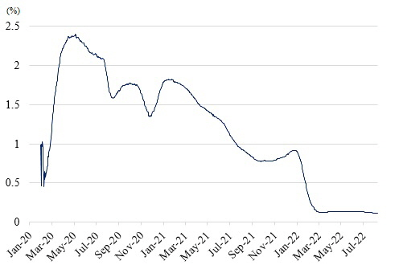

Supplemental Figure 3. P-score comparison between other countries and Republic of Korea.
7a, P-score of ‘Our world in data’ and this study; 7b, P-score of United States of America and Korea; 7c, P-score of United Kingdom and Korea; 7d, P-score of New Zealand and Korea; 7e, P-score of Japan and Korea.
Source of data (USA, UK, New Zealand, and Japan): Our world in data.
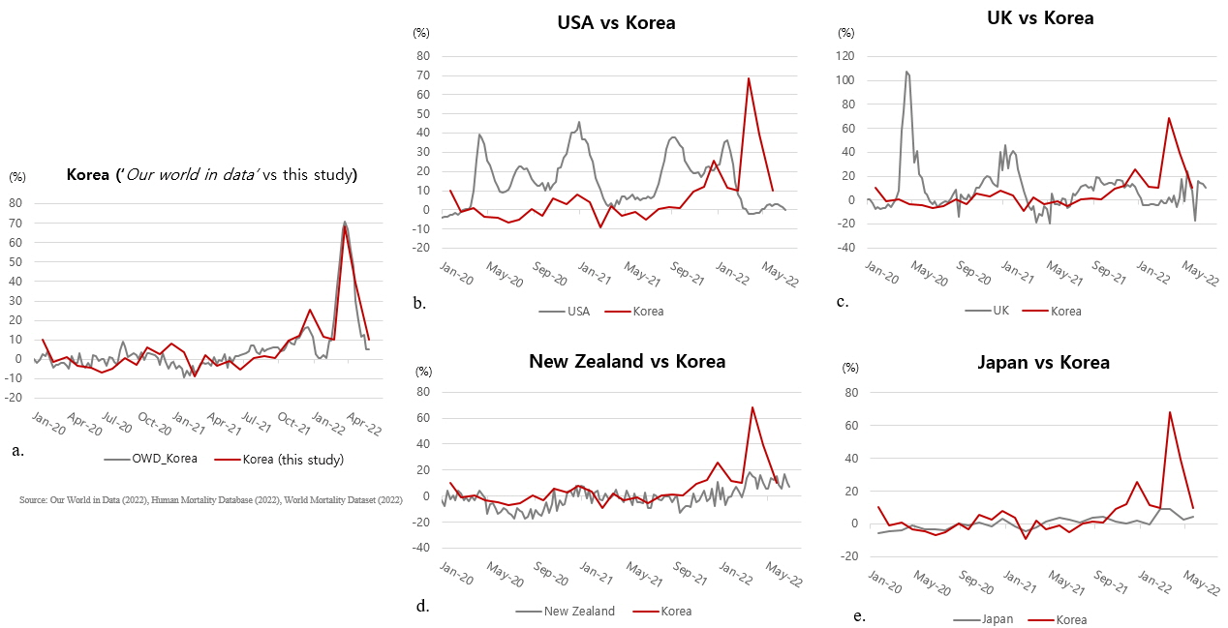
Supplemental Figure 4. Daily excess deaths between other countries and Republic of Korea.
8a, Comparison of daily excess deaths in Korea between ‘The Economist’ data and this study with P-score; 8b, Daily excess deaths of United States of America and Korea; 8c, Daily excess deaths of United Kingdom and Korea; 8d, Daily excess deaths of New Zealand and Korea; 8e, Daily excess deaths of Japan and Korea. Source of data (USA, UK, New Zealand, and Japan): Our world in data (2022), The Economist (2022), Johns Hopkins University (2022)
