Supplementary Figure
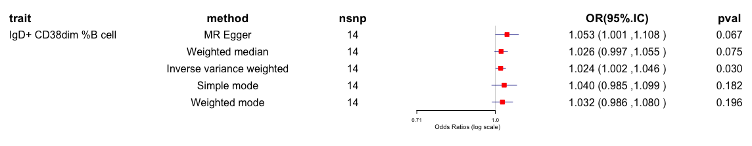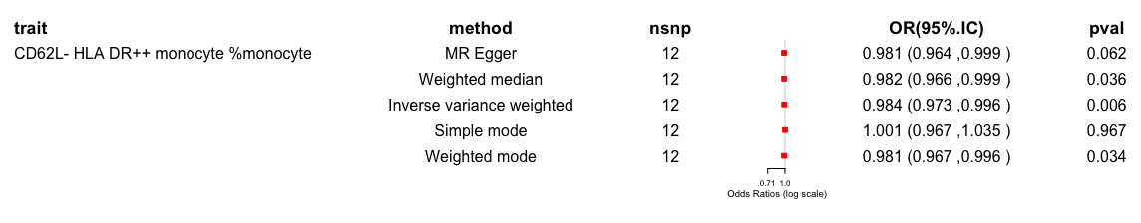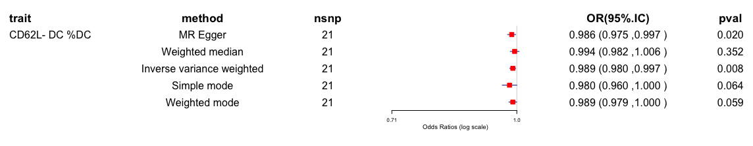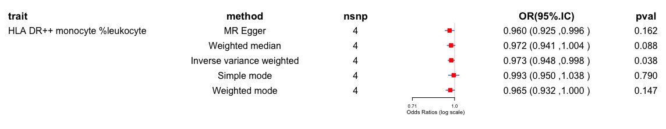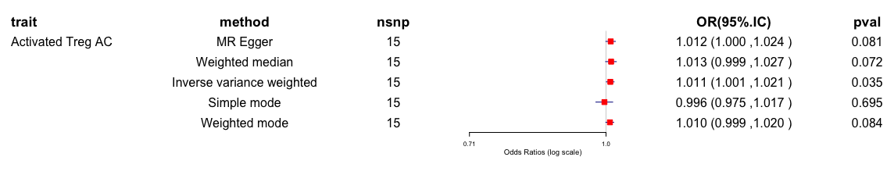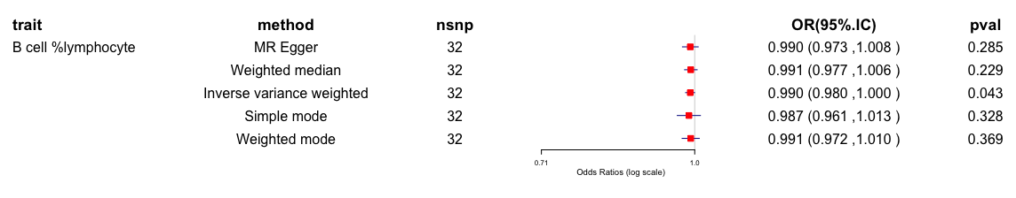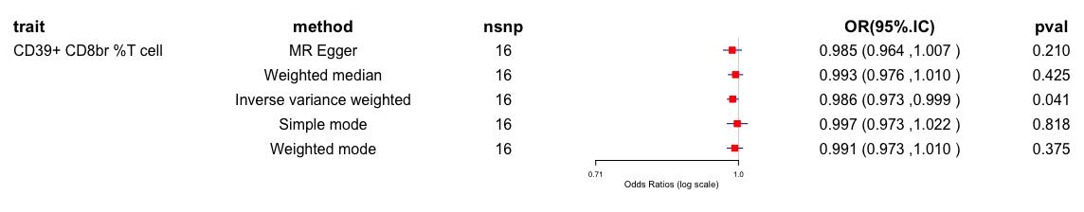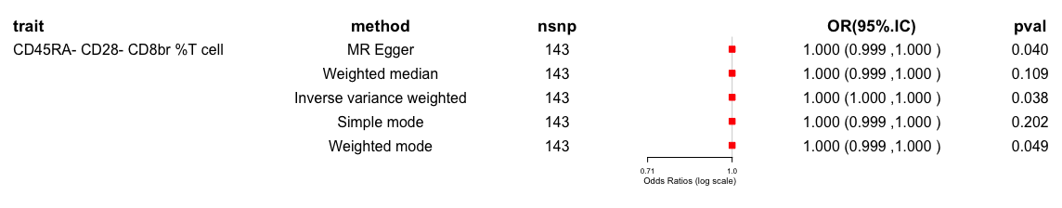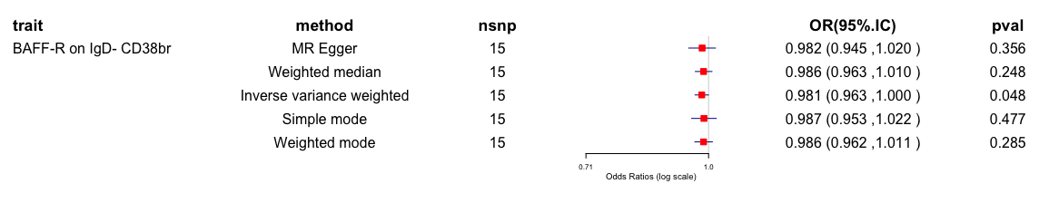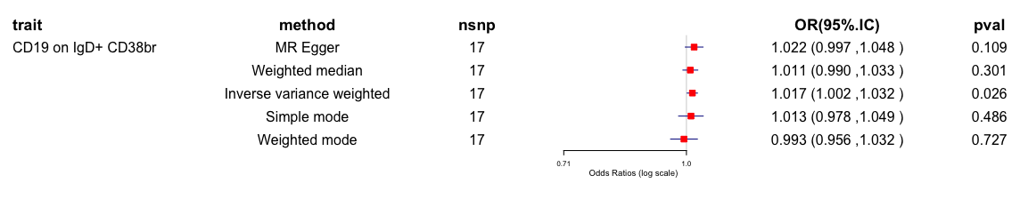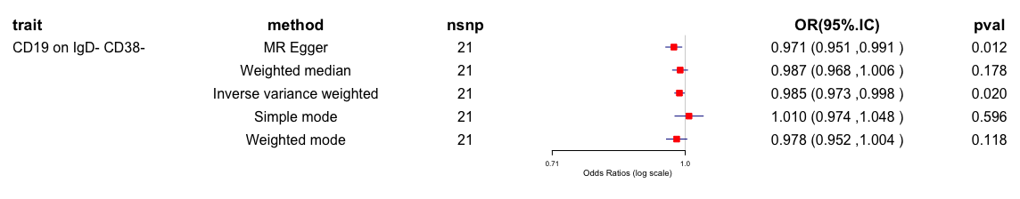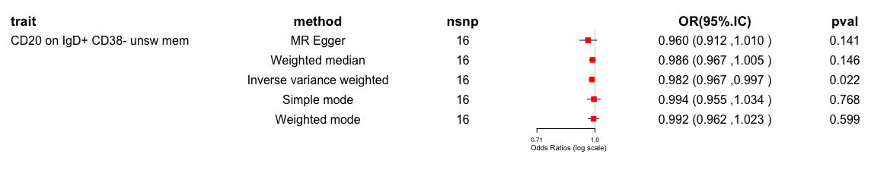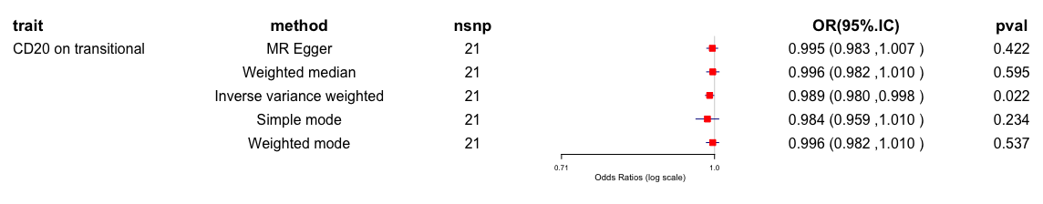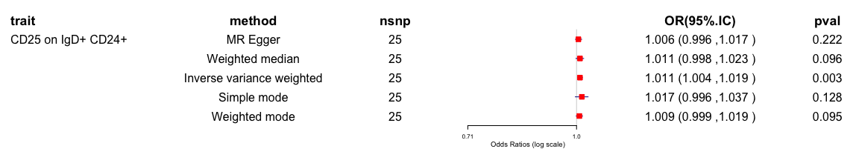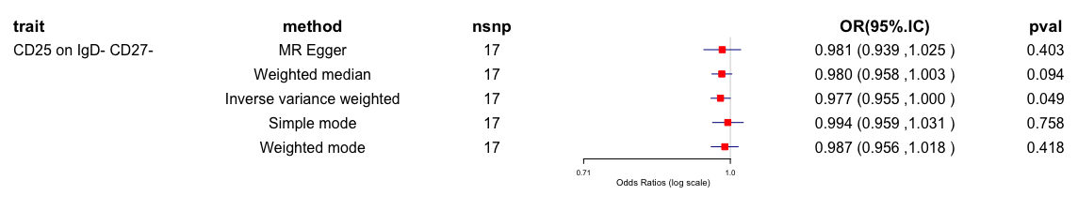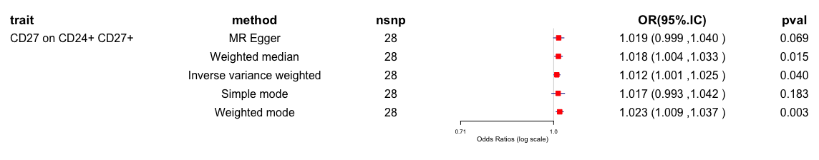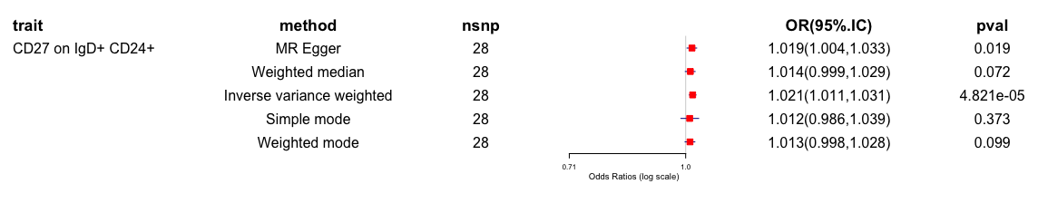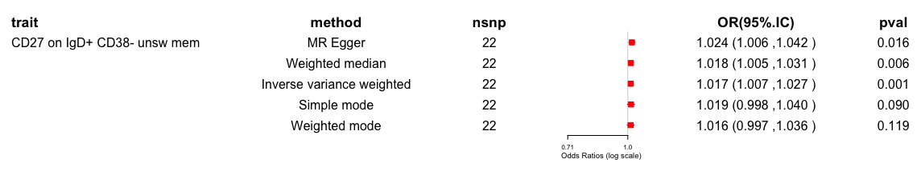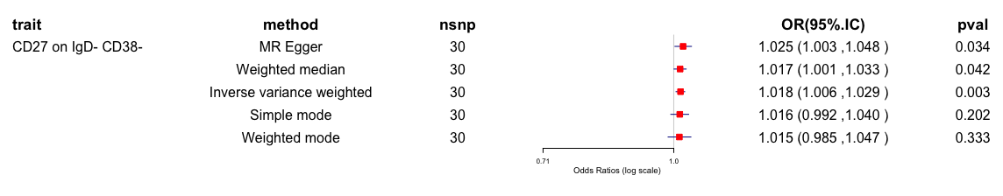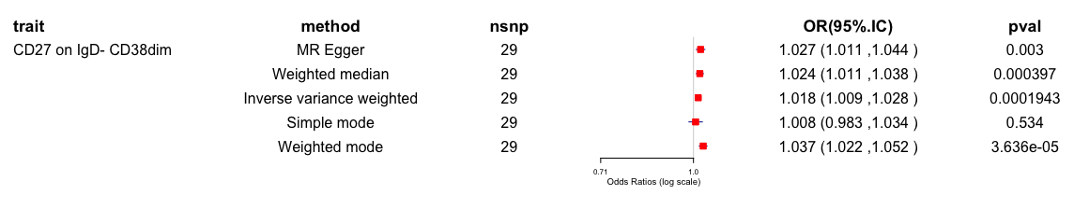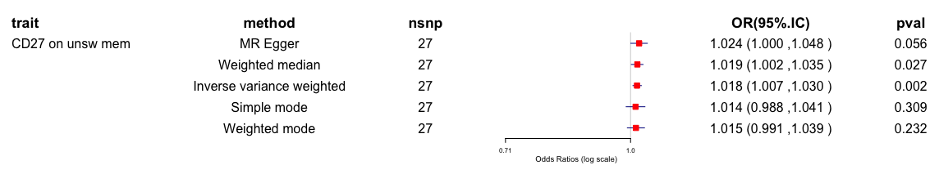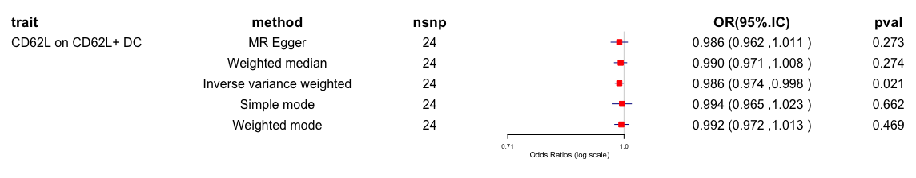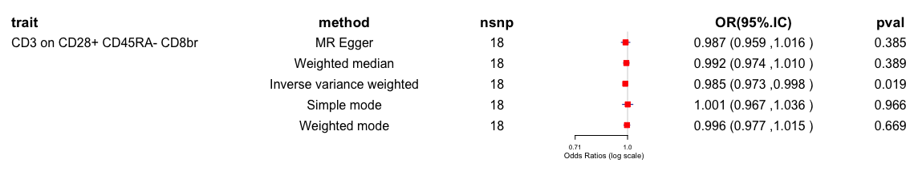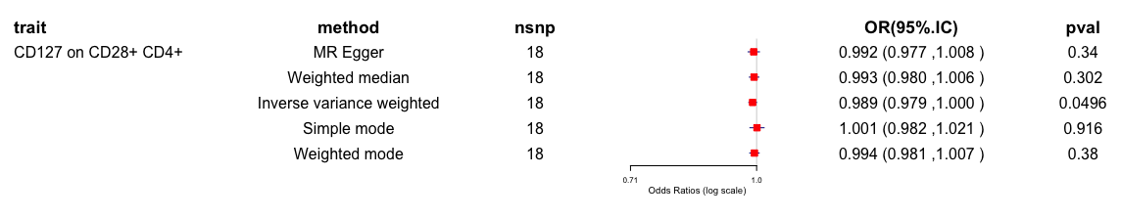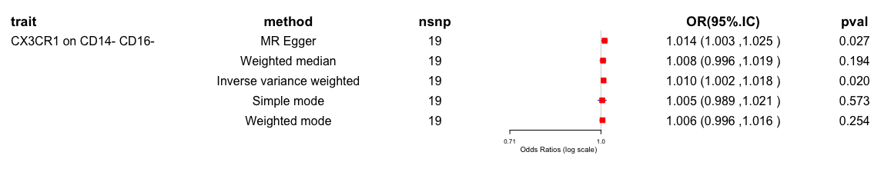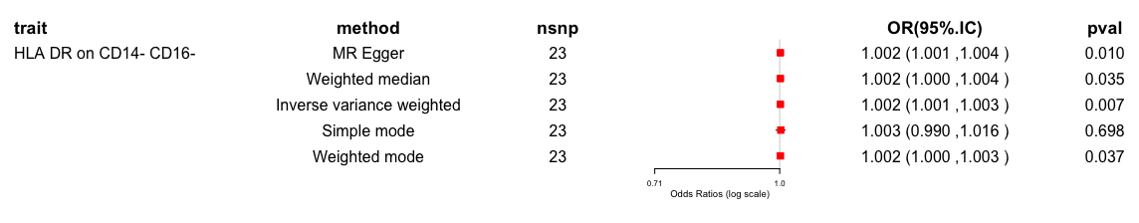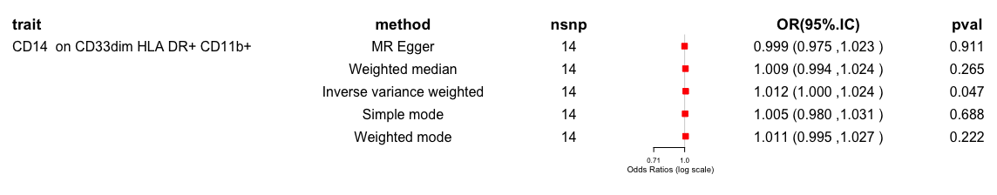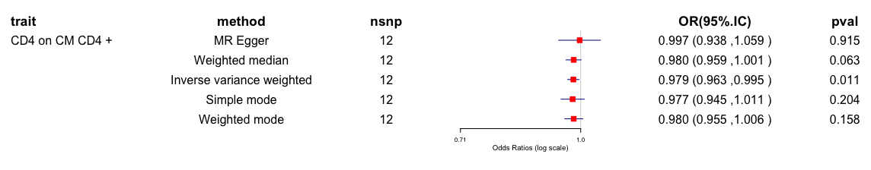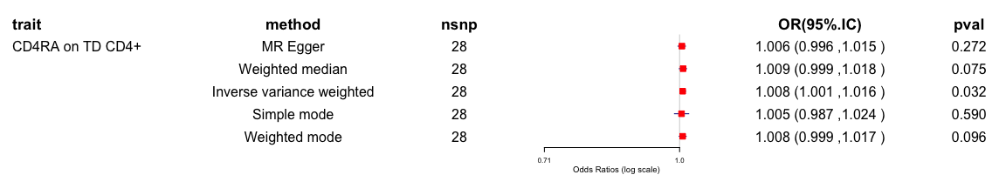
Supplementary Figure 1. The causal relationship between immune cells and MDD.

(a) (b) (c)
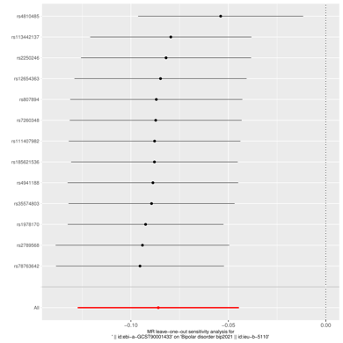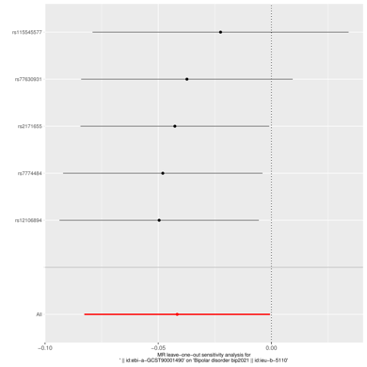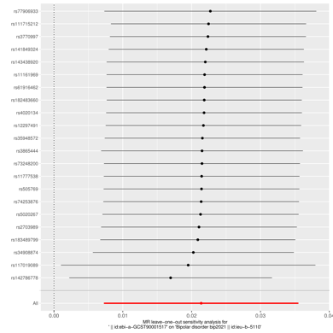
(d) (e) (f)
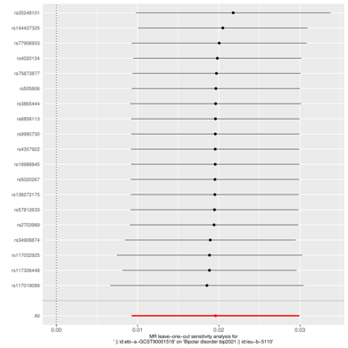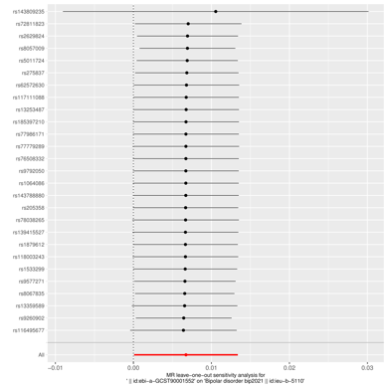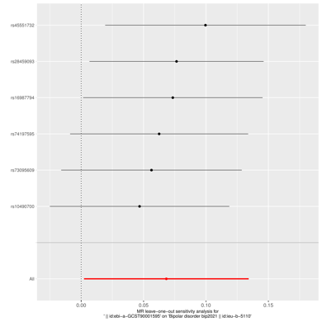
(g) (h) (i)
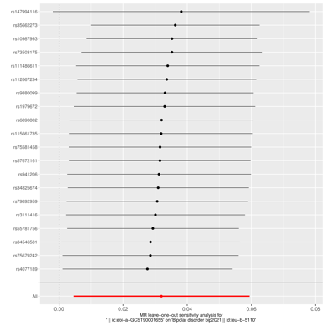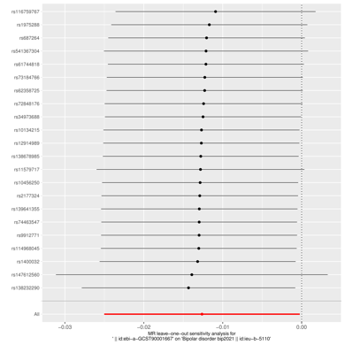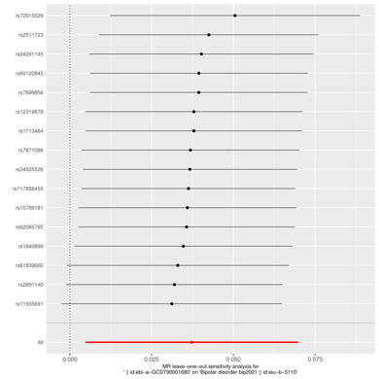
(j) (k) (l)
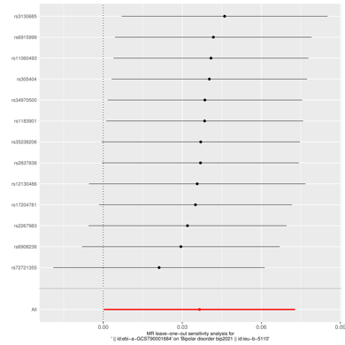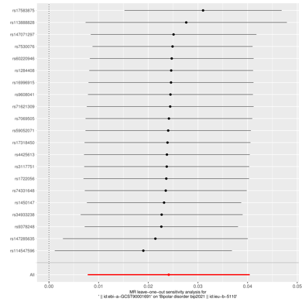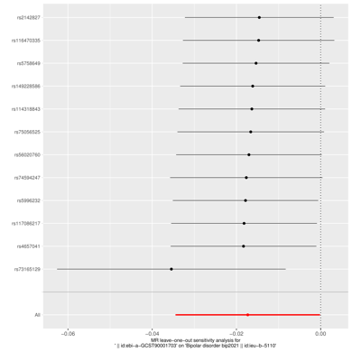

(m) (n) (o)
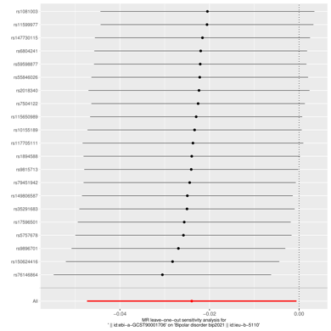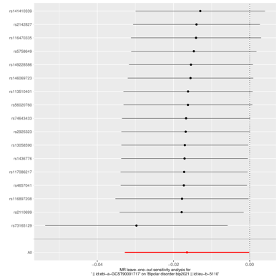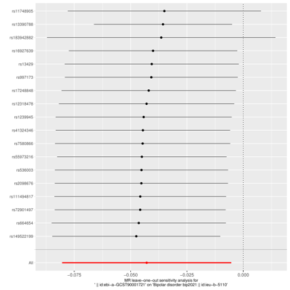
(p) (q) (r)
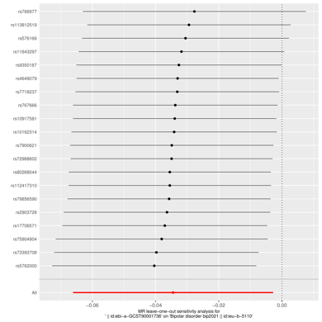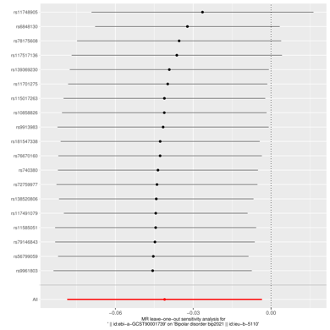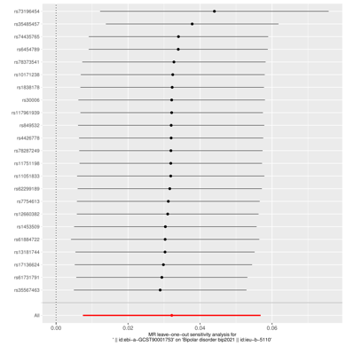
(s) (t) (u)
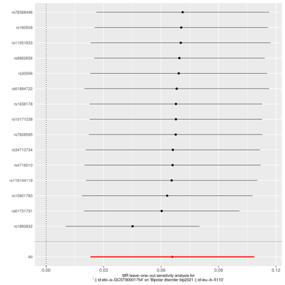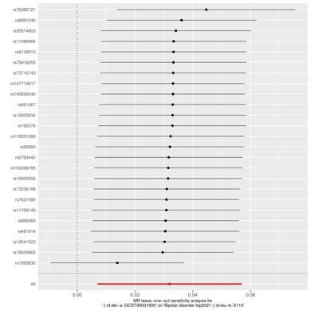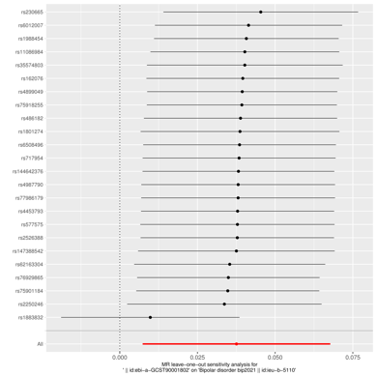
(v) (w) (x)
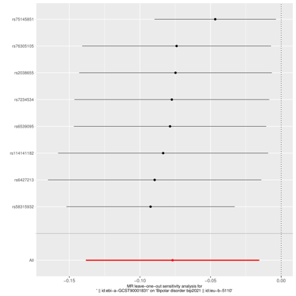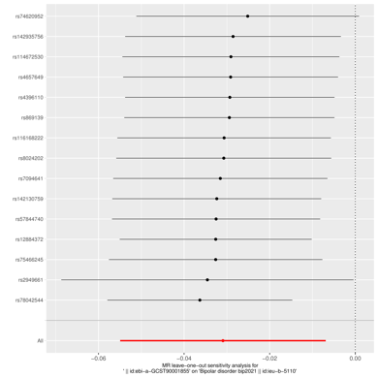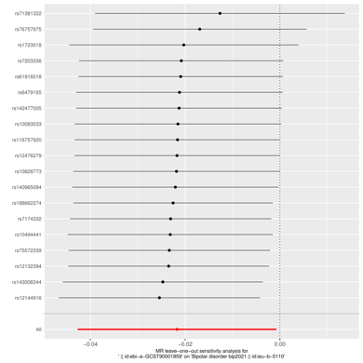

(y) (z) (aa)
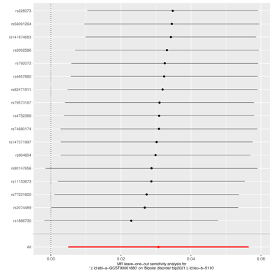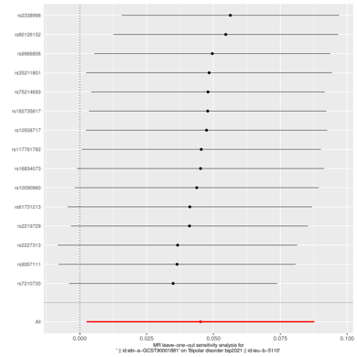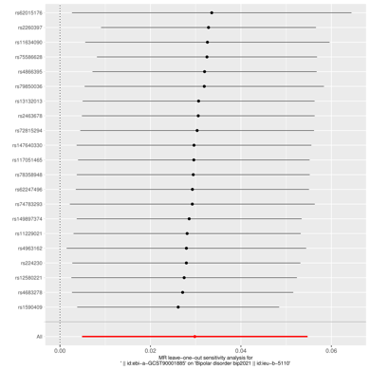
(bb) (cc) (dd)
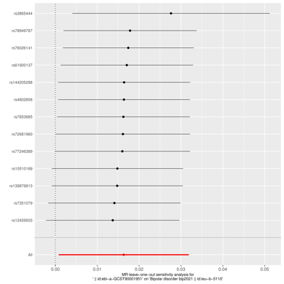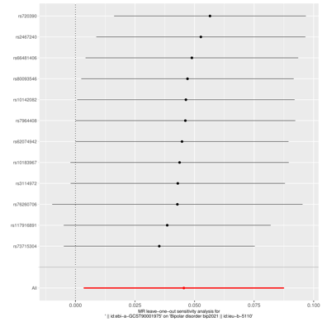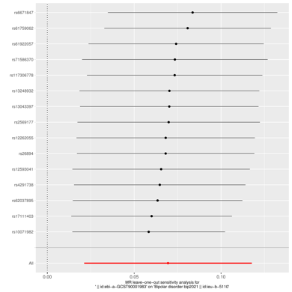
(ee) (ff) (gg)
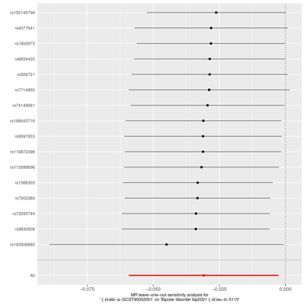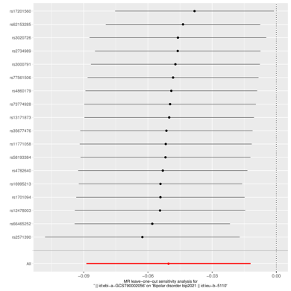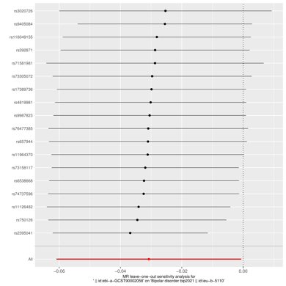
(hh) (ii)
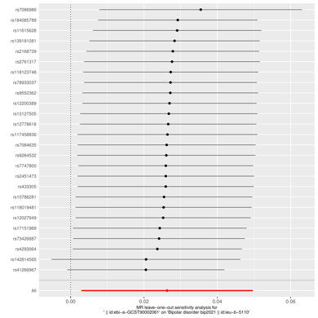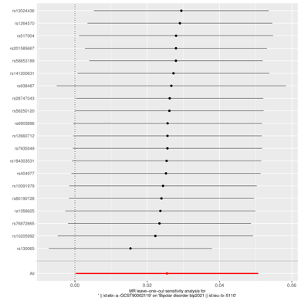
Supplementary Figure 2. The causal relationship between immune cells and BD (a) Sensitivity-analysis plot between IgD- CD27- %lymphocyte and BD risk; (b)Sensitivity-analysis plot between CD39+ activated Treg %activated Treg and BD risk; (c)Sensitivity-analysis plot between CD33br HLA DR+ AC and BD risk; (d) Sensitivity-analysis plot between CD33br HLA DR+ CD14- AC and BD risk; (e) Sensitivity-analysis plot between CD62L on CD62L+ myeloid DC and BD risk; (f) Sensitivity-analysis plot between CD8 on EM CD8br and BD risk; (g) Sensitivity-analysis plot between CD28+ DN (CD4-CD8-) %T cell and BD risk; (h) Sensitivity-analysis plot between CD28+ CD45RA- CD8dim %T cell and BD risk; (i) Sensitivity-analysis plot between CD25++ CD8br %CD8br and BD risk; (j) Sensitivity-analysis plot between CD127- CD8br AC and BD risk; (k) Sensitivity-analysis plot between CD28+ CD45RA- CD8br %T cell and BD risk; (l) Sensitivity-analysis plot between BAFF-R on IgD+ CD24+ and BD risk; (m) Sensitivity-analysis plot between BAFF-R on IgD+ CD38- naïve and BD risk; (n) Sensitivity-analysis plot between BAFF-R on unsw mem and BD risk; (o) Sensitivity-analysis plot between CD19 on CD20- and BD risk; (p) Sensitivity-analysis plot between CD19 on memory B cell and BD risk; (q) Sensitivity-analysis plot between CD19 on PB/PC and BD risk; (r) Sensitivity-analysis plot between CD20 on IgD- CD24- and BD risk; (s) Sensitivity-analysis plot between CD20 on IgD- CD27- and BD risk; (t) Sensitivity-analysis plot between CD27 on IgD+ CD24+ and BD risk; (u) Sensitivity-analysis plot between CD27 on IgD- CD38- and BD risk; (v) Sensitivity-analysis plot between CD64 on CD14- CD16- and BD risk; (w) Sensitivity-analysis plot between CD3 on secreting Treg and BD risk; (x) Sensitivity-analysis plot between CD3 on CD8br and BD risk; (y)Sensitivity-analysis plot between CD8 on CD8br and BD risk; (z) Sensitivity-analysis plot between Naive CD8br %CD8br and BD risk; (aa) Sensitivity-analysis plot between CD16-CD56 on HLA DR+ NK and BD risk; (bb) Sensitivity-analysis plot between CD33 on CD66b++ myeloid cell and BD risk; (cc) Sensitivity-analysis plot between HVEM on CD45RA- CD4+ and BD risk; (dd) Sensitivity-analysis plot between HVEM on CD8br and BD risk; (ee) Sensitivity-analysis plot between FSC-A on HLA DR+ T cell and BD risk; (ff) Sensitivity-analysis plot between DP (CD4+CD8+) %T cell and BD risk; (gg) Sensitivity-analysis plot between CD14 on CD14+ CD16+ monocyte and BD risk; (hh) Sensitivity-analysis plot between CD4 on CD39+ CD4+ and BD risk; (ii) Sensitivity-analysis plot between CD8 on CD28+ CD45RA+ CD8br and BD risk.

(a) (b) (c)
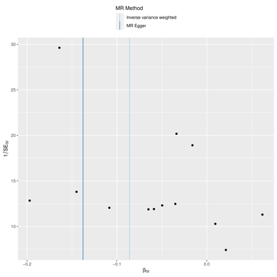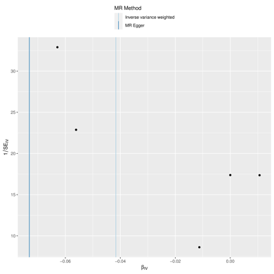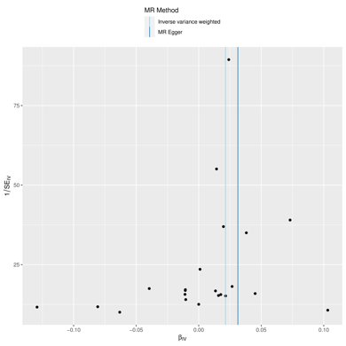
(d) (e) (f)
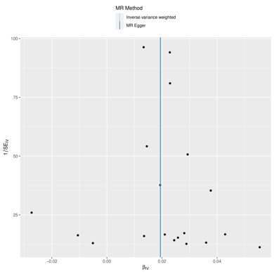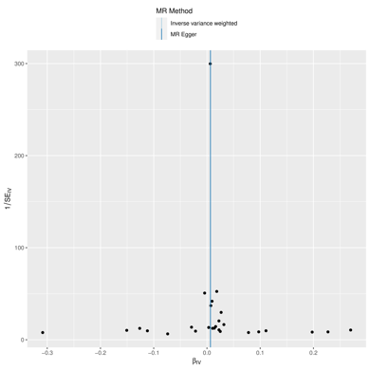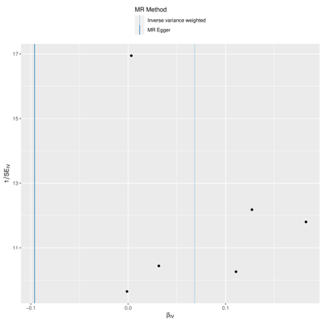
(g) (h) (i)
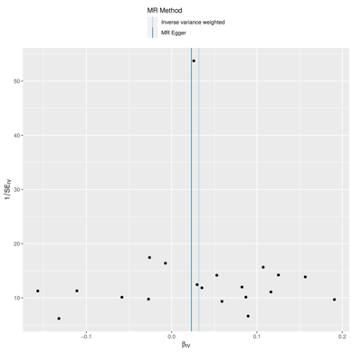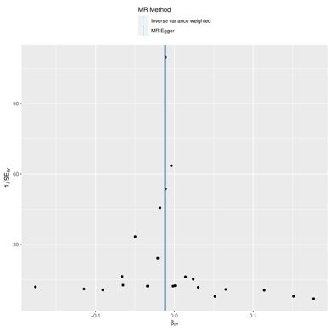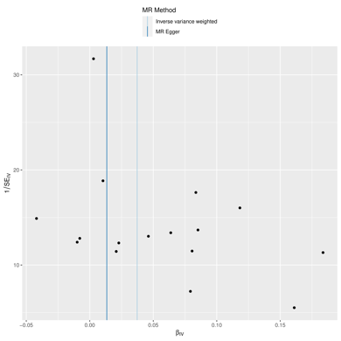
(j) (k) (l)
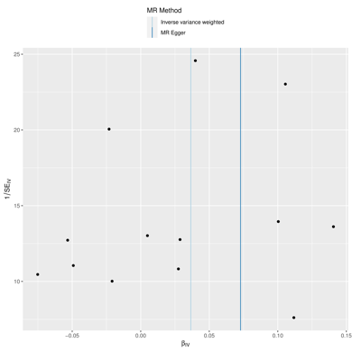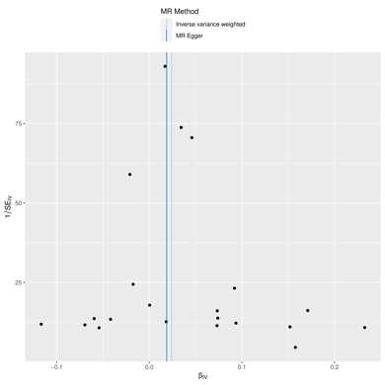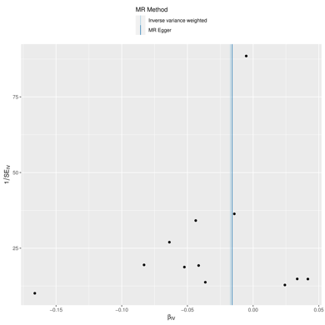

(m) (n) (o)
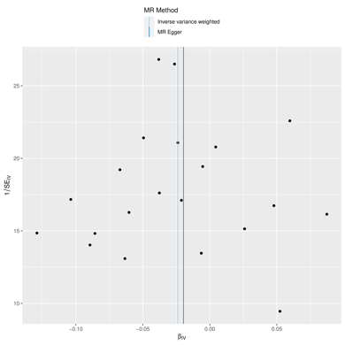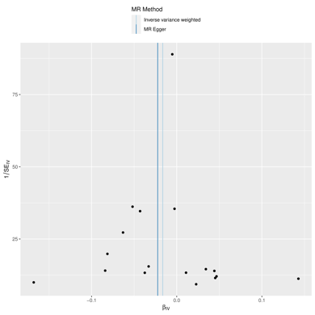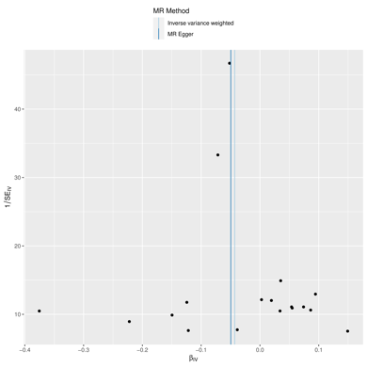
(p) (q) (r)
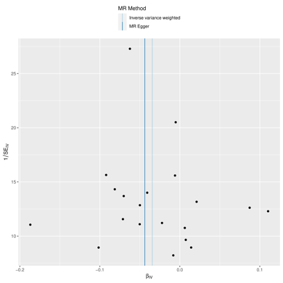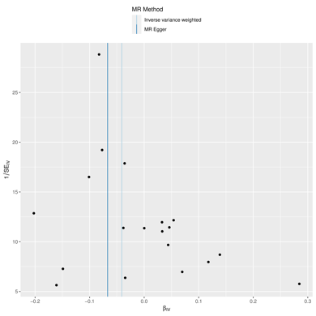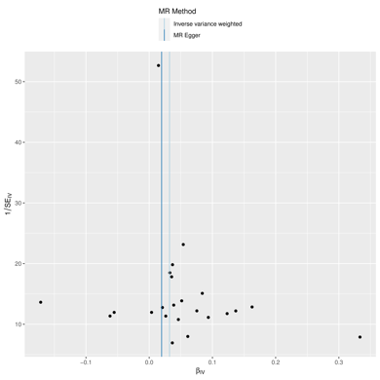 (s) (t) (u)
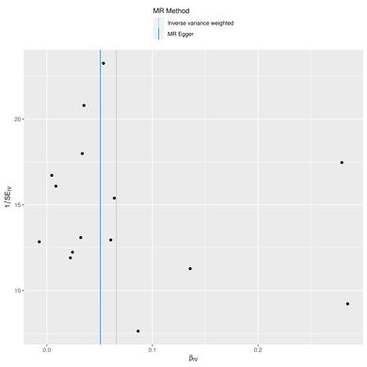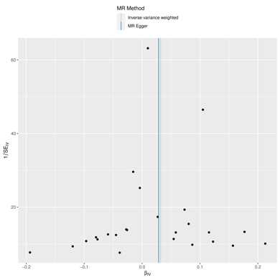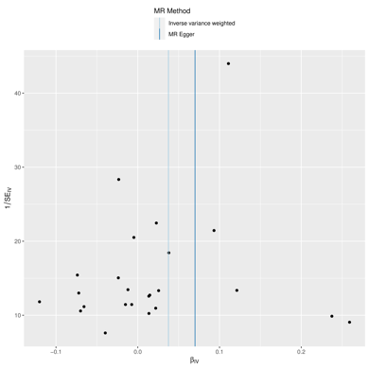(v) (w) (x)
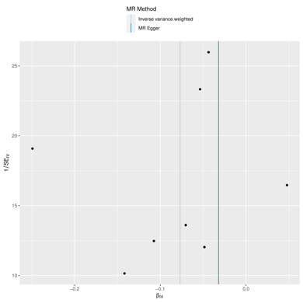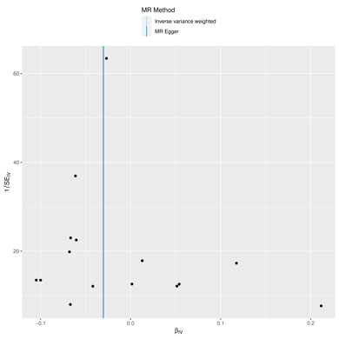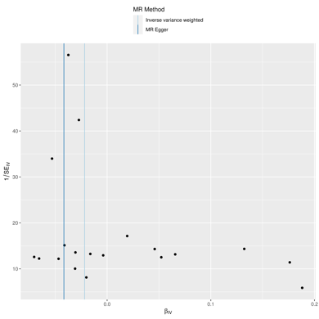

(y) (z) (aa)
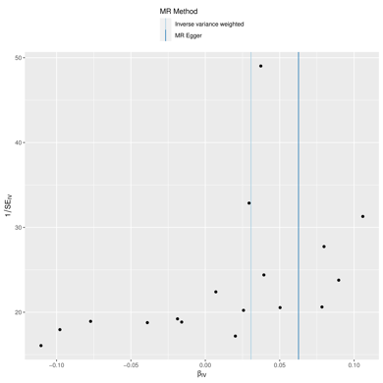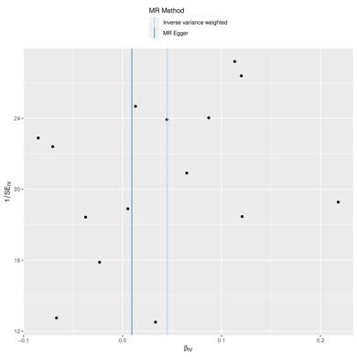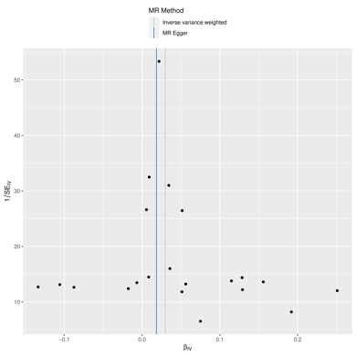(bb) (cc) (dd)
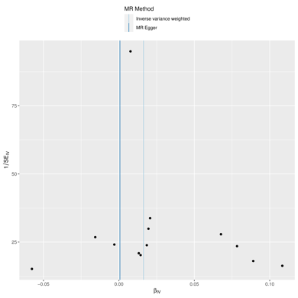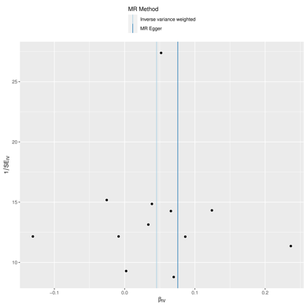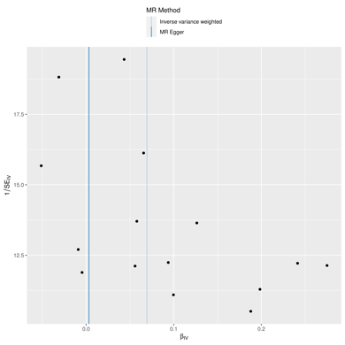(ee) (ff) (gg)
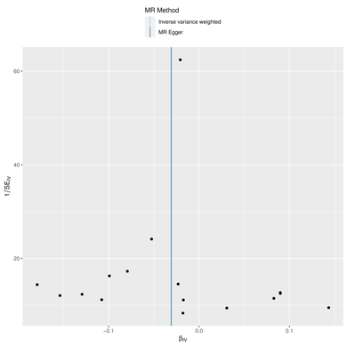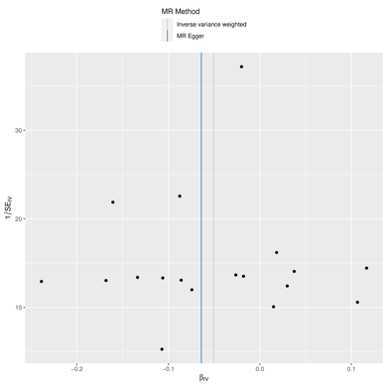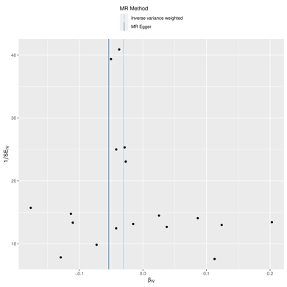
(hh) (ii)
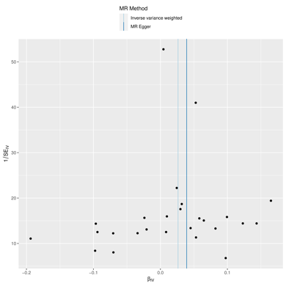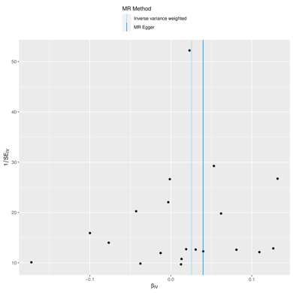
Supplementary Figure 3. The causal relationship between immune cells and BD (a) Funnel plot between IgD- CD27- %lymphocyte and BD risk; (b)Funnel plot between CD39+ activated Treg %activated Treg and BD risk; (c)Funnel plot between CD33br HLA DR+ AC and BD risk; (d) Funnel plot between CD33br HLA DR+ CD14- AC and BD risk; (e) Funnel plot between CD62L on CD62L+ myeloid DC and BD risk; (f) Funnel plot between CD8 on EM CD8br and BD risk; (g) Funnel plot between CD28+ DN (CD4-CD8-) %T cell and BD risk; (h) Funnel plot between CD28+ CD45RA- CD8dim %T cell and BD risk; (i) Funnel plot between CD25++ CD8br %CD8br and BD risk; (j) Funnel plot between CD127- CD8br AC and BD risk; (k) Funnel plot between CD28+ CD45RA- CD8br %T cell and BD risk; (l) Funnel plot between BAFF-R on IgD+ CD24+ and BD risk; (m) Funnel plot between BAFF-R on IgD+ CD38- naïve and BD risk; (n) Funnel plot between BAFF-R on unsw mem and BD risk; (o) Funnel plot between CD19 on CD20- and BD risk; (p) Funnel plot between CD19 on memory B cell and BD risk; (q) Funnel plot between CD19 on PB/PC and BD risk; (r) Funnel plot between CD20 on IgD- CD24- and BD risk; (s) Funnel plot between CD20 on IgD- CD27- and BD risk; (t) Funnel plot between CD27 on IgD+ CD24+ and BD risk; (u) Funnel plot between CD27 on IgD- CD38- and BD risk; (v) Funnel plot between CD64 on CD14- CD16- and BD risk; (w) Funnel plot between CD3 on secreting Treg and BD risk; (x) Funnel plot between CD3 on CD8br and BD risk; (y)Funnel plot between CD8 on CD8br and BD risk; (z) Funnel plot between Naive CD8br %CD8br and BD risk; (aa) Funnel plot between CD16-CD56 on HLA DR+ NK and BD risk; (bb) Funnel plot between CD33 on CD66b++ myeloid cell and BD risk; (cc) Funnel plot between HVEM on CD45RA- CD4+ and BD risk; (dd) Funnel plot between HVEM on CD8br and BD risk; (ee) Funnel plot between FSC-A on HLA DR+ T cell and BD risk; (ff) Funnel plot between DP (CD4+CD8+) %T cell and BD risk; (gg) Funnel plot between CD14 on CD14+ CD16+ monocyte and BD risk; (hh) Funnel plot between CD4 on CD39+ CD4+ and BD risk; (ii) Funnel plot between CD8 on CD28+ CD45RA+ CD8br and BD risk.

(a) (b) (c)

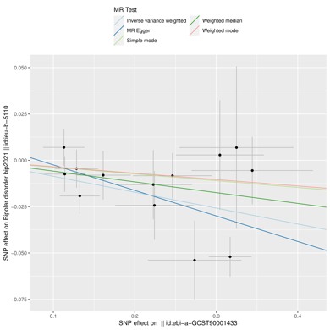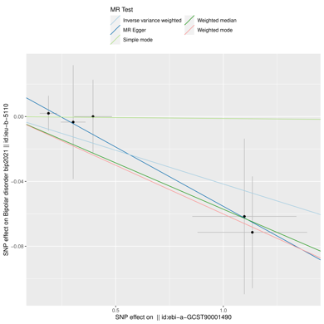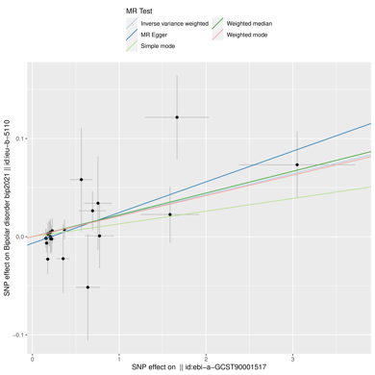
(d) (e) (f)

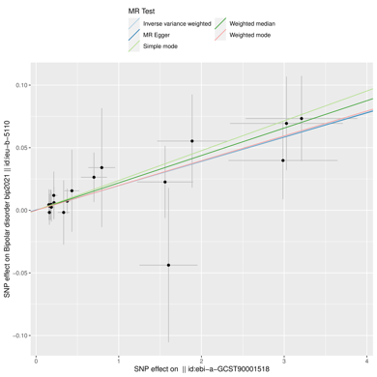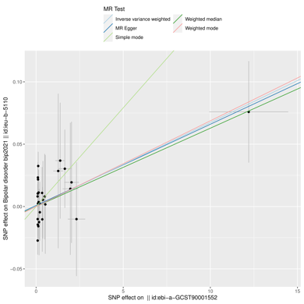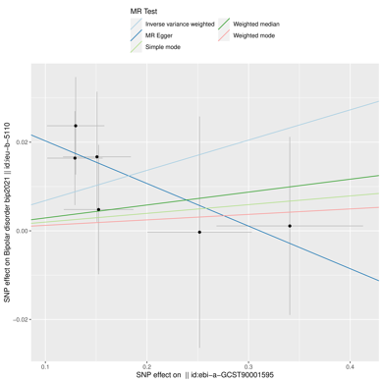
(g) (h) (i)
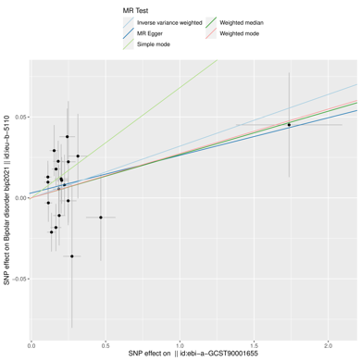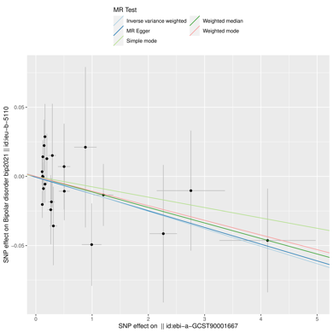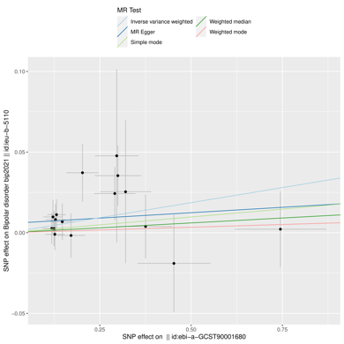
(j) (k) (l)
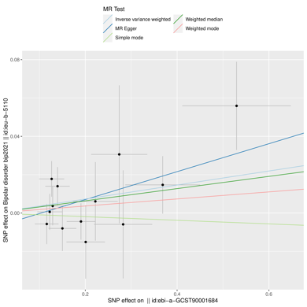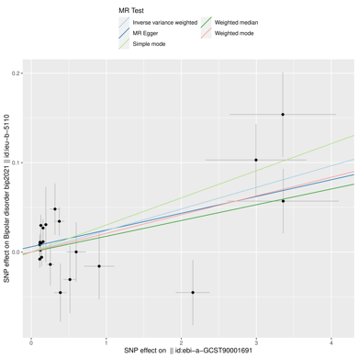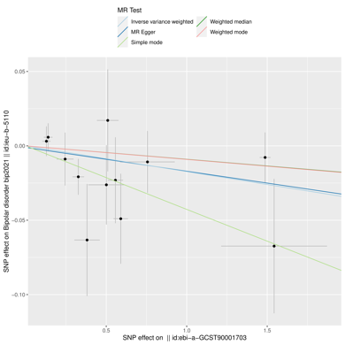

(m) (n) (o)
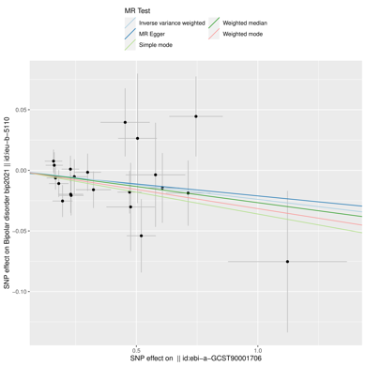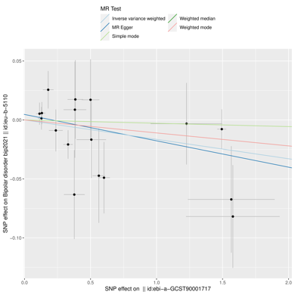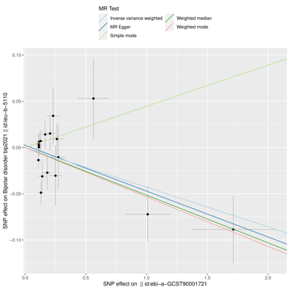
(p) (q) (r)
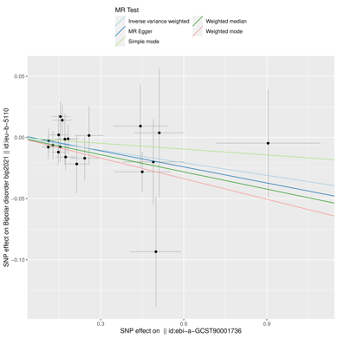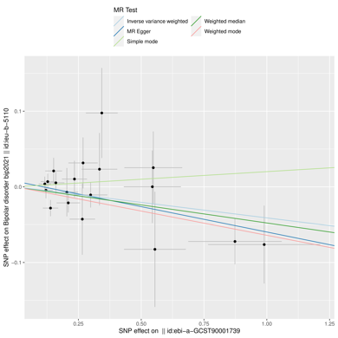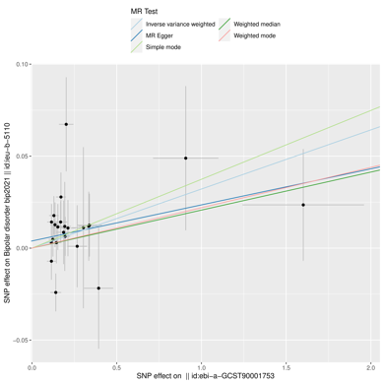
(s) (t) (u)
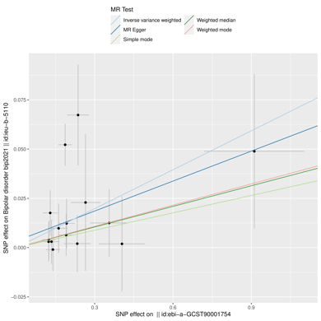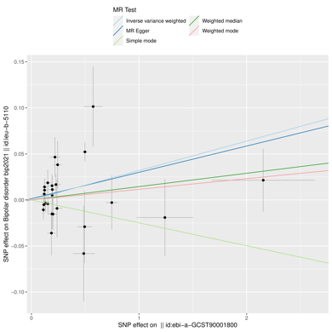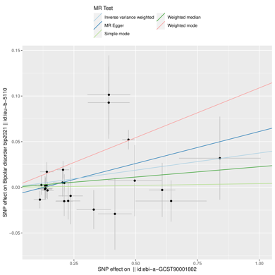
(v) (w) (x)
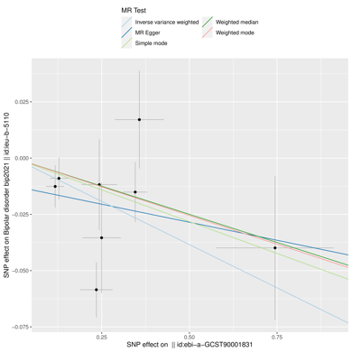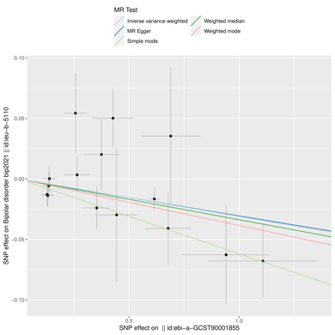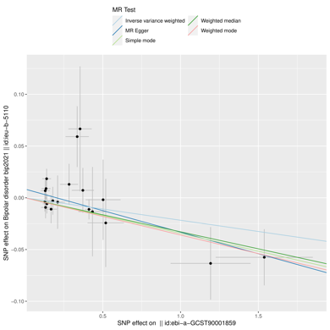

(y) (z) (aa)
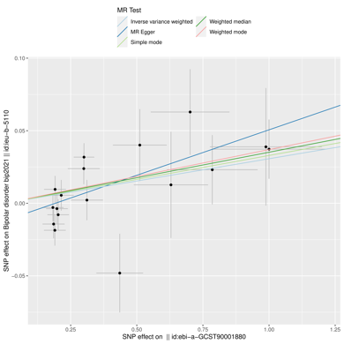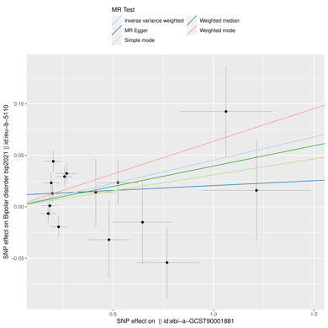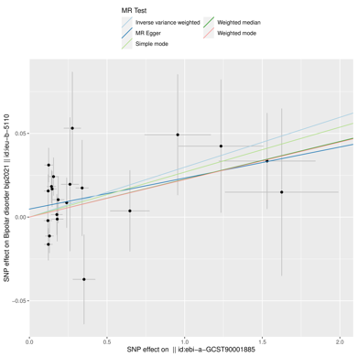
(bb) (cc) (dd)
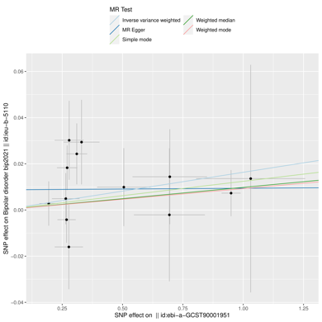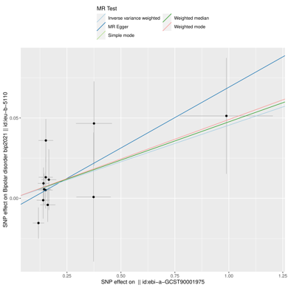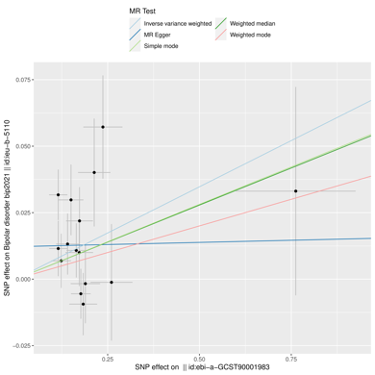
(ee) (ff) (gg)
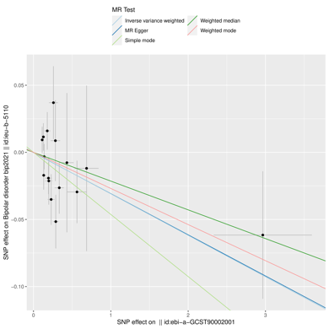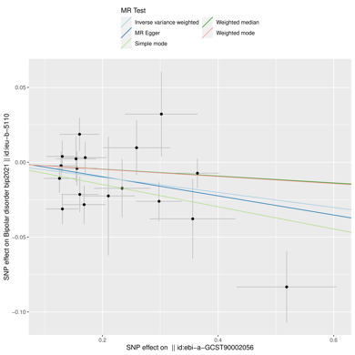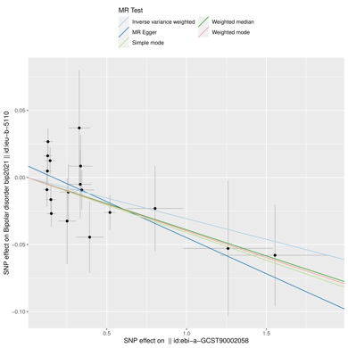
(hh) (ii)
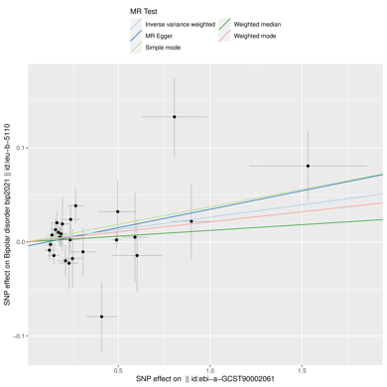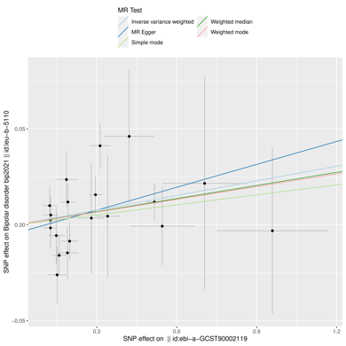
Supplementary Figure 4. The causal relationship between immune cells and BD (a) Scatter plot between IgD- CD27- %lymphocyte and BD risk; (b)Scatter plot between CD39+ activated Treg %activated Treg and BD risk; (c)Scatter plot between CD33br HLA DR+ AC and BD risk; (d) Scatter plot between CD33br HLA DR+ CD14- AC and BD risk; (e) Scatter plot between CD62L on CD62L+ myeloid DC and BD risk; (f) Scatter plot between CD8 on EM CD8br and BD risk; (g) Scatter plot between CD28+ DN (CD4-CD8-) %T cell and BD risk; (h) Scatter plot between CD28+ CD45RA- CD8dim %T cell and BD risk; (i) Scatter plot between CD25++ CD8br %CD8br and BD risk; (j) Scatter plot between CD127- CD8br AC and BD risk; (k) Scatter plot between CD28+ CD45RA- CD8br %T cell and BD risk; (l) Scatter plot between BAFF-R on IgD+ CD24+ and BD risk; (m) Scatter plot between BAFF-R on IgD+ CD38- naïve and BD risk; (n) Scatter plot between BAFF-R on unsw mem and BD risk; (o) Scatter plot between CD19 on CD20- and BD risk; (p) Scatter plot between CD19 on memory B cell and BD risk; (q) Scatter plot between CD19 on PB/PC and BD risk; (r) Scatter plot between CD20 on IgD- CD24- and BD risk; (s) Scatter plot between CD20 on IgD- CD27- and BD risk; (t) Scatter plot between CD27 on IgD+ CD24+ and BD risk; (u) Scatter plot between CD27 on IgD- CD38- and BD risk; (v) Scatter plot between CD64 on CD14- CD16- and BD risk; (w) Scatter plot between CD3 on secreting Treg and BD risk; (x) Scatter plot between CD3 on CD8br and BD risk; (y)Scatter plot between CD8 on CD8br and BD risk; (z) Scatter plot between Naive CD8br %CD8br and BD risk; (aa) Scatter plot between CD16-CD56 on HLA DR+ NK and BD risk; (bb) Scatter plot between CD33 on CD66b++ myeloid cell and BD risk; (cc) Scatter plot between HVEM on CD45RA- CD4+ and BD risk; (dd) Scatter plot between HVEM on CD8br and BD risk; (ee) Scatter plot between FSC-A on HLA DR+ T cell and BD risk; (ff) Scatter plot between DP (CD4+CD8+) %T cell and BD risk; (gg) Scatter plot between CD14 on CD14+ CD16+ monocyte and BD risk; (hh) Scatter plot between CD4 on CD39+ CD4+ and BD risk; (ii) Scatter plot between CD8 on CD28+ CD45RA+ CD8br and BD risk.

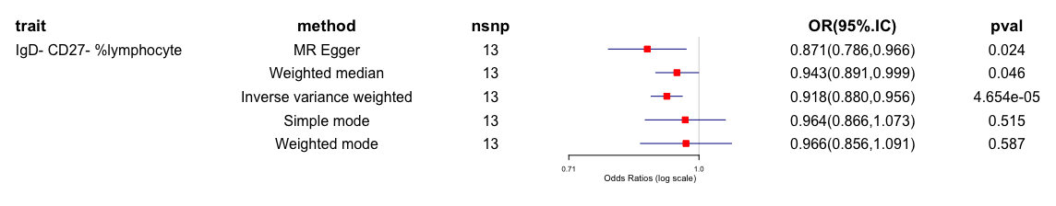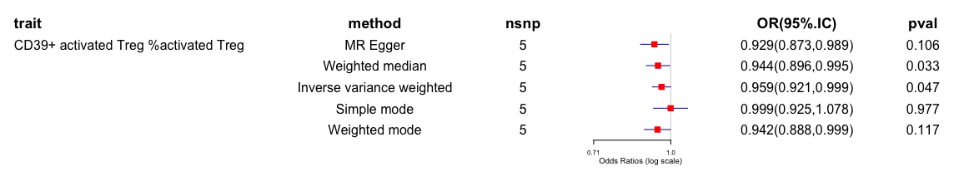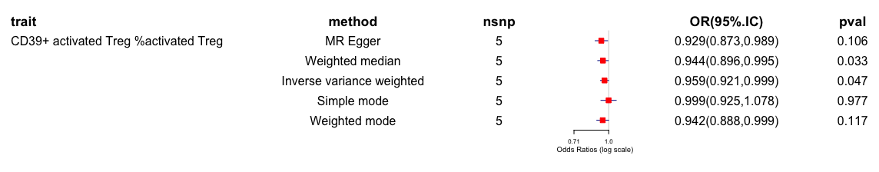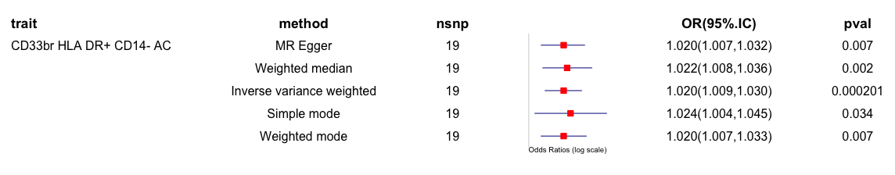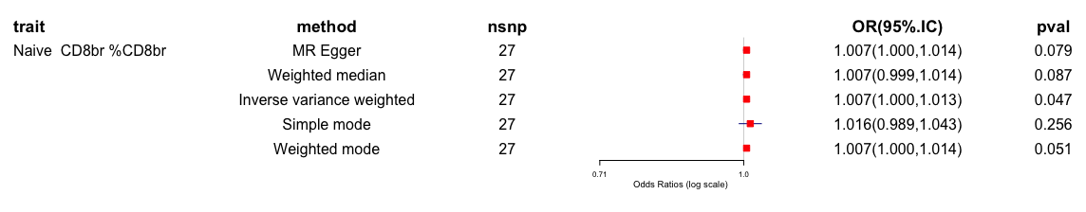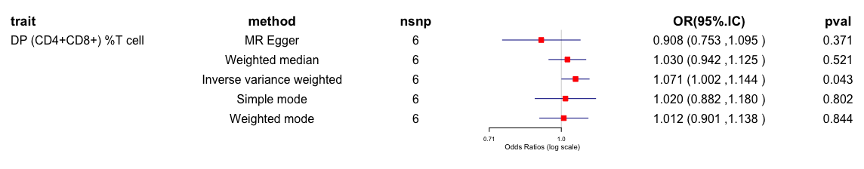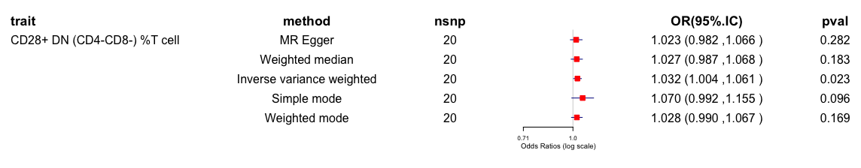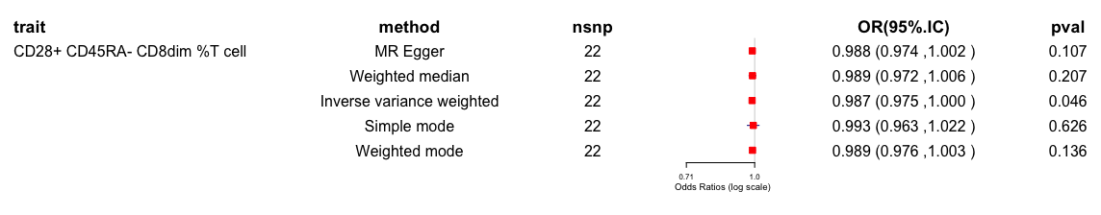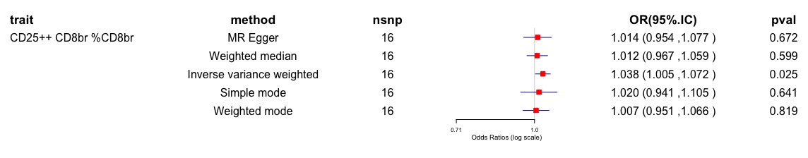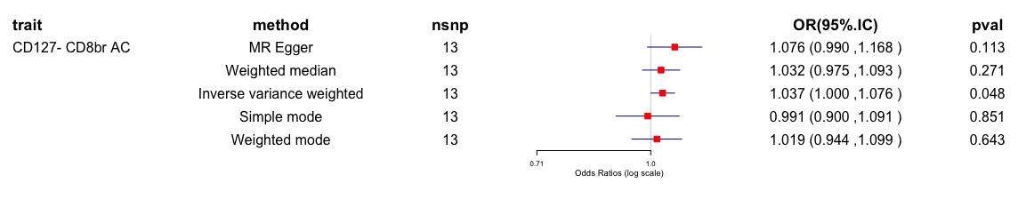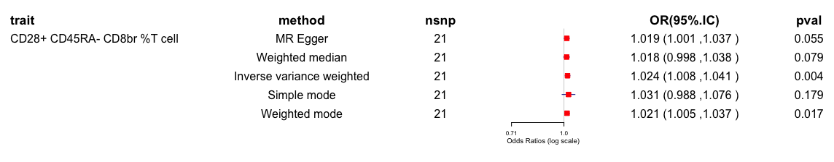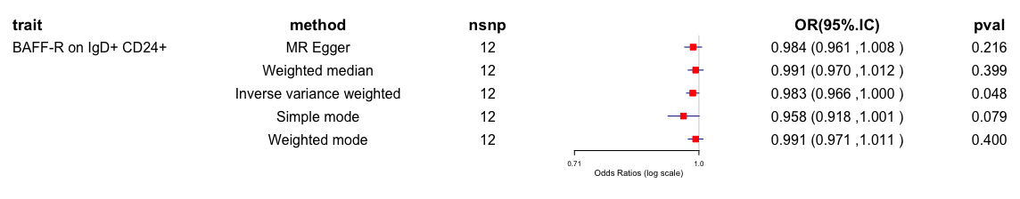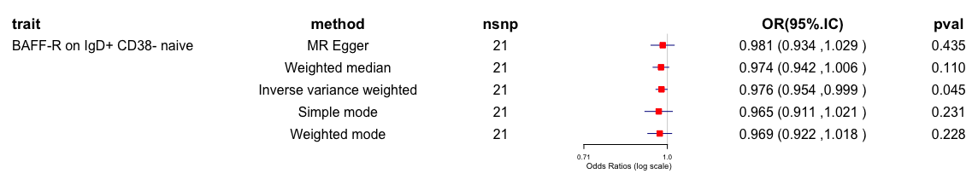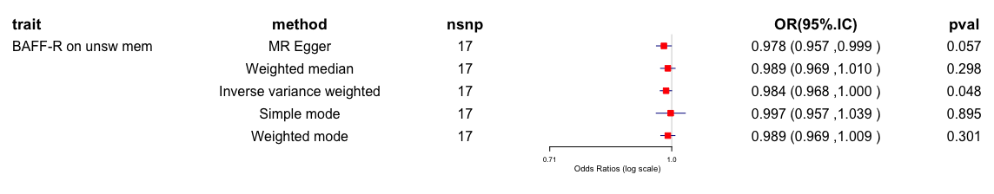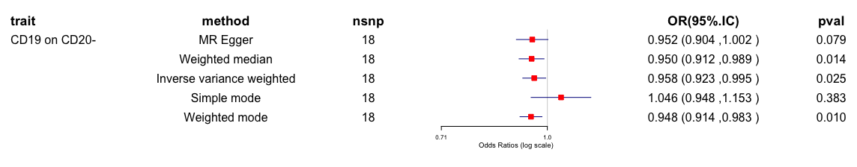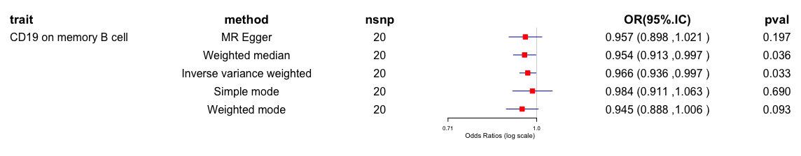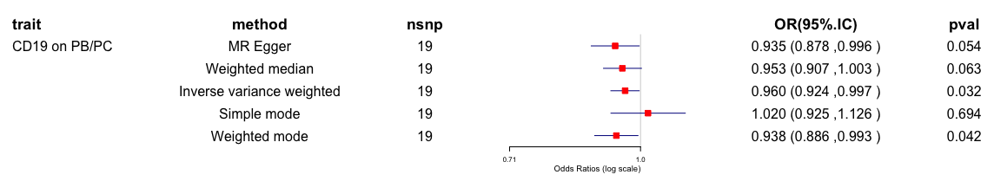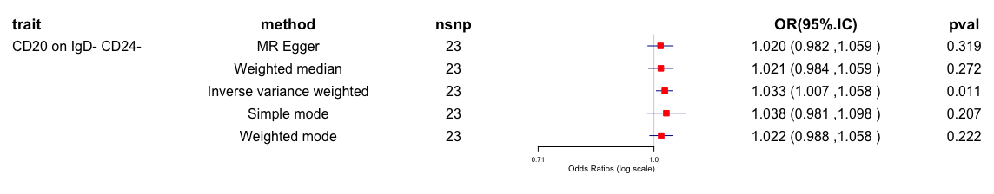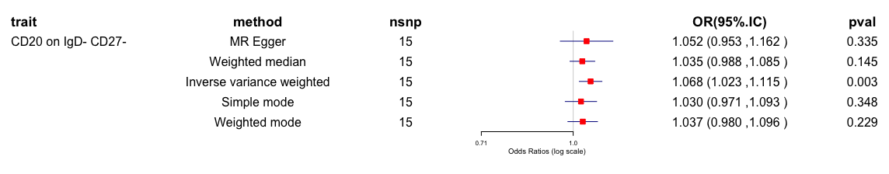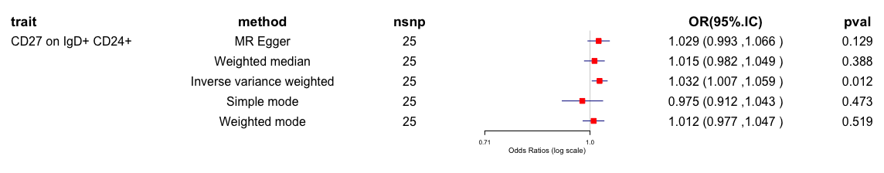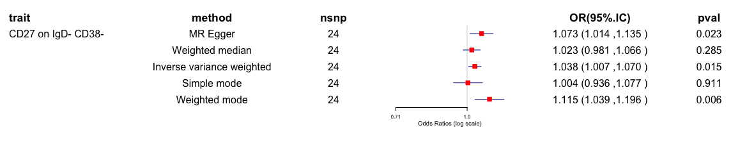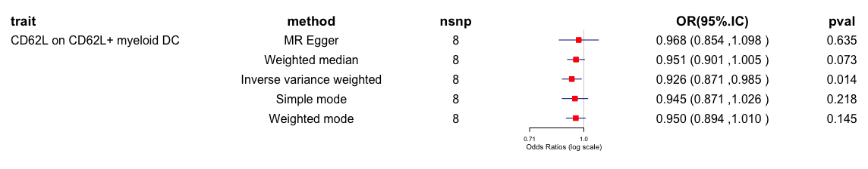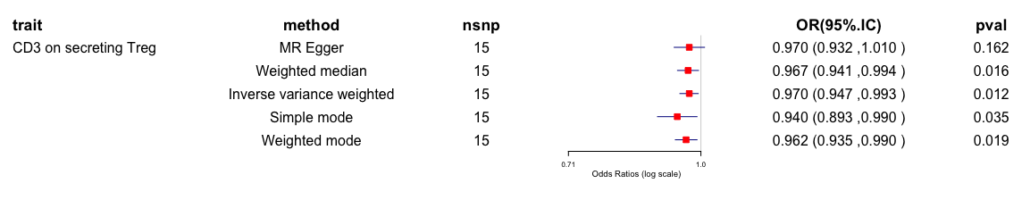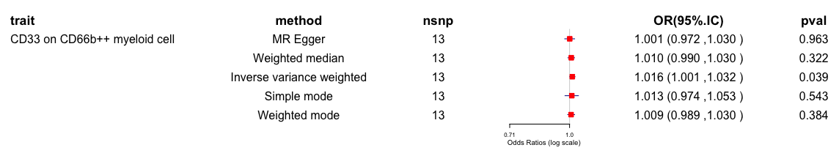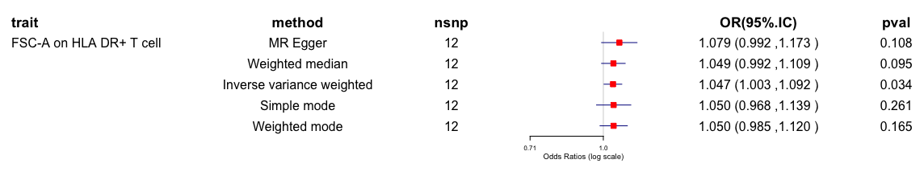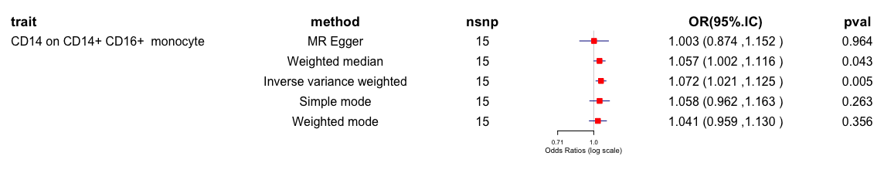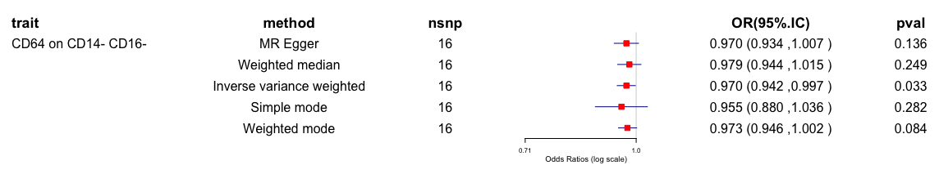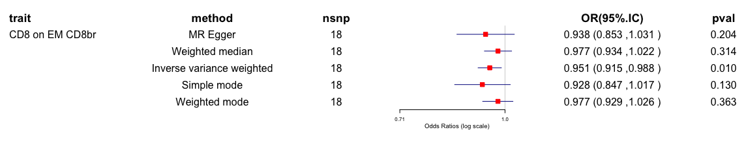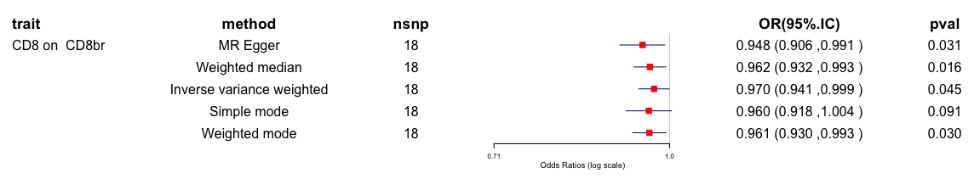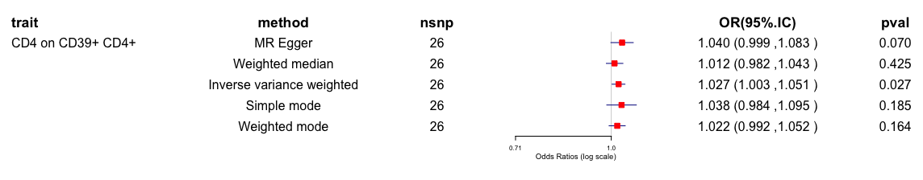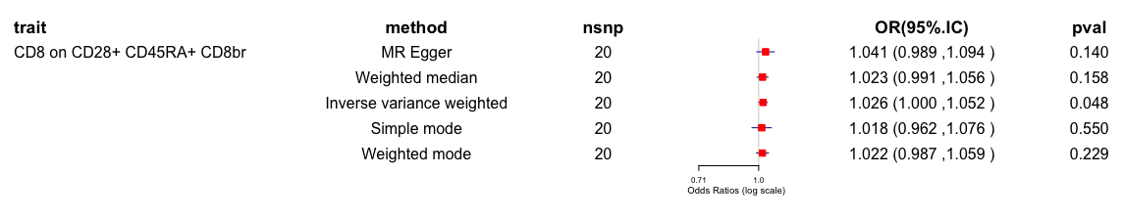
Supplementary Figure 5. The causal relationship between immune cells and BD.

(a) (b) (c)
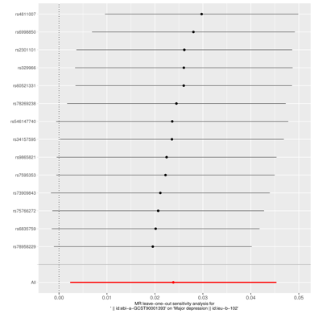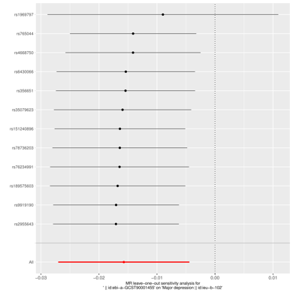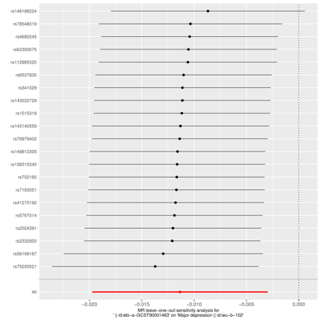
(d) (e) (f)
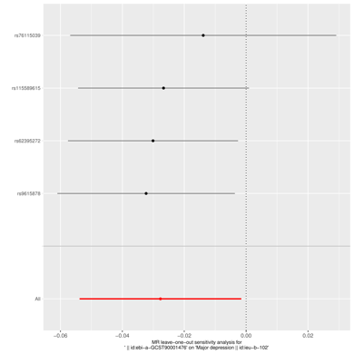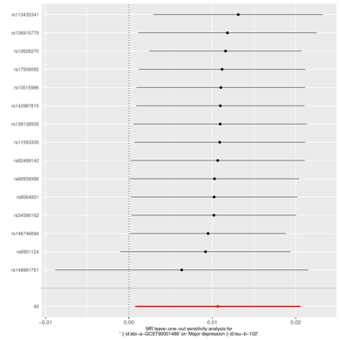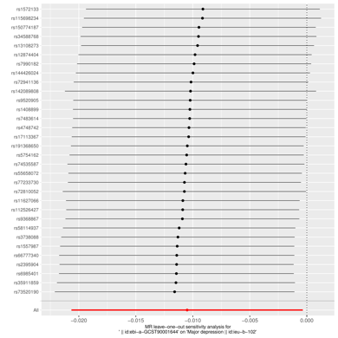
(g) (h) (i)
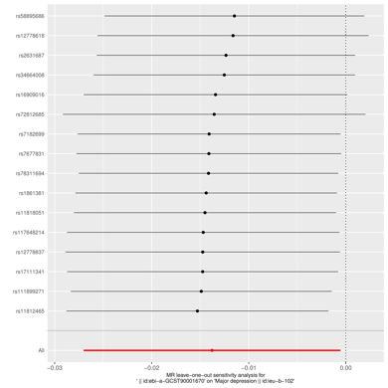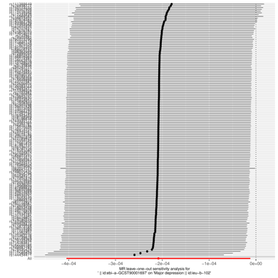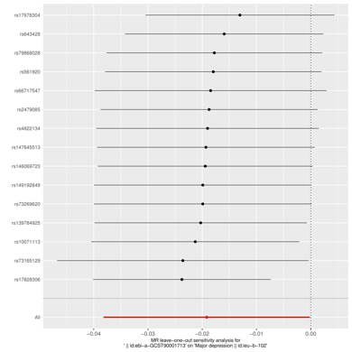
(j) (k) (l)
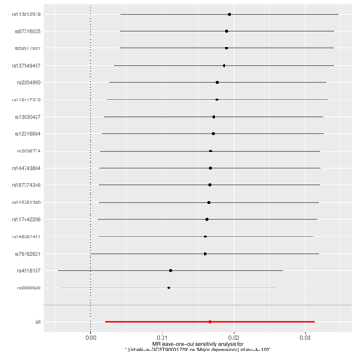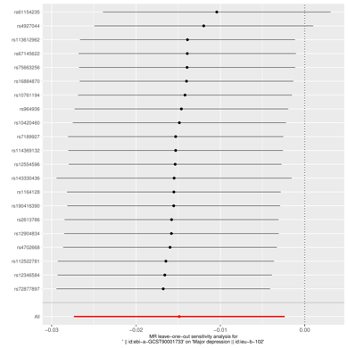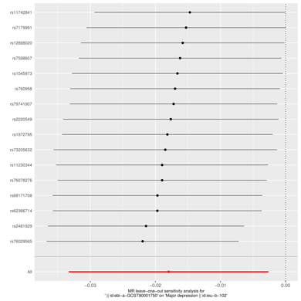

(m) (n) (o)
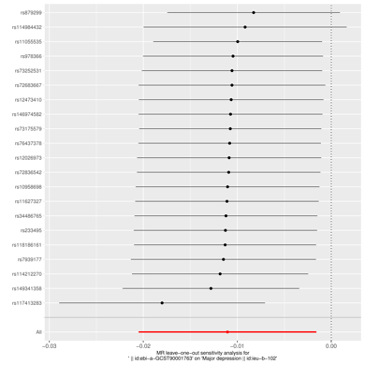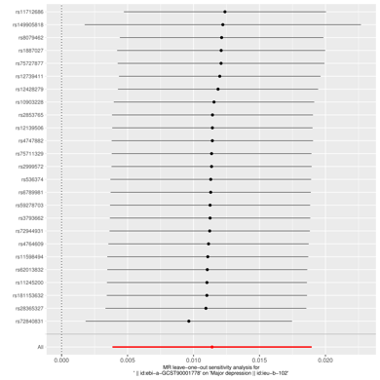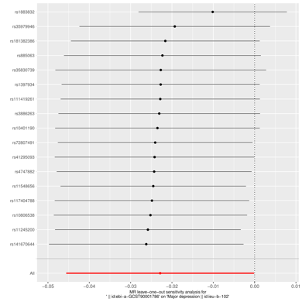
(p) (q) (r)
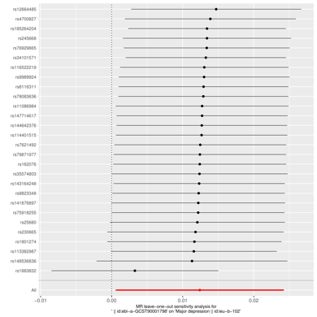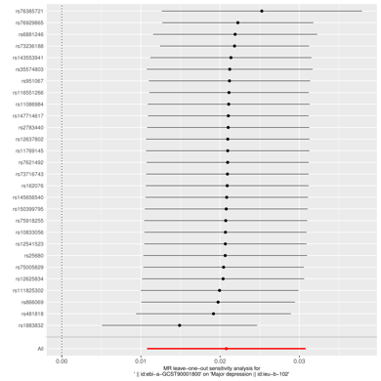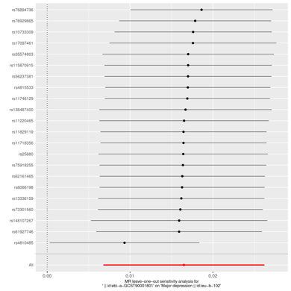
(s) (t) (u)
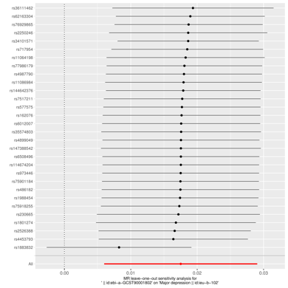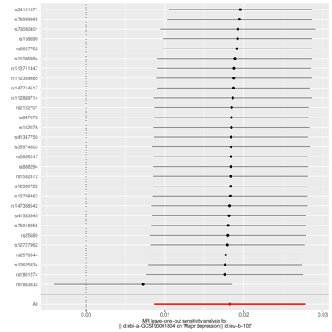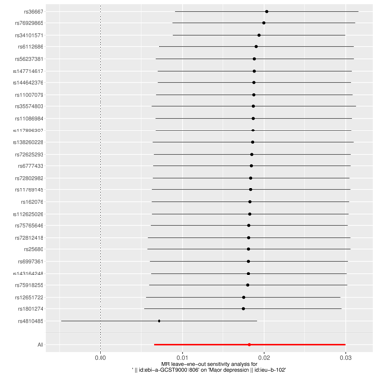
(v) (w) (x)
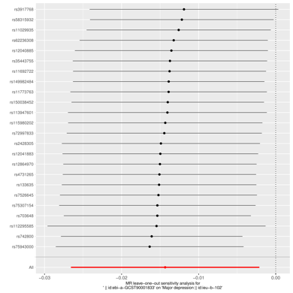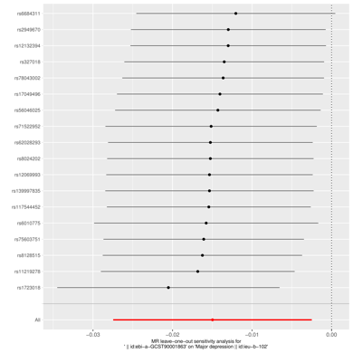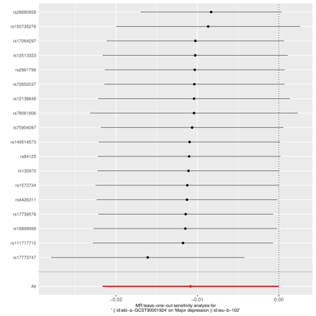

(y) (z) (aa)
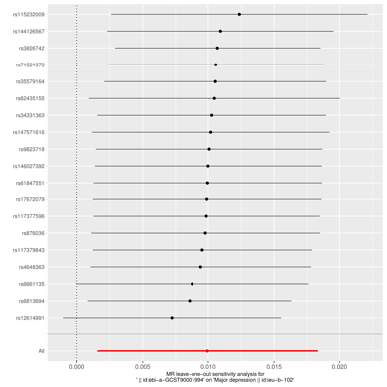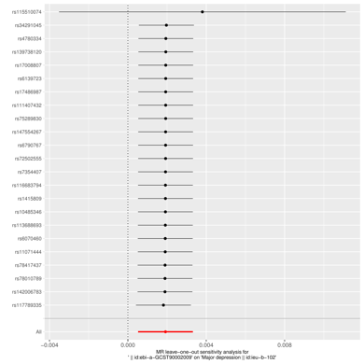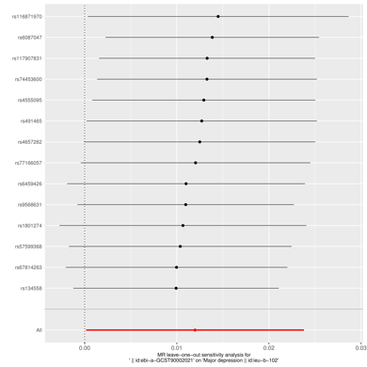
(bb) (cc)
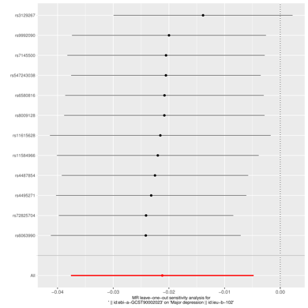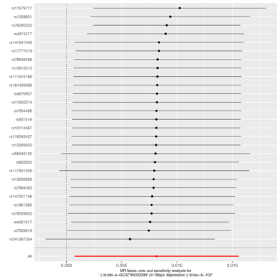
Supplementary Figure 6. The causal relationship between immune cells and MDD (a) Sensitivity-analysis plot between IgD+ CD38dim %B cell and MDD risk; (b)Sensitivity-analysis plot between CD62L- HLA DR++ monocyte %monocyte and MDD risk; (c)Sensitivity-analysis plot between CD62L- DC %DC and MDD risk; (d) Sensitivity-analysis plot between HLA DR++ monocyte %leukocyte and MDD risk; (e) Sensitivity-analysis plot between Activated Treg AC and MDD risk; (f) Sensitivity-analysis plot between B cell %lymphocyte and MDD risk; (g) Sensitivity-analysis plot between CD39+ CD8br %T cell and MDD risk; (h) Sensitivity-analysis plot between CCD45RA- CD28- CD8br %T cell and MDD risk; (i) Sensitivity-analysis plot between BAFF-R on IgD- CD38br and MDD risk; (j) Sensitivity-analysis plot between CD19 on IgD+ CD38br and MDD risk; (k) Sensitivity-analysis plot between CD19 on IgD- CD38- and MDD risk; (l) Sensitivity-analysis plot between CD20 on IgD+ CD38- unsw mem and MDD risk; (m) Sensitivity-analysis plot between CD20 on transitional and MDD risk; (n) Sensitivity-analysis plot between CD25 on IgD+ CD24+ and MDD risk; (o) Sensitivity-analysis plot between CD25 on IgD- CD27- and MDD risk; (p) Sensitivity-analysis plot between CD27 on CD24+ CD27+ and MDD risk; (q) Sensitivity-analysis plot between CD27 on IgD+ CD24+ and MDD risk; (r) Sensitivity-analysis plot between CD27 on IgD+ CD38- unsw mem and MDD risk; (s) Sensitivity-analysis plot between CD27 on IgD- CD38- and MDD risk; (t) Sensitivity-analysis plot between CD27 on IgD- CD38dim and MDD risk; (u) Sensitivity-analysis plot between CD27 on unsw mem and MDD risk; (v) Sensitivity-analysis plot between CD62L on CD62L+ DC and MDD risk; (w) Sensitivity-analysis plot between CD3 on CD28+ CD45RA- CD8br and MDD risk; (x) Sensitivity-analysis plot between CD127 on CD28+ CD4+ and MDD risk; (y)Sensitivity-analysis plot between CX3CR1 on CD14- CD16- and MDD risk; (z) Sensitivity-analysis plot between HLA DR on CD14- CD16- and MDD risk; (aa) Sensitivity-analysis plot between CD14 on CD33dim HLA DR+ CD11b+ and MDD risk; (bb) Sensitivity-analysis plot between CD4 on CM CD4 + and MDD risk; (cc) Sensitivity-analysis plot between CD4RA on TD CD4+ and MDD risk.

(a) (b) (c)
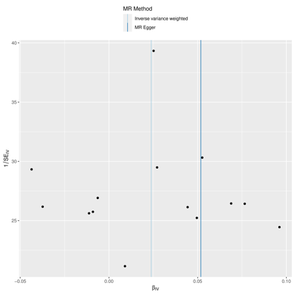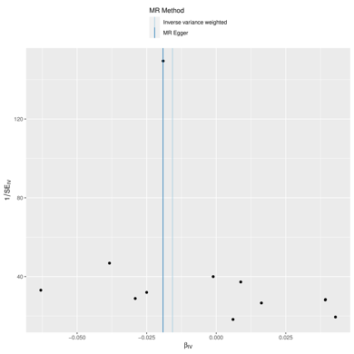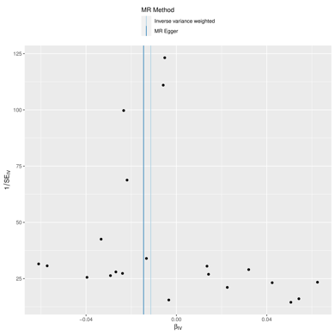
(d) (e) (f)
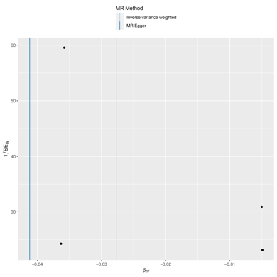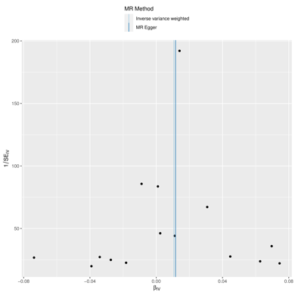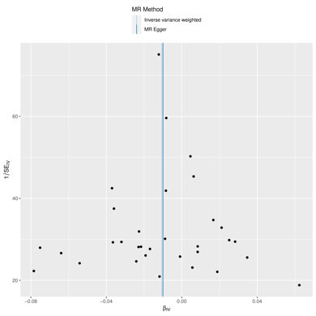
(g) (h) (i)
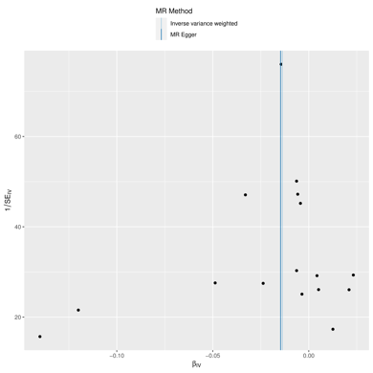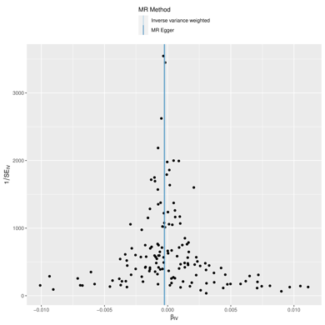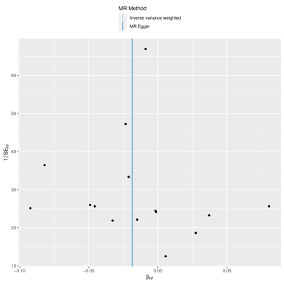
(j) (k) (l)
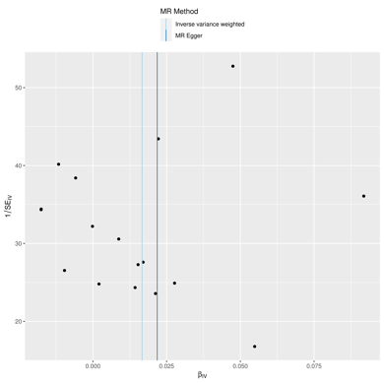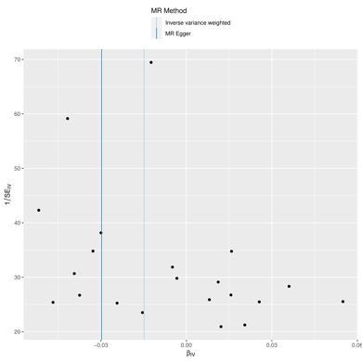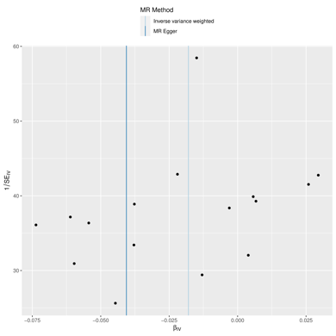

(m) (n) (o)
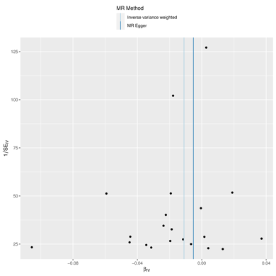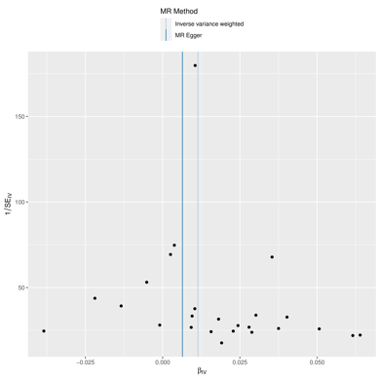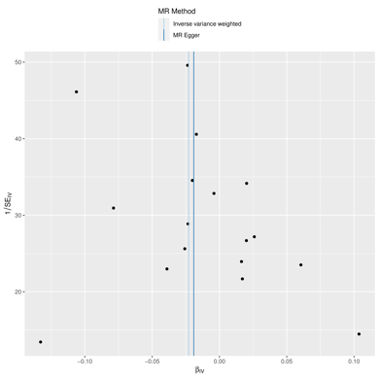
(p) (q) (r)
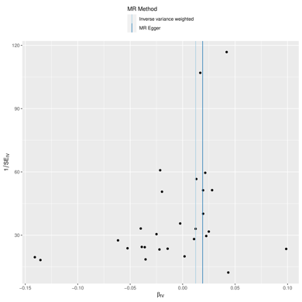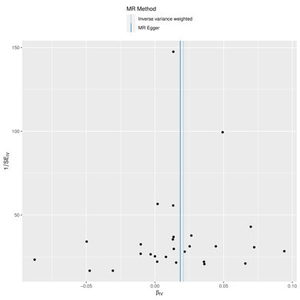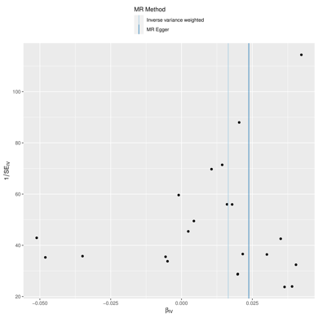
(s) (t) (u)
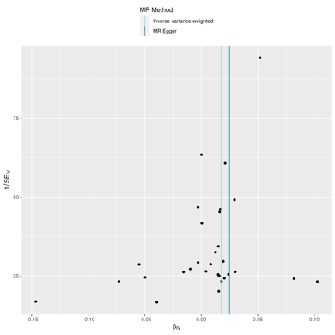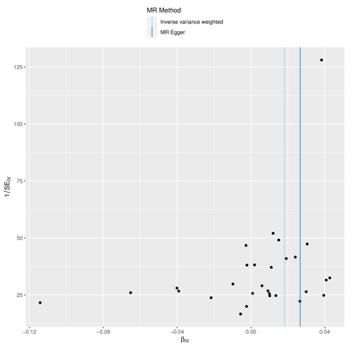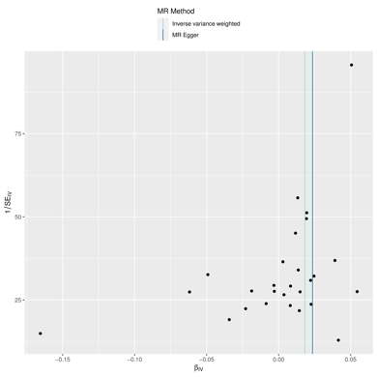
(v) (w) (x)
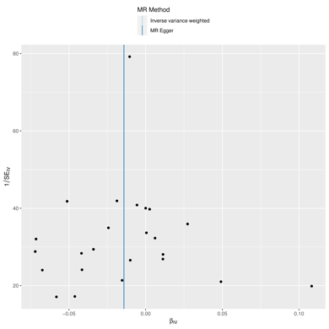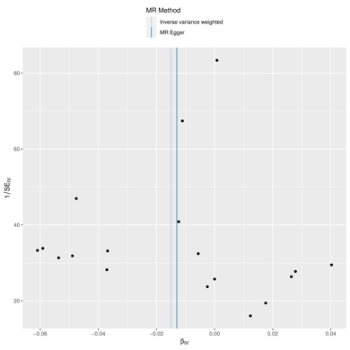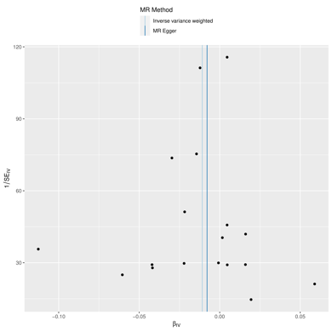

(y) (z) (aa)
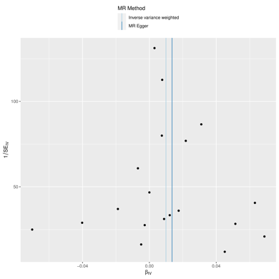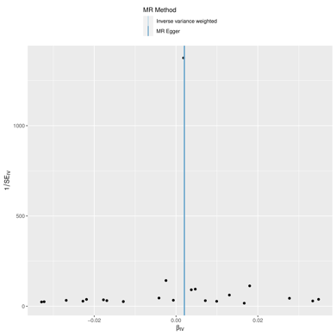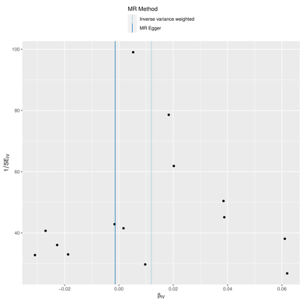
(bb) (cc)
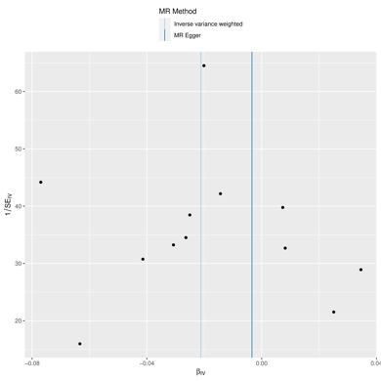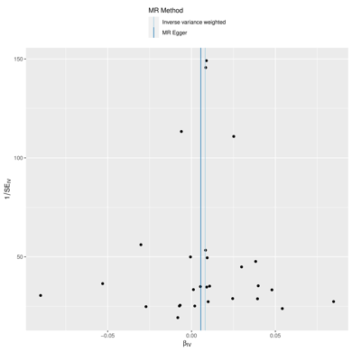
Supplementary Figure 7. The causal relationship between immune cells and MDD (a) Funnel plot between IgD+ CD38dim %B cell and MDD risk; (b)Funnel plot between CD62L- HLA DR++ monocyte %monocyte and MDD risk; (c)Funnel plot between CD62L- DC %DC and MDD risk; (d) Funnel plot between HLA DR++ monocyte %leukocyte and MDD risk; (e) Funnel plot between Activated Treg AC and MDD risk; (f) Funnel plot between B cell %lymphocyte and MDD risk; (g) Funnel plot between CD39+ CD8br %T cell and MDD risk; (h) Funnel plot between CCD45RA- CD28- CD8br %T cell and MDD risk; (i) Funnel plot between BAFF-R on IgD- CD38br and MDD risk; (j) Funnel plot between CD19 on IgD+ CD38br and MDD risk; (k) Funnel plot between CD19 on IgD- CD38- and MDD risk; (l) Funnel plot between CD20 on IgD+ CD38- unsw mem and MDD risk; (m) Funnel plot between CD20 on transitional and MDD risk; (n) Funnel plot between CD25 on IgD+ CD24+ and MDD risk; (o) Funnel plot between CD25 on IgD- CD27- and MDD risk; (p) Funnel plot between CD27 on CD24+ CD27+ and MDD risk; (q) Funnel plot between CD27 on IgD+ CD24+ and MDD risk; (r) Funnel plot between CD27 on IgD+ CD38- unsw mem and MDD risk; (s) Funnel plot between CD27 on IgD- CD38- and MDD risk; (t) Funnel plot between CD27 on IgD- CD38dim and MDD risk; (u) Funnel plot between CD27 on unsw mem and MDD risk; (v) Funnel plot between CD62L on CD62L+ DC and MDD risk; (w) Funnel plot between CD3 on CD28+ CD45RA- CD8br and MDD risk; (x) Funnel plot between CD127 on CD28+ CD4+ and MDD risk; (y)Funnel plot between CX3CR1 on CD14- CD16- and MDD risk; (z) Funnel plot between HLA DR on CD14- CD16- and MDD risk; (aa) Funnel plot between CD14 on CD33dim HLA DR+ CD11b+ and MDD risk; (bb) Funnel plot between CD4 on CM CD4 + and MDD risk; (cc) Funnel plot between CD4RA on TD CD4+ and MDD risk.

(a) (b) (c)
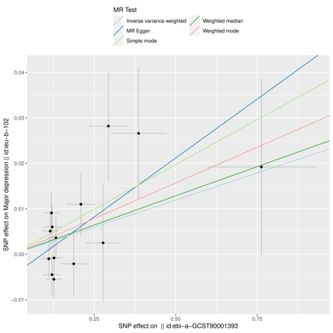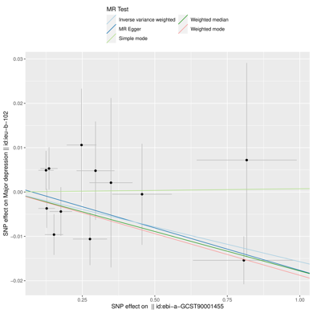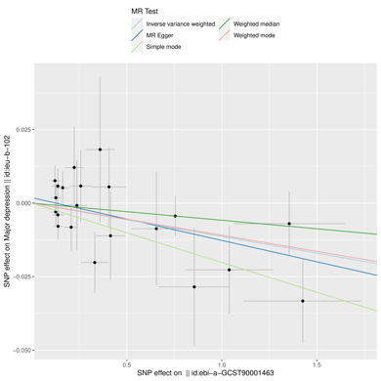
(d) (e) (f)
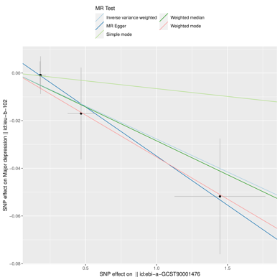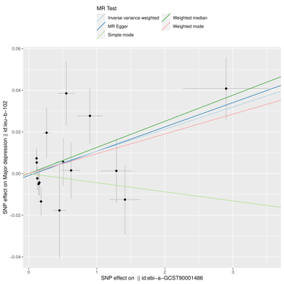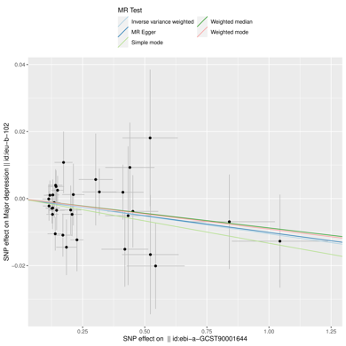
(g) (h) (i)
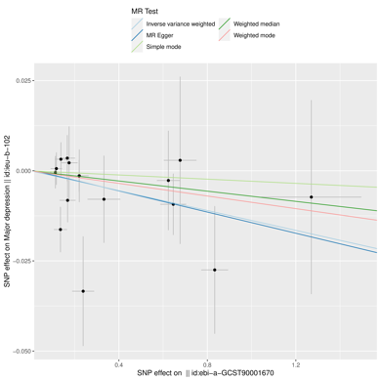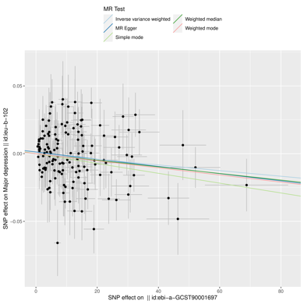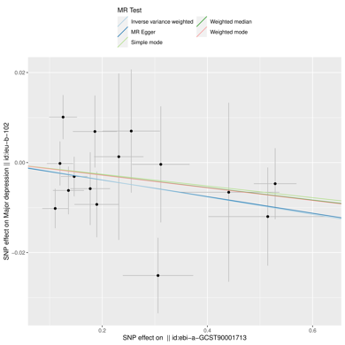
(j) (k) (l)
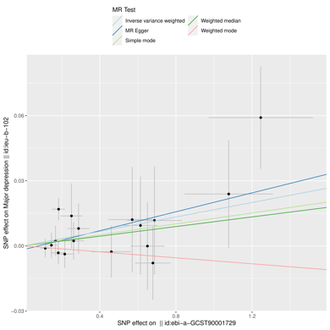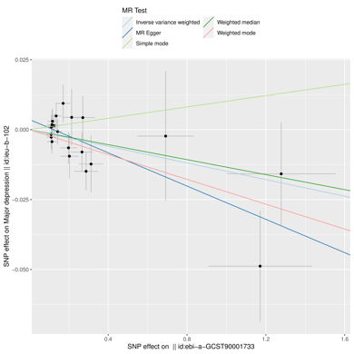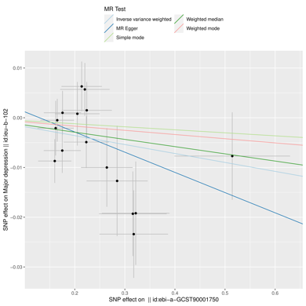

(m) (n) (o)
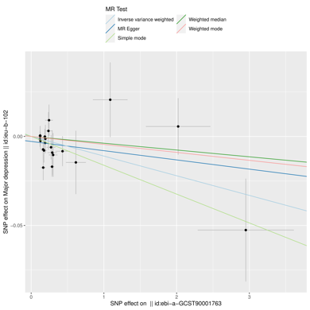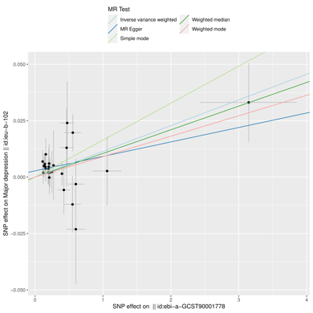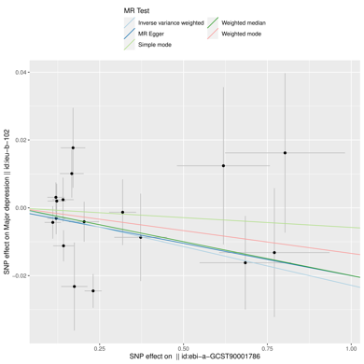
(p) (q) (r)
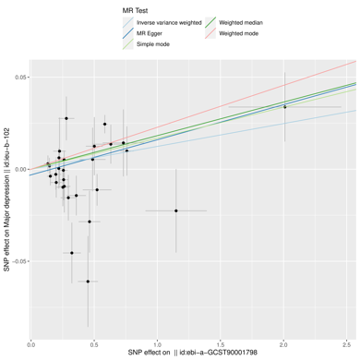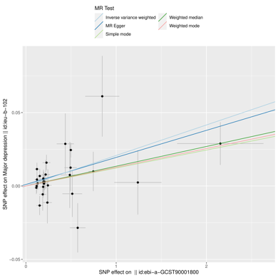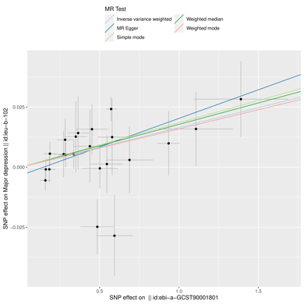
(s) (t) (u)
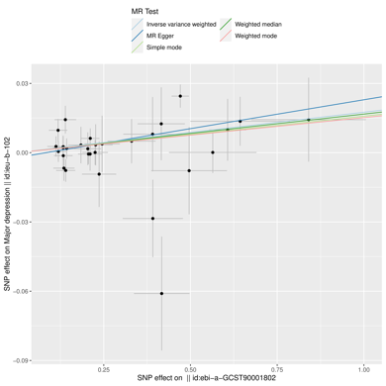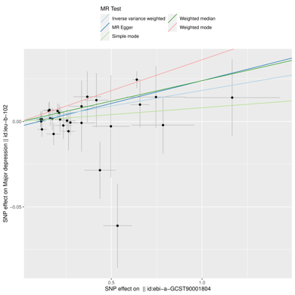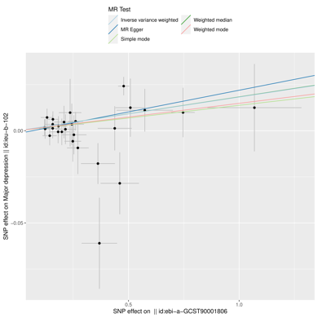
(v) (w) (x)
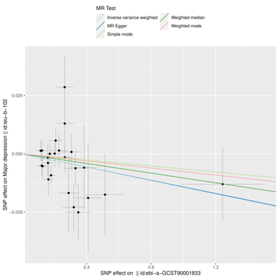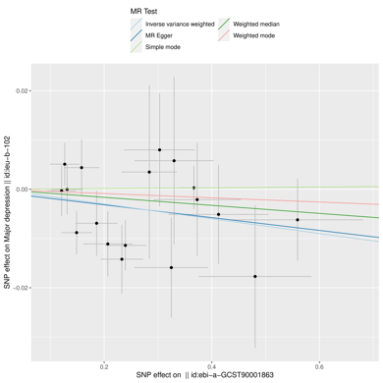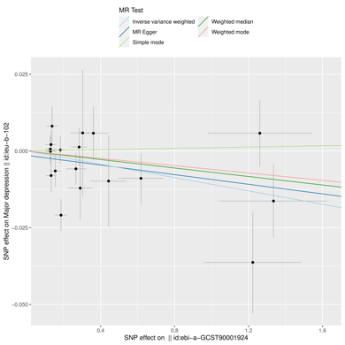

(y) (z) (aa)
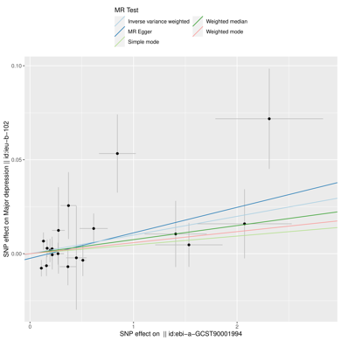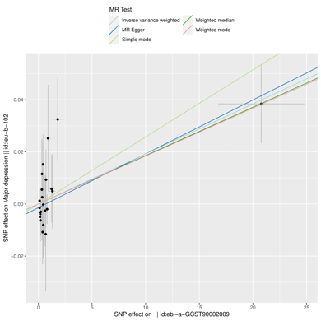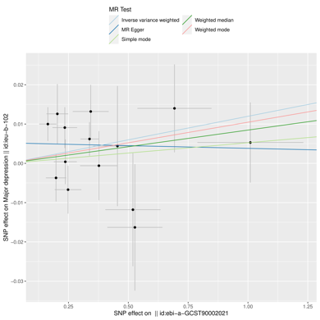
(bb) (cc)
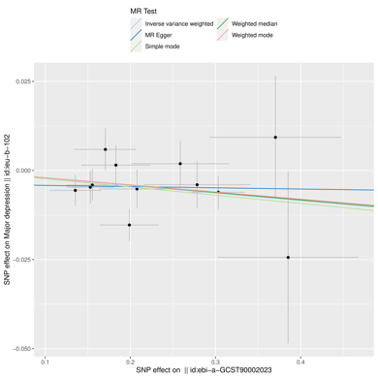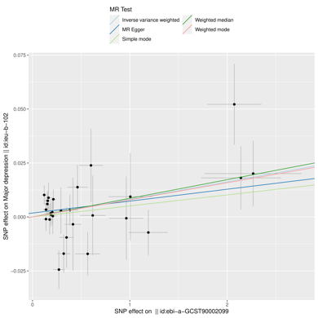
Supplementary Figure 8. The causal relationship between immune cells and MDD (a) Scatter plot between IgD+ CD38dim %B cell and MDD risk; (b)Scatter plot between CD62L- HLA DR++ monocyte %monocyte and MDD risk; (c)Scatter plot between CD62L- DC %DC and MDD risk; (d) Scatter plot between HLA DR++ monocyte %leukocyte and MDD risk; (e) Scatter plot between Activated Treg AC and MDD risk; (f) Scatter plot between B cell %lymphocyte and MDD risk; (g) Scatter plot between CD39+ CD8br %T cell and MDD risk; (h) Scatter plot between CCD45RA- CD28- CD8br %T cell and MDD risk; (i) Scatter plot between BAFF-R on IgD- CD38br and MDD risk; (j) Scatter plot between CD19 on IgD+ CD38br and MDD risk; (k) Scatter plot between CD19 on IgD- CD38- and MDD risk; (l) Scatter plot between CD20 on IgD+ CD38- unsw mem and MDD risk; (m) Scatter plot between CD20 on transitional and MDD risk; (n) Scatter plot between CD25 on IgD+ CD24+ and MDD risk; (o) Scatter plot between CD25 on IgD- CD27- and MDD risk; (p) Scatter plot between CD27 on CD24+ CD27+ and MDD risk; (q) Scatter plot between CD27 on IgD+ CD24+ and MDD risk; (r) Scatter plot between CD27 on IgD+ CD38- unsw mem and MDD risk; (s) Scatter plot between CD27 on IgD- CD38- and MDD risk; (t) Scatter plot between CD27 on IgD- CD38dim and MDD risk; (u) Scatter plot between CD27 on unsw mem and MDD risk; (v) Scatter plot between CD62L on CD62L+ DC and MDD risk; (w) Scatter plot between CD3 on CD28+ CD45RA- CD8br and MDD risk; (x) Scatter plot between CD127 on CD28+ CD4+ and MDD risk; (y)Scatter plot between CX3CR1 on CD14- CD16- and MDD risk; (z) Scatter plot between HLA DR on CD14- CD16- and MDD risk; (aa) Scatter plot between CD14 on CD33dim HLA DR+ CD11b+ and MDD risk; (bb) Scatter plot between CD4 on CM CD4 + and MDD risk; (cc) Scatter plot between CD4RA on TD CD4+ and MDD risk.

