Supplementary Information

Qu et al.

Supplementary Figures

Supplementary Figure 1. Microscopic images. (a, b) TEM, and (c, d) HAADF-STEM images of RhRu₃O_{x}.

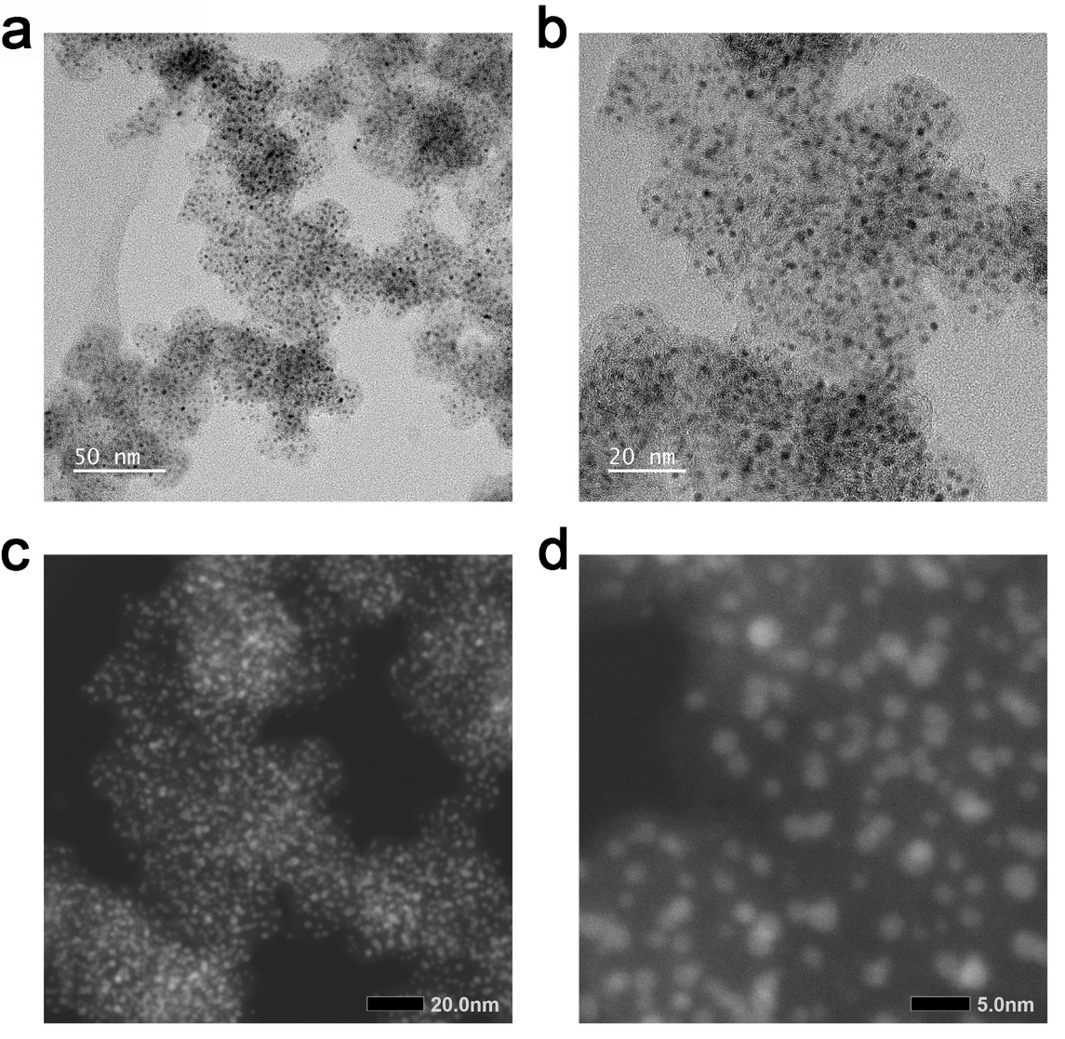
Supplementary Figure 2. Microscopic images. (a, b) TEM, and (c, d) HAADF-STEM images of RhRu₃/C.

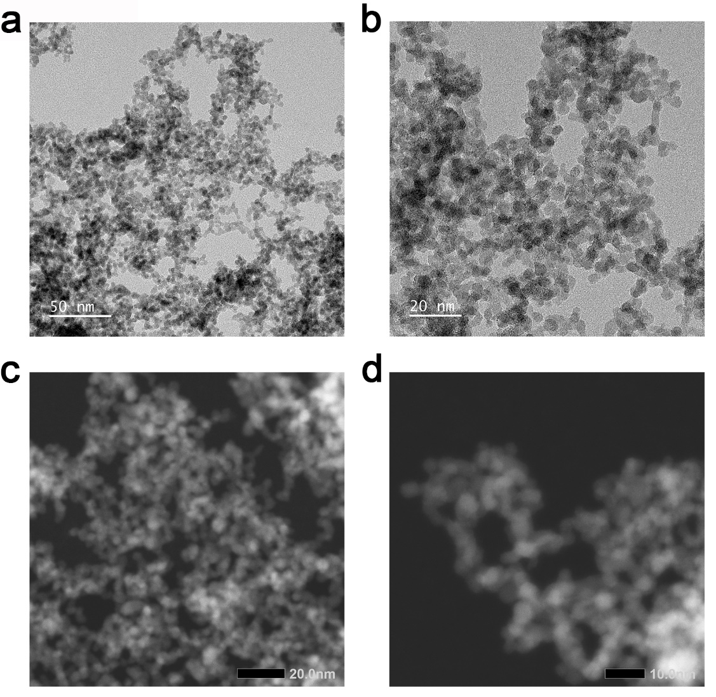
Supplementary Figure 3. Microscopic images. (a, b) TEM, and (c, d) HAADF-STEM images of Hom-RuO₂.

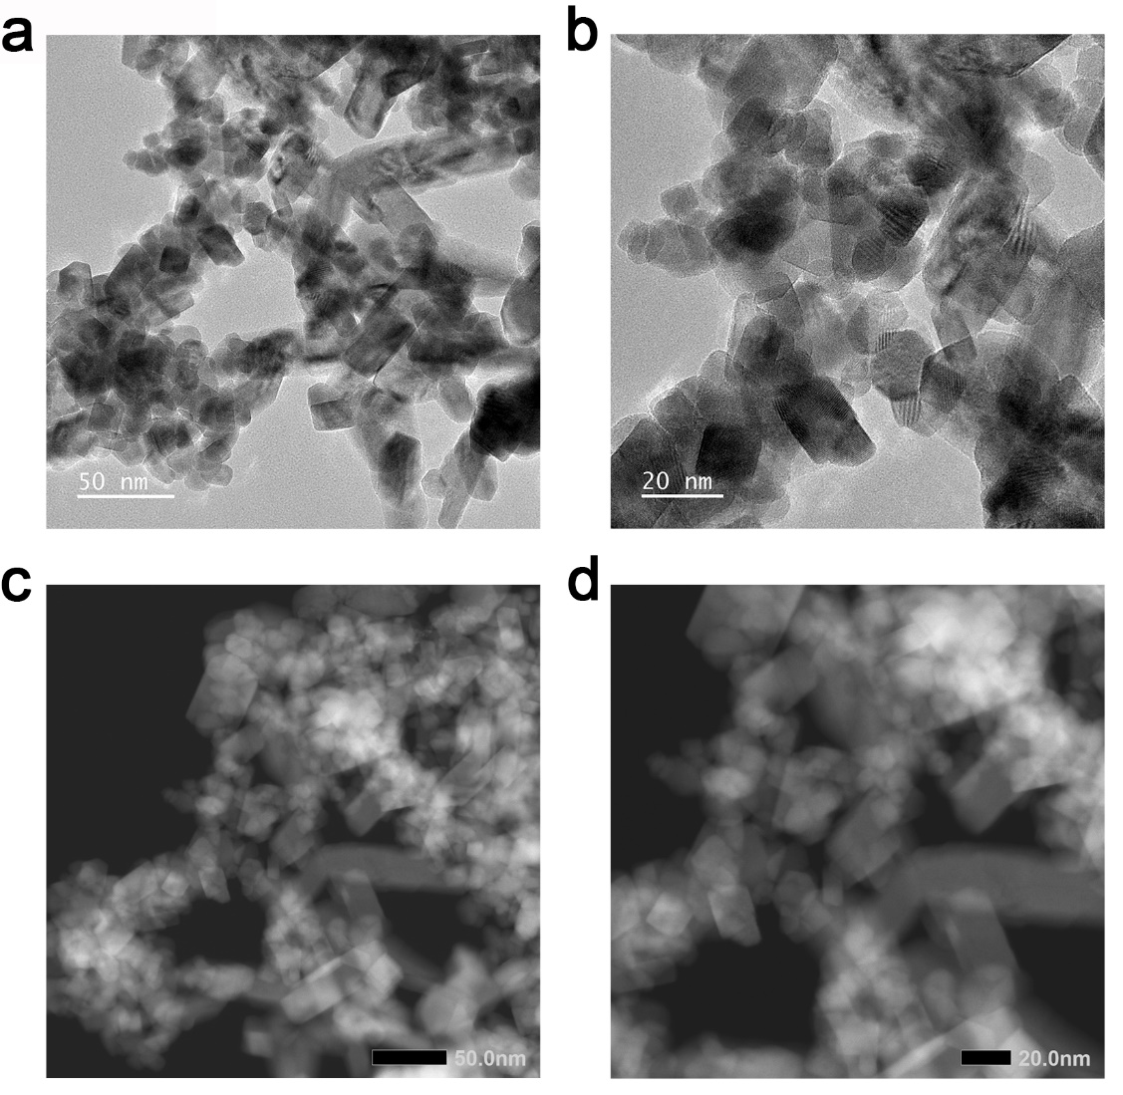
Supplementary Figure 4. Microscopic images. (a, b) TEM, and (c, d) HAADF-STEM images of Com-RuO₂.

Supplementary Figure 5. line-scan analysis. Line-scan analysis corresponds to the part passed by the yellow arrow in Fig. 1f, indicating that Ru and Rh are evenly distributed.

Supplementary Figure 6. N₂ adsorption/desorption isotherms of catalysts. (a) RhRu₃O_{x}. (b) Hom-RuO₂. (c) Com-RuO₂. STP, standard temperature and pressure. The BET surface area and Langmuir surface area of each sample are shown in the inset table. The BET surface area of RhRu₃O_{x}, Hom-RuO₂ and Com-RuO₂ are 197.1450, 164.2436 and 7.8856 m² g⁻¹, respectively. The Langmuir surface area of RhRu₃O_{x}, Hom-RuO₂ and Com-RuO₂ are 1,897.5052, 1,553.6120 and 51.1520 m² g⁻¹, respectively.
Supplementary Figure 7. XPS spectra of catalysts. (a) XPS survey spectra of RhRu₃O_{x}, Hom-RuO₂ and Com-RuO₂. High-resolution O 1s spectra for RhRu₃O_{x} (b), Hom-RuO₂ (c) and Com-RuO₂ (d). The peaks at 533.0, 531.5, and 530.1 eV are lattice oxygen (O_{L}), oxygen vacancy (O_{V}), and adsorbed water¹⁻³, respectively.

Supplementary Figure 8. High-resolution Rh 3d XPS spectrum of RhRu₃O_{x}. There are two peaks at 314.0 and 309.2 eV, corresponding to Rh⁰ 3d_{3/2} and 3d_{5/2}. and the peak at 314.6 and 310.4 eV can be attributed to Rh³⁺ 3d_{3/2} and 3d_{5/2}^{4,5}.

Supplementary Figure 9. High-resolution Ru 3d XPS spectrum of catalysts. The peaks observed around 285.8 and 281.5 eV corresponding to Ru⁴⁺ 3d_{3/2} and 3d_{5/2}, and the peaks observed around 287.2 and 282.9 eV can be attribute to their accompanying satellites^{6,7}. The C 1s peek observed in the sample is due to the carbon bands used in the XPS test⁸. Compared to Hom-RuO₂, the binding energies of Ru⁴⁺ 3d_{3/2} and 3d_{5/2} in RhRu₃O_{x} show a slight negative shift, which indicates that the Ru oxidation state on the surface of RhRu₃O_{x} is slightly lower than that in Hom-RuO₂ and Com-RuO₂.

Supplementary Figure 10. XAS spectra of RhRu₃O_{x}, Hom-RuO₂ and Com-RuO₂ at O K-edge. Sharp peak A (531.5eV) represents the electronic transitions from O 1s to unoccupied O 2p-Ru 4d_t_{2g} hybridized orbitals, and Sharp peak B (534.5eV) represents the transition from O 1s to unoccupied O 2p-Ru 4d_e_{g} hybridized orbitals. The A peak intensity of RhRu₃O_{x} is lower than that of Hom-RuO₂ and Com-RuO₂, which means that the metal atoms in RhRu₃O_{x} occupy more 4d orbital electrons and have fewer empty orbitals, which is consistent with the conclusion that the oxidation state of Ru in RhRu₃O_{x} is the lowest in XPS.

Supplementary Figure 11. Operando XAS spectra of Hom-RuO₂ during the OER. a,b, Operando XANES (a) and EXAFS (b) spectra of Hom-RuO₂ at the Ru K-edge. The black rectangle inserted in (a) shows the magnified Operando spectrum.

Supplementary Figure 12. OER activity of catalysts on RDE in 0.1 M HClO₄. LSV curve of RhRu₃O_{x}, IrRu₃O_{x}, PdRu₃O_{x}, PtRu₃O_{x}, Hom-RuO₂ and Com-RuO₂.

Supplementary Figure 13. Cdl measurement. CV curves of (a) RhRu₃O_{x}, (b) Hom-RuO₂ and (c) Com-RuO₂ collected in the non-faradic current range at scan rates of 2.5, 5, 7.5, 10, 15 and 20 mV/s in 0.1 M HClO₄ electrolyte.

Supplementary Figure 14. Tafel plots of Hom-RuO₂ at different temperatures.

Supplementary Figure 15. Stability evaluation. (a)The dissolution of Ru and Rh during RhRu₃O_{x} stability test on RDE. The volume of electrolytic liquid in RDE test was 200 mL. (b) S numbers of RhRu₃O_{x} during the stability test.

Supplementary Note 1:
The calculation formula is as follows:
$S$ = $\frac{n_{O_{2}}}{n_{Ru(Dissolved)} }$
$n_{O_{2}}$ = $\frac{N_{O_{2}}}{N_{A} }$ = $\frac{N_{e}}{4N_{A} }$ = $\frac{Q}{4{eN}_{A} }$ = $\frac{it}{4{eN}_{A} }$
$n_{Ru(Dissolved)}$ = $\frac{c_{Ru\left(Dissolved\right)*V_{Solution}}}{M_{Ru}}$
$S$ = $\frac{itM_{Ru}}{4{eN}_{A} c_{Ru\left(Dissolved\right)*V_{Solution}}}$ = $\frac{10*{10}^{-3}*0.19625*101.1*t}{4*1.6*{10}^{-19}*6.02*{10}^{23}*200*{10}^{-9} c_{Ru\left(Dissolved\right)}}$ = 2.57$\frac{t}{c_{Ru(Dissolved)} }$

Supplementary Figure 16. Microscopic images. (a, b) TEM, and (c, d) HADDF-STEM images of RhRu₃O_{x} after stability test in RDE.

Supplementary Figure 17. HAADF image and corresponding EDS elem ental mapping images of RhRu₃O_{x} after stability test in RDE.

Supplementary Figure 18. XPS spectra of catalysts. (a) XPS survey spectra of RhRu₃O_{x} after stability test in RDE. Hom-RuO₂ and Com-RuO₂. High-resolution Rh 3d spectra for RhRu₃O_{x} before (b) and after (c) stability test in RDE. High-resolution O 1s spectra for RhRu₃O_{x} before (d) and after (e) stability test in RDE. High-resolution Ru 3d and Ru 3p_{3/2} spectra for RhRu₃O_{x} before (f) and after (g) stability test in RDE.
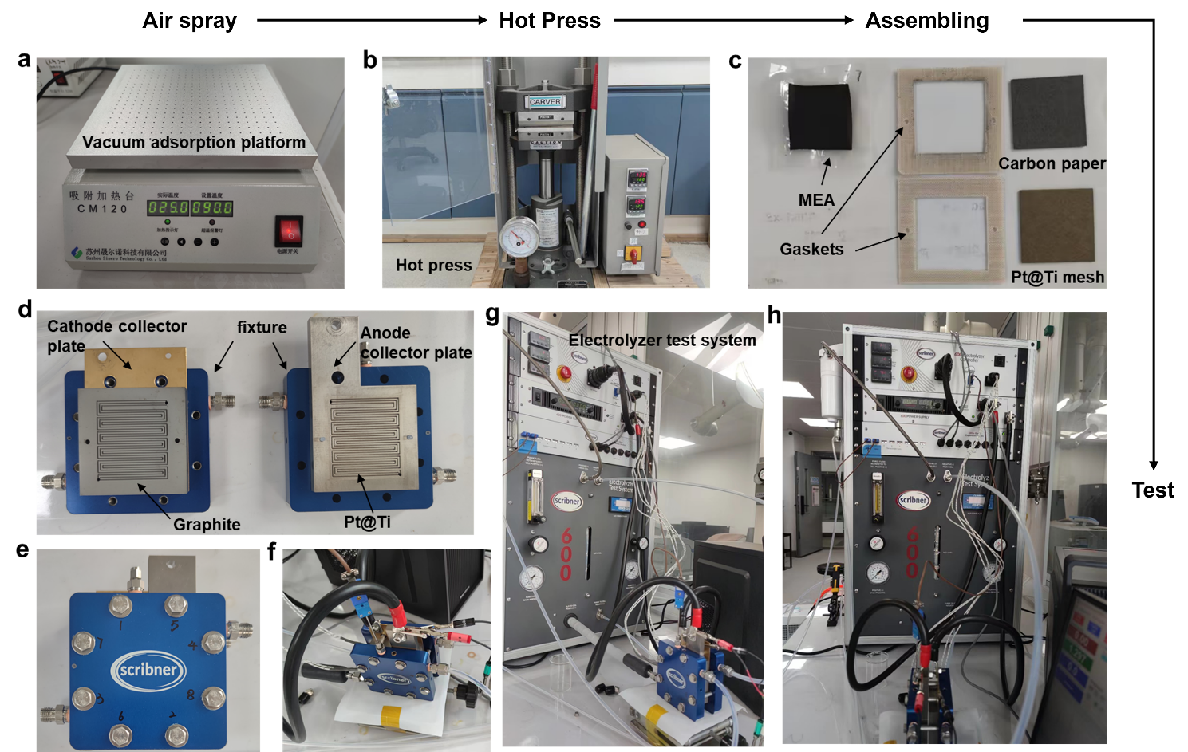
Supplementary Figure 19. Flow diagram of membrane electrode assembly fabrication and PEM-WE device assembly. (a) The vacuum adsorptin platform. (b) Hot press equipment. (c) MEA, gaskets and PTL. (d) Fluid fields and end plates. (e,f) The assembled electrolyzer. (g,h) Integrated PEM electrolytic test system.

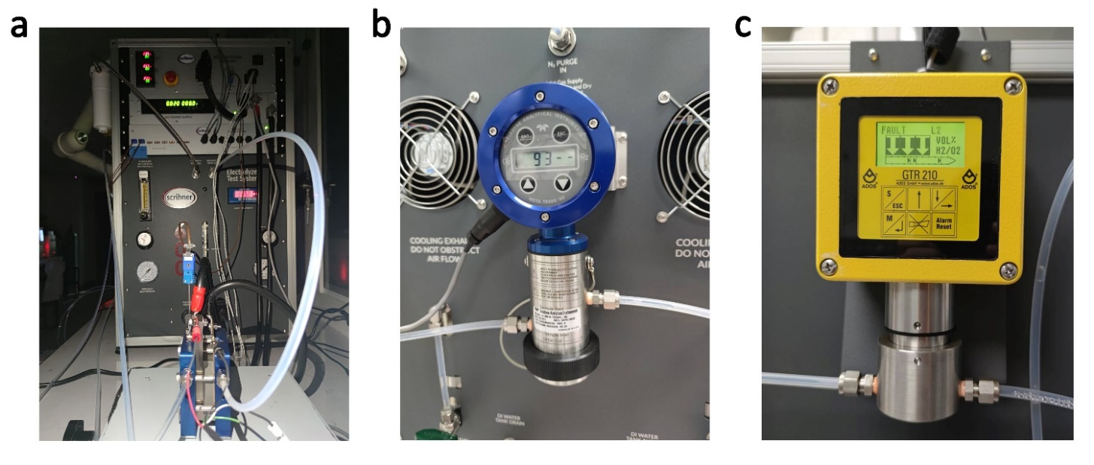
Supplementary Figure 20. Photograph of the integrated PEM electrolytic test system used in this work. (a) The front side of our integrated PEM Electrolysis Test System. (b) The Teledyne analytical instrument InstaTrans-XD O₂ transmitter (O₂ detector) on the back side of our Test System. (c) The ADOS GTR 196 H₂ transmitter (H₂ detector) on the left side of our Test System.

Supplementary Note 2:
The configuration used for the PEM-WE test in this work.
• Model 600 electrolytic cell test system
• Pressure (4-5 bar, 60-75 PSI) high purity purge gas (N₂ > 99.9%)
• Pressure source (2-4.5 bar, 30-65 PSI), high purity water (18 MΩ*cm)
• Electrolysis cell test fixture
• Uninterrupted power supply (Capacity: 3kVA/2.7Kw, AC output: 220VAC, 50Hz, 13.7A)

Supplementary Note 3:
Electrolyzer test fixture electrical connections.
The 600 ETS electrical connection consists of a set of heavy cables for transmitting cell current and independent sense lead connections to measure the voltage of the cell. For accurate measurement, the Leads must be connected directly to the cell terminal. All cells have at least four electrical connections: negative electrode voltage and current, and positive electrode voltage and current. Independent current and voltage inputs are provided for accurately measure the voltage of the cell end plates or current collectors. To be specific, connect the cathode (I-) and anode (I+) current leads of the cell (i.e., the load cable) to the negative and positive end plates of the cell (i.e., the collector), respectively. Then connect the whole cell cathode voltage (V-) and whole cell anode voltage (V+) sense leads to the negative end plate and positive end plate (collector) of the cell respectively. The auxiliary sense leads should be suspended in this configuration to avoid contact with any conductor. It is very important that these leads be used and connected properly. Cell voltage and internal resistance measurements are taken between the sense leads, so their placement on the cell end plates will affect the actual readings.

Supplementary Note 4:
Assembly instructions for standard fluid interface metal pipe fittings and fixing instructions for fixtures.
First, insert the oil pipe into the pipe fitting to ensure that the oil pipe is firmly fixed on the shoulder of the pipe body, and the nut is tightened. Then carve the nut in any position, while maintaining the stability of the accessory body, turn 90 degrees counterclockwise to tighten the nut. The eight bolts of the fixture are tightened diagonally using a torque wrench (DB12N5-S, Tohnichi Mfg. Co.). First tighten the eight bolts with 2 N·m of torque, then increase by 1 N·m in turn, and finally increase to 5 N·m to complete the fixation.

Supplementary Note 5:
Measures to ensure gas purity and safety.
In order to ensure the purity of the generated H₂ and O₂ and the safety of the experiment. The Teledyne analytical instrument InstaTrans-XD O₂ transmitter is installed at the cathode outlet to monitor the O₂ concentration in product H₂ (Supplementary Fig. 21b). The ADOS GTR 196 H₂ transmitter is installed at the anode outlet to monitor the concentration of H₂ in the product O₂ (Supplementary Fig. 21c). A four-pin circular external alarm input connector is connected to an external alarm source, such as a combustible (H₂) gas sensor or other device with a normally closed relay contact output. This will cause the system to shut down automatically. This ensures that the gas product (O₂) purity of all data reported in this work is greater than 99.8%.

Supplementary Figure 21. Equivalent circuit and J-HFR curve of the PEM electrolyzer using RhRu₃O_{x}, Hom-RuO₂ or Com-RuO₂ as anodic catalyst. (a) Associated equivalent electrical circuit of PEM-WE. (b) Cross-sectional SEM of our MEA. (c) Current density vs. high frequency resistance obtained by integrated electrolysis system. (d) Diagram of possible interpretations of the J-HFR curve in (c). The J-HFR curve is divided into three stages, Ⅰ is the stage of curve decline, Ⅱ is the stage of curve rise, and Ⅲ is the stage of continuous decline after reaching the peak.

Supplementary Note 6:
The meaning of different circuit component symbols:
R₀ (Ω·cm²): membrane resistance.
Rª₁ and R^{c}₁ (Ω·cm²): electronic resistance of electron conducting metallic cell components at anode and cathode respectively.
Zª (Ω·cm²): anodic diffusion impedance due to O₂ transport away from the anode and/or to H₂O transport to the anode. Za = Rª₂ + Lª₂ + Cª₂.
Z^{c} (Ω·cm²): cathodic diffusion impedance due to H₂ transport away from the cathode. Z^{c} = R^{c}₂ + L^{c}₂ + C^{c}₂.
Rª₃ and R^{c}₃ (Ω·cm²): electronic contact resistance at anode and cathode respectively.
Qª₃ (F·cm⁻²·s^{n-1}): anodic constant phase element of the anode/electrolyte interface; n is related to the rotation Angle of the pure capacitance line on a complex planar plot.
Q^{c}₃ (F·cm⁻²·s^{n-1}): cathodic constant phase element of the cathode/electrolyte interface.

Supplementary Note 7:
As reported previously, the HFR represents the sum of electronic contact resistance and membrane resistance⁹, and the increase of current density will lead to two diametrically opposite changes in HFR values (Supplementary Figure 21a,b). The first is that the increase of current density will generate more heat, resulting in a local temperature increase at the electrode/membrane interface, so that the ionic conductivity of the membrane increases, manifested as a decrease in HFR value, but this is essentially achieved through other energy dissipation¹⁰; The second is that at high current density, the water flow caused by electroosmotic drag increases (The electroosmotic drag coefficient is defined as the number of water molecules per proton transferred through the membrane in the case of a vanishing gradient in the chemical potential of H₂O), resulting in a decrease in the water content in the area near the membrane anode, which is represented by an increase in the HFR value¹¹. Therefore, the HFR value gradually shifted to the right with Com-RuO₂, Hom-RuO₂, RhRu₃O_{x}, indicating that the mass transfer resistance of the catalyst layer composed of RhRu₃O_{x} was the lowest among the three (Supplementary Figure 21c). Based on the above understanding, we believe that the J-HFR curve presents a phenomenon of first decreasing, then increasing, and then decreasing, because in the initial stage, the anode water supply is sufficient, and the ion conductivity of the membrane dominates the HFR value. After that, the decrease of water content near the membrane anode limited the further decrease of HFR value. Finally, the decrease in HFR value caused by the increase in ionic conductivity gradually compensated for the increase in HFR value caused by the decrease in water content, and gradually dominated the HFR value again (Supplementary Figure 21d).

Supplementary Figure 22. Stability test of Hom-RuO₂. Chronopotentiometry curve of the PEM electrolyzer using Hom-RuO₂ as anodic catalyst and Pt/C as the cathode catalyst operated at 200 mA cm⁻² at room temperature with Nafion 115 membrane.

Supplementary Figure 23. The specific flow diagram of our integrated PEM electrolytic test system.

Supplementary Note 8:
Hydrogen production cost estimation using commercial RuO₂ and RhRu₃O_{x} as anode materials in PEM-WE devices.

Turnover frequency (TOF)
To estimate the turnover frequency of RhRu₃O_{x} and RuO₂ catalysts in the PEM-WE device, we assume that the Faraday efficiency of OER is 100% and we assume all units of RhRu₃O_{x} and RuO₂ are active for the OER¹².

Current density (electrolyzer)  RhRu₃O_{x} loading  RhRu₃O_{x} (Rh_{0.25}Ru_{0.75}O₂) molecular weight  RuO₂ loading  RuO₂ molecular weight | = 0.2 A·cm⁻²  = 3.0 mg·cm⁻²  = 224.2 g·mol⁻¹  = 3.0 mg·cm⁻²  = 133.1 g·mol⁻¹
Elementary charge = 1.602 x 10⁻¹⁹ C
Faraday’s constant, F= 96500 C mol⁻¹
Avogadro’s number = 6.022 x 10²³ mol⁻¹
Reaction: 2H₂O – 4e⁻ → O₂ + 4H⁺

O₂ production per second @ 0.2 A·cm⁻² = (j A·cm⁻²)(1 e⁻ / 1.602 x 10⁻¹⁹ C)(1 O₂ / 4e⁻)
= 0.2 A·cm⁻² / (1.602 x 10⁻¹⁹ C x 4)
= 3.125 x 10¹⁷ O₂·cm⁻²·s⁻¹

Loading RhRu₃O_{x} = 3 x 10⁻³ g·cm⁻²
Loading (mols)of RhRu₃O_{x} = 3 x 10⁻³ g·cm⁻² / 224.2 g·mol⁻¹
= 1.338 x 10⁻⁵ mol·cm⁻²
= 1.338 x 10⁻⁵ mol·cm⁻² x 6.022 x 10²³ mol⁻¹
= 8.057 x 10¹⁸ RhRu₃O_{x} units·cm⁻²

RhRu₃O_{x} TOF = O₂ production rate / number of RhRu₃O_{x} sites
= (3.125 x 10¹⁷ O₂·cm⁻²·s⁻¹) / 8.057 x 10¹⁸ RhRu₃O_{x} units·cm⁻²
= 0.03878 O₂·s⁻¹ (assuming all RhRu₃O_{x} units active)
= 0.07756 H₂·s⁻¹

Loading RuO₂ = 3 x 10⁻³ g·cm⁻²
Loading (mols) of RuO₂ = 3 x 10⁻³ g·cm⁻² / 133.1 g·mol⁻¹
= 2.25 x 10⁻⁵ mol·cm⁻²
= 2.25 x 10⁻⁵ mol·cm⁻² x 6.022 x 10²³ mol⁻¹
= 1.357 x 10¹⁹ RuO₂ units·cm⁻²

RuO₂ TOF = O₂ production rate / number of RuO₂ sites
= (3.125 x 10¹⁷ O₂·cm⁻²·s⁻¹) / 1.357 x 10¹⁹ RuO₂ units·cm⁻²
= 0.02303 O₂·s⁻¹ (assuming all RuO₂ units active)
= 0.04606 H₂·s⁻¹
Membrane Electrode Assembly Efficiency
The lower heating value (LHV) of hydrogen is used to determine the efficiency of the MEA for each PEM-WE device.

O₂ production rate @ 0.2 A·cm⁻² = (j A·cm⁻² )(1 e⁻/1.602 x 10⁻¹⁹ C)(1 O₂/4e⁻)
= 0.2 A·cm⁻² /(1.602 x 10⁻¹⁹ C x 4)
= 3.125 x 10¹⁷ O₂·cm⁻²·s⁻¹

H₂ production rate @ 0.2 A·cm⁻² = 3.125 x 10¹⁷ O₂·cm⁻²·s⁻¹ x 2
=6.25 x 10¹⁷ H₂·cm⁻²·s⁻¹ / 6.022 x 10²³ mol⁻¹
= 1.04 x 10⁻⁶ mol H₂·cm⁻²·s⁻¹

LHV for H₂ = 120 kJ·g⁻¹ H₂ x 2 g·mol⁻¹
= 2.4 x 10⁵ J·mol⁻¹ H₂

H₂ Power Out = (1.04 x 10⁻⁶ mol H₂·cm⁻²·s⁻¹)·( 2.4 x 10⁵ J·mol⁻¹ H₂)
= 0.2496 W·cm⁻²

Electrolyzer Power (RhRu₃O_{x}) @ 0.2 A·cm⁻² = (0.2 A·cm⁻²)·(1.61 V)
= 0.322 W·cm⁻²

Electrolyzer Power (RuO₂) @ 0.2 A·cm⁻² = (0.2 A·cm⁻²)·(1.84 V)
= 0.368 W·cm⁻²
Energy Conversion Efficiency = (H₂ Power Out) / (Electrolyzer Power)

Efficiency of RhRu₃O_{x} - based PEM = (0.2496 W·cm⁻²) / (0.322 W·cm⁻²)
= 77.5%
Efficiency of RuO₂ - based PEM = (0.2496 W·cm⁻²) / (0.368 W·cm⁻²)
= 67.8%

Hydrogen production cost estimation
Specific sample for calculating the cost of hydrogen production by water splitting:
Taking the 50-ton daily capacity of H₂ as an example at a current density of 0.2 A cm⁻². At the current density of 0.2 A cm⁻², the operating voltage of RhRu₃O_{x} is 1.61V and Com-RuO₂ is 1.84V.
The specific assumptions made for the TEA are listed as follows:

- According to the International Renewable Energy Agency's "Renewable Energy Generation Costs in 2022", The global weighted-average levelized cost of electricity (LCOE)¹³ for solar photovoltaic is 0.049$ kWh⁻¹, onshore wind is 0.033$ kWh⁻¹, and offshore wind is 0.081$ kWh⁻¹. Here we take the LOCE for solar photovoltaic, that is, the electricity price of 0.049$ kWh⁻¹ as an example.

- Using a 200 kW PEM system as an example, the cost of a PEM stack is 686 $ kW⁻¹, with PTL accounting for about 17%-25% of the stack cost, bipolar plates about 12%-21%, and end plates and assembly about 3%-13%¹⁴. Here, we take the highest cost required for evaluation, with PTL accounting for 25% of the stack cost, bipolar plate about 21%, and end plate and assembly about 13%.

- CCM uses our own materials, so it needs to be listed separately for evaluation. According to the precious metal futures price in March 2024, platinum is 875.8$ ounce⁻¹ (30.89$ g⁻¹) and ruthenium is 435$ ounce⁻¹ (15.34$ g⁻¹).

- The anticipated service life of the electrolyzer was set at 5 years and the working time per year was set at 330 days.

- The cost of Balance of Plant (BOP) was set as 613$ kW⁻¹. The power electronics system accounts for half of the cost of a blowout preventer, while the water cycle and hydrogen treatment subsystems each account for one-fifth of the cost of a blowout preventer. The remaining one-tenth we classify as cooling costs¹⁴.

The required total current is calculated as:
Total Current = $\frac{200000 kg}{day}$ × $\frac{1 day}{86400 s}$ × $\frac{1000 g}{kg}$ × $\frac{1 mol}{32g}$ × 4e⁻ × $\frac{96485 C}{mol}$ × $\frac{1}{100\%}$ = 27918113 A

The needed electrolyzer area was determined as:
𝐸𝑙𝑒𝑐𝑡𝑟𝑜𝑙𝑦𝑧𝑒𝑟 𝐴𝑟𝑒𝑎 = 27918113A × $\frac{1}{{0.2 A cm}^{-2}}$ × $\frac{m^{2}}{{10000 cm}^{2}}$ = 13959 m²

The total cost of the proposed water electrolysis process for hydrogen production includes PEM stack costs, operating costs and balance of plant costs.

- PEM stack cost：
  - CCM:
The anode load of the CCM prepared by us is 3 mg cm⁻², and the cathode load is 0.6 mg cm⁻².
Anode: 15.34 $ g⁻¹ × $\frac{3 mg}{{cm}^{2}}$ × 13959 m² × $\frac{1 g}{1000 mg}$ × $\frac{{10000 cm}^{2}}{m^{2}}$ × $\frac{1}{5 year}$ × $\frac{1 year}{330 day}$ × $\frac{day}{200 ton}$ = 19.466 $ per ton O₂ = 77.866 $ per ton H₂
Producing 4-ton O₂ is equivalent to producing 1-ton H₂, so 19.466 $ per ton O₂ is equivalent to 77.866 $ per ton H₂.
Cathode: 30.89 $ g⁻¹ × $\frac{0.6 mg}{{cm}^{2}}$ × 40% × 13959 m² × $\frac{1 g}{1000 mg}$ × $\frac{{10000 cm}^{2}}{m^{2}}$ × $\frac{1}{5 year}$ × $\frac{1 year}{330 day}$ × $\frac{day}{200 ton}$ = 3.136 $ per ton O₂ = 12.544 $ per ton H₂
  - PTL:
686 $ kW⁻¹ ×13959 m² × 0.2 A cm⁻² × 1.61V × $\frac{1}{5 year}$ × $\frac{1 year}{330 day}$ × $\frac{day}{200 ton}$ × $\frac{{10000 cm}^{2}}{m^{2}}$ × $\frac{1kW}{1000 W}$ × 25% = 23.36 $ per ton O₂ = 93.44 $ per ton H₂
  - Bipolar Plate:
686 $ kW⁻¹ ×13959 m² × 0.2 A cm⁻² × 1.61V × $\frac{1}{5 year}$ × $\frac{1 year}{330 day}$ × $\frac{day}{200 ton}$ × $\frac{{10000 cm}^{2}}{m^{2}}$ × $\frac{1kW}{1000 W}$ × 21% = 19.62 $ per ton O₂ = 78.49 $ per ton H₂
  - End Plate and Assembly:
686 $ kW⁻¹ ×13959 m² × 0.2 A cm⁻² × 1.61V × $\frac{1}{5 year}$ × $\frac{1 year}{330 day}$ × $\frac{day}{200 ton}$ × $\frac{{10000 cm}^{2}}{m^{2}}$ × $\frac{1kW}{1000 W}$ × 21% = 12.15 $ per ton O₂ = 48.59 $ per ton H₂

- Operating Cost：
  - Electricity:
27918113 A × 1.61V × $\frac{day}{200 ton}$ × $\frac{1kW}{1000 W}$ × $\frac{24 h}{day}$ × 0.049 $ kWh⁻¹ = 264.30 $ per ton O₂ = 1057.18 $ per ton H₂

- Balance of Plant：
  - Power Electronics System:
613 $ kW⁻¹ × 27918113 A × 1.61V × $\frac{1kW}{1000 W}$ × $\frac{1}{5 year}$ × $\frac{1 year}{330 day}$ × $\frac{day}{200 ton}$ × 50% = 41.75 $ per ton O₂ = 166.98 $ per ton H₂
  - Water Circulation:
613 $ kW⁻¹ × 27918113 A × 1.61V × $\frac{1kW}{1000 W}$ × $\frac{1}{5 year}$ × $\frac{1 year}{330 day}$ × $\frac{day}{200 ton}$ × 20% = 16.70 $ per ton O₂ = 66.80 $ per ton H₂
  - Hydrogen Processing:
613 $ kW⁻¹ × 27918113 A × 1.61V × $\frac{1kW}{1000 W}$ × $\frac{1}{5 year}$ × $\frac{1 year}{330 day}$ × $\frac{day}{200 ton}$ × 20% = 16.70 $ per ton O₂ = 66.80 $ per ton H₂
  - Cooling:
613 $ kW⁻¹ × 27918113 A × 1.61V × $\frac{1kW}{1000 W}$ × $\frac{1}{5 year}$ × $\frac{1 year}{330 day}$ × $\frac{day}{200 ton}$ × 10% = 8.35 $ per ton O₂ = 33.40 $ per ton H₂

- The total cost:
RhRu₃O_{x}:
Total Cost = 77.87 + 12.54 + 93.44 + 78.49 + 48.59 + 1057.18 + 166.98 + 66.80 + 66.80 + 33.40 = 1702.09 $ per ton H₂
Com-RuO₂:
Total Cost = 252 + 1208.2 + 381.68 = 1841.88 $ per ton H₂
Since Com-RuO₂ did not pass our stability tests, the cost here is calculated based on activity and is therefore for reference only.

Supplementary Figure 24. I–V curves at 60ºC. I–V curves of the PEM electrolyzer using RhRu₃O_{x} as anodic catalyst and Pt/C as cathodic catalyst obtained at room temperature or 60ºC with Nafion 115 membrane.

Supplementary Figure 25. Stability test of RhRu₃O_{x} at 60ºC. Chronopotentiometry curve of the PEM electrolyzer using RhRu₃O_{x} as anodic catalyst and Pt/C as the cathode catalyst operated at 500 mA cm⁻² at 60ºC with Nafion 115 membrane. The stack voltage at the beginning (1.6V) to reach 500 mA cm⁻² at 60 ºC was even lower than the stack voltage required in room temperature (1.61V) to reach 200 mA cm⁻².

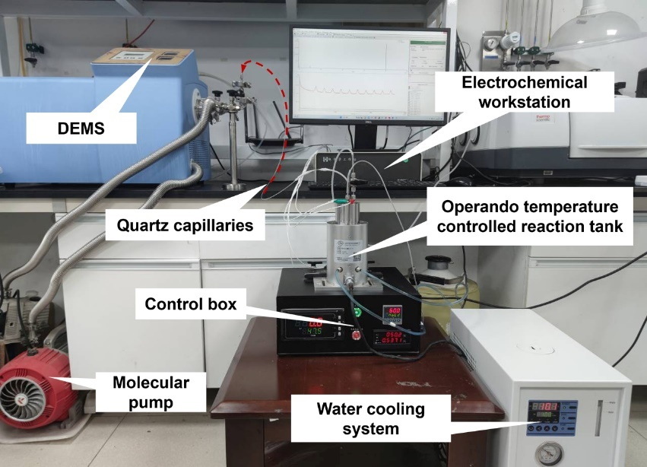
Supplementary Figure 26. Photograph of operando TC-DEMS tandem experimental device. The tandem experimental device consists of an electrochemical workstation, a differential electrochemical mass spectrometry, a homemade electrochemical reactor, and a water-cooling system. Some parameter information of our homemade electrochemical reactor. Pool volume: 20 mL; Variable temperature range: RT~200 ℃; Temperature control accuracy: ± 0.1 ℃; Magnetic stirring rate range 0-1,200 rpm. Maximum withstand pressure <=5MPa.

Supplementary Figure 27. Labeling experiments in H₂¹⁸O/0.1M HClO₄. Chronopotentiometry curve at constant current density of 10 mA cm⁻².

Supplementary Figure 28. Mass spectrum signal comparison. The signal base of ³²O₂ is flattened, then multiplied by the natural abundance of ¹⁸O by 0.2%, and compared with the signal of ³⁴O₂ after the baseline is flattened at room temperature (a) and 60ºC (b).

Supplementary Figure 29. Simplified schematic diagram of isotopic labeling experiments following different OER mechanisms. The upper part represents AEM and the bottom part represents LOM. The O atoms in the S1 plane represent adsorption by van der Waals forces, and the O atoms in the S2 plane represent adsorption by forming chemical bonds.

Supplementary Note 9:
Inference of OER reaction mechanism
If the reaction mechanism follows AEM, then after ¹⁸O labeling, ¹⁶O rinsing and finally reacting with ¹⁶O, the resulting ³⁴O₂:³²O₂ ratio should be maintained near 0.4%, which is derived from the natural abundance of ¹⁸O of 0.2% ¹⁵; The specific derivation process is as follows:
When the first and second oxygens of O₂ are both ¹⁶O,
³²O₂ (¹⁶O-¹⁶O) = 99.8%*99.8% = 99.6004%
When the first oxygen of O₂ is ¹⁶O and the second oxygen is ¹⁸O; Or when the first oxygen is ¹⁸O and the second oxygen is ¹⁶O,
³⁴O₂ (¹⁶O-¹⁸O, ¹⁸O-¹⁶O) = 99.8%*0.2%+99.8%*0.2% = 0.1996%+0.1996% = 0.3992%
When the first and second oxygens of O₂ are both ¹⁸O,
³⁶O₂ (¹⁸O-¹⁸O) = 0.2%*0.2% = 0.0004%
The ratio of ³⁴O₂:³²O₂ is:
³⁴O₂:³²O₂ = 0.3992%÷99.6004% ≈ 0.4%
If the LOM is followed, the resulting ³⁴O₂:³²O₂ ratio should be higher than 0.4% after the same labeling process, and as the reaction progresses, the lattice oxygen labeled ¹⁸O is gradually consumed, so that the resulting ³⁴O₂:³²O₂ ratio gradually decreases and approaches 0.4% during this process.

Supplementary Table 1. ECSA parameters for different catalysts.
Catalysts | C_{dl} (F) | ECSA (cm² _{ECSA})
RhRu₃O_{x}  Hom-RuO₂  Com-RuO₂ | 0.01877 | 536
RhRu₃O_{x}  Hom-RuO₂  Com-RuO₂ | 0.01203 | 344
RhRu₃O_{x}  Hom-RuO₂  Com-RuO₂ | 0.00376 | 107

Supplementary Table 2. Operating conditions and corresponding performance of anode catalysts in PEM-WE device.
Catalysts | Stability (h) | Cell voltage (V) | Electrolyte | T (ºC) |  | j (mA cm⁻²) | ref
RhRu₃O_{x}  Ni-RuO₂  SnRuO_{x}  SS Pt-RuO₂ HNSs  W_{0.2}Er_{0.1}Ru_{0.7}  Nb_{0.1}Ru_{0.9}O₂  RuO₂/Ag nanowire  SrRuIr  (Mn_{0.94}Ru_{0.06})O₂  RuO₂/D-TiO₂  (Ru-W)O_{x}  (Ru-W)O_{x} | 1000 | 1.6 | DIW | RT | 200 |  | This work
 | 1000  1300 | ~1.725  1.565 | 0.1M HClO₄  DIW | RT  50 | 200  1000 |  | ³  ⁶
 | 100 | 1.75 | DIW | RT | 100 |  | ¹⁶
 | 120 | 1.6 | 0.5M H₂SO₄ | RT | 100 |  | ¹⁷
 | 100 | 1.54 | DIW | 80 | 300 |  | ¹⁸
 | 120  150  200  100  50  500 | ~1.74  1.5  ~1.4  1.5  1.62  1.48 | DIW  DIW  DIW  0.5M H₂SO₄  DIW  DIW | 80  80  80  80  80  80 | 200  1000  10  200  1000  100 |  | ¹⁹  ²⁰  ¹  ²¹  ²²  ²²
T stands for Temperature, j stands for Current density.

Supplementary Table 3. Change in competitiveness of solar and wind by country based on global weighted average LCOE, 2010-2022. (Data comes from the International Renewable Energy Agency's "Renewable Energy Generation Costs in 2022")¹³
LCOE (US$ per kWh) | 2010 | 2022
Solar photovoltaic  Offshore wind  Onshore wind | 0.445  0.197 | 0.049  0.081
Solar photovoltaic  Offshore wind  Onshore wind | 0.107 | 0.033
Fossil fuel cost range from 0.244 to 0.069 US$ per kWh.

Supplementary Table 4. The probability of existence of ³²O₂, ³⁴O₂ and ³⁶O₂ (the natural abundance of ¹⁸O of 0.2%).
Types of isotopic oxygen | Probability of existence |  | Probability of existence | O₂ (¹⁶O-¹⁶O, ¹⁸O-¹⁸O)
¹⁶O  ¹⁸O | 99.8% | 99.8% |  | 99.6004%
¹⁶O  ¹⁸O | 0.2% | 0.2% |  | 0.0004%
O₂ (¹⁶O-¹⁸O, ¹⁸O-¹⁶O) | 0.1996% | 0.1996% |  | 100%
The ratio of ³⁴O₂:³²O₂ is:
³⁴O₂:³²O₂ = (0.1996%+0.1996%)÷99.6004% ≈ 0.4%

References
1 Kim, D. et al. Electronic structure modulation of MnO2 by Ru and F incorporation for efficient proton exchange membrane water electrolysis. J. Mater. Chem. A 10, 21985-21994, (2022).
2 Wang, Y. et al. Unraveling oxygen vacancy site mechanism of Rh-doped RuO₂ catalyst for long-lasting acidic water oxidation. Nat. Commun. 14, 10, (2023).
3 Wu, Z. Y. et al. Non-iridium-based electrocatalyst for durable acidic oxygen evolution reaction in proton exchange membrane water electrolysis. Nat. Mater. 22, 100-108, (2023).
4 Guo, Y. Y. et al. Noble metal alloy thin films by atomic layer deposition and rapid Joule heating. Sci Rep 12, 9, (2022).
5 Zhu, J. Y. et al. In situ bubble template-assisted synthesis of phosphonate-functionalized Rh nanodendrites and their catalytic application. Crystengcomm 19, 2946-2952, (2017).
6 Shi, Z. P. et al. Customized reaction route for ruthenium oxide towards stabilized water oxidation in high-performance PEM electrolyzers. Nat. Commun. 14, 14, (2023).
7 Chen, F. Y. et al. Efficient conversion of low-concentration nitrate sources into ammonia on a Ru-dispersed Cu nanowire electrocatalyst. Nat. Nanotechnol. 17, 759-767, (2022).
8 Lin, C. et al. In-situ reconstructed Ru atom array on α-MnO2 with enhanced performance for acidic water oxidation. Nat. Catal. 4, 1012-1023, (2021).
9 Bernt, M., Siebel, A. & Gasteiger, H. A. Analysis of Voltage Losses in PEM Water Electrolyzers with Low Platinum Group Metal Loadings. J. Electrochem. Soc. 165, F305-F314, (2018).
10 Suermann, M., Schmidt, T. J. & Buchi, F. N. Investigation of mass transport losses in polymer electrolyte electrolysis cells. ECS Trans. (USA) 69, 1141-1148, (2015).
11 Ise, M., Kreuer, K. D. & Maier, J. Electroosmotic drag in polymer electrolyte membranes: an electrophoretic NMR study. Solid State Ion. 125, 213-223, (1999).
12 King, L. A. et al. A non-precious metal hydrogen catalyst in a commercial polymer electrolyte membrane electrolyser. Nat. Nanotechnol. 14, 1071-1074, (2019).
13 Renewable power generation costs in 2022. ( International Renewable Energy Agency, 2023).
14 Mayyas., A., Ruth., M., Pivovar., B., Bender., G. & Wipke., K. Manufacturing Cost Analysis for Proton Exchange Membrane Water Electrolyzers. (National Renewable Energy Laboratory, 2019).
15 Grimaud, A. et al. Activating lattice oxygen redox reactions in metal oxides to catalyse oxygen evolution (vol 9, pg 457, 2017). Nat. Chem. 9, 1, (2017).
16 Wang, J. et al. Single-site Pt-doped RuO2 hollow nanospheres with interstitial C for high-performance acidic overall water splitting. Sci. Adv. 8, 11, (2022).
17 Hao, S. Y. et al. Dopants fixation of Ruthenium for boosting acidic oxygen evolution stability and activity. Nat. Commun. 11, 11, (2020).
18 Liu, H. et al. Eliminating over-oxidation of ruthenium oxides by niobium for highly stable electrocatalytic oxygen evolution in acidic media. Joule 7, 558-573, (2023).
19 Tang, J. Y., Zhong, Y. J., Su, C. & Shao, Z. P. Silver Compositing Boosts Water Electrolysis Activity and Durability of RuO2 in a Proton-Exchange-Membrane Water Electrolyzer. Small Sci. 3, 9, (2023).
20 Wen, Y. Z. et al. Stabilizing Highly Active Ru Sites by Suppressing Lattice Oxygen Participation in Acidic Water Oxidation. J. Am. Chem. Soc. 143, 6482-6490, (2021).
21 Wang, X. J. et al. Electronic Structure Modulation of RuO2 by TiO2 Enriched with Oxygen Vacancies to Boost Acidic O2 Evolution. ACS Catal. 12, 9437-9445, (2022).
22 Deng, L. et al. Valence Oscillation of Ru Active Sites for Efficient and Robust Acidic Water Oxidation. Advanced Materials 35.48 (2023): 2305939.

