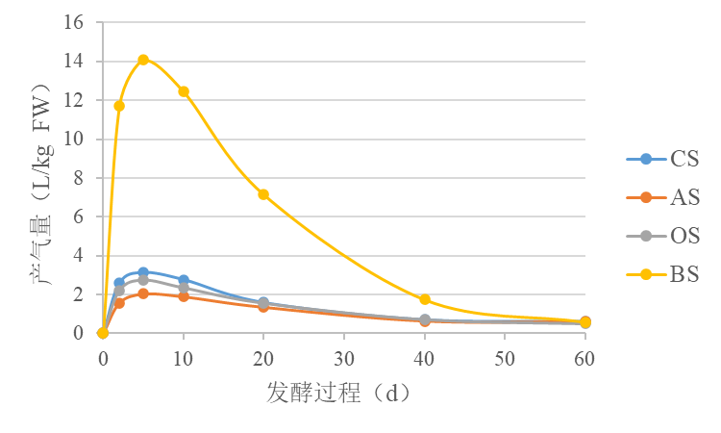
Figure S1. Gas production of different silages during fermentation (n = 4).
Gas productions (L/kg FW)
Ensiling day (d)
CS, Whole-plant corn silage; AS, Alfalfa silage; OS, Oat silage; BS, barley silage.
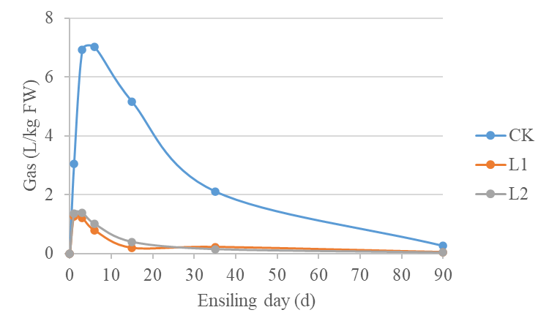
Figure S2. Gas production of barley silage during fermentation (n = 4).

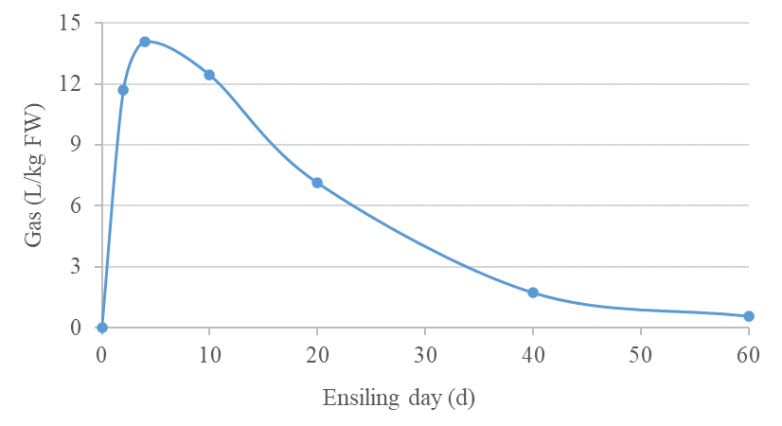Figure S3. Gas production of barley silage without any additives during fermentation in our other study (n = 4).
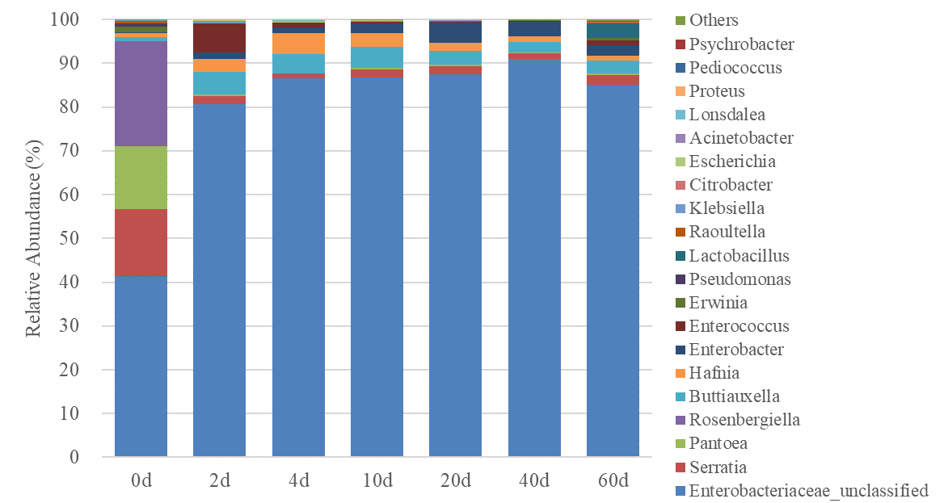
Figure S4. Relative abundance of bacterial communities (family level) of barley silage during fermentation in our other study (n = 4)
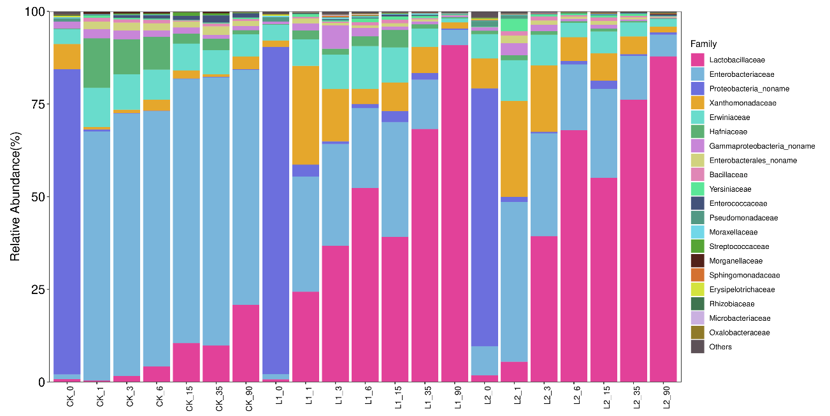
Figure S5. Relative abundance of bacterial communities (family level) of barley silage during fermentation (n = 4)

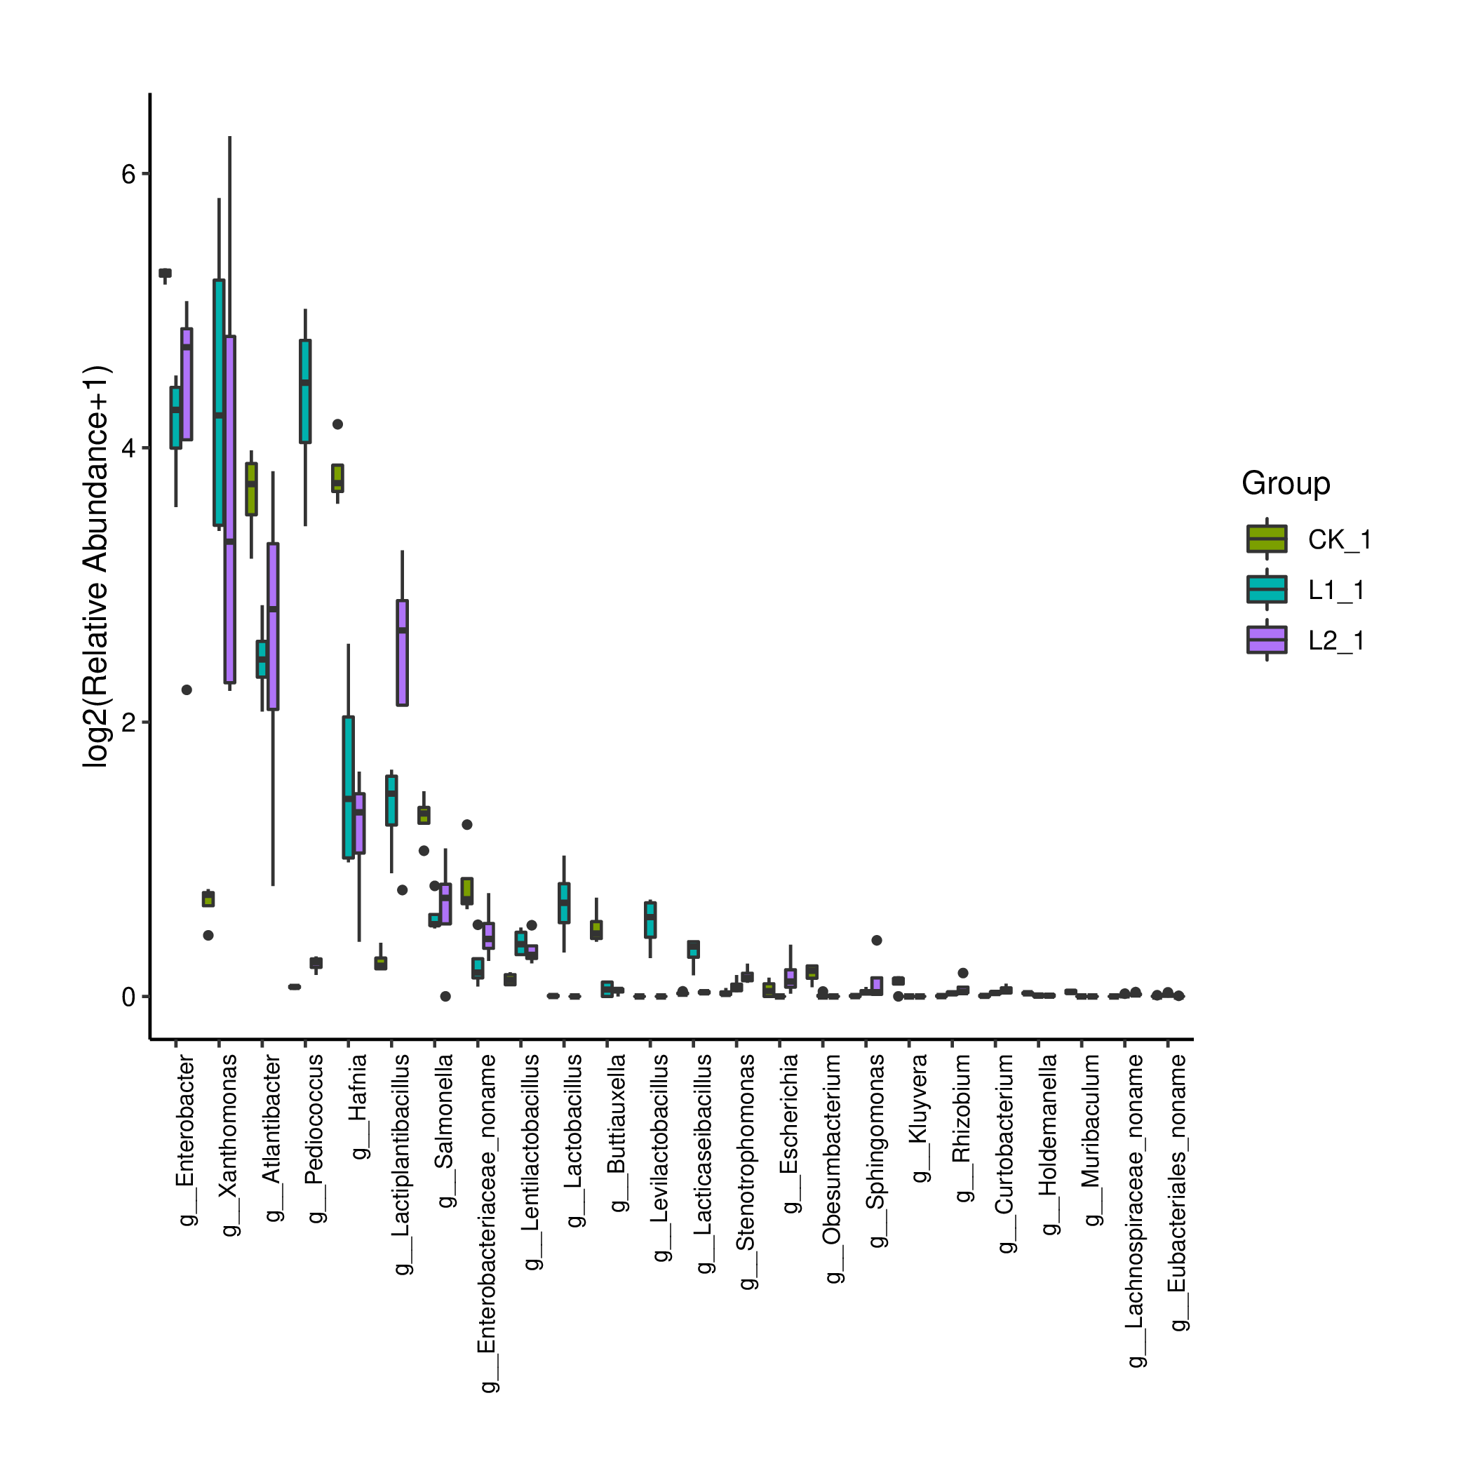
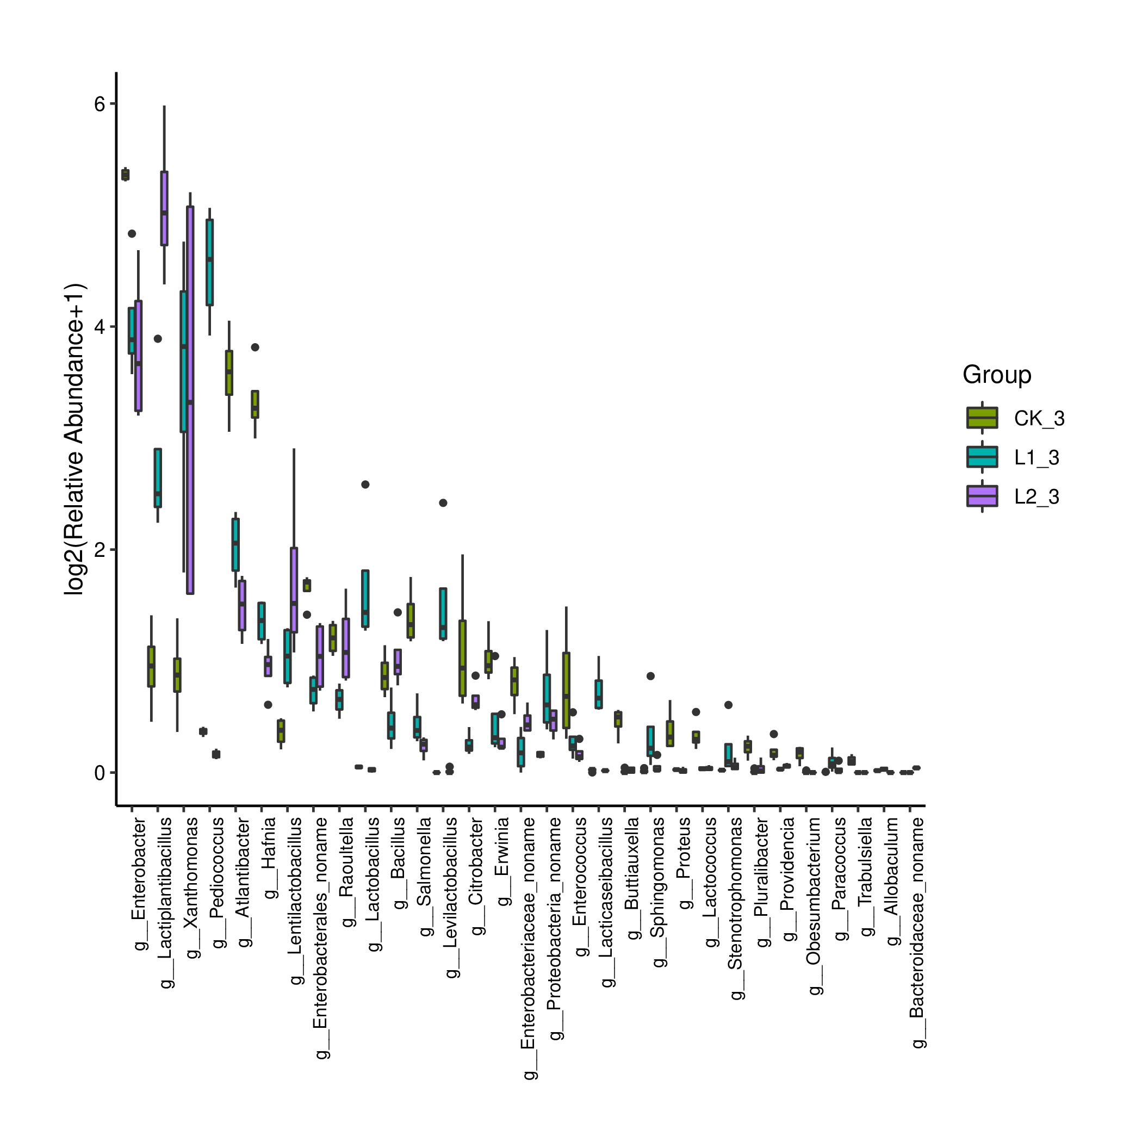
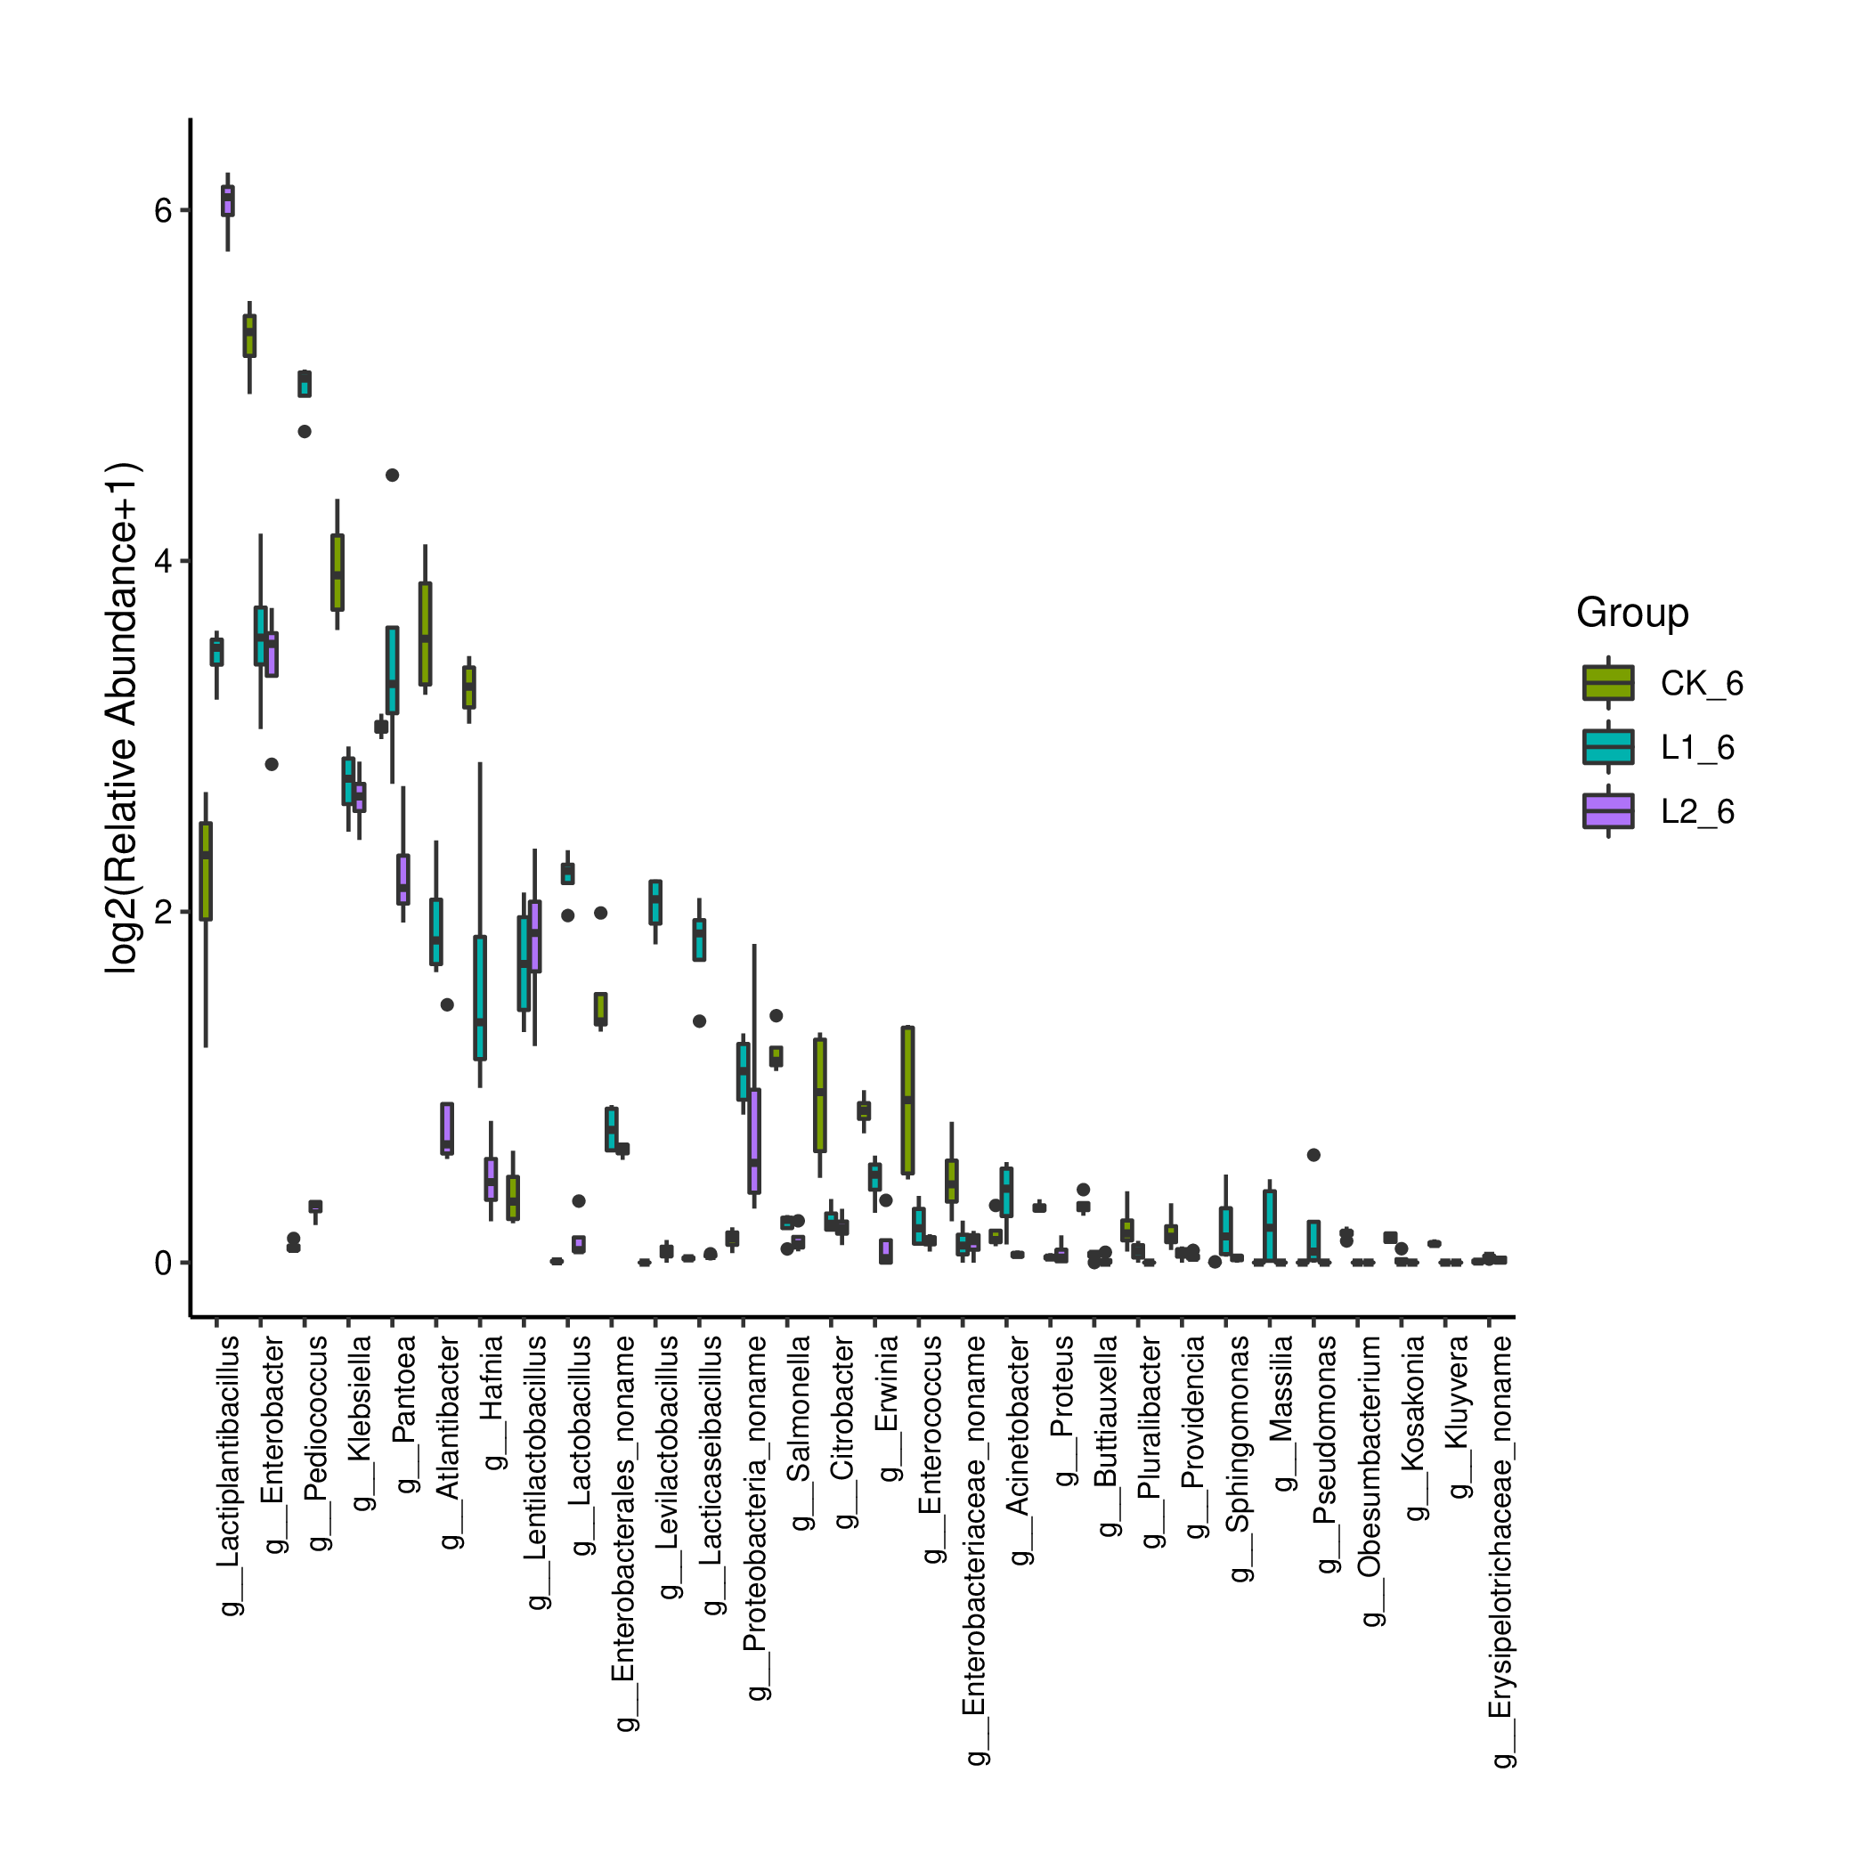
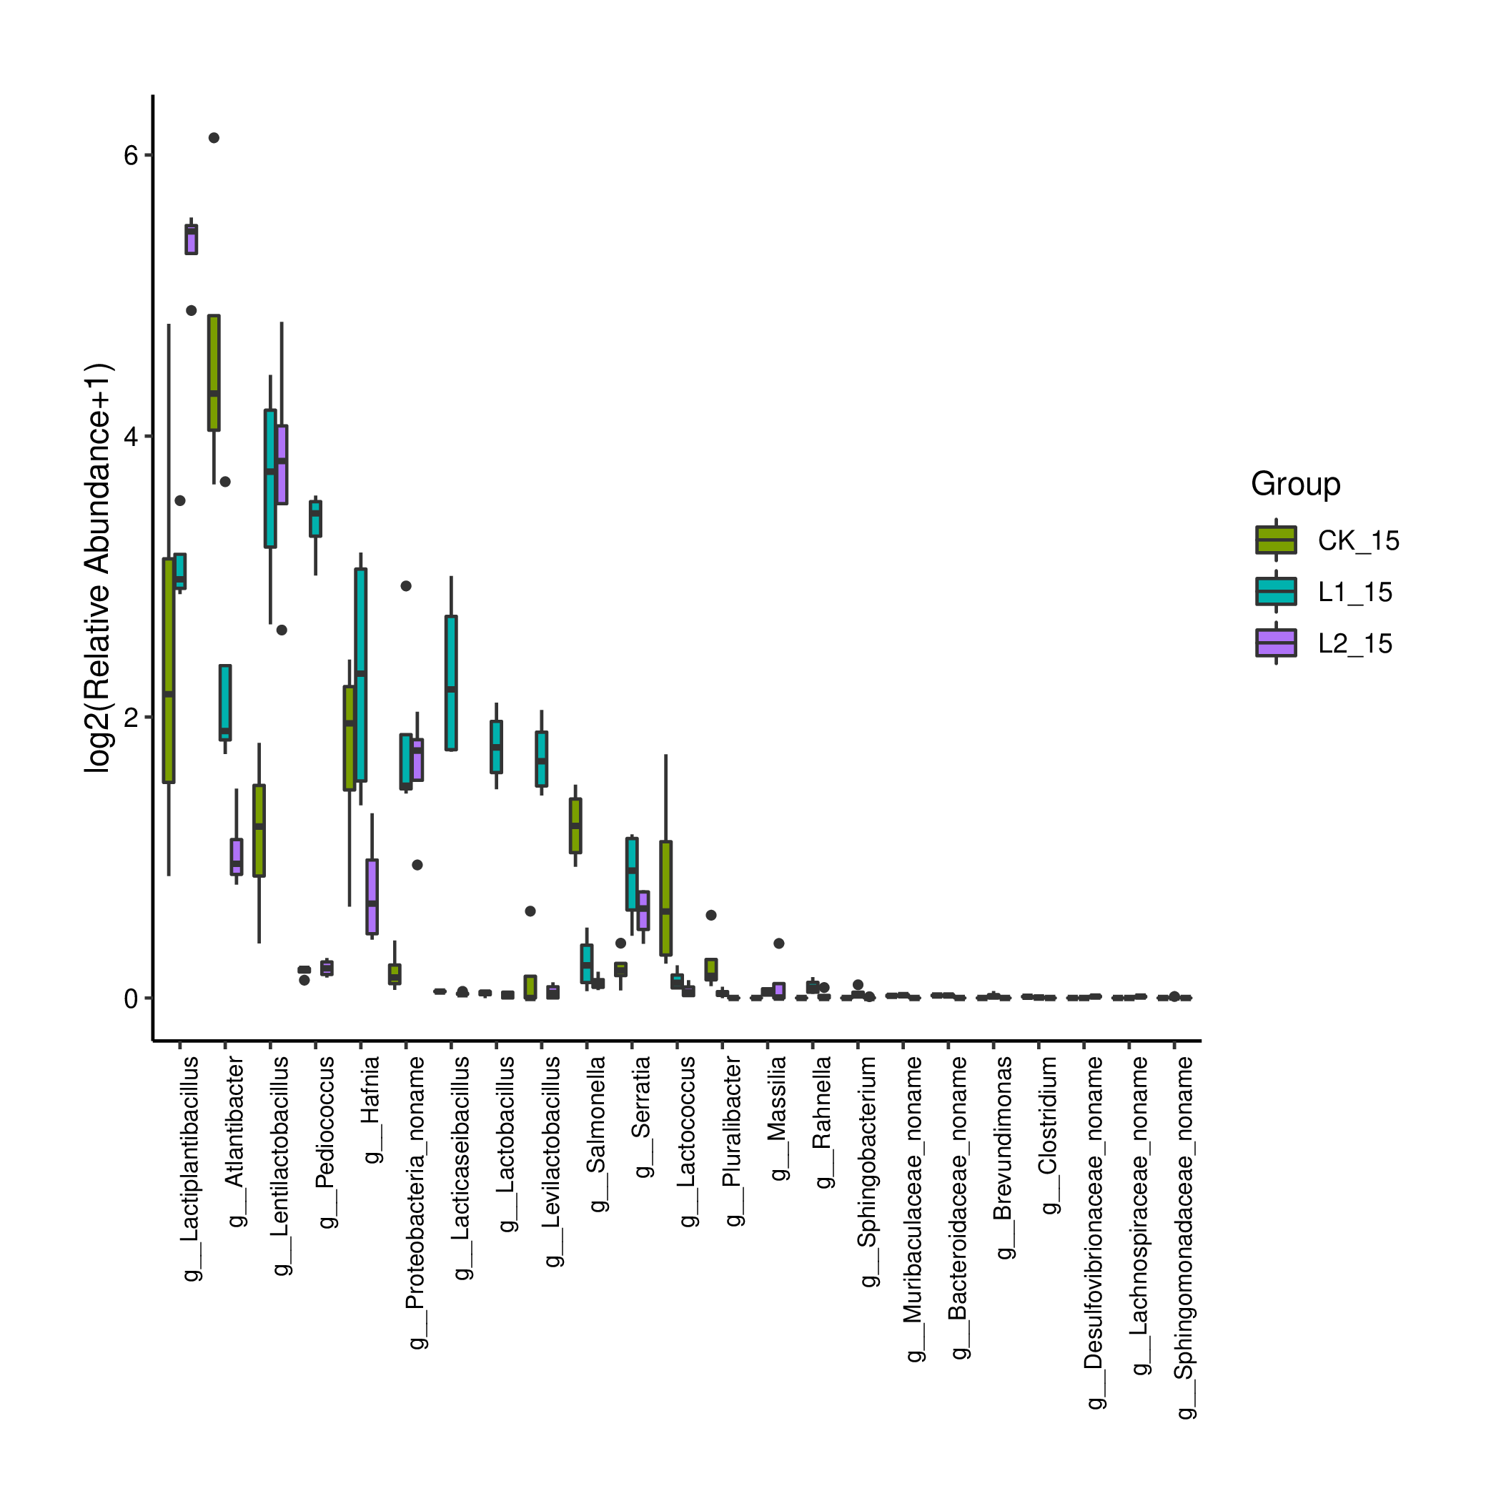
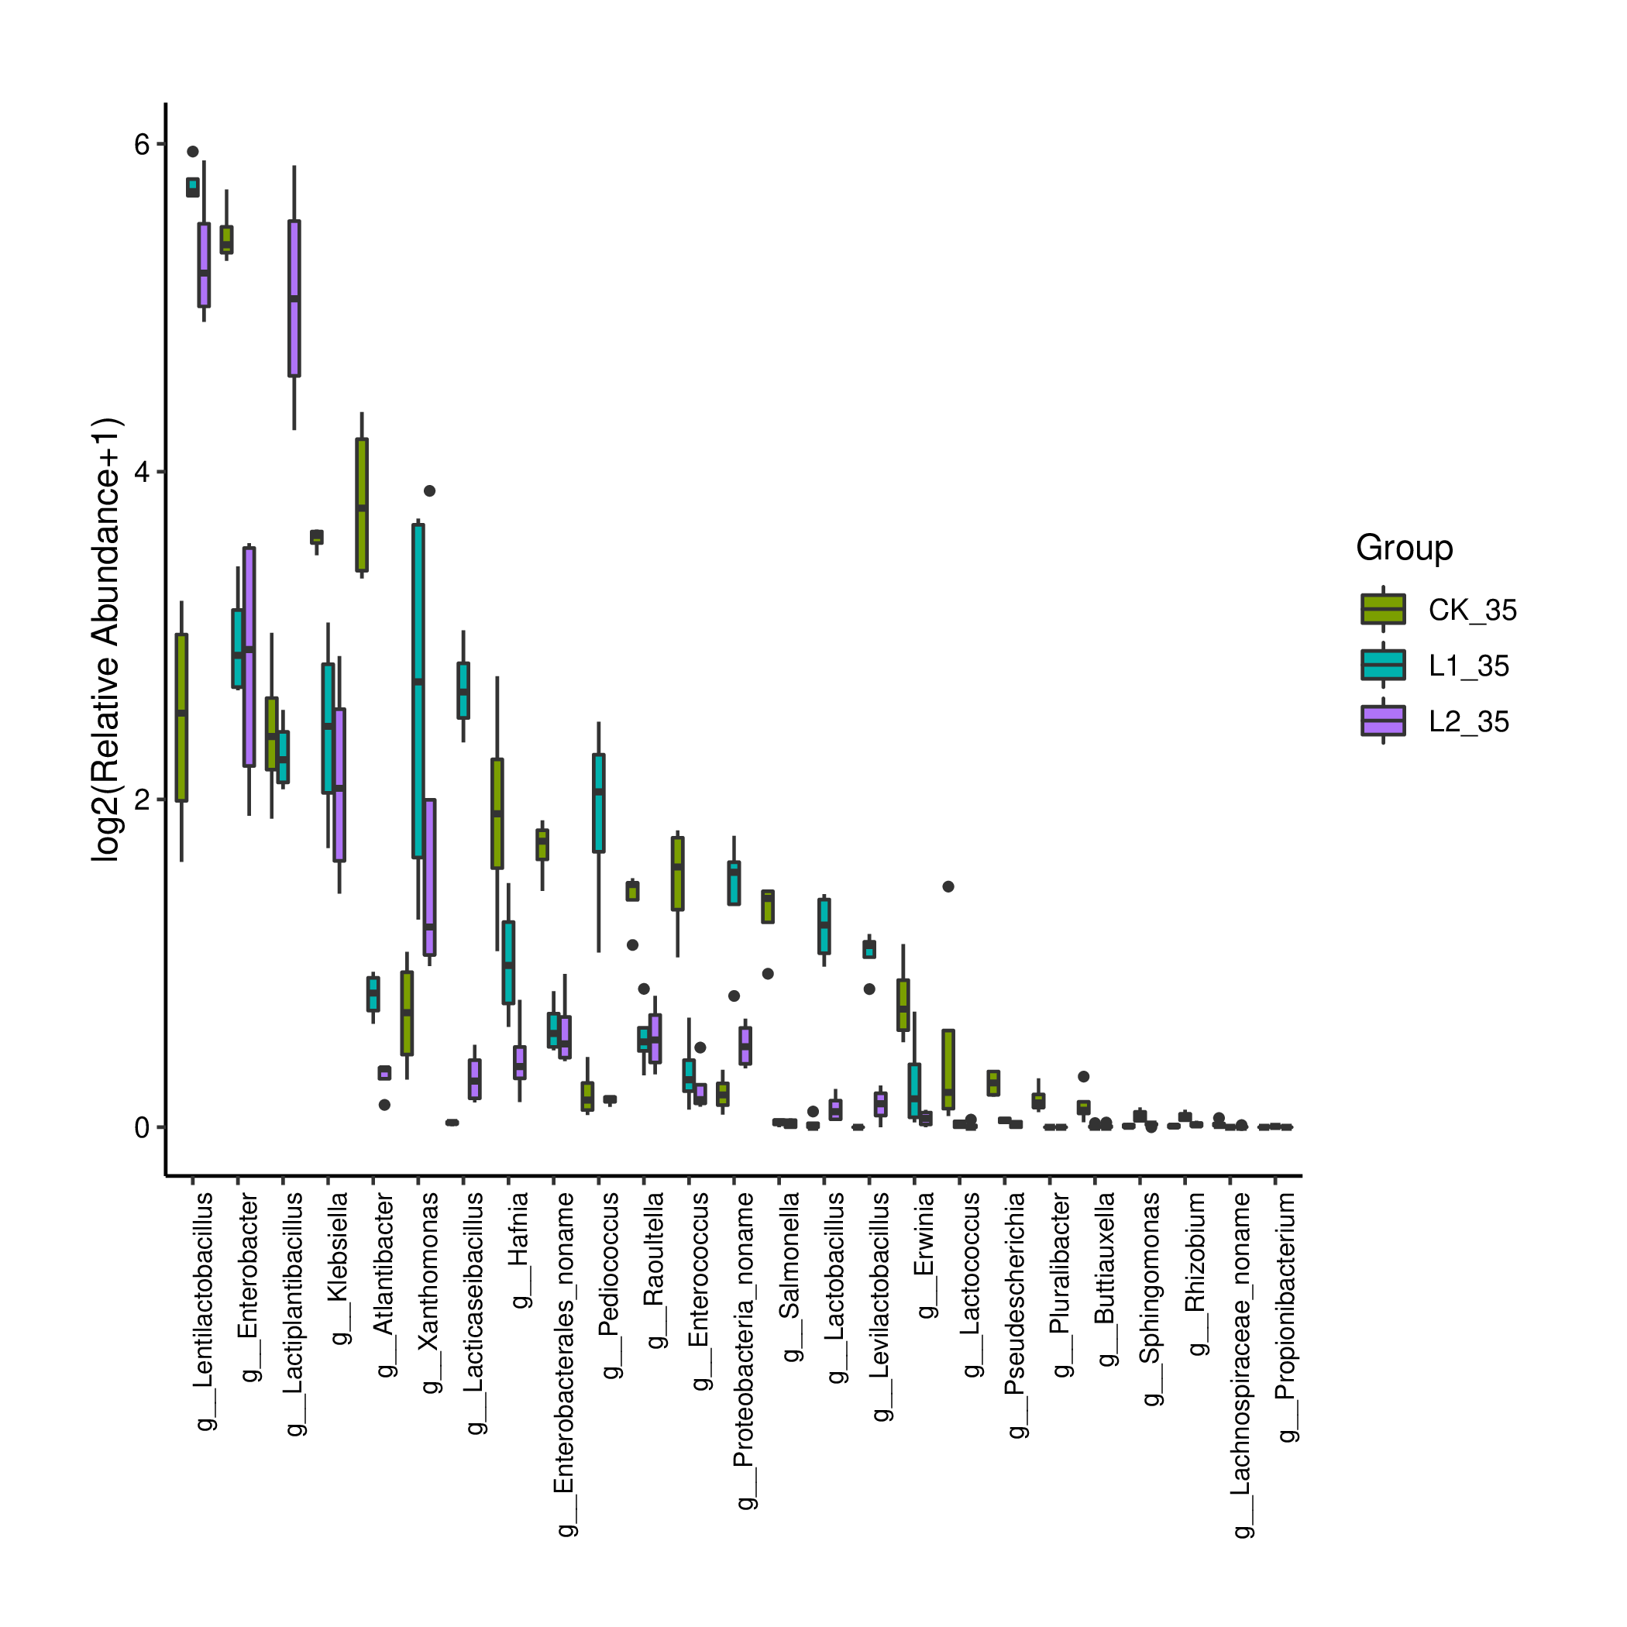
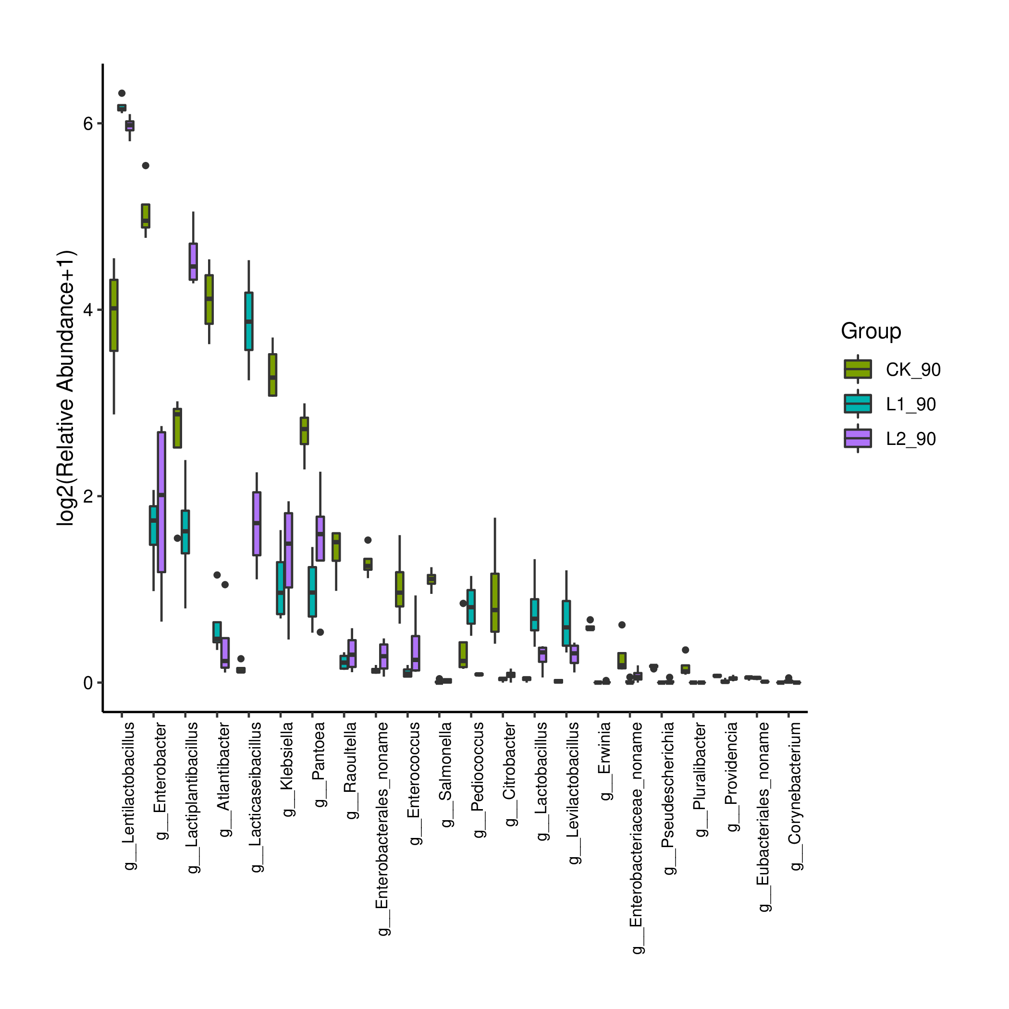
Figure S5. Difference in bacterial communities (genus level) among CK, L1, and L2 at d 1, d 3, d 6, d 15, d 35, and d 90 (n = 4).

Figure S7. Correlation networks among main bacterial genera (top 10), pH, lactic acid (LA), acetic acid (AA), ammoniacal nitrogen (AN), buffering capacity (BC), and fermentation weight loss (FWL) of barley silage at d 1 (A), d 3 (B), d 6 (C), d 15 (D), d 35 (E), and d 90 (F) (n = 12). P value < 0.05.
A
F
E
D
C
B

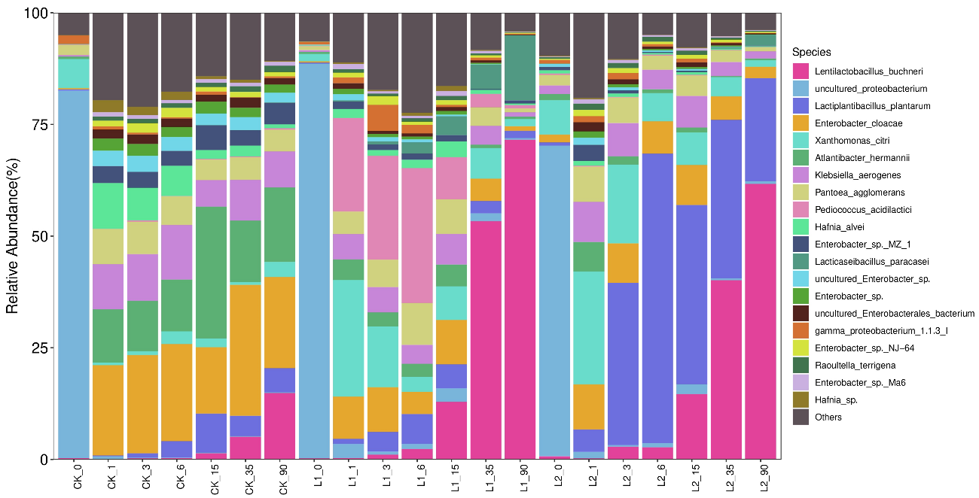
Figure S8. Relative abundance of bacterial communities (species level) of barley silage during fermentation (n = 4).
Figure S9. Correlation networks among main bacterial genera (top 10), pH, lactic acid (LA), acetic acid (AA), ammoniacal nitrogen (AN), buffering capacity (BC), and fermentation weight loss (FWL) of CK (A), L1 (B), and L2 (C) during fermentation (n = 28) , of L1 and L2 in the first 15 days (D) (n = 40), and L1 and L2 after 15 days (E) (n = 24). P value < 0.05.
B
D
C
E
A

