SUPPLEMENTARY FILES

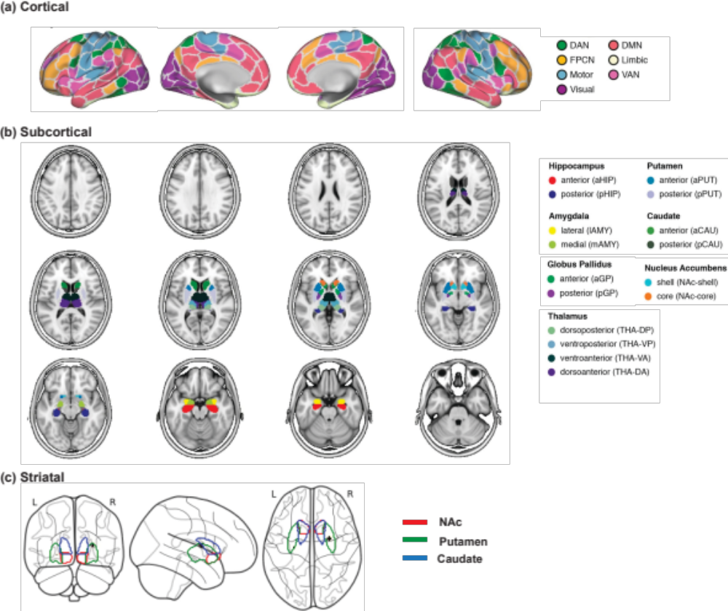
Figure S1. Illustration of the 200 ROI (7 networks) cortical (a) and 32 ROI subcortical (b) brain atlases that were used for fRMI dynamic analysis and PET D1R analysis. (Figures adapted from [1]). (c) striatal masks used for PET analysis.

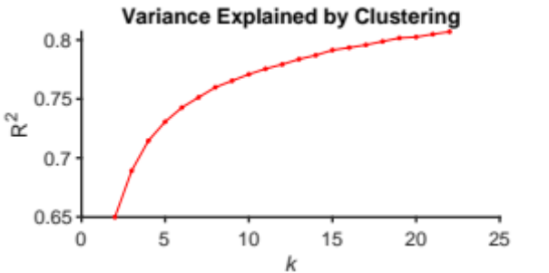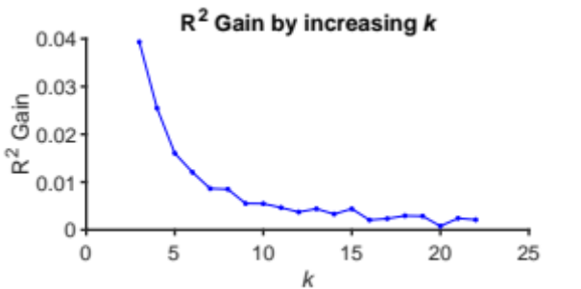

Figure S2. Choosing k. (a) Elbow plot of the variance explained by clustering for each choice of k, showing an ‘elbow’ around 6. (b) Plot of the gained variance explained by increasing k. Increasing k beyond k=6 results in less than a 1% increase of variance explained.

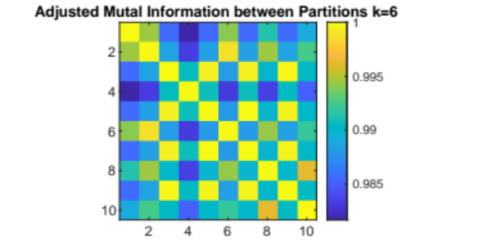
Figure S3. The adjusted mutual information shared between 10 independently generated partitions of our data at k=6. Values range from 0 to 1, with 1 indicating identical partitions.

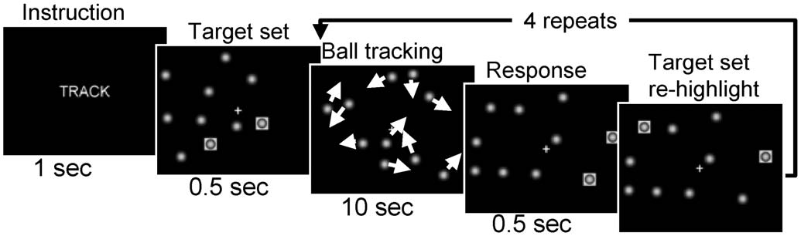
Figure S4. Visual attention (VA) paradigm. During ‘‘TRACK’’ epochs of the 2-ball-track task, subjects tracked the target ball set that was briefly highlighted after the instruction. Then all 10 balls moved with a random motion for 10 seconds and the subjects tracked the target balls until the balls stopped moving. Then subjects responded by pressing a button if the highlighted balls were those they were tracking. Finally, the target set was highlighted to refocus the subjects’ attention on the balls. This track and respond sequence were repeated 5 times during the 1-minute long ‘‘TRACK’’ epochs. (Figure adapted from [2]).

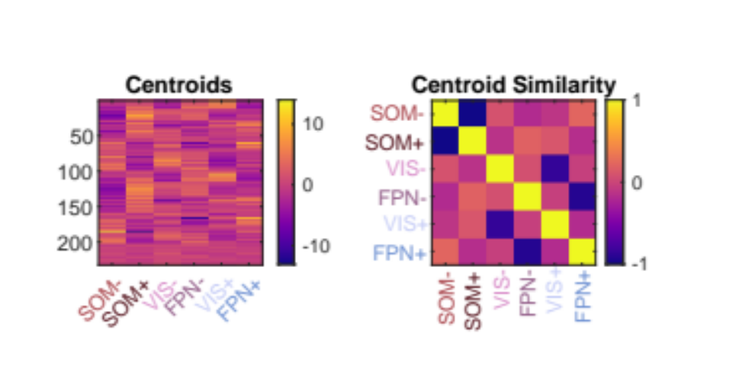
Figure S5. Natural grouping of meta-states based on Pearson correlation. Left: Centroids of each cluster derived as the mean of all time-points assigned to that cluster. Right: Pearson correlation values between each cluster. The dark blue squares show the high values of negative correlations between clusters belonging to the same ‘meta-state’.

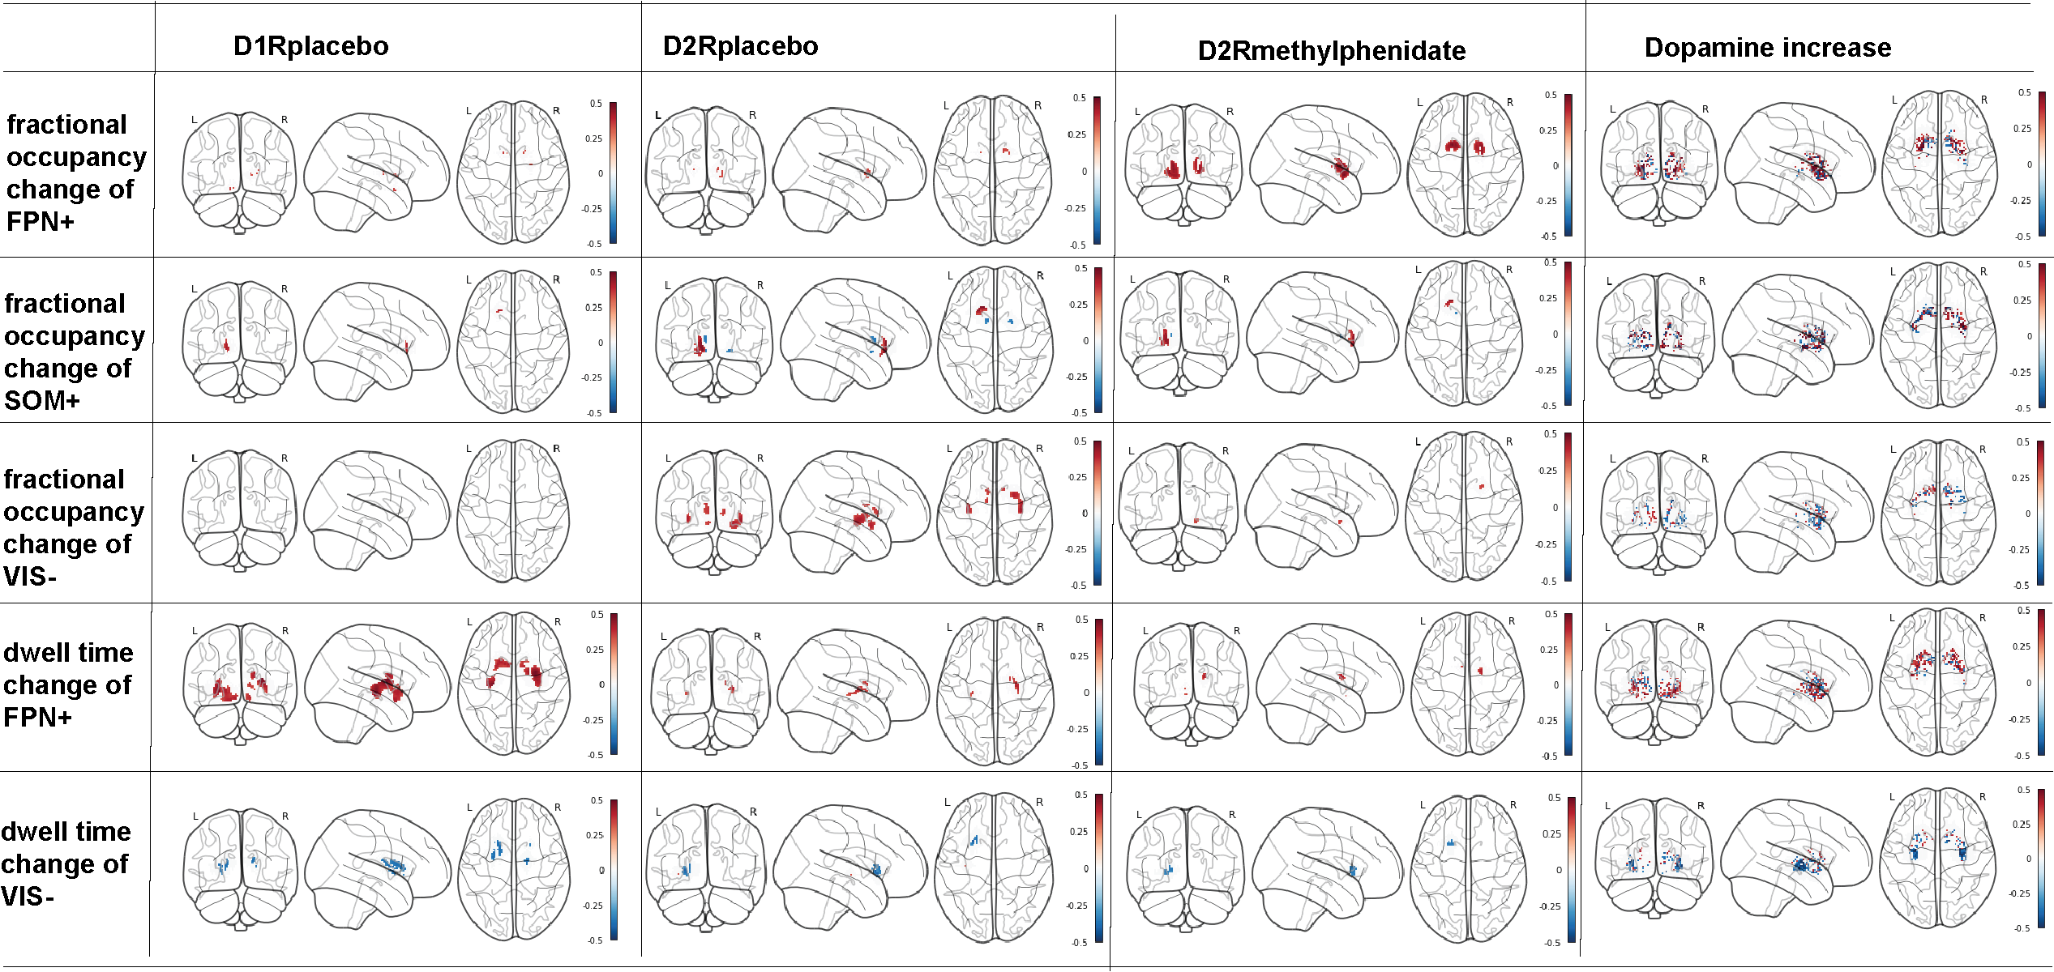
Figure S6. Voxel-wise correlation between dynamic features and striatal DA features, including D1R availability under placebo condition, D2R availability under placebo condition, D2R availability under methylphenidate condition, and dopamine increase. The voxels are shown with a threshold p < 0.05. Note: The dopamine increase was measured as follows:
$$dopamine increase= \frac{D2R_placebo-D2R_methylphenidate}{D2R_placebo}$$

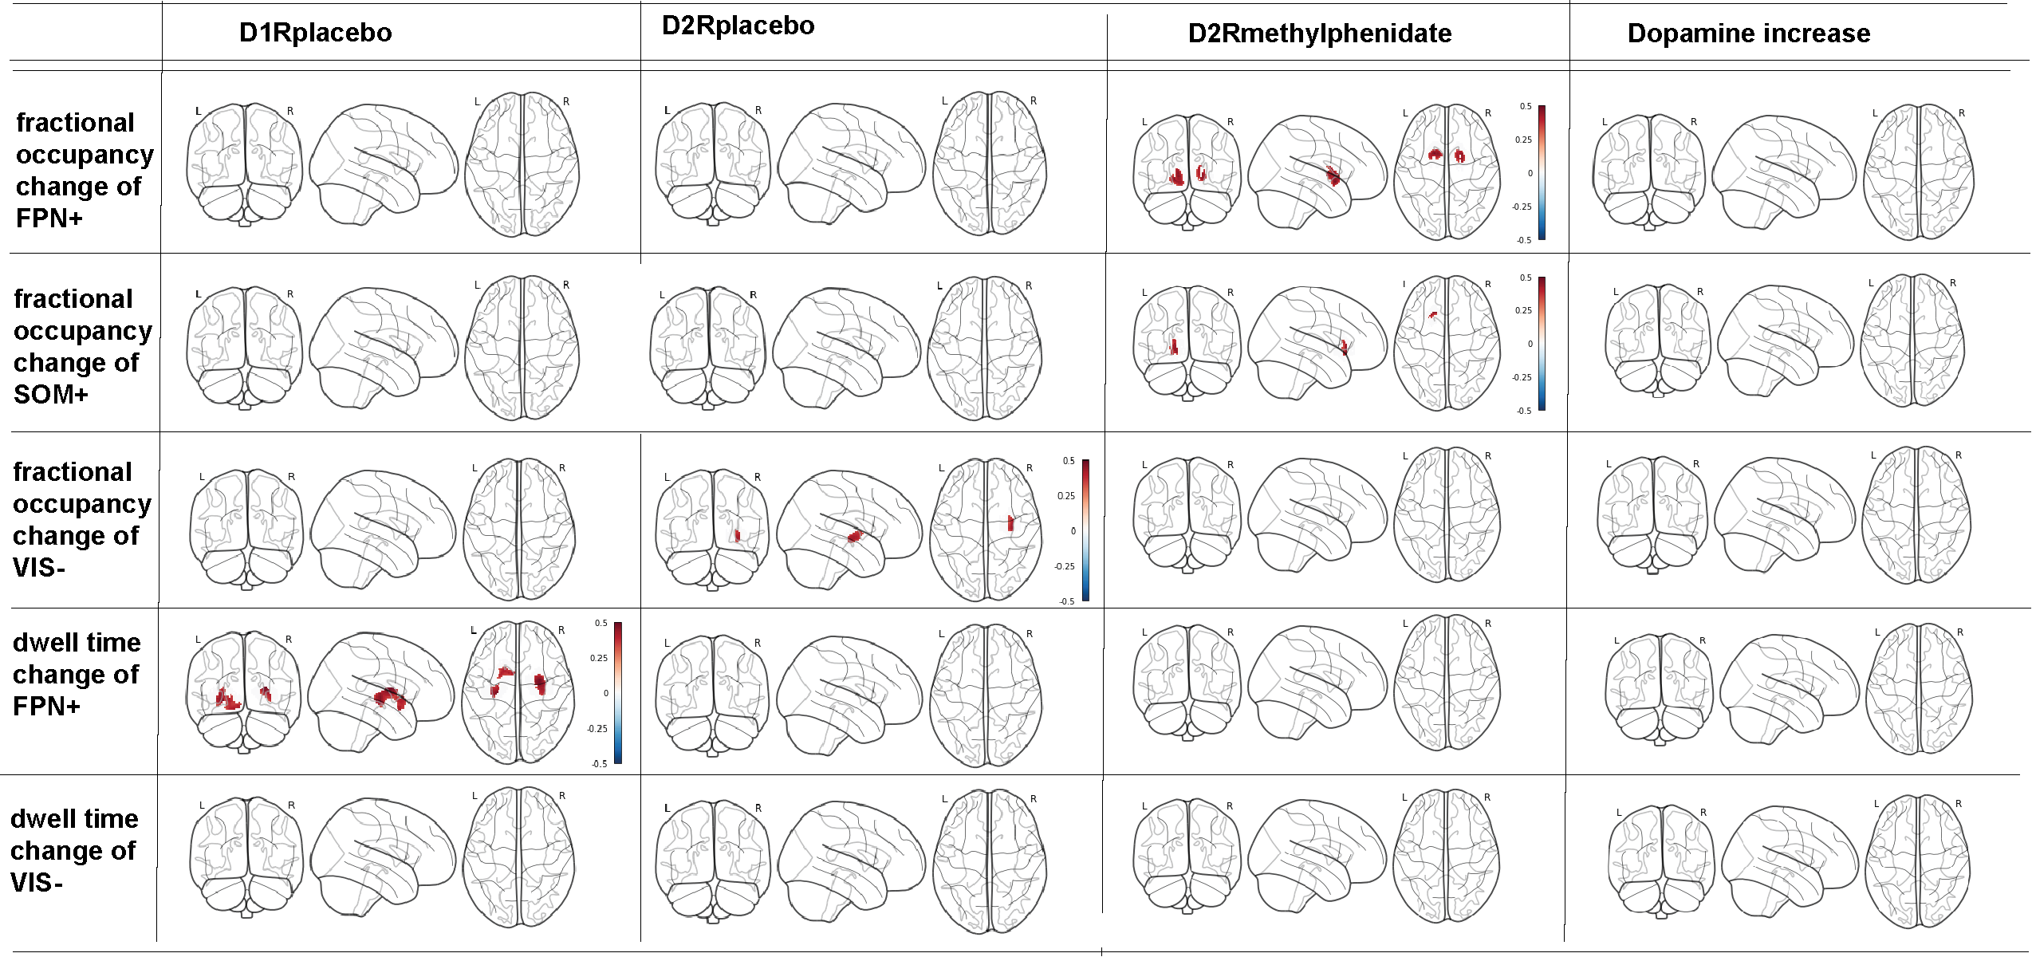
Figure S7. Voxel-wise correlation between dynamic features and striatal DA features, including D1R availability under placebo condition, D2R availability under placebo condition, D2R availability under methylphenidate condition, and dopamine increase. The voxels are shown using threshold p < 0.05 with a cluster size of at least 30 spatially contiguous voxels.

Table S1. Correlation between the change of dynamic features and change of ball-track task performances
Correlation |  | Change of 2-ball-track in |  | Change of 3-ball-track in
 |  | Response time | Hitting accuracy | Response time | Hitting accuracy
change of fractional occupancy in | FPN+ | -0.47(0.01) | 0.11(0.57) | -0.27(0.16) | 0.14(0.48)
change of fractional occupancy in | SOM+ | -0.23(0.23) | -0.21(0.27) | 0.26(0.17) | -0.11(0.58)
change of fractional occupancy in | VIS- | 0.14(0.47) | 0.23(0.24) | -0.02(0.92) | 0.07(0.72)
change of dwell time in | FPN+ | -0.42(0.02) | -0.28(0.14) | -0.08(0.69) | 0.22(0.25)
change of dwell time in | VIS- | 0.03(0.88) | 0.16(0.39) | 0.1(0.6) | 0.21(0.27)
Notes: The numbers before the parentheses indicate the correlation coefficients. The numbers in parentheses indicate the p-values significance. The bold texts are with p-value < 0.05.

Table S2. Correlation between the change of dynamic features and D1R availability (Placebo)
 | change of fractional occupancy in: |  |  | change of dwell time in:
D1R baseline availability | FPN+ | SOM+ | VIS- | FPN+ | VIS-
NAc-shell-rh | 0.13(0.46) | -0.07(0.67) | 0.07(0.7) | 0.26(0.11) | -0.11(0.5)
Nac-core-rh | 0.05(0.77) | 0.06(0.71) | 0.01(0.95) | 0.14(0.39) | -0.21(0.22)
aPUT-rh | 0.18(0.3) | -0.14(0.4) | 0.17(0.33) | 0.25(0.13) | -0.09(0.61)
pPUT-rh | 0.2(0.24) | -0.04(0.81) | 0.07(0.69) | 0.38(0.02) | -0.08(0.63)
aCAU-rh | 0.12(0.49) | 0.03(0.88) | 0.03(0.84) | 0.29(0.08) | -0.18(0.28)
pCAU-rh | 0.14(0.41) | 0.03(0.86) | 0.01(0.94) | 0.33(0.05) | -0.2(0.24)
Nac-shell-lh | 0.22(0.19) | -0.08(0.62) | 0.1(0.57) | 0.34(0.04) | -0.01(0.94)
Nac-core-lh | 0.13(0.44) | 0.15(0.39) | -0.01(0.93) | 0.27(0.1) | -0.14(0.4)
aPUT-lh | 0.15(0.39) | -0.03(0.87) | 0.05(0.77) | 0.27(0.1) | -0.18(0.29)
pPUT-lh | 0.15(0.36) | -0.02(0.91) | 0.06(0.72) | 0.31(0.06) | -0.13(0.44)
aCAU-lh | 0.06(0.74) | 0.02(0.9) | 0.07(0.67) | 0.28(0.09) | -0.14(0.41)
pCAU-lh | 0.01(0.93) | -0.04(0.83) | 0.09(0.59) | 0.23(0.16) | -0.19(0.25)
Notes: The numbers before the parentheses indicate the correlation coefficients. The numbers in parentheses indicate the p-value significance. The bold texts are with p-value < 0.05.

Table S3. Correlation between the change of dynamic features and D2R availability (Placebo)
 | change of fractional occupancy in: |  |  | change of dwell time in:
D2R availability (PL) | FPN+ | SOM+ | VIS- | FPN+ | VIS-
Nac-shell-rh | 0.06(0.72) | -0.13(0.45) | 0.1(0.56) | -0.01(0.93) | -0.02(0.91)
Nac-core-rh | 0.03(0.87) | 0.06(0.71) | 0.01(0.96) | -0.02(0.9) | -0.15(0.38)
aPUT-rh | 0.12(0.48) | -0.17(0.32) | 0.27(0.11) | 0.02(0.92) | -0.01(0.98)
pPUT-rh | 0.13(0.45) | -0.16(0.33) | 0.31(0.06) | 0.2(0.23) | 0.01(0.95)
aCAU-rh | 0.08(0.64) | -0.1(0.54) | 0.22(0.2) | 0.19(0.26) | -0.08(0.63)
pCAU-rh | 0.12(0.48) | -0.1(0.54) | 0.18(0.28) | 0.26(0.12) | -0.09(0.6)
Nac-shell-lh | 0.22(0.19) | -0.14(0.4) | 0.23(0.18) | 0.1(0.54) | 0.14(0.42)
Nac-core-lh | 0.08(0.63) | 0.23(0.17) | -0.09(0.61) | 0.1(0.54) | -0.16(0.34)
aPUT-lh | 0.09(0.59) | -0.03(0.86) | 0.16(0.33) | 0.11(0.52) | -0.06(0.7)
pPUT-lh | 0.08(0.62) | -0.14(0.42) | 0.29(0.08) | 0.19(0.25) | 0.04(0.8)
aCAU-lh | 0.02(0.91) | -0.06(0.72) | 0.2(0.23) | 0.21(0.22) | -0.08(0.65)
pCAU-lh | 0.04(0.83) | -0.2(0.23) | 0.25(0.13) | 0.19(0.26) | -0.08(0.62)
Notes: The numbers before the parentheses indicate the correlation coefficients. The numbers in parentheses indicate the p-value significance. The bold texts are with p-value < 0.05.

Table S4. Correlation between the change of dynamic features and D2R availability (MP)
 | change of fractional occupancy in: |  |  | change of dwell time in:
D2R availability (MP) | FPN+ | SOM+ | VIS- | FPN+ | VIS-
Nac-shell-rh | 0.13(0.45) | -0.07(0.66) | 0.17(0.32) | -0.03(0.86) | 0.05(0.79)
Nac-core-rh | 0.07(0.69) | 0.04(0.8) | 0.07(0.67) | -0.07(0.68) | -0.1(0.57)
aPUT-rh | 0.18(0.29) | -0.13(0.45) | 0.2(0.24) | -0.03(0.86) | 0.01(0.95)
pPUT-rh | 0.18(0.29) | -0.06(0.72) | 0.13(0.43) | 0.18(0.28) | 0.05(0.76)
aCAU-rh | 0.1(0.55) | -0.03(0.87) | 0.13(0.43) | 0.06(0.71) | -0.13(0.45)
pCAU-rh | 0.18(0.28) | -0.03(0.87) | 0.07(0.68) | 0.26(0.12) | -0.19(0.27)
Nac-shell-lh | 0.32(0.05) | -0.08(0.63) | 0.14(0.4) | 0.24(0.15) | 0.14(0.41)
Nac-core-lh | 0.11(0.5) | 0.17(0.31) | 0.03(0.87) | 0.08(0.62) | -0.07(0.66)
aPUT-lh | 0.24(0.15) | 0(0.99) | 0.06(0.74) | 0.11(0.53) | -0.12(0.46)
pPUT-lh | 0.2(0.24) | -0.1(0.55) | 0.2(0.24) | 0.19(0.27) | 0.13(0.46)
aCAU-lh | 0.05(0.76) | 0.01(0.97) | 0.13(0.44) | 0.16(0.34) | -0.14(0.41)
pCAU-lh | 0.05(0.76) | -0.12(0.49) | 0.19(0.26) | 0.17(0.31) | -0.15(0.37)
Notes: The numbers before the parentheses indicate the correlation coefficients. The numbers in parentheses indicate the p-value significance. The bold texts are with p-value < 0.05.

Table S5. Correlation between the change of dynamic features and dopamine increase
 | change of fractional occupancy in: |  |  | change of dwell time in:
Dopamine increase | FPN+ | SOM+ | VIS- | FPN+ | VIS-
Nac-shell-rh | -0.07(0.69) | -0.05(0.76) | -0.08(0.64) | 0.02(0.92) | -0.05(0.78)
Nac-core-rh | -0.06(0.71) | 0.03(0.84) | -0.1(0.56) | 0.06(0.73) | -0.07(0.67)
aPUT-rh | -0.06(0.73) | -0.05(0.77) | 0.09(0.61) | 0.05(0.79) | 0(1)
pPUT-rh | -0.09(0.59) | -0.09(0.61) | 0.13(0.43) | -0.03(0.85) | -0.03(0.84)
aCAU-rh | -0.06(0.73) | -0.13(0.44) | 0.12(0.47) | 0.2(0.23) | 0.09(0.58)
pCAU-rh | -0.1(0.55) | -0.13(0.43) | 0.19(0.27) | 0.02(0.92) | 0.15(0.37)
Nac-shell-lh | -0.12(0.47) | -0.07(0.66) | 0.09(0.58) | -0.18(0.3) | 0(1)
Nac-core-lh | -0.05(0.77) | 0.11(0.5) | -0.16(0.34) | 0.03(0.86) | -0.14(0.42)
aPUT-lh | -0.16(0.33) | -0.03(0.86) | 0.09(0.58) | -0.01(0.94) | 0.08(0.65)
pPUT-lh | -0.14(0.4) | -0.01(0.96) | 0.04(0.83) | -0.04(0.81) | -0.08(0.63)
aCAU-lh | -0.07(0.69) | -0.13(0.43) | 0.14(0.42) | 0.08(0.65) | 0.14(0.41)
pCAU-lh | -0.02(0.9) | -0.2(0.24) | 0.14(0.4) | 0.05(0.79) | 0.15(0.36)
Notes: The numbers before the parentheses indicate the correlation coefficients. The numbers in parentheses indicate the p-value significance. The bold texts are with p-value < 0.05.

References
[1] Franzmeier N, Brendel M, Beyer L, Slemann L, Kovacs GG, Arzberger T, et al. Tau deposition patterns are associated with functional connectivity in primary tauopathies. Nature Communications. 2022;13(1):1362.
[2] Rustichini A, Tomasi D, Volkow ND, Wang R, Telang F, Wang G-J, et al. Dopamine Transporters in Striatum Correlate with Deactivation in the Default Mode Network during Visuospatial Attention. PLoS ONE. 2009;4(6).

