Supplementary Data
The antimicrobial potentialities of (Nk-lysin peptides of chicken, bovine, and human) against bacteria and rotavirus
Maged. M. Mahmoud^{1,2,3}, , Ahmed M. Al-Hejin⁴, Turki Abujaml^{2,5}, Abd-Elmaksoud, S⁶, , Salem M. El-Hamidy⁴, Haitham, A.Yacoub*⁷
¹Regerenative Medicine Unit, King Fahd Medical Research Center, King Abdulaziz University, P.O. Box 80216, Jeddah 21589, Saudi Arabia
²Department of Medical Laboratory Technology, Faculty of Applied Medical Sciences, King Abdulaziz University, Jeddah, Saudi Arabia
³Molecular Genetics and Enzymology Department, Human Genetics Division and Genome Research, National Research Centre, Cairo, Egypt
⁴Biological Sciences Department, Faculty of Sciences, King Abdulaziz University, Jeddah, Saudi Arabia
⁵Vaccines and immunotherapy Unit, King Fahd Medical Research Center, King Abdulaziz University, P.O. Box 80216, Jeddah 21589, Saudi Arabia
⁶Environmental Virology Laboratory, Water Pollution Research Department, Environmental Research Division, National Research Centre, Cairo, Egypt.
⁷Cell Biology Department, Genetic Engineering and Biotechnology Research Division, National Research Centre, Dokki, Cairo, P.O. Box 12622, Egypt

* Corresponding author current address: ⁶Cell Biology Department, Genetic Engineering and Biotechnology Division, National Research Centre, 33 El Bohouth St., Dokki, Gizza, P.O. 12622, Egypt, email: Haithamyacoub46@gmail.com

The Original gel image for Figure 13
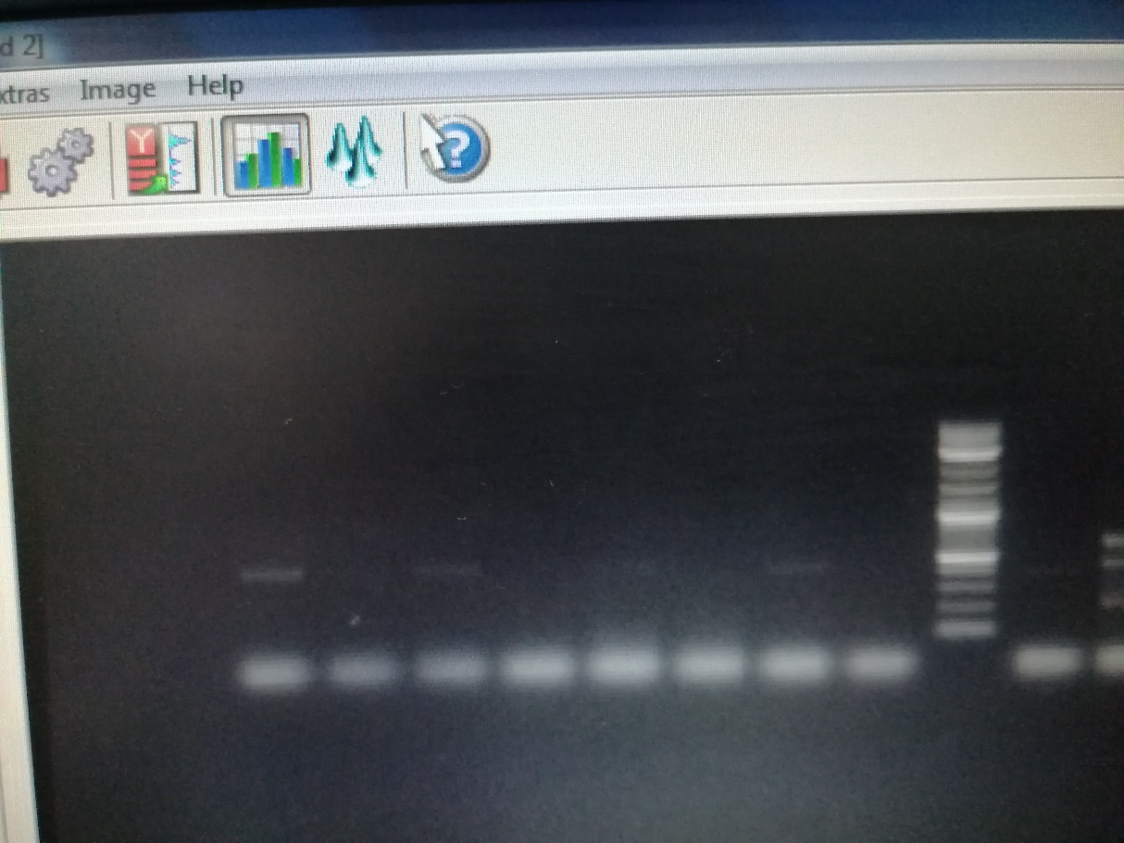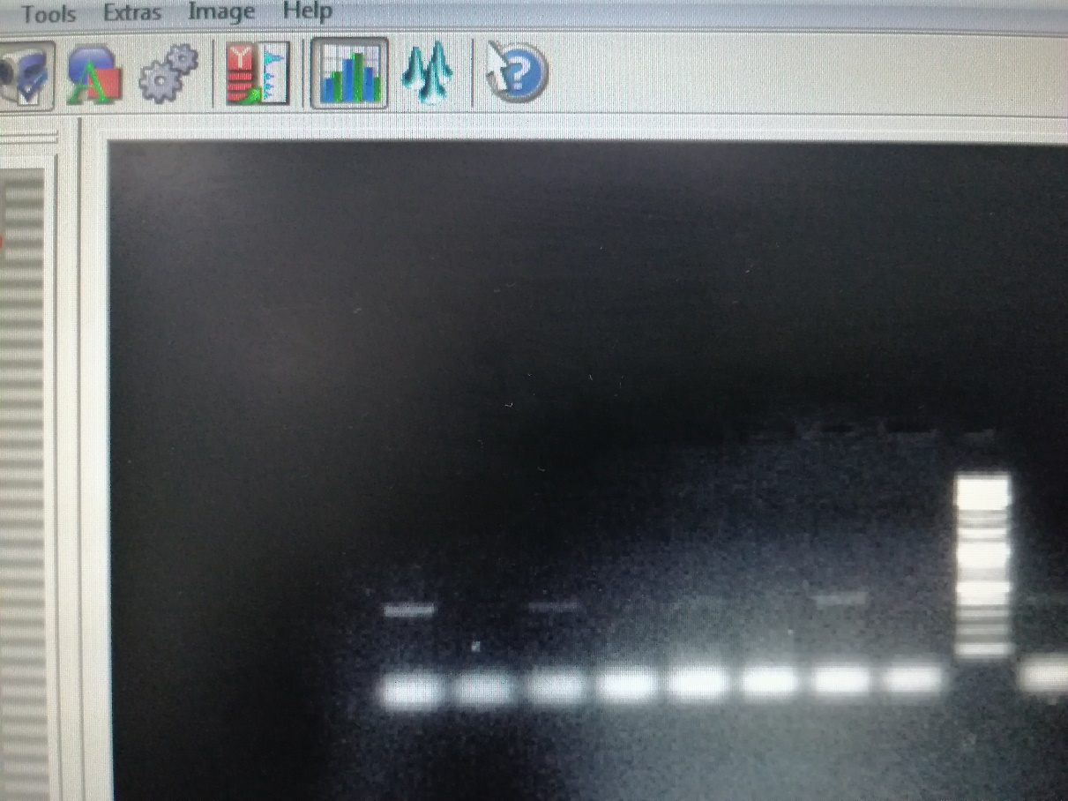

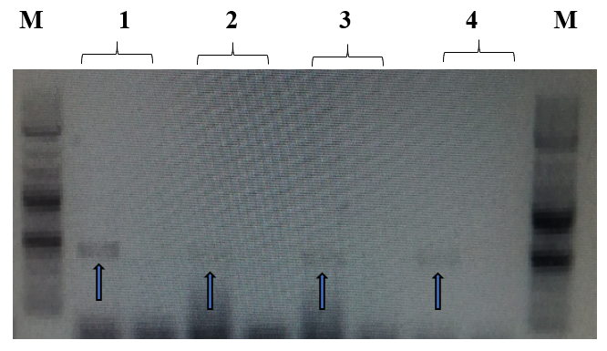 Figure.13. The amplified fragment of CTX-M1 gene with 499 bp, where M (DNA ladder =100 bp), 1(S. typhi ATCC 14028 untreated and treated cells), 2 (P. aeruginosa ATCC 9027 untreated and treated cells), 3 (Klebsiella oxytoca ATCC 49131 untreated and treated cells), 4 (St. pyrogens ATCC 19615 untreated and treated cells) and arrows indicate gene in untreated bacteria whereas empty well indicates treated bacteria after challenge with Nk-lysin.

The original image for figure.14
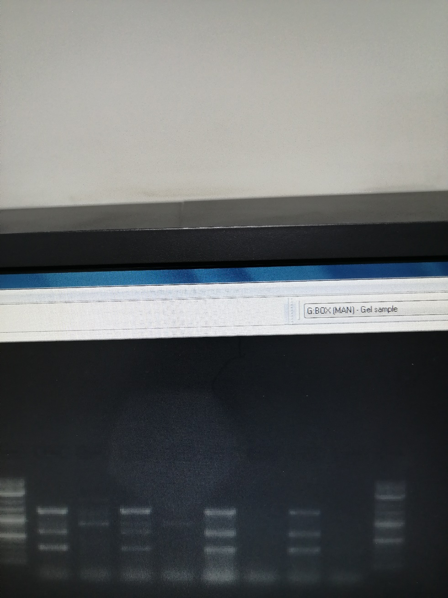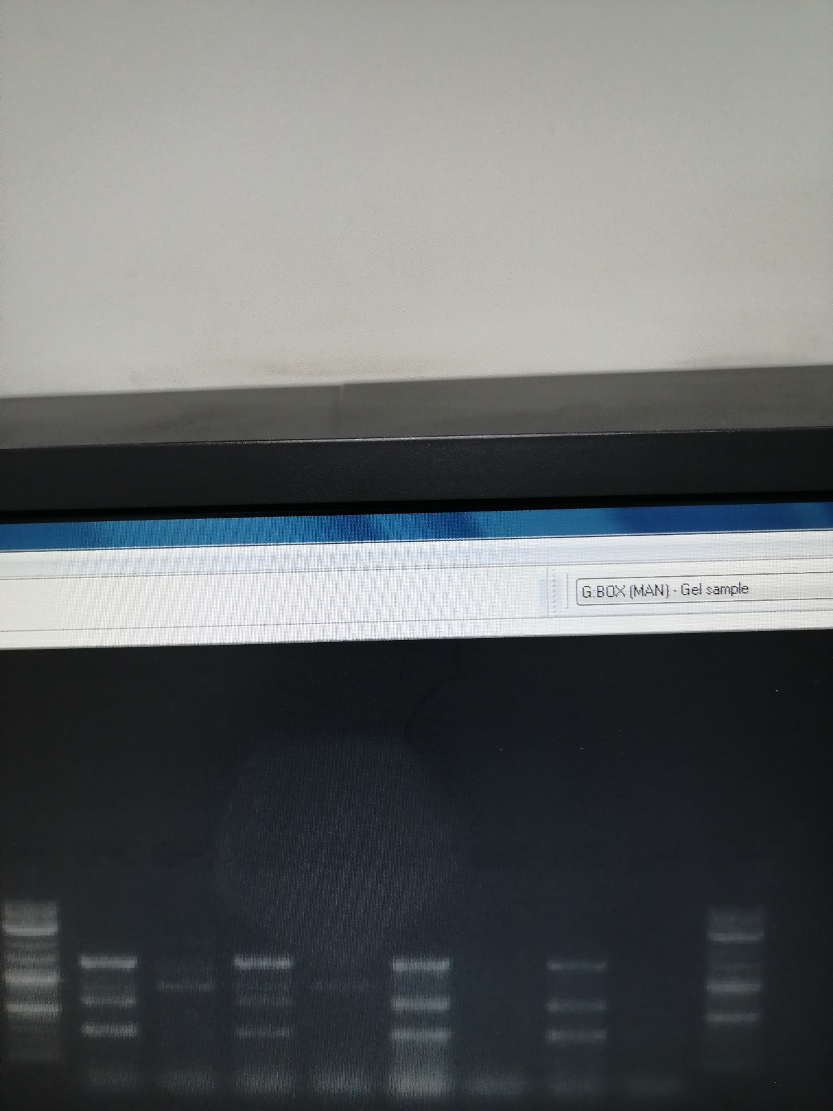

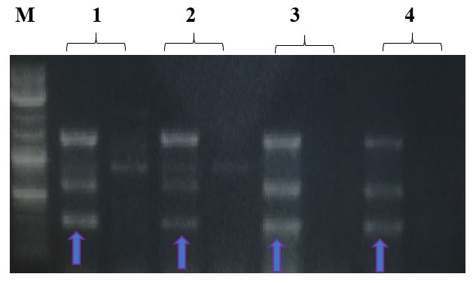 Figure.14. The amplified fragment of CTX-M8 gene with 307 bp, where M (DNA ladder =100 bp), 1(S. typhi ATCC 14028 untreated and treated cells), 2 (P. aeruginosa ATCC 9027 untreated and treated cells), 3 (Klebsiella oxytoca ATCC 49131 untreated and treated cells), 4 (St. pyrogens ATCC 19615 untreated and treated cells) and arrows indicate gene in untreated bacteria whereas empty well indicates treated bacteria after challenge with Nk-lysin.

