Supplementary Figures

Suppl. Figure S1 related to Figure 2:
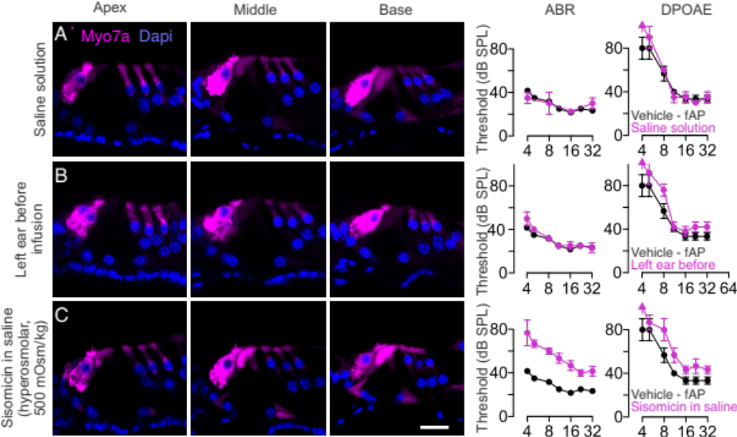

A. 24 hours after infusion of saline solution, normal histology (no hair cell loss) is apparent in transverse vibratome sections from the apex, middle, and base. Normal ABR and DPOAE thresholds (magenta) were measured and not different from vehicle fAP control measurements.
B. Confocal images from a control left ear without any kind of injection showing normal morphology with one row of inner hair cells and three rows of outer hair cells. ABRs and DPs were measured before infusion (magenta) and are not different from vehicle fAP control measurements.
C. Infusion of 20 mg/mL sisomicin in hyperosmolar (500 mOsm/kg) saline showed little outer hair cell loss (an example with a full complement of hair cells is shown), accompanied by a shift of ABR and DPOAE thresholds (magenta).
ABR and DPOAE thresholds of the vehicle fAP control cochlea are shown in black in panels B-F for reference. Scale bar = 20 µm; N = 3 - 5 cochleae at each time point.
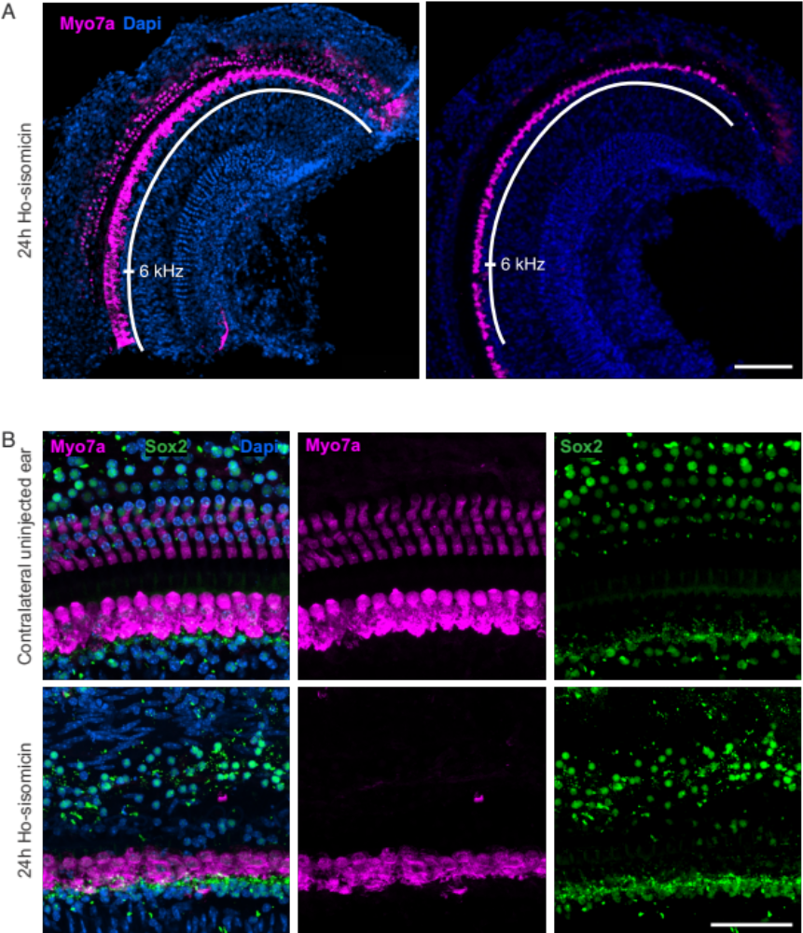
Suppl. Figure S2 related to Figure 3:

A. Two examples of the observed variability of outer hair cell loss in the apex of the cochlea. Wholemount preparations show the apex of two cochleae 24 hours after ho-sisomicin infusion. Left: Cochlea with surviving apical outer hair cells corresponding to the 6 kHz region. Right: Cochlea exhibiting complete loss of outer hair cells. Note the presence of a single row of inner hair cells in both cochleae. Scale bar = 100 µm.
B. Presence of supporting cells 24 hours post-infusion. Wholemount preparations comparing a control cochlea with a cochlea 24 hours post-infusion. The three rows of outer hair cells are absent, while the single row of inner hair cells remains after infusion (labeled in magenta, Myosin 7a). The supporting cell nuclei, labeled with Sox2 (in green), are still present, although a disorganization of the supporting cells in the outer hair cell region is observed. Scale bar = 50 µm.

Suppl. Figure S3 related to Figure 5:

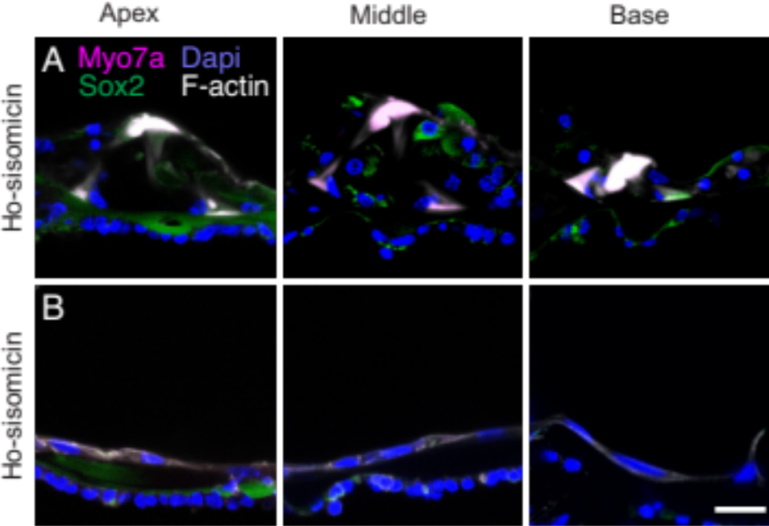

A, B. Examples of profound cochlear cell loss observed in a few post-ho-sisomicin cochleae after 7 days; middle turn cross-sections are shown. Supporting cells are lost in (A) and a flat epithelium is visible in (B).
Scale bar = 20 µm.

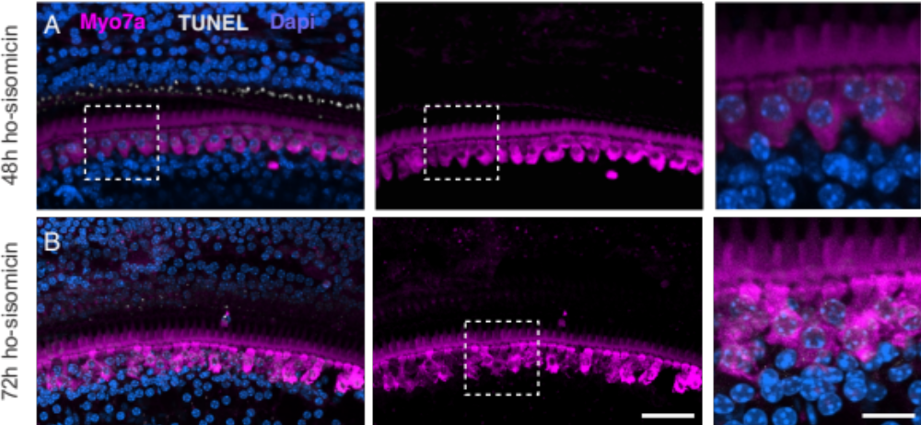
Suppl. Figure S4 related to Figure 6:

A, B. Wholemount preparations of cochleae 48h (A) and 72h (B) post ho-sisomicin infusion showed some missing inner hair cells and disturbed inner hair cell cytomorphology at 72 h (B). The remaining inner hair cells do not show TUNEL labeling.
Left scale bar = 50 µm, right scale bar: 10 µm.

