Table 1: Optimal Routes as a Function of Truck Capacity
 | Out-and-Back Delivery  One package/truck | Neighborhood Delivery  ~11 packages/truck | One Optimal Route  100 packages/truck
Euclidian  Distance Metric | 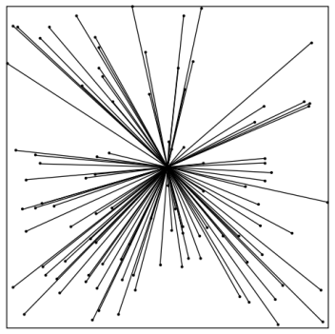  75.4 miles | 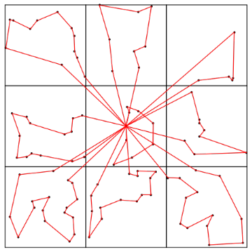  12.1 miles (84% shorter) | 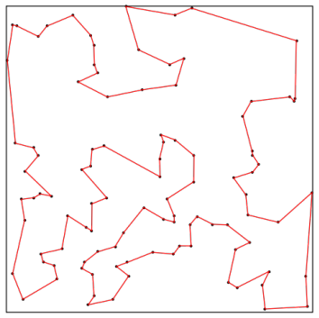  7.9 miles (90% shorter)
Taxicab  Distance Metric  (30% longer than Euclidian) | 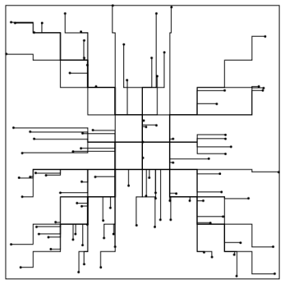  98.7 miles | 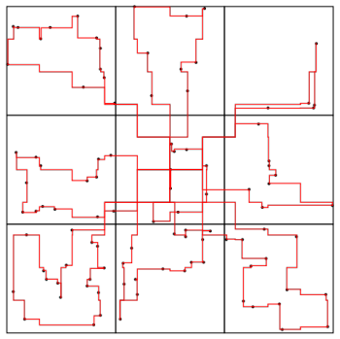  15.26 Miles (84% shorter) | 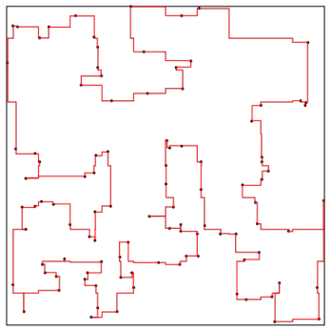  9.64 miles (90% shorter)

Table 2: Geographic Clusters and Optimal Routes in Austin for n=2,500
Clusters and routes | 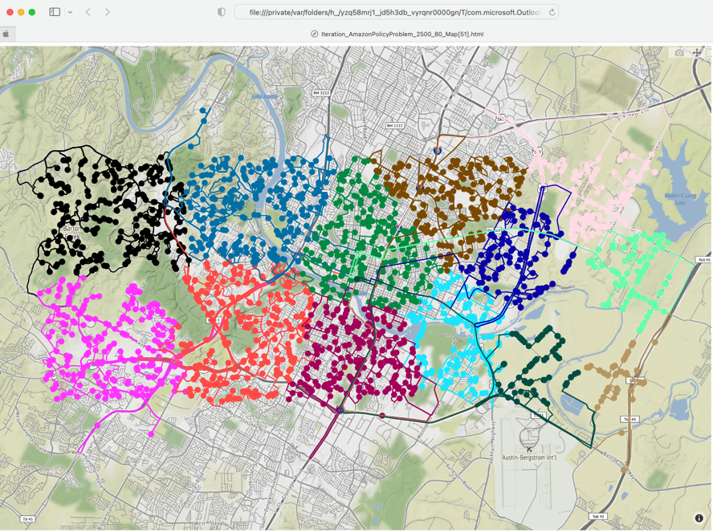
Zoom in on Brown Route | 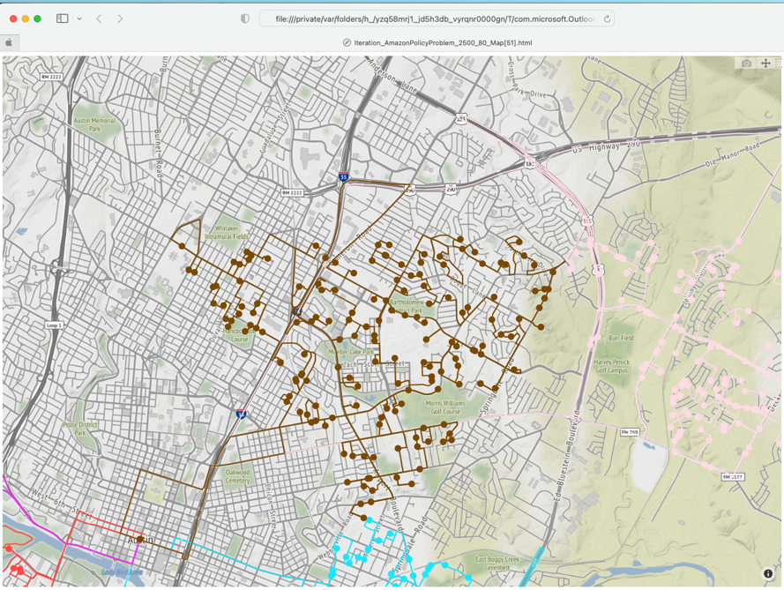

Table 3: Optimal Routes as a Function #Firms and #Deliveries
