(a) Class 1: Severe symptom group (b) Class 2: Movement-limitation and lymph-stasis symptom group
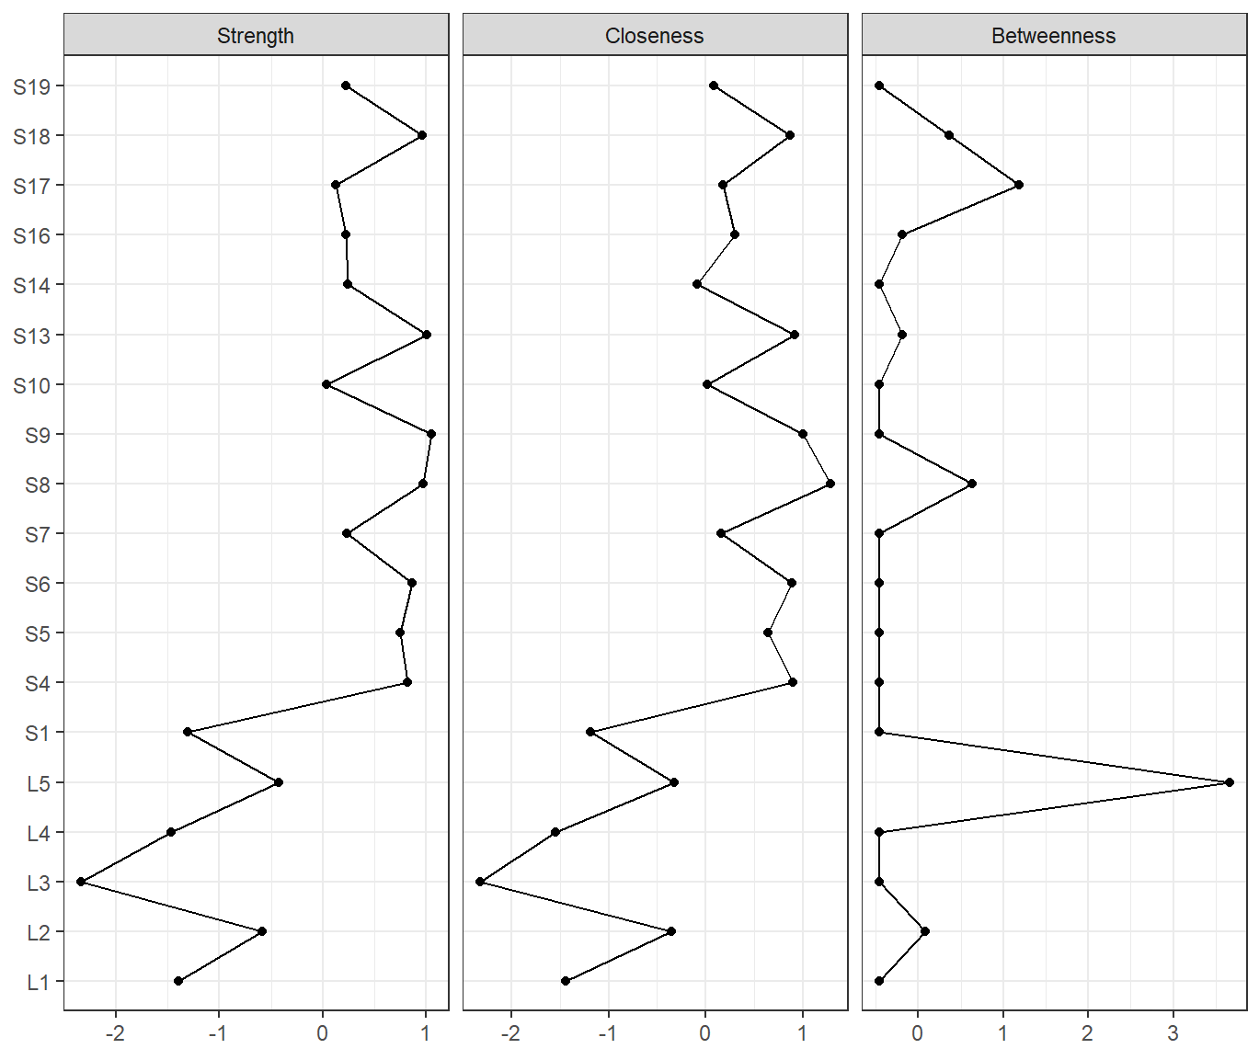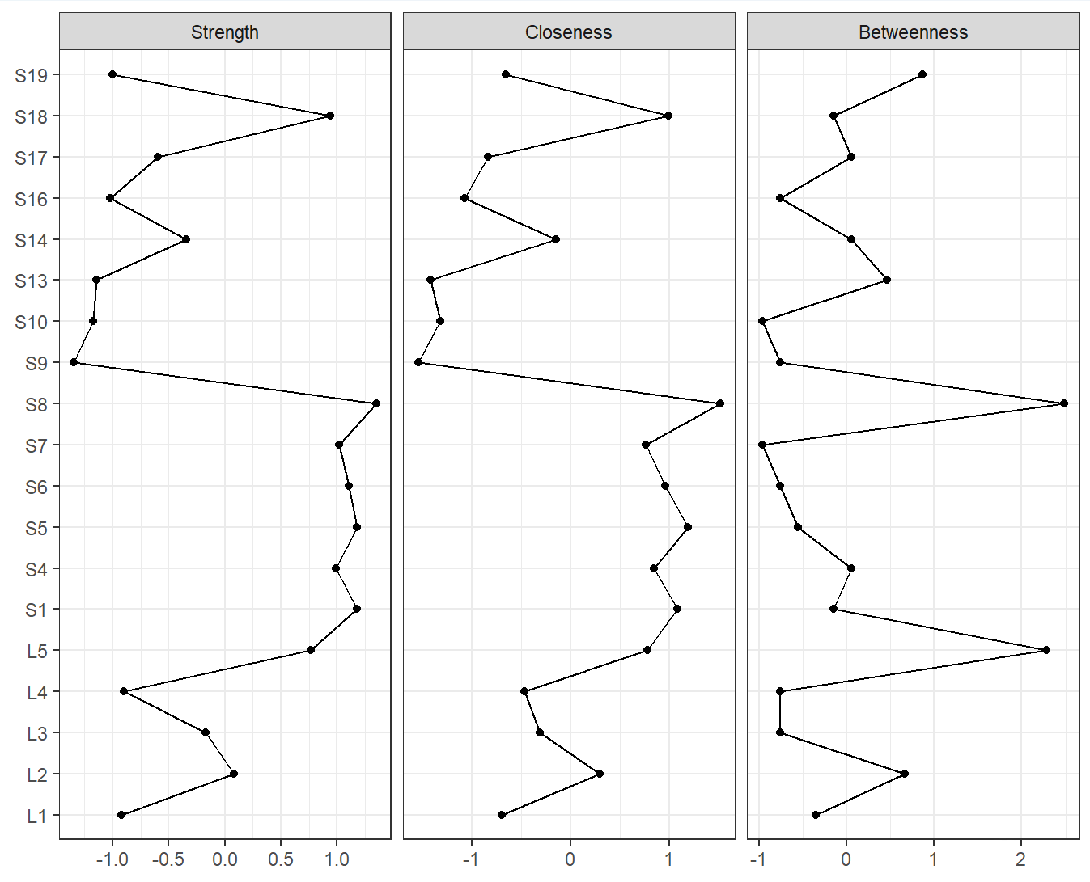
(c) Class 3: Lymph-stasis symptom group (d) Class 4: Mild symptom group
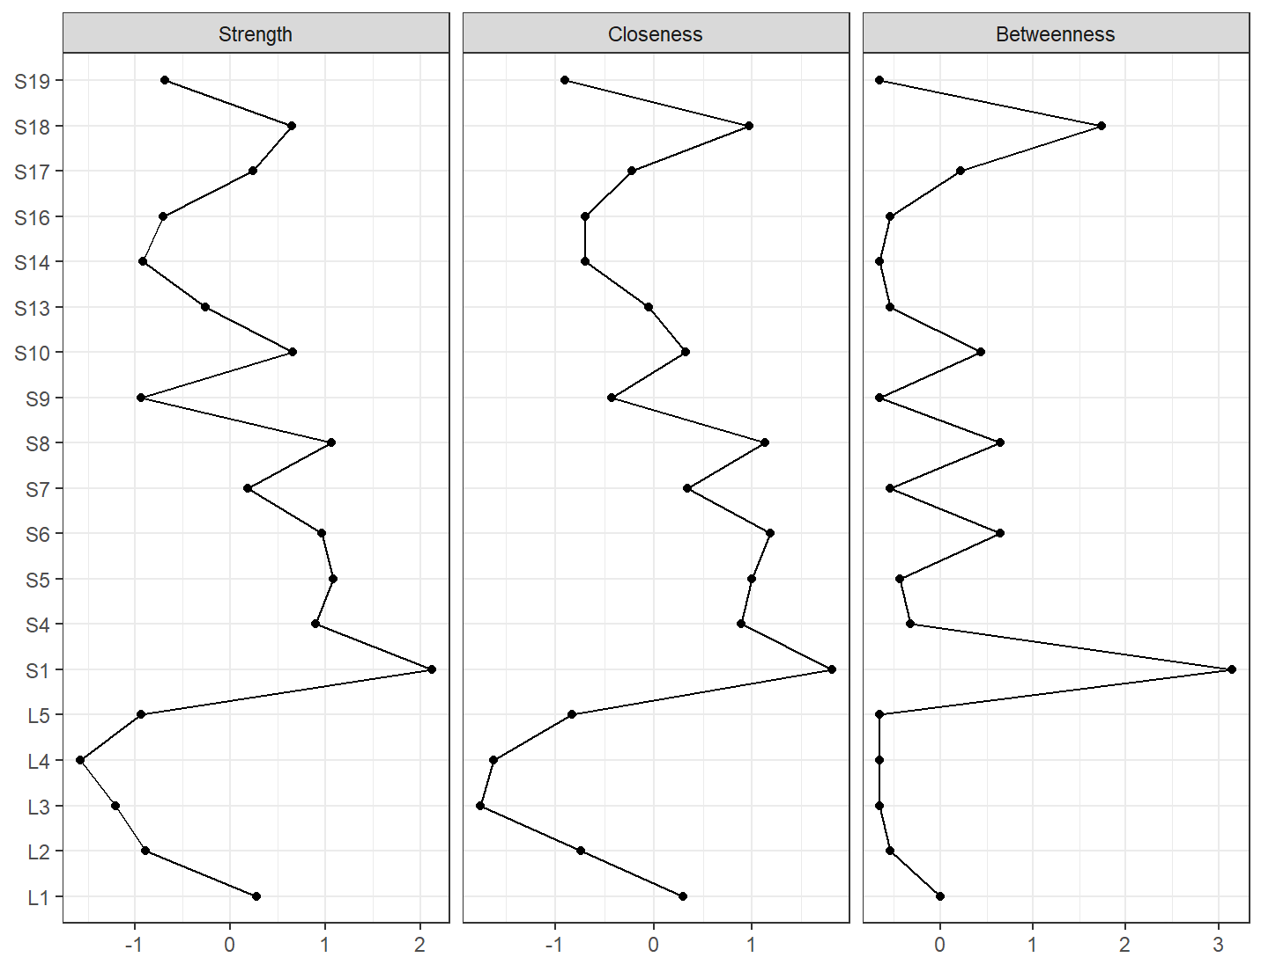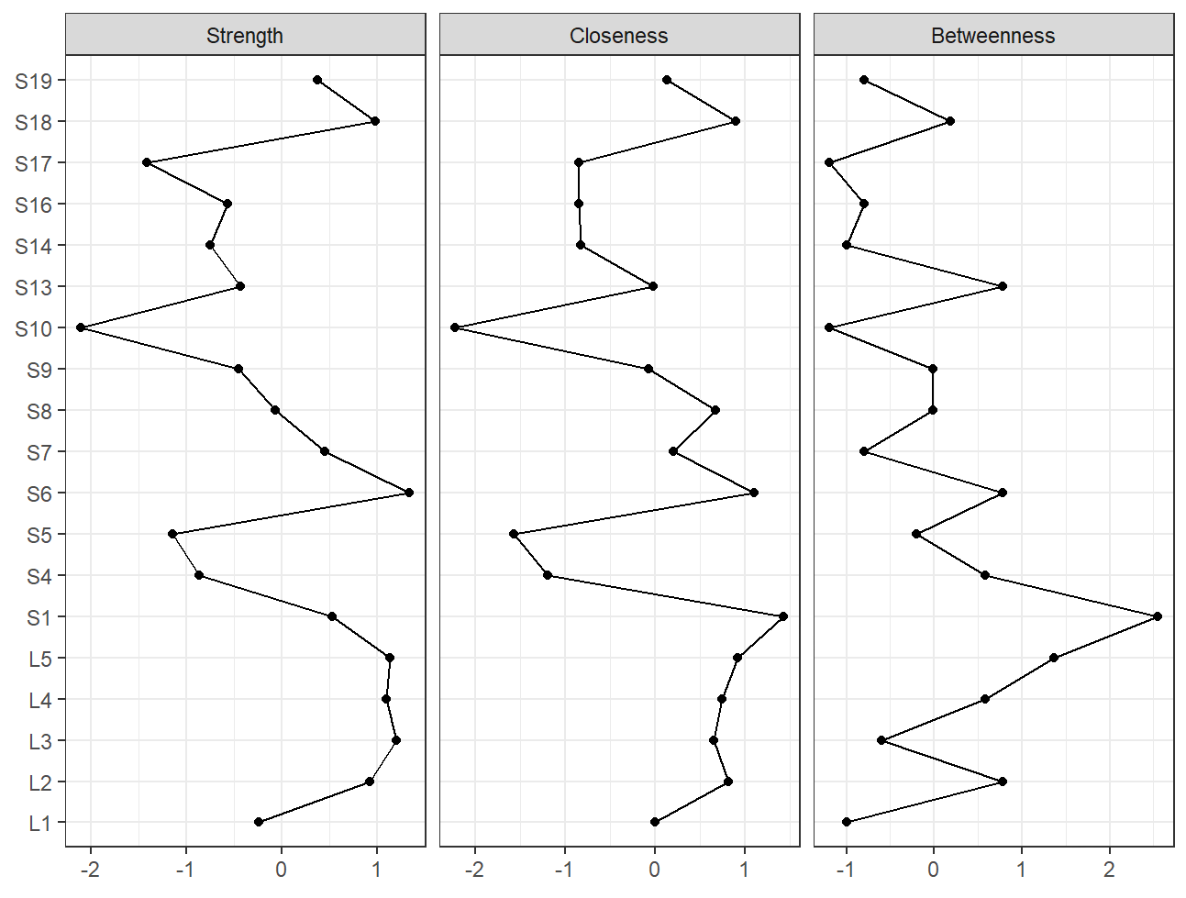
Supplementary Figure 1 Centrality indices of symptom networks for four latent class group

Supplementary Table 1 Upper limb symptom prevalence of breast cancer-related lymphedema (n = 341)
ID | Symptoms | Overall  (n = 341) n (%) | Severe symptom group  (n = 32) n (%) | Movement-limitation and lymph-stasis symptom group  (n = 84) n (%) | Lymph-stasis symptom group  (n = 128) n (%) | Mild symptom group  (n = 97) n (%)
L1 | Limited-shoulder-movement | 206 (60.41) | 28 (87.5) | 72 (85.7) | 77 (60.2) | 29 (29.9)
L2 | Limited-elbow-movement | 180 (52.79) | 28 (87.5) | 81 (96.4) | 60 (46.9) | 11 (11.3)
L3 | Limited-wrist-movement | 131 (38.42) | 31 (96.9) | 84 (100.0) | 4 (3.1) | 12 (12.4)
L4 | Limited-fingers-movement | 114 (33.43) | 30 (93.8) | 67 (79.8) | 8 (6.3) | 9 (9.3)
L5 | Limited-arm-movement | 200 (58.65) | 30 (93.8) | 84 (100.0) | 70 (54.7) | 16 (16.5)
S1 | Arm-swelling | 290 (85.04) | 32 (100.0) | 80 (95.2) | 121 (94.5) | 57 (58.8)
S2 | Breast-swelling | 40 (11.73) | 12 (37.5) | 11 (13.1) | 10 (7.8) | 7 (7.2)
S3 | Chest wall-swelling | 59 (17.3) | 15 (46.9) | 20 (23.8) | 20 (15.6) | 4 (4.1)
S4 | Arm-stiffness | 192 (56.3) | 30 (93.8) | 67 (79.8) | 85 (66.4) | 10 (10.3)
S5 | Arm-tightness | 238 (69.79) | 31 (96.9) | 74 (88.1) | 117 (91.4) | 16 (16.5)
S6 | Arm-heaviness | 259 (75.95) | 31 (96.9) | 83 (98.8) | 118 (92.2) | 27 (27.8)
S7 | Fibrosis (toughness or thickness of skin) | 171 (50.15) | 28 (87.5) | 61 (72.6) | 74 (57.8) | 8 (8.2)
S8 | Arm-firmness | 200 (58.65) | 31 (96.9) | 65 (77.4) | 95 (74.2) | 9 (9.3)
S9 | Tenderness | 98 (28.74) | 32 (100.0) | 26 (31.0) | 29 (22.7) | 11 (11.3)
S10 | Hotness | 75 (21.99) | 24 (75.0) | 20 (23.8) | 23 (18.0) | 8 (8.2)
S11 | Redness | 49 (14.37) | 17 (53.1) | 18 (21.4) | 13 (10.2) | 1 (1.0)
S12 | Blistering | 32 (9.38) | 11 (34.4) | 10 (11.9) | 7 (5.5) | 4 (4.1)
S13 | Pain/aching/soreness | 155 (45.45) | 32 (100.0) | 49 (58.3) | 57 (44.5) | 17 (17.5)
S14 | Numbness | 144 (42.23) | 30 (93.8) | 40 (47.6) | 51 (39.8) | 23 (23.7)
S15 | Burning | 52 (15.25) | 25 (78.1) | 8 (9.5) | 19 (14.8) | 0 (0.0)
S16 | Stabbing | 73 (21.41) | 29 (90.6) | 13 (15.5) | 29 (22.7) | 2 (2.1)
S17 | Tingling | 79 (23.17) | 30 (93.8) | 15 (17.9) | 25 (19.5) | 9 (9.3)
S18 | Arm-fatigue | 237 (69.5) | 31 (96.9) | 76 (90.5) | 108 (84.4) | 22 (22.7)
S19 | Arm-weakness | 162 (47.51) | 29 (90.6) | 59 (70.2) | 60 (46.9) | 14 (14.4)

Supplementary Table 2 Differences in sample characteristics among the latent classes
Variables | Groups | Severe symptom group  (n = 32) | Movement-limitation and lymph-stasis symptom group  (n = 84) | Lymph-stasis symptom group  (n = 128) | Mild symptom group  (n = 97) | F/χ²/ Fisher’s | P
Age |  | 55.07 (9.46) | 56.58 (11.05) | 57.40 (10.28) | 54.59 (10.39) | 1.497 | 0.215
Education | Primary school or below | 7 | 6 | 11 | 10 | 17.112 | 0.145
 | Middle school | 9 | 22 | 35 | 20
 | High school | 7 | 26 | 34 | 32
 | Junior college | 5 | 16 | 14 | 20
 | University or above | 4 | 14 | 34 | 15
Marital status | Single | 0 | 8 | 10 | 8 | 3.131 | 0.372
 | Coupled | 32 | 76 | 118 | 89
Employment | Unemployed | 27 | 61 | 99 | 73 | 1.915 | 0.590
 | Employed | 5 | 23 | 29 | 24
Medical insurance | Without insurance | 5 | 3 | 4 | 2 | 12.188 | 0.007
 | With insurance | 27 | 81 | 124 | 95
Post-surgery year | <1 year | 4 | 6 | 18 | 27 | 25.279 | 0.003
 | 1-3 years | 4 | 24 | 36 | 21
 | 3-5 years | 6 | 22 | 35 | 25
 | >5 years | 18 | 32 | 39 | 24
Type of breast surgery | Mastectomy | 28 | 79 | 114 | 84 | 2.865 | 0.413
 | Lumpectomy | 4 | 5 | 14 | 13
Type of lymphadenectomy | SLNB | 3 | 5 | 7 | 20 | 16.210 | 0.001
 | ALND | 29 | 79 | 121 | 77
Adjuvant chemotherapy | No | 3 | 3 | 9 | 9 | 2.554 | 0.466
 | Yes | 29 | 81 | 119 | 88
Radiotherapy | No | 12 | 24 | 43 | 49 | 10.697 | 0.013
 | Yes | 20 | 60 | 85 | 48
Endocrine therapy | No | 16 | 40 | 58 | 57 | 4.292 | 0.232
 | Yes | 16 | 44 | 70 | 40
Lymphedema stage | Mild-to-moderate stage | 20 | 53 | 75 | 58 | 0.504 | 0.918
 | Severe stage | 12 | 31 | 53 | 39
Abbreviations: SLNB, sentinel lymph node biopsy; ALND, axillary lymph node dissection.

Supplementary Table 3 Centrality indices of symptom networks for four latent class group
node | Class 1 |  |  | Class 2 |  |  | Class 3 |  |  | Class 4
node | Betweenness | Closeness | Strength | Betweenness | Closeness | Strength | Betweenness | Closeness | Strength | Betweenness | Closeness | Strength
L1 | -0.463 | -1.445 | -1.396 | -0.352 | -0.691 | -0.921 | 0.000 | 0.295 | 0.277 | -0.994 | -0.001 | -0.242
L2 | 0.087 | -0.350 | -0.585 | 0.662 | 0.299 | 0.085 | -0.542 | -0.743 | -0.889 | 0.777 | 0.815 | 0.925
L3 | -0.463 | -2.327 | -2.340 | -0.758 | -0.308 | -0.171 | -0.651 | -1.762 | -1.207 | -0.601 | 0.650 | 1.204
L4 | -0.463 | -1.551 | -1.464 | -0.758 | -0.468 | -0.902 | -0.651 | -1.621 | -1.584 | 0.580 | 0.749 | 1.101
L5 | 3.661 | -0.322 | -0.429 | 2.284 | 0.782 | 0.765 | -0.651 | -0.832 | -0.943 | 1.367 | 0.923 | 1.133
S1 | -0.463 | -1.187 | -1.302 | -0.149 | 1.084 | 1.175 | 3.145 | 1.809 | 2.121 | 2.548 | 1.429 | 0.532
S4 | -0.463 | 0.903 | 0.825 | 0.053 | 0.848 | 0.988 | -0.325 | 0.890 | 0.900 | 0.580 | -1.192 | -0.868
S5 | -0.463 | 0.643 | 0.750 | -0.555 | 1.190 | 1.182 | -0.434 | 0.996 | 1.083 | -0.207 | -1.569 | -1.144
S6 | -0.463 | 0.892 | 0.869 | -0.758 | 0.963 | 1.107 | 0.651 | 1.188 | 0.964 | 0.777 | 1.106 | 1.338
S7 | -0.463 | 0.161 | 0.235 | -0.961 | 0.767 | 1.019 | -0.542 | 0.344 | 0.183 | -0.797 | 0.207 | 0.452
S8 | 0.637 | 1.287 | 0.970 | 2.487 | 1.517 | 1.349 | 0.651 | 1.134 | 1.068 | -0.010 | 0.670 | -0.067
S9 | -0.463 | 1.007 | 1.051 | -0.758 | -1.540 | -1.345 | -0.651 | -0.430 | -0.939 | -0.010 | -0.070 | -0.452
S10 | -0.463 | 0.014 | 0.034 | -0.961 | -1.316 | -1.172 | 0.434 | 0.322 | 0.659 | -1.191 | -2.217 | -2.103
S13 | -0.188 | 0.914 | 1.005 | 0.459 | -1.414 | -1.141 | -0.542 | -0.048 | -0.260 | 0.777 | -0.024 | -0.430
S14 | -0.463 | -0.083 | 0.241 | 0.053 | -0.148 | -0.340 | -0.651 | -0.698 | -0.920 | -0.994 | -0.822 | -0.754
S16 | -0.188 | 0.304 | 0.228 | -0.758 | -1.067 | -1.021 | -0.542 | -0.695 | -0.711 | -0.797 | -0.845 | -0.565
S17 | 1.187 | 0.176 | 0.126 | 0.053 | -0.836 | -0.597 | 0.217 | -0.220 | 0.238 | -1.191 | -0.847 | -1.414
S18 | 0.362 | 0.875 | 0.961 | -0.149 | 0.995 | 0.940 | 1.735 | 0.972 | 0.649 | 0.186 | 0.902 | 0.977
S19 | -0.463 | 0.088 | 0.222 | 0.865 | -0.655 | -0.999 | -0.651 | -0.899 | -0.690 | -0.797 | 0.135 | 0.376
Note: L1, Limited-shoulder-movement; L2, Limited-elbow-movement; L3, Limited-wrist-movement; L4, Limited-fingers-movement; L5, Limited-arm-movement; S1, Arm-swelling; S4, Arm-stiffness; S5, Arm-tightness; S6, Arm-heaviness; S7, Fibrosis (toughness or thickness of skin); S8, Arm-firmness; S9, Tenderness; S10, Hotness; S13, Pain/aching/soreness; S14, Numbness; S16, Stabbing; S17, Tingling; S18, Arm-fatigue; S19, Arm-weakness

