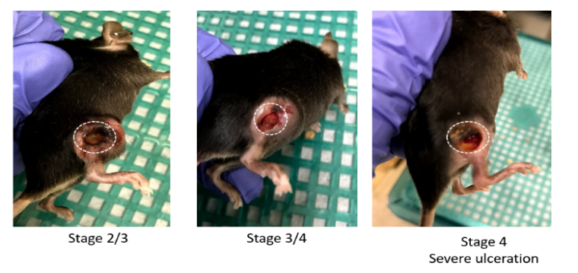
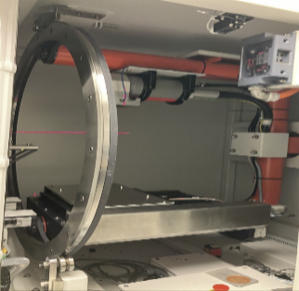

Fig. S1. (left) Experiential set up. Tumor-bearing mice were irradiated with 10 to 40 Gy according to multiple schedules (Table S1), using local irradiations with a small animal dedicated x-ray irradiator (X-RAD 32, Precision X-ray, Inc). (right) The tumor volumes were measured by length (x), width (y), and height (z) and calculated as xyz/2. If the tumor volume exceeds 1500 mm³, or the mouse has significant ulceration in the tumor, the mouse reaches the survival endpoint and is euthanized.

Table S1. The timing diagram of the combined therapy in our study (26 groups in total). For immunotherapy, either anti-PD-L1 or isotype control was administered. For radiation, different doses were delivered (10, 15, 20, 40 Gy). The first pulse of radiation was always delivered 14 days after the implantation. Tumor volume measurements were carried out sequentially on certain days.

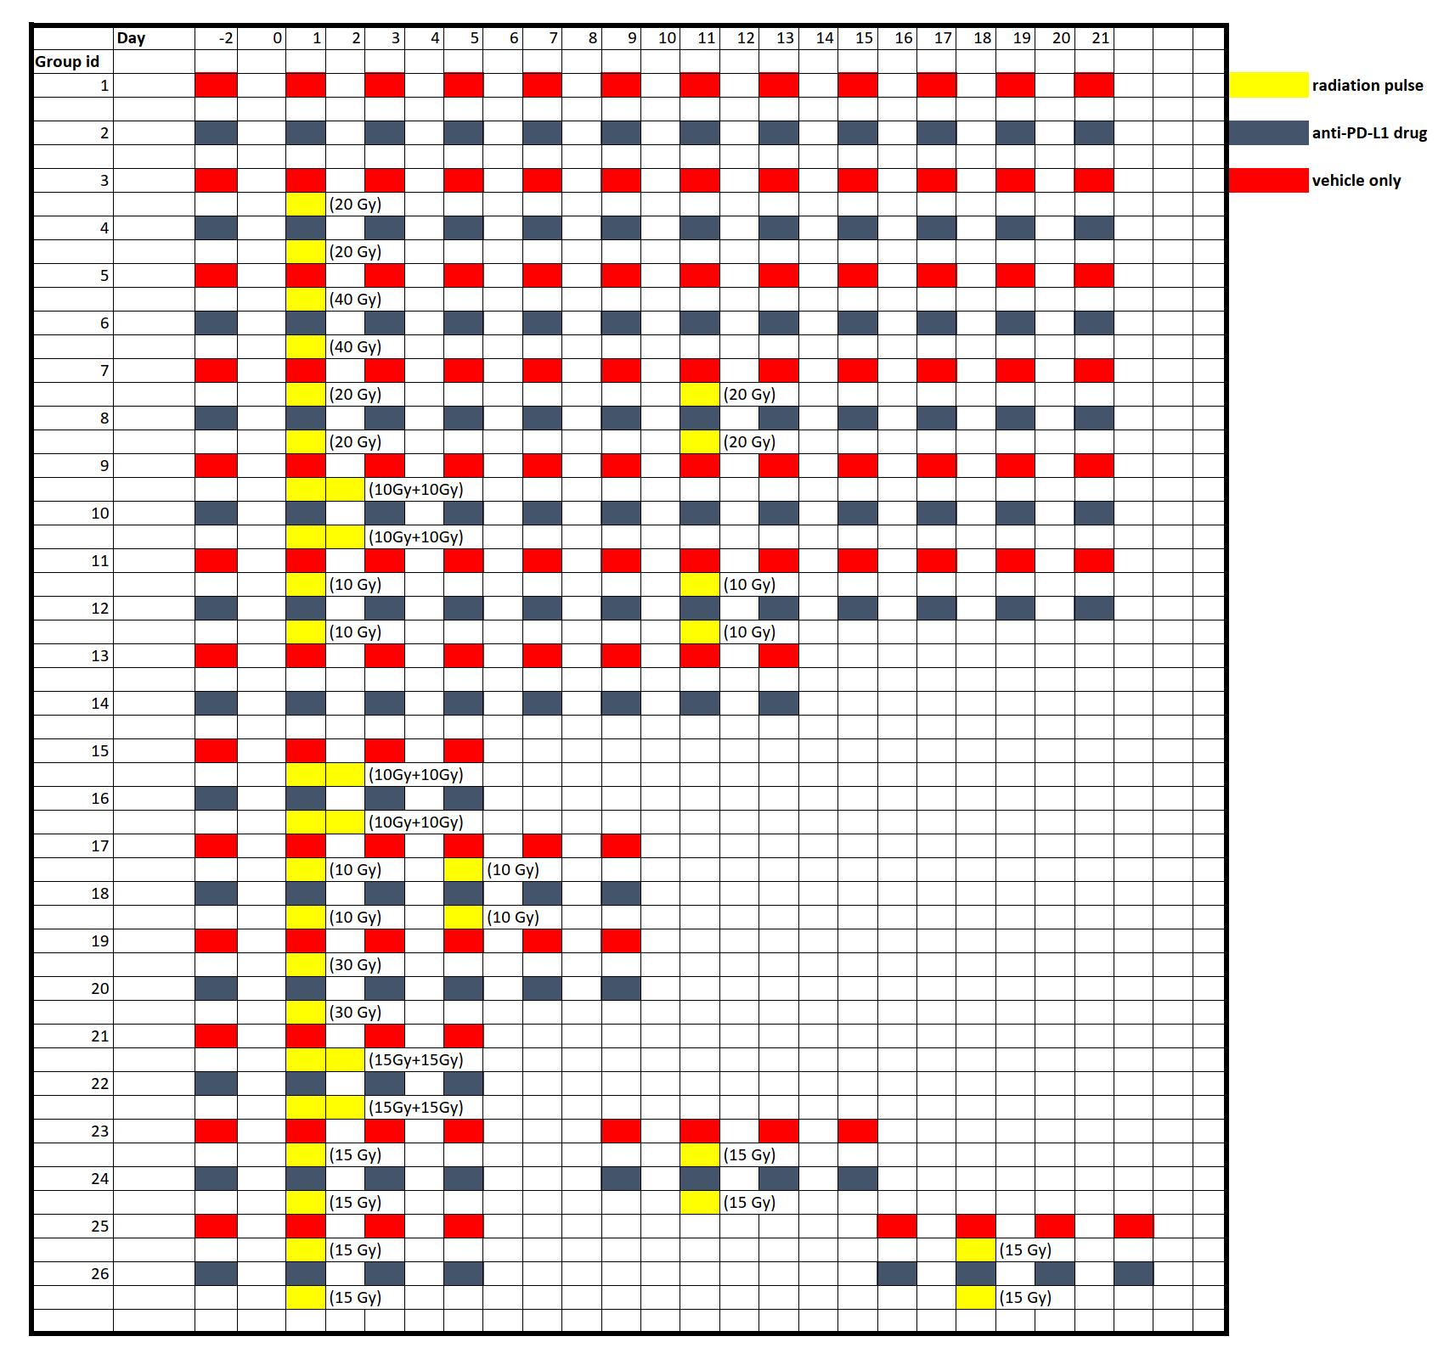

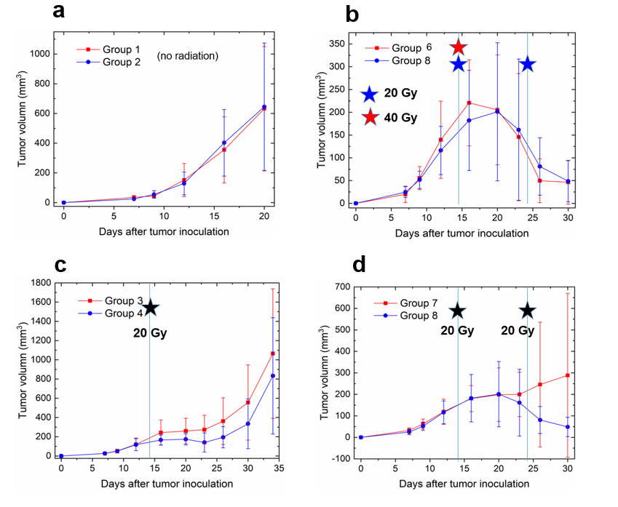
Fig. S2. Illustration of tumor volume change under different delivery schemes. The vertical line on day 14 represents the first radiation pulse. (a) In the absence of radiation, there is no significant difference observed between the control group (group 1) and the α-PD-L1 antibody group (group 2). (b) Similarly, when comparing a single pulse of 40 Gy (group 6, α-PD-L1) to two pulses of 20 Gy with a 10-day interval (group 8, α-PD-L1), both effectively suppress tumor growth. The survival fraction between 40 Gy and 20 Gy appears comparable with the presence of large error bars. (c) In the case of a single pulse of 20 Gy, there is a noticeable benefit in tumor control for group 4 (α-PD-L1) compared to group 3 (control), which becomes apparent one to two days after the first pulse and becomes more pronounced over time. (d) The overall trend is similar to (c) when two radiation pulses (20 Gy with a 10-day interval) are delivered. However, between day 15 and day 20, there is no significant impact of α-PD-L1 observed (group 7 with control, group 8 with α-PD-L1).

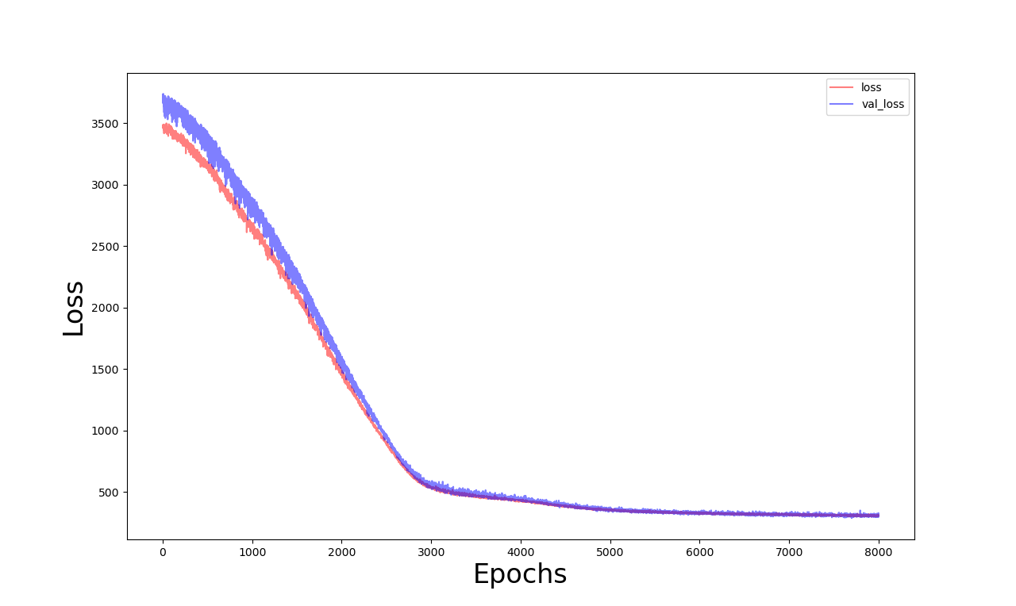
Fig. S3. Training-loss and validation-loss curves in terms of mean-squared error as a function of epochs (batch size=32).

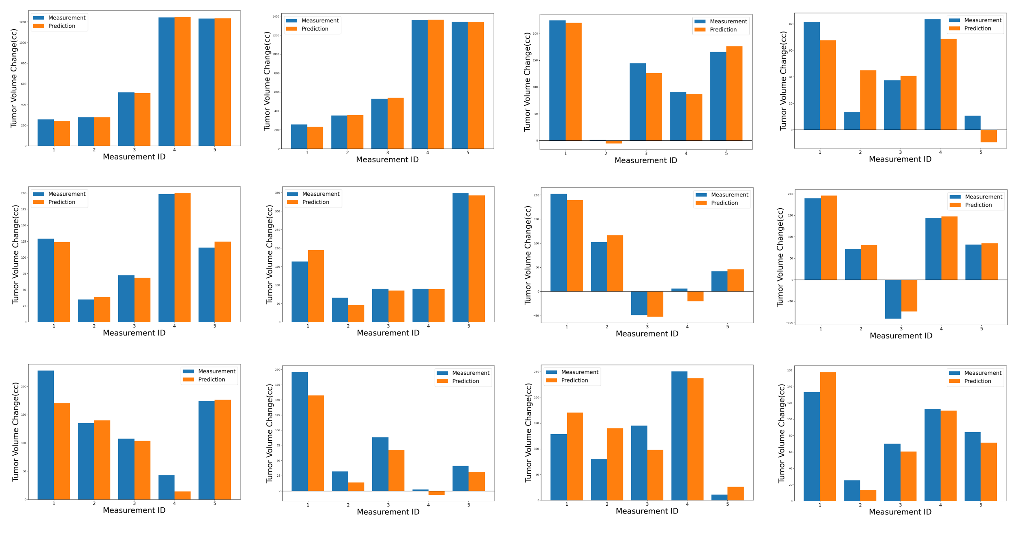
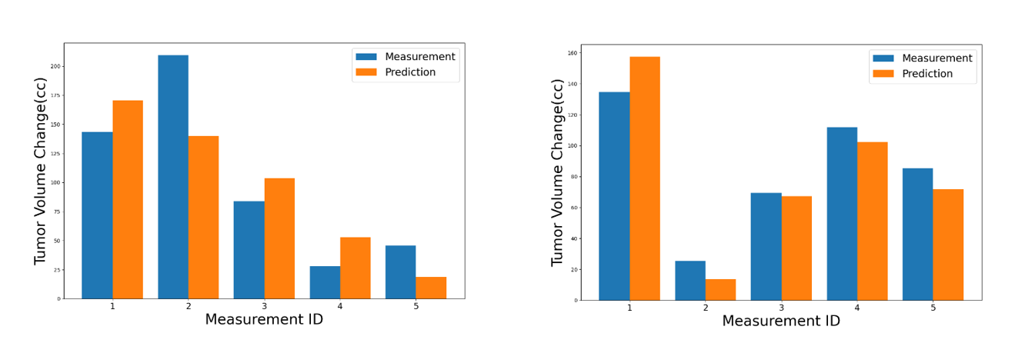

Fig. S4. Predicted tumor volume change for groups 13-26 (top row: 13-16, second row: 17-20, third row: 21-24, fourth row: 25-26), in comparison with the results of measurements.

