Appendix 1
Study setting and site selection
Burkina Faso
In Burkina Faso, the study was implemented in Saponé health district (see Figure 2), which is located approximately 40km southwest of the capital, Ouagadougou, and has 26 health facilities (25 rural and one urban). The most commonly spoken language is Mooré, the rainy season starts from June to October, and SMC implementation in the district began in 2016. Sambin health centre was selected for study implementation, with a catchment area consisting of 3 villages and a total 3-59-month population of 1,083(21).

Sambin was selected due to its location within the health district, for being the health facility with the lowest SMC coverage in the district in 2020, and for its accessibility. The study was implemented in each of the three villages in the health facility catchment area, with each village corresponding to a cluster. Cluster 1 was the closest to the health facility (0 km), cluster 2 was 7km from the health facility and cluster 3 was the furthest, at 9km from the health facility.

Chad
In Chad, the study was implemented in Bokoro health district of Hadjer Lamis province in central Chad. Bokoro has a total population of 50,347 children under five, is supported by 24 health facilities and is comprised of urban and rural areas(22). Local languages include French and Arabic, and SMC has been implemented in the district since 2014. Tersefe health centre was selected for the study implementation, with a catchment area consisting of 14 villages and a total under-five population of 2,920(22).

The health centre was selected for its accessibility during the rainy season, the relatively stable security situation, high malaria endemicity and for being located within an SMC implementation district. Villages in the catchment area were divided into three clusters on the basis of distance from the health facility. Cluster 1 was less than 5 km from the health facility, while clusters 2 and 3 were 10km and 27km respectively from the health facility.

Togo
In Togo, Blitta health district (in Centrale region) was selected for the implementation of the role model approach. The district has 22 health facilities with a total population of 163,585 in rural areas and 9,274 in urban areas. The total under five population is 31,632(23). The majority spoken language is Ewé, and SMC has been implemented in the district since 2020. Pagala Gare health centre was selected for study implementation, with a catchment area consisting of 14 villages and a total under-five population of 5,232(24). Pagala Gare health centre was selected due to its accessibility to limit possible disruptions to movement due to the COVID-19 pandemic control measures. Villages in the catchment area were clustered based on distance from the health facility. Cluster 1 was the closest, cluster 2 was 4km from the health facility and cluster 3 was 7km from the health facility.

Appendix 2
Adaptation of 2022 SMC campaigns
Using the results of the formative and evaluation phases, tailored recommendations for each country were compiled to aid future SPAQ administration within communities. These were integrated into each country’s respective 2022 SMC communication campaigns to ensure the continuation of activities and sustainability, as well as making the information more accessible on a larger scale.

In Burkina Faso, posters on two role model behaviours were shared in all health facilities of Saponé district and used during awareness sessions by volunteers. First, a poster on the flattery of children to encourage them to swallow SPAQ and second, a poster on the involvement of spouses, in-laws, grandparents and neighbours to help remind caregivers of SMC administration. Town criers were also involved in the dissemination of the two messages in the communities. A further scale up of these promotion posters for community members and/or healthcare workers is planned for the 2023 SMC campaign.

In Chad, the main role model behaviours identified during the formative phase of this study were promoted during the 2022 campaign in all districts where Malaria Consortium implements SMC. Role model messages were included in the sensitisation of key actors involved in SMC information dissemination at community level (e.g. health facility in-charges and community distributors). Community members were sensitised through the integration of role model behaviours into community mobilisation messages prior to and during SMC distribution. Four main role model behaviours were promoted in the 2022 campaign. First, the use of positive incentive techniques such as coaxing, flattering and cuddling the child, or promising sweets. These techniques were promoted both for their successful outcome reported by some caregivers during the formative phase of the study and to promote an alternative to counter other, more forceful behaviours reported during formative discussions. Second, the use of circumstantial reminders to administer AQ on day 2 and 3, such as placing blister packs next to tea, cooking condiments and mirrors, or other items regularly accessed by caregivers, to set a visual reminder. Third, involvement of spouses, extended family and other community members in SPAQ administration and adherence to support mothers who were largely reported as the primary caregivers and in charge of SPAQ administration. Fourth, the use of mosquito nets alongside SMC in protecting children against malaria.

In Togo, nine new villages were selected in Blitta district and eight were selected in Oti-Sud district in Savanes region for the promotion of role model messages. Volunteers raised awareness in their communities using pictorial messages produced by the study team. Five key behaviours emerging from the formative study phase were promoted. First, the role of paternal and maternal affection before SPAQ administration, including playing with the child, promising small gifts or food and discouraging any type of violent administration behaviour by caregivers. Second, the presence of both mother and father during SPAQ administration to promote male involvement and spousal support. Third, dissolving SPAQ in a small amount of water prior to administration to help reduce the risk of vomiting and to avoid mixing SPAQ with other food or beverages. Fourth, placing the child in a vertical position during administration and avoiding the obstruction of the child’s nostrils. Fifth, placing blister packs in a visible location out of reach for children to help remind caregivers to administer day 2 and 3 AQ doses while preventing children from accessing the tablets.

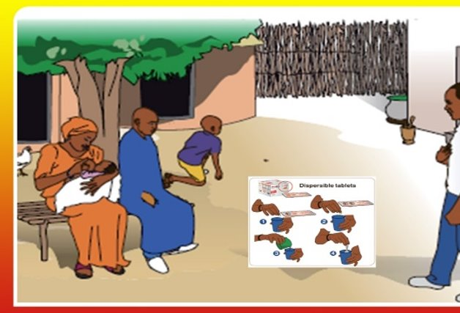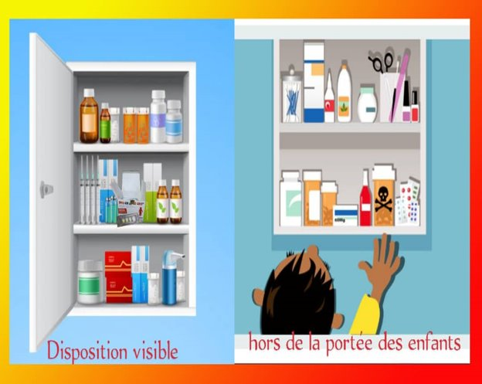
Figure 3. Pictorial messages used by community volunteers in Togo to promote role model behaviours during the 2022 SMC campaign: presence of both mothers and fathers during SMC administration (left), keeping drugs visible and out of reach of children (right).

In Burkina Faso, two posters were created following a workshop with stakeholders on the study results. A pre-test of these took place in a health facility among community distributors, caregivers and health workers. This allowed them to match pictures with the relevant messages for promoting two role model behaviors: flattering children with treats prior to SPAQ administration (figure 4) and the role of family members in reminding caregivers to administer SPAQ (figure 5).

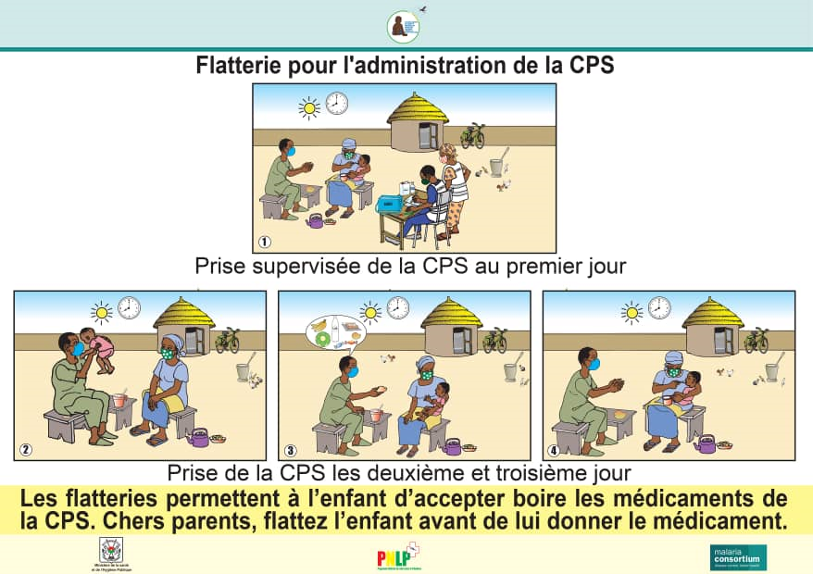
Figure 4. Poster illustrating the use of treats to flatter children prior to SPAQ administration.
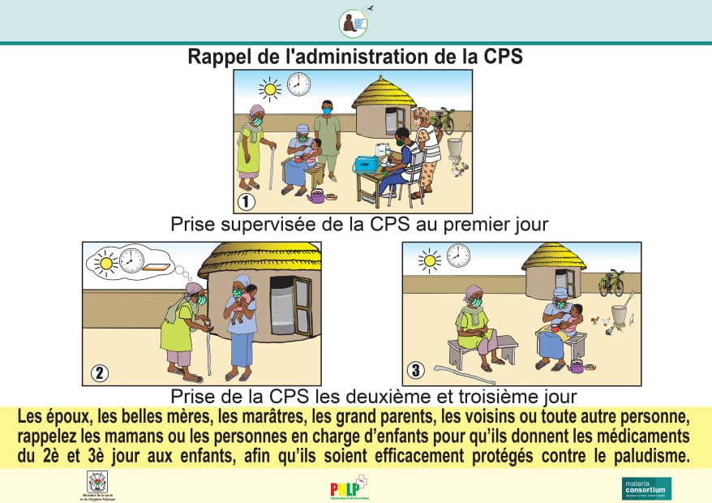
Figure 5. Poster illustrating the role of family members in reminding caregivers to administer SPAQ.

To evaluate the promotion of role model behaviours during the 2022 SMC campaign, routine surveys were adapted in each country. In Burkina Faso, an end-of-cycle and EoR survey was created for the area of Ipelce including questions on the role model approach during November and December 2022. In Chad, questions on role model behaviours were added to routine end-of-cycle surveys after SMC cycle 2 and to routine EoR surveys, acting respectively as baseline and endline surveys. In Togo, questions related to role model messaging were also included in the routine SMC coverage surveys.

Appendix 3
Table 1: Number of evaluative FGDs per cluster by type of respondent in each country.
 | Number of FGDs per cluster by type of respondent | Participants per FGD | Participants per country
Burkina Faso | Cluster 1: 1 (mothers)  Cluster 2: 1 (mothers), 1 (fathers)  Cluster 3: 1 (mothers) | 8 per FGD = 8  8 per FGD = 16  8 per FGD = 8 | 32
Chad | Cluster 1: 1 (mothers), 1 (fathers)  Cluster 2: 1 (fathers)  Cluster 3: 1 (mothers) | 8 per FGD = 16  8 per FGD = 8  8 per FGD = 8 | 32
Togo | Cluster 1: 3 (mothers), 2 (fathers)  Cluster 2: 3 (mothers), 2 (fathers)  Cluster 3: 3 (mothers), 2 (fathers) | 9 per FGD (mothers), 8 per FGD (fathers)  8 per FGD (mothers), 9 per FGD (fathers)  9 per FGD (mothers), 7 per FGD (fathers [one participant withdrew]) | 126
Total participants | 190

Table 2: Key role model behaviours that were promoted based on formative phase findings, by country.
Country | Promoted role model behaviour
Burkina Faso | Involvement of fathers by administering SPAQ themselves, reminding their wife of administration times or using gentle encouragement tactics on the child to facilitate administration
Burkina Faso | Involvement of other relatives such as mothers-in-law to remind the mother to administer SPAQ
Burkina Faso | Crushing and hiding the medicine in local foods (e.g. cornflour and porridge) to deceive children and ease consumption
Burkina Faso | Flattering the child with food and drink (e.g. tea) as an encouragement tactic
Burkina Faso | Mixing SPAQ with drinks (e.g. coffee and milk) prior to administration
Chad | Placing SPAQ tablets next to sugar packets so each time the caregiver prepares tea, they are reminded of the need to administer SPAQ
Chad | Incorporating SPAQ administration as part of a daily routine, occurring at the same time each day. By doing daily actions in chronological order (e.g. washing and feeding children, administering SPAQ and placing children under a mosquito net before bed), this makes the task easier to remember
Chad | Diluting the medicine in a glass of water prior to administration
Chad | Involvement of fathers by:  - Encouraging children to ingest SPAQ by promising sugar in return  - Supporting the mother and reminding her of when it is time to administer SPAQ  - Keeping the remaining doses of SPAQ in a clean, safe place that is easy to remember
Togo | Mixing SPAQ with food (e.g. porridge or maize) or drink (e.g. milk or juice) to make it easier to swallow
Togo | Involvement of fathers by:  - Singing songs to encourage and reassure children  - Helping mothers to administer SPAQ  - Promising to take children on a motorcycle ride in return for ingesting SPAQ

Table 3. Sample characteristics and role model outcomes among sampled children, caregivers and households in Blitta prefecture, Togo, and Ipelcé commune, Burkina Faso
 | Variable | Category | Togo |  | Burkina Faso |  |  | Total
 | Variable | Category | n | % | n | % | weighted % | n | %
Community | Pagala-Gare_Centre |  | 249 | 69.8 |  |  |  | 249 | 50.8
Community | Pagala-Lassa |  | 77 | 21.6 |  |  |  | 77 | 15.7
Community | Tantakoté |  | 31 | 8.7 |  |  |  | 31 | 6.3
Community | Sambin (division C14) |  |  |  | 39 | 29.3 |  | 39 | 8.0
Community | Sambin (division C15) |  |  |  | 40 | 30.1 |  | 40 | 8.2
Community | Sagabtinga-Yarcé |  |  |  | 25 | 18.8 |  | 25 | 5.1
Community | Bandéba |  |  |  | 29 | 21.8 |  | 29 | 5.9
SMC indicators (cycle 4 2021) | Child received day 1 SPAQ | Yes | 322 | 90.2 | 129 | 97.0 | 96.9 | 451 | 92.0
SMC indicators (cycle 4 2021) | Child received day 1 SPAQ | No | 35 | 9.8 | 4 | 3.0 | 3.1 | 39 | 8.0
SMC indicators (cycle 4 2021) | Caregiver adhered to administration of AQ on day 2 and day 3 | Yes | 312 | 98.1 | 125 | 97.7 | 97.4 | 437 | 100.0
SMC indicators (cycle 4 2021) | Caregiver adhered to administration of AQ on day 2 and day 3 | No | 6 | 1.9 | 3 | 2.3 | 2.6 | 9 | 2.0
Role model variables | Heard of role model approach | Yes | 90 | 25.2
Role model variables | Heard of role model approach | No | 267 | 74.8
Role model variables | Source of information about role model approach* | Local political leader | 9 | 3.4 | 8 | 11.1 | 9.2 | 17 | 7.6
Role model variables | Source of information about role model approach* | Local religious leader | 0 | 0.0 | 6 | 8.3 | 7.3 | 6 | 2.7
Role model variables | Source of information about role model approach* | Health facility personnel | 9 | 3.4 | 28 | 38.9 | 39.8 | 37 | 16.5
Role model variables | Source of information about role model approach* | Community health worker/SMC distributor | 47 | 17.5 | 29 | 40.3 | 40.6 | 76 | 33.9
Role model variables | Source of information about role model approach* | Radio | 1 | 0.4 | 5 | 6.9 | 6.4 | 6 | 2.7
Role model variables | Source of information about role model approach* | Printed materials or banners | 0 | 0.0 | 0 | 0.0 | 0.0 | 0 | 0.0
Role model variables | Source of information about role model approach* | Television | 0 | 0.0 | 0 | 0.0 | 0.0 | 0 | 0.0
Role model variables | Source of information about role model approach* | Town announcer | 30 | 11.2 | 5 | 6.9 | 6.5 | 35 | 15.6
Role model variables | Source of information about role model approach* | Word-of-mouth | 9 | 3.4 | 33 | 45.8 | 48.7 | 42 | 18.8
Role model variables | Source of information about role model approach* | Other | 2 | 0.7 | 3 | 4.2 | 4.6 | 5 | 2.2
Role model variables | Participated in role model activity | Yes | 66 | 18.5 | 72 | 54.1 | 55.9 | 138 | 28.2
Role model variables | Participated in role model activity | No | 291 | 81.5 | 61 | 45.9 | 44.1 | 352 | 71.8

 | Activities participated in* | Community orientation meeting | 23 | 30.7 | 9 | 12.5 | 11.3 | 32 | 33.3
 | Activities participated in* | Group discussion | 46 | 61.3 | 60 | 83.3 | 85.8 | 106 | 110.4
 | Activities participated in* | Talk/presentation | 2 | 2.7 | 13 | 18.1 | 18.5 | 15 | 15.6
 | Activities participated in* | Training session | 0 | 0.0 | 2 | 2.8 | 2.5 | 2 | 2.1
 | Activities participated in* | One-on-one session at health facility | 3 | 4.0 | 3 | 4.2 | 3.9 | 6 | 6.3
 | Activities participated in* | Other | 1 | 1.3 | 4 | 5.6 | 4.4. | 5 | 5.2
Caregiver engagement outcomes | "It is easy to remember to administer the second and third SMC doses (day 2 and day 3)" ("Il est facile de se rappeler d'administrer les deuxième et troisième doses (jour 2 et jour 3)") | Strongly agree | 68 | 20.1 | 62 | 47.0 | 46.2 | 130 | 27.6
Caregiver engagement outcomes |  | Agree | 234 | 69.0 | 65 | 49.2 | 50.0 | 299 | 63.5
Caregiver engagement outcomes |  | Neither agree nor disagree | 19 | 5.6 | 1 | 0.8 | 0.5 | 20 | 4.2
Caregiver engagement outcomes |  | Disagree | 18 | 5.3 | 4 | 3.0 | 3.3 | 22 | 4.7
Caregiver engagement outcomes |  | Strongly disagree | 0 | 0.0 | 0 | 0.0 | 0.0 | 0 | 0.0
Caregiver engagement outcomes | "I believe it is (or would be) easy to administer the second and third SMC doses (day 2 and day 3) to my children aged under five years" ("Je pense qu'il est (ou serait) facile d'administrer les deuxième et troisième doses (jour 2 et jour 3) à mes enfants de moins de cinq ans") | Strongly agree | 81 | 23.9 | 61 | 46.2 | 45.9 | 142 | 30.1
Caregiver engagement outcomes |  | Agree | 216 | 63.7 | 63 | 47.7 | 48.0 | 279 | 59.2
Caregiver engagement outcomes |  | Neither agree nor disagree | 21 | 6.2 | 3 | 2.3 | 2.2 | 24 | 5.1
Caregiver engagement outcomes |  | Disagree | 20 | 5.9 | 4 | 3.0 | 3.3 | 24 | 5.1
Caregiver engagement outcomes |  | Strongly disagree | 1 | 0.3 | 1 | 0.8 | 0.5 | 2 | 0.4
Caregiver engagement outcomes | "The project has improved my knowledge and skills in malaria prevention and administration of SPAQ" ("Le projet a amélioré mes connaissances et compétences en matière de paludisme, et mes connaissances et compétences en matière d'administration de SPAQ") | Strongly agree | 19 | 29.7 |  |  |  | 19 | 29.7
Caregiver engagement outcomes |  | Agree | 44 | 68.8 |  |  |  | 44 | 68.8
Caregiver engagement outcomes |  | Neither agree nor disagree | 1 | 1.6 |  |  |  | 1 | 1.6
Caregiver engagement outcomes |  | Disagree | 0 | 0.0 |  |  |  | 0 | 0.0
Caregiver engagement outcomes |  | Strongly disagree | 0 | 0.0 |  |  |  | 0 | 0.0
Caregiver engagement outcomes | "I would like to practice the model behaviours for administration of SPAQ that I learned from this project during upcoming [SMC] campaigns" ("Je voudrais pratiquer les comportements modèles que j'ai appris de ce projet dans l'administration du SPAQ, lors des prochaines campagnes") | Strongly agree | 15 | 23.4 |  |  |  | 15 | 23.4
Caregiver engagement outcomes |  | Agree | 49 | 76.6 |  |  |  | 49 | 76.6
Caregiver engagement outcomes |  | Neither agree nor disagree | 0 | 0.0 |  |  |  | 0 | 0.0
Caregiver engagement outcomes |  | Disagree | 0 | 0.0 |  |  |  | 0 | 0.0
Caregiver engagement outcomes |  | Strongly disagree | 0 | 0.0 |  |  |  | 0 | 0.0

Caregiver use of food/drink in SMC administration (cycle 4 2021) | Use of food (day 1 SPAQ administration)** | Yes | 11 | 3.4 | 28 | 21.9 | 21.9 | 39 | 8.7
 | Use of food (day 1 SPAQ administration)** | No | 309 | 96.6 | 100 | 78.1 | 78.1 | 409 | 91.3
 | Use of food (day 2 and/or day 3 AQ administration)** | Yes | 14 | 4.4 | 32 | 25.0 | 25.0 | 46 | 10.3
 | Use of food (day 2 and/or day 3 AQ administration)** | No | 304 | 95.6 | 96 | 75.0 | 75.0 | 400 | 89.7
 | Use of drink (day 1 SPAQ administration)** | Yes | 147 | 45.7 | 26 | 20.2 | 20.6 | 173 | 38.4
 | Use of drink (day 1 SPAQ administration)** | No | 175 | 54.3 | 103 | 79.8 | 79.4 | 278 | 61.6
 | Use of drink (day 2 and/or day 3 AQ administration)** | Yes | 148 | 46.4 | 26 | 20.3 | 21.2 | 174 | 38.9
 | Use of drink (day 2 and/or day 3 AQ administration)** | No | 171 | 53.6 | 102 | 79.7 | 78.8 | 273 | 61.1
Caregiver characteristics | Sex | Female | 335 | 93.8 | 125 | 94.0 | 93.6 | 460 | 93.9
Caregiver characteristics | Sex | Male | 22 | 6.2 | 8 | 6.0 | 6.4 | 30 | 6.1
Caregiver characteristics | Marital status | In a marriage or partnership | 322 | 90.2 | 124 | 93.2 | 93.6 | 446 | 91.0
Caregiver characteristics | Marital status | Not in a marriage or partnership | 35 | 9.8 | 9 | 6.8 | 6.4 | 44 | 9.0
Caregiver characteristics | Employment status | Employed*** | 264 | 73.9 | 50 | 37.6 | 65.1 | 314 | 64.1
Caregiver characteristics | Employment status | Not working | 93 | 26.1 | 83 | 62.4 | 34.9 | 176 | 35.9
Caregiver characteristics | Household poverty status (>50% probability household is below poverty threshold of $1.90/day (2011 PPP), 2015 definition | Yes | 209 | 58.5 | 64 | 48.1 | 51.4 | 273 | 55.7
Caregiver characteristics |  | No | 148 | 41.5 | 69 | 51.9 | 48.6 | 217 | 44.3
Interview characteristics | Interview language | French | 142 | 39.8 | 6 | 4.5 | 3.5 | 148 | 30.2
Interview characteristics | Interview language | Local majority language**** | 147 | 41.2 | 125 | 94.0 | 94.8 | 272 | 55.5
Interview characteristics | Interview language | Minority language | 68 | 19.0 | 2 | 1.5 | 1.7 | 70 | 14.3
*Non-exclusive response categories: respondents could list more than one information source or activity. **Responses of "don't know" or "don't remember" were considered missing and excluded from the analysis. **Including unremunerated employment (e.g. farmers working their own land as a sole income source). ***Majority languages in the areas studied were Éwé in Togo and Mooré in Burkina Faso.

