Supplementary:
Table.S1 Drug treatment ranges from literature
Inhibitor | Study | Ranges
Ruxolitnib | Qian et al 2022 [65] | 0.1 – 5 mM
Ruxolitnib | Baqca et al 2022 [66] | 94.07 nM
Ruxolitnib | Beckman et al 2023 [67] | 0.4 mM
Ruxolitnib | Heine et al 2013 [68] | 0.1 – 10 uM
Ruxolitnib | McCann et al 2021 [69] | 1 mM
Ruxolitnib | Song et al 2022 [70] | - – 100 uM
Fedratinib | Wernig et al 2008 [71] | 0.003 uM
Fedratinib | Ruan et al 2021 [72] | 0.5, 1, 2 uM
Fedratinib | Beckman et al 2023 [67] | 1 uM
Upadacitinib | Zhao et al 2021 [73] | 4 uM
Upadacitinib | Reddig et al 2021 [74] | 0.001 - 10 uM
Upadacitinib | Joyo et al 2022 [75] | 0.1 - 1 uM
Upadacitinib | Yu et al 2023 [76] | 0.1 - 10 uM

Table.S2 Exposures applied
Primary Antibody | Wavelength nm | Exposure ms
Vimentin | 488 | 300
S100B | 488 | 300
CellROX | 488 | 300
DAPI | 461 | 240

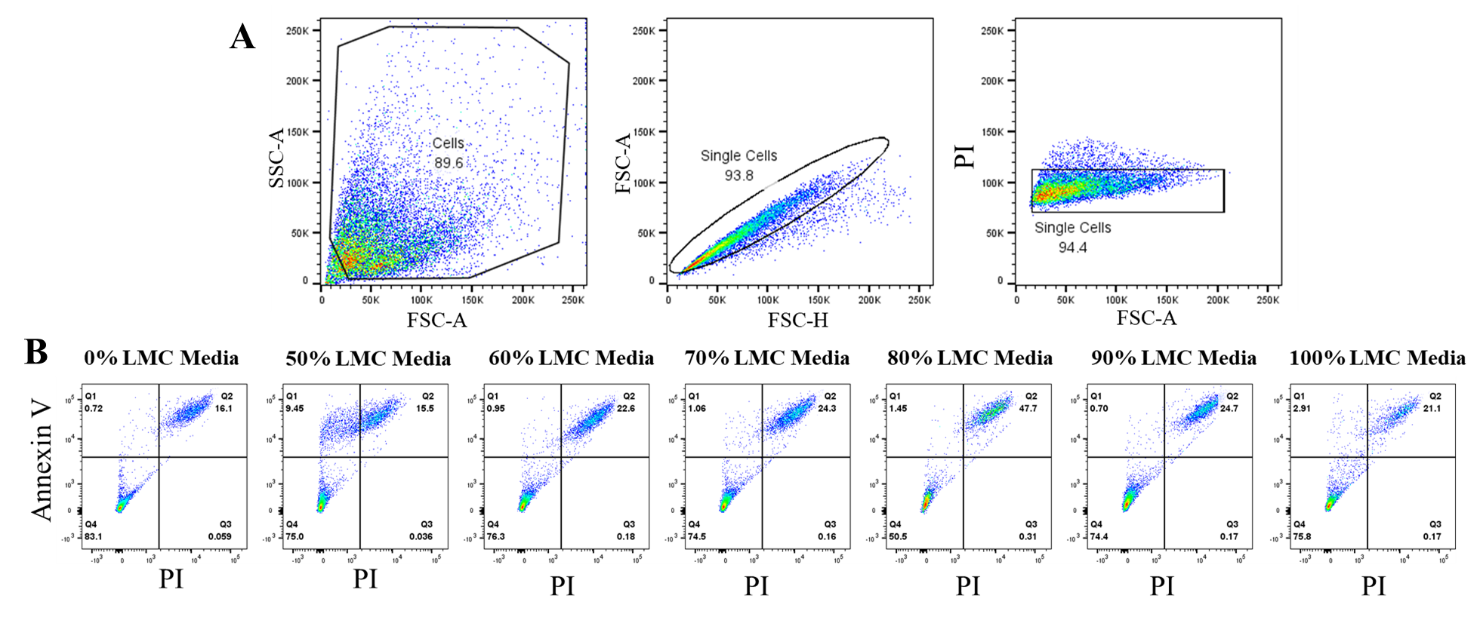
Fig.S1 (A) Gating strategy for the astrocytes. (B) Cell Annexin V response measured for cell apoptosis. Q1 necrotic cells, Q2 late apoptotic cells, Q3 normal cells, Q4 early apoptotic cells. Astrocytes showed no difference in all percentages of LMC media in comparison to the 0% LMC media control

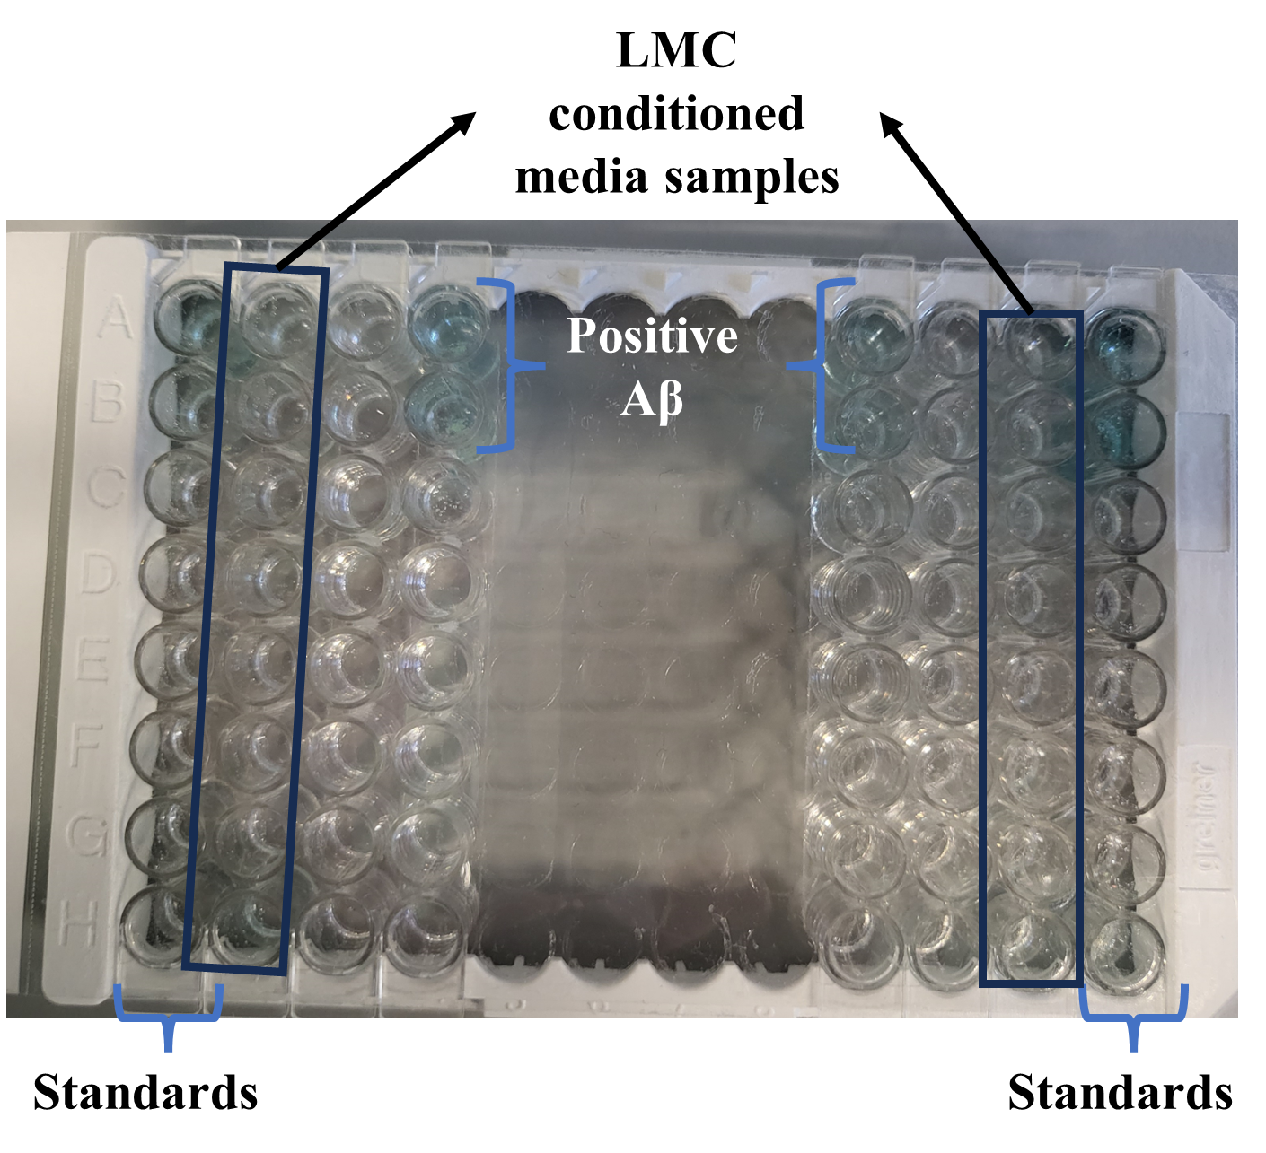
Fig.S2 ELISA kit to test presence of Aβ in the LMC conditioned media. Positive AB control stained blue. While the LMC conditioned media did not stain indicating no Aβ presence in the media

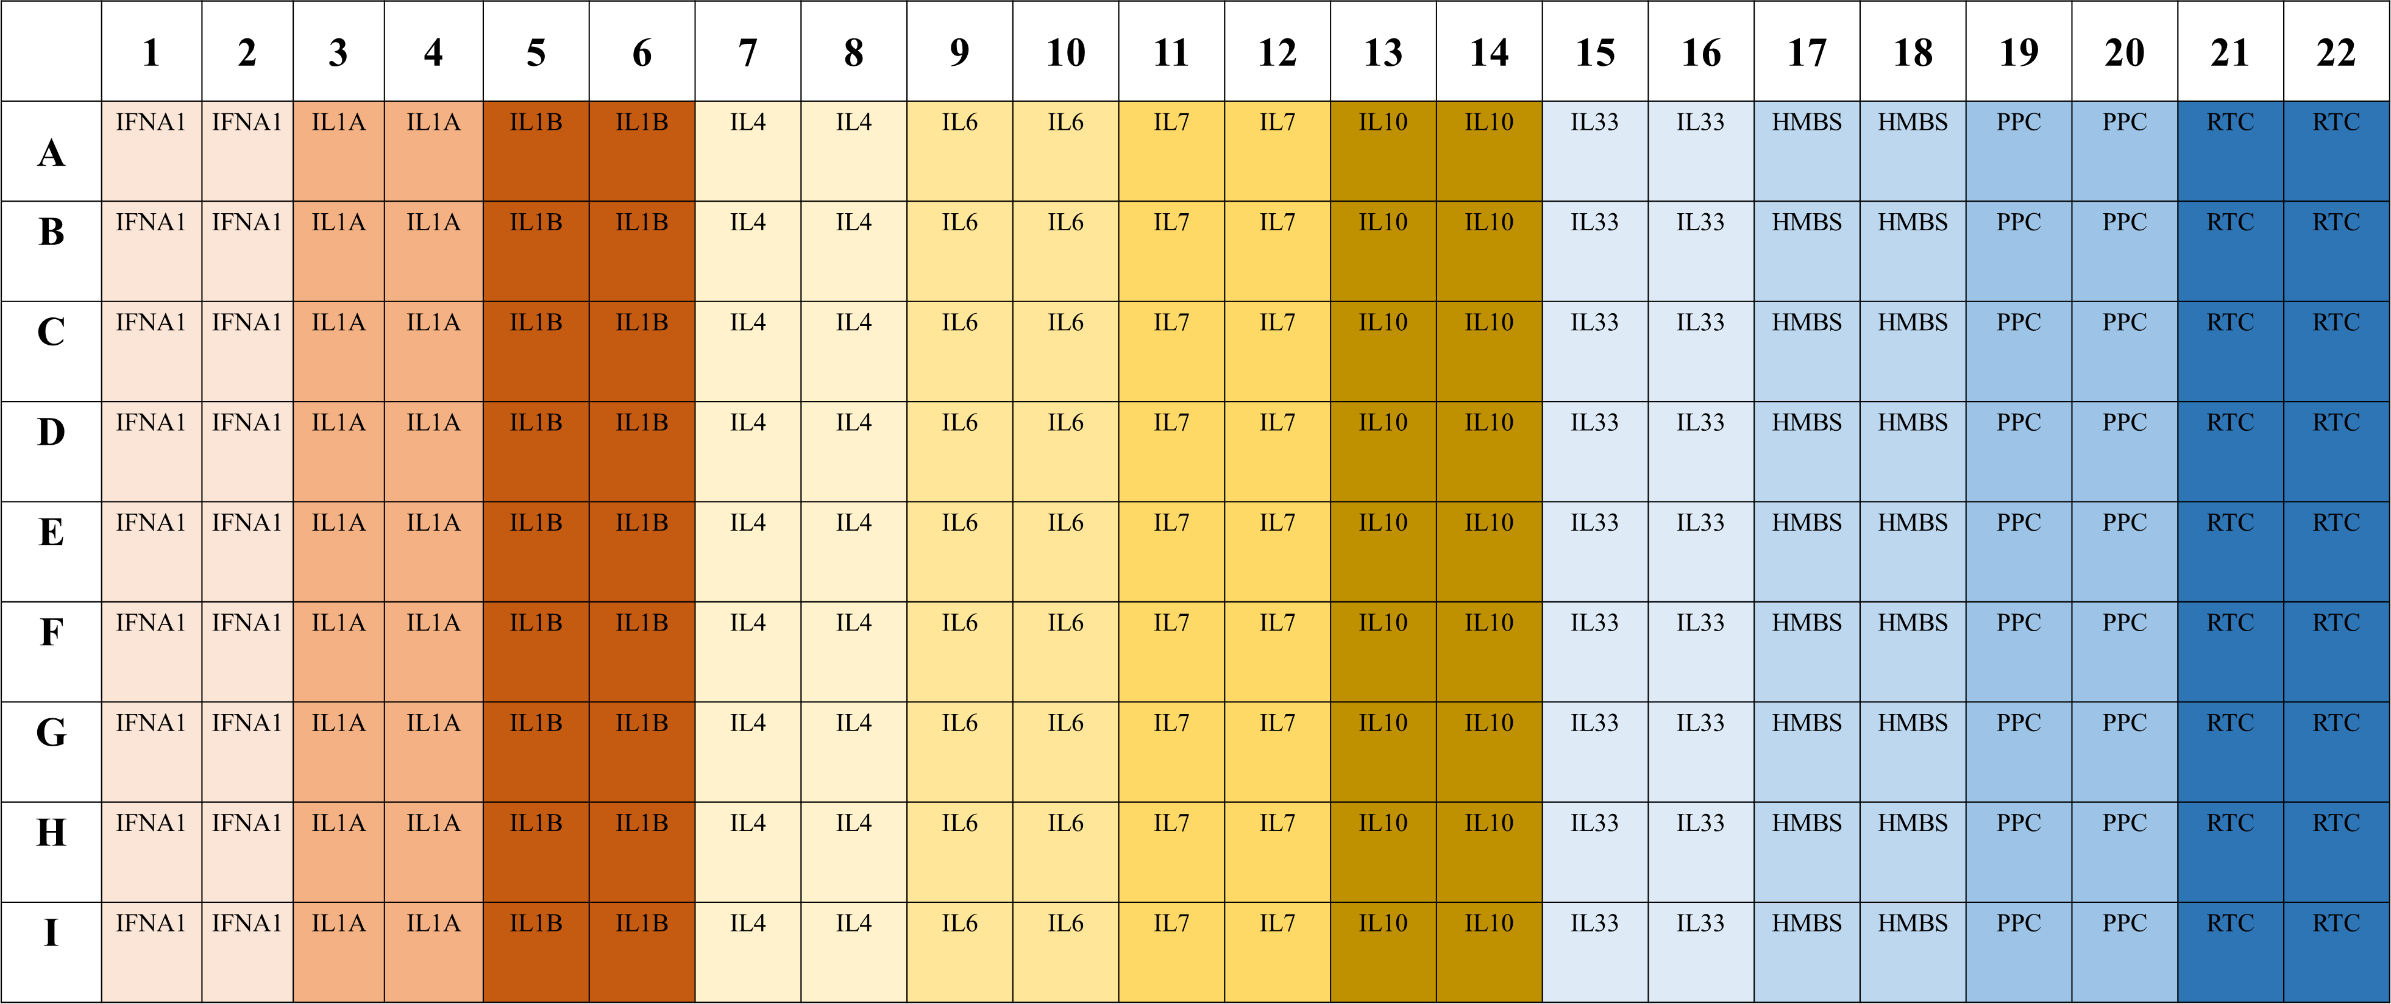
Fig.S3 Overview on the plate layout of the RT²-Profiler assays
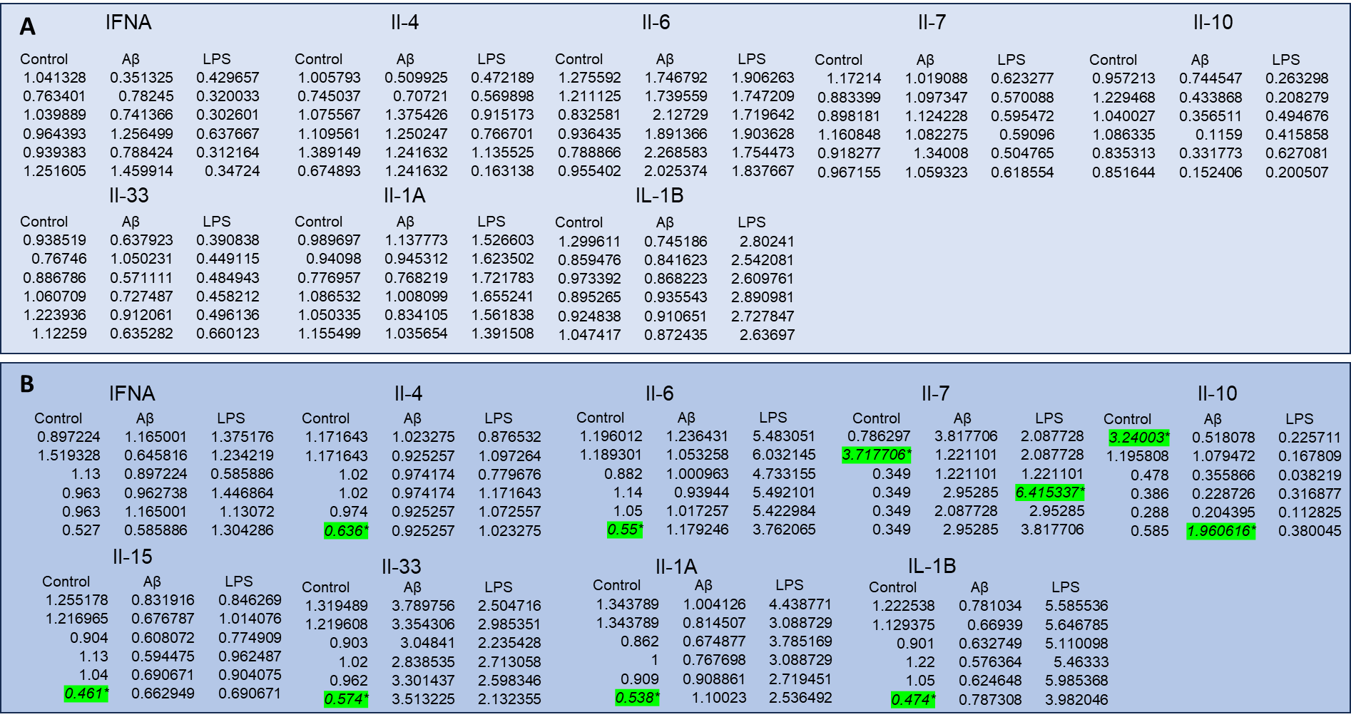
Fig.S4 (A) mRNA qPCR values. (B) Luminex plate values. Green highlights outliers identified and removed before analysis

