Supplementary materials
Table S1 Baseline clinical information of all cervical LNs in PTC
Parameters | Training cohort(n=129) | Testing cohort(n=54) | P value
Sex |  |  | 0.237
Male | 39 (30) | 11 (20)
Female | 90 (70) | 43 (80)
Age | 38±12 | 37±12 | 0.685
Location |  |  | 0.172
Lateral | 95(74) | 41(76)
Central | 34(26) | 13(24)
Size(mm) | 11.86±4.74 | 14.07±5.65 | 0.044
Ratio(L/S) |  |  | 0.213
≥2 | 79 (61) | 39 (72)
＜2 | 50 (39) | 15 (28)
Shape |  |  | 0.559
irregular | 77 (60) | 29 (54)
Oval | 52 (40) | 25 (46)
Border |  |  | 0.761
Ill-defined | 55 (43) | 21 (39)
Well-defined | 74 (57) | 33 (61)
Hilum |  |  | 0.814
Present | 104 (81) | 42 (78)
Absent | 25 (19) | 12 (22)
Echogenicity |  |  | 0.577
Isoechoic or hyperechoic | 72 (56) | 27 (50)
Hypoechoic | 57 (44) | 27 (50)
Homogeneity |  |  | 0.959
Homogeneous | 50 (39) | 20 (37)
Heterogeneous | 79 (61) | 34 (63)
Cystic necrosis |  |  | 0.672
Present | 5(4) | 1(2)
Absent | 124(96) | 53(98)
Calcification |  |  | 0.186
Absent or macrocalcification | 104 (81) | 38 (70)
Microcalcification | 25 (19) | 16 (30)
CDFI vascular pattern |  |  | 0.457
Avascular or hilar type | 67 (52) | 32 (59)
Peripheral or mixed type | 62 (48) | 22 (41)
CDFI vascular index |  |  | 0.065
0 | 30 (23) | 14 (26)
1 | 84 (65) | 32 (59)
2 | 13 (10) | 3 (6)
3 | 2 (2) | 5 (9)
SMI vascular pattern |  |  | 0.933
Avascular or hilar type | 50 (39) | 22 (41)
Peripheral or mixed type | 79 (61) | 32 (59)
SMI vascular index |  |  | 0.950
0 | 5 (4) | 2 (4)
1 | 71 (55) | 30 (56)
2 | 35 (27) | 13 (24)
3 | 18 (14) | 9 (16)
Class |  |  | 0.718
Reactive LNs | 58 (45) | 22 (41)
Metastatic LNs | 71 (55) | 32 (59)
Note: LN, lymph node; PTC, papillary thyroid carcinoma; CDFI, color doppler flow imaging; SMI, superb microvascular imaging

Fig.S1
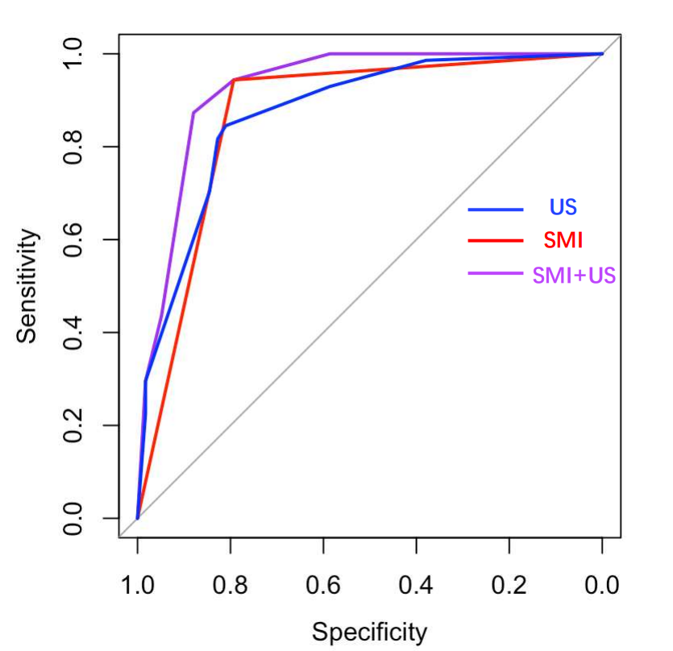
ROC curve analysis for predicting cervical lymph node metastasis in training cohort. AUC for SMI combined with US was the largest (AUC: 0.926), the sensitivity and specificity were 87.3% and 87.9% respectively; the sensitivity and specificity of SMI were observably higher than US (94.4%&87.3%; 79.3&69.3%, respectively). AUC: area under curve.

