Supplementary Tables

Supplementary Table 1. The distribution of PET/CT scanner used in the cohort.
Scanner | uMI-550 | uMI-780 | uEXPLORER | GE Discovery VCT 64
No. of patients | 11 | 23 | 11 | 4

Supplementary Table 2. Specific information of 4 patients using GE Discovery VCT 64
 |  |  | PET/CT | PET/MRI
#1 | Primary nonmetastatic | T | Left pharyngeal recess, left tensor/Levator veli palatine muscle, left medial pterygoid muscle, bilateral prevertebral muscle, clivus, left foramen lacerum, left foramen ovale, basis of sphenoid bone | Left pharyngeal recess, left tensor/Levator veli palatine muscle, left medial pterygoid muscle, bilateral prevertebral muscle, clivus, left foramen lacerum, left foramen ovale, basis of sphenoid bone
 |  | N | Right IIB, left IIA, IIB, VA | Right IIB, left IIA, IIB, VA
 |  | M | / | /
#2 | Primary metastatic | T | Right pharyngeal recess | Right pharyngeal recess
 |  | N | Right IIB | Right IIB
 |  | M | Liver metastasis (5 lesions) | Liver metastasis (>10 lesions)
#3 | Post-treatment metastatic | T | / | /
 |  | N | Left IB, IV, right IB | Left IB, IV, right IB
 |  | M | Right parotid gland, left occipital posterior region,bone (multiple) | Right parotid gland, left occipital posterior region,bone (multiple)
#4 | Post-treatment follow-up | T | / | /
 |  | N | / | /
 |  | M | / | /
Abbreviations: T=primary tumor, N=locoregional lymph node metastasis, M=distant metastasis.

Supplementary Table 3. The detail information of lung and/or bone metastases in this cohort.
 | Mets site | PET/CT | PET/MRI
#1 | bone | Skull base bone, spine, pelvis, bilateral ribs, sternum, bilateral scapula, and bilateral upper femur | equivalent to PET/CT
#2 | bone | Skull base bone, left scapula, multiple vertebral bodies of the spine, and upper left femur | equivalent to PET/CT
#3 | lung | Several small nodules in both lungs, some with increased glucose metabolism; Several ground glass nodules in the right lung; Mediastinum, bilateral hilar, bilateral internal mammary, and superior phrenic enlarged lymph nodes; Local nodular thickening of bilateral pleura; Minor pleural effusion on both sides | The display of nodules smaller than 5mm and ground-glass nodules can be more challenging with PET/MRI compared to PET/CT, while the display of other lesions is equivalent to that of PET/CT
 | bone | Skull base bone, spine, sternum, bilateral scapula, right clavicle, bilateral multiple ribs, pelvic bone, right humerus, bilateral femur | equivalent to PET/CT
#4 | lung | Right upper lobe posterior segment (2 lesions), lower lobe posterior basal segment, and left upper lobe apical posterior segment | equivalent to PET/CT

Supplementary Table 4. Diagnostic performance of the two modalities based on six patients (ceMRI serves as the gold standard)
 | ceMRI  Standard | PET/CT | PET/MR | Consistency rate
 |  |  |  | ceMRI vs. PET/CT | ceMRI vs. PET/MR
T  #1 | Parietal posterior wall, basis of sphenoid bone | Parietal posterior wall, basis of sphenoid bone | Parietal posterior wall, basis of sphenoid bone | 100% | 100%
#2 | Right (pharyngeal recess, musculus longus capitis, parapharyngeal space, tensor/levator veli palatine muscle, medial pterygoid muscle and pterygoid process), basis of sphenoid bone | Right (pharyngeal recess, musculus longus capitis, parapharyngeal space, tensor/levator veli palatine muscle, medial pterygoid muscle and pterygoid process), basis of sphenoid bone | Right (pharyngeal recess, musculus longus capitis, parapharyngeal space, tensor/levator veli palatine muscle, medial pterygoid muscle and pterygoid process), basis of sphenoid bone | 100% | 100%
#3 | Right pharyngeal recess | Right pharyngeal recess | Right pharyngeal recess | 100% | 100%
#4 | bilateral (pharyngeal recess, cavernous sinus, musculus capitis longus), left (parapharyngeal space, pterygopalatine fossa, medial pterygoid plate, tensor/levator veli palatine muscle, medial pterygoid muscle, foramen lacerum, foramen ovale, foramen rotundum, petrous apex, hypoglossal canal, lateral pterygoid muscle, pterygoid process), nasal cavity, occipital bone, clivus | bilateral (pharyngeal recess, cavernous sinus, musculus capitis longus), left (parapharyngeal space, pterygopalatine fossa, medial pterygoid plate, tensor/levator veli palatine muscle, medial pterygoid muscle, foramen lacerum, foramen ovale, foramen rotundum, petrous apex, hypoglossal canal, lateral pterygoid plate), nasal cavity, basis of sphenoid bone, clivus | bilateral (pharyngeal recess, cavernous sinus, musculus capitis longus), left (parapharyngeal space, pterygopalatine fossa, medial pterygoid plate, tensor/levator veli palatine muscle, medial pterygoid muscle, foramen lacerum, foramen ovale, foramen rotundum, petrous apex, hypoglossal canal, pterygoid process, lateral pterygoid muscle), nasal cavity, occipital bone, clivus | 85.7% | 95.2%
#5 | Bilateral (pharyngeal recess, musculus capitis longus), clivus, sphenoidal sinus | Right pharyngeal recess, bilateral musculus capitis longus, clivus | Bilateral (pharyngeal recess, musculus capitis longus), clivus, sphenoidal sinus | 66.7% | 100%
#6 | Left (parapharyngeal space, tensor/levator veli palatine muscle, medial pterygoid muscle, medial pterygoid plate), clivus, basis of sphenoid bone | Left (parapharyngeal space, tensor/levator veli palatine muscle, medial pterygoid plate), bilateral prevertebral muscle | Left (parapharyngeal space, tensor/levator veli palatine muscle, medial pterygoid muscle, medial pterygoid plate), clivus, basis of sphenoid bone | 50% | 100%
RLN  #1 | L1R1 | L1R1 | L1R1 | 100% | 100%
#2 | L1R2 | R1 | L1R2 | 0% | 100%
#3 | 0 | 0 | 0 | 100% | 100%
#4 | R1 | L1 | L1R1 | 0% | 50%
#5 | L1R1 | L1 | L1 | 50% | 50%
#6 | L2R3 | L2R2 | L2R3 | 80% | 100%
CLN  #1 | - IIb  R- IIa/IIb/Va | L- IIb  R- IIa/IIb | L- IIb  R- IIa/IIb/Va | 75% | 100%
#2 | L- IIa/IIb/III/IV/Va  R- IIa/IIb | L- IIa/IIb/III/IV/Va  R- IIa/IIb | L- IIa/IIb/III/IV/Va  R- IIa/IIb | 100% | 100%
#3 | - IIb/III/IV  R- IIb/III | L- IIb/III  R- IIb/III | L- IIb/III/IV  R- IIb/III | 80% | 100%
Note: The consistency rate was determined by dividing the number of same structures detected (bilateral structures were counted as two) by the total number of detected structures by ceMRI.
Abbreviations: ceMRI=contrast-enhanced magnetic resonance imaging, T=primary tumor, RLN=retropharyngeal lymph node, CLN=cervical lymph node, L=left, R=right.

Supplementary Figures
Supplementary Fig 3. The b0 (a) and b1000 (b) images demonstrating high signal intensity and the corresponding apparent diffusion coefficient (ADC) image (c) showing low signal intensity in the lest massa lateralis atlantis lesion.

Supplementary Fig 2. Comparison of a patient with liver metastasis scanned with GE Discovery VCT 64 scanner for PET/CT (a-c, right row) and PET/MR (a-c, left row). PET/MR detected more liver metastases compared to PET/CT.

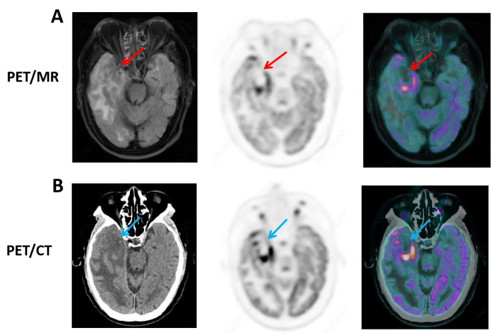Supplementary Fig 3. Detection of radiotherapy complications between PET/CT and PET/MR. Each panel: left (MRI or CT), middle (PET), and right (fused image). Right temporal lobe necrosis was detected both on PET/MR (A, red arrow) and PET/CT (B, blue arrow). PET/MR could provide more internal morphological characteristics.

