Supplemental Information for
“Hard x-ray projection imaging below 5 nm resolution”

Wenhui Zhang¹, J. Lukas Dresselhaus², Holger Fleckenstein¹, Mauro Prasciolu¹, Margarita Zakharova¹, Nikolay Ivanov¹, Chufeng Li¹, Oleksandr Yefanov¹, Tang Li², Dmitry Egorov¹, Ivan De Gennaro Aquino¹, Philipp Middendorf¹, Johannes Hagemann³, Shan Shi^{4,5}, Saša Bajt^{1,2}, and Henry N. Chapman^{1,2,6}
¹Center for Free-Electron Laser Science CFEL, Deutsches Elektronen-Synchrotron DESY, Notkestr. 85, 22607 Hamburg, Germany
²The Hamburg Centre for Ultrafast Imaging, 22761 Hamburg, Germany
³Center for X-ray and Nano Science CXNS, Deutsches Elektronen-Synchrotron DESY, Notkestr. 85, 22607 Hamburg, Germany
⁴Research Group of Integrated Metallic Nanomaterials Systems, Hamburg University of Technology, 21073 Hamburg, Germany
⁵Institute of Hydrogen Technology, Helmholtz-Zentrum Hereon, 21502 Geesthacht, Germany
⁶Department of Physics, Universität Hamburg, 22761 Hamburg, Germany

S1. Ground truth of the nanoporous gold slab
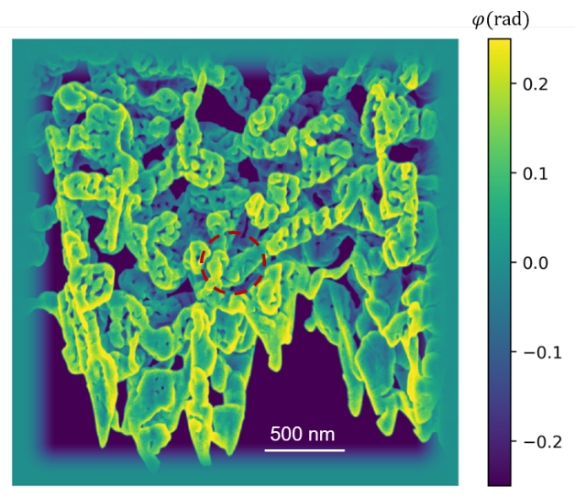
Fig. S1. Ground truth of the pure-phase object used in the simulations, adapted from an SEM image of a nanoporous gold slab. The area bounded by a red circle was used as the region of interest, as shown in Fig. 8 in the main text. The color scale indicates the phase, which ranges from -0.25 to 0.25 radian.

S2. Incident fluence calculation
The integrated fluence distribution over the course of a scan is the convolution of the beam intensity profile at the sample plane with the scan positions. When the beam size is much larger than the step size, as it is in near-field ptychography, the fluence that the sample experiences (and hence also the dose) is maximum at the center of the scan area. The normalized fluence distributions for the calculated datasets are shown in Fig. S2, without background noise, and indicating the central region where the maximum average fluence was calculated. This was also the region used for the determination of the FRC. The simulated scans followed spiral paths. For the low-NA case, there were 500 scan points with a scan step of 44 nm, and 50 scan points with a step size of 110 nm for the high-NA case.
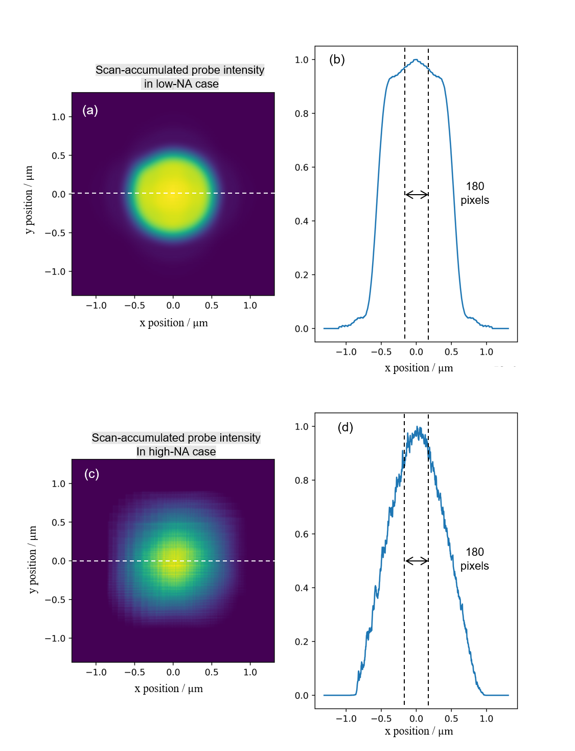
Fig. S2. Scan-accumulated normalized incident intensity distributions for the simulated datasets, and plots of these along the dashed white lines for (a-b) low-NA case, and (c-d) the high-NA case. The region of interest is denoted by the 180 pixels in (b) and (d).
The simulated datasets for different fluences were obtained by setting the total photon number in the probe, per frame. In the low-NA case, these were $6.15×{10}^{4}$,$2.05×{10}^{5}$,$6.15×{10}^{5}$,$2.05×{10}^{6}$,$6.15×{10}^{6}$, and $2.05×{10}^{7}$, giving maximum average fluences of 31.7 photons/nm², 105.6 photons/nm², 316.7 photons/nm², 1055.7 photons/nm², 3167.1 photons/nm², and 10557 photons/nm², respectively. In the high-NA case, the photon number per frame was increased to give the same maximum average fluences. These values were $6.45×{10}^{5}$,$2.15×{10}^{6}$,$6.45×{10}^{6}$,$2.15×{10}^{7}$,$6.45×{10}^{7}$, and $2.15×{10}^{8}$.

S3. Reconstructed phase images and corresponding FRC curves in the numerical study

To investigate whether background scattering can be mitigated, reconstructions were carried out both with and without background correction. In the main text, we only showed the results with background correction. Here, we showed both. From the comparison between reconstructions with and without background correction, it is evident that background correction does improve images obtained in the low-NA case, especially when fluence is higher than 3167.1 photons/nm²; and has a minor effect on the high-NA case where the background noise hardly affects the high-NA imaging, presumably due to the strong reference wave, as shown in Fig. S3 and Fig. S4.
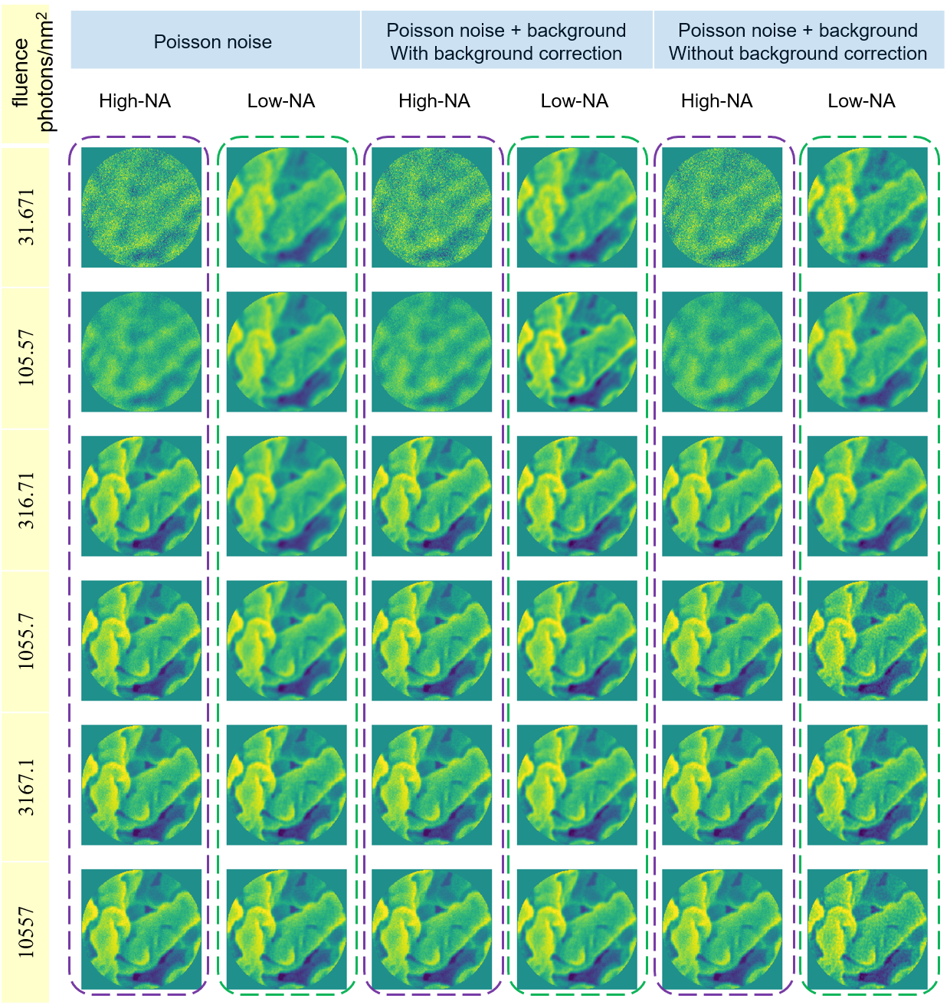
Fig. S3. Reconstructed phase images in both high-NA and low-NA cases under different fluence and noise/reconstruction conditions.

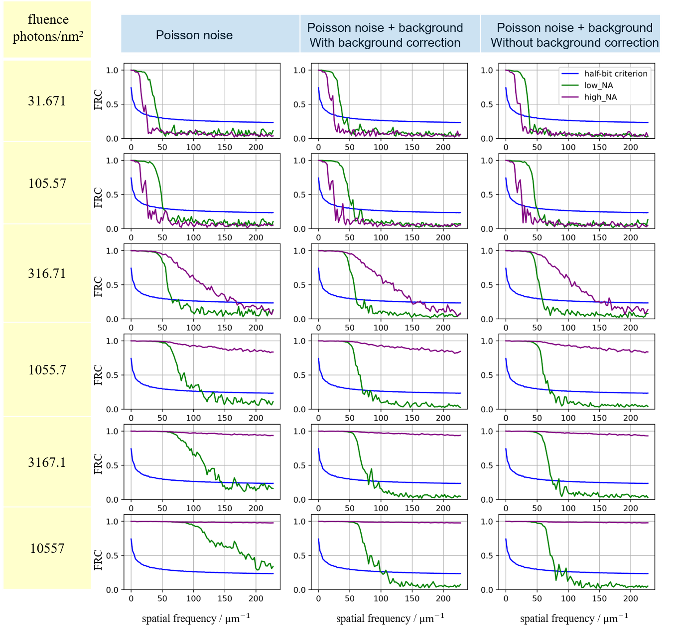
Fig. S4. FRC curves corresponding to the images in Fig. S3.

