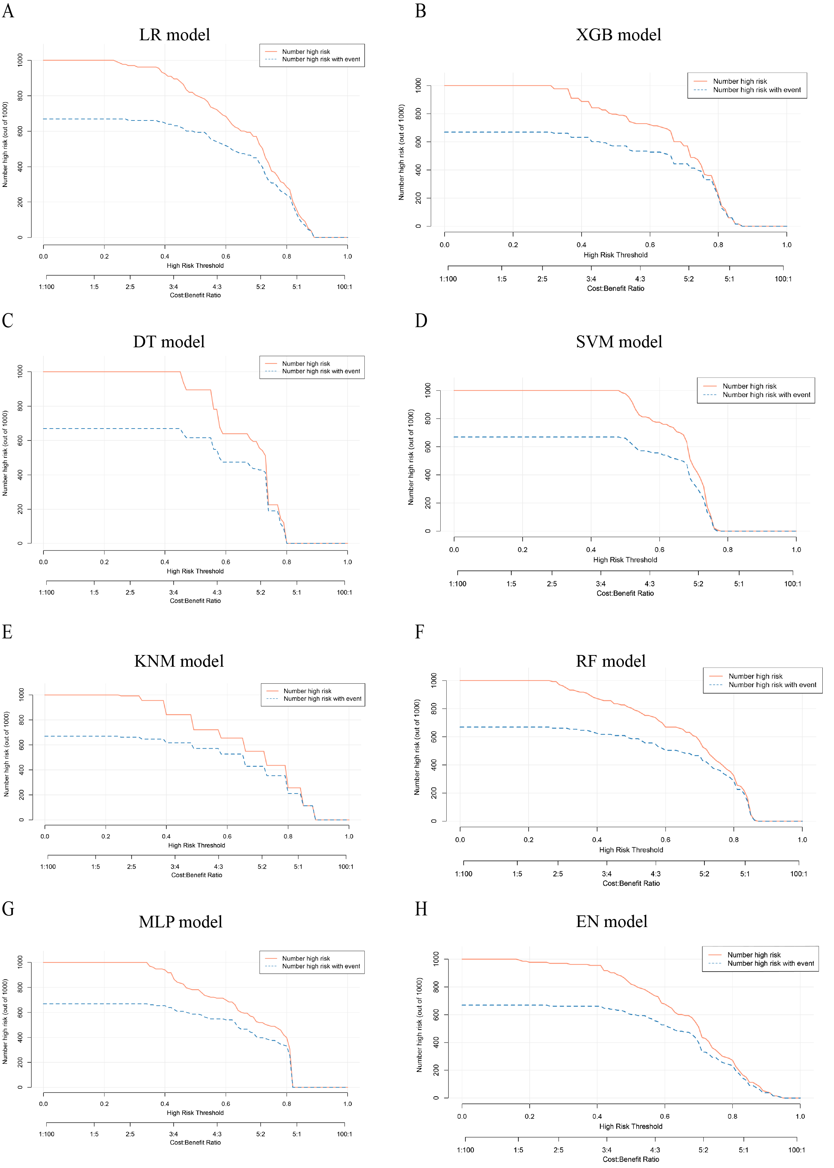
Supplementary figure 1 The clinical impact curves of the eight machine learning models. LR, logistic regression; extreme gradient boosting (XGB); DT, decision tree; SVM, support vector machine; KNN, k-nearest neighbors; RF, random forest; MLP, multilayer perceptron; EN, elastic net.

