Supporting Information
Highly Effective Bifunctional Electrocatalysts: Synthesizing NiCo₂O₄ Nanostructures via Chemical Precipitation for Enhanced Oxygen Evolution and Reduction Reaction

Ananta Sasmal, Dipankar Gogoi*, and T. D. Das
Department of Basic and Applied Science, National Institute of Technology Arunachal Pradesh, Jote, 791113, India
*Email: nehu.nanodg@gmail.com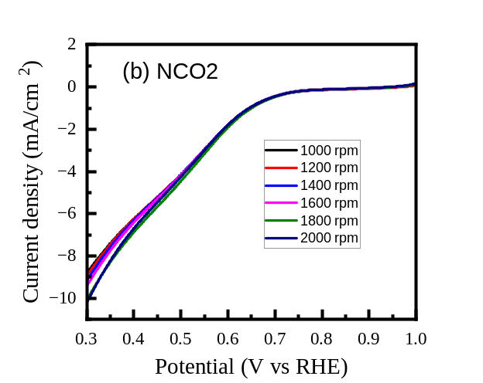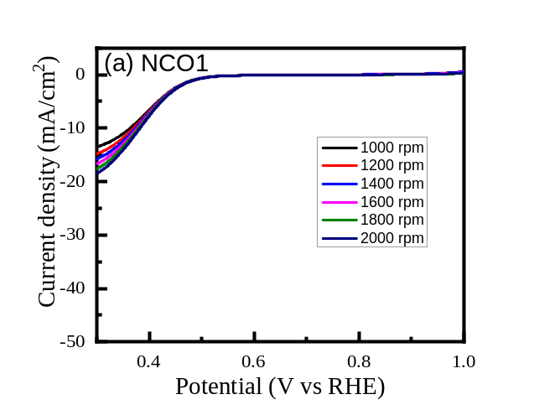

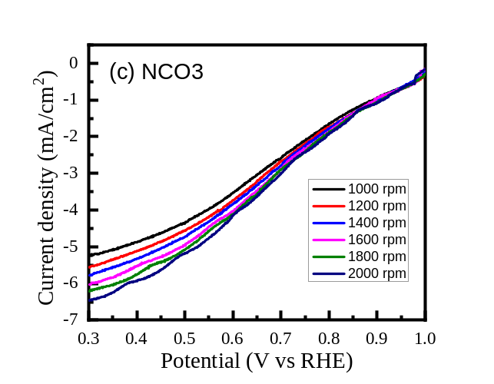
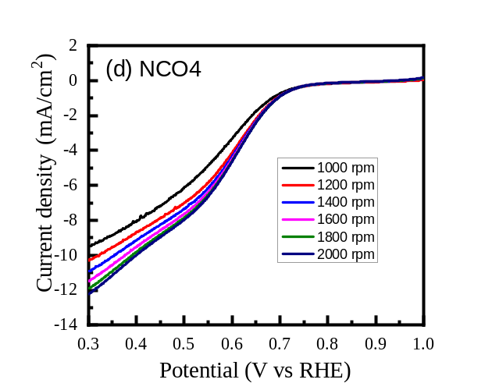

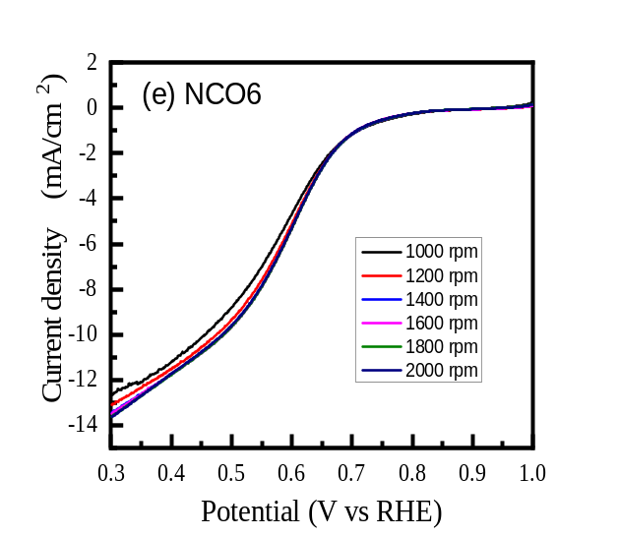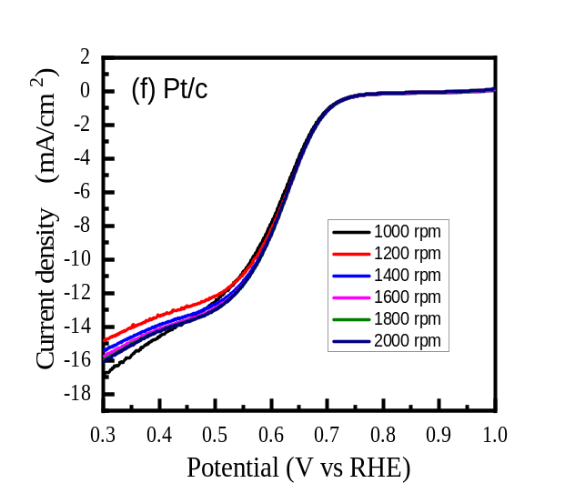

Fig. S1 shows the LSV plots of synthesized NiCo₂O₄ nanomaterials and Pt/c: (a) NCO1, (b) NCO2, (c) NCO3, (d) NCO4, (e) NCO5 and (f) Pt/c respectively.
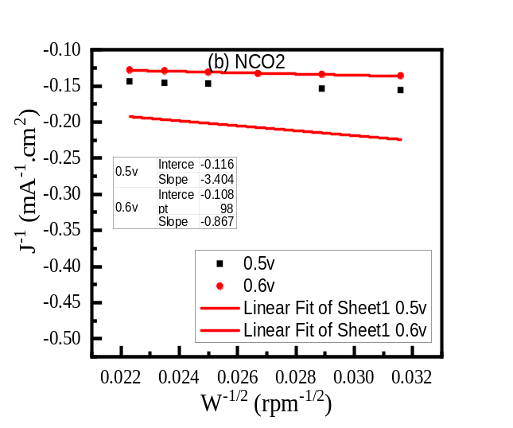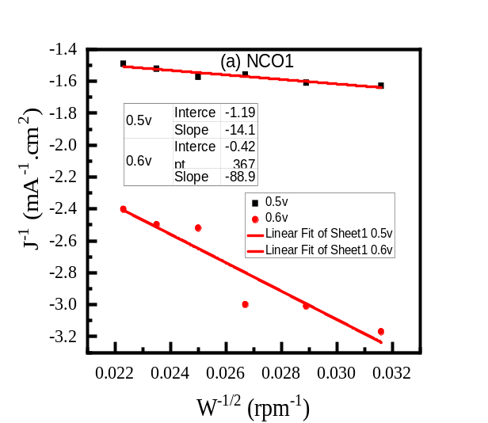

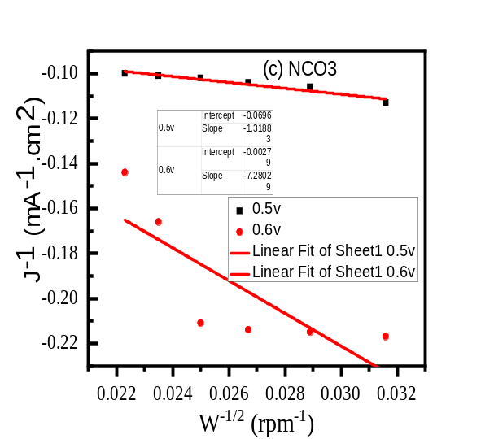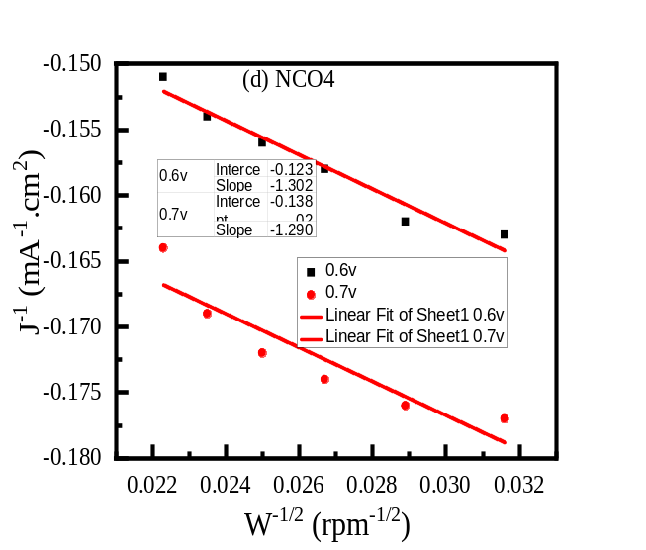

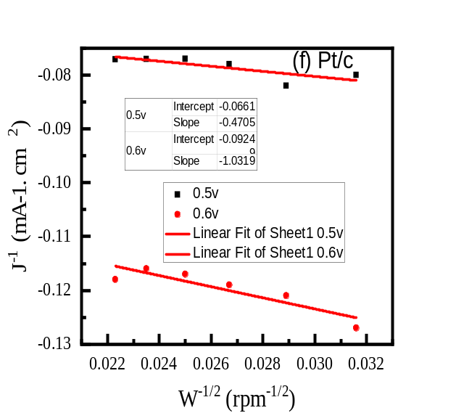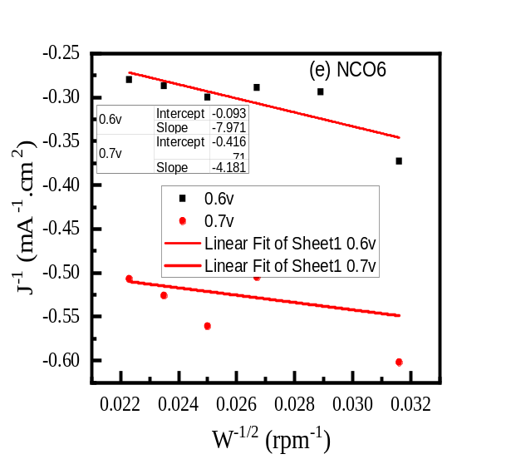

Fig. S2 shows the KL- plots of synthesized NiCo₂O₄ nanomaterials and Pt/c: (a) NCO1, (b) NCO2, (c) NCO3, (d) NCO4, (e) NCO5 and (f) Pt/c respectively.

