Supplementary Material for:
USP1 activates the Wnt/β-catenin pathway by deubiquitinating KRT17, thereby facilitating thyroid cancer proliferation

This supplementary material includes 1 table and 3 figures.

Supplemental table 1. Primer sequence used for RT-QPCR.
name | sequence | accession number
Primers for real-time PCR:
USP1 forward | 5'- CTCCCGGGATGTAGTTGGTG -3′ | NM_003368.5
USP1 reverse | 5'-CCAGGAAAATCTGGTCGGCT-3′
KRT17 forward | 5'-CAGTCCCAGCTCAGCATGAA-3′ | NM_000422.3
KRT17 reverse | 5'- CCACAATGGTACGCACCTGA-3′
β-catenin forward | 5’- GAAGACTGCTGCCTGTCTGT-3’ | NM_001904.4
β-catenin reverse | 5’-GCAGTCTCTGGATGATGCGT -3’
Tubulin forward | 5’-CCGCTACTTAAGAGGCTCCA-3’ | NM_006082.2
Tubulin reverse | 5’-CTCACGCATAGTGGCTAGGG -3’
The target sites of shRNA:
shUSP1#1 | CCCGGGATGTAGTTGGTGTT
shUSP1#2 | GCGGAGTGCTAAAGACCCTA
shNC | GGTCTCGCACCTTCACGTGC

Supplemental figure 1. (A) USP1 and β-catenin cannot interact directly. (B) Correlation of USP1 and CTNNB1 mRNA level. (C) Expression of genes not associated with USP1 at the mRNA level in thyroid cancer.
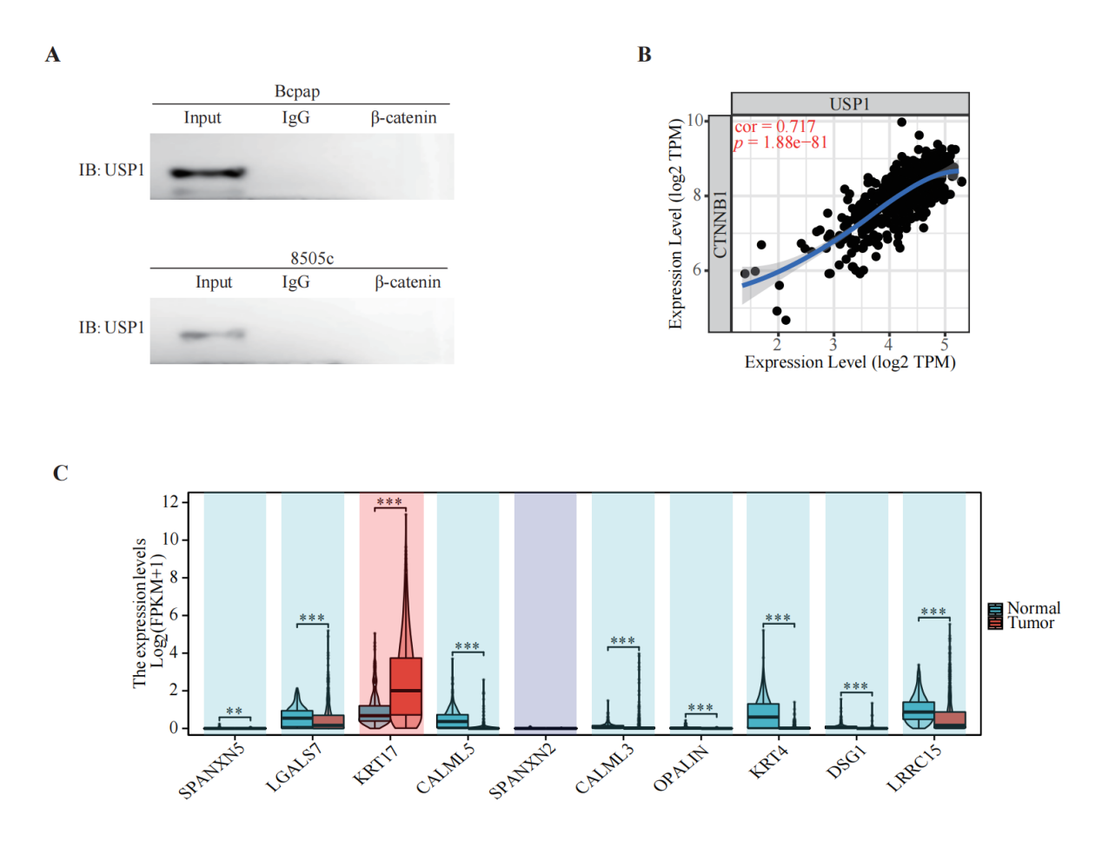
Supplemental figure 2. Relationship between USP1 expression and IC50 of parthenolide based on GDSC database (A) scatter plot, (B) box plot.
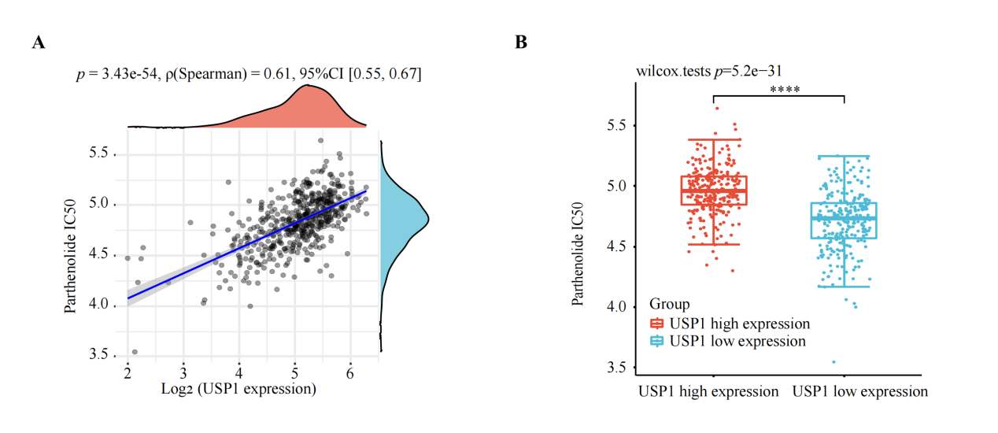
Supplemental figure 3. USP1 promotes cells proliferation in TC by the mechanism of USP7-KRT17-WNT/β-catenin pathway.
