- Materials and Methods
The STM measurements were performed using an ultra-high vacuum (1.5 x 10⁻¹⁰ Torr) Createc microscope with an etched tungsten (W) tip operating at T = 5.3K. The tip was prepared by repeatedly crashing and pulsing into the Cu (111) surface and its quality verified by the Cu (111) surface state. The clean Cu (111) surface was prepared by repeated cycles of argon ion sputtering and annealing. The sample was placed on the scanner and allowed to cool to base temperature before dosing with 7.0 x 10⁻⁸ Torr of carbon monoxide (CO) molecules for 10 seconds. Spectroscopy of the symmetry protected topological (SPT) states were measured using a standard lock-in technique with a modulation voltage of 20mV and a modulation frequency of 1.125kHz.

2. Muffin Tin Calculations
The arrangement of CO molecules results in a change in potential landscape of the free electron like surface states of Cu. We follow the approach of Kempkes et. al. [20] to numerically solve the two-dimensional (2D) Schrödinger equation for the potential landscape derived from the arrangement of CO molecules. Specifically, the effect of the CO molecules is modeled as a cylindrical potential barrier with height, V_{CO}=0.9 eV and radius R=0.3 nm [20]. The 2D periodic unit cell of our artificial graphene lattice and the corresponding potential landscape are shown in Supplementary Figure 1. The surface electrons are modeled as independent particles with an effective mass $m^{*}=0.42m_{e}$, where $m_{e}$ is the mass of the electron[25].

We first obtain the band structure (Supplementary Figure 2) corresponding to the unit cell of 2D periodic artificial graphene by solving the Schrödinger equation
 | $$\left[\frac{-ℏ^{2}}{2m_{e}^{*}}+V_{unitcell}\right]ψ=Eψ$$ | $$(1)$$
where $V_{unitcell}$ is the 2D periodic potential landscape corresponding to the unit cell of our artificial lattice. We choose the energy of the Cu surface state to be $V_{o}=-390 meV.$We use the Octopus package [26] to solve the above equation under periodic boundary conditions and obtain the dispersion.
The parameters for the tight binding model are then obtained by fitting (discussed below) the band dispersion with that computed from Muffin Tin calculations

3. Tight Binding Calculations
The lattice formed by electronic states confined by CO molecules is modeled under tight binding (TB) approximation. The artificial atoms or the electronic confinement (anti-lattice of the CO arrangement) is considered as a single electron orbital in TB with their corresponding positions. We include the interaction of the sites with the nearest ($t_{nn})$ and next nearest ($t_{nnn}$) neighbor. All the sites are approximated to have the same onsite energy $ε.$ Following Ref. [20], we also include an orbital overlap matrix $S$ with nearest neighbor overlap s in order to capture the overlap present in the experiments. The numerical values of the parameters $ε$, $t_{nn}$, $t_{nnn}$ and s are determined by fitting the band dispersion to the muffin tin band structure (Supplementary Figure 2). The wavefunctions and the energies of the states can be obtained by solving the generalized eigenvalue problem posed as
 | $$Hψ=ESψ$$ | $$(2)$$
All the TB systems and Hamiltonians were constructed using Kwant package [27]. We use the Linear Algebra module within scipy package[28] to solve the generalized eigenvalue problem.
The LDOS from TB is calculated by applying a Lorentzian function (equation (3)) with a broadening of b = 30 meV to account for the scattering. Our value of the parameter b is obtained empirically and based on the width of the experimentally measured spectra.
 | $$LDOS\left(r,E\right)=\sum_{i}{{|ψ_{i}|}^{2}\frac{b}{{({E-ε}_{i})}^{2}+{(\frac{b}{2})}^{2}}}$$ | $$(3)$$

4. Parameterization of tight binding parameters
The tight binding band dispersion obtained from the Hamiltonian of the 2D periodic unit cell shown in Supplementary Figure 1 is fitted to the muffin tin dispersion (Supplementary Figure 2). The fitting parameters are $ε$, $t_{nn}$, $t_{nnn}$ and s. The values obtained using a non-linear least squares fit through Levenberg-Marquardt algorithm as implemented in the curve_fit() function of scipy package [28] is shown in Supplementary Table 1. These parameters will be used for the rest of the discussion.

5. Topological classification
The different artificial GNR geometries studied in experiments are classified as topologically non-trivial or topologically trivial based on the Z₂ invariant [17] defined as
 | $$Z_{2}=\frac{1}{π}\int_{-π/d}^{π/d}{dk\left\langle ψ_{n,k} | ∂_{k} | ψ_{n,k}\right\rangle } mod 2$$ | $$(4)$$
As noted by Lin et. al [17], the above definition of the Z₂ invariant is independent of the real space origin but still depends on the unit cell definition. The definition of the unit cell is uniquely determined by the termination of the finite nanoribbon [11,12,16,17]. Since the GNRs are 1D periodic, the above integral can be numerically computed as the sum of Wannier Charge Centers (WCCs) computed from $ψ_{n,k}$. We make use of the software package Z2pack [29] for the numerically calculation of Z₂ invariant. We note that the default functions in Z2pack is designed to compute the total Zak phase (see equation (5) below) using the periodic part of the wavefunctions ($u_{n,k}$’s) and the position of the orbitals, x. However, as discussed below, the Z₂ invariant depends only on the intercell Zak phase (see equation 6 below) and is independent of the real space origin. In order to compute the correct Z₂ invariant, we pass the $ψ_{n,k}$’s to Z2pack instead of the periodic part of the wavefunction ($u_{n,k}$’s) and set the position of the orbitals (x) to zero making $γ_{1,n} =0$. As an illustrative example, we have attached a Jupyter notebook with all the scripts and demonstrating the usage of Kwant and Z2pack for the calculation of Z₂ invariant. Supplementary Table 2 shows the different unit cell geometry considered in this work and their respective Z₂ invariant.

6. Manipulating topology by changing the unit cell.
As shown in Supplementary Table 2, moving three atoms in the unit cell (effectively changing the termination of the semi-infinite nanoribbon), changes the topological class. Following the conventions used in Ref. [17], the total Zak phase for any 1D periodic structure can be written as
 | $$γ_{n}=i \int_{-π/d}^{π/d}{dk\left\langle u_{n,k} | ∂k | u_{n,k}\right\rangle }$$ | $$(5)$$

where $u_{n,k}$ is the periodic part of the Block wavefunction $ψ_{n,k}$ with band index n and momentum k. By definition, the value of the Zak phase depends on the choice of real space origin [16,17, 24,30,31]. This can be seen clearly by substituting $u_{n,k}=e^{-ikx}ψ_{n,k}$ into the above equation
 | $$γ_{n}=\underset{γ_{1,n}}{\underbrace{i \int_{-π/d}^{π/d}{dk\left\langle ψ_{n,k} | x | ψ_{n,k}\right\rangle }}}+\underset{γ_{2,n}}{\underbrace{\int_{-π/d}^{π/d}{dk\left\langle ψ_{n,k} | ∂k | ψ_{n,k}\right\rangle }}}$$ | $$(6)$$
While $γ_{1,n}$ depends on the expectation value of $x$, $γ_{2,n}$ is independent of the real space origin. $γ_{2,n}$ can be interpreted as the intercell Zak phase which depends on the choice of the unit cell but independent of the choice of the real space origin [16,24]. Additionally, we note that the Z₂ invariant is related to $γ_{2,n}$ as $Z_{2}=\sum_{n}{γ_{2,n} } mod 2$. In general, when M new (or old) lattice sites are added (or removed) to the unit cell definition of the nanoribbon, the total intercell Zak phase of the modified unit cell ($γ_{2}^{'}= \sum_{n}{γ_{2,n}^{'} )}$ is related to the original unit cell as $γ_{2}^{'}$= $γ_{2}-Mπ$ [17]. Hence, when M is odd, we have a change in the topological class and when M is even the topological class is preserved (see Supplementary Table 2).

7. Effective Hamiltonian of topological states.
The 9GNR/7GNR/9GNR heterostructure discussed in the main text results in 4 spatially protected topological states ($ψ_{\{A,B,C,D\}})$ at the four interfaces between: (i) vacuum (Z₂=0) and 9GNR (Z₂=1), (ii) 9GNR (Z₂=1) and 7GNR (Z₂=0), (iii) 7GNR (Z₂=0) and 9GNR (Z₂=1) and (iv) 9GNR (Z₂=1) and vacuum (Z₂=0). The interaction between the 4 states can be modeled as a tight binding Hamiltonian as illustrated in Supplementary Figure 3.

The Hamiltonian of such a 4-state model can be written as
 | $$H_{4-state}=\left[\begin{matrix}ε_{A} & t_{AB}\left(L_{AB}\right) & 0 & 0 \\ t_{AB}\left(L_{AB}\right) & ε_{B} & t_{BC}\left(L_{BC}\right) & 0 \\ 0 & t_{BC}\left(L_{BC}\right) & ε_{C} & t_{CD}\left(L_{CD}\right) \\ 0 & 0 & t_{CD}\left(L_{CD}\right) & ε_{D}\end{matrix}\right]$$ | $$(7)$$
where $ε_{\{A,B,C,D\}}$ are the on-site energies and the coupling parameters $t_{\{AB,BC,CD\}}$ depends on the distance of separation between the states $L_{\{AB,BC,CD\}}$. However, to construct such a model we first need to extract the topological states $ψ_{\{A,B,C,D\}}$, the coupling parameters $t_{\{AB,BC,CD\}}$ and the onsite energies $ε_{\{A,B,C,D\}}$ from the full tight binding Hamiltonian of the nanoribbon as explained below.
The first step is to obtain the individual topological states $ψ_{\left\{A,B,C,D\right\}}(r)$ when they are isolated, or, when the distance of separation between them is large ($L→∞$). We achieve this by solving for the eigenstates of tight binding Hamiltonian of the nanoribbon geometries shown in Supplementary Figures 4 and 5. $ψ_{A}(r)$ (or $ψ_{D}(r)$) is the topological state at the end of the finite 9GNR geometry while $ψ_{B}(r)$ (or $ψ_{C}(r)$) is the interface state on 9GNR/7GNR heterostructure. The topological states in these geometries are well separated and can be considered as isolated from each other.

Let the position of the states, $r_{i}(i∈A,B,C,D)$, be defined by the position of their respective interface. We can then determine the localized states $ψ_{i}(r-r_{i})$ by extracting the weights of the wavefunction on the basis sites within their respective masks (Supplementary Figures 4 and 5) positioned at $r_{i}$. For example, to obtain $ψ_{A}(r-r_{A})$, we pass the wavevector through mask A as shown in Supplementary Figure 4 and extracting the amplitude on all the sites with position $(r-r_{A})$ lying within the mask. Similarly, we can extract the other states by passing the wavevector through their respective masks. $ψ_{A}$ and $ψ_{D}$ are obtained for a 9GNR geometry of length 25-unit cells while $ψ_{B}$ and $ψ_{C}$ are obtained from a 9GNR/7GNR/9GNR of length 20/20/20-unit cells respectively for each segment. The length of the mask for A, B, C and D are 6-, 10-, 10- and 6-unit cells from the interface respectively.
Next, we extract the coupling parameters $t_{\{AB, BC,CD\}}$ as a function of the distance of separation ${(L}_{\{AB,BC,CD})$ by modeling the nanoribbon geometries shown in Supplementary Figures 6 and 7. The geometries shown in Supplementary Figure 6 are 9GNR/7GNR interface where $L_{AB}$ is varied while keeping the length of 7GNR fixed to 25 unit cells. These geometries are used to extract $t_{AB}(L_{AB})$. Similarly, in Supplementary Figure 7 we model 9GNR/7GNR/9GNR heterostructure where $L_{BC}$ is varied while keeping the length of the 9GNR segments on both sides fixed to 20-unit cells. These geometries are used extract $t_{BC}(L_{BC})$. The coupling parameters can be determined by
 | $$t_{ij}(L_{ij})= <ψ_{i}^{'} \left| H(L_{ij}) \right| ψ_{j}^{'}>$$ | $$(8)$$
 | $${| ψ}_{i}^{'}> = \frac{| ψ_{i}>}{\sqrt{< ψ_{i} \left| S \right| ψ_{i}>}}$$ | $$(9)$$
$$i∈A,B,C j ∈nearest neighbor of i$$
where $H(L_{ij})$ is the tight binding Hamiltonian, hosting the states $ψ_{i}$ and $ψ_{j}$ separated by $L_{ij}$, and S the overlap matrix. The vector |$ψ_{i}>$ for the different geometries are constructed from the isolated $ψ_{i}(r-r_{i})$ by assigning the amplitude on the equivalent basis sites within mask and setting the rest of the elements to zero.

Supplementary Table 3 lists the values of $t_{BC}$ computed using the procedure described above. We note that $t_{BC}$ decays exponentially with length and can be approximated as an exponential fit $t_{BC}=α e^{-βL_{BC}}$ as shown in Supplementary Figure 8.

While $t_{BC}$ is found to be finite at $L_{BC}=1$and decays exponentially, we find that $ψ_{A}$ and $ψ_{B}$ are decoupled ($t_{AB}$=0) for all the lengths (see Supplementary Table 4). This phenomenon can be explained by at the parity of the wavefunctions. The real part of the wavefunctions $ψ_{A}$ and $ψ_{B}$ are mapped on the geometry with $L_{AB}=1$in Supplementary Figure 9.

Calling $y=0$ the plane indicated by the dashed line in Supplementary Figure 9 dividing the ribbon in two equal components, we note that $ψ_{A}(x,y) = ψ_{A}(x,-y)$, while $H(x,y)=H(x,-y)$ and $ψ_{B}(x,y) = ψ_{A}(x,-y)$. Hence, we have
 | $$t_{AB}=\int_{-∞}^{∞}{dy}{ ψ}_{A}^{*}(x,y) H(x,y) ψ_{B}(x,y)=0$$ | $$(10)$$
Additionally, by symmetry, we have $t_{AB}=t_{CD}=0$.
Next, we calculate the onsite energies using equation (11) and the corresponding values are listed in Supplementary Table 4.
 | $$e_{i}= <ψ_{i}^{'} \left| H(L_{ij}) \right| ψ_{i}^{'}> i∈A,B,C,D$$ | $$(11)$$

Using the above computed parameters $ε_{\{A,B,C,D\}}$ and $t_{\{AB,BC\}}$, we solve the 4-state model for the geometries experimentally studied in Fig. 4 of the main text. The LDOS computed on site C and site B are shown in Supplementary Figure 10. The qualitative trend of the LDOS on B and C with change in distance between the states are captured in our 4-state model. Additionally, we note that the peaks on site C for “3-5-1” and “3-4-2” configuration have undergone a red shift with respect to the other peaks on site B and C. This can be explained by the shift at lower energy of the valence band maximum /highest occupied molecular orbital (HOMO) of a finite-length 9GNR at short lengths (Supplementary Figure 11). Specifically, excluding topologically protected states decoupled by parity, the energy of the HOMO of a 9GNR decreases by ~15 meV and ~ 51 meV at lengths L=2 unit cells and L=1 unit cell respectively.
This explains the energy shift observed in the TB modeling for the “3-5-1” and “3-4-2” configuration, as the 9GNR segment that state B is always in contact with has a length 3-unit cells, while state C is in contact with a relatively short 9GNR segment. We conjecture that the reduced interaction between the 9GNR HOMO and the SPT state due to the larger energy difference between these states in the short segment (state C) leads to further stabilization of the SPT in state C that can be understood in second-order perturbation theory on the energy. This conclusion is also in agreement with the experimental observation of a more localized wavefunction on state C for the 3-5-1 configuration (Fig. 4 in the main text).

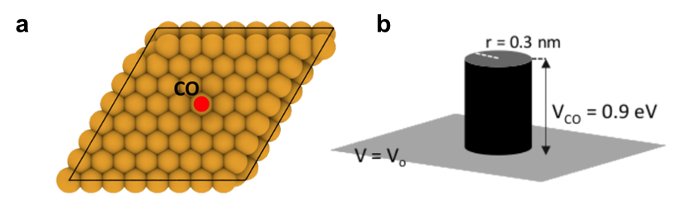
Supplementary Figure 1 | a, Unit cell with 1 CO molecule. b, Corresponding Muffin Tin potential landscape corresponding to the unit cell

Supplementary Figure 2 | Band dispersion of the unit cell from Muffin Tin calculation and the tight binding fit. The tight binding parameters after the fit are reported in Supplementary Table 1.
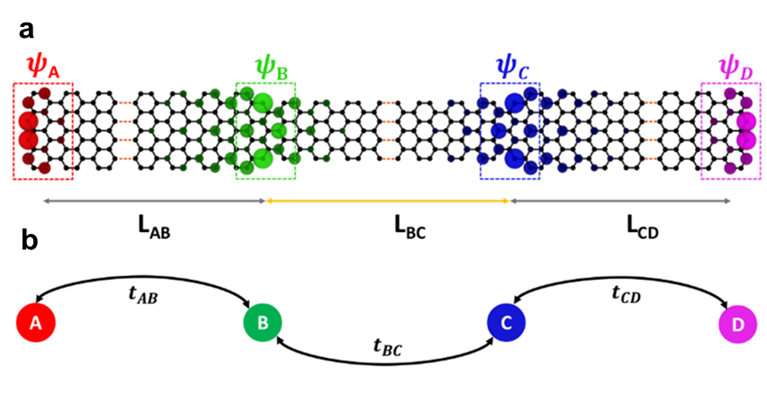
Supplementary Figure 3 | a, Schematic of the9GNR/7GNR/9GNR heterostructure and wavefunctions of 4 SPT states. The distances between the states are represented as L_{AB}, L_{BC} and L_{CD}, respectively. b, Schematic of the 4-state model. The coupling parameter $t_{\{AB,BC,CD\}}$ depends on the distance of separation

Supplementary Figure 4 | Long 9GNR geometry used to extract $ψ_{A}$ and $ψ_{D}$ visualized on the structure. The amplitude of the wavefunction corresponding to the basis site within their masks are extracted.

Supplementary Figure 5 | 9GNR/7GNR heterostructure geometries used to extract $ψ_{B}$ and $ψ_{C}$, visualized on the structure. The amplitude of the wavefunction corresponding to the basis site within their masks are extracted.

Supplementary Figure 6 | 9GNR/7GNR interfaces to extract $t_{AB}(L_{AB})$. $L_{AB}$ is varied while keeping the length of 7GNR fixed to 25-unit cells.

Supplementary Figure 7 | 9GNR/7GNR/9GNR heterostructures to extract $t_{BC}(L_{BC})$. $L_{BC}$ is varied while keeping the length of the 9GNR segments on both sides fixed to 20-unit cells.
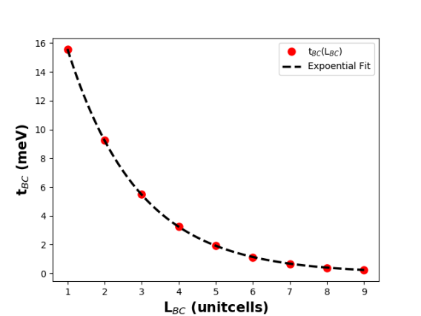
Supplementary Figure 8 | Exponential fit $t_{BC}=α e^{-βL_{AB}}$. The values of the fitting parameters are $α=26.324 mev$and $β= 0.524$/unitcell.

Supplementary Figure 9 | Real part of the wavefunctions $ψ_{A}$ and $ψ_{B}$. The mirror symmetric plane along the y-direction is indicated by the dashed line dividing the ribbon in two equal parts.

Supplementary Figure 10 | LDOS on site B and site C computed from tight binding (left) and 4 state model (right). The qualitative trend of the LDOS with change in distance between the states are captured in our 4-state model.

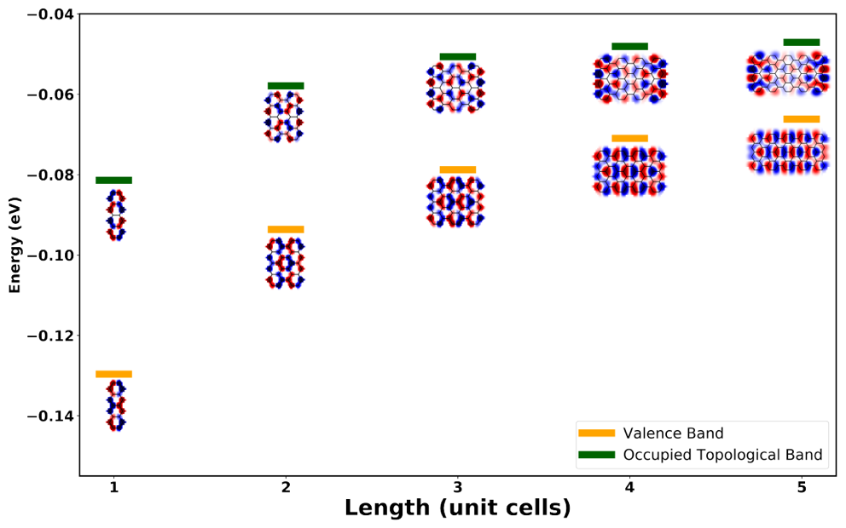
Supplementary Figure 11 | Energy levels for the valence band and occupied topological band along with their respective wavefunctions as a function of length.

Supplementary Table 1 | Numerical values of the TB fitting parameters
$$ε$$ | 0.107 eV
$$t_{nn}$$ | -0.121 eV
$$t_{nnn}$$ | -0.028 eV
s | 0.293

Supplementary Table 2 | Z₂ invariant of the unit cells considered in this work
Unit Cell | Z₂ invariant
 | 1
 | 0
 | 1
 | 0

Supplementary Table 3 | Coupling parameter $t_{BC}(L_{BC})$
$$L_{BC}(unit cells)$$ | $$t_{BC} (meV)$$
1 | 15.575
2 | 9.258
3 | 5.492
4 | 3.248
5 | 1.910
6 | 1.108
7 | 0.627
8 | 0.371
9 | 0.220

Supplementary Table 4 | Coupling parameter $t_{AB}(L_{AB})$
$$L_{AB}(unit cells)$$ | $$t_{AB} (meV)$$
1 | 1.355 $×$ 10⁻¹⁴
2 | 1.062 $×$ 10⁻¹⁴
3 | 1.366 $×$ 10⁻¹⁴
4 | 1.225 $×$ 10⁻¹⁴
5 | 1.008 $×$ 10⁻¹⁴
6 | 6.776 $×$ 10⁻¹⁵
7 | 5.095 $×$ 10⁻¹⁵
8 | 4.025 $×$ 10⁻¹⁵
9 | 2.297 $×$ 10⁻¹⁵

Supplementary Table 5 | Onsite energies
$$e_{A}$$ | -46.609 meV
$$e_{B}$$ | -36.814 meV
$$e_{C}$$ | -36.814 meV
$$e_{D}$$ | -46.609 meV

References and Notes:
- L. Fu, C. L. Kane, Topological insulators with inversion symmetry. Physical Review B 76, 045302 (2007).
- M. Z. Hasan, C. L. Kane, Colloquium: Topological insulators. Reviews of Modern Physics 82, 3045-3067 (2010).
- B. A. Bernevig, T. L. Hughes, S.-C. Zhang, Quantum Spin Hall Effect and Topological Phase Transition in HgTe Quantum Wells. Science 314, 1757-1761 (2006).
- C. Xu, J. E. Moore, Stability of the quantum spin Hall effect: Effects of interactions, disorder, and Z2 topology. Physical Review B 73, 045322 (2006).
- L. Fu, Topological Crystalline Insulators. Physical Review Letters 106, 106802 (2011).
- M. König et al., Quantum Spin Hall Insulator State in HgTe Quantum Wells. Science 318, 766-770 (2007).
- L. Fu, C. L. Kane, Superconducting Proximity Effect and Majorana Fermions at the Surface of a Topological Insulator. Physical Review Letters 100, 096407 (2008).
- B. Jäck et al., Observation of a Majorana zero mode in a topologically protected edge channel. Science 364, 1255-1259 (2019).
- S. Nadj-Perge et al., Observation of Majorana fermions in ferromagnetic atomic chains on a superconductor. Science 346, 602-607 (2014).
- W. P. Su, J. R. Schrieffer, A. J. Heeger, Solitons in Polyacetylene. Physical Review Letters 42, 1698-1701 (1979).
- D. J. Rizzo et al., Topological band engineering of graphene nanoribbons. Nature 560, 204-208 (2018).
- T. Cao, F. Zhao, S. G. Louie, Topological Phases in Graphene Nanoribbons: Junction States, Spin Centers, and Quantum Spin Chains. Physical Review Letters 119, 076401 (2017).
- O. Gröning et al., Engineering of robust topological quantum phases in graphene nanoribbons. Nature 560, 209-213 (2018).
- C. L. Kane, E. J. Mele, Z2 Topological Order and the Quantum Spin Hall Effect. Physical Review Letters 95, 146802 (2005).
- R. M. Kaufmann, D. Li, B. Wehefritz-Kaufmann, Notes on topological insulators. Reviews in Mathematical Physics 28, 1630003 (2016).
- Y.-L. Lee, F. Zhao, T. Cao, J. Ihm, S. G. Louie, Topological Phases in Cove-Edged and Chevron Graphene Nanoribbons: Geometric Structures, Z2 Invariants, and Junction States. Nano Letters 18, 7247-7253 (2018).
- K.-S. Lin, M.-Y. Chou, Topological Properties of Gapped Graphene Nanoribbons with Spatial Symmetries. Nano Letters 18, 7254-7260 (2018).
- L. Yan, P. Liljeroth, Engineered electronic states in atomically precise artificial lattices and graphene nanoribbons. Advances in Physics: X 4, 1651672 (2019).
- T. S. Gardenier et al., p Orbital Flat Band and Dirac Cone in the Electronic Honeycomb Lattice. ACS Nano 14, 13638-13644 (2020).
- S. N. Kempkes et al., Robust zero-energy modes in an electronic higher-order topological insulator. Nature Materials 18, 1292-1297 (2019).
- K. K. Gomes, W. Mar, W. Ko, F. Guinea, H. C. Manoharan, Designer Dirac fermions and topological phases in molecular graphene. Nature 483, 306-310 (2012).
- S. W. Hla, Atom-by-atom assembly. Reports on Progress in Physics 77, 056502 (2014).
- Materials and methods are available as supplementary materials on Science Online.
- J.-W. Rhim, J. Behrends, J. H. Bardarson, Bulk-boundary correspondence from the intercellular Zak phase. Physical Review B 95, 035421 (2017).
- L. Bürgi, et al., Noble metal surface states: deviations from parabolic dispersion. Surface Science, 447, 157-161 (2000).
- N. Tancogne-Dejean, et al., Octopus, a computational framework for exploring light-driven phenomena and quantum dynamics in extended and finite systems. The Journal of Chemical Physics 152, 124119 (2020).
- C.W. Groth, et al., Kwant: a software package for quantum transport. New Journal of Physics 16, 063065 (2014).
- P. Virtanen, et al., SciPy 1.0: fundamental algorithms for scientific computing in Python. Nature Methods 17, 261-272 (2020).
- D. Gresch, et al., Z2Pack: Numerical implementation of hybrid Wannier centers for identifying topological materials. Physical Review B 95, 075149 (2017).
- K.N. Kudin, R. Car, and R. Resta, Berry phase approach to longitudinal dipole moments of infinite chains in electronic-structure methods with local basis sets. The Journal of Chemical Physics 126, 234101 (2007).
- M. Atala, et al., Direct measurement of the Zak phase in topological Bloch bands. Nature Physics 9, 795-800 (2013).

