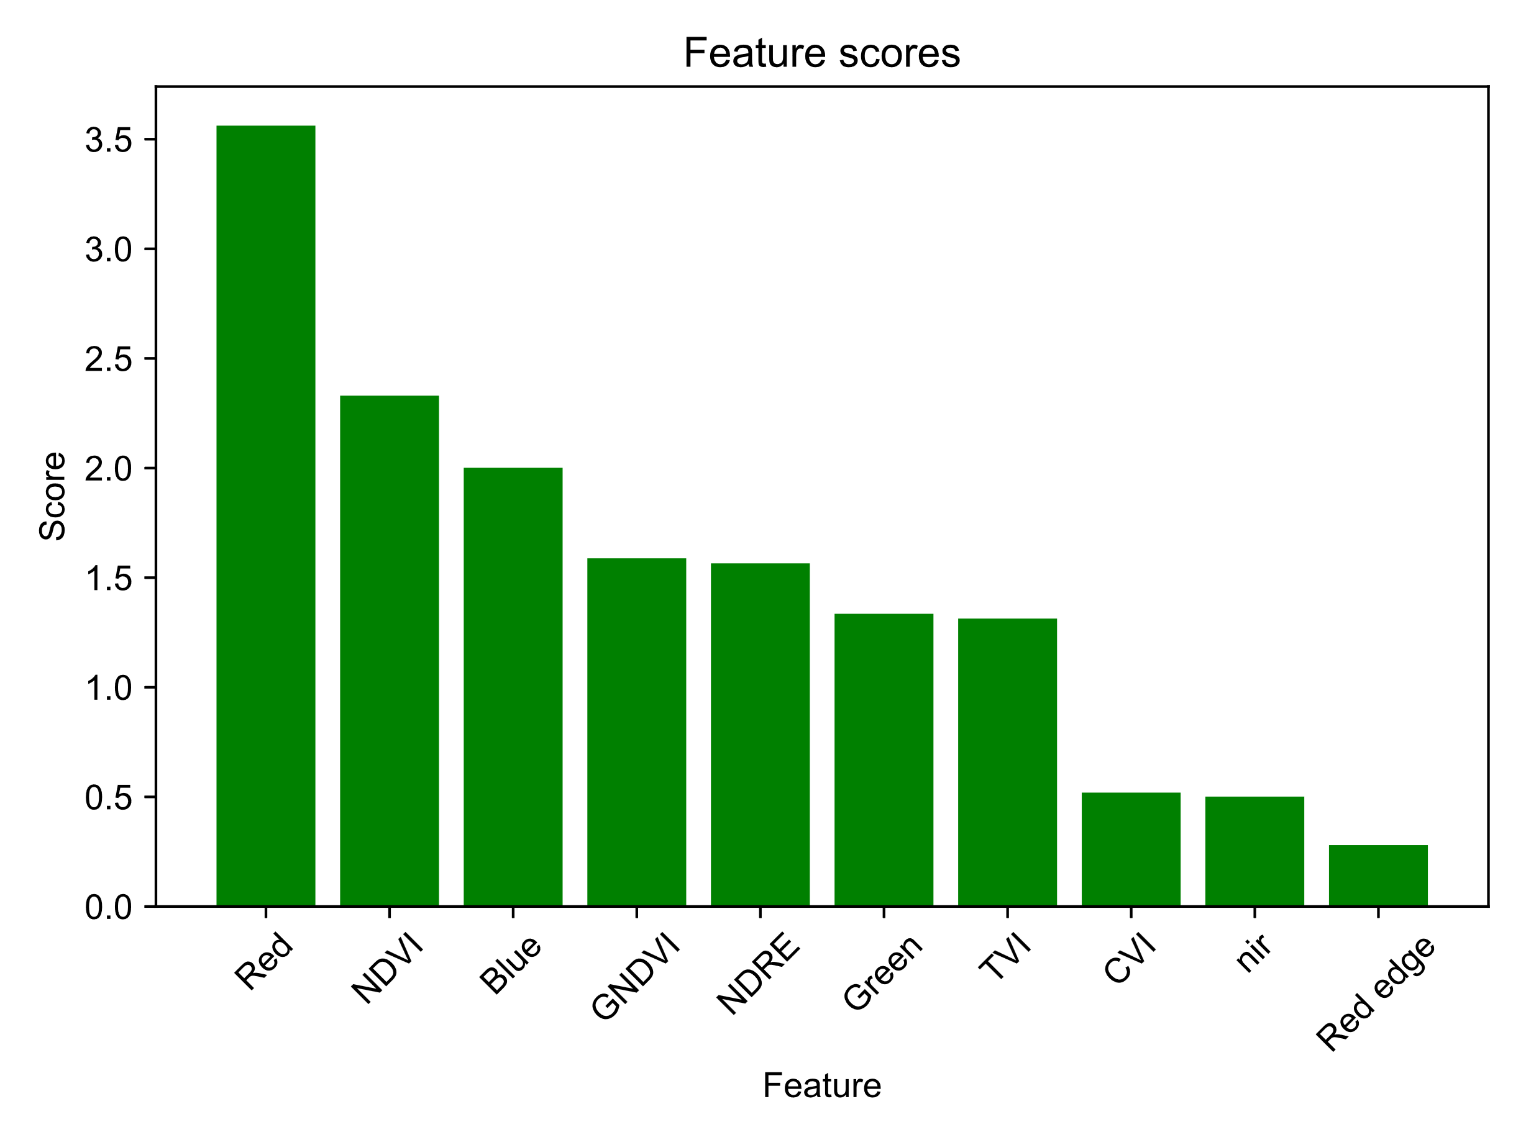
Fig. S1 Chi-square test and feature selection of the spectral vegetation indices (SVIs) and the canopy visual estimation among four sites. The bar plot of the scores of the 10 SVIs. The x-axis shows the SVIs and the y-axis shows the scores.

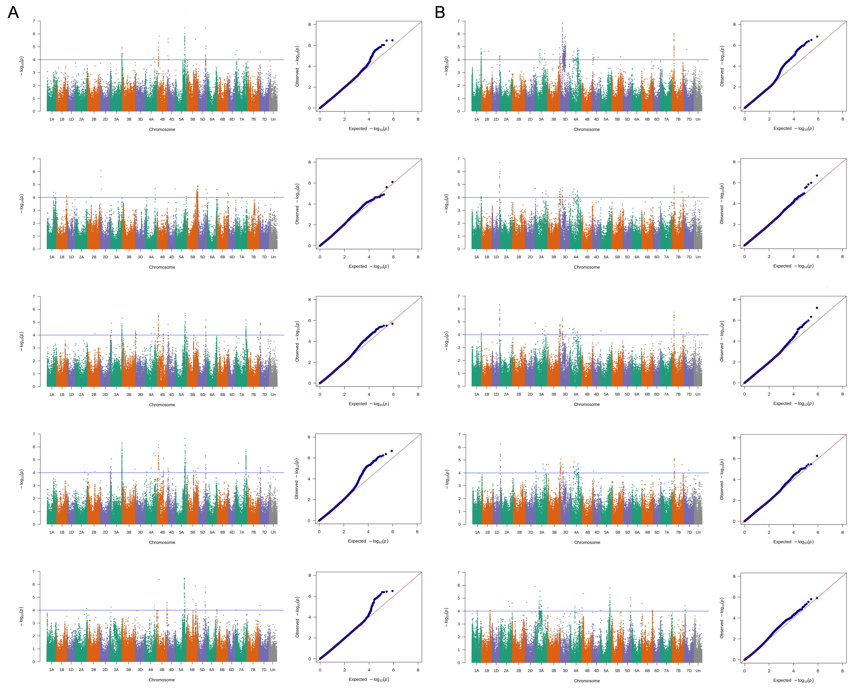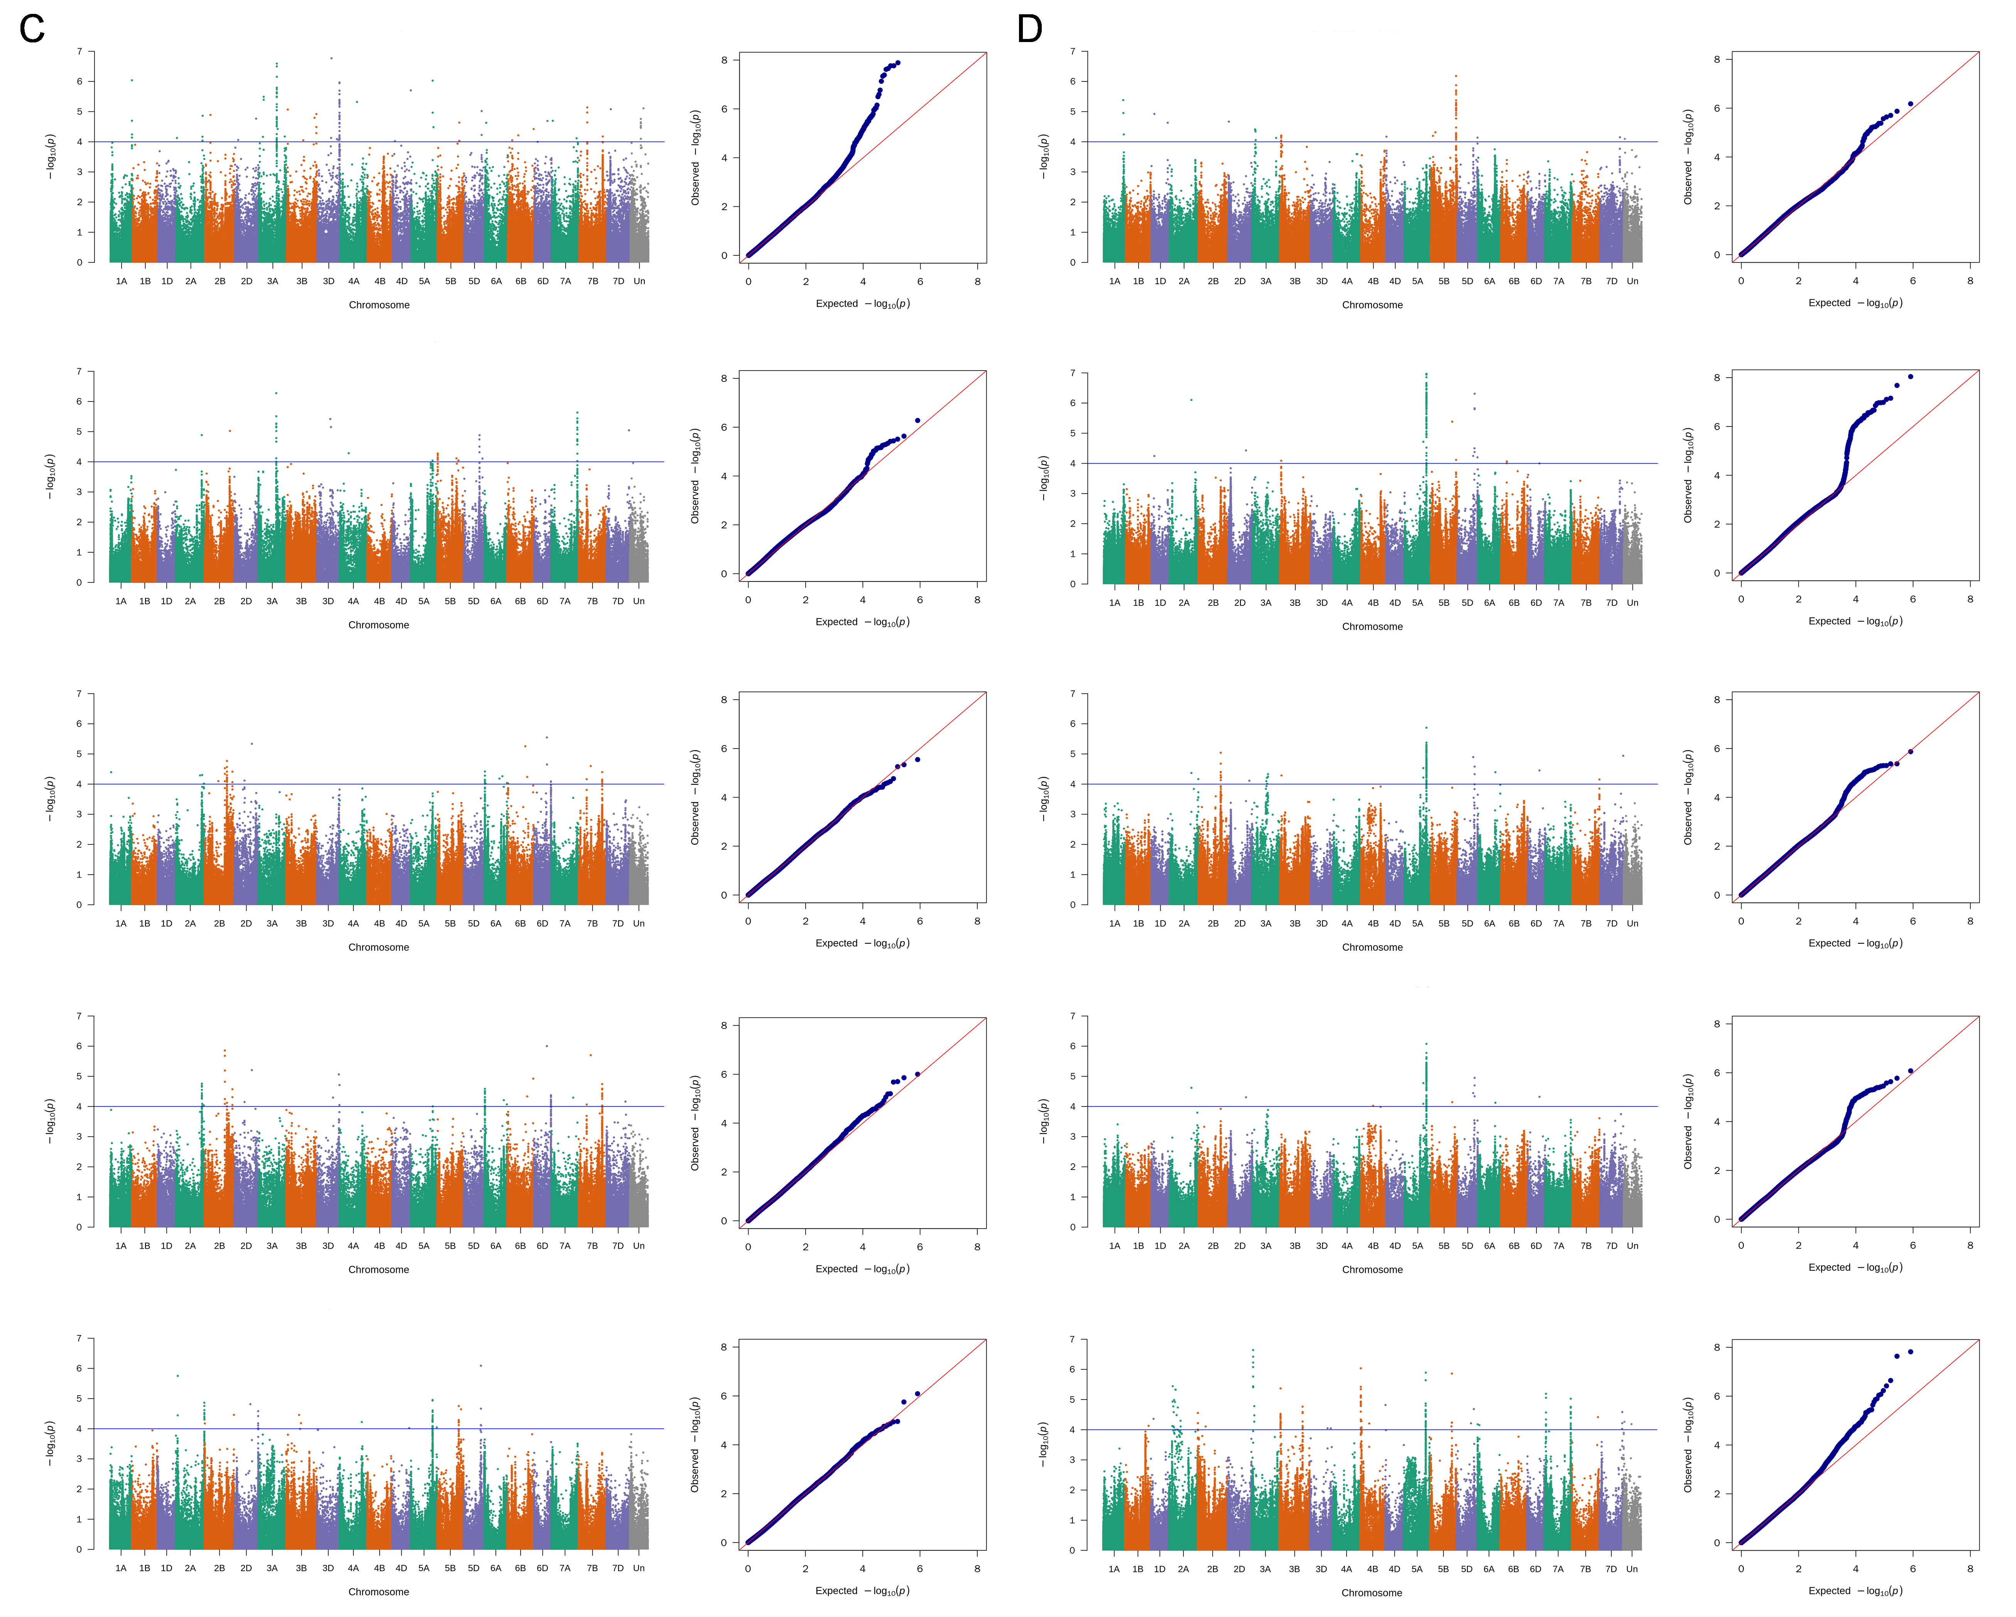
Fig. S2 Manhattan plots and Q-Q plots of BLUE, RED, NDVI, and GNDVI (from top to bottom) in SQ (A), LY (B), NY (C), and YL (D).

