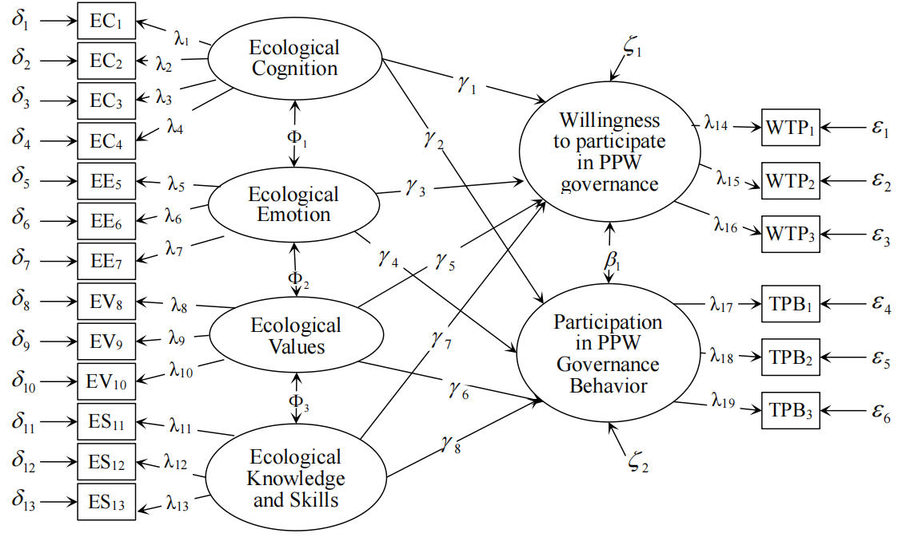
Figure. S1. Structural equation model of farmers’ participation in PPW governance behavior.

