Supplementary materials.
Table 1: LULC change matrix for the years 1990, 2000, 2010 and 2020, in the LKV catchment, Rwanda.
LULC/  Area | 1990 |  | 2000 |  | 2010 |  | 2020
LULC/  Area | km² | % | km² | % | km² | % | km² | %
Agriculture | 935.65 | 27.76 | 1500.20 | 43.17 | 1316.52 | 37.86 | 1327.73 | 38.19
Bare land | 126.83 | 3.76 | 79.02 | 2.27 | 16.22 | 0.47 | 19.32 | 0.56
Built-up | 32.73 | 0.97 | 60.55 | 1.74 | 53.77 | 1.55 | 91.08 | 2.62
Grass | 326.53 | 9.69 | 144.94 | 4.17 | 163.64 | 4.71 | 119.35 | 3.43
Forest | 896.60 | 26.60 | 652.73 | 18.78 | 807.26 | 23.22 | 861.69 | 24.78
River | 30.61 | 0.91 | 7.72 | 0.22 | 14.09 | 0.41 | 3.09 | 0.09
Tea plantation | 21.09 | 0.63 | 25.10 | 0.72 | 105.63 | 3.04 | 50.68 | 1.46
Lake | 1000.35 | 29.68 | 1004.64 | 28.91 | 1000.01 | 28.76 | 1004.07 | 28.88

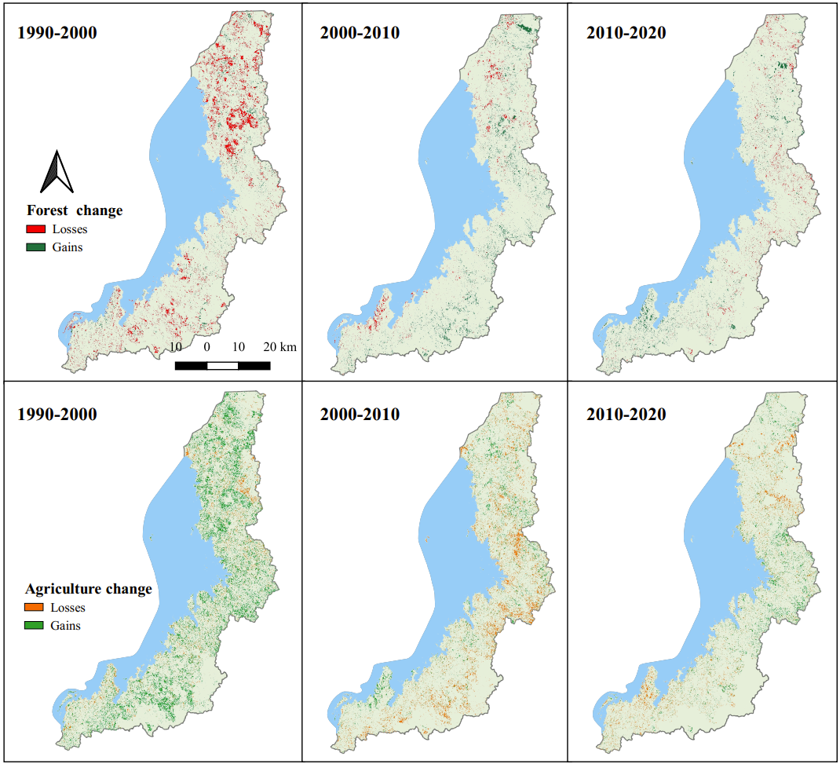
Figure 1: Forest and agriculture losses and gains for (a) first decade, (b) second decade, and (c) third decade.

