Supplementary Information
Pyroelectrocatalytic CO₂ reduction for methanol driven by temperature-variation
Lingbo Xiao^{1,†}, Xiaoli Xu^{1,†}, Yanmin Jia^{2,*}, Ge Hu³, Jun Hu^{3,*}, Biao Yuan,⁴ Yi Yu,⁴ Guifu Zou^{1,*}
¹College of Energy, Soochow Institute for Energy and Materials Innovations, and Key Laboratory of Advanced Carbon Materials and Wearable Energy Technologies of Jiangsu Province Soochow University, Suzhou 215006, China;
²School of Science, Xi’an University of Posts & Telecommunications, Xi’an, 710121, China;
³School of Physical Science and Technology & Jiangsu Key aboratory of Thin Films, Soochow University, Suzhou 215006;
⁴School of Physical Science and Technology, ShanghaiTech University, Shanghai, 201210, China.
*E-mail: jiayanmin@xupt.edu.cn (Y. Jia), jhu@suda.edu.cn (J. Hu) and zouguifu@suda.edu.cn (G. Zou).
† These authors contributed equally.

Fig. S1 The COMSOL simulation of pyro-potential of Bi₂WO₆ nanoplate, different colors represent different potentials. It can be seen potential difference occurs on the surfaces of the Bi₂WO₆ nanoplate.

Fig. S2 Photoelectric response of Bi₂WO₆ excited by xenon lamp.

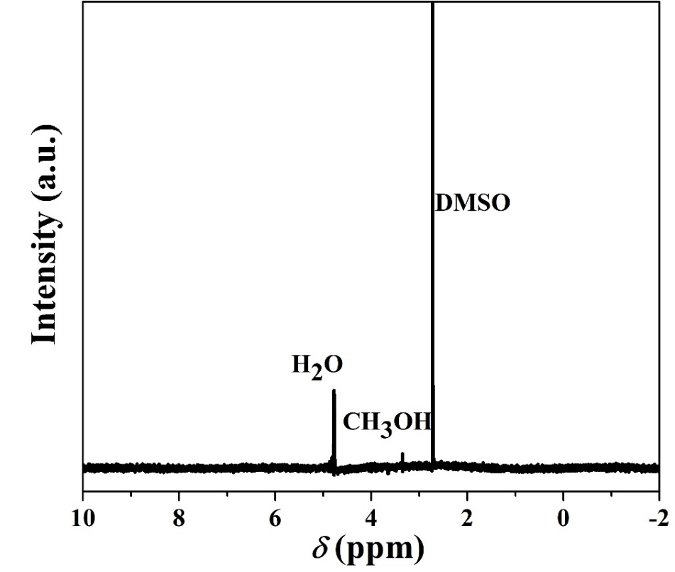
Fig. S3 ¹H NMR spectra of the pyroelectrocatalytic reaction solution, the DMSO were added as internal standard reference

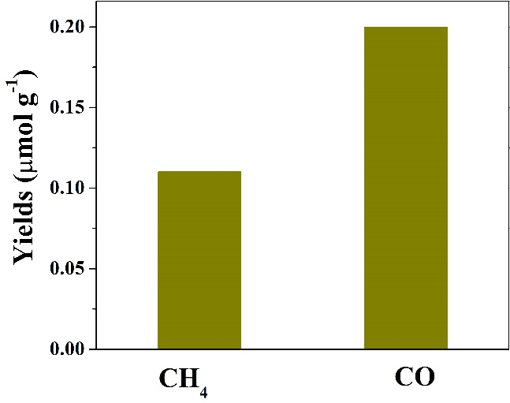
Fig. S4 Gas products by the pyroelectrocatalytic after 20 thermal cycles.

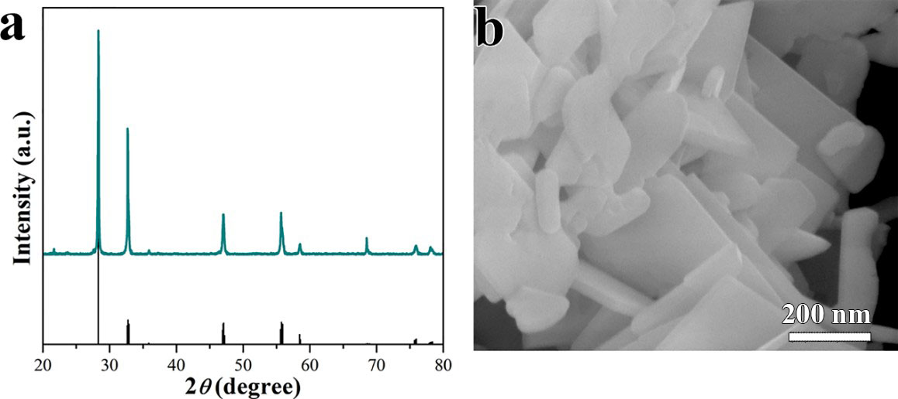
Fig. S5 Characterization of Bi₂WO₆ after pyroelectrocatalytic CO₂ reduction. (a) XRD, (b) SEM.

Fig. S6 (a) pyroelectrocatalytic CO₂ conversion without Bi₂WO₆ (b) pyroelectrocatalytic CO₂ conversion at different stable temperature

Fig. S7 (a) The absorption spectra of RhB in aqueous dispersion systems after experiencing different temperature-variation cycles. The inset picture in (a) shows an intuitive diagram of RhB dye decomposition. (b) The pyro-electric catalytic decomposition efficiency of RhB with or without Bi₂WO₆ under different cycles.

Fig. S8 Slab model for the Bi₂WO₆(001) surface. (a) and (b) Side and top views of the Bi₂WO₆(001) surface. The red, cyan, purple and light grey spheres stand for O, W, Bi and H atoms, respectively. In (b), the surface O and W atoms are highlighted to distinguish them from the atoms underneath.

Fig. S9 Temperature variation between 15 ºC-70 ºC during the pyroelectrocatalytic CO₂ reduction.

