Supporting Information

Polyphenols from foxtail millet improve non-alcoholic fatty liver disease by regulating intestinal flora
Ghani Israr¹, An Yuxuan¹, Qiao qinqin¹, He Shuiling¹, Zhuoyu Li¹*
Institute of Biotechnology, Key Laboratory of Chemical Biology and Molecular Engineering of National Ministry of Education, Shanxi University, Tai Yuan, China

Figure 2 (C) Clud

Figure 2 (C) GAPDH

Figure 2 (C) Ocld

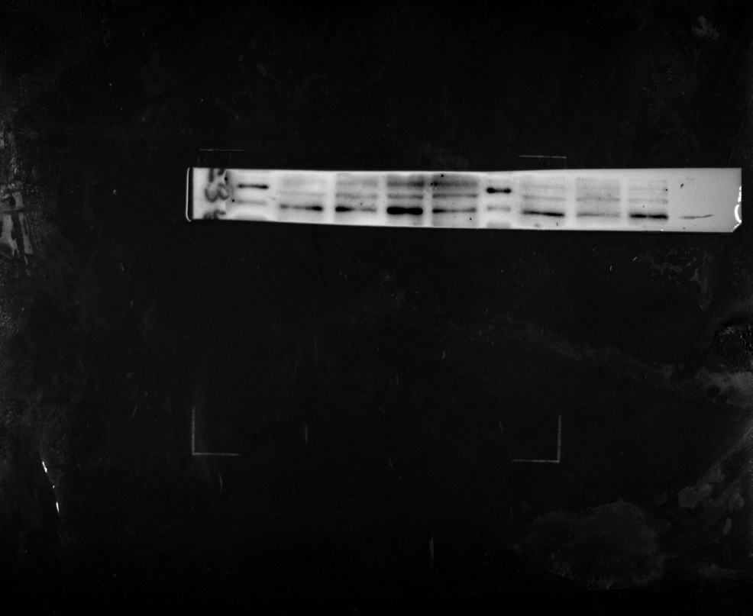
Figure 2 (C) Zo-1

