Supplementary Figures

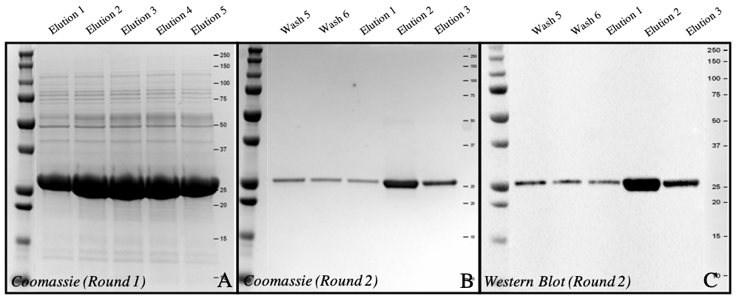
Figure S1. Gel images of WSCP (25.12 kDa) after purification (A) Coomassie image of elutions from 1st round of His-Tag purification. (B) Coomassie of elutions from 2nd round of His-Tag purification. (C) Western Blot of second round of His-Tag purification.

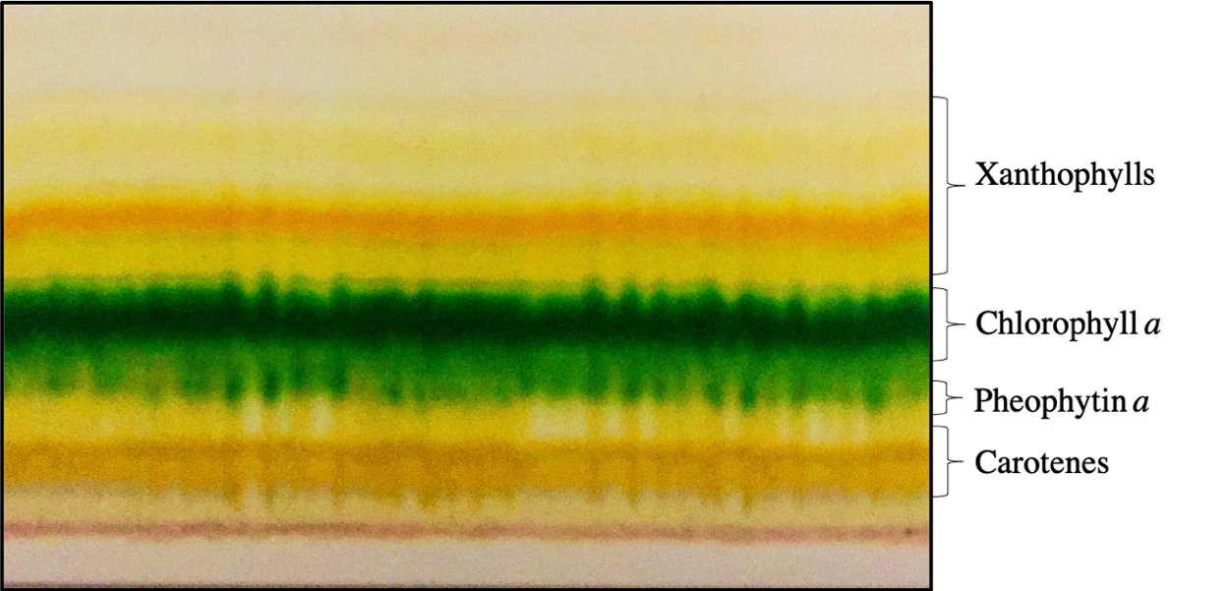
Figure S2. TLC of pigments extracted from Synechococcus elongatus UTEX 2973. Separated by reverse phase TLC, visible bands starting from the bottom in order of polarity correspond to carotenes, pheophytin a, chlorophyll a, and xanthophylls.

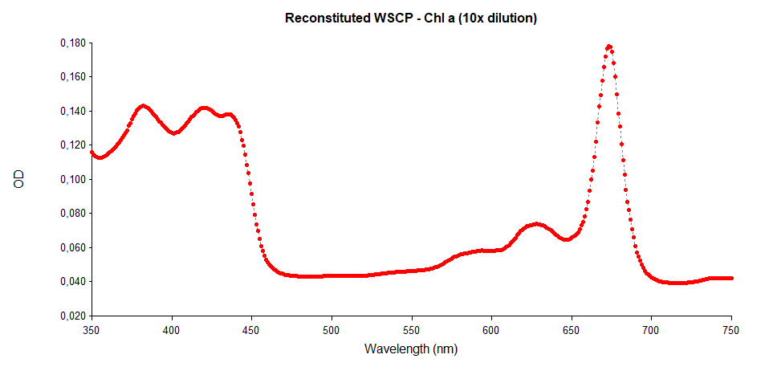
Figure S3. Absorbance spectrum from 250-750 nm of reconstituted WSCP-Chl a. Maximum peak (Q_{y}) is seen at 673 nm.

