Supplemental Information

Engineered nanobodies with programmable target antigen proteolysis (PTAP) fusions regulate intracellular alpha-synuclein in vitro and in vivo

Diptaman Chatterjee, Lianna Y. D’Brant, Benjamin M. Hiller, David J. Marmion, Ivette M. Sandoval, Kelvin C. Luk, Fredric P. Manfredsson, Anne Messer, Jeffrey H. Kordower, David C. Butler

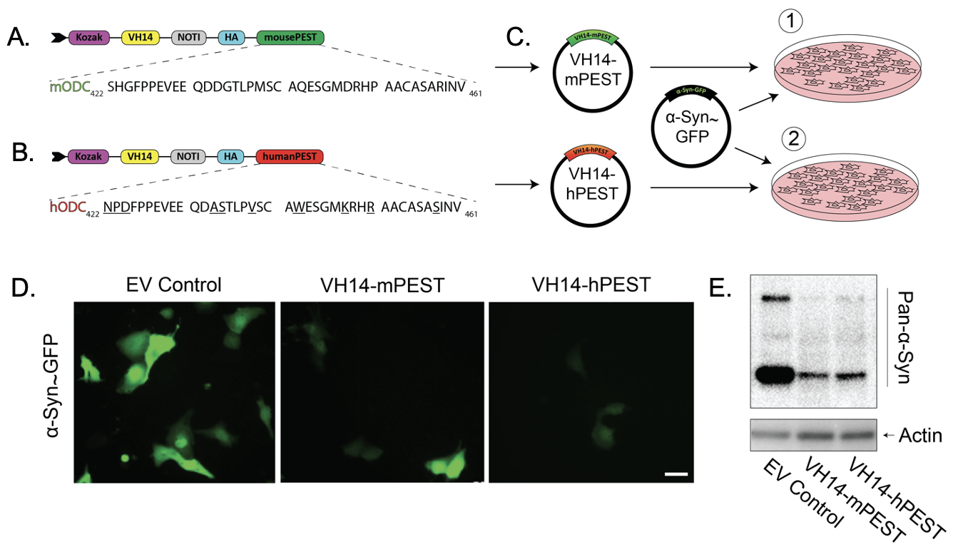 Supplementary Figure S1. VH14-hPEST-mediated αSyn turnover is equally efficient to that of VH14-mPEST in ST14A cells. A) Sequence comparison of the C-terminal PEST degron from murine ornithine decarboxylase and B) human ornithine decarboxylase. C) Study design: ST14A cells were co-transfected with αSyn~GFP and either VH14-mPEST or VH14-hPEST. D) Native fluorescent images of GFP indicating αSyn expression levels, illustrating αSyn signal reduction in intrabody treated cells. F) Corresponding immunoblot data demonstrated reductions in αSyn protein expression with both murine and human PEST constructs.

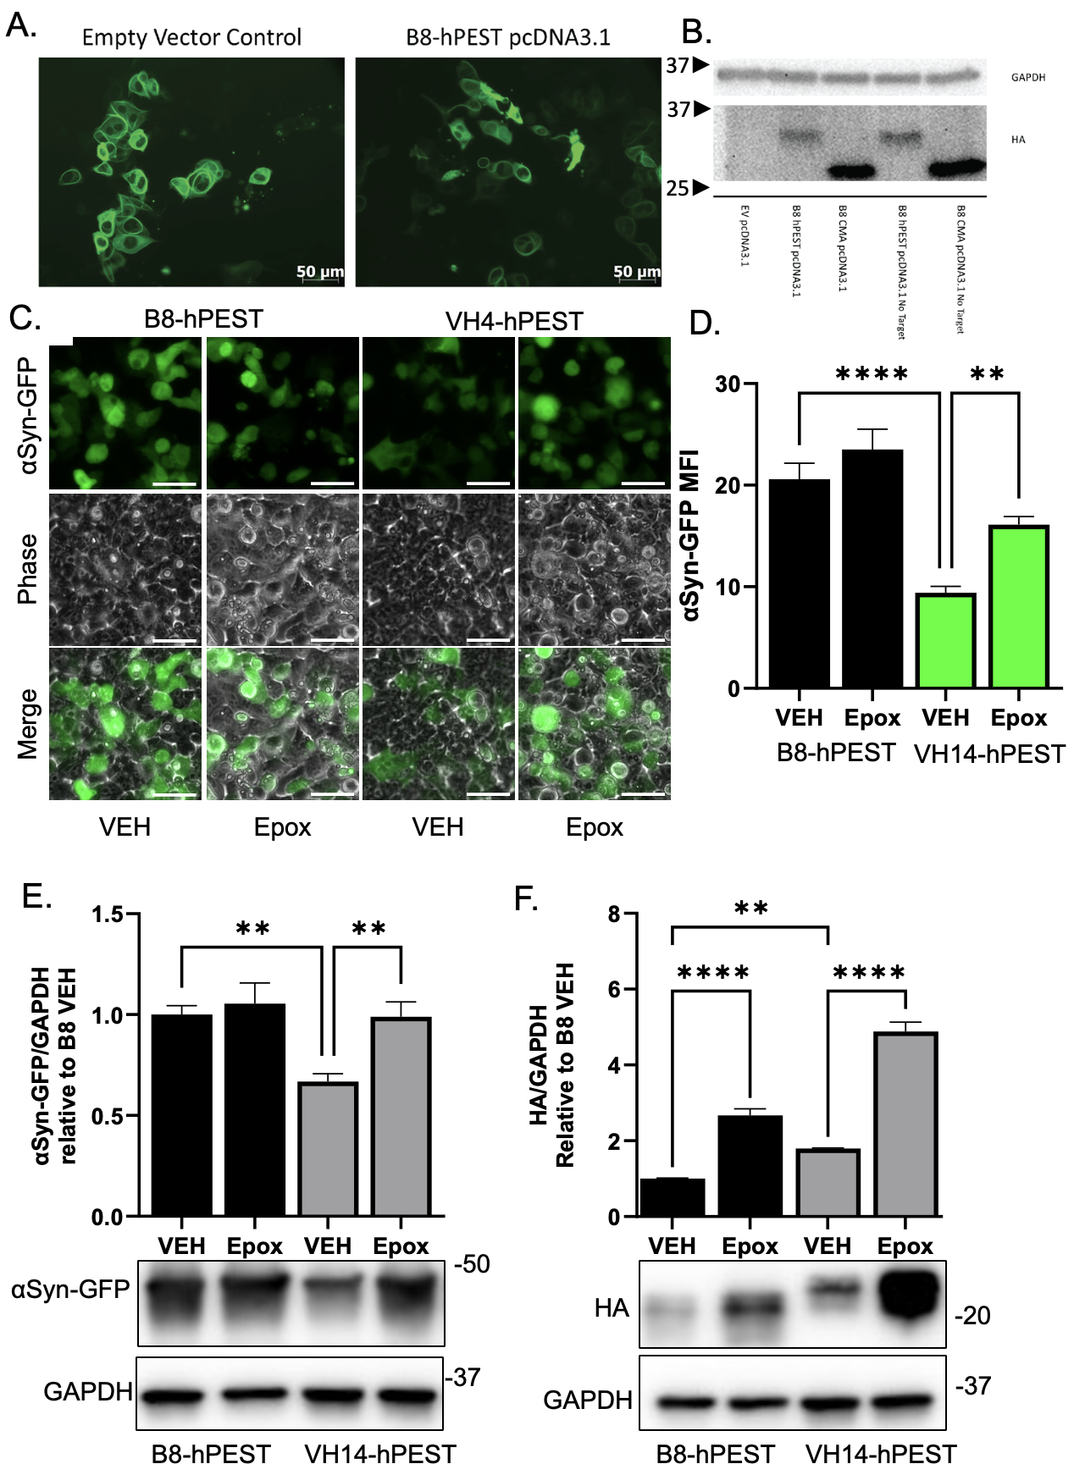Supplemental Figure S2. Validation of B8-hPEST control antibody with affinity to botulinum toxin and Effect of Proteasome Inhibition on αSynGFP Expression Levels. A) Representative fluorescent images of ST14A cells co-transfected with αSyn~GFP and B8-hPEST pcDNA demonstrating no reduction of signal as a result of intrabody expression. B) Corresponding immunoblot analysis with B8 intrabodies tagged with hPEST or a CMA degradation tag, showing stable expression of B8 intrabodies in all systems. HEK293 cells were co-transfected with αSyn~GFP and either VH14-HA-hPEST or B8-HA-hPEST control plasmids. C) Live Cell Imaging showing native αSyn~GFP expression. Scale bar 50 = µm. D) Densitometry bars representing native αSyn~GFP mean expression. Data bars presented as GFP mean fluorescent intensity (MFI) ± standard deviation. E) Western blot analysis showing αSyn~GFP (Probed with Syn1), intrabody expression (anti-HA), and GAPDH as a loading control. F) Densitometry bars depicting αSynGFP mean pixel intensity relative to GAPDH, normalized to the B8-HA-hPEST VEH control, presented as mean ± standard deviation. (All statistics: **p< 0.01, ****p<0.0001).

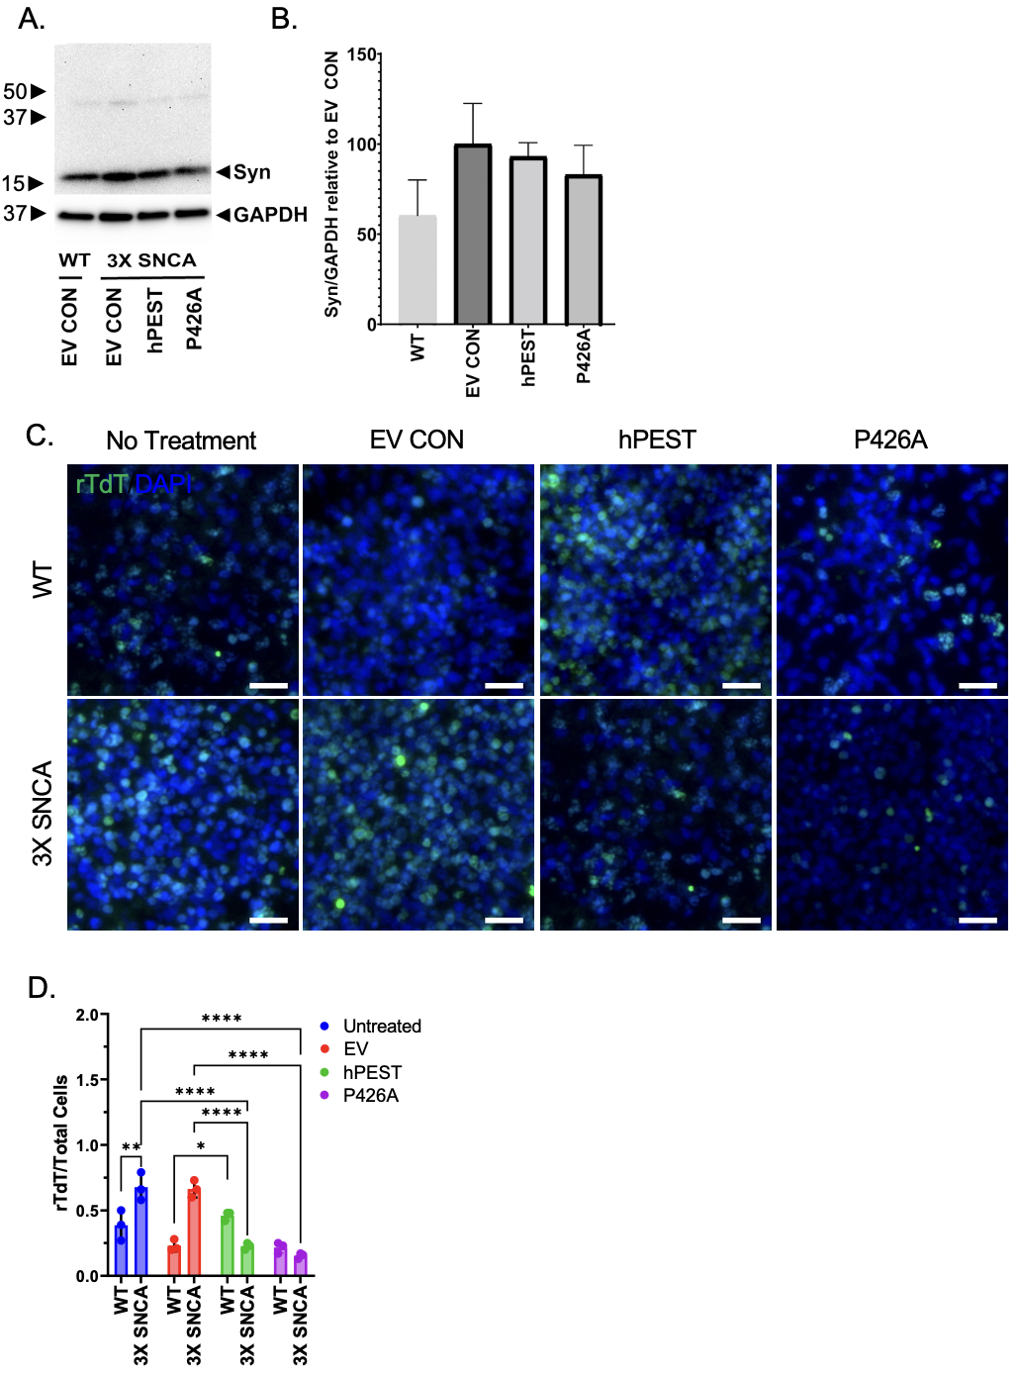
Supplementary Figure S3. Characterization of midbrain organoids treated with VH14-PTAP intrabodies. A) Immunoblot illustrating relative total aSyn levels in 3X SNCA organoids after treatment with VH14-PTAP intrabodies and B) relative densitometric quantification of aSyn signal. C) Representative images of Terminal transferase-mediated dUTP nick end labeling (TUNEL) stained sections (green) and total nuclei (Dapi; blue). Scale bar 20 µm. D) Quantification of TUNEL staining of midbrain organoids indicating apoptotic cell death under treatment conditions. (All Statistics: *p<0.05, **p<0.01, ***p<0.001, ****p<0.0001).

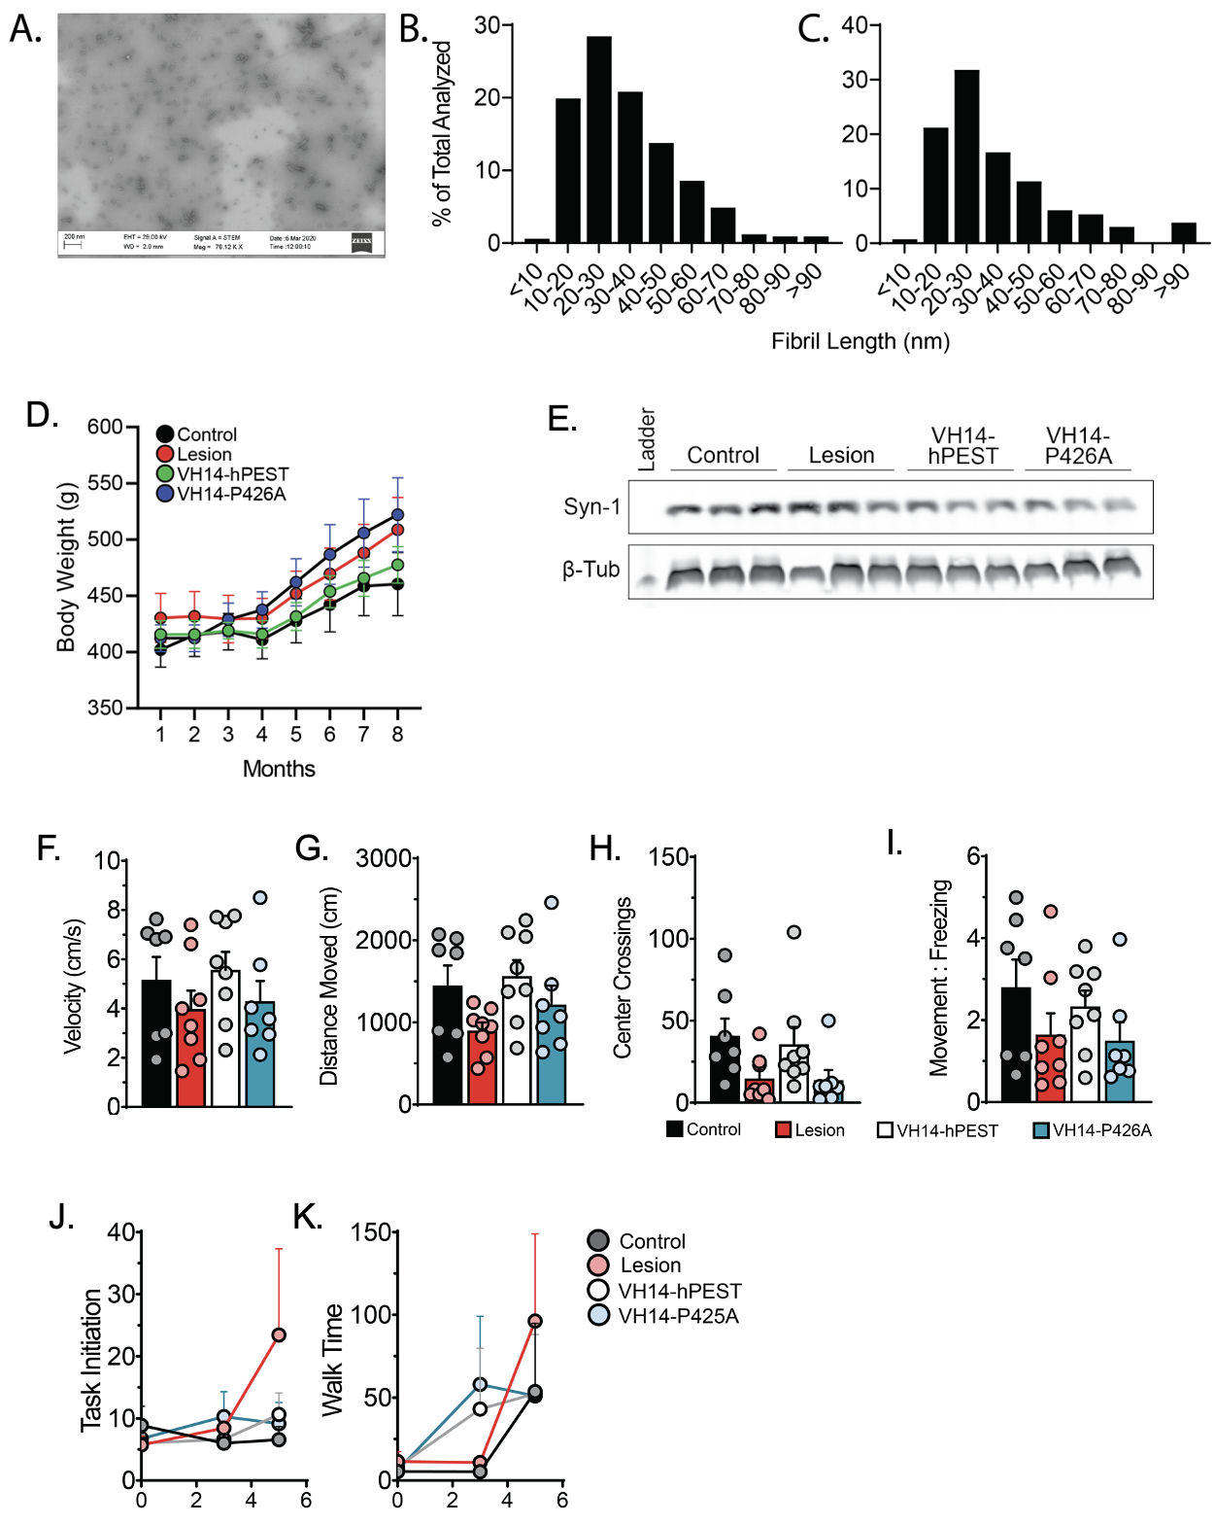

Supplementary Figure S4. Characterization of pre-formed fibrils and In vivo analysis for intrabody-treated animals that received dual intranigral αSyn lesions. A) Representative image taken with scanning electron microscope illustrating scattered αSyn fibrils and fibril lengths. B) Histogram of fibril distribution from pre-surgical prep for animals receiving intranigral injections of AAV-αSyn and PFFs. C) Histogram of fibril distribution for animals receiving striatal injections of PFFs. D) Corresponding changes in body weight throughout the time frame of experimentation. Animals underwent lesion surgeries at ~2 months and subsequent treatment surgeries at 3 months. E) Immunoblot analysis of αSyn levels from midbrain lysates. F) Narrow beam challenge behavioral analysis carried out at two-month intervals. Data represents the latency to task initiation (turn around on platform) and G) latency to reach end goal chamber. F) Open field behavioral analysis showing animal velocity, G) total distance traveled, H) frequency of center crossings and I) ratio of movement time to immobile time.

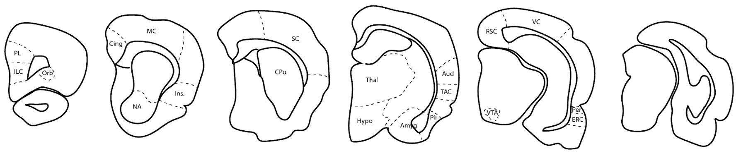
Supplementary Figure S5. Schematic of neuroanatomic regions of interest for quantification of pS129-labeled pathology. Contours were traced at level matched sections for each subject. Abbreviations: PL – prelimbic area, ILC – infralimbic cortex, Cing – cingulate, MC – motor cortex, Ins. – insular cortex, NA – nucleus accumbens, Thal – thalamus, Hypo – hypothalamus, Amyg – amygdala, Pir – piriform area, TAC – temporal association cortex, Aud – auditory cortex, VTA – ventral tegmental area, RSC – retrosplenial cortex, VC – visual cortex, Per – perirhinal cortex, and ERC – entorhinal cortex.

