[Supplementary Information]

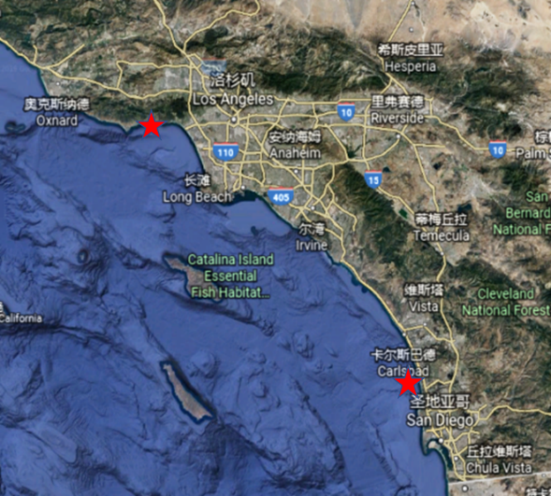
Fig.S1.Sites of sample collection along the south California coast at Malibu pier (34.03^{O}N, 118.78 ^{O}W) and La Jolla cove (32.85^{O}N, 117.27 ^{O}W).

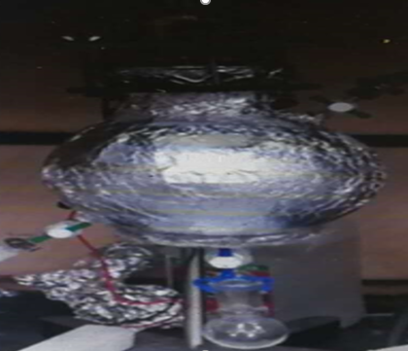
Fig.S2. The developed transparent glass reactor for bioconversion process of carbon dioxide to short chain hydrocarbons. Glass reactor was wrapped by the foil for light aggregation.

Fig.S3. Sequential profiles of gas chromatograph by a long-term cultivation experiment of the enriched microbial community for bioconversion of carbon dioxide to SCAs when LED light involved. C1 represents methane; C2 represents ethene and ethane; C3 represents propene and propane; C4 represents i-butane and n-butane; C5 represents i-pentane and n-pentane; C6 represents i-hexane and n-hexane.

Fig.S4. Detection and confirmation of ¹³C labeled hydrocarbons by GC-MS.

Fig.S5. Statistics of functional genes involved in CO₂ fixation and the synthesis of hydrocarbon via metagenomic sequencing. (A) Time-serial distribution of unique KEGG orthologue group (KO) in four samples. At the functional level, the unique KEGG orthologue groups (KOs) were calculated and showed in venn diagram during cultivation, in which the original culture of the shorter cultivation time (S1) and the subculture (S3 and S4) showed lower diversity than the original (S1 and S2). (B) Heatmap of predicted protein genes involved in metabolic pathways including carbon fixation and hydrocarbon synthesis.

Fig.S6. Analysis of carbon metabolism pathways in KEGG database. The whole set of predicted protein genes in all samples were utilized to reconstruct the carbon metabolism pathways. Red shaded boxes indicated complete pathways that capable of carrying out all the processes included, while gray shaded boxes indicated the incomplete ones.

Fig.S7. Taxonomic analysis of functional genes in carbon metabolism pathways. Each gene identified in Calvin cycle (M00165), Reductive TCA cycle (M00173), and WL pathway (M00377) was blasted against the microbe NR database to find the best hit gene. Based on the accession ID, taxonomic ID number and corresponding lineage, taxonomic information was retrieved and calculated with normalized gene abundance. Results were displayed at the phylum (A), class (B), order(C), family(E) and genus(E) levels, respectively.

Fig.S8. Phylogenetic tree of discovered bins in this study at the class level. Total reads from all samples were combined for Megahit assembly and gene annotation with Prokka program. The whole set of contigs were used for binning with Maxbin software. For a specified bin, taxonomic information of each constituent/component gene was determined by searching the microbe NR database, accession ID, taxonomic ID number and corresponding lineage item. After sorting by the sum of normalized abundance, the most abundant category was designated for the object bin. The newick file was generated by querying the PhyloT database (https://phylot.biobyte.de/), and unrooted phylogenetic tree at class level was obtained by using the web-based tool iTOL (https://itol.embl.de/).

Fig.S9. Phylogenetic analysis of key gene for nitrogenase and the distribution of normalized abundance among samples according to the phylogenetic tree.

Fig.S10. Phylogenetic analysis of key genes for hydrogenase/hydrogenlyase and the distribution of normalized abundance among samples according to the phylogenetic tree.

Fig.S11. Sequential profiles of gas chromatograph by a long-term cultivation experiment of the developed biogroups microbial community for bioconversion of carbon dioxide to SCAs when LED light involved. C1 represents methane; C2 represents ethene and ethane; C3 represents propene and propane; C4 represents i-butane and n-butane; C5 represents i-pentane and n-pentane; C6 represents i-hexane and n-hexane.

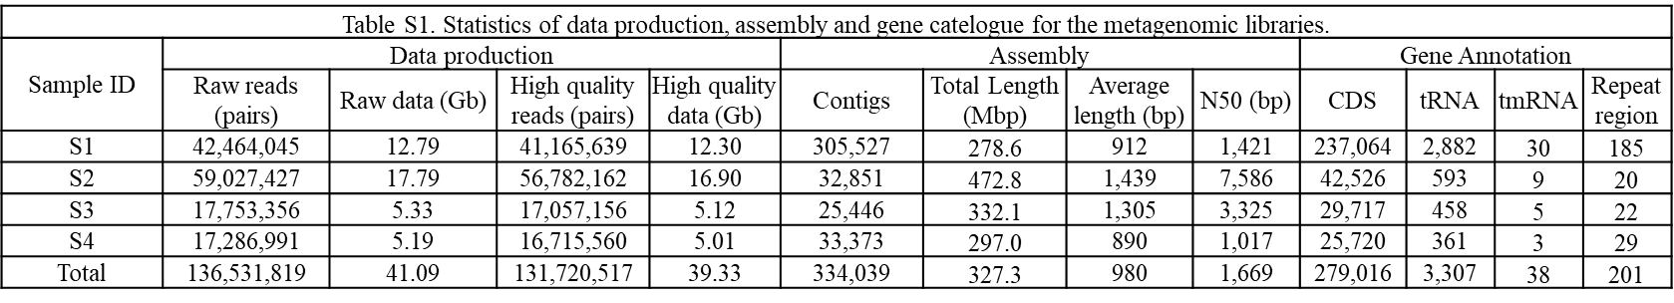

Table. S2 Annotation of the gene catelogues and Abundance of KOs, ECs and NOGs in water samples of different cultivation time
 | KEGG |  | OG
Sample ID | KO | EC | Total | COG
S1 | 8,067 | 3,579 | 449,569 | 351,268
S2 | 6,060 | 2,701 | 72,128 | 52,129
S3 | 5,222 | 2,378 | 47,991 | 34,587
S4 | 5,194 | 2,372 | 32,496 | 23,320
Total | 17,435 | 6734 | 602,184 | 461,304

Table. S3 The isolated microbes from the enriched microbial community
Isolated strain | Phylum | GeneBank No.
Pseudomonas sp. XPn-1 | Alphaproteobacteria | MN538968
Rhodospirillum rubrum XPn-2 | Alphaproteobacteria | MN538969
Thalassospira sp. XPn-3 | Alphaproteobacteria | MN538970
Celeribacter ethanolicus XPn-4 | Alphaproteobacteria | MN538971
Thioclava nitratireducens XPn-5 | Alphaproteobacteria | MN538972
Serratia marcescens XPn-6 | Gammaproteobacteria | MN538973
Stenotrophomonas maltophilia XPn-7 | Gammaproteobacteria | MN538974
Vibrio sp. XPn-8 | Gammaproteobacteria | MN538975
Salmonella enterica XPn-9 | Gammaproteobacteria | MN538976
Candidatus Thiodictyon syntrophicum XPn-10 | Gammaproteobacteria | MN538977
Desulfovibrio sp. XPn-11 | Deltaproteobacteria | MN538978
Sporomusa sphaeroides XPn-12 | Firmicutes | MN538979
Paenibacillus sonchi XPn-13 | Firmicutes | MN538980
Enterococcus faecalis XPn-14 | Firmicutes | MN538981
Clostridium sp. XPn-15 | Firmicutes | MN538982
Methanosarcina lacustris XPn-16 | Euryarchaeota | MN538983

