Plasma biomarkers in dementia with Lewy bodies: evidence from memory clinic settings

Agathe Vrillon, Olivier Bousiges, Karl Götze, Catherine Demuynck, Candice Muller, Alix Ravier, Benoit Schorr, Nathalie Philippi, Claire Hourregue, Emmanuel Cognat, Julien Dumurgier, Matthieu Lilamand, Benjamin Cretin, Frederic Blanc, Claire Paquet.

Supplementaries

Supplementary Figure 1, Correlation between plasma biomarkers in the whole cohort and in the diagnosis subgroups

Suppplementary Table 1, Cohort characteristics and plasma biomarkers levels by center

Supplementary Table 2, Association of plasma biomarkers with age, sex and APOE ɛ4 carriership

Supplementary Table 3, Plasma biomarkers performance for diagnosis

Supplementary Table 4, Association of MMSE with plasma biomarkers levels in the whole cohort and in the diagnosis subgroups

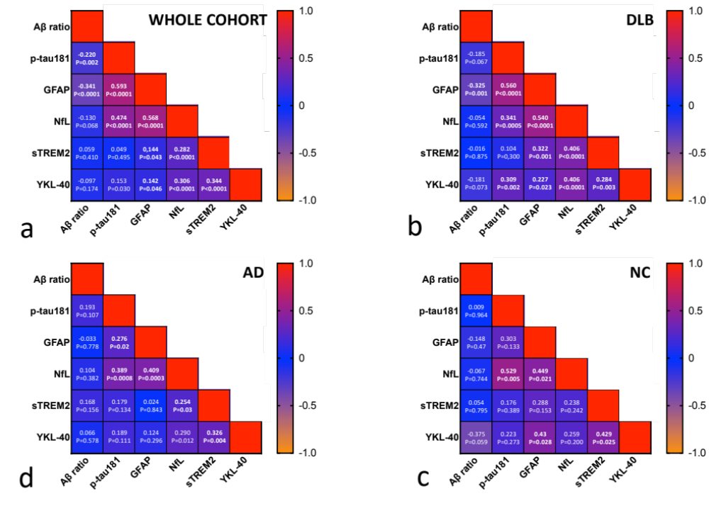
Supplementary Figure 1, Correlation between plasma biomarkers in the whole cohort and in the diagnosis subgroups
Correlation of plasma biomarkers in a, the whole cohort; b, DLB group; c, AD group; d, neurological controls. Correlations were computed with Spearman’s correlation. Results are displayed as rho, P-value. Significant correlations (P<0.05) are indicated in bold.
 | PARIS Lariboisière |  |  | STRASBOURG CMRR
 | NC | AD | DLB | NC | AD | DLB
Total n=207 | n=19 | n=71 | n=56 | n=8 | n=5 | n=48
Age, years | 61.3 [8.60] | 72.0 [12.6] | 72.2 [7.47] | 60.5 [8.50] | 77.0 [2.00] | 68.0 [12.8]
Sex, male | 30% (6) | 39% (28) | 69% (38) | 25% (2) | 40% (2) | 46% (22)
APOE ɛ4 carriership* | 35% (11/17) | 70% (45/64) | 47% (15/32) | 25% (2) | 40% (2) | 33% (16)
MMSE | 28.5 [2.75] | 19.0 [5.75] | 24.0 [6.00] | 28.5 [1.0] | 22 [6.00] | 27.0 [5.00]
Level of education, years | 15 [3.00] | 9 [6.00] | 11.0 [6.00] | 15 [3.00] | 11 [1.00] | 11 [6.00]
Plasma biomarkers levels
Plasma Aβ ratio | 0.0646 [0.0101] | 0.0587 [0.0151] | 0.0530 [0.0151] | 0.0637 [0.0233] | 0.0591 [0.00873] | 0.0592 [0.0201]
Plasma GFAP, pg/mL | 1.51 [0.847] | 1.87 [1.56] | 3.85 [1.80] | 1.79 [0.253] | 3.18 [1.25] | 2.10 [1.45]
Plasma NfL, pg/mL | 69.1 [34.8] | 105 [75.9] | 162 [99.2] | 57.1 [27.9] | 91.4 [26.6] | 114 [93.3]
Plasma p-tau181, pg/mL | 15.1 [8.84] | 21.5 [13.5] | 25.3 [13.4] | 18.8 [3.54] | 26.4 [5.08] | 21.5 [12.7]
Plasma s-TREM2, pg/mL | 568 [288] | 539 [417] | 510 [355] | 418 [162] | 1111 [470] | 729 [432]
Plasma YKL-40, ng/mL | 74.6 [95.7] | 83.6 [106] | 77.5 [66.7] | 70.5 [51.4] | 89.6 [26.3] | 96.4 [101]

Supplementary Table 1, Cohort characteristics and plasma biomarkers levels presented by center
Continuous variables are presented as median [IQR] and categorical data as number (%).
Abbreviations: AD, Alzheimer disease; AUC, area under the curve; DLB, dementia with Lewy bodies; GFAP, glial fibrillary acidic protein; NC, neurological controls; MMSE, mini mental state examination; NfL, neurofilament light chain.

 | Age |  | Sex |  | APOE ɛ4 status
 | Unadjusted  (Spearman r) | Adjusted on sex and APOE ɛ4 status | Unadjusted | Adjusted on age and APOE ɛ4 status | Unadjusted | Adjusted on age and sex
Plasma Aβ ratio | r=-0.131, P= 0.066 | β=-0.042, P=0.593 | P=0.961 | β=-0.020, P=0.803 | P=0.002 | β=-0.228, P=0.004
Plasma p-tau181 | r=0.254, P<0.001 | β=0.261, P<0.001 | P=0.913 | β=-0.039, P=0.598 | P<0.001 | β=0.220, P=0.004
Plasma GFAP | r=0.393, P<0.001 | β=0.464, P<0.001 | P=0.011 | β=-0.258, P<0.001 | P=0.013 | β=0.091, P=0.181
Plasma NfL | r=0.485, P<0.001 | β=0.538, P<0.001 | P=0.614 | β=-0.073, P=0.278 | P=0.054 | β=0.055, P=0.412
Plasma sTREM-2 | r=0.287, P<0.001 | β=0.310, P<0.001 | P=0.610 | β=-0.042, P=0.578 | P=0.267 | β=-0.165, P=0.028
Plasma YKL-40 | r=0.315, P<0.001 | β=0.236, P=0.002 | P<0.001 | β=-0.198, P=0.008 | P=0.122 | β=-0.092, P=0.215

Supplementary Table 2, Association of plasma biomarkers with age, sex and APOE ɛ4 carriership
Unadjusted association of plasma biomarkers were studied with spearman correlations for age and with Welchs-test for sex and APOE ɛ4 carriership. Adjusted analysis was performed using linear regression adjusting for age, sex and APOE ɛ4 carriership. Standardised regression coefficient (β) estimates and p-values are displayed for adjusted analysis.

 | DLB versus NC |  | DLB versus AD |  | AD versus NC |  | Aβ+ versus Aβ-
 | AUC | 95% CI | AUC | 95% CI | AUC | 95% CI | AUC | 95% CI
Plasma Aβ ratio | 0.77 | 0.66- 0.88 | 0.66 | 0.58- 0.73 | 0.87 | 0.79- 0.96 | 0.72 | 0.64- 0.79
Plasma p-tau181 | 0.78* | 0.68- 0.87 | 0.80* | 0.74- 0.87 | 0.97* | 0.93- 1.00 | 0.84* | 0.78- 0.90
Plasma GFAP | 0.76 | 0.66- 0.86 | 0.72 | 0.65- 0.80 | 0.91 | 0.84- 0.97 | 0.78 | 0.72- 0.85
Plasma NfL | 0.75 | 0.64- 0.85 | 0.67 | 0.59- 0.75 | 0.85 | 0.75- 0.95 | 0.74 | 0.67- 0.81
Plasma YKL-40 | 0.74 | 0.63- 0.84 | 0.63 | 0.54- 0.71 | 0.79 | 0.70- 0.88 | 0.65 | 0.57- 0.72
Plasma sTREM2 | 0.75 | 0.65- 0.85 | 0.65 | 0.57- 0.74 | 0.78 | 0.67- 0.88 | 0.67 | 0.59- 0.74

Supplementary Table 3, Plasma biomarkers performance for diagnosis
Area under the curve (AUC) were calculated using ROC analysis and binary logistic regression models, including the biomarker, age and sex, to evaluate the performance of each biomarker for distinguishing between diagnostic groups and to identify amyloid positivity. Akaike information criterion (AIC) was calculated for each logistic regression model> * Compared to all other plasma biomarkers, plasma p-tau181 was the best predictor, with the lowest AIC (δAIC>4).
Abbreviations: AD, Alzheimer disease; AUC, area under the curve; DLB, dementia with Lewy bodies; GFAP, glial fibrillary acidic protein; NC, neurological controls; NfL, neurofilament light chain; 95% CI, 95% confidence interval
 | Whole cohort |  | NC |  | AD |  | DLB
 | Unadjusted | Adjusted on sex, age, LoE | Unadjusted | Adjusted on sex, age, LoE | Unadjusted | Adjusted on sex, age, LoE | Unadjusted | Adjusted on sex, age, LoE
Plasma Aβ ratio | r=-0.194 (P=0.007) | β=0.092 (-0.224-0.040), P=0.171 | r=-0.049 (P=0.816) | β=0.016 (-0.490-0.459), P=0.946 | r=-0.071 (P=0.554) | β=0.013 (-0.216-0.242), P=0.908 | r=0.059 (P=0.573) | β=-0.116 (-0.073-0.305), P=0.226
Plasma p-tau181 | r=0.461 (P< .001) | β=-0.378 (-0.253—-0.503), P< .001 | r=0.119 (P=0.570) | β=-0.065 (-0.453-0.583), P=0.796 | r=0.142 (P=0.239) | β=0.082 (-0.147-0.311), P=0.477 | r=-0.231 (P=0.024) | β=-0.176 (-0.016-0.369), P=0.072
Plasma GFAP | r=0.444 (P< .001) | β=-0.373 (-0.229—-0.517), P< .001 | r=0.365 (P=0.073) | β=-0.464 (-0.046-0.974), P=0.072 | r=-0.253 (P=0.032) | β=0.214 (-0.016-0.444), P=0.067 | r=-0.156 (P=0.134) | β=-0.049 (-0.188-0.286), P=0.681
Plasma NfL | r=0.327 (P< .001) | β=-0.178 (-0.032—-0.325), P=0.017 | r=-0.010 (P=0.964) | β=0.087 (-0.638-0.463), P=0.744 | r=0.161 (P=0.178) | β=0.207 (-0.0369-0.4500), P=0.095 | r=-0.139 (P=0.183) | β=-0.040 (-0.170-0.250), P=0.705
Plasma sTREM-2 | r=-0.121 (P=0.090) | β=-0.139 (-0.273— -0.0038), P=0.044 | r=0.402 (P=0.042) | β=-0.429 (-0.015-0.873), P=0.058 | r=-0.208 (P=0.075) | β=-0.005 (-0.258-0.247), P=0.968 | r=-0.136 (P=0.183) | β=0.170 (-0.365-0.025), P=0.087
Plasma YKL-40 | r=0.010 (P=0.889) | β=0.094 (-0.231-0.042), P=0.175 | r=0.350 (P=0.079) | β=-0.371 (-0.068-0.810), P=0.094 | r=-0.016 (P=0.894) | β=0.089 (-0.155-0.332), P=0.468 | r=-0.012 (P=0.909) | β=0.132 (-0.325-0.061), P=0.177

Supplementary Table 4, Association of MMSE with plasma biomarkers levels in the whole cohort and in the diagnosis subgroups.
Unadjusted analysis was studied with Spearman’s r correlations. Adjusted analysis on age, sex and level of education was performed using linear regression with post Hoc Tukey’s adjusting for multiple comparisons. Standardised regression coefficient (β) estimates and p-values are displayed for adjusted analysis.
Abbreviations: AD, Alzheimer’s disease; DLB, dementia with Lewy bodies; GFAP, glial fibrillary acidic protein; LoE, level of education; MMSE, mini mental state examination; NC, neurological controls; NfL, neurofilament light chain; p-tau181, tau phosphorylated at serine 181; sTREM-2, soluble triggering receptor expressed myeloid.

