Supplemental Table S1: Evidence of the lack of effect of treatment duration on ovarian development between females kept for 2 or 4 days following treatment in 2022. Treatment duration had no significant effect either alone or as part of an interaction with dose level.
OD measure | Predictor | df | F | p | R²
NO | HW | 1 | 0.48 | 0.49 | 0.073
NO | Week² | 2 | 4.73 | 0.011
NO | Treatment duration | 1 | 2.80 | 0.097
NO | Dose | 1 | 1.71 | 0.19
NO | Treatment duration * Dose | 1 | 0.72 | 0.40
NO | Residuals | 111
TOD | HW | 1 | 1.72 | 0.19 | 0.35
TOD | Week² | 2 | 32.9 | <0.001
TOD | Treatment duration | 1 | 0.26 | 0.61
TOD | Dose | 1 | 0.31 | 0.58
TOD | Treatment duration * Dose | 1 | 0.24 | 0.63
TOD | Residuals | 111
OD3L | HW | 1 | 1.44 | 0.23 | 0.39
 | Week² | 2 | 38.3 | <0.001
 | Treatment duration | 1 | 0.0006 | 0.98
 | Dose | 1 | 1.34 | 0.25
 | Treatment duration * Dose | 1 | 0.41 | 0.52
 | Residuals | 111
VOL3 | HW | 1 | 5.55 | 0.020 | 0.41
VOL3 | Week² | 2 | 36.2 | <0.001
VOL3 | Treatment duration | 1 | 0.76 | 0.39
VOL3 | Dose | 1 | 8.57 | 0.0041
VOL3 | Treatment duration * Dose | 1 | 0.085 | 0.77
VOL3 | Residuals | 111

Supplemental Table S2: Changes in wing wear scores based on initial wing wear (WW) when bees were treated, time spent captive, and methoprene dose (500 and 1000 µg doses combined).
Measure | Predictor | df | F | p | R²
WW difference | WW when treated | 1 | 26.9 | <0.001 | 0.56
WW difference | Treatment level | 1 | 6.58 | 0.093
WW difference | Days survived | 1 | 13.68 | <0.001
WW difference | Residuals | 30

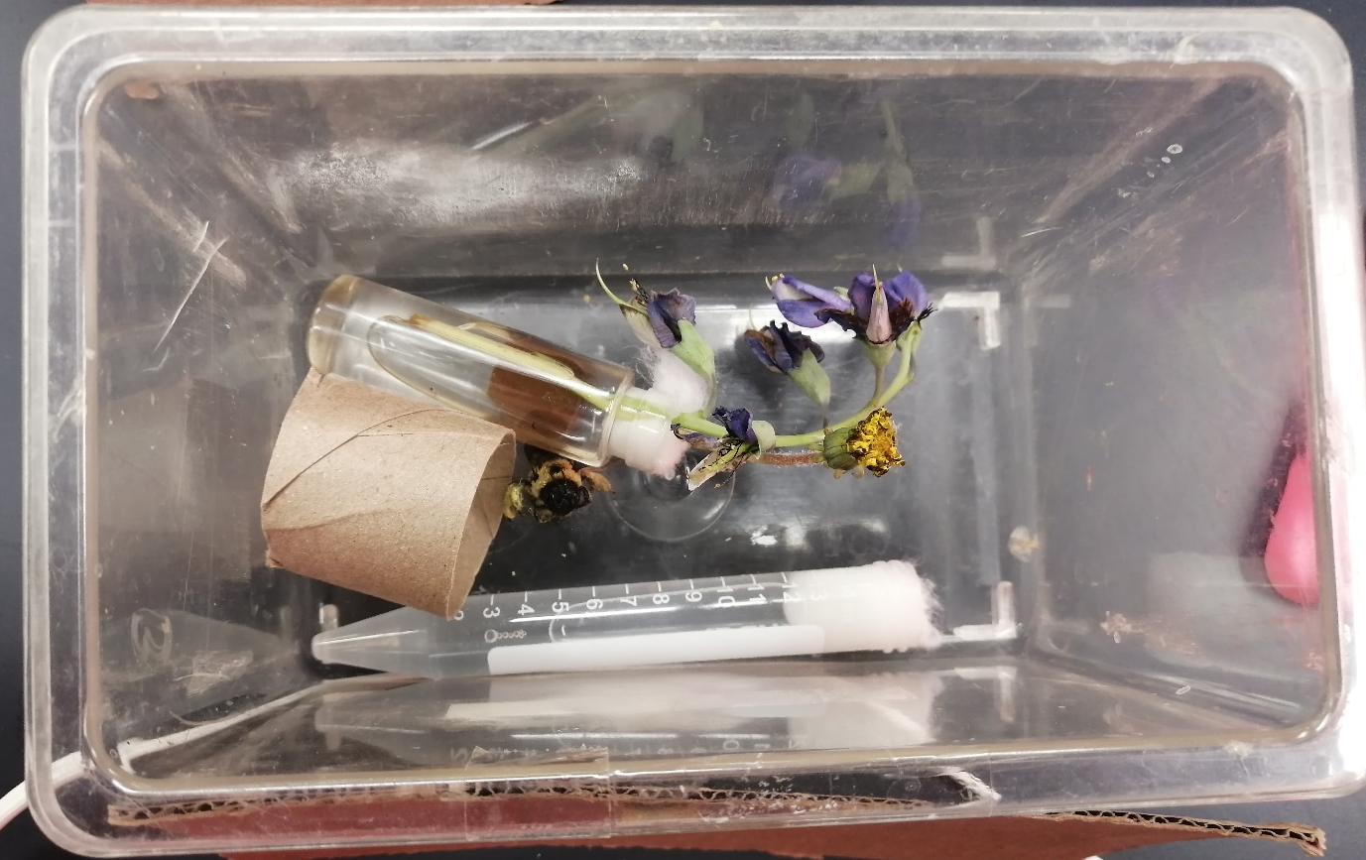Supplemental figure S1: Holding conditions for bees after methoprene treatment including, a bee, a cardboard tube for shelter, a tube of honey water stoppered with cotton for water, and flowers for food.

