Appendix 1
Soil moisture technique for calculating hydrological processes
An estimation of the actual hydrological process taking place in the study plain is made in this attempt using a soil moisture model. This model simulates the entire hydrological cycle, from precipitation to irrigation to evapotranspiration to plant water consumption to soil maintenance and moisture conditions to infiltration rate to horizontal flow rate in the soil to runoff from precipitation and irrigation return water. It takes into account climate factors like temperature, wind speed, sunshine hours, air humidity, location, and type of land use. Because it can precisely predict the amount of recharge from rainfall and irrigation water as well as the amount of river and aquifer interchange, the groundwater model was selected for the simulation. Numerous additional elements of the water cycle are also utilized.
The lower portion of this model's framework focuses on connections related to depth penetration in the secondary section of the soil (saturated zone), while the upper portion concentrates on equations and factors related to the surface and major soil profile. The saturated zone is simulated in this work using the MODFLOW model, and the results are fed back into the groundwater model via a dynamic connection with the surface water model. Soil moisture models were used in this experiment to replicate the top (unsaturated) zone.
The main water balance equation in this model is defined as follows:
(2) | 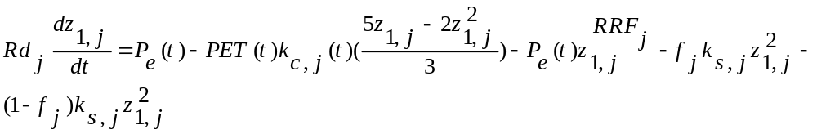
Where j denotes the number of each zone from the total N zones. Z_{1,j} represents the realtive storage relative to the total effective storage in the soil root zone in each month of the simulation and is determined numerically between zero and one. ${Rd}_{j}$ is the total effective water storage in the root zone (in mm) related to the zone j in the time t.
In the first part of the equation, $P_{e }(t)$ is the amount of total effective precipitation in the time $t$, which includes snow melting and calculated using the following equations:

(3) | 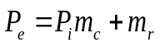
(4) | 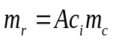
(5) | 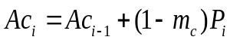
(6) | 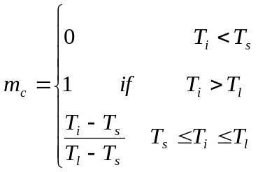
where:
$m_{c}$ is the snow melting factor. $T_{i}$ is the observed temperature recorded in the i_{th} month. $T_{l}$ and $T_{s}$ are the snow melting temperature and freezing temperature in the region respectively. $P_{j}$ is the total monthly rainfall recorded in the region is (mm).
In the second part of the equation, $PET$ stands for the amount of the potential evapotranspiration of the reference plant (mm) based on the Penman-Monteith method and $K_{c‚j}$ represents the crop coefficient related to each of plants in the region and various land uses.
In the third part of the above equation, ${RRF}_{j}$ is the runoff durability factor is in each month and for each land use. The more this factor increases, the amount of surface runoff decreases. The fourth and fifth parts of the above equation are respectively related to the internal flows of the unsaturated zone and the amount of deep infiltration into the saturated zone. In these parts, $K_{s‚j}$ represents the hydraulic conductivity of the root zone in saturated conditions (after rain or irrigation) in millimeters per month. $f_{j}$ is the partial conductivity coefficient that depends on the soil, land use and topographical conditions. The following equation calculates the sum of direct surface runoff and subsurface runoff due to internal flow in each area. This coefficient is between zero and one and expresses what portion of the water flow in the root zone in saturated conditions moves horizontally and what portion penetrates vertically.
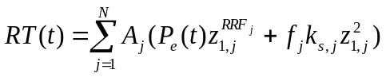 | (7)

$A_{j}$ is each region area.
The quantity of recharge to the aquifer is determined per volume unit per month in the case of the dynamic connection between surface and groundwater using the following equation.
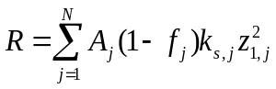 | (8)
The depth penetration rate in millimeters is computed from the following equation when the groundwater model is not utilized in place of the recharge parameter.
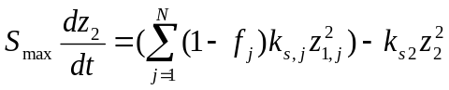 | (9)
The baseflow, which travels through the deep, saturated zone of the soil and toward the river, is represented by the second component of this equation. $Z_{2}$ is the relative water storage in the deep or secondary zone of the zone, which is defined as a part of the overall water holding capacity of the soil in the deep region, and $K_{z2 }$is the saturated conductivity of the soil deep zone in mm per month. A schematic representation of the performance of the soil moisture model in primary and secondary soil profiles to help understand the issue is presented in figure S1.

Figure (S1) provides a schematic representation of the performance of the soil moisture model in primary and secondary soil profiles to help understand the issue. As it is clear in this figure, in bucket 1, surface water modeling is done using the WEAP model, and the values of evaptranspiration, runoff and subsurface flow and groundwater recharge are calculated. In bucket 2, groundwater modeling and simulation of changes in the groundwater level are done using the MODFLOW model. Surface water and groundwater are always in exchange and interaction. To investigate their mutual effects, a coupled dynamic model is needed to simulate the movement of water in two saturated and unsaturated parts of the soil.
All effective components in surface water and groundwater models are present in the coupled model. At each monthly time interval, data, information and results flow between WEAP and MODFLOW. In the coupled model, values of depth infiltration into groundwater (recharge), withdrawal by demands (pumping), river water level and seepage from rivers are calculated by WEAP and sent as input to MODFLOW. Then, the simulation results in MODFLOW including groundwater level fluctuations, lateral flows between aquifers and surface water-groundwater exchange are returned to WEAP as input for recalculations. This feedback between WEAP and MODFLOW occurs at each computational time step.
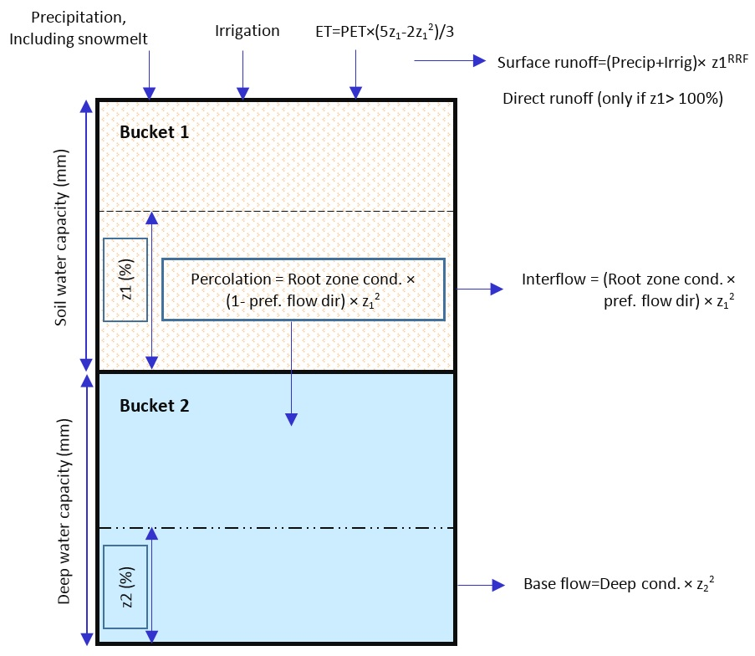
Figure S1- Schematic of soil moisture model components

Appendix 2
Verification of groundwater and surface water models in steady-state and transient-state
For calibrating the groundwater model in a steady state using data from 60 observation wells in Kermanshah Plain for the base month of October 2016. The model verification was carried out using the nonlinear regression method and MODFLOW. In this method, parameter estimation starts by assigning initial values to each parameter. In the iterations of parameter estimation, with the aim of reducing the difference between computational and observational values, the initial values change. In the calibration of the steady-state mode, hydraulic conductivity, river conductance, and general head boundaries (GHB) were optimized. After calibration, the root means square error (RMSE) was calculated by the model as 0.428 meters, meaning that overall in the plain, the difference between observational and computational data in piezometers is less than one meter and equals 428 millimeters. Figure S2 shows the calculated and observational level error at the piezometer locations at the end of verification in the steady-state model.
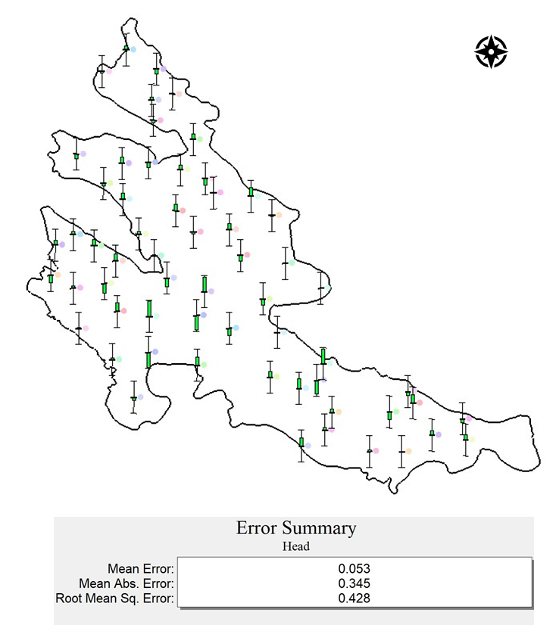
Figure S2. Calibration of the steady-state model and RMSE Value for the Entire Plain

After coding and linking the two groundwater and surface water models, the transient model was developed for a six-year period from October 2008 to September 2014. The first four years were considered for calibration, and the following two years were for validation.
In the surface water model (WEAP), soil moisture model coefficients including holding capacity, runoff factor, root zone conductivity, and root zone flow dispersion coefficient were optimized for the entire Kermanshah Plain. The average of these coefficients in the northern, central, and southern regions of Kermanshah Plain was calculated and presented in Table S1.

Table S1. Average soil moisture model calibration coefficients
Plain areas | Storage capacity (mm) | Runoff Resistance Factor | Root Zone Conductivity (mm/month) | Preferred Flow Direction
Northern | 45.29 | 2.35 | 1083 | 0.08
The middle | 54.39 | 2.98 | 991 | 0.08
South | 49.86 | 2.9 | 650 | 0.07

This study, to determine the ranges of hydraulic conductivity and specific yield coefficients in the aquifer area used groundwater level contour maps, land use, Thiessen polygons of piezometers, and soil maps of the region. The values of hydrodynamic coefficients reported at exploratory well locations were used as initial estimates. Then, during model calibration, the ranges and values of hydraulic conductivity and specific yield coefficients were adjusted. Thus, in the validation and calibration of the model, the values of aquifer hydrodynamic coefficients including hydraulic conductivity and specific yield were optimized. The optimal value of hydraulic conductivity ranges from 0.09 to 40 meters per day, and the specific yield coefficient ranges from 1 to 25 percent (Table S2 and Figure S3).

Table S2. Aquifer hydrodynamic coefficients for Kermanshah after model validation
Name | K(m/day) | Sy | Name | K(m/day) | Sy | Name | K(m/day) | Sy
LU1 | 1 | 0.12 | LU22 | 12 | 0.15 | LU43 | 0.25 | 0.015
LU2 | 2 | 0.12 | LU23 | 10 | 0.01 | LU44 | 4 | 0.25
LU3 | 5 | 0.23 | LU24 | 0.3 | 0.01 | LU45 | 18 | 0.01
LU4 | 1 | 0.25 | LU25 | 10 | 0.23 | LU46 | 1 | 0.02
LU5 | 6 | 0.25 | LU26 | 32 | 0.06 | LU47 | 0.12 | 0.15
LU6 | 15 | 0.25 | LU27 | 1.75 | 0.25 | LU48 | 9 | 0.15
LU7 | 2 | 0.175 | LU28 | 30 | 0.02 | LU49 | 25 | 0.135
LU8 | 1 | 0.09 | LU29 | 7 | 0.25 | LU50 | 23 | 0.03
LU9 | 7 | 0.03 | LU30 | 17 | 0.23 | LU51 | 3 | 0.08
LU10 | 1 | 0.02 | LU31 | 1 | 0.15 | LU52 | 18 | 0.11
LU11 | 20 | 0.23 | LU32 | 0.25 | 0.015 | LU53 | 30 | 0.075
LU12 | 30 | 0.23 | LU33 | 1 | 0.01 | LU54 | 1.185 | 0.15
LU13 | 22 | 0.21 | LU34 | 0.5 | 0.11 | LU55 | 0.12 | 0.146
LU14 | 7 | 0.02 | LU35 | 0.09 | 0.25 | LU56 | 2 | 0.15
LU15 | 5 | 0.02 | LU36 | 0.09 | 0.25 | LU57 | 25 | 0.15
LU16 | 0.5 | 0.02 | LU37 | 6 | 0.02 | LU58 | 0.415 | 0.115
LU17 | 6 | 0.15 | LU38 | 1 | 0.021 | LU59 | 0.155 | 0.095
LU18 | 15 | 0.15 | LU39 | 2 | 0.02 | LU59-1 | 40 | 0.125
LU19 | 15 | 0.215 | LU40 | 3 | 0.01 | LU60 | 1 | 0.095
LU20 | 30 | 0.01 | LU41 | 0.85 | 0.23 | LU60-1 | 40 | 0.125
LU21 | 10 | 0.165 | LU42 | 1 | 0.15

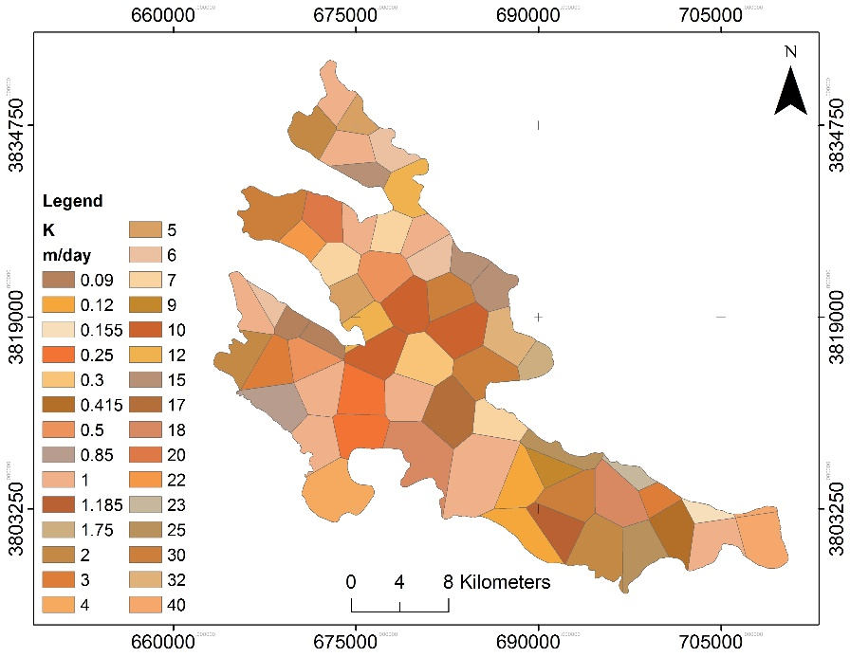
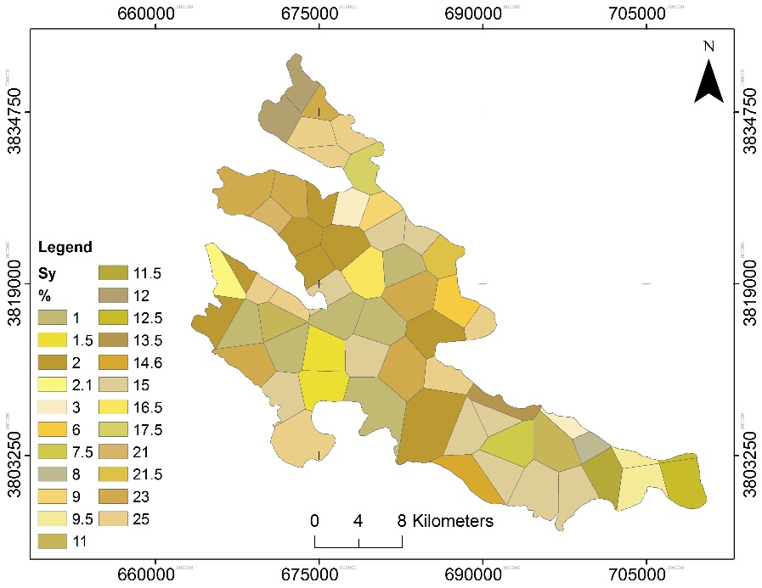
Figure S3. Map of hydrodynamic coefficients after recalibration and validation of the model in transient state

