Supplementary figure
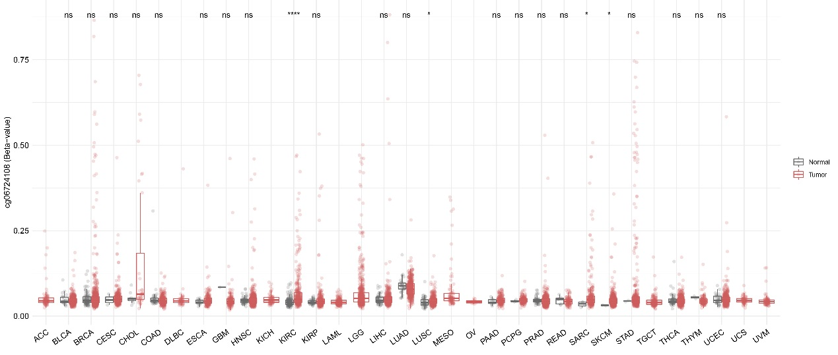Fig. S1 Abnormal expression of CBLL1(cg06724108) methylation in pan-cancerous tissues.
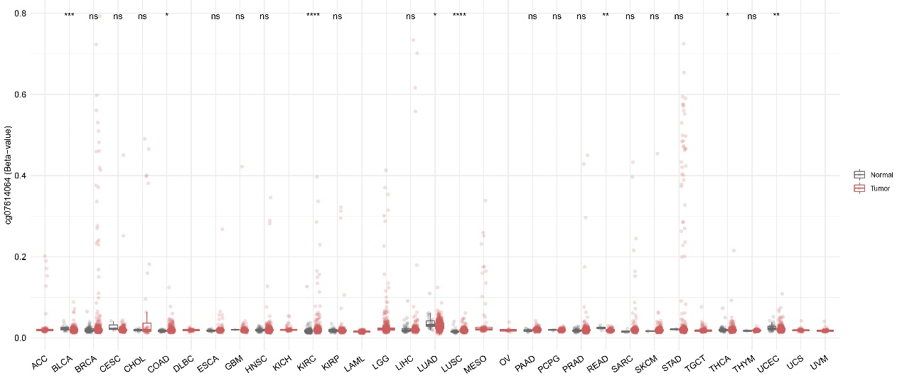Fig. S2Abnormal expression of CBLL1(cg07614064) methylation in pan-cancerous tissues.
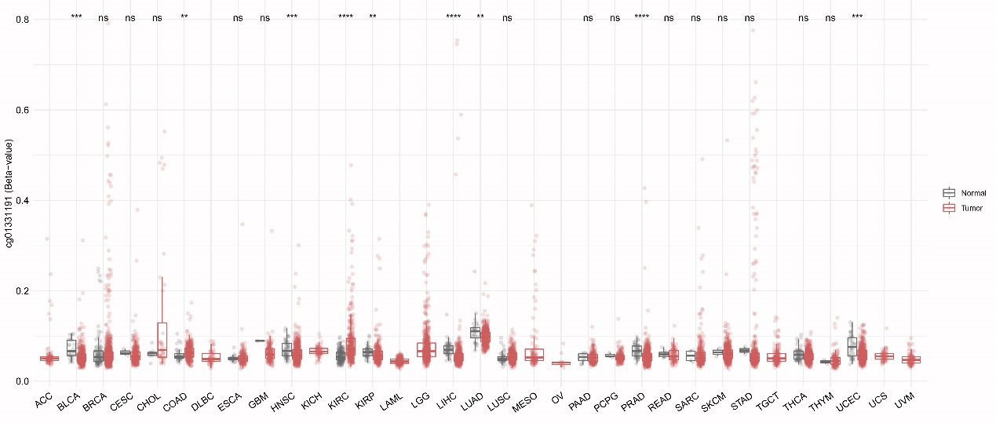
Fig. S3Abnormal expression of CBLL1(cg01331191) methylation in pan-cancerous tissues.
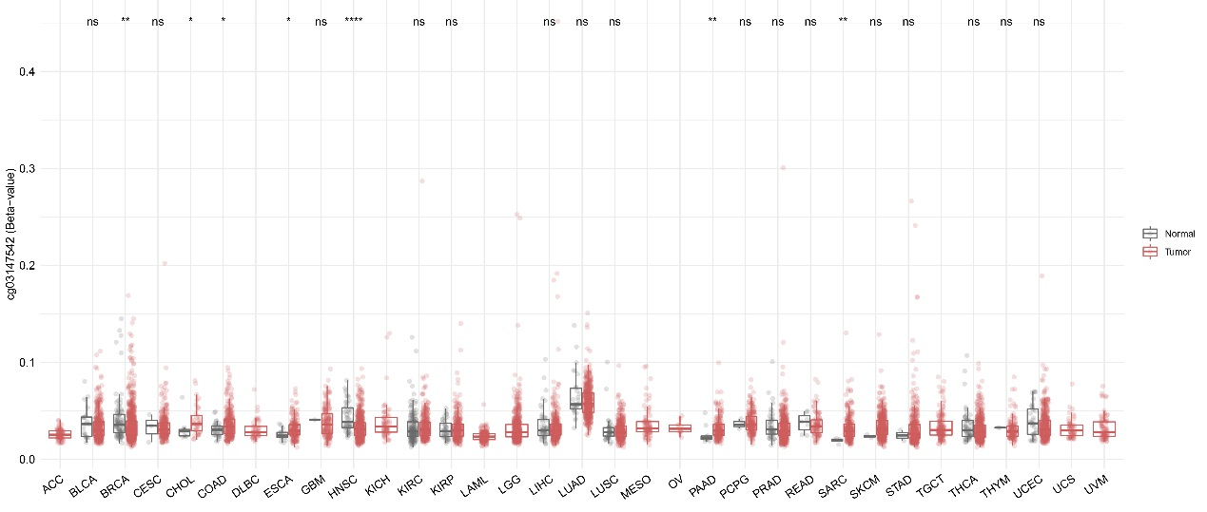
Fig. S4Abnormal expression of CBLL1(cg03147542) methylation in pan-cancerous tissues.
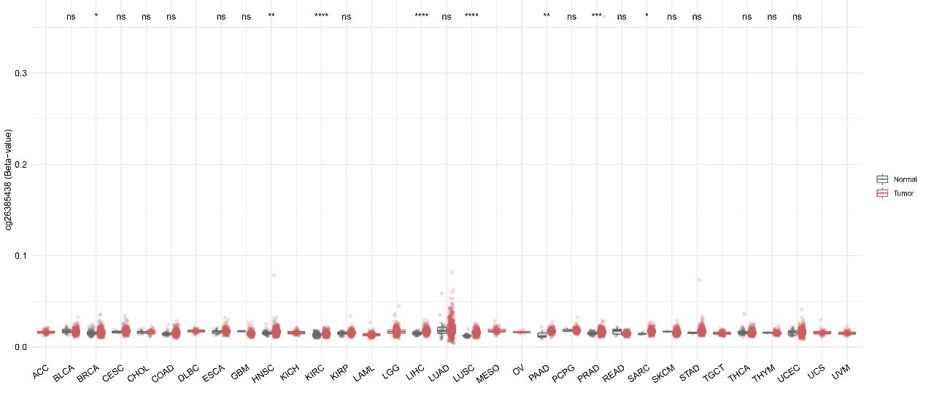Fig. S5Abnormal expression of CBLL1(cg26385438) methylation in pan-cancerous tissues.
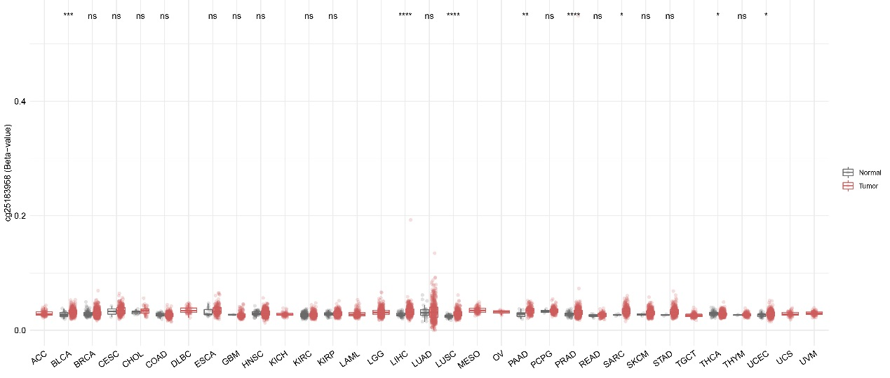
Fig. S6Abnormal expression of CBLL1(cg25183958) methylation in pan-cancerous tissues.
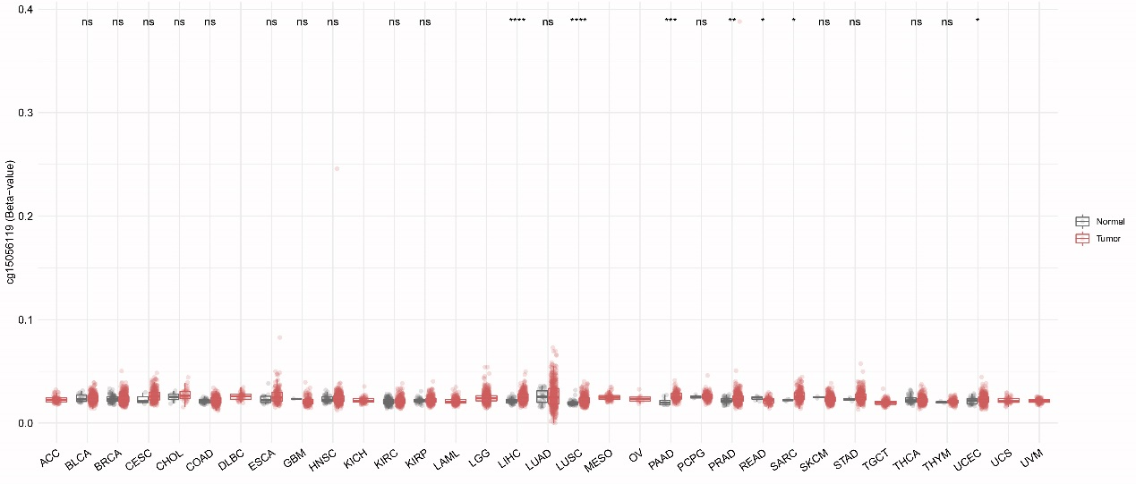
Fig. S7Abnormal expression of CBLL1(cg15056119) methylation in pan-cancerous tissues.
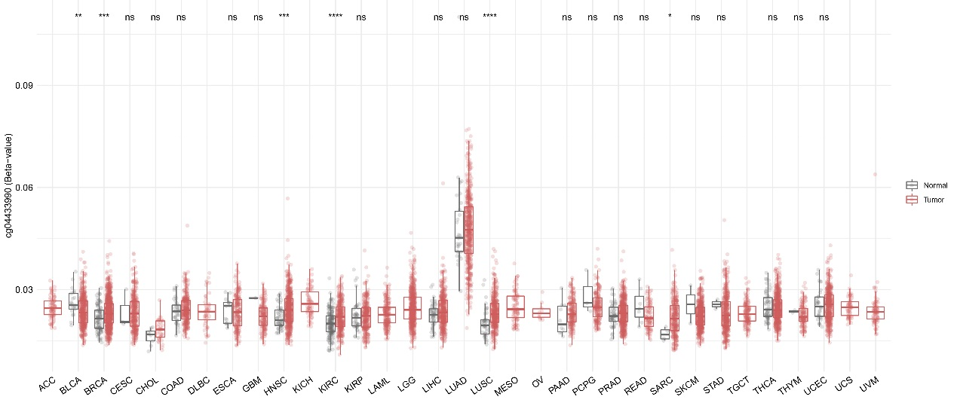
Fig. S8Abnormal expression of CBLL1(cg04433990) methylation in pan-cancerous tissues.
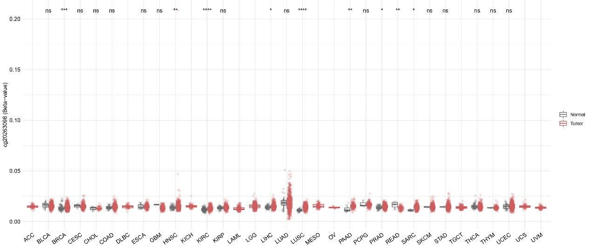Fig. S9Abnormal expression of CBLL1(cg20263098) methylation in pan-cancerous tissues.
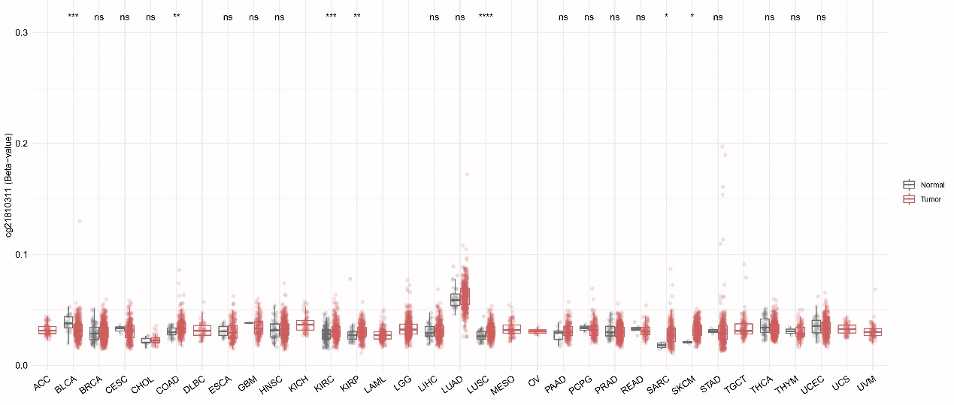Fig. S10Abnormal expression of CBLL1(cg21810311) methylation in pan-cancerous tissues.
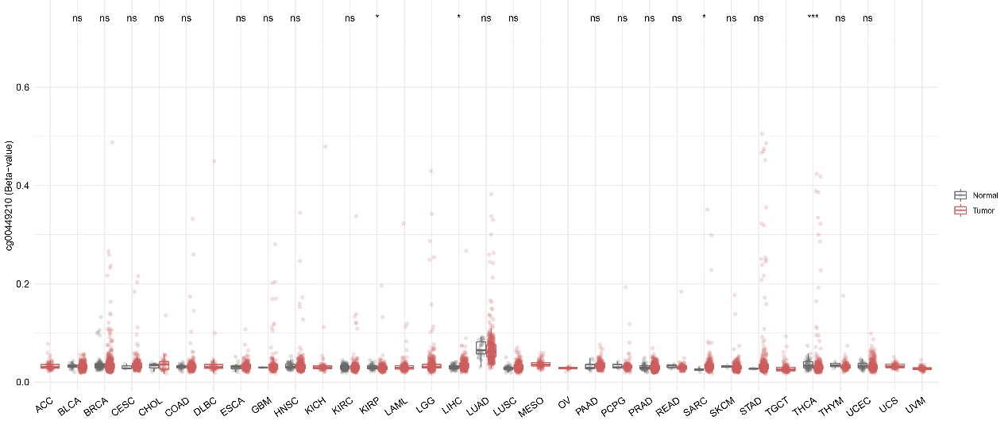Fig. S11Abnormal expression of CBLL1(cg00449210) methylation in pan-cancerous tissues.
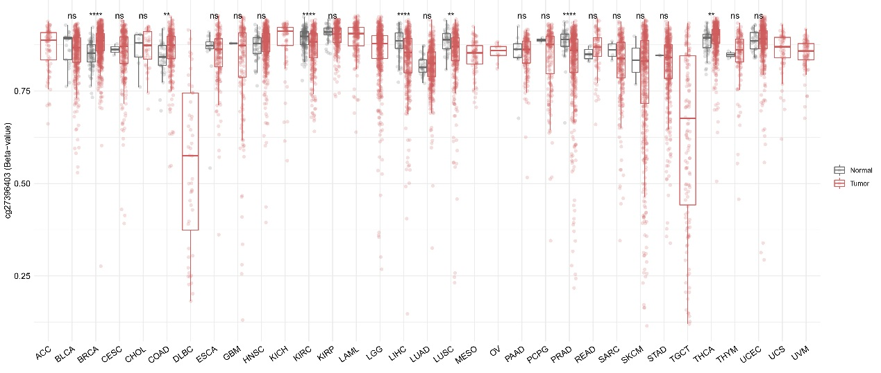Fig. S12Abnormal expression of CBLL1(cg27396403) methylation in pan-cancerous tissues.
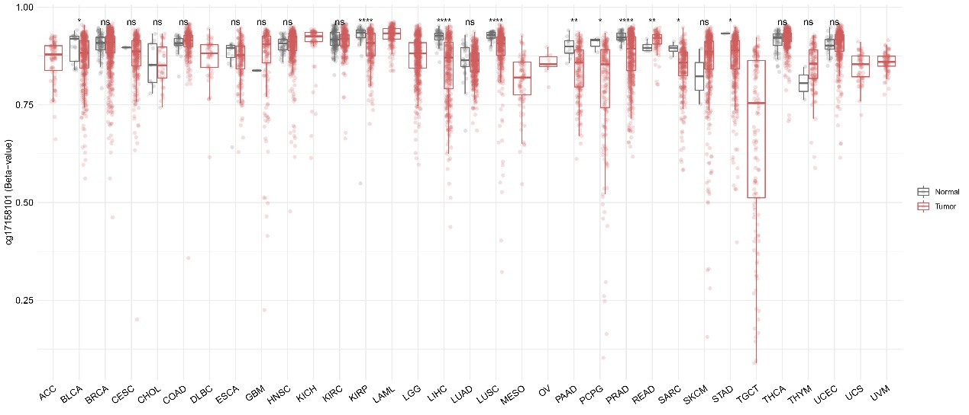Fig. S13 Abnormal expression of CBLL1(cg17158101) methylation in pan-cancerous tissues.
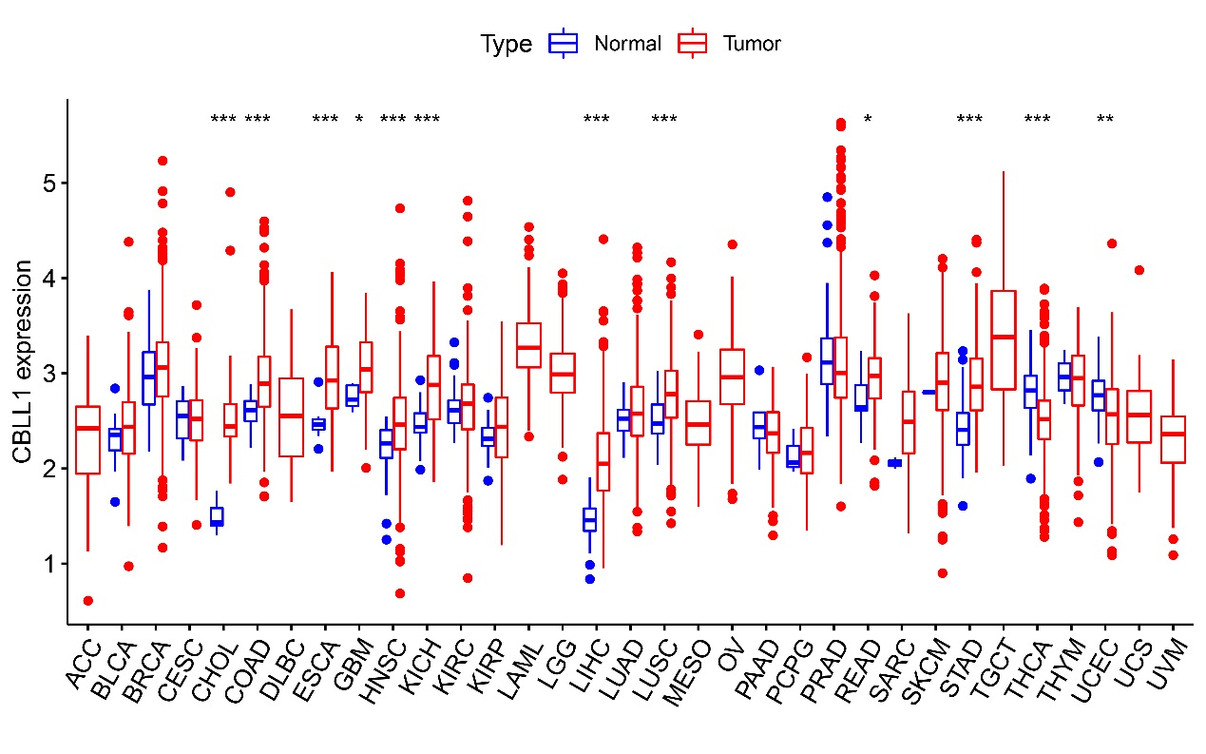Fig. S14 Abnormal expression of CBLL1 mRNA in pan-cancerous tissues by Box diagram.
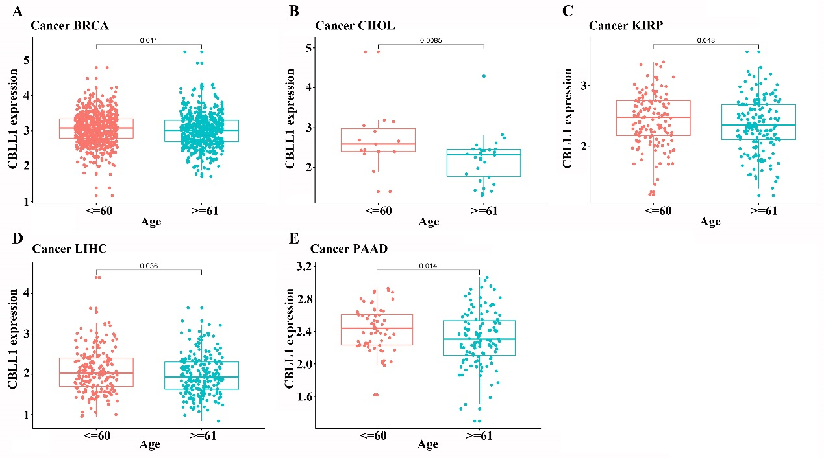Fig. S15 The expression of CBLL1 mRNA is related to the age of patients with pan-cancer（A）BRCA；（B）CHOL；（C）KIRP；（D）LIHC；（E）PAAD.
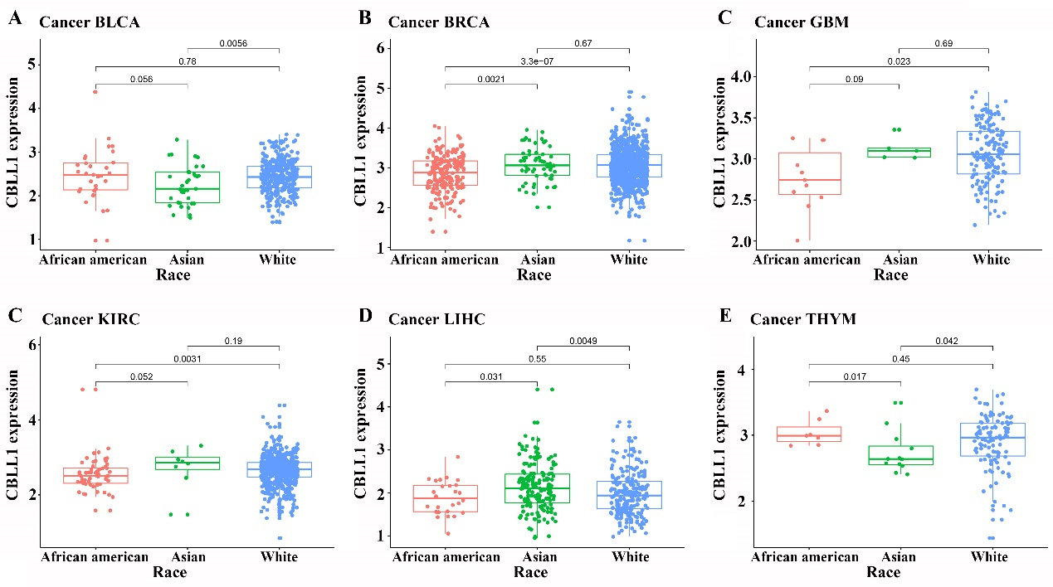Fig. S16 The expression of CBLL1mRNA is related to the race of patients with pan-cancer（A）BLCA；（B）BRCA；（C）GBM；（D）KIRC；（E）LIHC；（F）THYM.
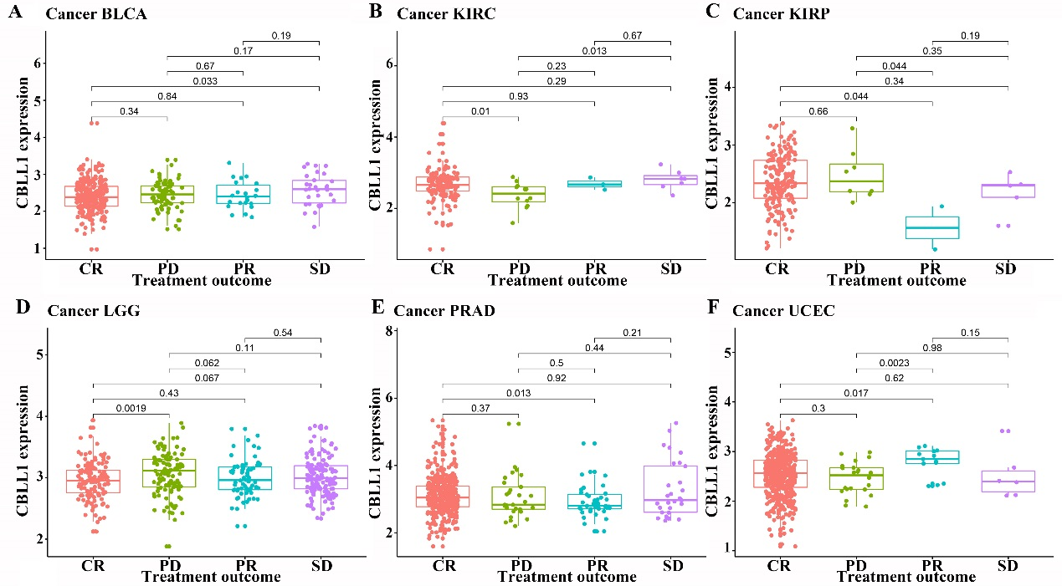Fig. S17 The expression of CBLL1mRNA is related to the therapeutic effect of patients with pan-cancer（A）BLCA；（B）KIRC；（C）KIRP；（D）LGG；（E）PRAD；（F）UCEC.
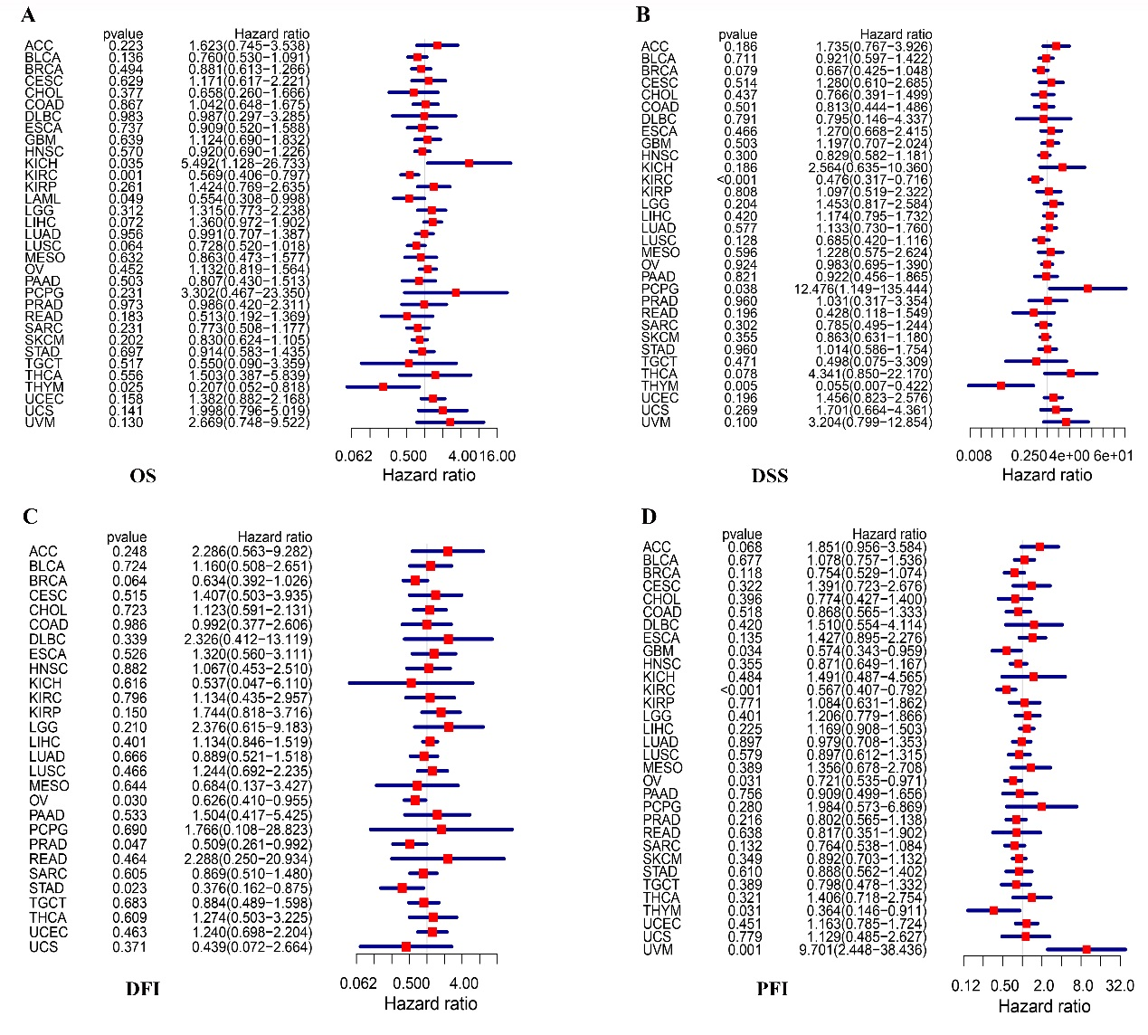Fig. S18 Univariate COX regression analysis showed that the expression of CBLL1 mRNA was related to the prognosis of pan-cancer （A）OS；（B）DSS；（C）DFI；（D）PFI.
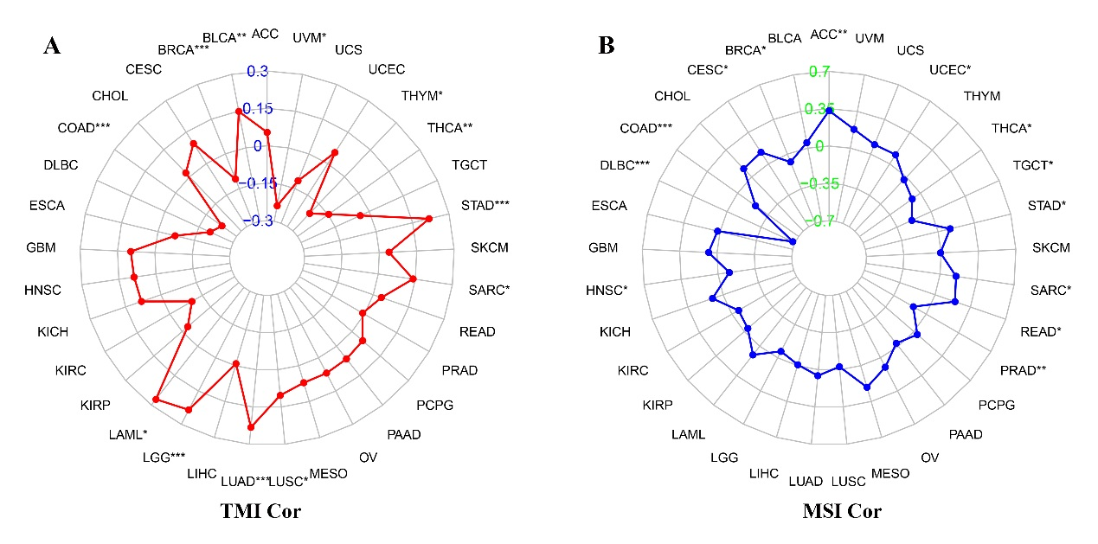Fig. S19 The expression level of CCBL1 is related to TMB and MSI in patients with pan-cancer. (A)TMB; (B)MSI.
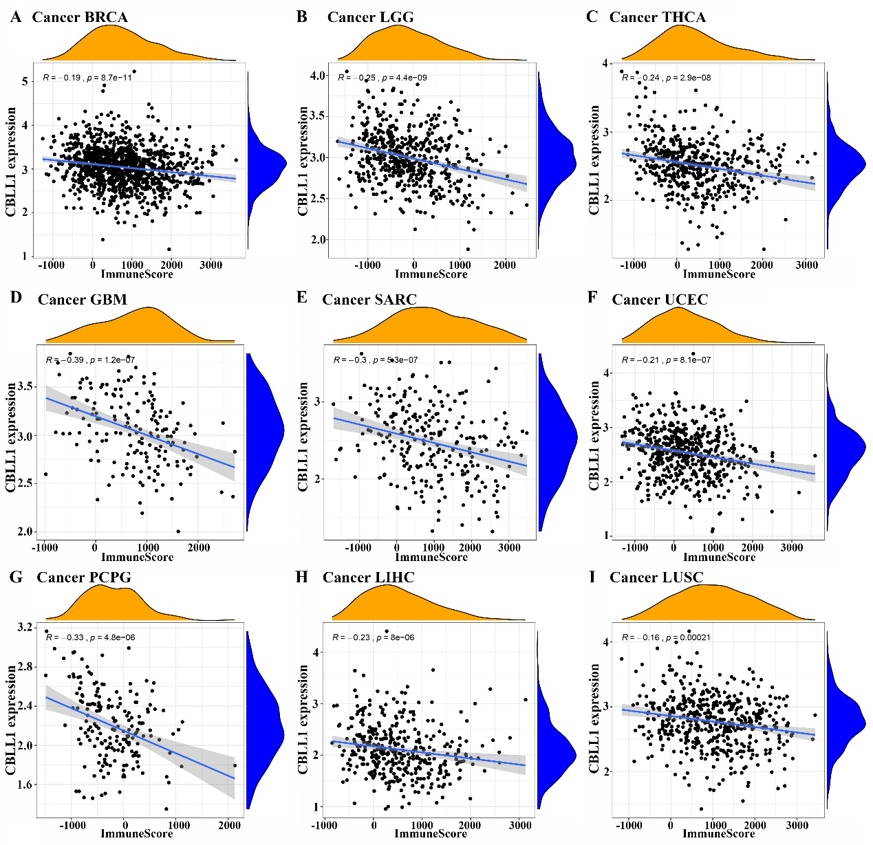
Fig. S20 The expression level of CBLL1 mRNA is related to the immune infiltration of pan-cancerous tumors.
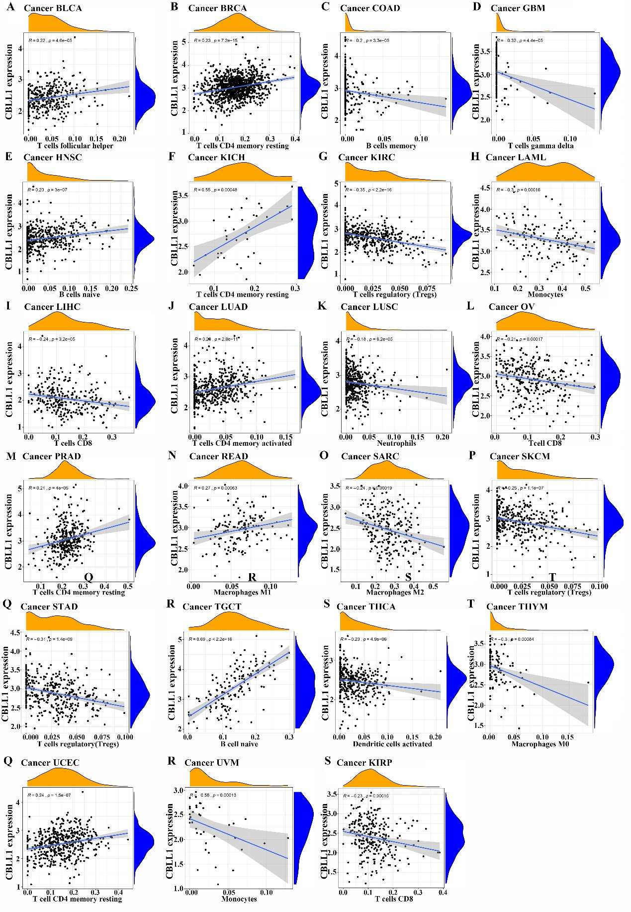Fig. S21 Correlation between CBLL1 mRNA expression level and pan-cancerous immune infiltrating cells.
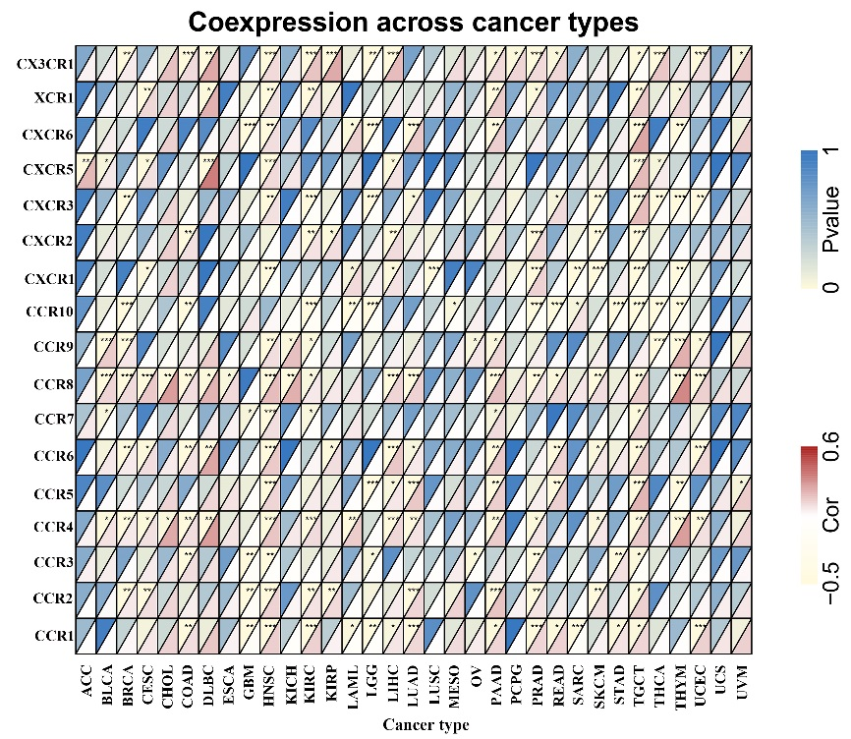Fig.S22 The expression level of CBLL1 is related to tumor immune receptors.
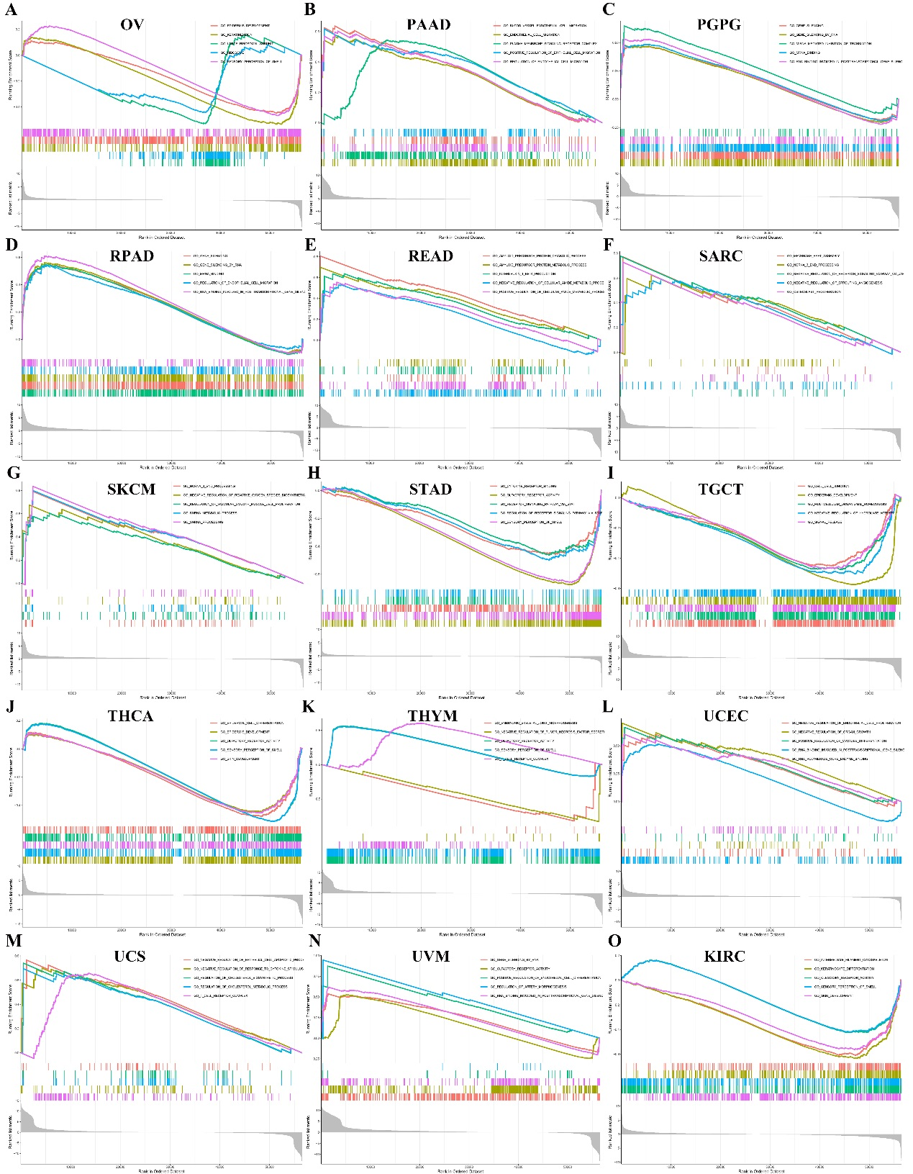Fig.S23 GSEA analysis of CBLL1 may be involved in the regulation of pan-cancer progression.

