Engineering Immunomodulatory and Osteoinductive Implant Surfaces via Mussel Adhesion-Mediated Ion Coordination and Molecular Clicking
Tao Wang^{1,} ²†, Jiaxiang Bai³†, Min Lu¹, Chenglong Huang², Dechun Geng³, Gang Chen², Lei Wang¹, Jin Qi¹*, Wenguo Cui¹*, and Lianfu Deng¹*
¹Department of Orthopaedics, Shanghai Key Laboratory for Prevention and Treatment of Bone and Joint Diseases, Shanghai Institute of Traumatology and Orthopaedics, Ruijin Hospital, Shanghai Jiao Tong University School of Medicine, 197 Ruijin 2nd Road, Shanghai 200025, P. R. China.
²Jiaxing Key Laboratory of Basic Research and Clinical Translation on Orthopedic Biomaterials, Department of Orthopaedics, The second Affiliated Hospital of Jiaxing University, 1518 North Huancheng Road, Jiaxing 314000, P. R. China.
³Department of Orthopaedics, The First Affiliated Hospital of Soochow University, 188 Shizi Street, Suzhou, Jiangsu 215006, P. R. China.
†These authors contributed equally to this work.
*Corresponding author. E-mail: jinjin838@hotmail.com (J. Qi); wgcui80@hotmail.com (W. Cui); lf_deng@126.com (L. Deng)

Figure S1. The molecular structures of (DOPA)₆-PEG₅-DBCO (A) and (2-Azido)-PEG₅-BMP-2 (B).

Figure S2. HPLC spectra of (DOPA)₆-PEG₅-DBCO (A) and (2-Azido)-PEG₅-BMP-2 (B) with purity (>95%).

Figure S3. (A) ALP staining and (B) Alizarin Red S staining of BM-MSCs cultured in osteogenic medium supplemented with rhBMP-2 or (2-Azido)-PEG₅-BMP-2.

Figure S4. SEM images of the different surfaces (TiO₂, DBCO-TiO₂, Zn, BMP-2 and Zn/BMP-2 groups).

Figure S5. Images of the BM-MSCs after immunofluorescent staining:(green: ALP; red: cytoskeleton and blue: nuclei) and (H) quantitative results.

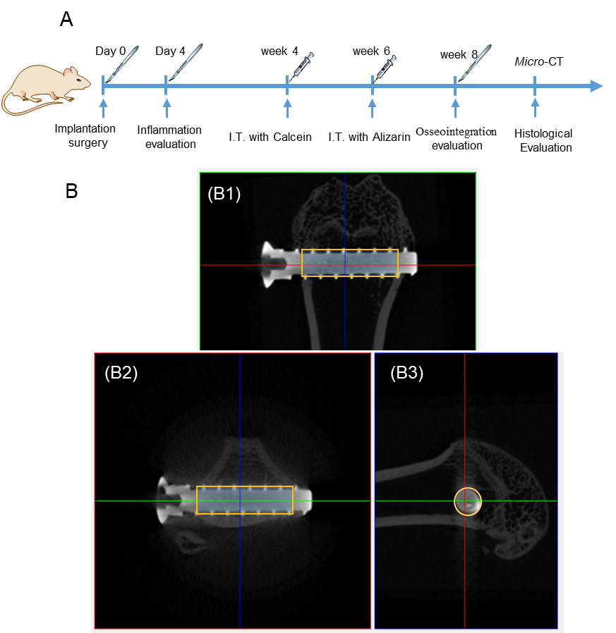
Figure S6. (A) Scheme for implantation surgery for in vivo tests and treatment process; (B) At each 3D location (shown as cross-hair), three orthogonal views are retrieved from the whole dataset and shown as (B1) coronal view (the normal images, in x-y plane), (B2) transaxial view (x-z plane), (B3) sagittal view (z-y plane).

Figure S7. Toxicities of samples on heart, liver, spleen, lung and kidney. H&E staining of the organ tissue sections (50 μm).

Table S1. Statistics of chemical compositions using XPS on the different surfaces (TiO₂, DBCO-TiO₂, Zn, BMP-2 and Zn/BMP-2 groups).
Element | Atomic (%)
Element | TiO₂ | DBCO-TiO₂ | Zn | BMP-2 | Zn/BMP-2
Ti | 16.71 | 12.65 | 10.0 | 9.83 | 9.15
C | 39.22 | 45.97 | 44.77 | 50.30 | 45.10
O | 43.20 | 37.15 | 39.73 | 33.10 | 38.29
N | 0.87 | 4.20 | 2.72 | 6.74 | 4.89
Zn | 0.00 | 0.00 | 2.78 | 0.03 | 2.57
N/Ti | 0.052 | 0.332 | 0.272 | 0.686 | 0.534
Zn/Ti | 0.000 | 0.000 | 0.278 | 0.003 | 0.281

Table S2. Primers used in the RT-PCR of BM-MSCs and BMMs cells.
Cell | Gene | Primers Sequence(5‘-3‘)
BM-MSCs | ALP | F: ATGCTCAGGACAGGATCAAA
BM-MSCs |  | R: CGGGACATAAGCGAGTTTCT
BM-MSCs | Col-1 | F: AGCTCGATACACAATGGCCT
BM-MSCs |  | R: CCTATGACTTCTGCGTCTGG
BM-MSCs | Runx-2 | F: ATCATTCAGTGACACCACCA
BM-MSCs |  | F: ATCATTCAGTGACACCACCA
BM-MSCs | OPN | F: GAACATGAAATGCTTCTTTCTCAG
BM-MSCs |  | R: TCCATGAAGCCACAAACTAAACTA
BM-MSCs | β-actin | F: CCTCTATGACAACACAGT
BM-MSCs |  | R: AGCCACCAATCCACACAG
RAW 264.7 | TNF-α | F: GTTCCCAAATGGCCTCCC
RAW 264.7 |  | R: GTGCTCCTCACCCACACCG
RAW 264.7 | IL-10 | F: CCCTTTGCTATGGTGTCCT
RAW 264.7 |  | R: GTGGCCAGTTTGTTATTTAT
RAW 264.7 | CD206 | F: TACTTGGACGGATAGATGGAGG
RAW 264.7 |  | R: CATAGAAAGGAATCCACGCAGT
RAW 264.7 | CCR7 | F: GGTGGCTCTCCTTGTCATTTTC
RAW 264.7 |  | F: GGTGGCTCTCCTTGTCATTTTC
RAW 264.7 | VEGF | F: AGGAGTACCCCGACGAGATAGA
RAW 264.7 |  | R: CACATCTGCTGTGCTGTAGGAA
RAW 264.7 | BMP-2 | F: AACGAGAAAAGCGTCAAGCC
RAW 264.7 |  | R: AGGTGCCACGATCCAGTCAT
RAW 264.7 | β-actin | F: GTGACGTTGACATCCGTAAAGA
RAW 264.7 |  | R: GTAACAGTCCGCCTAGAAGCAC

