Supplementary Information

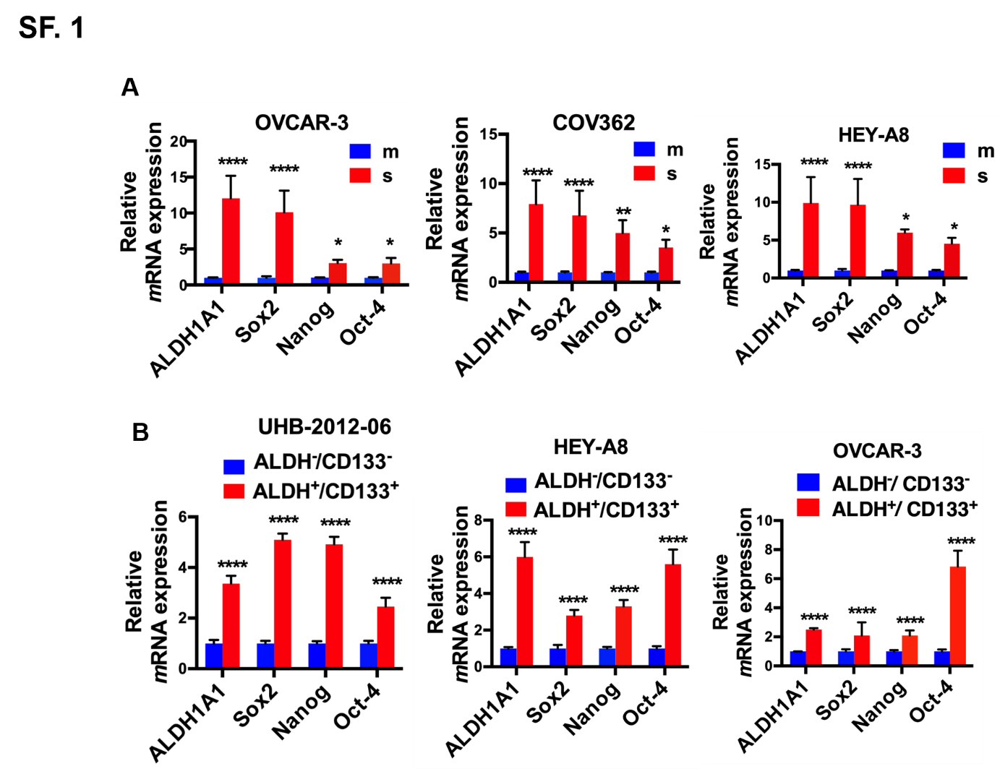
Figure S1: ILK promotes the CSC phenotype. A. ALDH1A1, Sox-2, Nanog, and Oct-4 mRNA levels measured by qRT-PCR in OVCAR-3, COV362, and HEY-A8 cells grown as monolayers (m) and spheroids (s) (N = 3; *P < 0.05, **P < 0.01, ****P < 0.0001). B. ALDH1A1, Sox-2, Nanog, and Oct-4 mRNA levels measured by qRT-PCR in ALDH⁺/CD133⁺ vs ALDH⁻/CD133⁻ isolated from UHB-2012-06, primary human OC cells, HEY-A8, and OVCAR-3 cells (N = 3; ****P < 0.0001).

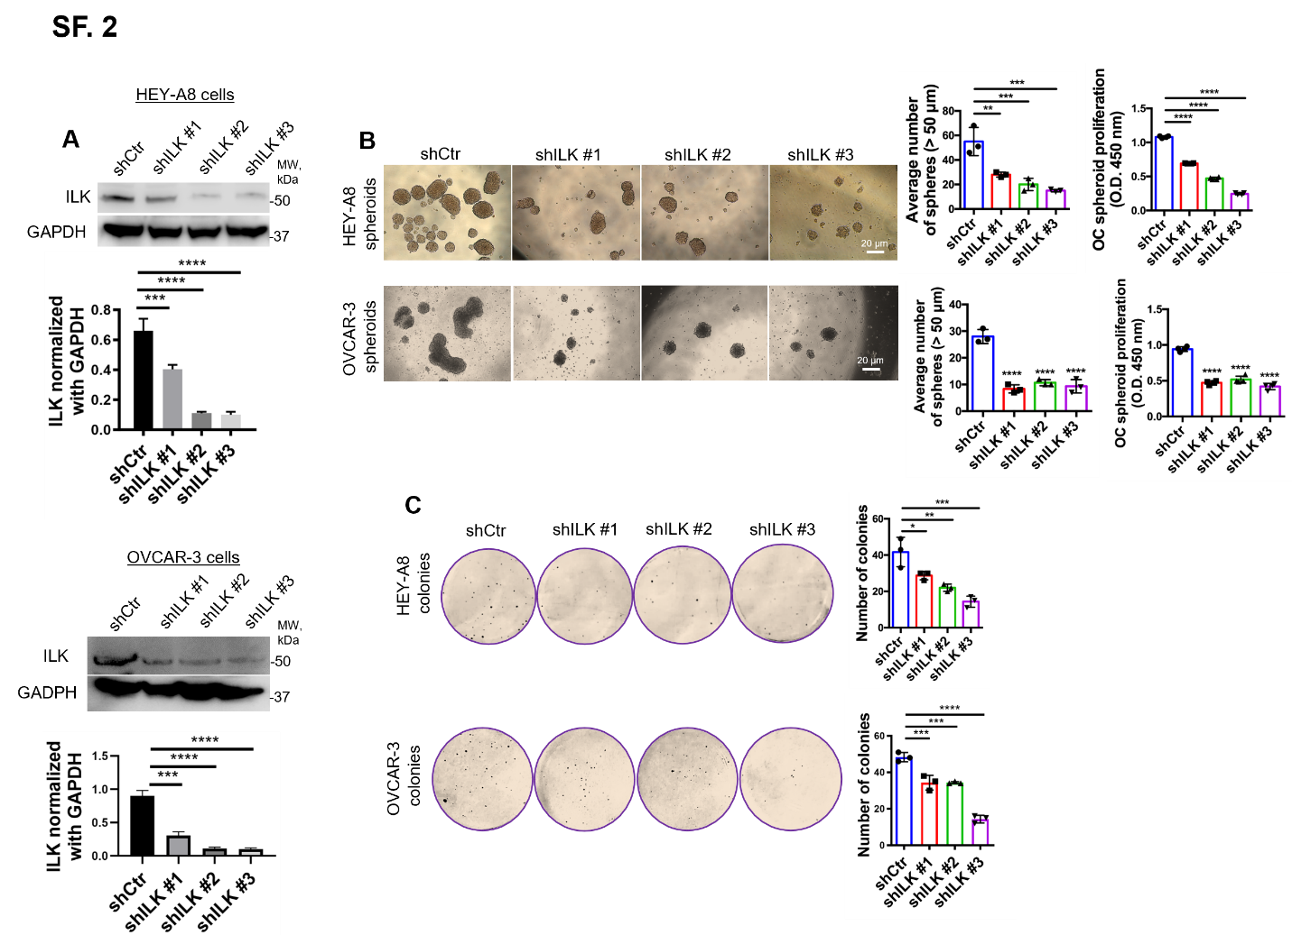
Figure S2: ILK inhibition blocks OC spheroid proliferation, colony formation, and tumor initiation. A. WB for ILK and GAPDH in shCtr and shILK (clones #1, #2, and #3) transduced HEY-A8 (upper panel) and OVCAR-3 cells (lower panel). B. Representative phase contrast images of shCtr and shILK (clones #1, #2, and #3) HEY-A8 and OVCAR-3 cells growing as spheroids (left panel). Average number of spheroid count (> 50 μm in diameter) (upper right panel) and CCK-8 quantification (lower right panel) of shCtr vs shILK (clones #1, #2, and #3) HEY-A8 and OVCAR-3 spheroids (N = 3; *P < 0.05, **P < 0.01, ***P < 0.001, ****P < 0.0001). C. Clonogenic assay of shCtr and shILK (clones #1, #2, and #3) HEY-A8 and OVCAR-3 cells (right panel). Representative images of single-cell clone proliferation, stained with crystal violet (left panel). Quantification of the results (left panel) (N = 3; *P < 0.05, **P < 0.01, ***P < 0.001P, ****P < 0.0001).
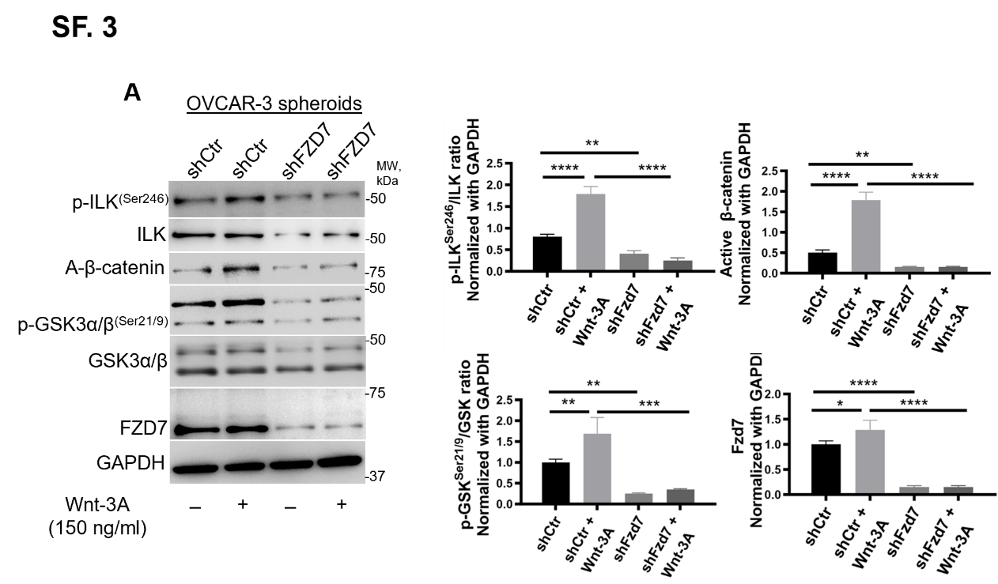
Figure S3: ILK inhibition blocks the OCSC phenotype and regulates Fzd7 expression. A. WB for A-β-catenin, p-GSK-3α/β^{Ser21/9}, GSK-3α/β, Fzd7, p-ILK^{Ser246}, ILK, and GAPDH in OVCAR-3 spheroids treated with or not with Wnt-3A (left panel). Densitometry quantifies A-β-catenin and Fzd7 expression levels and p-ILK^{Ser246}/ILK and p-GSK-3α/β^{Ser21/9}/GSK-3α/β ratio (right panel) (N = 3; *P < 0.05, **P < 0.01, ***P < 0.001, ****P < 0.0001).

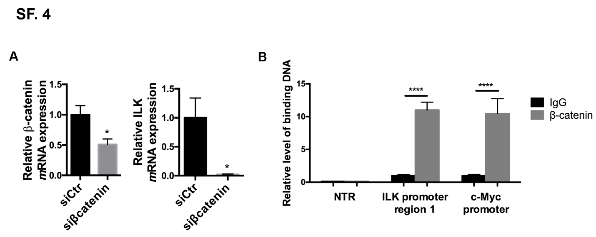
Figure S4: ILK is a β-catenin target gene. A. QRT-PCR for β-catenin and ILK mRNA expression levels in HEYA-8 cells transfected with scrambled or β-catenin targeting siRNA and grown as spheroids (N = 3; *P < 0.05). B. ChIP demonstrates that β-catenin/ TCF/LEF1 transcription complex binds the ILK promoter region. Immunoprecipitated chromatin with an antibody against β-catenin was used for quantitative PCR amplification. Primers flanking two predicted β-catenin/ TCF/LEF1-binding regions of the ILK promoter were used. Positive control was β-catenin antibody-immunoprecipitated chromatin amplified with primers for the c-Myc promoter, a known β-catenin target. Negative controls were chromatin immunoprecipitated with IgG and amplified with ILK promoter primers and chromatin immunoprecipitated with β-catenin antibody and amplified with primers to a region in the ILK promoter located upstream of the predicted β-catenin binding sites non-target region (NTR).

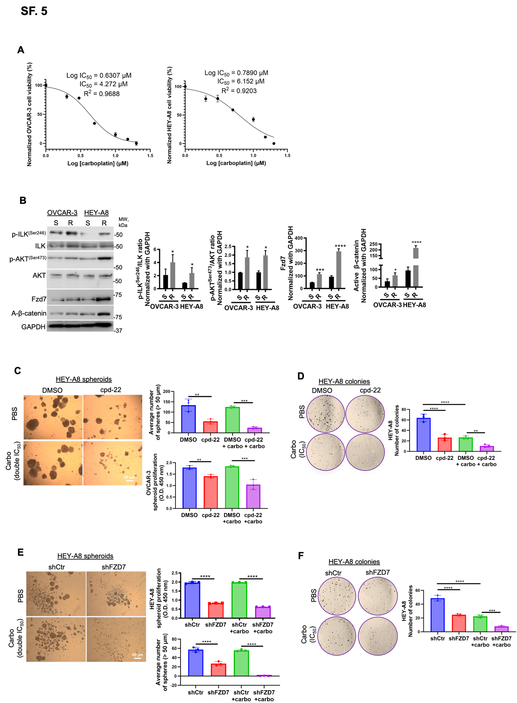
Figure S5: Fzd7-KD and ILK inhibition sensitize to platinum treatment. A. Survival curves for carboplatin tolerant OVCAR-3 (IC₅₀ = 4.272 µM, R² = 0.96; left panel) and HEY-A8 (IC₅₀ = 6.152 µM, R² = 0.92; right panel) cells. B. WB for Fzd7, p-ILK^{Ser246}, ILK, p-AKT^{Ser473}, AKT, and GAPDH in OVCAR-3 and HEY-A8 platinum (S) and platinum (R) (left panel). Densitometry quantifies Fzd7 expression and p-ILK^{Ser246}/ILK and p-AKT^{Ser473}/AKT ratio (right panel) (N = 3; *P < 0.05 and ***P < 0.001, ****P < 0.0001). C. Representative phase contrast images of HEY-A8 cells growing as spheroids and treated with DMSO, cpd-22, carboplatin (double IC₅₀) or combination (left panel). CCK-8 quantification (upper-left panel) and average number of spheroid count (> 50 μm in diameter) (lower-left panel) (N = 3; **P < 0.01, ****P < 0.0001). D. Clonogenic assay of HEY-A8 cells treated with DMSO, cpd-22, carboplatin (IC₅₀) or combination. Representative images of single-cell clone proliferation, stained with crystal violet (right panel) and quantification (left panel) (N = 3; **P < 0.01 and ****P < 0.0001). E. Representative phase contrast images of shCtr vs shFzd7 (clone #2) HEY-A8 cells growing as spheroids and treated with carboplatin (double IC₅₀) (right panel). CCK-8 quantification (upper-left panel) and average number of spheroid count (> 50 μm in diameter) (lower-left panel) (N = 3; ****P < 0.0001). F. Clonogenic assay of shCtr vs shFzd7 (clone #2) HEY-A8 cells treated with carboplatin (IC₅₀). Representative images of single-cell clone proliferation, stained with crystal violet (right panel) and quantification (left panel) (N=3; ***P < 0.001 and ****P < 0.0001).

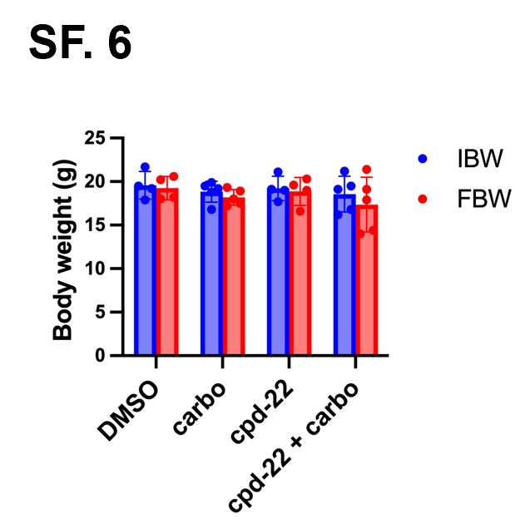
Figure S6: Body weight changes in NSG mice. Comparison between IBW and FBW in NSG mice treated with DMSO, carboplatin alone, cpd-22 alone, and/or combination (n = 5 per group). Data are shown as means ± s.e.m. Body weight was expressed in grams (g).

Supplementary Table S1: List of antibodies used for WB, IF, IHC, PLA.
ANTIBODIES | SOURCE | IDENTIFIER
AKT Rabbit | Cell Signaling | 9272
ALDH1A1 (5A11) Mouse | Invitrogen | MA5-15692
Bad (D24A9) Rabbit | Cell Signaling | 9239
Caspase 3 (D3R6Y) Rabbit | Cell Signaling | 14220
Cleaved Caspase 3 (Asp175) (5A1E) Rabbit | Cell Signaling | 9664
CD133 Recombinant APC antibody [EPR20980-104] | Abcam | ab252129
Frizzled 7 (4D9) Mouse | Santa Cruz Biotechnology | sc-293261
GAPDH (6C5) Mouse | Invitrogen | AM4300
GSK-3α/β (D75D3) Rabbit | Cell Signaling | 5676
ILK (3A9) Mouse | Invitrogen | MA5-17099
Non-phospho (Active) β-Catenin (Ser33/37/Thr41) Rabbit | Cell Signaling | 4270
Phospho-AKT (Ser473) Rabbit | Cell Signaling | 9271
Phospho-Bad (Ser136) (D25H8) Rabbit | Cell Signaling | 4366
Phospho-GSK-3α/β (Ser21/9) Rabbit | Cell Signaling | 9331
Phospho-ILK (Ser246) | Millipore-Sigma | AB1076
Mouse anti-rabbit IgG-HRP | Santa Cruz Biotechnology | sc-2357
Mouse control IgG | Santa Cruz Biotechnology | sc-515946
Mouse IgG₁ Alexa Fluor 488 | R&D Systems | IC002G
Mouse IgG₁ APC | R&D Systems | IC002A
Mouse IgG2a, κ APC Isotype Control; Clone #G155-178 | BD Biosciences | 555576
Rabbit control IgG | Santa Cruz Biotechnology | sc-2027
Rabbit IgG HRP | R&D Systems | HAF008
Rabbit IgG₁ Alexa Fluor 488 | R&D Systems | IC1051G
Rabbit IgG Alexa Fluor 647 | R&D Systems | IC1051R

Supplementary Table S2: Primers used for Quantitative RT-PCR
Gene | 5' Primer | 3' Primer
ALDH1A1 | AGGGGCAGCCATTTCTTCTCA | CACGGGCCTCCTCCACATT
β-catenin | GTTCGCCTTCACTATGGACTACC | GGACCCCTGCAGCTACTCTTT
c-Myc | CACCAGCAGCGACTCTGA | GATCCAGACTCTGACCTTTTGC
Fzd7 | GCCATCCCGCCGTGTCGTTCTCT | AGGGCGCGGTAGGGTAGGCAGTGG
ILK | TCAAACAGCTTAACTTCCTG | ATTTGGATGCGAGAAAATCC
Nanog | GATGCCTCACACGGAGACT | TTTGCGACACTCTTCTCTGC
Oct-4 | CTTCGCAAGCCCTCATTTC | GAGAAGGCGAAATCCGAAG
Sox2 | TGCTGCCTCTTTAAGACTAGGAC | CCTGGGGCTCAAACTTCTCT
18S | ACCCGTTGAACCCCATTCGTGA | GCCTCACTAAACCATCCAATCGG

Supplementary Table S3: Primers used for ChIP assay
Gene | 5' Primer | 3' Primer
ILK f1/r1 | CAGCGCTCCTCTGGAAGTC | GCCTGGCTAAACTCGATGGT
ILK upstream f/r | CATGCTCTCTTGTCCCAGGG | GACGTTGGGTCAGAGAGAGT
c-Myc | GTGAATACACGTTTGCGGGTTAC | AGAGACCCTTGTGAAAAAAACCG

Tumor grade | H-score < median | H-score > median | N
Serous low grade (stage IB-IIB) (FIGO) | 3 | 0 | 3
Serous high grade (stage IIIC) (FIGO) | 2 | 4 | 6
high grade (stage IV) (FIGO) | 1 | 5 | 6
Metastasis | 8 | 17 | 25
Normal ovary | 13 | 0 | 13
Normal fallopian tube | 5 | 0 | 5
All | 32 | 26 | 58
Controls/Blanks |  |  | 8
Missing/Torn/Rim/Artifact |  |  | 17
Fat |  |  | 1
SM Muscle |  |  | 2
Necrosis |  |  | 1
Stroma |  |  | 1
Total Cores |  |  | 88
Supplementary Table S4: p-ILK^{Ser246} expression in high grade serous ovarian tumors

(Median H-score = 0.137).

Supplementary Table S5: Expression levels of stemness associated genes in cpd-22 compared to control (DMSO) treated OVCAR-3 cells grown as spheroids fold-changes (≥2.0, n = 3) of downregulated genes.
RefSeq ID | Symbol | cpd-22 vs DMSO
NM_000051 | ATXN1 | -15.05755575
NM_000332 | AXL | -8.674227799
NM_002838 | SAV1 | -8.214037492
NM_032682 | FZD7 | -6.374486512
NM_002211 | JAG1 | -6.263738689
NM_030751 | ZEB2 | -5.53899926
NM_004827 | ALCAM | -5.50737858
NM_000116 | TGFBR1 | -5.067133595
NM_001699 | BMI1 | -4.757016711
NM_000210 | ITGB1 | -4.689551975
NM_015238 | YAP1 | -4.328181919
NM_001556 | CXCL8 | -4.320010749
NM_000689 | ATM | -3.853742897
NM_001627 | ALDH1A1 | -3.802971363
NM_000930 | PLAUR | -3.747200283
NM_002093 | HDAC1 | -3.641394425
NM_000610 | CHEK1 | -3.615716631
NM_002051 | GSK3B | -3.607434005
NM_001018016 | MYC | -3.55551124
NM_001775 | CD44 | -3.18734294
NM_017617 | NOTCH2 | -3.183730865
NM_000584 | ITGA2 | -3.144682918
NM_021818 | SIRT1 | -3.012940973
NM_002165 | IKBKB | -2.715820861
NM_002701 | PROM1 | -2.495132693
NM_006106 | ZEB1 | -2.424177898
NM_005985 | SOX2 | -2.345074826
NM_000222 | KITLG | -2.265580339
NM_005378 | NANOG | -2.192930996
NM_019074 | DNMT1 | -2.133446501

Tumor grade | H-score < median | H-score > median | N
Serous low grade (stage IB-IIB) (FIGO) | 3 | 0 | 3
Serous high grade (stage IIIC) (FIGO) | 2 | 4 | 6
high grade (stage IV) (FIGO) | 2 | 5 | 7
Metastasis | 10 | 15 | 25
Normal ovary | 13 | 0 | 13
Normal fallopian tube | 5 | 0 | 5
All | 35 | 24 | 59
Controls/Blanks |  |  | 8
Missing/Torn/Rim/Artifact |  |  | 16
Fat |  |  | 1
SM Muscle |  |  | 2
Necrosis |  |  | 1
Stroma |  |  | 1
Total Cores |  |  | 88
Supplementary Table S6: Fzd7 expression in high grade serous ovarian tumors

(Median H-score = 0.124).

