Supplemental Material 1
A Mathematical Explanation for Why Ratio-Based Isotopic Analyses are Commonly Misleading: Data Re-evaluations for Sr Isotopes
Abstract
Data from ⁸⁷Sr:⁸⁶Sr ratio studies spanning major investigative areas of Sr isotope research were re-evaluated to verify interpretive difficulties arising from ratio-related mathematical theory. Specifically, source evaluations rather than analyses of ratio-based expressions allow one to better 1) determine migration patterns and routes for ancient humans and animals, 2) define the dynamics of ⁸⁷Sr:⁸⁶Sr isotopic data within a watershed and 3) define Sr sources in a soil. The ⁸⁷Sr:⁸⁶Sr ratio changes associated with different times, locations or conditions do not necessarily reflect source changes. Migration researchers often mistakenly associate an observed ratio in an animal with a geographic source. Source ⁸⁷Sr:⁸⁶Sr ratios rather than observed ⁸⁷Sr:⁸⁶Sr ratios should be used. Sources for an animal for a specific time period must also be constant, but this is rarely confirmed. Using unknowingly confounded ⁸⁷Sr:⁸⁶Sr ratios or values calculated from these ratios are misleading. Traditional Keeling plots, other forms of mixing diagrams, or analyzing relationships between ⁸⁶Sr and ⁸⁷Sr concentrations or content should always be evaluated. Slopes for linear ⁸⁶Sr vs. ⁸⁷Sr relationships define constant sources. Derivatives (d⁸⁷Sr/d⁸⁶Sr) define changing sources. One would expect mathematical consequences of relying solely on ratio-based expressions apply to non-Sr mass isotope studies.
Keywords: derivatives; isotopic scaling; isotopic sources; Keeling plots; mixing diagrams

1 Introduction
Issues related to the use of ratios in scientific research (Atchley et al. 1976; Jackson et al. 1990; Packard and Boardman 1998; Jasienski and Bazzaz 1999; Isles 2020; Kratochvil and Fleger, 2009) have been ignored for decades (Jasienski and Bazzaz 1999; Righetti et al. 2007). In an introductory companion paper (Moots et al. 2024), we demonstrate that there is no reason to expect that isotopic ratios would somehow be immune to ratio problems that have been discussed in the literature for over 100 years. In many cases an isotopic ratio will be related to total isotope concentration (Moots et al. 2024). Isotopic researchers often assume an observed isotopic ratio reflects the source of a system, but this is often not true. Mathematical principles suggest that observed ratios in analyzed samples almost always differ from sources (Moots et al. 2024).
Keeling plots (Keeling 1958) and mixing diagrams (Goede et al. 1998; Montgomery et al. 2005; Li et al. 2005; Bentley 2006; Montgomery and Evans 2006) have been accepted approaches to identifying isotopic sources for over 60 years. However, purely mathematical concepts reveal that Keeling plots and isotopic mixing diagrams are indirect ways to calculate the slope and relative y-intercepts of linear denominator vs. numerator concentration isotope plots (Moots et al. 2024).
The only way a zero y-intercept for a linear denominator vs. numerator isotope function can mathematically occur is when sources and backgrounds are similar, which will produce flat mixing diagrams and constant isotopic ratios (Moots et al. 2024). Therefore, non-zero y-intercepts for linear denominator vs. numerator concentration plots are common, suggesting that isotopic ratios will often be related to their denominator or total elemental concentration (Moots et al. 2024). Non-linear relationships between denominator vs. numerator isotope concentrations affect how isotopic ratios change with increasing total element concentration in ways that are intuitively difficult to predict (Moots et al. 2024). However, derivatives (dnumerator isotope/ddenominator isotope) will define changing sources. Non-zero y-intercepts quantify relative backgrounds for linear and polynomial functions (Moots et al. 2024). Source evaluations (relatively rare in the isotopic literature even when total element concentrations are available) allow researchers to better understand and interpret isotopic studies and should always accompany isotopic ratio data.

2 Background and Motivation
This presentation builds on a mathematical explanation for why ratio-based isotopic data is commonly misleading. The simple theoretical concepts using ⁸⁷Sr:⁸⁶Sr ratios as an example (Moots et al. 2024) are supplemented here with five Sr isotope re-evaluations from the literature. Sr isotopes were used both to demonstrate mathematical principles in Moots et al. (2024) and in the first set of examples here, because ⁸⁷Sr:⁸⁶Sr ratios are less confusing than the delta notation used for other common isotopes.

3 Methods
We re-evaluate the following publications: (1) Montgomery and Evans (2006), (2) Horstwood et al. (2008), (3) Kowalik et al. (2023) and (4) Bailey et al. (1996). Publications (1)-(4) refer to studies on Sr sources in human teeth, migration possibilities for an ancient cow, migration possibilities for a European mammoth, and water Sr dynamics from a river inlet respectively. Another dataset, Whipkey et al. (2000) that deals with Sr sources in soil, is also presented. This is the original data that was modified to create the first artificial example (main text). For the Bailey et al. (1996) dataset an obvious outlier (shown in Figure S2a) was removed before analysis to eliminate a point statistically identified as having an excessive residual and excessive leverage.
Producing ⁸⁶Sr vs. ⁸⁷Sr plots were conducted as stated in the main text. The constant ⁸⁷Sr plus ⁸⁶Sr assumption is not perfect as portions of total isotope can change. Therefore, the three different assumptions discussed previously (main text) were evaluated with the Montgomery and Evans (2006) dataset. The generally accepted 1/total Sr mixing line estimate for the indigenous non-migrating group, which requires no assumptions, produces a source value of 0.709084, which is very close to the 1/⁸⁶Sr mixing line estimate for the constant ⁸⁶Sr plus ⁸⁷Sr assumption (0.709083) for the Montgomery and Evans (2006) dataset (Figure S1c). Both 1/total Sr and 1/⁸⁶Sr mixing lines y-intercepts are also very close to the ⁸⁶Sr vs. ⁸⁷Sr slope (0.709061) in Figure S1b. Furthermore, small differences in portion of total element for a given isotope are dwarfed by total element concentration effects. Therefore, the ⁸⁶Sr vs. ⁸⁷Sr slope, calculated with a constant ⁸⁷Sr plus ⁸⁶Sr portion assumption, which produces slope and y-intercept values intermediate to the other two assumptions is likely appropriate.

4 Data Re-evaluations
Isotopic datasets from Sr isotope studies (presented below) suggest that the theoretical concepts demonstrated with artificial ⁸⁷Sr:⁸⁶Sr ratio datasets and simulations (Moots et al. 2024) apply.

4.1 Studies 1), 2) and 3) Sr Sources Suggest Ancient Migration Patterns for Human Populations, Movements for an Ancient Bovine and a Prehistoric Mammoth.
Knowing how isotopic sources change within a landscape can help answer scientific questions regarding the sources, partitioning, or provenance of natural materials or organisms via their isotopic signatures (West et al. 2009; Bataille et al. 2020). Applications include resolving questions about migration, Earth's element cycles, human water use, climate, archaeological reconstructions, forensic science, and pollution (West et al. 2009; Bataille et al. 2020).
An isoscape is essentially a map of changing isotopic signatures that represents possible sources made from either geographic samples or mechanistic models (Bataille et al. 2020). Isoscapes for H, C, O, N, Sr and S isotopes have been created for many locations and applications (West et al. 2009; Bataille et al. 2020). Isoscape researchers often match observed isotopic ratios with similar source isotopic ratios for specific locations to define geographical relationships. For example, migration patterns over a lifetime for an Alaskan wooly mammoth (Mammuthus primigenius) that lived in Alaska17,000 years ago were derived from ⁸⁷Sr:⁸⁶Sr ratios in layers of a tusk that correspond to different animal ages (Wooller et al. 2021). Similarly, tooth enamel from the 5,000-year-old corpse of a prehistoric murdered human (The Ice Man) were analyzed for Sr, Pb, O and C isotopic ratios (Muller et al. 2003). Data suggest that this individual spent most of his life some distance from where the body was found (Muller et al. 2003). As explained below, however, without source analyses both mammoth and Ice Man reports are inconclusive.
An implicit assumption for determining geographic inferences from isotopic data is that observed isotopic ratios in animal or human tissues are related to sources. Without evaluations of total element (not conducted in the majority of isoscape-related research studies) true sources are often unknown. The observed ⁸⁷Sr:⁸⁶Sr ratio for mammoth tusk enamel or human and livestock teeth is likely a function of both geographic location and the total Sr in a sample. If total Sr concentrations are unknown one can only assume that observed ⁸⁷Sr:⁸⁶Sr ratios represent sources. Mathematically, this is unlikely (Moots et al. 2024). The dangers of assuming that observed isotopic ratios represent sources are demonstrated below (Figure S1a) for a human migration study during the time of Viking colonization of the Western Isles of Scotland (Montgomery and Evans 2006).
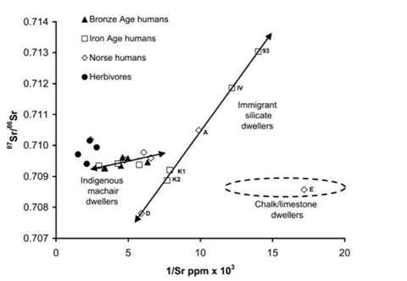
Figure S1a. The relationship between 1/total Sr and ⁸⁷Sr:⁸⁶Sr ratio for human tooth enamel for individuals from two villages in the Western Isles of Scotland spanning the time of Viking colonization of the islands. This figure is an exact copy of Figure 8.7 in Montgomery and Evans (2006). Different linear mixing line equations with statistically different slopes (p < 0.05) describe the villages suggesting that backgrounds differ. The statistically different y-intercepts (p < 0.05) defining the Sr source ratio for the two villages are 0.70908 and 0.70397 for the Indigenous Machair and Immigrant Silicate dwellers respectively.
-
Two different linear mixing line equations with statistically different slopes (p < 0.05) describe the two villages (Figure S1a), suggesting backgrounds differ. Confidence levels (95%) for the two y-intercepts do not overlap. The statistically significant y-intercepts (p < 0.05) suggest Immigrant Silicate and Indigenous Machair dwellers have different Sr sources. Indigenous Machair dwellers have a source of 0.7098 (close to modern seawater). The Immigrant Silicate dwellers source of 0.70397 reflects a low ⁸⁷Sr:⁸⁶Sr ratio source from igneous rock with much more silica. In this example, a constant source (implyied by a linear ⁸⁶Sr vs. ⁸⁷Sr relationship) that produces linear mixing lines adequately explains the results. Linear ⁸⁶Sr vs. ⁸⁷Sr relationsthips for various assumptions (as discussed above) are shown in Figure S1b.
The relatively flat mixing line for Indigenous Machair dwellers (Figure S1a) suggests that backgrounds and sources are similar, as expected, for long-term stationary residents at an ocean-influenced calcareous site with ⁸⁷Sr:⁸⁶Sr ratios that approximate seawater (0.7091). Similarly, the herbivores at the same site have an average ⁸⁷Sr:⁸⁶Sr ratio that approximates seawater. The source for herbivores, however, cannot be accurately determined because there are too few points to define an accurate mixing line.
Montgomery and Evans (2006) are correct. Resolving archaeological populations with strontium mixing diagrams is required to define sources. Without a mixing diagram analysis, there would be little to report other than the mean ⁸⁷Sr:⁸⁶Sr ratios are similar for both populations with Immigrant Silicate dwellers having more variability. Researchers could then only match the similar observed ratios for the two villages with known ⁸⁷Sr:⁸⁶Sr ratios at specific locations (as done in the mammoth study above). Results would wrongly suggest that residents of both villages originated from the same location. Observed ratios usually do not represent a source.
The y-intercepts for the equations for the modified y-intercept corrected mixing diagram for the two groups of individuals (data not shown) match the slopes for ⁸⁶Sr vs. ⁸⁷Sr linear equations for the two groups shown in Figure S1b. These y-intercepts also match the mixing lines (1/⁸⁶Sr vs. observed ⁸⁷Sr:⁸⁶Sr ratio) shown in Figure S1c. Any of the proposed methods for dealing with confounded ratios for constant source systems described in the main text (denominator vs. numerator slopes, traditional mixing diagrams, 1/total denominator isotope mixing diagrams, and average y-intercept corrected values) provide the same interpretation. Derivative approaches were not applied since denominator vs. numerator functions were linear (x² term in polynomial regression not statistically significant p = 0.639). The ⁸⁷Sr:⁸⁶Sr ratios of sources is far more informative than simple observed ⁸⁷Sr:⁸⁶Sr ratios.
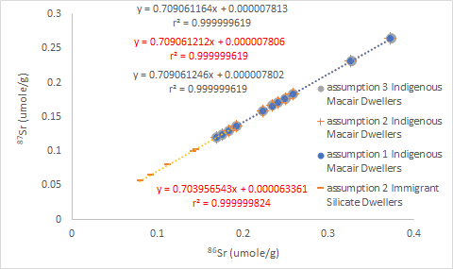
Figure S1b. The relationship between ⁸⁶Sr and ⁸⁷Sr for human tooth enamel from two villages in the Western Isles of Scotland spanning the time of Viking colonization of the islands. Calculating ⁸⁶Sr and ⁸⁷Sr regression equations requires some assumptions since total Sr consists of the sum of four unknown isotope concentrations. Regression lines for three different assumptions were evaluated for the Immigrant Silicate Dwellers (top three equations) using values for the SRM 987 Strontium Carbonate standard: (1) ⁸⁶Sr remains constant and is equal to the standard value of 9.8566%, (2) The sum of ⁸⁶Sr and ⁸⁷Sr remains constant and is equal to the standard value of 9.8566% +7.0015%, and (3) ⁸⁷Sr remains constant and is equal to the standard value of 7.0015%. All three approaches produce similar results. Assumption 2 values (in red) have slopes and y-intercepts with values between the other two assumptions. Data after Montgomery and Evans (2006).
-
The 1/⁸⁶Sr vs. vs. ⁸⁷Sr:⁸⁶Sr ratio form of mixing lines shown in Figure S1c, confirm the results presented by the original authors in Figure S1a. Differing y-intercepts suggest different sources for the two populations (0.7098 and 0.70399). These source estimates approximate slope estimates in Figure S1b for the Indigenous Machair and Immigrant Silicate Dwellers respectively. Mixing plot slopes are statistically different (p < 0.0001), suggesting different backgrounds (the flatter the mixing line, the smaller the difference between source and background).
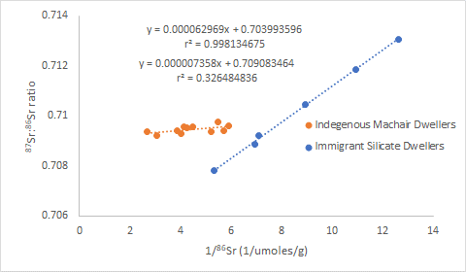
Figure S1c. Mixing diagram for 1/⁸⁶Sr vs. ⁸⁷Sr:⁸⁶Sr ratio for individuals from two villages in the Western Isles of Scotland spanning the time of Viking colonization of the islands. The original authors suggest that points occur in two very different biospheres which allows the differentiation of the two groups even though ⁸⁷Sr:⁸⁶Sr ratio values overlap. Slopes for these alternate forms of mixing lines approximate the original ⁸⁶Sr vs. ⁸⁷Sr positive y-intercepts. The y-intercepts approximate the original ⁸⁶Sr vs. ⁸⁷Sr slopes. Data after Montgomery and Evans (2006).
-
In another migration-related example, ⁸⁷Sr:⁸⁶Sr ratios in the third molar in an ancient bovine were evaluated at various distances from cusp to cervix (Horstwood et al. 2008). The ⁸⁷Sr:⁸⁶Sr ratios in the tooth are much higher than the limestone source (0.7084) where the tooth was buried and significantly increase from 0.7158 to 0.7885 from cusp to cervix (Horstwood et al. 2008). The authors suggest the change from cusp to cervix is due to differences in diet that occurred as the tooth developed. The direction of change is opposite to what might be expected if the animal moved from a high ⁸⁷Sr:⁸⁶Sr source ratio to a lower one. Therefore, the authors also suggest that the animal was likely slaughtered soon after moving to the low ⁸⁷Sr:⁸⁶Sr source before any tooth changes could occur. We agree with the slaughter soon after arrival conclusion but suspect that there was not a change in diet as the tooth formed.
A source analysis for the bovine tooth (data not shown) resolves conflicting information. The ⁸⁶Sr vs. ⁸⁷Sr function is linear with no detectable curvature (x² term p = 0.527). The slope (0.7244) of this function defines a constant source. A simple 1/total Sr vs. ⁸⁷Sr:⁸⁶Sr ratio mixing diagram is also linear and defines a similar source (0.7242). Both analyses suggest the animal was exposed to a constant source during tooth growth. Variation in ⁸⁷Sr:⁸⁶Sr ratio from cusp to cervix is entirely explained by differences in total Sr. There was likely no change in diet as the tooth developed. Once again, one cannot assume that changing ⁸⁷Sr:⁸⁶Sr ratios are related to changing sources. When identifying whether an individual or population resided at a specific location, it is also important to establish that isotopic source ratios are constant for a period of interest. Otherwise, it will be impossible to link changing source ratios derived from tissues in a migrating subject(s) with a geographic location. This is emphasized in a re-evaluation of a migration study where Kowalik et al. (2023) used data from a fossilized European mammoth tooth to support back and forth migrations (250 to 400 km). They suggest the mammoth moved from Southern Poland (low ⁸⁷Sr:⁸⁶Sr ratio) in winter to the Polish midlands (higher total Sr with higher ⁸⁷Sr:⁸⁶Sr ratio) each summer over a ten-year period.
Figure S1d shows the seasonal patterns for ⁸⁷Sr:⁸⁶Sr ratio and total Sr for positions between cusp and cervix on a fossilized mammoth tooth (Kowalik et al. 2023). The ⁸⁷Sr:⁸⁶Sr peak for the last year in Figure S1d starts earlier than the total Sr peak, thus this year, was not used in the analyses presented below. We have added red (~mid-summer) and grey (~January) boxes to the authors original figure to delineate time periods with ⁸⁷Sr:⁸⁶Sr peaks and troughs.
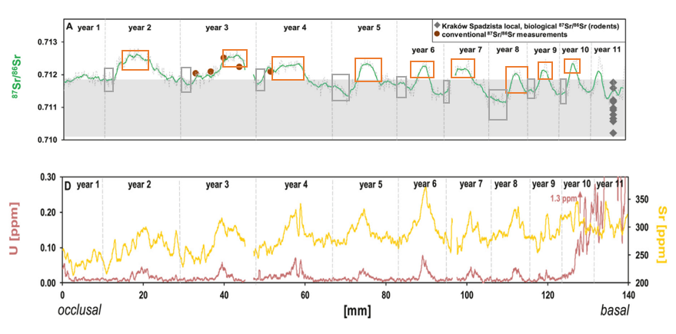
Figure S1d. Laser ablation MC ICPMS measurements of the ⁸⁷Sr:⁸⁶Sr ratio (top) and Sr and U concentrations (bottom) versus the distance along the occlusal to basal transect of a fossil mammoth tooth. The ⁸⁷Sr:⁸⁶Sr data were smoothed using a moving average with a period of 10. Typical 2SE (standard error) uncertainty of the smoothed data is 0.015%. The brown dots (top) indicate the measured ⁸⁷Sr:⁸⁶Sr values obtained via solution-based micro-sampled Sr isotope analysis of enamels. The vertical grey dashed lines bracket yearly segments determined by histological measurements. The local bioavailable Sr-isotopic signature for the Krakow Spadzista site is indicated by green diamonds and the light grey box across all time periods. We have added red (~mid-summer) and grey (~January) boxes to the authors original figure to delineate time periods with ⁸⁷Sr:⁸⁶Sr peaks and troughs. The ⁸⁷Sr:⁸⁶Sr peak for the last year starts earlier than the total Sr peak. Therefore, final year data was not used in the analyses presented below. Data from Figure 4 in Kowalik et al. 2023.
-
We have been unable to obtain the original data that would allow a pairing of ⁸⁷Sr:⁸⁶Sr ratio data with total Sr levels. Therefore, an alternate analysis is described below. Figures S1e and f show total Sr and ⁸⁷Sr:⁸⁶Sr ratio peak, trough and left and right shoulder points that were digitally extracted from Figure S1d. Both total Sr (Figure S1e) and ⁸⁷Sr:⁸⁶Sr ratio (Figure S1f) are plotted versus the distance along an occlusal to basal transect of the fossil tooth.
As was the case for the ancient bovine tooth, total Sr is variable suggesting that ⁸⁷Sr:⁸⁶Sr ratios will be a function of both total Sr and possible changing diets associated with changes in geographic locations. Within a given year, ⁸⁷Sr:⁸⁶Sr ratios increase with increases in total Sr, but over time, total Sr increases while ⁸⁷Sr:⁸⁶Sr ratios decrease. Other than the fact that ⁸⁷Sr:⁸⁶Sr values are likely confounded, it is difficult to determine the impact of variable total Sr on migration interpretations involving changing ⁸⁷Sr:⁸⁶Sr ratios. However, our limited data does allow an evaluation of whether source evaluations from peak or through time periods are stable over time.
Possible food types could differ in total Sr and ⁸⁷Sr:⁸⁶Sr sources when comparing bleak winter conditions in January with more lush and variable food sources at the height of the growing season in mid-summer even if the mammoth did not migrate. A migratory lifestyle may have been the exception rather than the rule for large herbivores (Wooller et al. 2021; Kowalik et al. 2023). Furthermore, small patches of highly desirable food with different total Sr and isotopic ratios could be encountered even within a restricted area.
Our cursory analysis suggests ⁸⁷Sr:⁸⁶Sr became more enriched as total Sr increases for the 9 years of summer data we evaluated. Sources appear to be constant for the same 9 years as total Sr increases over time in January. We are not claiming the mammoth migration routes the original authors propose are incorrect. More analyses are required. The purpose of this example is to demonstrate that a clear up and down pattern of observed ⁸⁷Sr:⁸⁶Sr ratios can be mathematically consistent with changing sources that are associated with observed peaks over time even when trough sources remain constant.

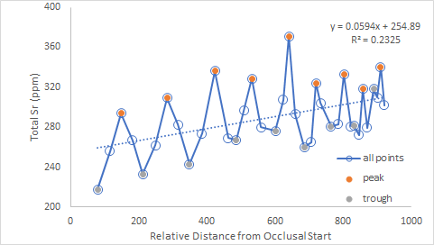

Figure S1e. Digitally extracted data for total Sr versus the distance along an occlusal to basal transect of a fossil mammoth tooth shown in Figure S1a. Total Sr values identified as trough (grey) correspond to the minimum total Sr in the grey box regions marked in Figure S1d. The peak (orange) total Sr values correspond to the maximum values in the orange box regions marked in Figure S1d. The left and right shoulders of each peak are identified as midway between the trough and peak (left shoulder) and a point the same distance from the peak (right shoulder). The slope is statistically significant (p = 0.00290). Data after Kowalik et al. 2023.
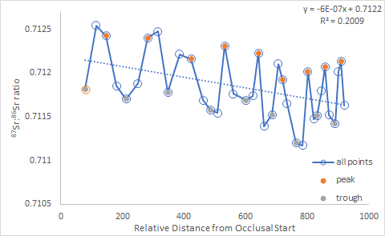
Figure S1f. Digitally extracted data for total ⁸⁷Sr:⁸⁶Sr ratio versus the distance along an occlusal to basal transect of a fossil mammoth tooth shown in Figure S1d Values shown are the smoothed ⁸⁷Sr:⁸⁶Sr values associated with trough, left shoulder, peak and right shoulder total Sr values presented in Figure S1e. The slope is statistically significant (p = 0.006117). Data after Kowalik et al. 2023.
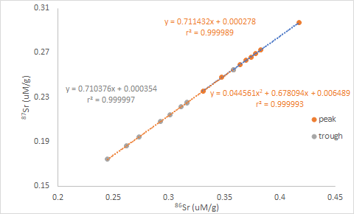
Figure S1g. The relationship between ⁸⁶Sr and ⁸⁷Sr for peak and trough points for the data collected from a fossil mammoth tooth that is presented in Figures S1e and f. Regression equations are color-coded to match data points. Linear slopes are statistically significant for both trough and peak data (p < 10⁻¹⁸). The linear y-intercept is statistically significant for the trough (p = 0.03603) but not for the peak. Neither the x² term or y-intercept are significant for the polynomial fit of the trough data (p = 0.533 and 0.738 respectively). Both the polynomial x² term and y-intercept approach statistical significance for the peak data (p = 0.102 and 0.113 respectively). Data after Kowalik et al. 2023.
-
The trough data in Figure S1g is linear with a significantly positive y-intercept (p = 0.03603) and no detectable curvature (x² term p = 0.533). This suggests that the source for the trough time periods is constant over the nine years we evaluated. As expected for a linear function with a positive y-intercept ⁸⁷Sr:⁸⁶Sr values decline for the trough points as ⁸⁶Sr increases (p = 0.0285) in Figure S1h. Because the declining ⁸⁷Sr:⁸⁶Sr ratio points approach the slope of the ⁸⁶Sr vs. ⁸⁷Sr regression line (Figure S1g), the mean for ⁸⁷Sr:⁸⁶Sr ratios (0.7115) will overestimate the likely trough source (slope = 0.71038). The lack of curvature is also verified by a flat spline smoothed derivative (Figure S1i) that matches the trough slope. Although curvature for the 86^{Sr} vs. ⁸⁷Sr peak points only approach statistical significance the possibility of source changes during peak time period is intriguing. With an analysis of the complete dataset this could be confirmed. As expected, a convex polynomial with a positive y-intercept would not produce declining ⁸⁷Sr:⁸⁶Sr values for the peak points as ⁸⁶Sr increases (Figure S1h).

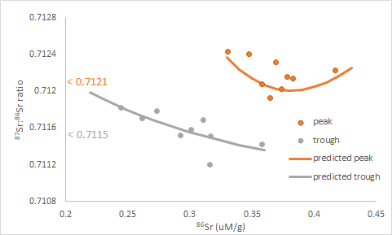
Figure S1h. The relationship between ⁸⁶Sr and ⁸⁷Sr:⁸⁶Sr ratio for peak and trough points for the data collected from a fossil mammoth tooth that is presented in Figures S1e and f. Predicted values for trough and peak points are derived from the linear trough equation and polynomial peak equation in Figure S1d. As expected for a linear function with a positive y-intercept (Figure S1d), values decline for the trough points with increasing ⁸⁶Sr (p = 0.0285). A constant decline for the peak points is not expected since a convex polynomial function with a positive y-intercept likely fits the data. Values positioned next to the y-axis are mean ⁸⁷Sr:⁸⁶Sr ratio for peak (top) and trough (bottom) points. Data after Kowalik et al. 2023.
-
Both the mathematical derived derivative and spline smoothed cubic derivative in Figure S1i match and suggest that there may be convex curvature for the peak ⁸⁶Sr vs. ⁸⁷Sr function. Both the changing source suggested by the spline smoothed and mathematical derivatives spans source estimates made by slopes for and mean ⁸⁷Sr:⁸⁶Sr ratios for both trough and peak points.
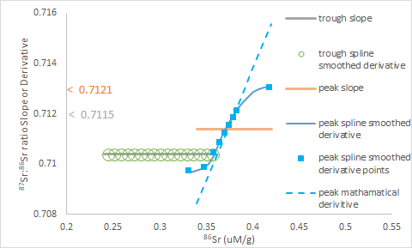
Figure S1i. The relationship between both linear ⁸⁶Sr vs. ⁸⁷Sr slopes and spline smoothed cubic derivatives plotted against ⁸⁶Sr concentrations for the data presented in Figure S1g. Individual spline smoothed derivative points for the winter season (trough points in green circles) and the ⁸⁶Sr vs. ⁸⁷Sr slope are identical. The spline smoothed derivatives (square blue points) for the actual summer season peak points evaluated (orange peak points in Figure S1g) and a mathematical derivative (blue dashed line) derived from the summer season polynomial equation in Figure S1g are also presented. Values positioned next to the y-axis are mean ⁸⁷Sr:⁸⁶Sr ratio for peak (top) and trough (bottom) points shown in Figure S1e. Data after Kowalik et al. 2023.
-
Changing source patterns in an animal will be difficult to match to an unchanging source value for a specific location. If migrating populations or individuals are to be accurately linked to specific locations for a given time period, source evaluations for the time period must be constant. We have been unable to find any instances where researchers have checked if this constant assumption is verified. Analyzing data (unsmoothed) for the time periods marked in the red and grey boxes in Figure S1a would determine if sources were constant or changing. One will not know if sources are constant and whether determining possible migration patterns are appropriate until more thorough source analyses are conducted. Evidence presented here is not conclusive but it does suggest that more evaluations are required. Matching the mean of changing and widely variable ⁸⁷Sr:⁸⁶Sr source ratios with constant ⁸⁷Sr:⁸⁶Sr ratios for specific locations is problematic.As stated above, the observed ⁸⁷Sr:⁸⁶Sr ratio for Alaskan mammoth tusk or human and animal teeth is likely a function of both geographic location and the total Sr in a sample. Observed ⁸⁷Sr:⁸⁶Sr ratios do not necessarily reflect ⁸⁷Sr:⁸⁶Sr sources.
Of the five migration studies discussed (Alaskan Mammoth, European Mammoth, Ice Man, Viking Era Human and Bovine Migrations), only the Viking Era human migration study conducted source analyses. The bovine and European mammoth studies determined total Sr but did not use it in source analyses. Total isotope amounts are not presented in the other two studies. Researchers are collecting excellent data to both develop and test sophisticated hypotheses. With little additional effort, possible errors can be detected and corrected with simple alterations to current data collection and analytical methods. Although unlikely, it is possible that observed ratios represent a source, but this cannot be confirmed unless it is evaluated. Tweaking current isoscape evaluations may result in delightfully pleasing results.

4.2 Study 5) Source Analyses Improve the Interpretation of Temporal Sr Isotope Patterns in a Water Inlet
To circumvent the difficulties in direct measurement of weathering Bailey et al. (1996) used Sr isotopes to define basic cation inputs and transport in a forest ecosystem. In small watersheds where the ⁸⁷Sr:⁸⁶Sr ratios of atmospheric and weathering inputs are distinct and relatively constant over time, this method can be used to trace the transport of Sr through the ecosystem (Graustein 1989). A re-evaluation of a Bailey et al. (1996) dataset for ⁸⁷Sr:⁸⁶Sr ratios for water from an inlet in the Cone Pond Watershed in New Hampshire demonstrates how patterns of an observed ratio can differ from what occurs when plotting changing Sr source over time. The relationship between ⁸⁶Sr and ⁸⁷Sr is described by a convex function with a statistically significant x² term and a positive y-intercept (Figure S2a).
This example was deliberately chosen to demonstrate that spline smoothed derivatives are often not as definitive as one might expect. The polynomial curvature demonstrated in Figure S2a is consistent with the spline smoothed derivatives and mathematically derived derivatives presented in Figures S2b, but there is considerable scatter in the spline smoothed derivative mostly due to the three highest Sr samples collected during the summer. Even when denominator vs. numerator r² values are spectacularly high, and polynomial curvature is statistically significant, enough noise often exists to complicate smoothing procedures. In some cases, the scatter is even more severe. Not all datasets can be usefully evaluated with spline-smoothed cubic derivatives.
Even so, a U-shaped relationship (more clearly shown in the insert of Figure S2b) between ratio denominator and an isotopic ratio is as expected for a statistically significant convex ⁸⁶Sr vs.⁸⁷Sr function with a negative y-intercept (Moots et al. 2024). The relationship between total Sr and the observed ⁸⁷Sr:⁸⁶Sr ratios and the mathematical derivatives for the ⁸⁶Sr vs.⁸⁷Sr function (Figure S2b), reveals the same patterns presented for the simulated data using total Sr on the x-axis presented in Moots et al. (2024), Supplemental Material: Section 12, Simulations demonstrating source, background and y-intercepts for curvilinear denominator vs. numerator functions. The observed ratio can be negatively related (left portion) unrelated (middle portion) or positively (right portion) related to the mathematically derived derivative source.

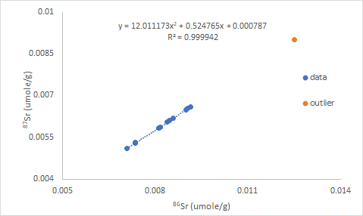
Figure S2a. The relationship between ⁸⁶Sr and ⁸⁷Sr for samples collected from an inlet surrounded by forests from the Cone Pond Watershed, White Mountains National Forest, Thornton, New Hampshire each month over one-year. The one outlier (December sampling time) was excluded from the analysis because of an excessive residual and excessive leverage. Therefore, only January through November samples were analyzed. Data after Bailey et al. (1996).
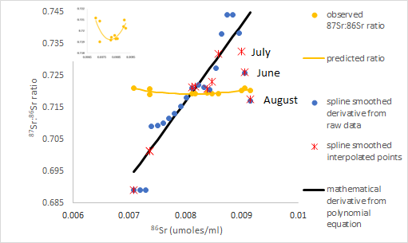
Figure S2b. Relationship between ⁸⁶Sr vs. ⁸⁷Sr:⁸⁶Sr ratio and ⁸⁶Sr vs. the spline smoothed derivative for the ⁸⁶Sr vs. ⁸⁷Sr data shown in Figure S2a, for samples collected from an inlet surrounded by forests from the Cone Pond Watershed, White Mountains National Forest, Thornton, New Hampshire each month over one-year. The mathematical derivative derived from the best-fit polynomial equation in Figure S2a is also shown. An outlier for the December sampling period was removed. The insert shows the same data presented in the main figure, but with a smaller y-axis scale. Data after Bailey et al. (1996).
-
In Figure S2c a plot of source (d⁸⁷Sr/d⁸⁶Sr spline smoothed derivatives) vs. sampling time is very different than the pattern for observed ⁸⁷Sr: ⁸⁶Sr ratios vs. sampling time. The insert shows the same observed ⁸⁷Sr:⁸⁶Sr ratio data presented in the main figure, but with a smaller y-axis scale to better clarify pattern differences between observed ratio and sources. A major difference between the derivative and observed ⁸⁷Sr:⁸⁶Sr ratio patterns occurs for the first five months where the high Sr values associated with spline smoothed derivative anomalies do not occur. In this region, spline smoothed and mathematical derivatives are similar. A plot of derivatives over time has greater variation (Figure S2c). As demonstrated in Moots et al. (2024), differences in the time course variability for sources and observed ratios are expected since a large isotopic pool size buffers observed ratio changes.
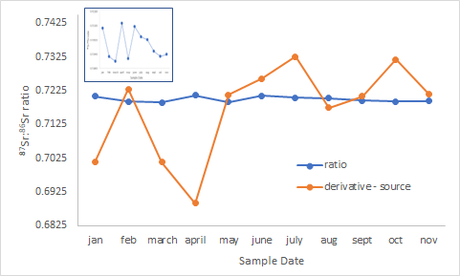
Figure S2c. The relationship for both observed ⁸⁷Sr:⁸⁶Sr ratios and derivatives calculated from the relationship between ⁸⁶Sr vs. ⁸⁷S for samples collected from an inlet surrounded by forests from the Cone Pond Watershed, White Mountains National Forest, Thornton, New Hampshire each month over one-year. An outlier for the December sampling period was removed. By matching derivatives calculated from ⁸⁶Sr vs. ⁸⁷Sr relationships to specific values of ⁸⁶Sr that correspond to specific sample dates, changes in source over time can be determined. The insert shows the same ⁸⁶Sr:⁸⁷Sr ratio data presented in the main figure but with a smaller y-axis scale. Data after Bailey et al. (1996).
-
Researchers collected excellent data in a study designed to access mineral fluxes in an entire watershed. Only a small portion of their study was used to re-evaluate data and determine isotopic sources. However, these preliminary results suggest that source analyses of isotopic data on a landscape scale could be valuable.

4.3 Study 6) Source Analyses Improve the Interpretation of a Possible Sea Spray Source of Sr in a Costal Hawaiian Soil
Whipkey et al. (2000) demonstrated that both ⁸⁷Sr:⁸⁶Sr ratios and the amount of total Sr that was derived from possible sea spray decline with depth (Figure S3a). Procedures for calculating total Sr, plotting umole ⁸⁶Sr vs. umole ⁸⁷Sr and calculating changing sources (spline smoothed derivatives) are described in the main text. The values in parentheses adjacent to the observed ⁸⁷Sr:⁸⁶Sr ratios indicate the portions of Sr derived from seawater. They were calculated with standard formulas assuming the generally accepted seawater source (0.7091) and the background basalt parent material (0.7035) suggested by the original authors. These portions can also be approximated by calculating the relative distance of an observed ⁸⁷Sr:⁸⁶Sr ratio point from the background line shown (grey) divided by the distance between background (grey) and source (green) in Figure S3a. Declines in ⁸⁷Sr:⁸⁶Sr ratios and portion of total Sr derived from sea spray occur in a system where ⁸⁶Sr (and the related total Sr) increase with soil depth (Figure S3a).
The fact that ⁸⁶Sr, total Sr, and Ca concentrations all generally increase with depth is perplexing. If seawater was deposited on the surface soil for thousands of years, why would generally immobile elements like Sr and Ca have higher concentrations with increasing depth? Especially if sea spray inputs of Sr decrease with depth. Perhaps a large portion of the four-fold increase in total Sr from the shallow to deep depth is mostly due to another Sr input such as weathering of the basalt parent material.
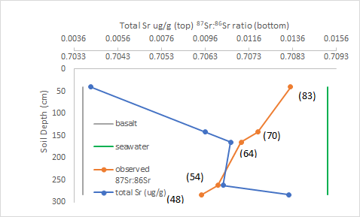
Figure S3a. The relationships between ⁸⁷Sr:⁸⁶Sr ratio and total Sr with soil depth from a study evaluating the possibiity that sea spray is a major source of Sr in a Hawaiian soil. The original authors suggest two possible end member sources (seawater and basalt) create a blended source that changes with depth. The basalt soil parent material value shown above was suggested by the original authors. The numbers adjacent to the ⁸⁷Sr:⁸⁶Sr ratio points indicate the percentage of Sr at a given depth that originated from seawater (using standard formulas). Data after Whipkey et al. (2000).
-
We hypothesize that although the shallowest depths studied may be strongly influenced by seawater spray, it is unlikely the Sr derived from seawater would be 64% to 48% at deeper depths (>150 cm) as the author’s state. Standard formulas that convert isotopic ratios to the portion of total element derived from an assumed source do not account for isotopic ratios being confounded by total element concentrations. The relationship between ⁸⁶Sr and ⁸⁷Sr (in molar units) is presented in Figure S3b. Neither the y-intercept (p = 0.1340) for the linear equation nor the x² term (p = 0.2597) for the polynomial equation are statistically significant. Most changes in labile ⁸⁷Sr:⁸⁶Sr ratio are driven by changes in total Sr (Figure S3c).
Increasing total Sr is clearly associated with declining ⁸⁷Sr:⁸⁶Sr ratios. The linear relationship between total Sr and ⁸⁷Sr:⁸⁶Sr ratio has an r² of 0.8698 with a p-value of 0.0207. However, whether this relationship is driven by a constant source (linear ⁸⁶Sr vs. ⁸⁷Sr function with a positive y-intercept) or a changing source (concave curvilinear function) is difficult to determine. Both a polynomial and linear relationship shown in Figure S3a can predict the observed ⁸⁷Sr:⁸⁶Sr ratios displayed in Figure S3c.
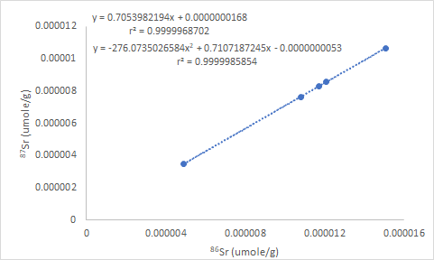
Figure S3b. The relationship between ⁸⁶Sr and ⁸⁷Sr from a study evaluating the possibiity that sea spray is a major source of Sr in a Hawaiian soil. Neither the y-intercept (p = 0.1340) for the linear equation nor the x² term (p = 0.2597) for the polynomial equation are statistically significant. Data after Whipkey et al. (2000).

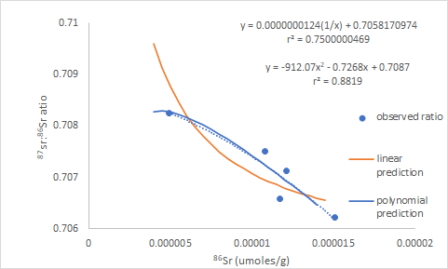

Figure S3c. The relationship between ⁸⁶Sr (umoles/g) and ⁸⁷Sr:⁸⁶Sr ratios from a study evaluating the possibiity that sea spray is a major source of Sr in a Hawaiian soil. Predicted values are derived from the linear and polynomial ⁸⁶Sr vs. ⁸⁷Sr equations presented in Figure S3b. The driver behind the ⁸⁷Sr:⁸⁶Sr ratio decline, with increasing ⁸⁶Sr, cannot be determined because neither the y-intercept for the linear equation nor the x² term for the polynomial equation are statistically significant (Figure S3b). However, the polynomial prediction shown here appears to have a better fit. Data after Whipkey et al. (2000).
-
The uncertainty about the cause of declining ⁸⁷Sr:⁸⁶Sr ratios is also apparent in traditional mixing lines (1/total Sr ug/g vs. molar based ⁸⁷Sr:⁸⁶Sr ratios) shown in Figure S3d. Either linear or curvilinear mixing lines can be defined by the data. Curvilinear best-fit equations are stronger for both the ⁸⁶Sr vs ⁸⁷Sr:⁸⁶Sr ratio in Figure S3c and the 1/total Sr vs. ⁸⁷Sr:⁸⁶Sr ratio in Figure S3d. Even so, a firm conclusion about why ⁸⁷Sr:⁸⁶Sr ratios decline with increasing total Sr is not possible.
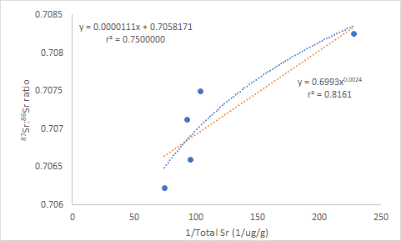
Figure S3d. The relationship between 1/total Sr (ug/g units) and ⁸⁷Sr:⁸⁶Sr ratios (umole/g units) from a study evaluating the possibility that sea spray is a major source of Sr in a Hawaiian soil. Linear and polynomial best-fit equations are shown. The driver behind the ⁸⁷Sr:⁸⁶Sr ratio decline, with increasing ⁸⁶Sr, cannot be determined because neither the y-intercept for the linear equation nor the x² term for the polynomial equation are statistically significant (Figure S3b). However, a curviliear power function shown here appears to have a better fit than a linear function for the mixing line. Data after Whipkey et al. (2000).
-
To deal with the fact that possible, sources could be constant or changing, both linear (Figure 3e) and polynomial models (Figure 3f) were evaluated. For the linear evaluation, the ⁸⁷Sr:⁸⁶Sr ratio of seawater (0.7091) is outside the 95% confidence interval for the linear slope (0.7054) of the original umole/g ⁸⁶Sr vs. umole/g ⁸⁷Sr plot (Figure S3b). This suggests that seawater cannot be a sole source but a relatively constant mixture of basalt and seawater sources with depth is possible.

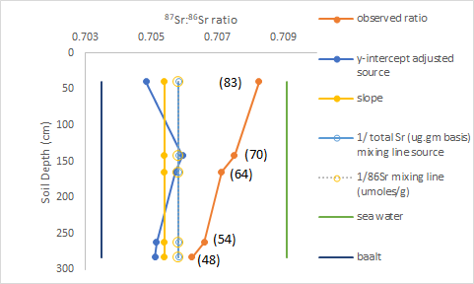
Figure S3e. Four different source estimates plotted vs. depth from a study evaluating the possibiity that sea spray is a major source of Sr in a Hawaiian soil. The four sources for a constant source (linear ⁸⁶Sr vs. ⁸⁷Sr model) are the y-intercept corrected ratios, the ⁸⁶Sr vs. ⁸⁷Sr slope, and both traditional 1/total Sr (ug/g units) and 1/⁸⁶Sr (umole/g units) mixing line y-intercepts. The numbers adjacent to the observed ⁸⁷Sr:⁸⁶Sr ratio points indicate the percentage of Sr at a given depth that originated from seawater (using standard formulas). Two possible endpoints (sources) basalt and sea spray shown were suggested by the original authors. Data after Whipkey et al. (2000).
-
All alternate approaches associated with a linear ⁸⁶Sr vs. ⁸⁷Sr relationship suggest a relatively constant blended source of about one third seawater and two thirds basalt that is relatively constant with depth. Traditional 1/total Sr or the very similar y-intercept for 1/⁸⁶Sr mixing lines (data not shown) suggest constant sources with depth (Figure S3e). When y-intercept-corrected data is calculated, the source does not markedly decrease from shallow to deepest depth and remains approximately equal to the slope of the original ⁸⁶Sr vs. ⁸⁷Sr plot slope for all depths (Figure S3e).
When a concave curvilinear model is used Figure S3f suggests ⁸⁷Sr:⁸⁶Sr ratios could decrease with depth. Seawater is not a major source of Sr below 150 cm. The spline smoothed cubic derivative (Figure S3f) declines with depth and closely approximates the shape of the original observed ratios, but the portions of Sr derived from seawater are much smaller. Again, the portions of total Sr derived from sea spray for either the observed ⁸⁷Sr:⁸⁶Sr ratios or spline smoothed derivative values can also be approximated by calculating the relative distance of ratio points from the background line shown (grey) divided by the distance between background (grey) and source (green) in Figure S3f. The authors state that the symbol size for observed ⁸⁷Sr:⁸⁶Sr ratios is larger than analytical error in their Figure 3 (similar to our Figure S3a). However, the number of replicates (if there were any) is not stated. Anecdotally, we have often observed that an increase from five to about 15 observations is associated with a large decrease in the p-values for initially non-significant x² terms.
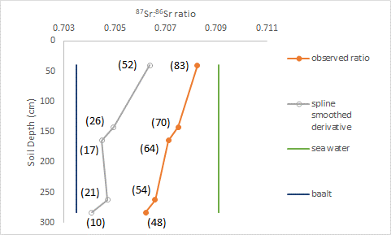
Figure S3f. Spline smoothed derivative source estimates plotted vs. depth from a study evaluating the possibiity that sea spray is a major source of Sr in a Hawaiian soil. The derivative pattern is similar to the observed ⁸⁷Sr:⁸⁶Sr ratio pattern but suggest much smaller portions of total Sr are derived from sea spray. The numbers adjacent to the ⁸⁷Sr:⁸⁶Sr ratio points indicate the percentage of Sr at a given depth that originated from seawater (using standard formulas). Two possible endpoints (sources) basalt and sea spray shown were suggested by the original authors. Data after Whipkey et al. (2000).
-
It is possible that the polynomial model is correct. This said, a more conservative conclusion based on both the linear and polynomial models suggests Whipkey et al. (2000) are likely correct that seawater could be a Sr source in this Hawaiian example. However, conventional techniques overestimate the magnitude of sea spray input. Standard formulas likely overestimate seawater importance for the surface sample. The portion of Sr derived from seawater is both small and does not markedly decrease among the deeper depths. The amount of material derived from a presumed source using standard formulas with likely confounded isotopic ratios, should be cautiously interpreted.

7 Discussion
This report expands on math-based theoretical predictions on how ⁸⁷Sr:⁸⁶Sr ratios are dependent on either total Sr or ⁸⁶Sr, the denominator of the isotopic ratio (Moots et al. 2024). An evaluation of Sr isotopic datasets from the literature suggest that as predicted, ⁸⁷Sr:⁸⁶Sr ratios are confounded when total Sr content varies among samples representing different conditions.
Observed ⁸⁷Sr:⁸⁶Sr ratios from different locations or sample types can vary in different ways depending on the total Sr levels associated with given ⁸⁷Sr:⁸⁶Sr ratios. Therefore, it is not surprising that time-based observed ⁸⁷Sr:⁸⁶Sr ratio patterns in different speleothem studies (main text) do not match one another even if sources are similar. Sources and whether these sources remain constant over time, rather than any features of an observed ⁸⁷Sr:⁸⁶Sr ratio pattern are what matters in climate change and migration studies.
Evaluating derivatives that reflect how sources change over time, allows clear clarification of ⁸⁷Sr:⁸⁶Sr source changes in a speleothem that agree with temporal ice core ¹⁸O evaluations known to reflect generally accepted weather changes (main text). Similarly, evaluating derivatives helps elucidate possible changing sources in the European mammoth and salt spray soil studies. Evaluating spline smoothed derivatives in an inlet time course study does not produce as clear an interpretation as the three examples described above. However, the source pattern that is very different than the observed ⁸⁷Sr:⁸⁶Sr ratio pattern in water from an inlet.
Source analyses may not conclusively suggest an evaluation of observed ratios is incorrect. The European mammoth study (Kowalik et ql. 2023) provides an example where cursory source analyses suggest more extensive data analyses would be helpful without conclusively discrediting a conclusion based on observed ratios.

6 Conclusion
Five ⁸⁷Sr:⁸⁶Sr ratio datasets suggest mathematical predictions and trends presented by Moots et al. (2024) do indeed occur. Many of the ⁸⁷Sr:⁸⁶Sr ratios evaluated here are confounded. This is supported by an unpublished review of 24 Sr isotope publications, containing over 75 datasets. Changes in ⁸⁷Sr:⁸⁶Sr ratio were always accompanied with changes in total Sr concentration (data not shown but re-evaluations of the original publications are available on request). Observed ⁸⁷Sr:⁸⁶Sr ratios are often not strongly related to sources. Isotopic Sr ratio patterns that change over time or for different conditions do not necessarily reflect how sources change.
The full extent of isotopic “ratio problems” requires confirmation with non-strontium isotopic examples. However, the mathematical consequences of relying solely on ratio-based expressions outlined here likely apply to most stable mass isotopes. One should always evaluate traditional Keeling plots; other forms of mixing diagrams; or an analysis of the relationship between ratio denominator and numerator. Source evaluations inform researchers when isotopic ratios are confounded. They can then better understand and interpret isotopic studies. Many datasets may not have ratio issues that alter an interpretation, thus ratio-based assessments can still be useful. That said, when total element data is available, finding confounded ratio examples is not difficult. One will never know if isotopic data is confounded unless it is evaluated.
FUNDING DETAILS

No external grant funds directly supported this effort. Rather, years of tangential thinking associated with many projects lead to this research.

DISCLOSURE STATEMENT
None of the co-authors have associations or affiliations that would lead to financial benefit from the publication of this document.

References
Atchley, W. R., Gaskins, C. T., and Anderson, D. (1976), “Statistical Properties of Ratios. I. Empirical Results,” Society of Systematic Biologists, 25, 137-148, DOI: 10.2307/2412740.
Bailey, S. W., Hornbeck, J. W., Driscoll, G.T., and Gaudette, H. E. (1996), “Calcium Inputs and Transport in a Base-Poor Forest Ecosystem as Interpreted by Sr. Isotopes,” Water Resources Research, 32, 707-719, DOI: 10.1029/95WR03642.
Bataille, C. P., Crowley, B. E., Wooller, M. J., and Bowen, G. J. (2020), “Advances in Global Bioavailable Strontium Isoscapes,” Palaeogeography, Palaeoclimatology, Palaeoecology, 555, 109849.
Bentley, R. A. (2006), “Strontium Isotopes from the Earth to the Archaeological Skeleton: A Review,” Journal of Archaeological Method and Theory, 13, 135-187, DOI: 10.1007/s10816-006-9009-x.
Goede, A., McCulloch, M., McDermott, F., and Hawkesworth, C. (1998), “Aeolian Contribution to Strontium and Strontium Isotope Variations in a Tasmanian Speleothem,” The Holocene, 9, 715-722.
Graustein, W. C. (1989), “⁸⁷Sr/⁸⁶Sr Ratios Measure the Sources and Flow of Strontium in Terrestrial Ecosystems,” In Stable Isotopes in Ecological Research, eds. P. W. Rundel, J. R. Ehleringer, and K. A. Nagy. New York: Springer-Verlag, pp. 491-512.
Horstwood, M. S. A., Evans, J. A., and Montgomery, J. (2008), “Determination of Sr Isotopes in Calcium Phosphates Using Laser Ablation Inductively Coupled Plasma Mass Spectrometry and their Application to Archaeological Tooth Enamel,” Geochimica et Cosmochimica Acta, 72, 5659-5674, DOI: 10.1016/j.gca.2008.08.016.
Isles, P. D. F. (2020), “The Misuse of Ratios in Ecological Stoichiometry,” Ecology, 101, 1-7.
Jackson, D. A., Harvey, H. H., and Somers, K. M. (1990), “Ratios in Aquatic Sciences: Statistical Shortcomings with Mean Depth and the Morphoedaphic Index,” Canadian Journal Fisheries and Aquatic Sciences, 47, 1788-1795, DOI: 10.1139/f90-203.
Jasienski, M. and Bazzaz, F. A. (1999), “The Fallacy of Ratios and the Testability of Models in Biology,” Oikos, 84, 321-326, DOI: 10.2307/3546729.
Keeling, C. D. (1958), “The Concentration and Isotopic Abundances of Atmospheric Carbon Dioxide in Rural Areas,” Geochimica et Cosmochimica, 13, 322-334, DOI: 10.1016/0016-7037(58)90033-4.
Kowalik, N., Anczkiewicz, R., Müller, W., Spötl, C., Bondioli, L., Nava, A., Wojtal, P., Wilczyński, J., Koziarska, M. and Matyszczak, M., (2023), “Revealing seasonal
woolly mammoth migration with spatially-resolved trace element, Sr and O isotopic records of molar enamel,” Quaternary Science Reviews, 306, p.108036, DOI: 10.1016/108036 0277-3791
Kratochvil, L., and Fleger, J. (2009), “Differences in the 2nd to 4th Digit Length Ratio in Humans Reflect Shifts along the Common Allometric Line,” Biology letters, 5, 643-646, DOI: 10.1098/rsbl.2009.0346.
Li, H. C., Ku, T. L., You, C F., Cheng, H., Edwards, R. L., Ma, Z. B., Tsai, W. S., and Li, M. D. (2005), “⁸⁷Sr/⁸⁶Sr and Sr/Ca in Speleothems for Paleoclimate Reconstruction in Central China between 70 and 280 kyr ago,” Geochimica et Cosmochimica Acta, 69, 3933-3947, DOI: 10.1016/j.gca.2005.01.009.
Montgomery, J., and Evans, J. A. (2006), “Immigrants on the Isle of Lewis - Combining Traditional Funerary and Modern Isotopic Evidence to Investigate Social Differentiation, Migration and Dietary Change in the Outer Hebrides of Scotland,” In Social Archaeology of Funerary Remains (pp. 123-142), eds. R. Gowland, and C. Knusel, Oxbow: Oxford.
Montgomery, J., Evans, J. A. and Cooper, R. E. (2005), “Resolving Archaeological Populations with Strontium Mixing Diagrams,” Geological Research Abstracts, 17, 10020.
Moots, K. Nguyen, C. P Nguyen C. Camacho, F., Lindstrom, D., and Righetti, T, L. (2024). A mathematical explanation for why ratio-based isotopic analyses are commonly misleading: Theory. Scientific Reports this issue .
Muller, W., Fricke, H., Halliday, A. N., McCulloch, M. T. and Wartho, J. A. (2003), “Origin and migration of the Alpine Iceman. Science, 302, 862-866.
Packard, G. C., and Boardman, T. J. (1998), “The Misuse of Indices and Percentages in Ecophysiological Research,” Physiological Zoology, 61, 1-9, DOI: 10.1086/physzool.61.1.30163730.
Righetti, T. L., Sandrock, D. R. Strik, B., Vasconcelos, C., Moreno, Y., Oretega-Farias, S., et al. (2007), “Analysis of Ratio-Based Responses,” Journal of the American Society for Horticultural Science, 132, 3-13, DOI: 10.21273/JASHS.132.1.3.
West, J. B., Bowen, G. J., Dawson, T. E. and Tu, K. P., eds. (2009), Isoscapes: Understanding Movement, Pattern, and Process on Earth through Isotope Mapping, London UK: Springer Science & Business Media.
Whipkey, C. E., Capo, R. C., Chadwick, O. A., and Stewart, B. W. (2000), “The Importance of Sea Spray to the Cation Budget of a Coastal Hawaiian Soil: A Strontium Isotope Approach,” Chemical Geology, 168, 37-48, DOI: 10.1016/S0009-2541(00)00187-X.
Wooller, M. J., Bataille, C., Druckenmiller, P., Erickson, G.M., Groves, P., Haubenstock, N., et al. (2021), “Lifetime Mobility of an Arctic Woolly Mammoth,” Science, 373, 806-808, DOI: 10.1126/science.abg1134.

