Supplemental Material 3
A Mathematical Explanation for Why Ratio-Based Isotopic Analyses are Commonly Misleading: Rethinking Fractionation Favoring the Common Isotope
Abstract
Fractionation factors are subject to the same limitations as the ratio-based expressions they are derived from. Rayleigh fractionation factors (ln total element vs. substrate isotopic ratio slope) are influenced by total isotope concentrations and the type of relationship between isotope ratio denominator and numerator. Perfectly linear denominator vs. numerator functions with non-zero y-intercepts can produce discrimination factors when no fractionation exists. Convex polynomial denominator vs. numerator functions with negative y-intercepts and concave polynomial functions with positive y-intercepts can produce statistically significant Rayleigh fractionation slopes. Convex polynomial functions with positive y-intercepts, and concave polynomial functions with negative y-intercepts often do not. Backgrounds can determine whether Rayleigh fractionation occurs rather than changing sources. There may not be a constant microbial preference for lighter common isotopes defined by a fractionation factor. Rather, significant Rayleigh fractionation factors can be caused by relatively constant ¹⁵N:¹⁴N or ¹³C:¹²C loss ratios even though substrate isotopic ratios vary. Directly calculated fractionation values (the difference between isotopic loss ratios and observed isotopic ratios) may have a mean that approximates a constant Rayleigh fractionation slope. However, varying directly calculated fractionation factors with soil or sediment depth may be misleading as they are perfectly related to total element or ratio denominator.
Keywords: derivatives; isotopic scaling; isotopic sources; Keeling plots; mixing diagrams

1 Introduction
A companion paper (Moots et al. 2024a) suggests isotopic ratios are not immune to ratio issues that have been discussed in the literature for over 100 years. Isotopic researchers often assume an observed isotopic ratio reflects the source of a system, but this is not true. Keeling (1958) proposed methods for determining isotopic sources, but source evaluations on isotopic datasets are relatively rare in the isotopic literature, even when the necessary total element concentrations are available (Moots et al. 2024a). The interpretation of Sr, N, C and S isotopic information is confounded by total element (Moots et al. 2024b Supplemental Material 1 and 2). Here we extend our ratio biases argument to challenge isotopic fractionation, a concept that deals with the difference between isotopic ratios of a substrate and material removed. Although fractionation studies are deeply rooted in the isotopic literature and the phenomenon does indeed occur, mathematical principles suggest that observed ratios will almost always differ from a source (Moots et al. 2024a) even if no isotopic discrimination occurs.
The two most important types of fractionations in the isotopic literature are equilibrium and kinetic fractionation. Equilibrium fractionation is a special case of chemical reaction where an exchange of isotopes takes place, which affects the equilibrium constant. Kinetic fractionation is associated with incomplete and unidirectional processes that affects the rate constant of the reaction. No isotopic equilibrium is attained in the case of kinetic fractionation. Isotopic fractionation refers to a situation where substrate and product fractions have different isotopic ratios. Regardless of type, fractionation values are calculated from isotopic ratios and subject to the same limitations as ratio-based expressions.
An important fractionation example involves stable isotopic techniques to study animal diets and trophic levels. To obtain meaningful results often requires a priori estimates of the differences in isotopic composition between an animal and its diet (Caut et al. 2009). These differences are called discrimination or fractionation factors (Δ¹³C and Δ¹⁵N). Whitledge and Rabeni (1997) present data where isotopic defined trophic levels do not agree with stomach contents in crayfish (Orconectes species). The Whitledge and Rabeni (1997) example demonstrates the importance of understanding why an observed isotopic ratio for an organism and the ratio of consumed sources might differ. Fractionation factors can be influenced by non-diet phenomena such as taxon, environment and tissue that are difficult to interpret (Caut et al. 2009).
Similar phenomena can occur with other physical or biochemical processes (Mobius 2013; Lerch et al. 2010; Wang et al. 2015). For example, fractionation is the generally accepted explanation for why soil organic matter is more enriched in ¹⁵N than its atmospheric source (Mobius 2013). Thousands of years of N-cycle transformations favor loss of the lighter common isotope and leave the heavy isotope behind, eventually creating these pool differences.
In the isotopic literature, the relationship between substrate and product is defined by a constant fractionation factor. In theory, at infinite amounts of substrate the conversion of substrate to product does not noticeably change the isotopic ratio of the substrate. The isotopic ratio of both substrate and product will remain constant and differ by the fractionation factor. If finite amounts of substrate exist, the creation of product changes the isotopic ratio of the remaining substrate as it is consumed. Therefore, the value of both substrate and product will change over time, although they will always be related to one another by the fractionation factor. Fractionation factors that are constant as substrate levels change are a key component of current thinking on fractionation principles. Many factors can alter fractionation across soils, sediments or taxonomic groups in trophic level studies. However, within a given unit, fractionation is viewed as constant. As shown below, when source analyses are used to better understand fractionation factors, relationships between substrate and product are more complex.
A common way of quantifying fractionation, especially in soil and sediment samples, is by calculating Rayleigh fractionation factors. For example, the slope of ln total N vs. δ¹⁵N plots defines the Rayleigh fractionation factor in the isotopic literature and explains the increase in ¹⁵N enrichment with declining organic matter and covarying decline in total N. Rayleigh fractionation factors define difference between the isotopic ratio of the substrate and the material being lost in delta units. The original fractionation model derived by Lord Rayleigh (Rayleigh, 1902) was associated with phase changes (Kendall and Caldwell 1998). However, as N is lost in soils or sediments, fractionation can theoretically increase the δ¹⁵N of the remaining organic matter substrate. This fractionation can be explained with a ln function (Mariotti et al. 1981).
Carbon fractionation concepts in soil systems serve as an introduction to the phenomenon in sediments and other geological systems. Inputs into a soil system likely have a near-constant source ¹³C:¹²C ratio. However, there are different observed ¹³C:¹²C ratios for many different-aged soil organic matter types, decomposing at different rates (Weiglein et al. 2022). Soil physiochemical and ecosystem properties (e.g., vegetation, climate) are the dominant factors controlling soil organic matter resistance to decay (Weiglein et al. 2022). In the short-term, organic matter in a soil is relatively constant as recent plant inputs are offset by the rapid loss of this easily decomposed organic material (even though input sources and losses of this input may be slightly different). Recently deposited plant material may decay within 1-2 years but older decay-resistant organic matter, at deeper depths, may be thousands of years old (Rumpel et al. 2002; Heckman et al. 2021). Explanatory variables associated with C concentrations differ from those associated with persistence (Heckman et al. 2021). The source of losses for the remaining more persistent organic matter, mostly at the deeper depths in soils, is of interest here. Even though there are many different types of soil organic matter found in various proportions at different soil depths, isotopic fractionation theory suggests discrimination is constant within a single soil type (Lerch et al. 2010).
Constant fractionation factors for an individual soil or sediment are common in the isotopic literature. By fitting the relationship between ln C and ð¹³C a constant soil fractionation factor for an evaluated soil of -1.71 ð¹³C units was found (Balesdent and Mariotti 1966). A ¹³C discrimination factor of 1-2 ð¹³C units was also estimated using the Rayleigh distillation model to fit the relationship between C content and ð¹³C values from different soil depths (Wynn et al. 2005, 2006). Other studies have used data collected at different depths to assign fractionation factors for individual soil profiles and then correlated soil properties and environmental conditions at a given site with calculated fractionation factors (Wang et al. 2015). Once incubation samples (Lerch et al. 2010) reached a steady state equilibrium (after 1 month) in laboratory incubation studies, C isotopic evaluations corroborate fractionation factors found in the field. Lerch et al. (2010) concluded that caution should be exercised in interpreting short-term incubation experiments. The variation observed at the beginning of the incubation is likely due to the perturbations associated with the setting up of the experiment. However, both long-term incubations and field studies suggest relatively constant fractionation factors for a given system over time.
Blair et al. (1985) and Wick et al. (2003) present data that suggests fractionation may be microorganism or substrate dependent. Wang et al. (2015) calculated constant fractionation factors for different soils, but fractionation factors decreased among soils with declining litter quality (higher C:N ratios, higher lignin contents and lower cellulose) and declining soil water. We suspect that the Rayleigh fractionation evaluation process has mathematical flaws that produce a very different interpretation than an evaluation of isotopic source ratio (ratio of material lost as substrate is consumed) and the isotopic ratio of the substrate (observed isotopic ratio).

2 Background and Motivation
Fractionation does occur in natural settings. However, differences in observed isotopic ratios associated with linear denominator vs. numerator datasets with ubiquitous non-zero y-intercepts are driven by a combination of background, source and total element (Moots et al. 2024a). For curvilinear denominator vs. numerator plots, ratio differences can be caused by both function curvature and non-zero y-intercepts (Moots et al. 2024a). Therefore, it is important to determine if scaling differences, fractionation or combination of the two mechanisms drive isotopic ratio differences between defined sources and observed ratios. We propose that the general assumption of constant fractionation factors (consistent differences between loss ratios and substrate) in soils or sediments for a given system when either total N or C change over time or depth is not true. The same argument can be applied to fractionation in trophic level studies.

3 Methods
Two data re-evaluations involving N and C isotopes from Mobius (2013) and Wang et al. (2015) are presented. Mobius et al. (2013) deals with N isotope evaluations in Aegean Sea sediments. Wang et al. (2015) covers a soil C isotope study on the Tibetan plateau. Reanalyzes are as explained in the N isotope examples (Moots et al. 2024b Supplemental Material 2). Unlike Sr isotope evaluations (Moots et al. 204b Supplemental Material 1) no assumptions (required when an element has more than two isotopic species) were used when calculating denominator or numerator ratio values. Nitrogen and C only have two major mass isotopes.

4 Data Re-evaluations

4.1 Study 1) Different N levels Confound Isotopic Fractionation Studies in Ocean Sediments
Mobius (2013) evaluated sediment decomposition in the North Aegean Sea. Until this effort, a fractionation factor for sediment loss had not been determined for the Aegean Sea sediments even though the ¹⁵N:¹⁴N isotopic ratio of marine particulate organic matter was known to increase with declining organic matter, probably as a consequence of preferential ¹⁴N losses during decay (Mobius, 2013). A re-evaluation of Mobius’ (2013) fractionation studies demonstrates how traditional calculations of fractionation factors are more complex than they appear.
Data from two different core samples (SL 152 and NS 14) that were collected are evaluated here. In this study there is a decreasing relationship between organic carbon and δ¹⁵N values (Figure S1a for SL 152). The author suggests that the ¹⁵N:¹⁴N ratio of marine particulate organic matter increases with a decline in organic matter because of preferential removal of the light (¹⁴N) isotope as NH₄⁺ is released from organic matter during decay. As stated above, the slope of a ln total N vs. δ¹⁵N value (Figure S1b for SL 152) can be used to define fractionation relationships and is often referred to as the Rayleigh fractionation factor (Mobius 2013). A fractionation factor (slope in delta units) approximates the delta difference between substrate and product (Mobius 2013). In Figure S1c the relationship between depth and total N in the SL 152 North Aegean Sea sample is presented. Data shown is for the same points in Figures S1a and b.
A mixing line identifies the ¹⁵N:¹⁴N ratio of suspected endogenous NH₄⁺ losses for core SL 152 (Figure S1d). The linear SL 152 mixing line has a y-intercept (source) of 0.003731. Since there are only two isotopes for nitrogen and ¹⁵N is very rare (unlike the situation for Sr), 1/total N and 1/common isotope mixing diagrams are similar. An evaluation of the linear (¹⁵N = 0.00373048 * ¹⁴N + 0.00000073) relationship between ¹⁴N and ¹⁵N where the x² term for a polynomial fit is not significant also suggests that the slope-based ¹⁵N:¹⁴N ratio of released NH₄⁺ is similar to modified y-intercept and mixing line source estimations. Although variable, the average spline smoothed cubic derivatives (0.003727) approximate the same constant source. Therefore, the source does not change with depth for core SL 152 (Figure S1e).
The ¹⁴N vs. ¹⁵N regression slope or y-intercept ¹⁵N:¹⁴N corrected ratios plotted against depth (Figure S1e) reveal a constant source even though the ¹⁵N:¹⁴N ratio of the substrate changes. Endogenous losses are always depleted when compared to substrate (¹⁵N:¹⁴N ratio in Figure S1e). Mobius (2013) is correct in that remineralization of NH₄⁺ releases depleted ¹⁵N. Differences in ¹⁵N:¹⁴N ratio of the SL 152 substrate (observed ratios) are driven by differences in total N. The¹⁵N:¹⁴N ratio of released NH₄⁺ (endogenous losses) cannot be predicted with a constant fractionation factor applied to substrate ¹⁵N:¹⁴N ratios that differ with depth (Figure S1e). For example, the relationship between y-intercept corrected estimates of endogenous losses and substrate ¹⁵N:¹⁴N ratio at different depths has an r² value of 0.0431 with a p value of 0.1984.
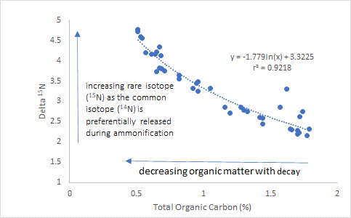
Figure S1a. The relationship between total organic carbon and δ¹⁵N in a North Aegean Sea core sample (SL 152). The authors suggest that the ¹⁵N:¹⁴N isotopic ratio of marine particulate organic matter increases with a decline in organic matter because of preferential ¹⁴N remineralization (the release of NH₄⁺ with organic matter decomposition referred to as ammonification) during decay in the oxic water-column and at the oxic seafloor. Data after Mobius (2013).
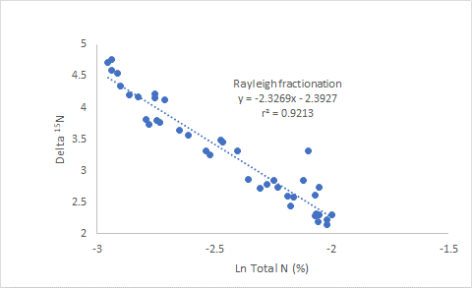
Figure S1b. The relationship between ln total N and δ¹⁵N in a North Aegean Sea core sample (SL 152). Data shown is for the same points in Figure S1a. This figure matches the second panel in Figure 4 in Mobius (2013). The slope of ln total N vs. δ¹⁵N plots defines the Rayleigh fractionation factor in the isotopic literature and explains the increase in ¹⁵N enrichment with declining organic matter and the covarying decline in total N.
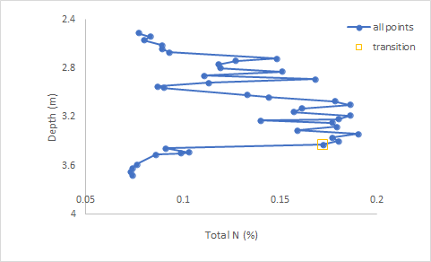
Figure S1c. The relationship between depth and total N in a North Aegean Sea core sample (SL 152). Data shown is for the same points in Figures S1a and b. The point marked in yellow denotes the start of a very quick transition with depth and appears as an outlier in several of the subsequent figures shown below. Data after Mobius (2013).
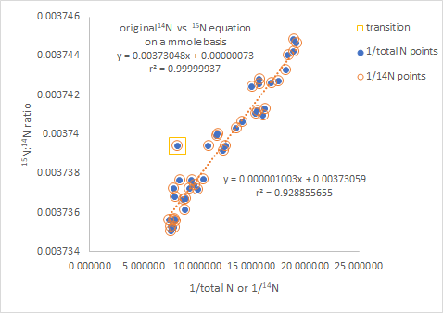
Figure S1d. A mixing diagram where 1/total N or 1/¹⁴N are plotted against ¹⁵N:¹⁴N ratio in a North Aegean Sea core sample (SL 152). The 1/total N and 1/¹⁴N values only differ slightly. The y-intercept for either expression (1/¹⁴N equation shown) identifies the likely source for the system and matches the slope for a ¹⁴N vs. ¹⁵N plot. The outlier is the same point marked in Figure S1c. Data after Mobius (2013).
-
In Figure S1f, the relationship between total N and either δ¹⁵N (left y-axis) or ¹⁵N:¹⁴N ratio (right y-axis) for core sample (SL 152) are shown for the region where data exists. It is possible that fractionation plays a major role. Similar patterns and equations, however, explain the relationship between total Sr and ⁸⁷Sr:⁸⁶Sr ratios for artificial (Moots et al. 2024a) and real data (Moots et al. 2024b Supplemental Material 1). This happens even though no fractionation occurs in artificial data and fractionation in Sr isotope studies is rare (Banner et al. 1996).
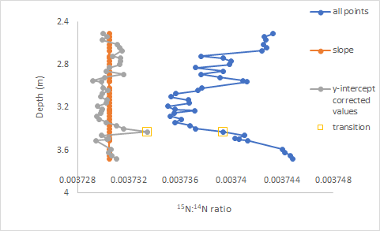
Figure S1e. The relationship between ¹⁵N:¹⁴N ratios and core depth in a North Aegean Sea core sample (SL 152). Also shown are two different estimates for sources, the ¹⁴N vs. ¹⁵N slope (red) and y-intercept corrected ratios (grey). The outlier point corresponds to the same point marked in Figure S1c. The data suggests a constant source with depth. Therefore, differences in ¹⁵N:¹⁴N ratio are driven by changes in total N. Data after Mobius (2013).
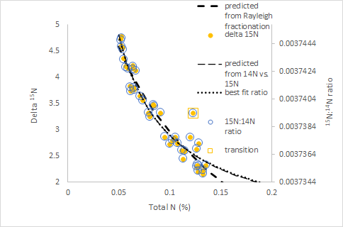
Figure S1f. The relationship between total N and either δ¹⁵N or ¹⁵N:¹⁴N ratio (the two values are perfectly correlated) in a North Aegean Sea core sample (SL 152). The Rayleigh fractionation predicted relationship; values predicted from the original ¹⁴N vs. ¹⁵N plot; and a best-fit y = (1/x) m + b equation all reasonably predict changing isotopic composition. Data after Mobius (2013).
-
For the constant source model (blue line in Figure S1g) ¹⁵N:¹⁴N ratios must approach a constant (the ¹⁴N vs. ¹⁵N relationship slope). However, the two models diverge for high total N values beyond the existing data range (Figure S1g). Datasets with linear ¹⁴N vs. ¹⁵N relationships that also have a wide data range are problematic. With increasing total N, Raleigh models produce a continuing decline in ¹⁵N:¹⁴N isotopic ratio that is mathematically impossible.
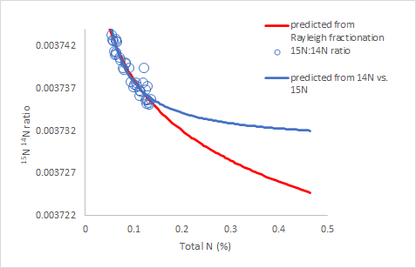
Figure S1g. The relationship between total N and either δ¹⁵N or ¹⁵N:¹⁴N ratio (the two values are perfectly correlated) in a North Aegean Sea core sample (SL 152). Both Rayleigh fraction models and predicted values from the original ¹⁴N vs. ¹⁵N equation are shown for regions where data exists and levels of total N beyond the range for which there are data points. Data after Mobius (2013).
The slope of ln total N vs. δ¹⁵N (Figure S1h) defines the Rayleigh fractionation factor for core NS 14. This figure is a copy of the fifth panel in Figure 4 from Mobius (2013). In Figure S1i there is a concave ¹⁴N vs. ¹⁵N relationship with a statistically significant positive y-intercept for core NS 14. The x² term for a polynomial best-fit equation is statistically significant, and spline smoothed cubic derivatives decrease with increasing ¹⁴N. Therefore, differences in ¹⁵N:¹⁴N ratio are driven by differences in both total N and ¹⁴N vs. ¹⁵N function curvature. Both the Rayleigh and changing source models fit total N vs.¹⁵N:¹⁴N ratio for the region where data exists (Figure S1j).
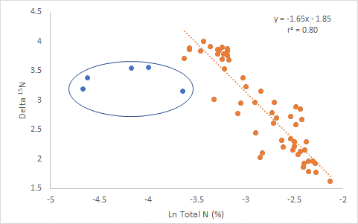
Figure S1h. The relationship between ln total N and δ¹⁵N in a North Aegean Sea core sample (NS 14). This figure matches the fifth panel in Figure 4 in Mobius (2013). The marked data (blue points) were considered outliers by the original author and are excluded from linear regression. Scattering of these outlier points from the oldest core section are attributed to enhanced lithogenic sediment supply (and hence dilution) in the nearshore environment. Data after Mobius (2013).
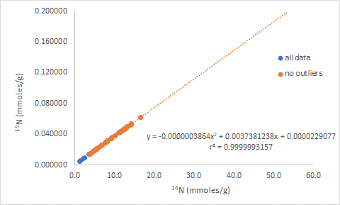
Figure S1i. The relationship between ¹⁴N vs. ¹⁵N in a North Aegean Sea core sample (NS 14) for the non-outlier data points (orange) in Figure S1h. Unlike data from core SL 152 in Figure S1b (which is described by a linear ¹⁴N vs. ¹⁵N function), the relationship for core NS 14 is defined by a concave polynomial with statistically significant x² terms (p = 0.0111) and a positive y-intercept (p = 0.0512). The spline smoothed cubic derivative (data not shown) for the same data generally declines with increasing ¹⁴N, thus supporting the concave curvature. To assist in later discussions the regression line has been extended beyond the data points. Data after Mobius (2013).
-
Levels for total N beyond the range of the data points for core NS 14 are included in Figure S1k. For a changing source model (blue line in Figure S1k) defined by a concave ¹⁴N vs. ¹⁵N equation with a positive y-intercept, ¹⁵N isotopic expressions continue to decline at a rate faster than the Rayleigh fractionation model. In datasets where concave ¹⁴N vs. ¹⁵N relationships exist with positive y-intercepts that include points over a wide total element range, declining isotopic expressions that match the less steep Rayleigh model are mathematically impossible.
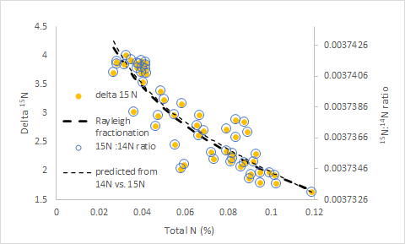
Figure S1j. The relationship between total N and either δ¹⁵N or ¹⁵N:¹⁴N ratio (the two values are perfectly correlated) in a North Aegean Sea core sample (NS 14). The Rayleigh fractionation predicted relationship, and values predicted from the original polynomial ¹⁴N vs. ¹⁵N plot both reasonably predict changing isotopic composition. Data after Mobius (2013).-
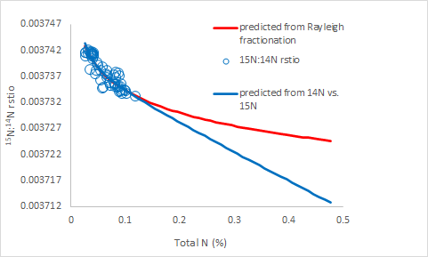
Figure S1k. The relationship between total N and either δ¹⁵N or ¹⁵N:¹⁴N ratio (the two values are perfectly correlated) in a North Aegean Sea core sample (NS 14). Both Rayleigh fraction models and predicted values from the original ¹⁴N vs. ¹⁵N equation are shown for regions where data exists and levels of total N beyond the range for which there are data points. For a changing source model defined by a concave ¹⁴N vs. ¹⁵N equation, with a positive y-intercept, ¹⁵N isotopic expressions continue to decline at a rate greater than the Rayleigh fractionation model. Data after Mobius (2013).
-
For the fractionation model ¹⁵N:¹⁴N ratios are underestimated at high N concentrations when compared to the constant source model (Figure S1g). The ¹⁵N:¹⁴N ratio predictions for the fractionation model are overestimated at high N concentration when compared to the increasing depletion source model (Figure S1k). If fractionation, rather than changing sources, created the polynomial denominator vs. numerator function (Figure S1i) and ln total concentration vs. isotopic ratios indeed quantify fractionation, one would expect the two models to predict similar isotopic ratios.
The type of relationship between denominator and numerator isotope will predict whether isotopic sources (or endogenous losses) are related to observed ratios (Moots et al. 2024a, Table S1). Function type also determines if linear ln total isotope vs. isotopic ratio relationships can occur. In convex denominator vs. numerator relationships with negative y-intercepts and concave relationships with positive y-intercepts, sources are respectively positively and negatively related to observed ratios. For constant source systems, sources and observed ratios are always unrelated. Convex denominator vs. numerator relationships with positive y-intercepts and concave denominator vs. numerator relationships with negative y-intercepts also produce sources and observed ratios that are usually unrelated to each other. This occurs for the latter two function types because relationships between total isotope and an isotopic ratio produce complex U-shaped or inverted U-shaped patterns (Moots et al. 2024a, Table S1). Stated another way, in systems with an increasingly enriched source as total element increases (convex denominator vs. numerator function), a linear Rayleigh fractionation function will be produced if it has a background lower than the initial source (negative y-intercept), but not if the background is higher (positive y-intercept). Similarly, a system with a source that is becoming more depleted as total element increases (concave denominator vs. numerator function) will produce a linear Rayleigh fractionation function if it has a background higher than the initial source (positive y-intercept), but not if the background is lower (negative y-intercept). The fact that backgrounds rather than whether isotopic discrimination occurs determines if a linear Rayleigh function exists is troubling.
Rayleigh function relationships can also occur with constant sources that do not suggest fractionation. Fractionation can also produce denominator vs. numerator curvature without producing Rayleigh function relationships. The first six simulation points in (Moots et al. 2024a Figure S5a) where ⁸⁷Sr:⁸⁶Sr ratios rapidly decline even though the simulation source is increasing suggest fractionation when it does not occur. The ln total Sr vs ⁸⁷Sr:⁸⁶Sr ratio for the modified constant-source, sea-spray dataset also with a constant source (main text; Figure 1a), produces a Rayleigh fractionation relationship, that although not perfectly linear, is exceptionally strong (r² = 0.9865), even though source and observed ⁸⁷Sr:⁸⁶Sr ratio are unrelated (p = 0.528).
In Figure S1l, the relationships between ln total N and both observed ratios and y-intercept corrected ¹⁵N:¹⁴N ratios in a North Aegean Sea core sample (SL 152) are shown. The y-intercept corrected values remove total N confounding effects and again demonstrate that the source is constant as total N changes. The results in Figure S1l for the observed ratios are similar to the results in Figure S1b. However, since ¹⁵N:¹⁴N ratios rather than ð values are presented on the y-axis fractionation, the slope (-0.00000870), is defined in ¹⁵N:¹⁴N ratio units. There is no relationship between ln total N and y-intercept corrected ratio values.
The ratio units in Figure S1l allow a comparison of the Rayleigh fractionation factor with an alternate approach to assessing fractionation. Figure S1m presents the results of directly calculating fractionation factors as the difference between the source (or in this case loss ratio and observed ratios in Figure S1e. These directly calculated fractionation values although variable (increasing with total or ¹⁴N) have a mean that approximates Rayleigh fractionation slopes calculated in Figure S1l. The constant Rayleigh fractionation factor, calculated as the slope of the ln total N vs. observed ratio, must mathematically differ from the ¹⁴N dependent source minus observed ratio calculated discrimination factor (both shown in Figure S1m). The relationship between total N and the ¹⁵N:¹⁴N observed ratio is not linear (Figure S1n). A Rayleigh plot (Figure S1l) linearizes the total N vs. observed ratio relationship (shown in Figure S1n; orange points) with a slightly higher r² value than the original linear fit (r² = 0.921 vs. 0.893) shown in Figure S1n, but the true relationship is defined by the 1/x function (r² = 0.972, also shown in Figure S1n). This 1/x function matches the traditional Keeling plot equation. The Rayleigh plot does not accurately describe the true relationship between total N and observed ratios.
The same changing fractionation factor result can be simulated (shown in Figure S1n) by using the equation listed in Figure S1d to create a “perfect” ¹⁴N vs. ¹⁵N dataset where the ¹⁴N vs. ¹⁵N relationship has an r² of 1.0 and ¹⁴N values in the real dataset are sorted to gradually decrease with depth. When apparent fractionation factors are calculated for the artificial simulated data, the ¹⁴N vs. fractionation factor curve is an exact match to the real data (Figure S1m), even though there is no fractionation in the artificial simulated dataset. The ¹⁴N vs. ¹⁵N relationship is perfectly linear implying a constant source. Since observed ¹⁵N:¹⁴N ratios (substrate) must be related to the denominator of the ratio (y/x = (1/x) b +m), and discrimination factors are defined as the constant source minus observed ratios, directly calculated discrimination factors must be perfectly related to the denominator. Fractionation factors are perfectly correlated to ¹⁴N (r² = 1.0) suggesting that apparent differing microbial preferences with depth (Figure S1o) that sometimes exhibit large differences over very short distances are entirely driven by total N differences.

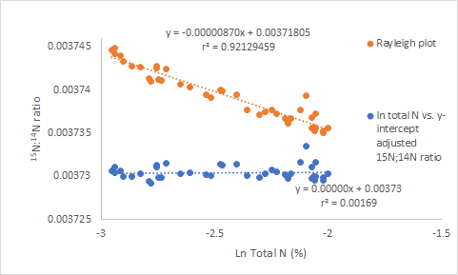
Figure S1l. The relationship between ln total N and both observed and y-intercept corrected ¹⁵N:¹⁴N ratios in a North Aegean Sea core sample (SL 152). Data shown is for the same points in Figure S1b except ¹⁵N:¹⁴N ratios are plotted on the y-axis rather than the original observed δ¹⁵N values. The slope for the observed ratios defines the Rayleigh fractionation factor in isotopic ratio rather than delta units but still explains the increase in ¹⁵N enrichment with declining organic matter and the covarying decline in total N. Data after Mobius (2013).
-
There are two possible conclusions: 1) Fractionation factors are not constant but both increase and decrease with changing depth (Figure S1o). As total N decreases there is more discrimination (fractionation factor more negative) against ¹⁵N. This implies that the ¹⁵N:¹⁴N loss ratio is constantly changing as microbes are exposed to different amounts of total N sometimes over small distances. This is unlikely since simulations with no discrimination produce similar perfect ¹⁴N vs. fractionation factor relationships (Figure S1m). A more likely explanation 2) is that there is not a fractionation change where microbes release products with different ¹⁵N:¹⁴N ratios depending on total N. Instead, the apparent fractionation patterns revealed in Figure S1o, are as expected for a system that has a relatively constant ¹⁵N:¹⁴N loss ratios regardless of changing total N content and covarying ¹⁵N:¹⁴N ratios in the substrate.
In current fractionation theory, substrates and sources both differ and are related to each other. It is quite possible there is no relationship between substrate and source (Figure S1e). Before either assuming that isotopic ratio differences between a source and observed ratios are caused by fractionation, or that fractionation has not occurred, it is crucial to fully evaluate all possibilities.
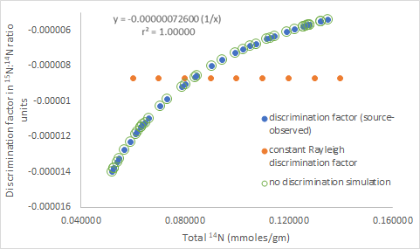
Figure S1m. The relationship between total N and discrimination factors in ¹⁵N:¹⁴N ratio units for a North Aegean Sea core sample (SL 152). Changing discrimination factors were calculated as the difference between source (y-intercept corrected ratios) and observed ratios shown in Figure S1e. These changing fractionation factors are perfectly related to total N. Results from an artificial simulation using the same equation for the real data (shown in Figure S1d and the constant Rayleigh discrimination factor derived from the slope in Figure S1l is also presented. Data after Mobius (2013).
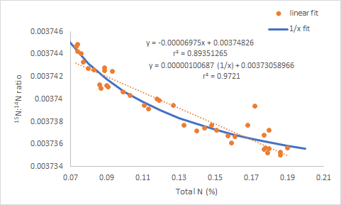
Figure S1n. Linear and 1/x best fit equations for the relationship between Total N and ¹⁵N:¹⁴N ratio for a North Aegean Sea core sample (SL 152). Data after Mobius (2013).
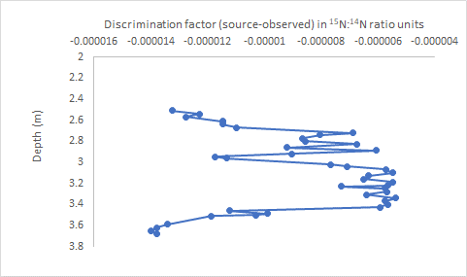
Figure S1o. The relationship between discrimination factors in ¹⁵N:¹⁴N ratio units and sediment depth for a North Aegean Sea core sample (SL 152). Discrimination factors were calculated as the difference between y-intercept corrected ratio sources and observed ratios shown in Figure S1e. The pattern is an exact match to the total N with depth pattern presented in Figure S1c. Data after Mobius (2013).
4.2 Study 2) Different C levels Confound the Interpretation of Isotopic Fractionation in Soils
Figure S1e for the Mobius (2023) fractionation re-evaluation study presents a very different mechanism than what is generally accepted for how older more decayed sediments become relatively more enriched in ¹⁵N:¹⁴N than younger sediments. Rather than constant fractionation factors causing decaying substrate to become more enriched in ¹⁵N:¹⁴N while various amounts of relatively depleted NH₄⁺ is released during decay, Figure S1e suggests that, for the Aegean Sea sediments, NH₄⁺ released during decay has a constant depleted ¹⁵N:¹⁴N ratio regardless of substrate ¹⁵N:¹⁴N ratio. There is not a constant difference between substrate and product ¹⁵N:¹⁴N ratios caused by microbial preference for the light (¹⁴N) isotope. The same argument could apply to ¹³C:¹²C ratios in soils.
Wang et al. (2015) studied carbon isotope fractionation in soil profiles from 27 different sites on the south-eastern side of the Tibetan Plateau. They point out that understanding carbon fractionation is crucial in modelling global carbon cycling. Sixty of 75 soil profiles with trends of decreasing C concentration and increasing ð¹³C with soil depth were evaluated. An example is presented in Figure S2a. The ¹⁴C derived ages of soil C generally increase with soil depth as C concentration decreases and ¹³C:¹²C ratios become more enriched (Liu et al. 2020), presumably caused by discrimination against the ¹³C isotope (¹³C left behind).
Data from the first five depths (organic matter almost disappears at depths > 40 cm) were digitally extracted from Figure S2a and appear in Table S1. Also presented are the necessary data needed to conduct loss analyses derived from the original organic carbon concentration and ð¹³C values. This small dataset is sufficient to demonstrate the principles involved and all data can be easily recalculated should the reader wish to check the accuracy of the values. Also shown in Table S1 are regression equations between various columns that are necessary to produce the source (or in this case loss analyses) summarized in Figure S2b.
Five different estimates of how losses change with soil depth are presented in Figure S2b. Estimates are the ¹²C vs. ¹³C slope; y-intercept corrected ratios; both traditional 1/C (mg/g units) and 1/¹²C (mmole/g units) mixing lines; and spline smoothed cubic derivatives of the ¹²C vs. ¹³C relationship. All but the derivative source estimates closely agree with the observed values for the surface leaf litter at depth zero. This is consistent with rapid turnover with similar input and loss ¹³C:¹²C ratio. The traditional 1/C concentration vs. ð¹³C y-intercept value for respired CO₂ (ð¹³C value of ~ -27 corresponds to a ¹³C:¹²C ratio of 0.010867). This ¹³C:¹²C ratio is an exact match to the y-intercept of the 1/¹²C mixing line (mmole units) loss. The soil respiration ð¹³C value is also close to what Pataki et al. (2005) reported for ecosystem respiration in tropical and temperate conifer forests (~-25.5).
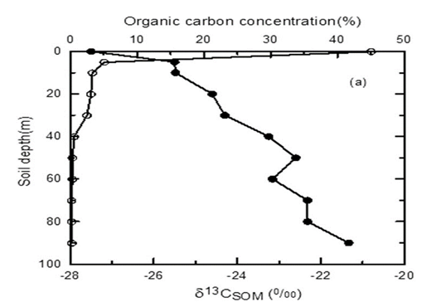
Figure S2a. Changes in ð¹³C (closed circles) and soil organic matter (SOM) (open circles) with soil depth (cm) for a representative soil profile on the eastern slope, Mount Gongga, of the Tibetan Plateau. Note that the ð¹³C and carbon concentration values at depth zero are for the surface leaf litter. The figure shown is an exact copy of Figure 2 from Wang et al. (2015).
-
The slope and mixing line loss estimates suggest a constant loss ¹³C:¹²C ratio for the CO₂ that is presumably released as organic matter decays regardless of the ¹³C:¹²C ratio of the substrate. Therefore, older organic materials become more enriched. The y-intercept corrected loss ratios (Figure S2b), although more variable than slope or mixing line data, also suggest a similar result. This is consistent with constant ¹⁵N:¹⁴N loss ratios regardless of substrate ¹⁵N:¹⁴N ratios revealed in Figure S1e for the Mobius fractionation study (2013).
The x² terms for the concave polynomial best-fit ¹²C vs. ¹³C function for either all five points or excluding the surface point are not statistically significant (p = 0.199 and 0.266 respectively). The spline smoothed cubic derivative (Figure S2b) values, however, do suggest that the ¹³C:¹²C loss ratios are not constant. The derivative suggests that for the two surface depths there are only small differences between observed ratios and sources. However, for the deeper samples, the derivative suggests that ¹³C:¹²C ratios of CO₂ released from decaying organic matter is relatively constant regardless of substrate ¹³C:¹²C ratios and always more depleted.
The relationship between ln total C and both observed and y-intercept corrected ¹⁴C:¹³C ratios are shown in Figure S2c for the same soil profile points in Figure S2b from the eastern slope, Mount Gongga, of the Tibetan Plateau. Again, since ¹³C:¹²C ratios rather than ð C values are presented on the y-axis, the fractionation factor slope (-0.000010829) is defined in ¹³C:¹²C ratio units. As was the case for the y-intercept corrected ¹⁵N:¹⁴N ratios (Figure S1l), ¹³C:¹²C loss ratios do not change with ln total N.
If Rayleigh fractionation factors are calculated using ð¹³C on the y-axis with the same five points in Figure S2c, the slope of -0.938 is similar to the nine-point slope (-1.05370) Wang et al. (2015) indirectly calculated (see their Figure 4 and original text for details). It is not surprising that a significant negative relationship occurs in the Raleigh plot whether or not fractionation occurs. Backgrounds are greater (positive y-intercept) than the constant source and ¹³C:¹²C ratios must decrease with total C (which means observed ratios are negatively related to total C).
Apparent fractionation could also be calculated directly as the source (y-intercept corrected values shown in Figure S2b) – (observed ratios also shown in Figure S2b). Similar calculations can be calculated as the source (spline smoothed derivative values also shown in Figure S2b) – (observed ratios also shown in Figure S2b). When this is done, apparent fractionation increases with total C as shown in Figure S2d. The constant Rayleigh fractionation value calculated in Figure S2c (-0.000010829) is included within the range of, the changing direct calculations. This implies that the apparent fraction is not constant but changes with depth as shown in Figure S2e.
The Himalayan plateau carbon data presents phenomena similar to the Aegean Sea nitrogen evaluation in sediments. The change with depth for Aegean Seain apparent fractionation factors (Figure S1l) is driven by differences in total N and may not be a real fractionation phenomenon. The relationship between calculated fractionation factors and total N is perfect (r² = 1.000). For the carbon data apparent fractionation differences with depth (Figure S2d; y-intercept corrected source values – observed value ) is driven by total C and may not be a real fractionation phenomenon. The relationship between calculated fractionation factors and total C is also perfect (r²=1.000)

Table S1. Changes in ð¹³C and soil organic matter (SOM) with soil depth for a representative soil profile on the eastern slope, Mount Gongga, of the Tibetan Plateau. Note that the ð¹³C and carbon concentration values at depth zero are for the surface leaf litter. Data from the first five depths (organic matter almost disappears at deeper depths) were digitally extracted from Figure S2a. Additional values calculated from ð¹³C and C concentration values that can be used in source analyses (in this case loss analyses) are also included. At the bottom of the table, important source regression analyses are shown. Data after Wang et al. 2015.
depth C conc 1/C conc ðC atom % C conc ¹³C ¹²C 1/¹²C ¹³C:¹²C y-intercept y-intercept spline
adjusted ¹³C adjusted smoothed
¹³C:¹²C derivative
(cm) (%) (%⁻¹) (permil) (%) (mM/g) (mM/g) (mM/g) (mM/g)⁻¹ (mM/g)_______________________________________
0 | 45.5 | 0.021978 | -27.5 | 1.0981570 | 37.881942 | 0.41614179 | 37.47842 | 0.026685 | 0.0111035 | 0.4160696 | 0.01110158 | 0.011096
5 | 4.75 | 0.210526 | -25.5 | 1.0041544 | 3.9547082 | 0.04353271 | 3.912493 | 0.255616 | 0.0111265 | 0.0434605 | 0.01110813 | 0.011132
10 | 3 | 0.333333 | -25.7 | 1.0100189 | 2.4977104 | 0.02748871 | 2.471054 | 0.404725 | 0.0111243 | 0.0274165 | 0.01109505 | 0.011106
20 | 2.5 | 0.4 | -24.7 | 1.1013188 | 2.0814254 | 0.02293077 | 2.059119 | 0.485676 | 0.0111358 | 0.0228585 | 0.01110075 | 0.011099
30 | 2 | 0.5 | -24.2 | 1.1018834 | 1.6651403 | 0.01835402 | 1.647341 | 0.607098 | 0.0111416 | 0.0182818 | 0.01109776 | 0.011099
1/C conc vs. ðC 1/C vs. ¹³C:¹²C 1/¹²C vs. ¹³C:¹²C
all depths ¹²C vs. ¹³C y = 6.5259x -27.433 y = 0.00007534x + 0.01110428 y = 0.00006205x +0.0110428
y = 0.01110161x + 0.00007223 r² = 0.91073043 r² = 0.91073182 r² = 0.9107315
r² = 0.99999999
exclude surface ¹²C vs. ¹³C
y = 0.01087859x + 0.00003443
r² = 0.9999991
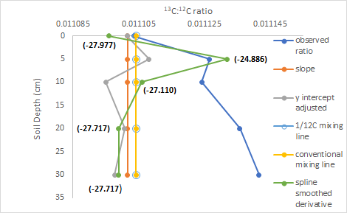
Figure S2b. Observed ¹³C:¹²C ratios and five different source estimates plotted vs. depth for a representative soil profile on the eastern slope, Mount Gongga, of the Tibetan Plateau. The five sources are the the ¹²C vs. ¹²C slope, y-intercept corrected ratios, both traditional 1/total C (mg/g units) and 1/¹²C (mmole/g units) mixing line y-intercepts, and spline smoothed cubic derivatives. The numbers in parentheses adjacent to derivative ratio points indicate the corresponding ð values at a given depth. Note that the ð¹³C and carbon concentration values at depth zero are for the surface leaf litter. Data after Wang et al. (2015).
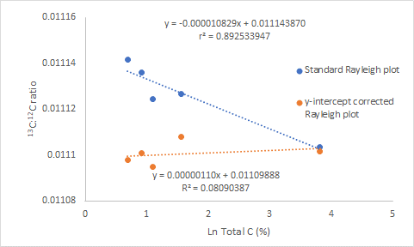
Figure S2c. The relationship between ln total C and both observed and y-intercept corrected ¹³C:¹²C ratios for a representative soil profile on the eastern slope, Mount Gongga, of the Tibetan Plateau. The slope for the observed ratios defines the Rayleigh fractionation factor in isotopic ratio rather than delta units but still explains the increase in ¹³C enrichment with declining organic matter and the covarying decline in total C. Data after Wang et al. (2015).
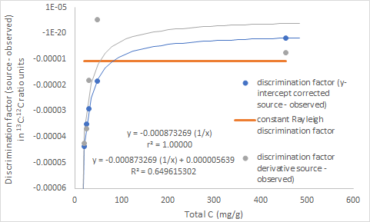
Figure S2d. The relationship between total C and discrimination factors in ¹³C:¹²C ratio units for a representative soil profile on the eastern slope, Mount Gongga, of the Tibetan Plateau. Changing discrimination factors were calculated in two different ways: 1) as the difference between y-intercept corrected ratio sources (presented in Figure S2b) and observed ratios, and 2) as the difference between derivative derived ratio sources (also presented in Figure S2b) and observed ratios. The constant Rayleigh discrimination factor derived from the slope in Figure S2c is also presented. Data after Wang et al. (2015).
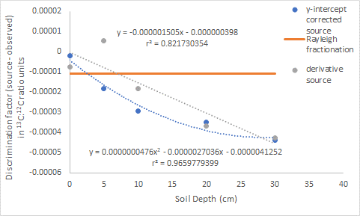
Figure S2e. The relationship between soil depth and discrimination factors in ¹³C:¹²C ratio units for a representative soil profile on the eastern slope, Mount Gongga, of the Tibetan Plateau. Discrimination factors were calculated in two different ways: 1) as the difference between y-intercept corrected ratio sources (presented in Figure S2b) and observed ratios, and 2) as the difference between derivative derived ratio sources (also presented in Figure S2b) and observed ratios. Data after Wang et al. (2015).
-
As previously stated for the Mobius (2013) sediment example there are two possible conclusions: 1) Fractionation factors are not constant but decrease with increasing depth. It is possible that at the deeper depths, the carbon in soil layers is older and therefore more enriched in ¹³C as depleted ¹³C is increasingly preferentially removed. This is unlikely. A better alternate explanation (2) is that there is no fractionation, rather the patterns revealed are as expected for a system that has a relatively constant ¹³C:¹²C loss ratio at deeper depths even though the substrate varies in ¹³C:¹²C ratio. The more enriched substrate in deeper, older and smaller amounts of organic matter that results from a constant depleted ¹³C:¹²C loss ratio would create a situation where the differences between observed ¹³C:¹²C ratios and a constant source will increase over time with decreasing C concentration and increasing age that is associated with increasing soil depth.
Alternate mechanisms may explain more enriched ¹³C:¹²C and ¹⁵N:¹⁴N for older organic matter, rather than standard constant fractionation explanations. However, two examples do not justify a change in thinking. How important these alternate mechanisms are is beyond our scope. The above exercise does demonstrate how supplementing traditional fractionation studies with loss analyses provides more insight.

5 Discussion
Isotopic preferences (fractionation or discrimination factors) are derived from isotopic ratios. Thus, these calculated values are subject to the same limitations as ratio-based expressions. Total N differences confound the interpretation of ¹⁵N fractionation studies in sediments. Total C confounds ¹³C:¹²C fractionation studies in soils. Although fractionation phenomena may occur, total element-driven changes in isotopic ratios make traditional fractionation evaluations, such as those conducted for N with the Aegean Sea and for C from soil profiles from the Tibetan plateau data suspect. Apparent fractionation can have alternate explanations. There may not be a constant microbial preference for lighter common isotopes defined by a constant fractionation factor. Rather, significant Rayleigh fractionation factors could be caused by relatively constant ¹⁵N:¹⁴N or ¹³C:¹²C loss ratios even though substrate isotopic ratios vary with depth.
Constant sources revealed by denominator vs. numerator slopes for linear functions or mixing lines do not reveal whether total net N or C change in the system increases or decreases. A Rayleigh fractionation factor (a simple ln total N or C vs observed ratios) could be calculated for either a system with decreasing or increasing total N. A fractionation factor calculated from a system with increasing N makes no since because there is not a decomposing substrate. In the Mobius (2013) and Wang et al. (2015) studies the declining total element assumption is likely met. Mobius (2013) purposely selected a system where long-term N losses were suspected. Declining C in deeper layers in a soil system is also likely due to increased long-term losses (Liu et al. 2020).
Including source analyses provides more information than traditional ratio-based isotopic fractionation assessments alone. There is certainly no harm in conducting both ratio-based inferences and source evaluations. The consequences of relying solely on ratio-based expressions have wide application. Mathematical principles suggest there is no reason to expect that isotopic ratios would somehow be immune to ratio issues that have been discussed in the literature for over 100 years. Fractionation factors calculated from confounded observed isotopic ratios are subject to error. Real isotopic datasets confirm what one would expect.

6 Conclusion
We have supplemented our discussion of mathematical theory, theoretical examples and simulations (Moots et al. 2024a), with re-analyses of N and C isotope datasets dealing with fractionation evaluations. Ratio-based isotopic expressions will likely cause interpretation difficulties in fractionation studies since fractionation factors are directly calculated from confounded ratios. For both C and N re-evaluations theoretical predictions and expectations are demonstrated.
Rayleigh factors are influenced by total isotope concentrations and the type of relationship between isotopic ratio denominator and numerator. Perfectly linear denominator vs. numerator functions with non-zero y-intercepts (constant sources) can produce discrimination factors when no fractionation exists. Convex polynomial functions with negative y-intercepts and concave polynomial functions with positive y-intercepts can produce statistically significant Rayleigh fractionation slopes. Convex polynomial functions with positive y-intercepts, and concave polynomial functions with negative y-intercepts often do not. The fact that backgrounds determine whether Rayleigh fractionation occurs for curvilinear functions rather than effects of changing sources is troubling.
Traditional Keeling plots, other forms of mixing diagrams, or an analysis of the relationship between ratio denominator and numerator concentrations or content should be evaluated for isotopic datasets. Source evaluations (relatively rare in the isotopic literature, even when total element concentrations are measured) allow researchers to better understand and interpret isotopic studies and should always accompany isotopic ratio data.
One will never know whether a dataset has errors related to ratio-based expressions unless it is evaluated. Unfortunately, we estimate that over half of C and N isotopic publications, including those that deal with fractionation evaluations, do not include measurements of total C and N which are required to fully evaluate isotopic data. Fractionation studies need to be more carefully evaluated.

FUNDING DETAILS
No external grant funds directly supported this effort. Rather, years of tangential thinking

associated with many projects lead to this research.

DISCLOSURE STATEMENT
None of the co-authors have associations or affiliations that would lead to financial benefit from the publication of this document.

References
Balesdent J, Mariotti A (1996) Measurement of soil organic matter turnover using 13C natural abundance. In: Boutton ETW, Yamasaki S (eds) Mass spectrometry of soils. Marcel Dekker, New York, pp 83–112
Banner, J. L., Musgrove, M., Edwards, R. L., Asmerom, Y., Hoff, J. A. (1996), “High- Resolution Temporal Record of Holocene Ground-Water Chemistry: Tracing Links between Climate and Hydrology,” Geology, 24, 1049-1052, DOI: 10.1130/0091-7613(1996)024<1049:HRTROH>2.3.CO;2.
Blair N, Leu A, Munoz E, Olsen J, Kwong E, Desmarais D (1985), Carbon isotopic fractionation in heterotrophic microbial metabolism. Appl Environ Microbiol 50:996–1001
Caut, S., Angulo, E., and Courchamp, F. (2009), “Variation in Discrimination Factors (Δ¹⁵N and Δ¹³C): The Effect of Diet Isotopic Values and Applications for Diet Reconstruction,” Journal of Applied Ecology, 46, 443-453, DOI: 10.1111/j.1365-2664.2009.01620.x.
Heckman, K.A., Nave, L.E., Bowman, M., Gallo, A., Hatten, J.A., Matosziuk, L.M., Possinger, A.R., SanClements, M., Strahm, B.D., Weiglein, T.L. and Rasmussen, C., (2021). Divergent controls on carbon concentration and persistence between forests grasslands of the conterminous US. Biogeochemistry, 156, pp.41-56. Biogeochemistry DOI: 10.1007/s10533-021-00856-x
Keeling, C. D. (1958), “The Concentration and Isotopic Abundances of Atmospheric Carbon Dioxide in Rural Areas,” Geochimica et Cosmochimica, 13, 322-334, DOI: 10.1016/0016-7037(58)90033-4.
Kendall, C., and Caldwell, E. A. (1998), “Fundamentals of Isotope Geochemistry,” In Isotope Tracers in Catchment Hydrology, London, UK. Elsevier, pp. 51-86.
Lerch, T. Z., Nunan, N., Dignac, M. F., Chenu, C., & Mariotti, A. (2011). Variations in microbial isotopic fractionation during soil organic matter decomposition. Biogeochemistry, 106, 5-21, DOI:10.1007/s10533-010-9432-7
Liu, X., Zou, X., Cao, M., and Luo, T. (2020). Organic carbon storage and ¹⁴C apparent age of upland and riparian soils in a montane subtropical moist forest of southwestern China. Forests, 11(6), 645.
Mariotti, A., Germon, J. C., Hubert, P., Kaiser, P., Letolle, R., Tardieux, A., et al. (1981), “Experimental Determination of Nitrogen Kinetic Isotope Fractionation: Some Principles; Illustration for the Denitrification and Nitrification Processes,” Plant and Soil, 62, 413-430, DOI: 10.1007/BF02374138.
Mobius, J. (2013), “Isotope Fractionation during Nitrogen Remineralization (Ammonification): Implications for Nitrogen Isotope Biogeochemistry,” Geochimica et Cosmochimica Acta, 105, 422-432, DOI: 10.1016/j.gca.2012.11.048.
Moots, K. Nguyen, C. P Nguyen C. Camacho, F., Lindstrom, D., and Righetti, T, L. (2024a). A mathematical explanation for why ratio-based isotopic analyses are commonly misleading: Theory. Scientific Reports this issue .
Moots, K. Nguyen, C. P Nguyen C. Camacho, F., Lindstrom, D., and Righetti, T, L. (2024b). A mathematical explanation for why ratio-based isotopic analyses are commonly misleading: Dealing with Confounded Isotopic Ratios. Scientific Reports this issue .
Pataki, L., Ehleringer, J. R., Flanagan, L. B., Yakir, D., Bowling, D. R., Still, C. J., et al. (2003), “The Application and Interpretation of Keeling Plots in Terrestrial Carbon Cycle Research,” Global Biochemical Cycles, 25, 1-14, DOI: 10.1029/2001GB001850.
Rayleigh O.M. F.R.S. (1902) LIX., “On the distillation of binary mixtures,” The London, Edinburg, and Dublin Philosophical Magazine and Journal of Science, 4:23, 521-537, DOI: 10.1080/14786440209462876
Rumpel, C., Kogel-Knaber, I., and Brun, F. (2002) Vertical distribution, age and chemical comparison of organic carbon in two forest soils of different pedogenesis. Organic Geochemistry,33 (10), 1131-1142.
Wang, G., Yufu, J., and Wei, L. (2015), Effects of environmental and biotic factors on carbon isotopic fractionation during decomposition of soil organic matter. Sci. Rep. 5, 11043; DOI: 10.1038/srep11043.
Weiglein, T.L., Strahm, B.D., Bowman, M.M., Gallo, A.C., Hatten, J.A., Heckman, K.A., Matosziuk, L.M., Nave, L.E., Possinger, A.R., SanClements, M.D. and Swanston, C.W., 2022. Key predictors of soil organic matter vulnerability to mineralization differ with depth at a continental scale. Biogeochemistry, 157, pp.87-107.DOI: 10.1007/s10533-021-00856-x
Wick, L.Y., Pasche, N., Bernasconi, S.M., Pelz, O., Harms, H., (2003) Characterization of multiple-substrate utilization by anthracene-degrading Mycobacterium frederiksbergense LB501T. Appl Environ Microbiol 69:6133–6142
Whitledge, G. W., and Rabeni, C. F. (1997), “Energy Sources and Ecological Role of Crayfishes in an Ozark Stream: Insights from Stable Isotopes and Gut Analysis,” Canadian Journal of Fisheries and Aquatic Sciences, 54, 2555-2563, DOI: 10.1139/f97-173.
Wynn J.G., Bird M.I., Wong V.N.L., (2005) Rayleigh distillation and the depth profile of ¹³C/¹²C ratios in soil organic carbon from two soils in Iron Range National Park, Far North Queensland, Australia. Geochim Cosmochim Acta 69:1961–1973
Wynn J.G., Harden J.W., Fries T.L., (2006) Carbon isotope depth profiles and soil organic carbon dynamics in the Mississippi Basin. Geoderma 131:89–109

