Supplemental Material 2
A Mathematical Explanation for Why Ratio-Based Isotopic Analyses are Commonly Misleading: Data Re-evaluations for N, C, and S Isotopes
Abstract
Recent research suggests the interpretation of Sr isotopic studies is clearly confounded by total Sr concentration. Here we identify “ratio-problem” issues for N, C, and S, isotopes. Total N differences confound the interpretation of ¹⁵N defined trophic levels, as source analyses assign species to different trophic levels than ¹⁵N:¹⁴N ratios. Labeled ¹⁵N tracer studies in an ornamental shrub greenhouse experiment suggest species differences in uptake efficiency are a scaling effect based on total N content rather than physiological differences. Differences in sources and backgrounds for C and S isotopes in Martian sediments evaluated by the Curiosity rover that are not revealed when evaluating ratio-based expressions, were detected with source analyses. Isotopic ratio changes over time or for different conditions do not necessarily reflect source changes. Using isotopic ratios or values calculated from confounded isotopic ratios such as portion of an isotopic pool derived from a source are often misleading. Traditional Keeling plots, other forms of mixing diagrams, or analyses of the relationship between ratio denominator and numerator concentrations or content should be evaluated for all isotopic datasets. Source evaluations allow researchers to better interpret isotopic studies.
Keywords: derivatives; isotopic scaling; isotopic sources; Keeling plots; mixing diagrams

1 Introduction
A companion paper (Moots et al. 2024a) suggests isotopic ratios are not immune to ratio issues that have been discussed in the literature for over 100 years. Isotopic researchers often assume an observed isotopic ratio reflects the source of a system, but this is not true. Mathematical principles suggest that observed ratios will almost always differ from a source (Moots et al. 2024a). Keeling (1958) proposed methods for determining isotopic sources, but source evaluations on isotopic datasets are relatively rare in the isotopic literature, even when the necessary total element concentrations are available (Moots et al. 2024a).

2 Background and Motivation
Traditional mixing diagrams (1/total Sr vs. ⁸⁷Sr:⁸⁶Sr ratio); other forms of mixing diagrams (1/⁸⁶Sr vs. ⁸⁷Sr:⁸⁶Sr ratio); analyses of the relationship between ratio ⁸⁶Sr and ⁸⁷Sr concentrations or content; and d⁸⁷Sr/d⁸⁶Sr derivatives suggest that theoretical mathematical predictions occur in real Sr isotope datasets (Moots et al. 2024b Supplemental Material 1). Here we describe alternative procedures that emphasize source evaluations to better analyze non-strontium isotopic data that could suggest widespread ratio issues.

3 Methods
Data re-evaluations involving isotopic analyses of N, C and S, from the following publications are presented: (1) Moyo et al. (2021), (2) Sandrock et al. (2005), and (3) House et al. (2022) Publication (1) deals with C and N isotope evaluations to evaluate trophic levels (only nitrogen isotopes were used in our re-evaluation); Publication (2) covers a ¹⁵N depleted tracer study on ornamental plants grown in pots; Publication (3) involves an isotopic analysis of ¹³C and ³⁴S on samples collected by the Curiosity rover on Mars. Data reanalyzes are as explained in the initial Sr isotope examples (Moots et al. 2024b). However, no assumptions (required when an element has more than two isotopic species) were used when calculating denominator or numerator ratio values for N and C studies. Nitrogen and C only have two major mass isotopes. Sulfur has more than two isotope species. However, denominator vs. numerator plots were not conducted for S isotopes as traditional mixing diagrams easily defined sources. For the Moyo et al. (2021) dataset, obvious outliers (shown in Figure S1a) were removed before analysis to eliminate points statistically identified as having excessive residuals or excessive leverage, or both in ¹⁴N vs. ¹⁵N plots.
Data for the tracer study (Sandrock et al. 2005) differs from most ¹⁵N tracer studies. To avoid background and starting point concerns the authors expressed their data as N gained (and by inference ¹⁴N and ¹⁵N gained) rather than total N, ¹⁴N and ¹⁵N concentration and contents. The dry weight and total N at planting were subtracted from final measurements of dry weight and plant N to determine growth and N uptake during the experimental period. This effectively eliminates y-intercepts (background effects) forcing denominator (¹⁴N) vs. numerator (¹⁵N) functions to pass through the origin. Under these conditions, if sources change, a curvilinear function that approaches the origin (such as a power function) may better describe data. Without background concerns, more theoretically correct predictive curvilinear functions with non-zero y-intercepts that would apply to unadjusted data are not necessary.

4 Data Re-evaluations

4.1 Study 1) Total N Differences Confound the Interpretation of ¹⁵N Defined Trophic Levels
Seaside sparrows (Ammospiza maritima) and marsh rice rats (Oryzomys palustris) are two ubiquitous terrestrial vertebrates that are thought to be bioindicators of animal responses to oil spills in saltmarsh ecosystems (Moyo et al. 2021). To improve the utility of these omnivorous taxa as bioindicators, Moyo et al. (2021) used carbon and nitrogen stable isotope analyses to quantify their trophic niches in saltmarshes in coastal Louisiana (USA) with differing oiling histories. In this example, linear ¹⁴N vs. ¹⁵N relationships that produce linear mixing lines adequately explain the results.
A re-evaluation of the Moyo et al. (2021) study suggests that using ¹⁴N vs. ¹⁵N slopes provides better resolution of trophic level assignment for sparrows and marsh rats, than using either ¹⁵N:¹⁴N ratios or Bayesian statistical applications on bivariate δ¹³C vs. δ¹⁵N plots. The ¹⁵N:¹⁴N ratios and the Bayesian-statistical results for trophic position and niche width provide similar information. Bayesian defined trophic levels for various treatments are related to δ¹⁵N values over the three-year period (r² = 0.671). The r² values for year 1, 2 and 3 are 0.817, 0.978 and 0.961 respectively. Bayesian defined niche widths are related to δ¹⁵N standard errors over the three-year period (r² = 0.769). The r² values for year 1, 2 and 3 are 0.760, 0.923 and 0.989 respectively. However, δ¹⁵N values and the Bayesian approaches may not reveal sources or niche width. Simple confounded ¹⁵N:¹⁴N ratios may not quantify sources. Standard errors may not define niche width.
Expanding the analysis to include other species, mussels (Geukensia demissa), insects (Blissidae family and Prokelisia species), plants (Spartina alterniflora) and phytoplankton in the original authors’ supplemental material reveals that source analyses produce different trophic level assignments than simple ¹⁵N:¹⁴N ratios. As shown below, five different types of source analyses (slopes; y-intercept adjusted ratios; average derivatives; traditional mixing diagrams with 1/total N (in mass units) as the x-axis; and a mixing diagram with 1/total ¹⁵N (in molar units) as the x-axis that is mathematically linked to ⁸⁶Sr vs. ⁸⁷Sr plots) all produce similar interpretations. A plot of total N vs. ¹⁵N:¹⁴N ratios (Figure S1a) reveals excluded outliers.
Figure S1b presents plots of ¹⁵N vs. ¹⁴N for sparrows and march rats. Figure S1c presents similar plots for mussels, insects, plants and phytoplankton. Differences in ¹⁴N vs. ¹⁵N slope (0.0037498) and mean ¹⁵N:¹⁴N ratio (0.0037603) were greatest for phytoplankton. Two factors affect how much isotopic ratios are confounded (Moots et al. 2024a; Supplemental Material) the size of the ¹⁴N vs. ¹⁵N y-intercepts and 2) the distance of data points from the origin. The positive y-intercept is 10-fold greater for marsh rats, thus marsh rat ¹⁵N:¹⁴N ratios are more confounded than ratios for sparrows. For functions with positive y-intercepts, low values for the denominator will lead to higher ¹⁵N:¹⁴N ratios. Therefore, the ¹⁵N:¹⁴N ratio for phytoplankton, with much smaller amounts of ¹⁴N, is more confounded than ratios for other species.
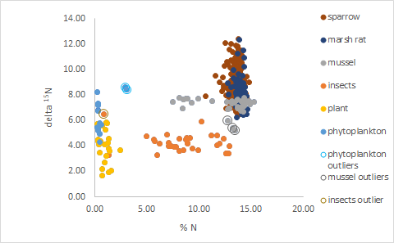
Figure S1a. The relationship between total N and ¹⁵N:¹⁴N ratio for six different organism types, revealing different distributions for a trophic level study in a Louisiana, USA marsh. Outliers in the original datasets are also shown. The remaining data was used to create Figures S1b-e. The same outliers identified above had excessive residuals or excessive leverage (or both) in ¹⁴N vs. ¹⁵N regressions. Data after supplemental material provided by Moyo et al. (2021).
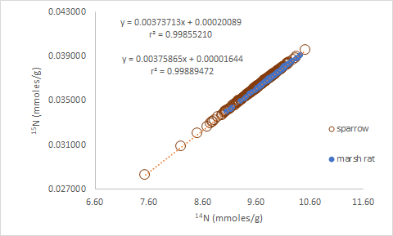
Figure S1b. The relationship between ¹⁴N vs. ¹⁵N for sparrows and marsh rats for a trophic level study in a Louisiana, USA marsh. Differences in ¹⁴N vs. ¹⁵N slope between sparrows and marsh rats (0.0037586 vs. 0.0037371) are much greater than differences in ¹⁵N:¹⁴N ratios (0.0037603 vs. 0.0037498). Data after Moyo et al. (2021).
-
All six ¹⁴N vs. ¹⁵N plots have positive y-intercepts (Figures S1b and c) for different trophic groups (phytoplankton, plants, insects, mussels, marsh rats and sparrows), suggesting that individuals with lowest ¹⁵N content could have overestimated ¹⁵N:¹⁴N ratios. An overestimate of ¹⁵N:¹⁴N ratios for low values of ¹⁴N (or total N) will bias results causing an overall overestimate of a mean. This appears to be true when comparing raw ratios to any of the source estimates presented in Figure S1d (paired Wilcoxon-test (p = 0.03125)) across all species. However, this error is only serious for phytoplankton and marsh rats where trophic positions are severely overestimated with simple ratios. This real data example is consistent with simulation estimates using combinations of y-intercept size and the distance of data points from the origin in a denominator vs. numerator plot to predict the degree of confoundedness (Moots et al. 2024a; Supplemental Material). The five different source analyses all produce similar values.

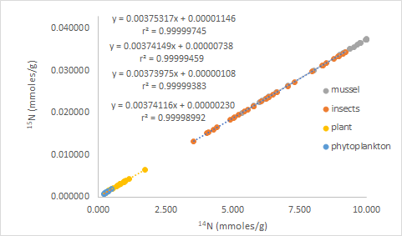
Figure S1c. The relationship between ¹⁴N vs. ¹⁵N for mussels, insects, plants and phytoplankton for a trophic level study in a Louisiana, USA marsh. Data after supplemental material provided Moyo et al. (2021).
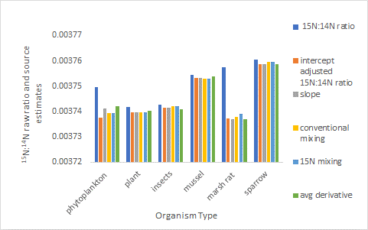
Figure S1d. A comparison of observed ¹⁵N:¹⁴N ratios with five different estimates of ¹⁵N:¹⁴N source ratio (traditional mixing diagrams with 1/total N as the x-axis; the more mathematical linked mixing diagram with 1/total ¹⁵N as the x-axis; ¹⁴N vs. ¹⁵N slopes; y-intercept adjusted ratios; and average derivatives) for six different organism types for a trophic level study in a Louisiana, USA marsh. Data after supplemental material provided by Moyo et al. (2021).
-
Figure S1e presents the relationship between spline smoothed cubic derivatives and ¹⁴N concentration for sparrows, marsh rats and mussels. There was no detectable consistent curvature (x² terms not significant) in ¹⁴N vs. ¹⁵N best-fit equations for these three species. Although average derivatives for all species closely align with other estimates of sources (Figure S1d) there is considerable variation for phytoplankton, plants and insects (data not shown) that suggests subtle changes (likely data noise) in the relationship between ¹⁴N and ¹⁵N. However, for mussel, marsh rat, and sparrow the derivatives are remarkably flat suggesting unchanging sources. For these three species, derivatives suggest very different trophic positions (sparrow > mussel >> marsh rat) than ¹⁵N:¹⁴N ratios (sparrow ≈ marsh rat > mussel). Derivatives support the differences found for the other five source analyses for these three species (Figure S1d).
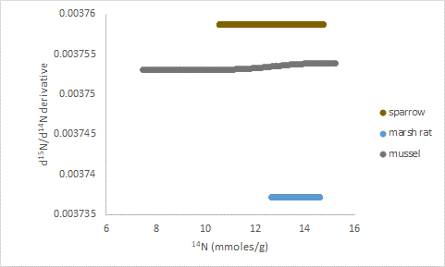
Figure S1e. The relationship between spline smoothed cubic derivatives and ¹⁴N concentration for mussels, marsh rats and sparrows for a trophic level study in a Louisiana, USA marsh. There was no detectable curvature (significant x² terms in polynomial best-fit ¹⁴N vs. ¹⁵N equations). Data after supplemental material provided by Moyo et al. (2021).
-
The original authors hypothesized that sparrows and marsh rats have similar trophic levels as they are both omnivores. With the large number of replicates (400 and 125 for sparrows and marsh rats respectively) small differences in the authors δ¹⁵N (~ 0.7 delta units) or ¹⁵N:¹⁴N ratios shown in Figure S1d are statistically significant (p < 0.05). This suggests sparrows occupy a slightly higher trophic level than marsh rats. However, when the five alternate source methods in Figure S1f are averaged, sparrows have a ¹⁵N:¹⁴N source ratio of 0.003759 vs. 0.003737 for marsh rats (an ~2.7 delta unit difference). Converting the derivatives for sparrows and marsh rats in Figure S1e to delta values indicates a delta unit difference similar to the delta difference listed above.
If one is interested in trophic levels, sources are the crucial factor to evaluate. One wants to know what different organisms eat, rather than what their often-confounded observed ratios are. Slopes or other slope-related source estimates are a better trophic level evaluation choice than confounded ratios or approaches where two possibly confounded ratios are plotted against each other. Determining how common scaling errors are among the copious isotopic trophic level studies in the literature is beyond the scope of this report.
Organism size and the covarying total N content could be important factors influencing ¹⁵N:¹⁴N ratios. There is strong theoretical (Layman et al. 2005) and observational (McGarvey et al. 2020) evidence that predators are usually larger than their prey. Villamarín et al. (2018) studying crocodilians and Jacobi et al. (2020) studying an Amazon fish (Arapaima), suggest it is possible that body size (and covarying total N) indirectly contribute to ¹⁵N:¹⁴N ratio differences between predators and prey. This could either mask or enhance trophic level induced isotopic differences. In the Villamarín et al. (2018) study, stable isotope estimates of trophic position in crocodilians are not supported by diet (stomach contents).
Whitledge and Rabeni (1997) also present data where isotopic defined trophic levels do not agree with stomach contents in crayfish (Orconectes species). This discrepancy is explained by extremely low assimilation efficiency (14%) for detritus material that constitutes over 80% of the crayfish diet. However, assimilation efficiency is much higher (~85%) for detritus in other crayfish (Austropotamobius pallipes) studies (Gherardi et al. 2004). Furthermore, even with gut-content corrections based on assimilation values, Whitledge and Rabeni’s (1997) isotopic approaches overestimate animal input and underestimate detritus input by 15% and 21% respectively. Trophic position assignment could be confounded by total N content.
The Whitledge and Rabeni (1997) example discussed above demonstrates the importance of understanding why an observed isotopic ratio for an organism and the ratio of consumed sources might differ. The use of stable isotopic techniques to study animal diets and trophic levels, therefore, often requires a priori estimates of the differences in isotopic composition between an animal and its diet (Caut et al. 2009). These differences are called discrimination or fractionation factors (Δ¹³C and Δ¹⁵N).
Pearson et al. (2003) report that N and C concentrations, tissue type (which varies in total element concentrations) and diet all influence fractionation values in yellow-rumped warblers (Dendroica coronata). Although Seminoff et al. (2006) did not evaluate the relationships in a turtle (Chelonia mydas) study, observed ð¹³C and ð¹⁵N values and the N and C fractionation factors derived from these ratio-based expressions are related to total N and C. When four tissue types (whole blood, red blood cells, plasma and epidermis) are evaluated. The r² and p values are 0.9492, p = 0.0257; 0.9619 p = 0.0171; 0.8703 p = 0.0671 and 0.9621 p = 0.0191 for C vs. ð¹³C, N vs. ð¹⁵N, C vs. Δ¹³C and N vs. Δ¹⁵N respectively (data not shown). Differences in ð¹³C, ð¹⁵N, Δ¹³C and Δ¹⁵N are indirectly driven by differences in N and C concentrations.
Fractionation factors influenced by non-diet phenomena such as taxon, environment and tissue that are difficult to interpret (Caut et al. 2009) may be due to confounded effects related to differences in total element. Unfortunately, mathematical principles previously described (Moots et al. 2024a) dictate that observed isotopic ratios will often not equal a source even with no fractionation. Moots et al. (2024a) demonstrated that an artificial ⁸⁶Sr vs. ⁸⁷Sr vs. plot with a positive y-intercept mimics isotopic fractionation as total Sr is lost from a system. However, this increase in ⁸⁷Sr:⁸⁶Sr enrichment is caused by a constant loss source that is independent of substrate levels (observed ratios) rather than constant discrimination (defined by a constant fractionation factor) that favours the light isotope. These scaling effects should be evaluated before one speculates on the importance of fractionation factors.

4.2 Study 2) Different N Levels Confound Interpretation of a Tracer Study
Knowledge of fertilizer nitrogen (N) uptake and fertilizer N uptake efficiency in container-grown nursery crops is necessary for the development of fertilizer schedules that match timing, amount, and frequency of N applications to plant N requirements. Sandrock et al. (2005) made isotopic and nonisotopic estimates of nitrogen uptake efficiency in container-grown woody ornamentals. Species evaluated were Cornus sericea, an upright dogwood, Weigela florida, a honeysuckle and Euonymus alatus, a burning bush.
Linear best-fit relationships between ¹⁴N and ¹⁵N for shoots of the three combined ornamental species grown outside in plastic pots for 345 days at five different fertilizer rates (25, 50, 100, 200, 300 ppm) are presented in Figure S2a. The high slope value for the lowest rate approaches the assumed ¹⁵N:¹⁴N background ratio (0.003676 for the atmosphere). The low slope value for the highest rate approaches the ¹⁵N:¹⁴N fertilizer source ratio (0.000500250). Different slopes for different fertilizer rates suggest a blending of sources (fertilizer N and media N) that is altered with increasing fertilizer addition. This is similar to possible blended Sr sources (basalt and seawater) for a Hawaiian soil (Moots et al. 2024b Supplemental Material 1). For the lowest N fertilizer rates presented, a mix of the two sources with more N derived from the media explains results. For higher rates a mix of the two sources with more N derived from the fertilizer is suggested. Portion of N derived from the fertilizer (NDFF) can be calculated from both standard formulas and slopes NDFF = (background slope – treatment slope) / (background slope –source slope). The portion NDFF for formula estimates are 24.3%, 45.4%, 71.6%, 84.6%, 90.4% for 25, 50, 100, 200, and 300 ppm rates, respectively. The portion NDFF for slope estimates are 11.7%, 31.4%, 64.6%, 83.6%, and 89.6% for 25, 50, 100, 200, and 300 ppm rates, respectively. Formulas produce significantly higher NDFF values than slopes for the combined species average for the three lowest application rates. The negative y-intercepts are statistically significant (p < 0.05) for the three lowest, but not the two highest, rates.
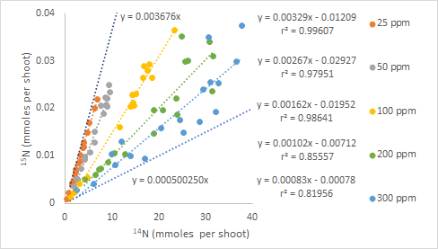
Figure S2a. Linear relationships between ¹⁴N and ¹⁵N for shoots of three ornamental species (Cornus sericea, Weigela florida, Euonymus alatus) grown outside in plastic pots for 345 days. Six replicate plants for each species were exposed to double labeled (both NH₄-N and NO₃-N) 0.05 atom % depleted ammonium nitrate at five different addition rates (25, 50, 100, 200 and 300 ppm). Data for all species are combined for each rate (18 points). The r² values are much lower than the natural abundance data previously shown. The background (far left, assumed natural abundance, 0.003676) and source (far right, converted from atom% to ratio, 0.000500250) equation lines are also presented. The negative y-intercepts are statistically significant (p < 0.05) for the three lowest, but not the two highest rates. Data after Sandrock et al. (2005).
-
A scaling effect causes an underestimate of ¹⁵N:¹⁴N ratios and an overestimate of NDFF for the lowest three rates. The smaller y-intercepts for the 200 and 300 ppm fertilizer rate functions (Figure S2a) cause only a slight overestimate of the formula calculated NDFF compared to the slope derived NDFF (84.6 vs. 83.6 = 1.15% and 90.4 vs. 89.6 = 0.892%, respectively) for 200 and 300 ppm rates compared to 108, 46 and 11% respective formula-based overestimates for the 25, 50 and 100 ppm rates.
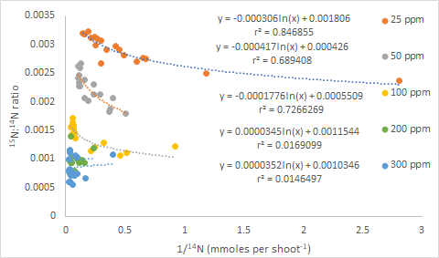
Figure S2b. Mixing diagram (1/¹⁴N vs. ¹⁵N:¹⁴N ratio) for shoots of three ornamental species (Cornus sericea, Weigela florida, Euonymus alatus) grown outside in plastic pots for 345 days. Six replicate plants for each species were exposed to double labeled 0.05 (both NH₄-N and NO₃-N) atom % depleted ammonium nitrate at five different rates (25, 50, 100, 200 and 300 ppm). Data for all three species are combined for each rate (18 points) shown. Data after Sandrock et al. (2005).
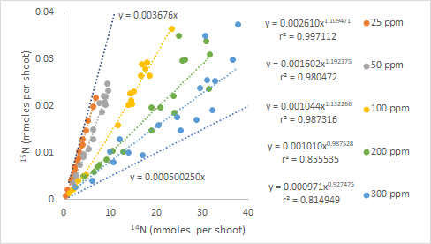
Figure S2c. The power function relationships between ¹⁴N and ¹⁵N for shoots of three ornamental species (Cornus sericea, Weigela florida, Euonymus alatus) grown outside in plastic pots for 345 days. Six replicate plants for each species were exposed to double labeled (both NH₄-N and NO₃-N) 0.05 atom % depleted ammonium nitrate at five different rates (25, 50, 100, 200 and 300 ppm). Data for all species are combined for each rate (18 points) shown. These are the same points evaluated in Figure S2a. Data after Sandrock et al. (2005).
-
Two things are amiss in the linear interpretation described above: (1) the mixing line analyses shown in Figure S2b for the three lowest rates are clearly not linear. Linear ¹⁴N vs. ¹⁵N plots must produce linear mixing lines. Nonlinear mixing lines suggest subtle curvature exists that is difficult to detect. All five rates described with linear function in Figure S2a can be fitted with a convex polynomial, but only for the 25-ppm rate is this curvature significant. (2) If this were a normal dataset, we would expect positive y-intercepts since the background (0.003676 for the atmosphere) is greater than the depleted source, rather than the negative y-intercepts observed. Data, however, was expressed as total N, ¹⁴N and ¹⁵N gain, to minimize y-intercept (background effects). A curvilinear function that approaches the origin (such as a power function) may better describe the data than the more theoretically correct curvilinear function with non-zero y-intercepts that would apply to unadjusted data. Mathematically, a perfect power function (r² = 1.0) data set (for example, one produced with the 25-ppm equation in Figure S2c, y = 0.00261x^{1.10947}), with only slight convex curvature, can be closely approximated with a linear function with a non-zero y-intercept (y = 0.0032908x - 0.0120900) with an r² value of 0.9987534. This equation is very close to the observed data in Figure S2a (y = 0.0032933x - 0.0120859, r² = 0.99607).
Mixing diagrams for the three lowest rates are not linear (Figure S2b). This suggests that the relationship between ¹⁴N and ¹⁵N is also not linear for these three treatments. The three low-rate power functions (Figure S2c) indicate convex curvature as exponents are significantly greater than one (positively allometric). Ratios increase with increasing ¹⁴N. This convex curvature has a biological interpretation. At low rates, the added and easily available depleted fertilizer is quickly consumed as total N increases. Fertilizer N disappears as plants grow. The N in the growing media becomes more important, thus shoots become relatively more enriched as total N increases. Larger plants have larger ¹⁵N:¹⁴N ratios and thus, less NDFF.
Traditional log-log scaling analyses (Figure S2d) are often used to determine if differing proportional relationships are caused by fundamental differences among species or if ratio differences are due to scaling effects (Glazier 2003). If all species’ points fall on the same log-log line, scaling rather than physiological differences account for isotopic differences among species. This analysis suggests that the significant ¹⁵N:¹⁴N ratio and NDFF differences for E. alatus are caused by scaling effects, because these differences are indirectly caused by smaller total N composition associated with smaller plant size. One should not conclude E. alatus differs in its physiology and is fundamentally more efficient. Datapoints for all species fall on the same log ¹⁴N vs. log ¹⁵N regression lines for the different fertilizer rates. Species differences in fertilizer uptake efficiency do not exist.
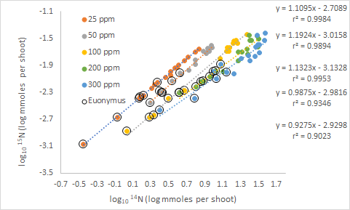
Figure S2d. A log-log plot (log₁₀ ¹⁴N vs. log₁₀ ¹⁵N) for shoots of three ornamental species (Cornus sericea, Weigela florida, Euonymus alatus) grown outside in plastic pots for 345 days. The log-log analysis is similar to what is presented by (Kerkhoff and Enquist, 2009). Six replicate plants for each species were exposed to double labeled (both NH₄-N and NO₃-N) 0.05 atom % depleted ammonium nitrate at five different addition rates (25, 50, 100, 200 and 300 ppm). Data for all species are combined for each rate (18 points). Log-log slopes are significantly different than 1.0 (p < 0.05) for the three lowest rates. The points for the smallest species (E. alatus) are marked with black circles on each treatment line. Data after Sandrock et al. (2005).
-
Figure S2e supports the conclusions suggested by the log-log plots in Figure S2d. The ¹⁵N:¹⁴N ratios for the three lowest application rates are dependent on ¹⁴N (or total N). However, this is not true at the two highest rates. Dashes with the same color after the data points refer to the original ¹⁵N vs. ¹⁴N slopes in Figure S2a. A power function denominator vs. numerator model defines the points shown. A linear model would make a similar prediction, but ¹⁵N:¹⁴N ratios would asymptotically approach the slopes presented (data not shown). However, as stated above the mixing diagram curvature (Figure S2b) suggests the original denominator vs. numerator functions are not linear for the three lowest rates.
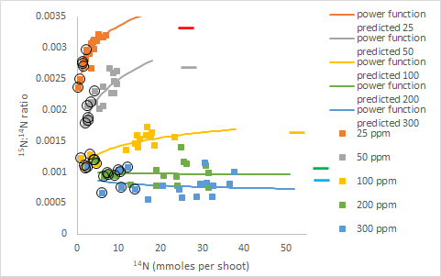
Figure S2e. Relationships between ¹⁴N and ¹⁵N:¹⁴N ratio for shoots of three ornamental species (Cornus sericea, Weigela florida, Euonymus alatus) grown outside in plastic pots for 345 days. Six replicate plants for each species were exposed to double labeled (both NH₄-N and NO₃-N) 0.05 atom % depleted ammonium nitrate at five different addition rates (25, 50, 100, 200 and 300 ppm). Also marked (large open black circles) are the values for E. alatus, the smallest species. Dashes with the same color after the data points refer to the original ¹⁵N vs. ¹⁴N slopes in Figure S2a. Data for all species are combined for each rate (18 points). Data after Sandrock et al. (2005).
-
Also marked in Figure S2e are the values for E. alatus, the smallest species, with the lowest ¹⁵N:¹⁴N ratio and the highest N derived from fertilizer (NDFF). The average ¹⁵N:¹⁴N ratios across all three species is reduced when (E. alatus) is included. The scaling effect results in an underestimation of ¹⁵N:¹⁴N ratios and an overestimation of combined species NDFF for the lowest three rates. Figures S2f-h support the above conclusions. Statistical differences among species for ¹⁵N:¹⁴N ratio (Figure S2g) and the related NDFF (Figure S2h) are caused by scaling effects. Statistical differences are likely caused by the smaller size and less total N of E. alatus (Figure S2f), rather than any physiological differences.
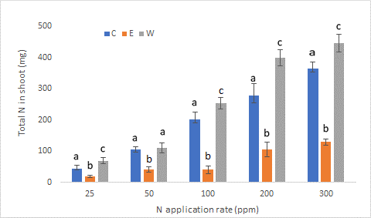
Figure S2f. Total N for shoots of three ornamental species (Cornus sericea, Weigela florida, Euonymus alatus; labeled C, W and E respectively) grown outside in plastic pots for 345 days. Six replicate plants for each species were exposed to double labeled (both NH₄-N and NO₃-N) 0.05 atom % depleted ammonium nitrate at five different addition rates (25, 50, 100, 200 and 300 ppm). Vertical bars represent ± one standard error. Values with the same letter corresponding to different species within a given fertilizer rate are not statistically significant (p < 0.05; after log transformation to meet homogeneity of variance assumptions). E. alatus is clearly much smaller and has less N content than the other two species. Data after Sandrock et al. (2005).
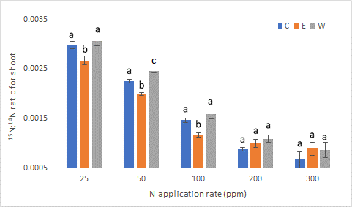
Figure S2g. The ¹⁵N:¹⁴N ratio for shoots of three ornamental species (Cornus sericea, Weigela florida, Euonymus alatus; labeled C, W and E respectively) grown outside in plastic pots for 345 days. Six replicate plants for each species were exposed to double labeled (both NH₄-N and NO₃-N) 0.05 atom % depleted ammonium nitrate at five different addition rates (25, 50, 100, 200 and 300 ppm). Vertical bars represent ± one standard error. Values with the same letter corresponding to different species within a given fertilizer rate are not statistically significant (p < 0.05; after log transformation to meet homogeneity of variance assumptions). E. alatus has a smaller ¹⁵N:¹⁴N ratio than the other two species at the three lowest N application rates. Data after Sandrock et al. (2005).
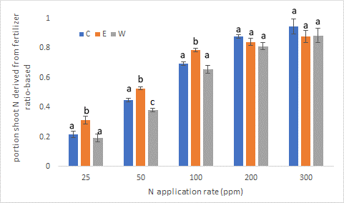
Figure S2h. The potion of N derived from the fertilizer (NDFF) for shoots of three ornamental species (Cornus sericea, Weigela florida, Euonymus alatus; labeled C, W and E respectively) grown outside in plastic pots for 345 days. Six replicate plants for each species were exposed to double labeled (both NH₄-N and NO₃-N) 0.05 atom % depleted ammonium nitrate at five different addition rates (25, 50, 100, 200 and 300 ppm). Vertical bars represent ± one standard error. Values with the same letter corresponding to different species within a given fertilizer rate are not statistically significant (p < 0.05; after log transformation to meet homogeneity of variance assumptions). E. alatus has greater NDFF than the other two species at the three lowest N application rates. Data after Sandrock et al. (2005).
-
Without measuring total pool size (total N), and plotting ¹⁴N vs. ¹⁵N in mmoles / shoot (Figure S2a), scaling issues are not detected. In trophic level studies (Figures S1), differences in N concentration (that can sometimes be large) can help detect scaling difficulties. The method of choice, however, is quantifying total N. This will cause obvious logistical difficulties in some trophic studies with large animal size, but it is always important to know if one is dealing with a scaling system. Had only %N been measured here, the fact that E. alatus ¹⁵N:¹⁴N ratios and NDFF differences are likely caused by scaling relationships rather than physiological factors would not have been detected. All three species have similar %N but vary greatly in total N. The same argument applies to advantages in measuring total pool size (elemental content differences) rather than concentrations in broader ecological or geochemical studies.

4.3 Study 3) Source and Background Analyses Improve Interpretation of ¹³C and ³⁴S Isotopic Data from Mars.
Determining whether life does or has existed on Mars is an omnipresent question. Obtaining isotopic information for organic carbon from Martian sediments has potential to elucidate the origin of such carbon with possible implications on whether life ever existed on Mars. Carbon with depleted δ¹³C in Earth’s marine sediments is an indication of biological methane production by primitive archaebacteria (Hinrichs et al. 1999).
The National Aeronautics and Space Administration (NASA) used the Curiosity rover on Mars to collect and analyze sediments for both ¹³C and ³⁴S and then speculated on possible causes for the depleted ¹³C samples detected. House et al. (2022) present data on 24 Gale crater samples from different aged sediments. Ten measured samples with δ¹³C values less than -70 were found in samples from four different sediments. The expanded re-evaluations presented here include denominator vs. numerator plots and mixing diagram source analyses that House et al. (2022) did not conduct. These re-evaluations indicate Martian sediments differ in sources and backgrounds for both ¹³C and ³⁴S, and further suggest that much of the observed variability in δ¹³C and δ³⁴S is driven by total C and S concentrations, respectively.
We will argue that scaling effects rather than ¹³C depleted sources account for the highly depleted δ¹³C samples in the younger Caroline Shoemaker, Murray and Stimson sediments. Depleted samples in the older Sheepbed sediment samples can be attributed to depleted ¹³C sources.
To create Martian denominator vs. numerator plots and mixing diagrams, the TLS nmole concentrations in Table 1 for methane and the BSW nmole concentrations in Table 2 for total S in the original House et al. (2022) publication were used. Mixing diagrams provide the same information as linear denominator vs. numerator plots. The y-intercept of a denominator vs. numerator plot and the slope of 1/denominator vs. isotopic ratio form (in molar units) of the mixing line are the same (Moots et al. 2024a).
As stated above, samples were collected as the Curiosity rover moved over four different sediments in Gale crater, Mars. Regression equation slopes in Figure S3a represent the ¹³C:¹²C source of C either added to or removed from the systems. However, these plots do not provide information and whether C is accumulating or being lost over time.
The Sheepbed samples were the first collected. These samples are associated with an ancient habitable environment for life on Mars (Grotzinger et al. 2014) and differ from the other three sediments in both age (much older) and CH₄ concentrations (lower). A linear ¹³C vs. ¹²C plot is presented for the Martian Sheepbed sediments in Figure S3a. The slope (0.010433) corresponds to a delta value of approximately -140, suggesting a depleted source. The positive y-intercept for the ¹²C vs. ¹³C relationship for Sheepbed sediment samples suggests the background is higher than the source, thus ¹³C:¹²C ratios or δ¹³C values must decline with increasing total C. In Figure S3b, ¹³C:¹²C ratio variability in the Sheepbed sediments is clearly driven by C concentrations. Even so, the points with the lowest C concentration still have depleted ratios. Although samples with highly depleted δ¹³C were found in all four sediments, only the Sheepbed samples have a substantially depleted source.
Also shown in Figure S3a are linear ¹²C vs. ¹³C plots for the younger Stimson, Carolyn Shoemaker and Murray sediments. Including extreme outlier points (the maximum CH₄ concentration for the Carolyn Shoemaker sediments and the minimum CH₄ concentration for the Murray sediments) does not radically change source conclusions (data not shown). The slopes for the Stimson, Carolyn Shoemaker and Murray datasets do not support strongly depleted sources.
The overall inverse relationship between ¹²CH₄ (and the highly correlated total C) and ¹³C:¹²C ratios for the three youngest sediments in Figure S3c is statistically significant (r²= 0.2081 p = 0.0496) when data from all three sediments are combined. However, relationships for individual sediments generally follow the expected increase in ¹³C:¹²C ratios that approach the source value as total C increases for these systems with enriched sources and depleted backgrounds suggested by the regressions in Figure S3a.
Figure S3c is consistent with depleted backgrounds that existed long ago for the Stimson, Carolyn Shoemaker and Murray sediments. One interpretation could be that as new material with enriched ¹³C was added to the system in more recent times, the sediments became less depleted. Several strongly depleted ¹³C samples the Curiosity rover collected are from the Carolyn Shoemaker and Murray formations even though these sediments do not have highly depleted sources.
It is unlikely, but possible, that the younger sediments lost total Carbon over time. A depleted background with an enriched or slightly depleted source for the released carbon could occur. The enriched or slightly depleted C loss could leave more depleted ¹²C:¹³C behind, thus ¹²C:¹³C ratios decline with declining total C as shown in Figure S3c. Neither the C gain or C loss scenario support depleted ¹³C sources for the three youngest sediments.
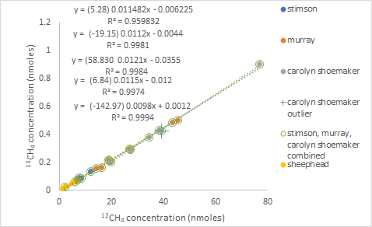
Figure S3a. The relationship between ¹²CH₄ and ¹³CH₄ for Stimson, Carolyn Shoemaker, Murray and Sheepbed sediment samples collected and analyzed with the Curiosity rover at Gale crater, Mars. The x² term for polynomial equations for any of the relationships shown are not statistically significant (p > 0.5) and adding the curvature component does not substantially change the y-intercept terms. An outlier for the Carolyn Shoemaker formation that was kept for this analysis but not included in the mixing line presentation (Figure S3e) is shown. Regression equation slopes represent the ¹³C:¹²C source of methane either added to or removed from the systems. The values in parentheses at the start of the legends are the δ¹³C equivalents of the linear slopes. Data after House et al. (2022).

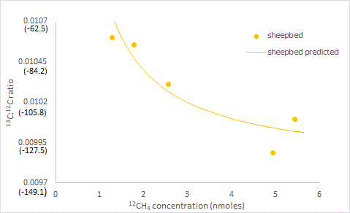
Figure S3b. The relationship between CH₄ concentration and δ¹³C for Sheepbed sediment samples (mudstone) collected and analyzed with the Curiosity rover at Gale crater, Mars. Values in parenthesis are the corresponding delta values for the ¹³C:¹²C ratio presented. The Sheepbed samples were the first that the Curiosity rover collected and come from an ancient habitable environment for life on Mars (Grotzinger et al. 2014). The predicted relationship is derived from the ¹²C vs. ¹³C plot for the Sheepbed samples in Figure S3a. The relationship between ¹²CH₄ (and the highly correlated total C) and ¹³C:¹²C ratio generally follow the expected decrease in ¹³C:¹²C ratios as total C increases for a system with a depleted source and less depleted backgrounds suggested by the regressions in Figure S3a. Data after House et al. (2022).
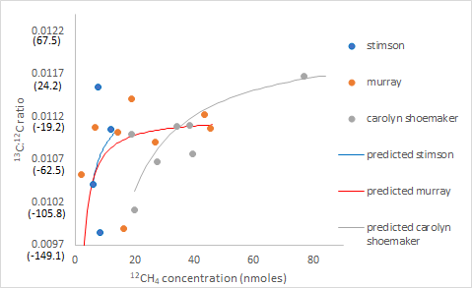
Figure S3c. The relationship between CH₄ concentration and ¹³C:¹²C ratios for the Stimson, Murray and Carolyn Shoemaker samples collected and analyzed with the Curiosity rover at Gale crater, Mars. Values in parenthesis are the corresponding delta values for the ¹³C:¹²C ratio presented. The Stimpson formation overlies the Carolyn Shoemaker formation and represents an ancient aeolian (wind-blown) lithified dune field. The Carolyn Shoemaker formation is a lacustrine (derived under a lake) sediment that overlies another lacustrine deposit, the Murray formation. Predicted relationships are derived from the ¹²C vs. ¹³C plots presented in Figure S3a. Data after House et al. (2022).
-
The mixing line data for the Sheepbed samples in Figure S3d confirms source and background conclusions based on the ¹²CH₄ vs. ¹³CH₄ plot in Figure S3a. The mixing line y-intercept suggests a depleted source while a positive slope suggests the background, although still depleted, is higher (less negative) than the source. The mixing line data (Figures S3e-g) for the Simpson, Carolyn Shoemaker and Murray sediments also confirm conclusions based on the ¹²C vs. ¹³C slopes in Figure S3a. The strongly depleted ¹³C values from the Carolyn Shoemaker and Murray sediments cannot be explained by strongly depleted sources.
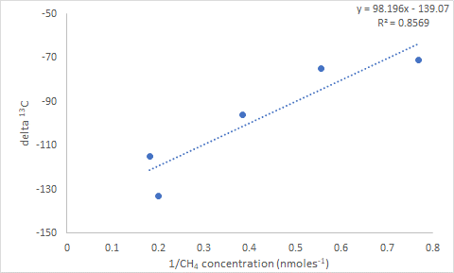
Figure S3d. The relationship between CH₄ concentration and ¹³C:¹²C ratio for the Sheepbed samples. The Sheepbed samples were the first that the Curiosity rover collected and come from an ancient habitable environment for life on Mars (Grotzinger et al. 2014). Data after House et al. (2022).

.

.
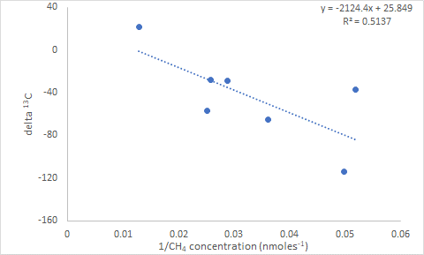
Figure S3e. Mixing diagrams (1/total CH₄ concentration vs. δ¹³C) for the Murray formation collected and analyzed with the Curiosity rover at Gale crater, Mars. The Murray formation is a lacustrine (derived under a lake) sediment that underlies another likely younger lacustrine deposit, the Carolyn Shoemaker formation.
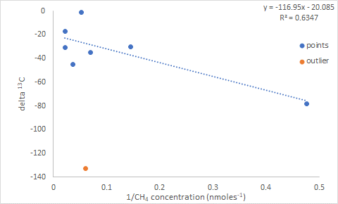
Figure S3f. Mixing diagrams (1/total CH₄ concentration vs. δ¹³C) for the Carolyn Shoemaker formation collected and analyzed with the Curiosity rover at Gale crater, Mars. An outlier was not used in the regression analysis. This outlier point is the same as marked in Figure S3a. The Carolyn Shoemaker formation is a lacustrine (derived under a lake) sediment that overlies another lacustrine deposit, the Murray formation. Data after House et al. (2022).
-
The final sediment mixing diagram (Figure S3g) is for the Stimpson formation, which was encountered twice as the Curiosity rover traversed Gale crater. The Stimpson formation overlies the Carolyn Shoemaker formation and represents a lithified dune field with an ancient aeolian (wind-blown) source. Although the Stimpson formation was more recently deposited than underlying Carolyn Shoemaker and Murray layers, the actual material deposited may be older than the Carolyn Shoemaker and Murray formations. The Stimpson and Sheepbed sediments are geologically similar (Bedford et al. 2020). Both have much lower total CH₄ concentration than the Carolyn Shoemaker and Murray sediments. However, the Stimson formation is still likely younger than the Sheepbed samples.
The relationship in Figure S3g is weak and not statistically significant. However, the source value (y-intercept equals -6.52 delta ¹³C approximates the source value derived from the ¹²C vs. ¹³C slope in Figure S3a (as it mathematically must) of 5.28 delta ¹³C. Mixing line source estimates for the four sediments are strongly related to slope-based source estimates in Figure S3a (r² = 0.9856; p = 0.00725). Both mixing line and slope-based source estimates suggest only the oldest formation (Sheepbed) has a highly depleted source.
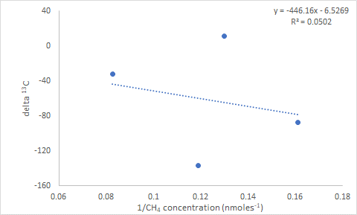
Figure S3g. Mixing diagrams (1/total CH₄ concentration vs. δ¹³C) for the Stimpson formation collected and analyzed with the Curiosity rover at Gale crater, Mars. The Stimpson formation overlies the Carolyn Shoemaker formation and represents an ancient aeolian (wind-blown) lithified dune field. This formation was encountered twice as the Curiosity rover traversed Gale crater. The combined four points from both encounters are plotted above. Data after House et al. (2022).
-
Martian sediments also have different sources and backgrounds for ³⁴S:³²S isotopic ratios. In Figure S3h, mixing diagrams (1/total S vs. δ³⁴S) for the Stimpson and Murray formations suggest depleted ³⁴S sources (y-intercepts) and relatively enriched backgrounds (positive slopes). The Carolyn Shoemaker formation mixing diagram suggests enriched ³⁴S sources and relatively depleted backgrounds (Figure S3h). The Sheepbed samples exhibit a weak mixing line relationship that is inconclusive. The predicted relationship between S concentration and δ³⁴S values derived from the Stimpson, Murray and Carolyn Shoemaker mixing diagram equations closely approximate the actual data (Figure S3i). Data clearly suggests that δ³⁴S variability is driven by differences in total S.
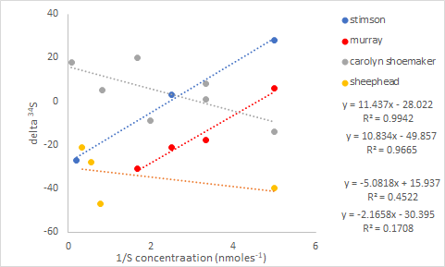
Figure S3h. Mixing diagrams (1/total S concentration vs. δ ³⁴S) for the Sheepbed sediments (an ancient mudstone), the lacustrine Carolyn Shoemake and Murray formations and the Stimson sediments (lithified wind-blown dunes) collected and analyzed with the Curiosity rover at Gale crater, Mars. Data after House et al. (2022).
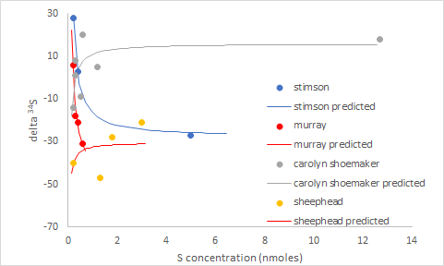
Figure S3i. The relationship between S concentration and δ ³⁴S for the Sheepbed sediments (an ancient mudstone), the lacustrine Carolyn Shoemake and Murray formations and the Stimson sediments (lithified wind-blown dunes) collected and analyzed with the Curiosity rover at Gale crater, Mars. The points are the same as those shown in Figure S3h. The predicted relationships are derived from the mixing line equations shown in Figures S3h. Data after House et al. (2022).
-
Data suggests that the variability encountered in Martian ¹³C and ³⁴S isotopes is mostly related to C and S concentrations. Furthermore, Martian sediments have different sources and backgrounds for ¹³C and ³⁴S. More data is required to confirm these hypotheses, but no hint of these possibilities is available when only analyzing traditional ratio-based isotopic data. House et al. (2022) proposed three explanations for depleted ¹³C values: biological methane production; photoreduction of atmospheric CO₂; and cosmic dust.
All these explanations are unconventional and differ from processes common on Earth. Additional insight reported here, where the oldest sediment appears to have depleted ¹³C sources may help determine whether possible Martian life or other phenomenon explain ¹³C isotopic observations. Our major point is that C sources rather than possibly confounded observed ¹³C:¹²C ratios should be the variable of interest if one is searching for evidence of present or past life on Mars. However, any firm conclusions are beyond the scope of this report. The expanded analyses make one quite curious about the Curiosity data.

5 Discussion
Data re-evaluations suggest that theoretical mathematical concepts predict how ⁸⁷Sr:⁸⁶Sr ratios might change over time or among treatments (Moots et al. 2024a, Supplemental Material 1). Here, we identify “ratio problems” in non-strontium datasets that include N, C and S. Specifically, total N differences confound the interpretation of ¹⁵N defined trophic levels and labeled ¹⁵N tracer studies in a greenhouse experiment. Total C and S confound the interpretation of Martian ¹³C and ³⁴S data collected by the Curiosity rover. Isotopic ratio changes over time or for different conditions do not necessarily reflect source changes.
The portion of an element derived from an exogenous source is traditionally calculated from isotopic ratios. Therefore, these isotopic estimates are subject to the same confounding scaling effects as the original ratios. This is clearly demonstrated in the ¹⁵N tracer study we evaluated. Isotopic preferences (fractionation or discrimination factors) are also derived from isotopic ratios. Although fractionation phenomena may occur, total element-driven changes in isotopic ratios make traditional fractionation evaluations suspect. A detailed discussion of scaling issues in fractionation studies is included in Moots et al. 2024b Supplementary Material 3. Including source analyses provides better information than traditional ratio-based isotopic assessments. There is certainly no harm in conducting both ratio-based inferences and source evaluations.
The consequences of relying solely on ratio-based expressions have wide application. Mathematical principles suggest there is no reason to expect that isotopic ratios would somehow be immune to ratio issues that have been discussed in the literature for over 100 years. Real isotopic datasets with a range of isotopes confirm what one would expect.

6 Conclusion
Isotopic researchers are collecting excellent data while developing and testing sophisticated hypotheses. Not all isotopic datasets will have ratio-based interpretive issues. However, in a subset of the ratio literature, very small denominator vs. numerator y-intercepts and other statistical quirks confound conclusions. These errors can be corrected with simple alterations to current analytical methods.
Traditional Keeling plots, other forms of mixing diagrams, or an analysis of the relationship between ratio denominator and numerator concentrations or content should be evaluated for isotopic datasets. Source evaluations (relatively rare in the isotopic literature, even when total element concentrations are measured) allow researchers to better understand and interpret isotopic studies and should always accompany isotopic ratio data.
One will never know whether a dataset has errors related to ratio-based expressions unless it is evaluated. Unfortunately, we estimate that over half of C and N isotopic publications do not include measurements of total C and N. Readers have a choice. They should conclude that that a given study is inconclusive unless researchers have determined that confounded ratios are not a problem. This is easily achieved with a source analysis.

FUNDING DETAILS
No external grant funds directly supported this effort. Rather, years of tangential thinking

associated with many projects lead to this research.

DISCLOSURE STATEMENT
None of the co-authors have associations or affiliations that would lead to financial benefit from the publication of this document.

References
Bedford, C. C., Schwenzer, S. P., Bridges, J. C., Banham, S., Wiens, R. C., Gasnault, O., et al. (2020), “Geochemical Variation in the Stimson Formation of Gale Crater: Provenance, Mineral Sorting, and a Comparison with Modern Martian Dunes,” Icarus, 341, 113622, DOI: 10.1016/j.icarus.2020.113622.
Caut, S., Angulo, E., and Courchamp, F. (2009), “Variation in Discrimination Factors (Δ¹⁵N and Δ¹³C): The Effect of Diet Isotopic Values and Applications for Diet Reconstruction,” Journal of Applied Ecology, 46, 443-453, DOI: 10.1111/j.1365-2664.2009.01620.x.
Gherardi, F., Acquistapace, P., and Santini, G. (2004), “Food Selection in Freshwater Omnivores: A Case Study of Crayfish Austropotamobius pallipes,” Archiv für Hydrobiologie, 15, 357-376, DOI: 10.1127/0003-9136/2004/0159-0357.
Glazier, D. S. (2021), “Biological Scaling Analyses are More than Statistical Line Fitting,” Journal of Experimental Biology, 224, jeb241059, DOI: 10.1242/jeb.241059.
Grotzinger, J. P., Sumner, D. Y., Kah, L. C., Stack, K., Gupta, S., Edgar, L., et al. (2014), “A habitable Fluvio-Lacustrine Environment at Yellowknife Bay, Gale Crater, Mars,” Science, 343, 1242777, DOI: 10.1126/science.1242777.
Hinrichs, K. U., Hayes, J. M., Sylva, S. P., Brewer, P. G. and DeLong, E. F. (1999), “Methane-Consuming Archaebacteria in Marine Sediments,” Nature, 398, 802-805.
House, C. H., Wong, G. M., Webster, C. R., Flesch, G. J., Franz, H. B., Stern, J. C., et al. (2022), “Depleted carbon isotope compositions observed at Gale crater, Mars,” Proceedings of the National Academy of Sciences, 119(4), e2115651119, DOI: 10.1073/pnas.2115651119.
Jacobi, C. M., Villamarin, F., Jardine, T. D., and Magnusson, W.E. (2020), “Uncertainities Associated with Trophic Discrimination Factor and Body Size Complicate Calculation of d¹⁵N-Derived Trophic Positions in Arapaima sp.,” Ecology of Freshwater Fish, 29, 779-789, DOI: 10.1111/eff.12553.
Keeling, C. D. (1958), “The Concentration and Isotopic Abundances of Atmospheric Carbon Dioxide in Rural Areas,” Geochimica et Cosmochimica, 13, 322-334, DOI: 10.1016/0016-7037(58)90033-4.
Layman, C. A., Winemiller, K. O., Arington, D. A., and Jepsen, D. B. (2005), “Body Size and Trophic Position in a Diverse Tropical Food Web,” Ecology, 86, 2530-2535, DOI: 10.1890/04-1098.
McGarvey, D. J. (2020), “Individual Level Data Reveal High Prevalence of Positive Size Trophic Position Relationship for Vertebrates,” Freshwater Biology, 66, 628-639, DOI: 10.1111/fwb.13666.
Moots, K. Nguyen, C. P Nguyen C. Camacho, F., Lindstrom, D., and Righetti, T, L. (2024a). A mathematical explanation for why ratio-based isotopic analyses are commonly misleading: Theory. Scientific Reports this issue .
Moots, K. Nguyen, C. P Nguyen C. Camacho, F., Lindstrom, D., and Righetti, T, L. (2024b). A mathematical explanation for why ratio-based isotopic analyses are commonly misleading: Dealing with Confounded Isotopic Ratios. Scientific Reports this issue .
Moyo, S., Bennadji, H., Laguaite, D., Pérez-Umphrey, A. A., Snider, A. M., Bonisoli-Alquati, A., et al. (2021), “Stable Isotope Analyses Identify Trophic Niche Partitioning between Sympatric Terrestrial Vertebrates in Coastal Saltmarshes with Differing Oiling Histories,” PeerJ, 9, e11392, DOI: 10.7717/peerj.11392.
Pearson, S. F., Levey, D. J., and Greenberg, C. H. (2003), “Effects of Elemental Composition on the Incorporation of Dietary Nitrogen and Carbon Isotopic Signatures in an Omnivorous Songbird,” Oecologia, 135, 516-523, DOI: 10.1007/s00442-003-1221-8.
Sandrock, D. R., Righetti, T. L., and Azarenko, A. N. (2005), “Isotopic and Nonisotopic Estimation of Nitrogen Uptake Efficiency in Container-Grown Woody Ornamentals,” HortScience, 40, 665-669, DOI: 10.21273/HORTSCI.40.3.665.
Seminoff, J. A., Jones, T. T., Eguchi, T., Jones, D. R., and Dutton, P. H. (2006), “Stable Isotope Discrimination (δ¹³C and δ¹⁵N) Between Soft Tissues of the Green Sea Turtle Chelonia mydas and Its Diet,” Marine Ecology Progress Series, 308, 271-278, DOI: 10.3354/meps308271.
Villamarín, F., Jardine, T. D., Bunn, S. E., Marioni, B., and Magnusson, W. E. (2018), “Body Size is More Important Than Diet in Determining Stable-Isotope Estimates of Trophic Position in Crocodilians,” Scientific Reports, 8, 1-11, DOI: 10.1038/s41598-018-19918-6.
Whitledge, G. W., and Rabeni, C. F. (1997), “Energy Sources and Ecological Role of Crayfishes in an Ozark Stream: Insights from Stable Isotopes and Gut Analysis,” Canadian Journal of Fisheries and Aquatic Sciences, 54, 2555-2563, DOI: 10.1139/f97-173.

