Supplemental Material
A mathematical explanation for why ratio-based isotopic analyses are commonly misleading: Theory

1. REVIEW OF ISOTOPIC PRINCIPLES

Stable mass isotopes are forms of an element with different numbers of neutrons. Unlike radioactive isotopes they do not decay, thus they are defined as stable. Although their chemical characteristics are almost identical, they have different atomic weights. Elements differ with respect to the total number of stable mass isotopes. For example, strontium (Sr) has four major mass isotopes, whereas carbon and nitrogen both have two. The isotopic makeup of a sample can be described by a ratio of isotopes such as ¹³C:¹²C, ¹⁵N:¹⁴N, ¹⁸O:¹⁶O, ³⁴S:³²S or ⁸⁷Sr:⁸⁶Sr, where the superscripts refer to atomic weight.
Variation in stable mass isotopic ratios over time or among different sample types is often interpreted as being due to exogenous additions, or endogenous removal of material that has a different isotopic ratio than the original pool. In much of the isotopic literature, exogenous additions (or endogenous losses) are referred to as the “source,” and the isotopic composition of the initial pool of material before additions or withdrawals are made is referred to as the “background.”
Many disciplines routinely use slopes and derivatives to evaluate how one variable changes relative to another. For example, the effect of variable x on variable y can be represented by a function, y = f(x). For a linear dependence of y on x, it is sufficient to provide the slope of the x–y plot, whereas derivatives (dy/dx) may be required to describe more complex relationships. It is possible to determine slopes or derivatives when one mass isotope concentration or content of an element is plotted against another. This approach, however, is not used in the isotopic literature, which depends on the analysis of ratio-based isotopic data. Analysis of slopes and derivatives, if extended to the isotopic literature, will provide more information about important sources and how they change than simply using ratio-based expressions.

Various ratio-based expressions rather than an actual isotopic ratio are used in the isotopic literature (Brand and Coplen 2012; Hayes 2004; Coplen 2011). The delta value (δ) is the most used ratio-based expression (Brand and Coplen 2012), especially when evaluating carbon, nitrogen, and oxygen isotopes. Rather than an actual ratio, δ values represent the relative difference between a sample and a standard (Brand and Coplen 2012; Hayes 2004; Coplen 2011). Equations for the calculation of δ values are presented in the Supplemental Material: Section 2, Formulas for converting isotopic ratios to ratio-based expressions. Also in Supplemental Material: Section 2 are examples of how different ⁸⁷Sr:⁸⁶Sr ratios based on different units (umole/ml or ug/ml) are related.
Delta values are therefore a ratio of ratios. Positive values denote higher ratios (relatively more enriched for the ratio numerator compared to the standard reference material); negative values denote lower ratios (relatively more depleted for the ratio numerator compared to the standard reference material). For example, a ¹⁵N:¹⁴N ratio of 0.003676 would have a delta value of zero since the ratio of the atmosphere (0.003676) is used as a standard (δN = [(Rsample/Rstandard) − 1] × 1000 = 0, as Rsample = Rstandard (atmosphere) = 0.003676). A ¹⁵N:¹⁴N ratio of 0.003850 would have a delta value of 47.33.
This convention likely developed because isotope ratio mass spectrometers measure relative isotopic ratios much better than actual ratios. By comparing to a standard, the precision of data values is much better since all values are relative to a given value. If the ratio for both a sample and standard are overestimated (or underestimated) by the same relative amount, then dividing the two values will account for this inaccuracy, thus making it possible to compare δ values among laboratories around the world. For example, if both an atmospheric standard and a sample ¹⁵N:¹⁴N ratio were both overestimated (0.003850 and 0.003850) the delta value for the sample would still be zero.
Commonly used isotopic ratio expressions can be algebraically converted to simple ratios. For some elements evaluated in isotopic studies, the actual isotopic ratio (for example ⁸⁷Sr:⁸⁶Sr), rather than a ratio-based expression is used. To simplify presentations for statisticians that are not familiar with delta notation, we have used isotopic ⁸⁷Sr:⁸⁶Sr ratios for the introductory examples in this report.
Isotopic ratios serve as a proxy for past climates (Shackleton et al. 1987; Banner et al. 1996; O’Reilly et al. 2003; Li et al. 2005; Sundquist 2007; Zhou et al. 2009), and are widely used as tracers in archaeological (Ericson 1985; Grupe et al.1997; Bentley 2006; Montgomery and Evans 2006; Katzenberg 2008; Reitsema et al. 2013), ecological (Gannes et al. 1998; Crawford et al. 2008; Inger and Bearhop 2008), geological (Faure 1986; Banner et al. 1989; Banner and Hanson 1990), and plant or animal physiological processes (Smith and Epstein 1970; Ehleringer et al. 1993; Jackson et al. 1993; Gannes et al. 1998; Reitsema et al. 2013). Since stable mass isotopes are not radioactive, and thus safe, they are often used in field studies, most often nitrogen experiments (Sanchez et al. 1992; Sandrock et al. 2005), to evaluate how an added element is distributed in a system. If the isotopic ratio of added material (for example ¹⁵N:¹⁴N) is different than the ¹⁵N:¹⁴N isotopic ratio for an existing system, standard formulas can be used to estimate the portion of total element that is derived from the added material for a sample being analyzed (Supplemental Material: Section 3, Formulas for converting isotopic ratios to portion of total element derived from a source). For example, the portion of N derived from fertilizer (NDFF) can be determined for different tissues in a fruit tree (flower buds, flowers, leaves, branches, roots, structural wood) (Sanchez et al. 1992).
The fate of N added to an ecosystem, either naturally, as in migrating salmon (Bilby et al. 1996), or anthropogenically, as in the application of fertilizer or waste, (Sanchez et al. 1992; Sara et al. 2004; Sandrock et al. 2005) can also be determined (such as detection of added N in vegetation, animals, soil organic matter, streams, ponds, and groundwater). Nitrogen isotopes are also used to identify trophic levels (herbivores, omnivores, predators, and apex predators) among various species (Gilbert and Rasmussen 1994; Villamarin et al. 2018; Jacobi et al. 2020; McGarvey et al. 2020). Carbon isotope studies can often differentiate between terrestrial and aquatic sources of carbon for distinct groups of organisms (Finlay 2001). The ¹³C:¹²C ratio of sediments on Earth is relatively depleted in ¹³C (House et al. 2022), likely caused by biological methane production. This has led to searches for depleted ¹³C:¹²C ratios in sediments on Mars as evidence of past life (House et al. 2022). Oxygen isotopes in sediments or ice cores are especially sensitive to changes in past temperature (Shackleton 1987).
Isotopic fractionation is an important concept. For example, the use of stable isotopic techniques to study animal diets and trophic levels often requires a priori estimates of the differences in isotopic composition between an animal and its diet (Caut et al. 2009). These differences are called discrimination or fractionation factors (Δ¹³C and Δ¹⁵N). Similar phenomena can occur with other physical or biochemical processes (Mobius 2013; Lerch et al. 2011; Wang et al. 2015). In general, fractionation is defined as a separation process in which a mixture is divided into fractions (smaller distinct quantities). Isotopic fractionation refers to a situation where substrate and product fractions have different isotopic ratios. Fractionation hereafter refers to isotopic fractionation.
Fractionation likely occurs. For example, fractionation is the generally accepted explanation for why soil organic matter is more enriched in ¹⁵N than its atmospheric source (Mobius 2013). Thousands of years of N-cycle transformations that favor the loss of the lighter common isotope leave the heavy isotope behind, eventually creating these pool differences. Unfortunately, mathematical principles presented in this report dictate that observed isotopic ratios will often not equal a source, even in systems with no fractionation.

2. FORMULAS FOR CONVERTING ISOTOPIC RATIOS TO RATIO-BASED EXPRESSIONS
The formula for calculating delta value notation is shown below. Stable isotope compositions are often expressed in terms of delta values (δ) in permil (‰), i.e., parts per thousand differences from a standard. They express the relative proportion of the numerator of an isotopic ratio that is in a sample. The values are expressed as:
δX = [(R_{sample} / R_{standard}) – 1] × 10³
where X represents the isotope of interest (for example ¹³C), and R_{sample} represents the observed ratio of the isotope of interest and its natural form (for example ¹³C:¹²C), and R_{standard} represents the ratio of a reference standard. The information below provides values for common standards and the formula for converting delta values to atom%. Atom% is defined as the amount of a specific isotope divided by the sum of all isotopes (calculated as atom%X = nX/(nX + nY + nZ ...), where n denotes molar quantity (mol) and X, Y, Z denote isotopes). Atom % is not equivalent to ug numerator/ug total element, as different isotopes have slightly different molar masses.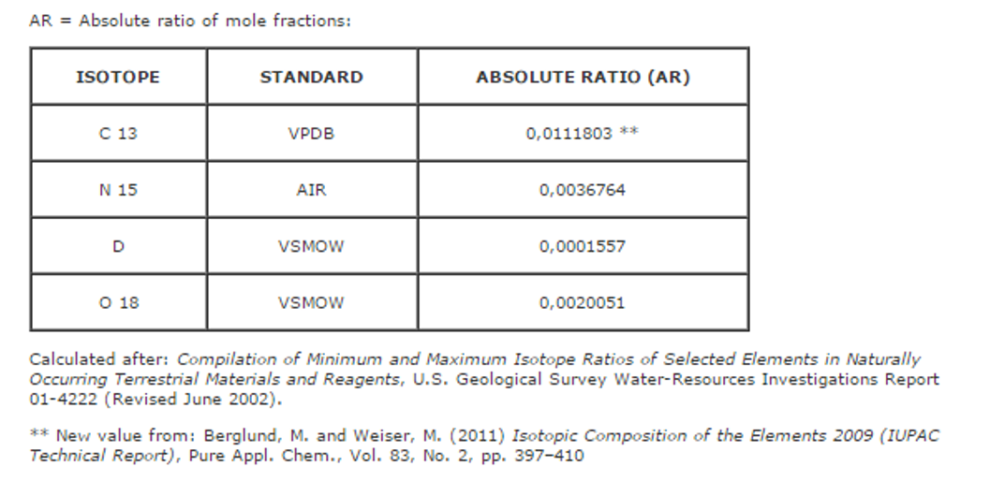
atom % = 100 * AR * ((Delta/1000) + 1) / 1 + (AR * ((Delta/1000)+ 1))

where AR is the Absolute Ratio (constant), and Delta is the value in permil to be converted to atom%.
-
Either isotopic abundance ratios [(umoles/ml or umoles/g numerator) / (umoles/ml or umoles/g denominator)] or isotopic mass ratios [(ug/ml or ug/g numerator)/ (ug/ml or ug/g denominator)] can be analysed. Since the two expressions are not the same, denominator vs. numerator plots will differ. For example, the artificial equation for the umole/ml ⁸⁶Sr vs. umole/ml ⁸⁷Sr in Figure 1a with the large positive y-intercept (y = 0.7091x + 0.003; r² = 1.0000000) becomes (y = 0.71733453x + 0.261; r² = 1.0000000) when plotted on a ug/ml basis (Figure S1a). All mathematical principles discussed in the main text using umole/ml expressions also apply to ug/ml forms of ratio expression. For example, the same consequences of non-zero y-intercepts in Figure 1b for umole/ml evaluations are apparent in Figure S1b for the ug/ml evaluations. Either type of expression produces similar results. However, sources calculated from denominator vs. numerator slopes have different values and units depending on the units of the denominator vs. numerator plots.
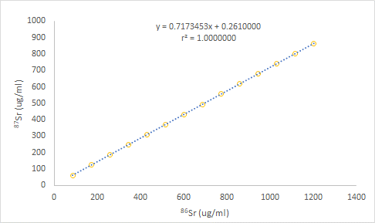
Figure S1a. A plot of the relationship between ug/ml ⁸⁶Sr vs. ug/ml ⁸⁷Sr. Artificial ⁸⁶Sr vs. ⁸⁷Sr data created to have a umole/ml vs. umole/ml slope that is equivalent to the ⁸⁷Sr:⁸⁶Sr ratio of modern seawater and a 0.003 y-intercept shown in Figure 1a has been modified. The data here is expressed on a ug/ml vs. ug/ml basis. Although very small (~0.025 % of y-axis range) the non-zero y-intercept still leads to interpretive problems as shown in Figure S1b.
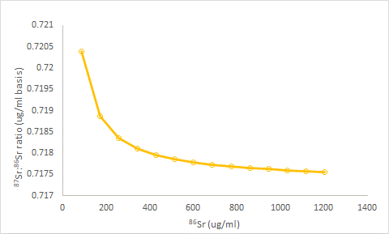
Figure S1b. The artificial ⁸⁶Sr vs. ⁸⁷Sr data shown in Figure S1a are replotted here. The ⁸⁶Sr concentration (ug/ml) is plotted against ⁸⁷Sr:⁸⁶Sr ratios (ug/ml-basis).
-
The ratio values for the two approaches are perfectly correlated. In Figure S1c, the regression equation is shown (ug/ml ratio = 1.0116279077 * umole/ml ratio with an r² value of 1.00000000). The slope of this equation (1.0116279077) can be approximated from the quotient of the previous slopes (0.7173453 for ug/ml plots / 0.7091 for umole/ml plots = 1.0116278381). The slope expressed on a mass basis (source = 0.7173453) derived from the original ug/ml ⁸⁷Sr and ⁸⁶Sr (in ug/g) values can be calculated from the molar-based slope (source = 0.7091) using the regression equation in Figure S1c (1.011627907 * 0.7091 = 0.7173453). The same conversion can be made by simply multiplying the umole/ml source value by the quotient of the molecular weights of the two isotopes (0.7091 * 87/86 = 0.7173453).
In summary atom%, delta values, umole/ml-based ratio values and ug/ml-based ratio values, are all perfectly correlated. Using umole/ml or umole/g-based isotope ratio expressions is the preferred standard in the isotopic literature. The slope of figure 1a (0.7091) matches the accepted value for the ⁸⁷Sr:⁸⁶Sr ratio of modern seawater. Although a ug/ml-based ratio expression for the ⁸⁷Sr:⁸⁶Sr ratio of modern seawater (0.7173453) in Figure S1a is technically correct, this can create confusion for those familiar with the conventional (0.7091) value.
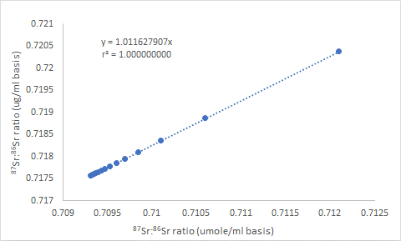
Figure S1c. The ⁸⁷Sr:⁸⁶Sr ratio calculated with umole/ml values taken from Figure 1b are plotted against ⁸⁷Sr:⁸⁶Sr ratios calculated with ug/ml values from Figure S1a.

-

3. FORMULAS FOR CONVERTING ISOTOPIC RATIOS TO PORTION OF TOTAL ELEMENT DERIVED FROM AN ADDED SOURCE
% Derived from an added source = (atom % of sample – atom % natural abundance) / (atom % of source – atom % of natural abundance) x 100
or
% derived from an added source = % atom excess of sample / % atom excess of source
Where % atom excess equals atom % minus natural abundance
4. REVIEW OF RATIO LITERATURE INCLUDING ISOTOPIC WARNINGS
Ratios often lead to biased or even opposite conclusions concerning the actual relationships between the denominator and numerator (Atchley et al. 1976; Jackson et al. 1990; Jasienski and Bazzaz 1999; Isles 2020). This is not a new issue, having been first reported by Pearson (1897) and elegantly restated by Tanner in (1949). However, in many disciplines, the pitfalls of using ratios in scientific research have been ignored for decades (Jasienski and Bazzaz 1999; Righetti et al. 2007a). There are many research papers with erroneous conclusions that can be corrected with a few simple additional analyses (Atchley et al. 1976; Jackson et al. 1990; Packard and Boardman 1998; Jasienski and Bazzaz 1999; Righetti et al. 2007a; Kratochvil and Fleger 2009). The use of ratios has been abandoned for many comparative evaluations, most notably in morphometrics (Kratochvil and Fleger 2009) and metabolic scaling (Enquist 2002; Xiao et al. 2011) studies. It is thus surprising that isotopic studies still rely almost exclusively on isotopic ratios or ratio-based expressions.
Rather than using ratios when evaluating experimental data, there is convincing evidence that either an evaluation of slopes (Righetti et al. 2007b) or using an analysis of covariance (ANCOVA) better define the true relationship between numerator and denominator. ANCOVAS demonstrate whether treatment differences are direct or indirectly caused by different denominator size by determining if data for different treatments or conditions fall on the same or different denominator vs. numerator regression lines (Packard and Boardman 1998; Righetti et al. 2007a; Kratochvil and Fleger, 2009).
Traditional log-log scaling analyses (Kerkhoff and Enquist, 2009; Xiao et al. 2011) are also often used to determine if treatments or conditions fall on the same or different allometric lines. Log denominator vs. log numerator plots can therefore be used to determine if differing proportional relationships are caused by fundamental differences among species or treatments; or if ratio differences are simply due to scaling effects (Glazier 2021). Scaling concepts, although most often applied to metabolic data have been expanded to include isotopes. Tejada-Lara et al. (2018) state that for almost two decades, most carbon isotope-based ecological tooth evaluations of extant and extinct herbivorous mammals have used a ¹³C isotope fractionation factor of 14.1 ‰. Assuming this single value applies to all herbivorous mammals, from tiny monkeys to giant elephants, overlooks potential scaling effects (Tejada-Lara et al. 2018). A single-factor body mass model that predicts ¹³C:¹²C ratios over more than 5 orders of magnitude of body sizes outperforms all other single factor or more complex combinatorial models evaluated, including metabolic rate and body temperature proxies (Tejada-Lara et al. 2018). Physiological differences between a monogastric mouse and a ruminant cow could affect ¹³C:¹²C ratios, but the comparison will be confounded by massive differences in animal size.
There are other studies suggesting that the “ratio problem” applies to isotopic data when denominator concentration or total content vary. For example, Phillips and Koch (2002) suggested that ¹⁵N:¹⁴N isotopic ratios will depend on nitrogen concentrations. Phillips and Koch (2002) further state that the use of standard models when concentration variations are large may produce misleading results with major ramifications on assessments of feeding ecology and management strategies. Since total element concentration is strongly correlated to the denominator in an isotopic ratio, Phillips’ and Koch’s (2002) argument is similar to suggestions that the actual relationships between the denominator and numerator are often obscured when the denominator of a ratio varies in size among treatments. (Atchley et al. 1976; Packard and Boardman 1998; Righetti et al. 2007a; Kratochvil and Fleger 2009).
Phillips’ and Koch’s (2002) concentration-weighted models are far more complex than the simpler source evaluations proposed here, but both approaches deal with the same fundamental problem. Pearson et al. (2003) verified the Phillips and Koch (2002) studies for both C and N isotopes and stated that it is critical that concentrations of elements be considered when attempting to use isotopic signatures to reconstruct diets.
Villamarín et al. (2018) studying crocodilians and Jacobi et al. (2020) studying an Amazon fish (Arapaima), suggest it is possible that body size (and covarying total N) indirectly contribute to ¹⁵N:¹⁴N ratio differences between predators and prey. This could either mask or enhance trophic level induced isotopic differences. In the Villamarín et al. (2018) study, stable N isotope estimates of trophic position in crocodilians are not supported by diet (stomach contents). Whitledge and Rabeni (1997) also present data where N isotope defined trophic levels do not agree with stomach contents in crayfish (Orconectes species). Righetti et al. (2012) reported that ¹⁵N:¹⁴N isotopic ratios are related to total element concentrations. Using an ANCOVA to determine if data for different treatments or conditions fall on the same or different total N gain vs. fertilizer N regression lines can account for differences in NDFF for different plant tissues and genera (Righetti et al. 2007c). Denominator size-related scaling effects are not limited to N and C isotopes. In an unpublished review of 24 Sr isotope publications, containing over 75 datasets. Changes in ⁸⁷Sr:⁸⁶Sr ratio were always accompanied with changes in total Sr concentration (data not shown but re-evaluations of the original publications are available on request).
Even though denominator size-related isotopic confounding has been regularly reported and cited (for example, the 2002 publication by Phillips and Koch has been cited over 800 times), total element concentrations that can be linked to isotopic ratios are not reported in most isotopic publications. Concentration-weighted models are rarely used. When total element concentrations that match isotopic ratios or delta values are not presented; the isotopic ratio of exogenous additions or endogenous losses cannot be determined. As shown below and in the companion publication (Moots et al. 2024a) isotopic ratios or delta values when interpreted without evaluating sources, that require knowledge of total element concentrations can be insufficient or misleading.
First presented by Keeling (1958) for CO₂ studies, mixing diagram approaches (plotting 1/total element concentration on a mass unit basis vs. isotopic ratios) are the only current way to determine sources (Section 5 below). Commonly used observed isotopic ratios do not provide as accurate and pertinent information as mixing diagrams. The importance of identifying isotopic sources is simply not appreciated.
Unfortunately, arguments against using ratios in scientific studies are counterintuitive. Statisticians have done a poor job in communicating well-known concerns about ratios to other disciplines. The importance of source analyses is not appreciated in the isotopic research community.
Despite a long history of ratio discussions in the literature and more recent reminders (Richardson 2020; Certo et al. 2020), sometimes in prestigious journals (Leslie, 2019), there is little optimism among statisticians for a quick paradigm shift in data analysis. For example, the Science paper by Leslie (2019) clearly describes the statistical problems associated with evaluating finger ratios (2nd digit/4th digit). Many statisticians are likely dismayed over more than 250 additional finger ratio publications (~ 50/year) produced since the Science report. As stated above, a simple ANCOVA can be used to determine if changes in a ratio are directly related to treatments or simply reflect differences in denominator size (in this case reflecting differences in hand size). Although covariance analyses are often conducted in finger ratio publications to normalize for other variables, a simple determination if finger ratio treatment effects are direct or indirect is rarely done. This misuse of finger ratio analyses is dwarfed by possible difficulties associated with ratio-based isotopic expressions. Numerous stable mass isotope publications with the same potential problems associated with finger ratios have been continually produced for over 7 decades.

5. QUANTIFYING ISOTOPIC SOURCES
Keeling (1958) suggested that sources for carbon dioxide can be determined by plotting 1/CO₂ concentration vs. δ¹³C values. The y-intercept of this plot identifies the δ¹³C (¹³C:¹²C ratio) of the source. Similar procedures, referred to as mixing diagrams, where 1/total element is plotted against isotopic ratios or ratio-based expressions for non-gas systems for other elements are also used (Goede et al. 1998; Li et al. 2005; Montgomery et al. 2005; Bentley 2006; Montgomery and Evans 2006). However, as demonstrated in Table 1, source analyses are relatively rare in the isotopic literature.
A hypothetical relationship of total C vs. δ¹³C from artificial data created by Pataki et al. (2003) in Figure S2a demonstrates the utility of Keeling plots (1/total carbon vs. δ¹³C values). Keeling’s (1958) original explanation was that when total C increases as additional C is added from a source with less ¹³C relative to ¹²C, the δ¹³C in the mixture declines. This decline over the long term will approach the source after addition of copious amounts of new material. This is true because at an infinite elemental concentration (1/element concentration approaches zero) the effect of the original background has been diluted and the observed isotopic ratio (associated with new levels of total C) approaches the source of material being added as can be seen in Figure S2b.
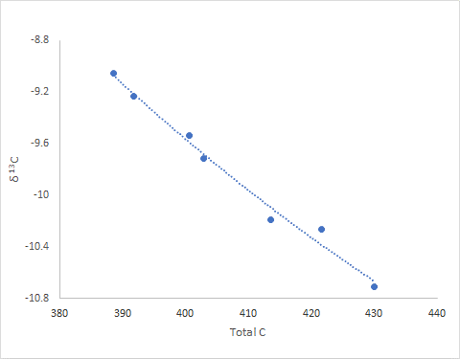
Figure S2a. A hypothetical relationship of total C vs. δ¹³C from artificial data created by Pataki et al. (2003) to demonstrate the utility of Keeling plots (1/total carbon vs. δ¹³C values).
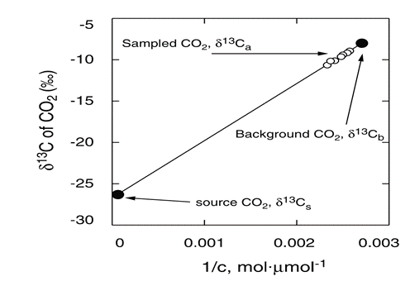
Figure S2b. Graphical illustration of the Keeling plot method for the artificial data presented in Figure S2a. Solid circles show the carbon isotope composition (δ¹³C) for two endpoints (1) source CO₂ (δ¹³C_{s}) and (2) well mixed, background atmospheric CO₂ (δ¹³C_{b}). Open circles show the carbon isotope composition of sampled air (δ¹³C_{a}). Isotopic ratios can be plotted against the inverse of CO₂ concentration, or in this case, 1/total carbon. This figure matches Figure 1 in Pataki et al. (2003).
-
Solid circles in Figure S2b show the carbon isotope composition (δ¹³C) of two endpoints (1) the source of CO₂ (δ¹³C_{s}) and (2) a well-mixed, background of atmospheric CO₂ (δ¹³C_{b}). Open circles in Figure S2b show the carbon isotope composition of sampled air (δ¹³C_{a}). Isotopic ratios can be plotted against the inverse of CO₂ concentration, or in this case 1/total carbon. Note the distance of the samples from the intercept. A major point in this mathematical review of isotopic ratios is that observed ratios will only rarely be similar to a source. Keeling (1958) used the 1/C expression, because it made the x-y relationship linear, thus the y-intercept (identified as the source) can be easily calculated.
However, as reemphasized, below a Keeling plot is a mathematically indirect way of calculating the slope of the original ¹²C vs. ¹³C regression line. For all linear functions (y = mx + b), the related function (y/x = [1/x] b + m) is defined. Because the portion of ¹²C is relatively constant (changes in portion is dwarfed by changes in total C), δ¹³C values plotted vs. 1/total C and 1/¹²C have similar y-intercepts.
A sediment mixing diagram is presented in Figure S2c. This figure is an exact copy from Figure 2 in Li et al. (2005) redrawn from Jahn et al. (2001). The mixing diagram presents strontium concentrations 1/Sr (ug/g)⁻¹ (x-axis) plotted against ⁸⁷Sr:⁸⁶Sr ratios (molar units) (y-axis); revealing a positive correlation between the two variables with the data falling into two distinct groups. Extrapolation of the relationship to 1/Sr = 0 indicates a strontium isotope ratio of ~0.7091 for the minimum end member source (approximate value of modern seawater). The strontium ratio for the largest 1/Sr values approaches a silicate source of ~0.7200. Values for the Lochmann paleosols (an old and well weathered soil type) that depart from the mixing line were interpreted by the original authors to possibly reflect influence of intense pedogenesis and/or a third component such as soil carbonate. Many sediment-related mixing diagrams use this format. The positive slope is related to positive y-intercepts for ⁸⁶Sr vs. ⁸⁷Sr relationships which suggest that backgrounds are greater than sources.

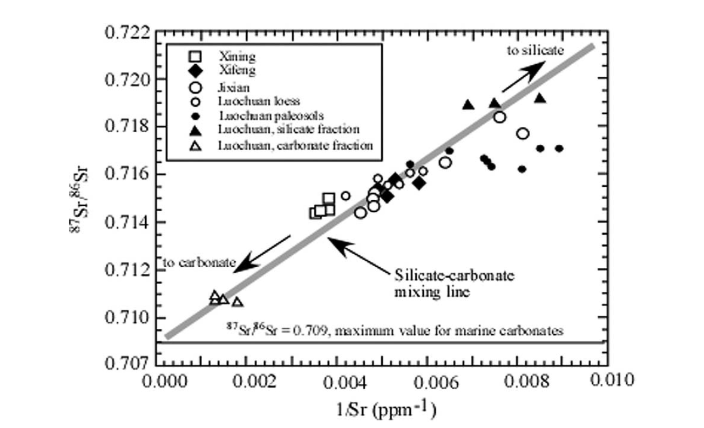
Figure S2c. Sediment mixing diagram. The mixing diagram presents strontium concentrations 1/Sr (ug/g)⁻¹ (x-axis) plotted against ⁸⁷Sr:⁸⁶Sr (molar units) ratios. Extrapolation of the relationship to 1/Sr = 0 indicates a strontium isotope ratio of ~0.7091 for the minimum end member source (approximate value of modern seawater). This figure is an exact copy from Figure 2 in Li et al. (2005) redrawn from Jahn et al. (2001).
-
Speleothem (stalactite and stalagmite) mixing diagrams for Sr isotopes are often presented in a slightly different form (reversed axes) than what is presented in Figure S2c for sediments. An example from Goede et al. (1998), is presented in Figure S2d. The mixing diagram presents ⁸⁷Sr:⁸⁶Sr ratios (x-axis) plotted against 1/Sr (ug/g)⁻¹ (y-axis); revealing a negative correlation between the two variables with the data falling into two distinct groups. Extrapolation of the relationship to 1/Sr = 0 indicates a strontium isotope ratio of ~0.7091 (an x-axis intercept) for the exogenic source (approximate value of modern seawater). The strontium ratio of the local limestone is represented by a value of 0.7086. The negative slope is related to negative y-intercepts for ⁸⁶Sr vs. ⁸⁷Sr relationships which suggests that backgrounds are less than sources. As total Sr increases the ⁸⁷Sr:⁸⁶Sr ratio also increases. A y-intercept in this form of mixing line is generally viewed as unimportant because it only refers to the theoretical minimum Sr levels (maximum 1/Sr levels) for the dataset. Many datasets with varying ⁸⁷Sr:⁸⁶Sr ratios for different total Sr values can all have the same source.
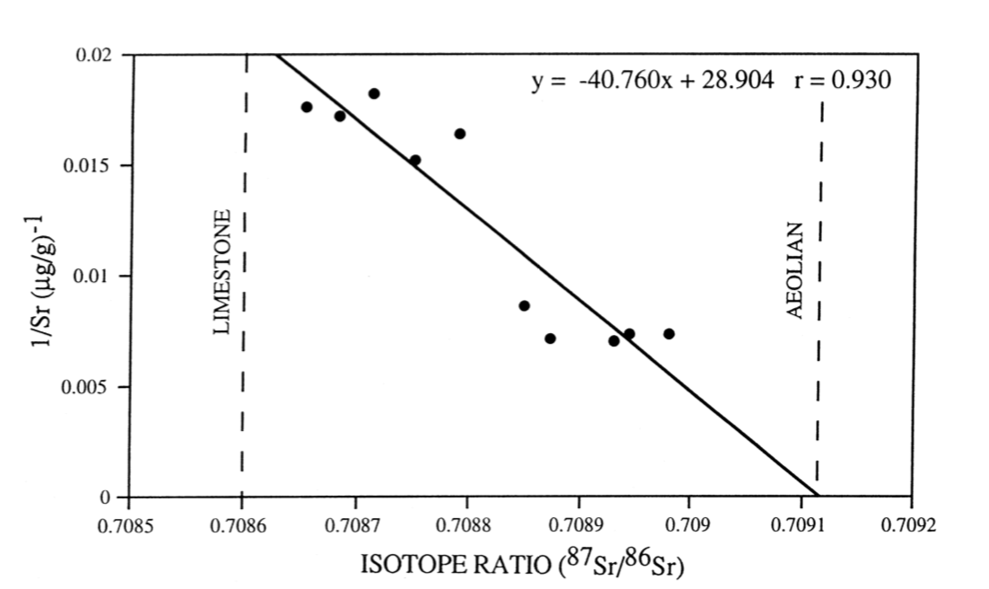
Figure S2d. Speleothem mixing diagram. The mixing diagram presents ⁸⁷Sr:⁸⁶Sr ratios (molar units) (x-axis) plotted against 1/Sr (ug/g)⁻¹ (y-axis). This reveals a negative correlation between the two variables with the data falling into two distinct groups. Extrapolation of the relationship to 1/Sr = 0 indicates a strontium isotope ratio of ~0.7091 (an x-axis intercept) for the exogenic source (approximate value of modern seawater). This figure is an exact copy from Figure 5 in Goede et al. (1998).
-
Any of the thousands of linear Keeling plots or mixing diagrams in the literature (that do indeed correctly identify a source) can be converted into denominator vs. numerator plots. The resulting linear functions will have small non-zero y intercepts. As stated above, mixing diagrams and denominator vs. numerator relationships are mathematically linked. Few scientists in the isotopic research community, however, believe that such small non-zero y-intercept values could be important. Researchers need to know that even the smallest non-zero y-intercept values hold importance. Variations in isotopic ratios for these datasets can be almost entirely explained by differences in total element.

6. MORE NUANCES OF KEELING PLOTS AND MIXING DIAGRAMS
Conventional Sr mixing diagrams use 1/total Sr (in ug/ml or ug/g) plotted against umole/ml or umole/g-based ⁸⁷Sr:⁸⁶Sr ratios. These inverse 1/total Sr values could also be plotted against mass-based ⁸⁷Sr:⁸⁶Sr ratios. Both types of plots accurately predict sources but with different values and units (Figure S3a). As stated in Section 1, although a ug/ml-based expression for the ⁸⁷Sr:⁸⁶Sr ratio of a modern seawater source (y-intercept = 0.717345) in Figure S3a is technically correct, this can create confusion for those familiar with the conventional (0.7091) value derived from molar units. The y-intercepts for the two mixing lines in Figure S3a closely match the respective denominator vs. numerator slopes in Figures 1a and S2a.
It is at first surprising that a ug/ml expression of total Sr predicts a umole/ml-based ratio. This occurs because total Sr in ug/ml units are always strongly related to ⁸⁶Sr values whether the ⁸⁶Sr values are expressed in either ug/ml or umole/ml forms. The reason Keeling plots or mixing diagrams work is that 1/total Sr in (1/ug/ml or ug/g units) is a surrogate for 1/total ⁸⁶Sr expressions in either ug/ml or umole/ml forms. The respective total Sr (ug/ml) vs.⁸⁶Sr relationships in both ug/ml and umole/ml units are presented in Figures S3b and S3c.
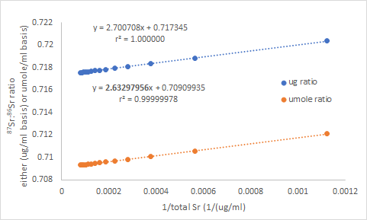
Figure S3a. Graphical illustration of the conventional Keeling plot method (referred to as a mixing diagram for non-gas samples) using an estimate of 1/total Sr (ug/ml) on the x-axis and ⁸⁷Sr:⁸⁶Sr ratios on both ug/ml and umole/ml bases for the ratio data derived from Figures 1a and S2a. The total Sr estimate was calculated by assuming the sum of ⁸⁶Sr and ⁸⁷Sr on a umole/ml basis was 0.168581 (value for the commonly used SRM 987 Strontium Carbonate reference standard) of the umole/ml total. Once the umole/ml total was known it was multiplied by the Molecular Weight of combined Sr isotopes (87.62) to determine the ug/ml total Sr.

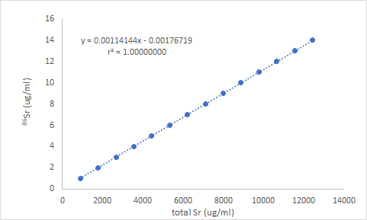
Figure S3b. The relationship between an estimate of total Sr (ug/ml) and ⁸⁶Sr (ug/ml) values from the same data presented in Figure S1a. The total Sr estimate was calculated by assuming the sum of ⁸⁶Sr and ⁸⁷Sr on a umole/ml basis was 0.168581 (value for the commonly used SRM 987 Strontium Carbonate reference standard) of the umole/ml total. Once the umole/ml total was known it was multiplied by the Molecular Weight of combined Sr isotopes (87.62) to determine the ug/ml total Sr.

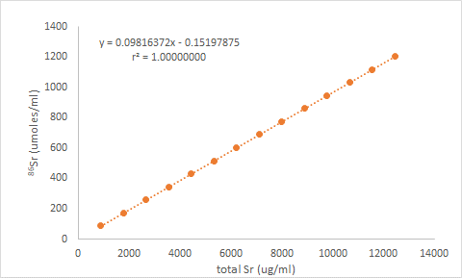
Figure S3c. The relationship between an estimate of total Sr (ug/ml) and ⁸⁶Sr (umole/ml) values from the same data presented in Figure 1a. The total Sr estimate was calculated by assuming the sum of ⁸⁶Sr and ⁸⁷Sr on a umole/ml basis was 0.168581 (value for the commonly used SRM 987 Strontium Carbonate reference standard) of the umole/ml total. Once the umole/ml total was known it was multiplied by the Molecular Weight of combined Sr isotopes (87.62) to determine the ug/ml total Sr.
-
Traditional Keeling plots or mixing diagrams (orange points in Figure S3a) are simply an indirect way of estimating the slope of linear numerator vs. denominator plots. An exact match of sources (⁸⁶Sr vs. ⁸⁷Sr slope and 1/⁸⁶Sr vs ⁸⁷Sr:⁸⁶Sr ratio y-intercept) and backgrounds (⁸⁶Sr vs. ⁸⁷Sr y-intercept and 1/⁸⁶Sr vs. ⁸⁷Sr:⁸⁶Sr ratio slope) will occur when all Sr values are expressed in molar units.

7. MATERIALS AND METHODS USED TO PRODUCE TABLE 1
Google was used to find Sr isotope papers by searching for ⁸⁶Sr:⁸⁷Sr ratios pdf. The first ten pages of this Google search were evaluated. A second Google search for Sr isotopes pdf was conducted and the first ten pages of this search were evaluated to select papers not found in the first search. After culling papers that did not evaluate treatments (mostly methods papers) 100 Sr publications were selected for analysis based on the alphabetic order of the first author. This produced a selection of 100 publications. A similar procedure was used for C and N isotope papers. Since this process produced less than 100 papers for C and N analyses, additional publications were added to the lists by evaluating the N and Sr papers to determine if they had ¹³C data and the Sr and C papers to determine if they had ¹⁵N data. Eventually, 100 C and N isotope papers were selected for analysis based on the alphabetic order of the first author. Papers were placed into three categories: (1) data that could be used to determine total element, which could then be matched to isotopic ratios was not available (2) data that could be used to determine total element, which could then be matched to isotopic ratios was available, but not used to evaluate sources (3) data that could be used to determine total element, which could then be matched to isotopic ratios was available, and this data was used to evaluate sources (mixing diagrams or Keeling plots).
The use of a single search engine may lead to bias. It is possible that other search engines such as the Web of Science or SciFinder might produce different results. However, our goal was to demonstrate that the use of source analyses is rare, rather than to define the exact portion of publications that may fall into a particular category. We suspect that other search engines will provide a similar conclusion.

8. NOTE ON ADJUSTING RATIOS TO ACCOUNT FOR NON-ZERO Y-INTERCEPTS FOR POLYNOMIAL FUNCTIONS
A function that identifies y-intercept corrected ratios can be calculated by maintaining the coefficients of a polynomial equation and reducing the exponents by a factor of one. For example:
y = 0.0000000089x³ - 0.0000039211x² + 0.7096379729x
becomes
y/x = 0.0000000089x² - 0.0000039211x + 0.7096379729
Polynomial function equation-derived y-intercept modified data and y-intercept modified data created by adding or subtracting a constant to existing numerator values are identical. Intercept modified data removes the y-intercept and total element effects on ratio values. For linear functions this creates a flat mixing diagram. Mean derivatives, slope and the mean y-intercept corrected ratios produce the same values and are indicative of a constant source for linear functions. Plotting intercept modified data for linear denominator vs. numerator functions reveals the slight changes in source for different times depths or other variables.
Intercept corrections for curvilinear functions present what the relationship would be if y-intercept and total element effects did not occur. This can be useful in visualizing the magnitude of these effects. However, y-intercept corrected mixing diagrams for curvilinear polynomial functions do not directly reveal source changes for curvilinear functions. Quantifying source changes requires derivatives for these non-linear functions.

9. NOTE ON THE MAGNITUDE OF NON-ZERO Y-INTERCEPTS
The math-derived non-zero y-intercepts that represent isotopic backgrounds presented here for denominator isotope vs. numerator isotope plots are small, but important. For the carbon examples, the non-zero y-intercepts represent from 1.4% to 2.5% of the simulated data range for ¹³C. For the strontium examples, the non-zero y-intercepts represent from 0.12% to 1.22% of the simulated data range for ⁸⁷Sr. Superimposed on small but real math-driven non-zero y-intercepts are other potential causes of allometric relationships.
The many possible reasons for non-zero y-intercepts are addressed elsewhere (Righetti et al. 2007a; Righetti et al. 2007b; Righetti et al. 2012). Systematic measurement error, interrupted equilibriums and hysteresis effects as systems gain and lose the numerator isotope have been proposed. For isotopic studies, even the slightest deviation from an isometric relationship has interpretive consequences. A small over or under estimation of ⁸⁷Sr in a dataset (for example a 0.12% systematic over or under estimation, (as demonstrated above) is enough to alter results. Almost all researchers would be pleased with this level of error, but for isotopic studies, this is not trivial. It is counterintuitive but true; tiny deviations from an isometric relationship have interpretive consequences.
10. SIMULATIONS DEMONSTRATING SOURCE, BACKGROUND AND Y-INTERCEPT EFFECTS ON ISOTOPIC RATIOS FOR CURVILINEAR DENOMINATOR VS. NUMERATOR FUNCTIONS
The following simulation reiterates the fact that changing observed isotopic ratios are not necessarily related to changing sources. A second simulation goal is to demonstrate that interpreting a nonlinear mixing diagram, although difficult, can theoretically be accomplished to define a changing source. A third goal was to demonstrate that even though y-intercepts for curvilinear ⁸⁶Sr vs. ⁸⁷Sr relationships in real datasets may be difficult to evaluate, they are mathematically related to system backgrounds.

10.1 Simulation Methods
Two simulations were conducted to verify and better illustrate mathematical predictions. The first simulation (Figures S4a-S4d) provides a detailed explanation on how observed ⁸⁷Sr:⁸⁶Sr ratios change as an ⁸⁷Sr:⁸⁶S source becomes more enriched. The second simulation (Figure S4e) demonstrates how different backgrounds affect the changing ⁸⁷Sr:⁸⁶Sr ratios that are observed. Both simulations are described below:
- This simulation produced one dataset. A 3-liter vessel was visualized as containing 500 mls water. This imaginary water had a Sr concentration of 995 ug/g (11.3558548 umoles/g) with an initial background ⁸⁷Sr:⁸⁶Sr ratio of 0.7121. Assuming the combined portion of ⁸⁶Sr and ⁸⁷Sr was 16.8581% (the value for the NBS SRM 987 Strontium Carbonate reference standard), initial values of ⁸⁶Sr and ⁸⁷Sr were 1.1181481 and 0.79623326 umoles/g respectively. The additional imaginary water added to the system had an initial ⁸⁷Sr:⁸⁶Sr ratio of 0.7090 with increasing source ⁸⁷Sr:⁸⁶Sr ratios thereafter. The ⁸⁷Sr:⁸⁶Sr ratios were always calculated in molar units. The ⁸⁷Sr:⁸⁶Sr ratio of water increases with each 110 ml increment added every minute. This increasing source ratio is defined by a convex ⁸⁶Sr vs. ⁸⁷Sr polynomial function shown in Figure S4b. Total concentrations of ⁸⁶Sr, ⁸⁷Sr, and total Sr (in both ug/g and umole/g units) in the vessel were calculated for every time period.
- This simulation produced six datasets, each from a simulation with a different background, but otherwise similar to what is described in (1) above. Six 3-liter vessels were visualized as containing 500 mls water. As above, the water had an initial Sr concentration of 995 ug/g. However, background ⁸⁷Sr:⁸⁶Sr ratios varied from 0.7100 to 0.7141. All six backgrounds had higher ⁸⁷Sr:⁸⁶Sr source ratios than the initial source. This dictates that all convex polynomial functions have positive y-intercepts. Water with an increasing source ratio, defined by the same convex function used above, was then conceptually added to the container in 110 ml increments every minute. Total concentration of ⁸⁶Sr, ⁸⁷Sr, and total Sr (in both ug/g and umole/g units) in the vessel were calculated for every time period.
-
For all seven artificial simulated datasets, the relationships between ⁸⁷Sr:⁸⁶Sr ratio and both total isotope and ratio denominator (⁸⁶Sr) were evaluated in both ug/g and umole/g units. Both total Sr and ⁸⁶Sr approaches produce similar results because ratio denominators are always strongly related to total isotope. The five approaches described in Moots et al. (2024) for dealing with confounded isotopic ratios were evaluated for each artificial simulation dataset. As long as ⁸⁷Sr:⁸⁶Sr ratios are expressed on a umole/g basis, any of the plots with the ⁸⁷Sr:⁸⁶Sr ratio on the y-axis produce similar patterns regardless of the units used for the expression on the x-axis.

10.2 Simulation Results
The simulation 1 relationship between total Sr and ⁸⁷Sr:⁸⁶Sr ratio for both observed ratios in the entire container (blue) and the source of added material (orange) is presented in Figure S4a. A denominator vs. numerator plot is presented in Figure S4b. A modified mixing diagram (using y-intercept modified ⁸⁷Sr:⁸⁶Sr ratios on the y-axis) for the same data is presented in Figure 4c.
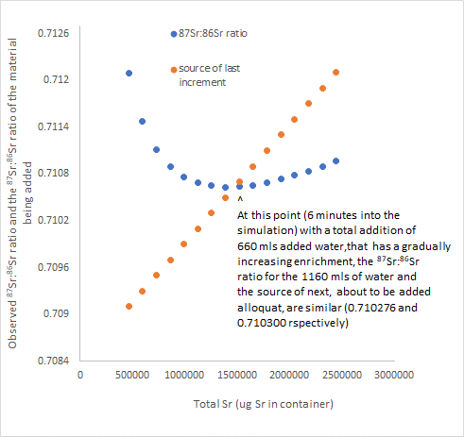
Figure S4a. Simulation 1 model for a single vessel system where the source ⁸⁷Sr:⁸⁶Sr ratio increases (becomes more enriched) over time. Total Sr vs. ⁸⁷Sr:⁸⁶Sr ratios are presented for both observed ratios (blue) and the source of added material (orange). A 3-liter vessel was visualized as containing 500 mls water. This imaginary water had a Sr concentration of 995 ug/g with a background ⁸⁷Sr:⁸⁶Sr ratio of 0.7121. Water with an increasing source ratio is defined by a convex function where the source becomes more enriched as total Sr increases in 110 ml increments every minute. The polynomial ⁸⁶Sr vs. ⁸⁷Sr relationship with a positive y-intercept produces an observed ratio ⁸⁷Sr:⁸⁶Sr ratio pattern that is difficult to interpret (main text).
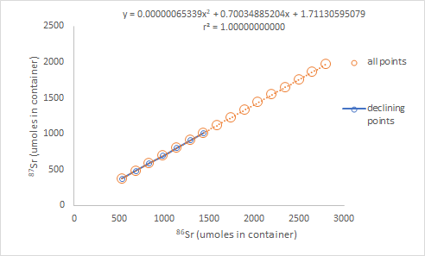
Figure S4b. The relationship between ⁸⁶Sr and ⁸⁷Sr in the simulated experiment described in Figure S4a. All of the datapoints and the datapoints from the region of declining ⁸⁷Sr:⁸⁶Sr ratio in Figure S4a are shown. Although the curvature is too miniscule to see, a perfect convex polynomial function with a positive y-intercept defines the relationship shown. The size of the y-intercept (when compared to the range of the ⁸⁷Sr values) appears negligible (~0.08% of y-axis range) but is mathematically consequential.

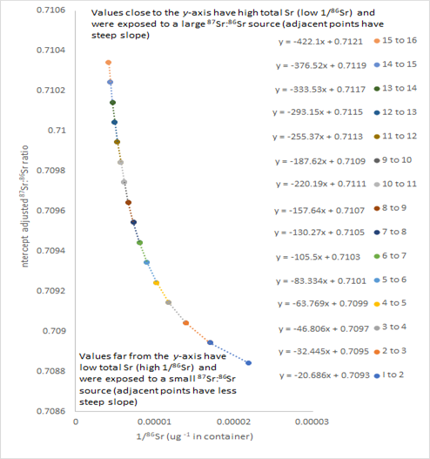
Figure S4c. A modified mixing diagram (using y-intercept corrected ⁸⁷Sr:⁸⁶Sr data with 1/⁸⁶Sr as the x-axis) for the same simulation described in Figure S4a. A 3-liter vessel was visualized as containing 500 mls water. This imaginary water had a Sr concentration of 995 ug/g with a background ⁸⁷Sr:⁸⁶Sr ratio of 0.7121. Water with an increasing source ratio is defined by a convex function where the source becomes more enriched as total Sr increases in 110 ml increments every minute. However, unlike standard mixing diagrams where 1/total Sr or 1/⁸⁶Sr is plotted against an observed ratio, in this case y-intercept corrected values are presented on the y-axis. Extrapolating a line from two-point segments of the curve produces a y-intercept estimated source for each segment. The two-point equations are shown at the right of the figure.
-
The observed ⁸⁷Sr:⁸⁶Sr ratios (Figure S4a) that are associated with curvilinear ⁸⁶Sr vs. ⁸⁷Sr relationships (changing sources as shown in Figure S4b) are difficult to interpret. This is especially true in this example where observed ratios present the characteristic trough or U shape that results from convex denominator isotope vs. numerator isotope relationships with positive y-intercepts (main text).
The size of the y-intercept (when compared to the range of the ⁸⁷Sr values) appears negligible (~0.08% of the y-axis) but is mathematically consequential, as the intercept effect produces a detectable decline in ⁸⁷Sr:⁸⁶Sr ratios that would be interpretively important. The relationship cannot be linear since an increasing source was used in the model. If the regression line were linear, the ⁸⁷Sr:⁸⁶Sr pattern shown in Figure S4a would change. The observed ⁸⁷Sr:⁸⁶Sr ratio would decline and asymptotically approach a constant source. The declining points (blue) in Figure S4c represent the first seven simulation time increments shown with declining ⁸⁷Sr:⁸⁶Sr ratios. Even though all portions of the data have the same ⁸⁶Sr vs. ⁸⁷Sr regression equation, the overall observed ratio pattern is unrelated to the constantly increasing source.
The observed ⁸⁷Sr:⁸⁶Sr ratio in this simulation (Figure S4a) can be negatively related (left portion), unrelated (middle portion) or positively related (right portion) to the changing source (i.e., comparing blue [observed ratio] with orange [source]). In much of the isotopic literature the reader has no idea if total element increased or decreased or whether a source is constant, decreasing or increasing. A similar complex relationship (hill or inverted U-shaped pattern) is associated with concave denominator isotope vs. numerator isotope relationships with a negative y-intercept (main text).
In our discussions we define “background” as the isotopic ratio of the starting reservoir to which an element is being added to or removed. Backgrounds are normally viewed as unchanging. However, if one were to start observations midway up the increasing part of the U-shaped curve in Figure S4a, the “new” background would be less than the source. Therefore, the observed ratio must increase with additions of more enriched water. The ⁸⁷Sr:⁸⁶Sr ratio of the system, however, is buffered due to the large size of the reservoir, thus the observed ⁸⁷Sr:⁸⁶Sr values increase more slowly than the source.
The overall ⁸⁶Sr vs. ⁸⁷Sr relationship (Figure S4b) for the entire time course of the simulation has a positive y-intercept. This suggests a background that is initially greater than the source. The initial ⁸⁷Sr:⁸⁶Sr ratio to the far left in Figure S4a (background for the start of the simulation) is much higher than the initial orange point representing the initial source. Observed ratios must initially decline since the source is less than the background. This occurs even though the source is becoming more enriched. We define this initial negative correlation phenomenon which applies to the left side of the curve for the observed ratio (blue) shown in Figure S4a as a “y-intercept effect” or “total isotope effect.”
At the minimum value of the U-shaped pattern in Figure S4a, the addition of Sr (660 ml of solution added) with an increasingly enriched ⁸⁷Sr:⁸⁶Sr ratio has now created a situation where the ⁸⁷Sr:⁸⁶Sr ratio of the water in the vessel is instantaneously approximately equal to the source (marked by ∧ in Figure S4a). At this point, adding more solution with an increasingly enriched source causes an increase in the observed ratio. If the experiment were viewed as being started at this point, the overall function would have a zero y-intercept. For this brief moment the convex curvature is the only factor driving the observed ratio. We have defined this final increase in observed ratios shown in Figure S4a as a “curvature effect.”
Figure S4c presents a mixing diagram (1/⁸⁶Sr x-axis format) for the same simulation described in Figure S4a. Unlike standard mixing diagrams where 1/total Sr or 1/⁸⁶Sr is plotted against an observed ratio, Figure S4c has y-intercept corrected values presented on the y-axis. These values were calculated as described in Section 2.1 of the main text. The y-intercept correction removes the intercept and total Sr effects thus the curve only reflects a changing source. In this example extrapolating a line from two-point segments of the curve to calculate a y-intercept predicts the changing source values in Figure S4a. A y-intercept modified mixing diagram approach can be made to work for non-linear ⁸⁶Sr vs. ⁸⁷Sr functions. However, this is simply an indirect way to estimate the changing slope (derivative) of the original ⁸⁶Sr vs. ⁸⁷Sr functions (Figure S4d).
Figure S4d presents a standard (not y-intercept corrected) mixing diagram in the 1/⁸⁶Sr format (blue points) for the same simulation described in Figure S4a. Superimposed on this mixing line are two estimates of the source over the time intervals evaluated in the simulation: (1) The derivative from the ⁸⁶Sr vs. ⁸⁷Sr regression equation in Figure S4b, and (2) the estimated source from the y-intercept corrected mixing diagram for individual two-point segments in Figure S4c. Although non-linear mixing diagrams can be manipulated to identify sources for individual segments (Figure S4c), this is not necessary. The information derived from Keeling plots (Keeling, 1958) or mixing diagrams is directly available from plots of the denominator vs. the numerator of an isotopic ratio. The small deviation between derivatives and the mixing line estimated source in Figure S4d is due to a rounding error of the x² term (only three significant digits) in Figure S4c and slight errors associated with the calculation of the 15 two-point y-intercepts (Figure S4c). Although there are subtle differences in the derivative and mixing line values in Figure S4d, both these patterns closely match the actual source used in the simulation (data not shown).
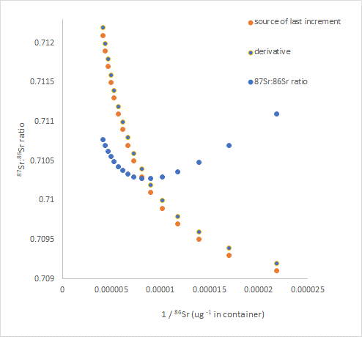
Figure S4d. A 1/⁸⁶Sr form of mixing diagram (blue points) for the same simulation described in Figure S4a. A 3-liter vessel was visualized as containing 500 mls water. This imaginary water had a Sr concentration of 995 ug/g with a background ⁸⁷Sr:⁸⁶Sr ratio of 0.7121. Water with an increasing source ratio is defined by a convex function where the source becomes more enriched as total Sr increases in 110 ml increments every minute. Superimposed on this mixing line are two estimates of the source over the time intervals evaluated in the simulation: (1) The derivative [from the ⁸⁶Sr vs. ⁸⁷Sr regression equation (Figure S4b), and (2) the estimated source (calculated from 2-point y-intercepts) from the mixing diagram in Figure S4c.
-
In Figure S4e all Simulation 2 relationships between 1/⁸⁶Sr (in molar units) and ⁸⁷Sr:⁸⁶Sr ratio for both observed ratios (different backgrounds in various colors) and the source of added material (open orange circles) are presented. The only difference between Simulation 1 and Simulation 2 procedures is that six different backgrounds were used. The lower of the two middle plots (blue) has the same data points presented in Figure S4a. The bottom two curves have the characteristic U shape that results from convex denominator isotope vs. numerator isotope relationships with a positive y-intercept (main text). However, in the top four curves for higher backgrounds in Figure S4e, the upward trend is not as apparent.
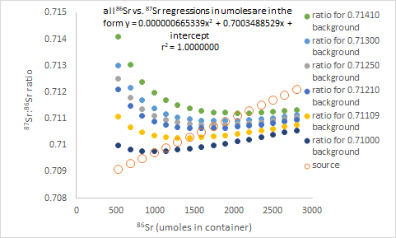
Figure S4e. Simulation 2 model for six vessels with different backgrounds. Total Sr vs. ⁸⁷Sr:⁸⁶Sr ratios for both observed ratios and the source are plotted. Six 3-liter vessels were visualized as containing 500 mls water. These imaginary vessels of water had a Sr concentration of 995 ug/g with background ⁸⁷Sr:⁸⁶Sr ratios varying from 0.7141 to 0.7100. Water with an increasing source ratio is defined by a convex function where the source becomes more enriched as total Sr increases in 110 ml increments every minute.
-
In Figure S4f, the y-intercepts for the Simulation 2 relationship (six original ⁸⁶Sr vs. ⁸⁷Sr plots in molar units) are plotted against simulated backgrounds. Background values are mathematically related to the y-intercept of ⁸⁶Sr vs. ⁸⁷Sr plots for both curvilinear relationships (shown here), and linear relationships (main text). In this example, all y-intercepts were positive indicating that ⁸⁷Sr:⁸⁶Sr ratio backgrounds were initially higher than the ⁸⁷Sr:⁸⁶Sr source.
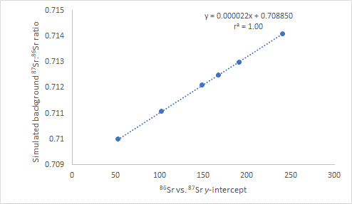
Figure S4f. Data for the Simulation 2 model for six containers with different backgrounds shown in Figure S4e. The y-intercept for the simulated relationship (original ⁸⁶Sr vs. ⁸⁷Sr plots) for six 3-liter containers is plotted against the background used for each individual vessel in the simulation. This imaginary water had a Sr concentration of 995 ug/g with background ⁸⁷Sr:⁸⁶Sr ratios varying from 0.7141 to 0.7100. Water with an increasing source ratio is defined by a convex function where the source becomes more enriched as total Sr increases in 110 ml increments every minute.
-
The Simulation 2 results also match patterns observed in real data for a European mammoth and a Cone Pond water inlet presented in Moots et al. (2024; Supplemental Material 2; A Mathematical Explanation for Why Ratio-Based Isotopic Analyses are Commonly Misleading: Data Re-evaluations for Sr Isotopes). The simulation patterns also match an early time period for a Songjia Cave speleothem (Moots et al. (2024).
For Simulation 2, the exact polynomial equations describing the changing sources were known and backgrounds could be predicted. However, in real datasets, it will be difficult to extrapolate beyond the range of observed data points to identify the y-intercept of a complex curvilinear function. Difficulties in defining backgrounds for linear denominator vs. numerator functions have been described (main text). The task of identifying backgrounds for curvilinear functions in real datasets is even more difficult.
Many systems are characterized by periods of elemental gain followed by elemental loss. For example, hibernating bears and deciduous tree fruit systems, go through many gain and loss cycles. Both linear and curvilinear denominator vs. numerator relationships can be complicated by this system history. Isotopic gain patterns may not be the same as isotopic loss patterns. With the beginning of each new gain cycle, the system has a new start point. The y-intercept of linear, concave and convex functions with a complicated history may be difficult to evaluate and interpret. Nonetheless, changing slopes or curvature evaluations (derivatives) still define how sources change.
11. SIMULATION DEMONSTRATING WHY NOT ALL TREATMENTS IN AN EXPERIMENTAL STUDY ARE SIMILARLY CONFOUNDED
Experimental datasets, even when all treatments are defined with linear denominator vs. numerator functions, may not be similarly confounded for individual treatments. The size of the non-zero y-intercept and the distance of data points from the origin affect isotopic ratio’s confounding severity. The effects of different y-intercepts and the position of points (both close to and farther away from the origin) can be clearly seen in main text Figures 1b and 1d. The distance from the origin is important because at large values of the denominator, a ratio will approach the denominator vs. numerator slope. For example, for treatments with similar slopes and positive denominator vs. numerator y-intercepts, an average isotope ratio will be larger for a treatment with many low denominator values than for a treatment with higher denominator values.
The following simulation (although not a perfect model) conceptionally outlines how approximated quantitative numerical indicators of the degree of isotopic confounding can be theoretically derived. Also demonstrated is how one could predict which of several treatments are likely most confounded. This is done by combining both y-intercept and denominator size effects.
This simulation represents the common situation where points of different treatments fall on different denominator vs. numerator regression lines. In Figure S5a, data used for main text Figure 1b (umoles ⁸⁶Sr vs. ⁸⁷Sr:⁸⁶Sr ratio) have been replotted. There are 15 different denominator concentrations (umole/ml) for each y-intercept in this version of the figure. These 15 individual points have been combined to form five different experimental categories (three points each). The variability within each y-intercept data range category is entirely due to isotopic scaling since the data is derived from perfect linear denominator vs. numerator relationships all with the same slope (0.7091).
The values for umole/ml concentrations for each group are listed above each category division. For example, conc 1, 2, 3 refers to the set of points on each y-intercept line that correspond to the category defined by 1, 2, and 3 umole/ml concentrations of ⁸⁶Sr. The ⁸⁶Sr concentrations (2, 5, 8, 11, and 14) listed in bold represent the median concentration values of each of the three y-intercept groups for the five different ⁸⁶Sr data ranges. Some of the intercept-denominator categories are more variable (more confounded) than others. A standard deviation for the three points in each of 15 intercept-denominator categories can be calculated and represents the “confoundedness” of the category. Fifteen “confoundedness” values (standard deviations for three points) can be calculated (five concentration categories and three y-intercept groups).
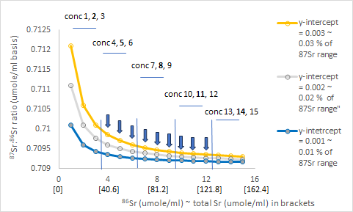
Figure S5a. ⁸⁶Sr concentrations (umole/ml) vs. ⁸⁷Sr:⁸⁶Sr ratio similar to the values shown in main text Figure 1b. There are 15 different denominator concentrations (umole/ml) for each y-intercept in this version of the figure. These 15 individual points have been combined to form 5 different experimental categories. The ⁸⁶Sr concentrations (2, 5, 8, 11, and 14) listed in bold represent the median concentration values of each of the three y-intercept groups for the five different ⁸⁶Sr data ranges. Nine replicates in simulated treatments can be created by assigning different categories on the same regression line to a particular treatment. For example, values in treatment 1 (largest y-intercept [0.003] for this simulation) are marked with vertical arrows. This treatment is identified as 0.003 (11,8,5) in Figures S5b, S5c, and S5e.
-
The standard deviations for six simulated treatments, consisting of 9 points each from a combined group of three intercept-denominator categories, all with an ⁸⁷Sr:⁸⁶Sr source similar to seawater can be calculated. The relationship between 1/median category values (umoles/ml) squared and the standard deviation for each 3-point category that when combined define a nine point treatment are shown in Figure S5b. For example, standard deviations for the treatment with three categories (each with three points) defined by 11, 8, and 5 median umoles/ml concentrations for the 0.003 y-intercept points are represented by open blue circles in Figure S5b.
Although not perfect, the relationship between median concentration for a category squared, and the standard deviations for the same categories that make up six different sets of nine treatment points are approximated with linear functions (Figure S5b). Regressions (0 y-intercept models) for each of the six simulated treatments are presented at the far right of Figure S5b. In this example, interval median concentration squared is associated with most of the variability in standard deviations (r² = 0.984865; shown in bold for the overall function). However, different y-intercepts produce different standard deviations for the same median concentration squared values associated with different y-intercepts. This is apparent in Figure S5b and even more strongly revealed in Figure S5c where relationships are shown in a narrower range. If the single very high value in Figure S5b (open square at upper right) is excluded only about 85% of the variability in standard deviations are explained by median concentration values squared (Figure S5c).
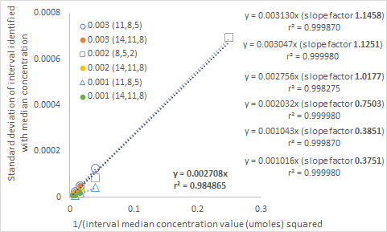
Figure S5b. The relationships between standard deviations for six simulated treatments (nine observations per treatment spread over 3 ranges of values on the same y-intercept line) and 1/ median category concentration value (middle of three values in parenthesis) squared. For example, the three standard deviation values for open blue circles are defined by 11, 8 and 5 median umole/ml concentration categories (3 points in each category) for the 0.003 y-intercept group. Regression equations (no y-intercept models) for each simulated treatment are presented at the far right of the figure. All data is derived from the same information presented in Figure S5a.

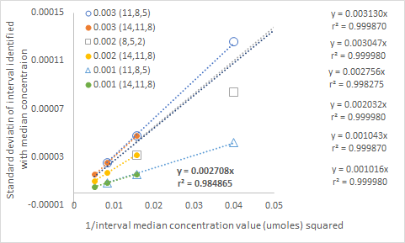
Figure S5c. The relationships between standard deviations for six simulated treatments (nine observations per treatment) and 1/ median category concentration value (middle of three values in parenthesis) squared. Regression equations (no y-intercept models) for each treatment are presented in the far right of the figure. This figure is identical to Figure S5b, as all data is derived from the same information presented in Figure S5a. However, the reduced x-axis data range better illustrates relationships for low values when the single extreme point in Figure S5b is removed.
-
Dividing a treatment slope by the overall slope (shown in bold at the bottom position in both Figures S5b and S5c) produces the slope factors presented in Figure S5b. These slope factors and the regression equations listed in Figure S5b can reasonably predict the standard deviations for each of the 15 categories defined in Figure S5b as presented in Figure S4d (standard deviation = slope factor * result produced by the treatment regression equation). Once the standard deviations are predicted for individual categories, the sum of the standard deviations for the three categories that make up the different simulated treatments can also be calculated.
Actual standard deviation sums and predicted standard deviation sums are in good agreement (Figure S5e). The sum of the standard deviations for the categories making up a simulated treatment are a numerical indicator of the degree of isotopic confounding. The data in Figure S5e clearly suggest that not all treatments have similar confounding issues. The simulated treatment with an intermediate y-intercept along with low denominator values (0.002 y-intercept; 8,5,2 median values) and the simulated treatment with a high y-intercept along with intermediate denominator values (0.003 y-intercept; 11,8,5 median values) are more confounded than the other simulated treatments. All denominator vs. numerator regression equations have positive y-intercepts, thus mean values for ⁸⁷Sr:⁸⁶Sr ratios will overestimate the source value (slopes) of 0.7091. However, only for the two treatments with large numerical confounding indicators (identified above) is this estimation substantially greater than seawater (0.7101 and 0.7097 respectively).
Alternatively, these numerical indicators can be predicted by multiple regression using slope factors and the sum of 1/numerator squared values for a simulated treatment ((0.00128 * slope factor) + (0.06265 * sum of [1/⁸⁶Sr]² values) – 0.00012). The p-values are 0.02834, 0.00142, and 0.02016 for the slope factor, sum of 1/numerator squared, and y-intercept, respectively. The multiple R² value is 0.99804.
A similar real data example (Moyo et al. 2021) reveals that all species in a trophic level study have confounded ¹⁵N:¹⁴N ratios (Moots et al. (2024); Supplemental Material 2). This occurs linear ¹⁴N vs. ¹⁵N regression lines with different positive y-intercepts describe all species. However, the scaling consequences are severe for only two of six species evaluated.
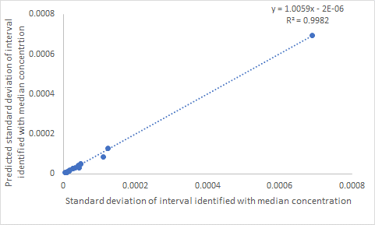
Figure S5d. The relationship between standard deviation of 15 categories identified with median ⁸⁶Sr concentration and ⁸⁶Sr vs. ⁸⁷Sr y-intercepts (presented in Figure S5a) and predicted standard deviations for the same category. Slope factors and the regression equations listed in Figure S5b for each simulated treatment can reasonably predict the standard deviations for each of the 15 categories even though the relationship is not perfect.
-
Approximated quantitative numerical indicators of the degree of isotopic confounding can be theoretically determined. This can be done by combining both y-intercept and denominator size effects. Although not perfect, the simulation provides a good example of the concepts involved.

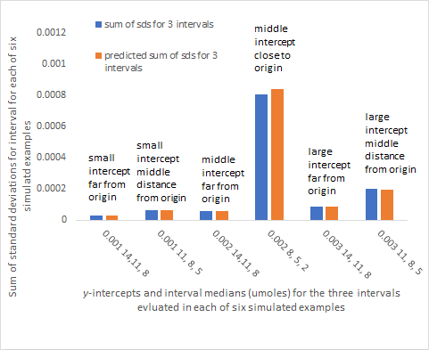

Figure 5e. The sum of the standard deviations for the three (three-point) observations in each of the six (nine-point) simulated treatments listed in Figure S5b and c. Once the standard deviations are predicted for individual categories, the sum of the standard deviations for the three categories that make up the simulated treatments can also be calculated. Actual standard deviation sums and predicted standard deviation sums are in good agreement. The sum of the standard deviations for the categories making up a simulated treatment are a numerical indicator of the degree of isotopic confounding.
-

12. TABLES S1 AND S2
.
Table S1. Patterns for the relationship between total isotope and isotopic ratio differ among nine possible functions that define how isotopic ratio denominator and numerator are related to each other. Function types are: - Row 1 linear, concave, and convex functions, with positive y-intercepts; - Row 2 linear, concave, and convex functions, with zero y-intercepts; and - Row 3 – linear, concave, and convex functions, with negative y-intercepts. Diagrams inserted into the boxes indicate the shape of the denominator vs. observed ratio (right corner; total concentration of denominator isotope (x-axis) vs. observed isotopic ratio (y-axis)), and the shape of the denominator isotopic concentration vs. numerator isotope concentration (left corner; denominator concentration (x-axis) and numerator concentration (y-axis)) for all nine function categories. The +, 0, and - notation in the figures refer to positive, zero and negative y-intercepts. Red curves of the right corner figures depict the shape of the total concentration of the denominator isotope vs. observed isotopic ratio shape. Blue curves depict what the total concentration of denominator vs. isotopic ratio curve would be if the function evaluated had a zero y-intercept. The y-intercepts of denominator vs. numerator functions are mathematically related to backgrounds. Both function curvature (for concave and convex functions) and non-zero y-intercepts cause changes in isotopic ratio as ratio denominator changes. For y-intercept effects, both denominator vs. ratio patterns and total element vs. ratio patterns are similar. This occurs because isotope ratio denominators are always strongly correlated to total element since the portion of total for each isotope is essentially constant.

Intercept | Linear | Concave | Convex
Positive  y-intercept | The observed isotopic ratio must decline with either increasing denominator or total element concentration due to a positive y-intercept (background > source) effect. For all linear functions y = mx + b; and y/x = (1/x) b + m. Therefore, the observed ratio (red) will decline and asymptotically approach the slope of the original denominator vs. numerator function. If the original denominator vs. numerator function had a zero y-intercept the isotopic ratio would not change with either denominator size or total elemental concentration (shown in blue). The original denominator vs. numerator slope (left side figure) equals the observed constant isotopic ratio shown in blue for the upper right corner figure. The drivers of isotopic ratio changes in this example are the background (indicated by the positive y-intercept of the original denominator vs. function) and total elemental concentration. | In addition to the positive y-intercept (background > source) effect described for linear functions which produces declining ratios as denominator or total element increases; changing concave curvature (representing a source that is becoming more depleted) also results in declining ratios. The combined intercept and curvature effects produces a pattern where the observed ratio (red) starts higher and declines more quickly than what occurs for a concave function with a zero y-intercept (shown in blue). However, the observed ratio will asymptotically approach the concave zero y-intercept values (blue) for large denominator or total element concentrations. The background (indicated by a positive y-intercept in the original denominator vs. numerator relationship) is the major driver during the early increase in total element concentration. A changing source (indicated by the concave denominator vs. numerator function) is the major driver during the late increase in total element concentration. | In addition to the positive y-intercept (background > source) effect described for linear functions which initially produces decreasing observed ratios (red) as denominator or total element increases, changing convex curvature (representing a source that is becoming more enriched) eventually results in increasing ratios. The combined intercept and curvature effects produces a pattern where the ratio first decreases and then flattens at a minimum value before increasing. Eventually, the ratio will asymptotically approach the concave zero y-intercept values (blue) for large denominator or total element concentrations. The background (indicated by a positive y-intercept in the original denominator vs. numerator relationship) is the major driver during the early increase in total element concentration. A changing source (indicated by the convex denominator vs. numerator function) is the major driver during the late increase in total element concentration.
Zero  y-intercept | The observed ratio (blue in the right figure) does not change with increasing denominator or total element concentration. For all linear functions (y = mx +b; and y/x = (1/x) b + m, if b in the first equation is zero (background = source) the slope m in the first equation and the observed ratio in the second equation are the same. The slope equals the constant source and both source and background are similar. Thus, the observed ratio will not change. There are no drivers to change isotopic ratios. | There is not an intercept (background) effect. The ratio (blue) will decline with increasing denominator or total element concentration because as the concave curvature suggests, the source is becoming more depleted. The original denominator vs. numerator concave curvature (indicating a changing source) is the only driver for changes in isotopic ratio. | There is not an intercept (background) effect. The ratio (blue) will increase with increasing denominator or total element concentration because as the convex curvature suggests, the source is becoming more enriched. The original denominator vs. numerator convex curvature (indicating a changing source) is the only driver for changes in isotopic ratio.
Negative  y-intercept | The observed isotopic ratio must increase with either increasing denominator or total element concentration due to a negative y-intercept (source > background) effect. For all linear functions y = mx + b; and y/x = (1/x) b + m. Therefore, the observed ratio (red) will increase and asymptotically approach the slope of the original denominator vs. numerator function. If the original denominator vs. numerator function had a zero y-intercept the isotopic ratio would not change with either denominator size or total elemental concentration (shown in blue). The original denominator vs. numerator slope (left side figure) equals the observed constant isotopic ratio shown in blue for the upper right corner figure. The drivers of isotopic ratio changes in this example are the background (indicated by the positive y-intercept of the original denominator vs. function) and total elemental concentration. | In addition to the negative y-intercept (source > background) effect described for linear functions which initially produces increasing ratios as denominator or total element increases; changing concave curvature (representing a source that is becoming more depleted) eventually results in declining ratios. However, the observed ratio will asymptotically approach the concave zero y-intercept values (blue) for large denominator or total element concentrations. The combined intercept and concave curvature effects produce a pattern (red) that is different from what occurs for a concave function with a zero y-intercept (shown in blue). The background (indicated by a non-zero y-intercept in the original denominator vs. numerator relationship) is the major driver during the early increase in total element concentration. A changing source (indicated by the concave denominator vs. numerator function) is the major driver during the late increase in total element concentration. | In addition to the negative y-intercept (source > background) effect described for linear functions which produces increasing ratios as denominator or total element increases; changing convex curvature (representing a source that is becoming more enriched) also results in increasing ratios. The combined intercept and curvature effects produce a pattern where the observed ratio (red) starts lower and increases more quickly than what occurs for a concave function with a zero y-intercept (shown in blue). However, the observed ratio will asymptotically approach the concave zero y-intercept values (blue) for large denominator or total element concentrations. The background (indicated by a negative y-intercept in the original denominator vs. numerator relationship) is the major driver during the early increase in total element concentration. A changing source (indicated by the convex denominator vs. numerator function) is the major driver during the late increase in total element concentration.

Table S2. Patterns for the relationship between total isotope and isotopic ratio (right figures) among nine possible denominator vs. numerator functions (left figures in black). Red curves refer to the total element vs. ratio relationships for the y-intercepts shown in left figures. Blue curves refer to what would occur for a zero y-intercept.
____________________________________________________________________________________________________________
Intercept | Linear  Denominator vs.  Numerator | Concave  Denominator vs.  Numerator | Convex  Denominator vs.  Numerator | Linear  Total Element vs.  Ratio | Concave  Total Element vs.  Ratio | Convex  Total Element vs.  Ratio
Positive
y-intercept
Zero
y-intercept
Negative
y-intercept

REFERENCES
Atchley, W. R., Gaskins, C. T., and Anderson, D. (1976), “Statistical Properties of Ratios. I. Empirical Results,” Society of Systematic Biologists, 25, 137-148, DOI: 10.2307/2412740.
Banner, J.L. and Hanson, G.N., 1990, “Calculation of simultaneous isotopic and trace element variations during water-rock interaction with applications to carbonate diagenesis.” Geochimica et Cosmochimica Acta, 54, 3123-3137, DOI: 10.1016/0016-7037(90)90128-8
Banner, J. L., Wasserburg, G. J., Dobson, P. F., Carpenter, A. B., and Moore, C. H. (1989), “Isotopic and Trace Element Constraints on the Origin and Evolution of Saline Groundwaters from Central Missouri,” Geochimica et Cosmochimica Acta, 53, 383-398, DOI: 10.1016/0016-7037(89)90390-6.
Banner, J. L., Musgrove, M., Edwards, R. L., Asmerom, Y., and Hoff, J. A. (1996), “High- Resolution Temporal Record of Holocene Ground-Water Chemistry: Tracing Links between Climate and Hydrology,” Geology, 24, 1049-1052, DOI: 10.1130/0091-7613(1996)024<1049:HRTROH>2.3.CO;2.
Bentley, R. A. (2006), “Strontium Isotopes from the Earth to the Archaeological Skeleton: A Review,” Journal of Archaeological Method and Theory, 13, 135-187, DOI: 10.1007/s10816-006-9009-x.
Berglund, M., and Wieser, M. E. (2011), “Isotopic Compositions of the Elements 2009 (IUPAC Technical Report),” Pure and Applied Chemistry, 83, 397-410, DOI: 10.1351/PAC-REP-10-06-02.
Bilby, R. E., Fransen, B. R., and Bisson, P. A. (1996), “Incorporation of Nitrogen and Carbon from Spawning Coho Salmon into the Trophic System of Small Streams: Evidence from Stable Isotopes,” Canadian Journal of Fisheries and Aquatic Sciences, 53, 164-173, DOI: 10.1139/f95-159.
Brand, W. A., and Coplen, T. B. (2012), “Stable Isotope Deltas: Tiny, Yet Robust Signatures in Nature,” Isotopes in Environmental Health Studies, 48, 393-409, DOI: 10.1080/10256016.2012.666977.
Caut, S., Angulo, E., and Courchamp, F. (2009), “Variation in Discrimination Factors (Δ¹⁵N and Δ¹³C): The Effect of Diet Isotopic Values and Applications for Diet Reconstruction,” Journal of Applied Ecology, 46, 443-453, DOI: 10.1111/j.1365-2664.2009.01620.x.
Certo, S. T., Busenbark, J. R., Kalm, M., and LePine, J. A. (2020), “Divided We Fall: How Ratios Undermine Research in Strategic Management,” Organizational Research Methods, 23, 211-237, DOI: 10.1177/1094428118773455.
Coplen, T. B. (2011), “Guidelinge and Recommended Terms for Expression of Stable Isotope-Ratio and Gas-Ratio Measurement Results,” Rapid Communications in Mass Spectrometry, 25, 2538-2560, DOI: 10.1002/rcm.5129.
Crawford, K., Mcdonald, R. A., and Bearhop, S. (2008), “Applications of Stable Isotope Techniques to the Ecology of Mammals,” Mammal Review, 38, 87-107, DOI: 10.1111/j.1365-2907.2008.00120.x.
Ehleringer, A. H, Hall, A. E., and Farquhar, G. (1993), Stable Isotopes and Plant Carbon-Water Relations, San Diego, CA.USA: Academic Press.
Enquist, B. J. (2002), “Universal Scaling in Tree and Vascular Plant Allometry: Toward a General Quantitative Theory Linking Plant Form and Function from Cells to Ecosystems,” Tree Physiology, 22, 1045-1064, DOI: 10.1093/treephys/22.15-16.1045.
Ericson, J. E. (1985), “Strontium Isotope Characterization in the Study of Prehistoric Human Ecology,” Journal of Human Evolution, 14, 503-514, DOI: 10.1016/S0047-2484(85)80029-4.
Faure, G. (1986), Principles of Isotope Geology (2nd ed.), New York, Brisbane Toronto, Singapore: John Wiley and Sons.
Finlay, J. C. (2001), “Stable Carbon-Isotope Ratios of River Biota: Implications for Energy Flow and lotic Food Webs,” Ecology, 82, 1052-1064, DOI: 10.2307/2679902.
Gannes, L. Z., Martinez del Rio, C., and Kock, K. (1998), “Natural Abundance Variations in Stable Isotopes and Their Potential Used in Animal Physiological Ecology,” Comparative Biochemistry and Physiology Part A: Molecular & Integrative Physiology, 119, 725-737, DOI: 10.1016/S1095-6433(98)01016-2.
Gilbert, C., and Rasmussen J. B. (1994), “Modelling Food Chain Structure and Contaminant Bioaccumulation using Stable Nitrogen Isotopes,” Nature, 372, 255-257, DOI: 10.1038/372255a0.
Glazier, D. S. (2021), “Biological Scaling Analyses are More than Statistical Line Fitting,” Journal of Experimental Biology, 224, jeb241059, DOI: 10.1242/jeb.241059.
Goede, A., McCulloch, M., McDermott, F., and Hawkesworth, C. (1998), “Aeolian Contribution to Strontium and Strontium Isotope Variations in a Tasmanian Speleothem,” The Holocene, 9, 715-722.
Grupe, G., Price, T. D., Schroter, P. Sollner, F. Johnson, C. M., and Beard, B. L. (1997), “Mobility of Bell Beaker People Revealed by Strontium Isotope Ratios of Tooth and Bone: A Study of Bavarian Skeletal Remains,” Applied Geochemistry, 12, 517-525, DOI: 10.1016/S0883-2927(97)00030-9.
Hayes, J. M. (2004), An Introduction to Isotopic Calculations, Woods Hole MA, USA: Woods Hole Oceanographic Institution.
House, C. H., Wong, G. M., Webster, C. R., Flesch, G. J., Franz, H. B., Stern, J. C., Pavlov, A., Atreya, S. K., Eigenbrane, J. L., Gilbert, A., and Hofmann, A. E. (2022), “Depleted carbon isotope compositions observed at Gale crater, Mars,” Proceedings of the National Academy of Sciences, 119(4), e2115651119, DOI: 10.1073/pnas.2115651119.
Inger, R., and Bearhop, S. (2008), “Applications of Stable Isotope Analyses to Avain Ecology,” Ibis, 150, 447-461, DOI: 10.1111/j.1474-919X.2008.00839.x.
Isles, P. D. F. (2020), “The Misuse of Ratios in Ecological Stoichiometry,” Ecology, 101, 1-7, DOI: 10.1002/ecy.3153.
Jackson, D. A., Harvey, H. H., and Somers, K. M. (1990), “Ratios in Aquatic Sciences: Statistical Shortcomings with Mean Depth and the Morphoedaphic Index,” Canadian Journal Fisheries and Aquatic Sciences, 47, 1788-1795, DOI: 10.1139/f90-203.
Jackson, P. C., Meinzer, F.C., Goldstein, G., Holbrook, N. M., Cavelier, J., and Rada, F. (1993), “Environmental and Physiological Influences on Carbon Isotope Composition of Gap and Understory Plants in a Lowland Tropical Forest,” In Stable Isotopes and Plant Carbon-Water Relations, eds. A.H. Ehleringer, A. E. Hall, and G. Farquhar, San Diego, CA. USA: Academic Press.
Jacobi, C. M., Villamarin, F., Jardine, T. D., and Magnusson, W.E. (2020), “Uncertainities Associated with Trophic Discrimination Factor and Body Size Complicate Calculation of d¹⁵N-Derived Trophic Positions in Arapaima sp.,” Ecology of Freshwater Fish, 29, 779-789, DOI: 10.1111/eff.12553.
Jahn, B., Gallet, S., and Han, J. (2001), “Geochemistry of Xining, Xifeng and Jixian Sections, Loess Plateau of China: Eolian Dust Provenance and Paleosol Evolution during The Last 140 ka,” Chemical Geology, 178, 71-94, DOI: 10.1016/S0009-2541(00)00430-7.
Jasienski, M., and Bazzaz, F. A. (1999), “The Fallacy of Ratios and the Testability of Models in Biology,” Oikos, 84, 321-326, DOI: 10.2307/3546729
Katzenberg, M. A. (2008), “Stable Isotope Analysis: A Tool for Studying Past Diet, Demography, and Life History,” In Biological Anthropology of the Human Skeleton (2nd ed.), eds. M. A. Katzenberg, and S. R. Saunders, Ottawa, ON. Canada: S. R. John Wiley and Sons, pp. 413-441.
Keeling, C. D. (1958), “The Concentration and Isotopic Abundances of Atmospheric Carbon Dioxide in Rural Areas,” Geochimica et Cosmochimica, 13, 322-334, DOI: 10.1016/0016-7037(58)90033-4.
Kerkhoff, A. J., and Enquist, B. J. (2009), “Multiplicative by Nature: Why Logarithmic Transformation is Necessary in Allometry,” Journal of Theoretical Biology, 257, 519-521, DOI: 10.1016/j.jtbi.2008.12.026.
Kratochvil, L., and Fleger, J. (2009), “Differences in the 2nd to 4th Digit Length Ratio in Humans Reflect Shifts along the Common Allometric Line,” Biology letters, 5, 643-646, DOI: 10.1098/rsbl.2009.0346.
Lerch, T. Z., Nunan, N., Dignac, M. F., Chenu, C., & Mariotti, A. (2011). Variations in microbial isotopic fractionation during soil organic matter decomposition. Biogeochemistry, 106, 5-21, DOI:10.1007/s10533-010-9432-7
Leslie, M. (2019), “The Mismeasure of Hands?” Science, 364, 923-925, DOI: 10.1126/science.364.6444.923.
Li, H. C., Ku, T. L., You, C F., Cheng, H., Edwards, R. L., Ma, Z. B., Tsai, W. S., and Li, M. D. (2005), “⁸⁷Sr/⁸⁶Sr and Sr/Ca in Speleothems for Paleoclimate Reconstruction in Central China between 70 and 280 kyr ago,” Geochimica et Cosmochimica Acta, 69, 3933-3947, DOI: 10.1016/j.gca.2005.01.009.
McGarvey, D. J. (2020), “Individual Level Data Reveal High Prevalence of Positive Size Trophic Position Relationship for Vertebrates,” Freshwater Biology, 66, 628-639, DOI: 10.1111/fwb.13666.
Mobius, J. (2013), “Isotope Fractionation during Nitrogen Remineralization (Ammonification): Implications for Nitrogen Isotope Biogeochemistry,” Geochimica et Cosmochimica Acta, 105, 422-432, DOI: 10.1016/j.gca.2012.11.048.
Montgomery, J., and Evans, J. A. (2006), “Immigrants on the Isle of Lewis - Combining Traditional Funerary and Modern Isotopic Evidence to Investigate Social Differentiation, Migration and Dietary Change in the Outer Hebrides of Scotland,” In Social Archaeology of Funerary Remains, eds. R. Gowland, and C. Knusel, Oxbow: Oxford, pp. 123-142.
Montgomery, J., Evans, J. A., and Cooper, R. E. (2005), “Resolving Archaeological Populations with Strontium Mixing Diagrams,” Geological Research Abstracts, 17, 10020.
Moots, K. Nguyen, C. P Nguyen C. Camacho, F., Lindstrom, D., and Righetti, T, L. (2024). A mathematical explanation for why ratio-based isotopic analyses are commonly misleading: Dealing with confounded isotopic ratios. Scientific Reports this issue .
Moyo, S., Bennadji, H., Laguaite, D., Pérez-Umphrey, A. A., Snider, A. M., Bonisoli-Alquati, A., et al. (2021), “Stable Isotope Analyses Identify Trophic Niche Partitioning between Sympatric Terrestrial Vertebrates in Coastal Saltmarshes with Differing Oiling Histories,” PeerJ, 9, e11392, DOI: 10.7717/peerj.11392.
O’Reilly, C. M., Alan, S. R., Pilisnier, P., Cohen, A. S., and Mckee, B. A. (2003), “Climate Change Decreases Aquatic Ecosystem Productivity of Lake Tanganykik, Africa,” Nature, 6950, 766-768, DOI: 10.1038/nature01833.
Packard, G. C., and Boardman, T. J. (1998), “The Misuse of Indices and Percentages in Ecophysiological Research,” Physiological Zoology, 61, 1-9, DOI: 10.1086/physzool.61.1.30163730.
Pataki, L., Ehleringer, J. R., Flanagan, L. B., Yakir, D., Bowling, D. R., Still, C. J., et al. (2003), “The Application and Interpretation of Keeling Plots in Terrestrial Carbon Cycle Research,” Global Biochemical Cycles, 25, 1-14, DOI: 10.1029/2001GB001850.
Pearson, K. (1897), “Mathematical Contribution to the Theory of Evolution: On a Form of Spurious Correlation Which May Arise When Indices are Used in the Measurement of Organs,” Proceeding of the Royal Society of London, 60, 489-498, DOI: 10.1098/rspl.1896.0076.
Pearson, S. F., Levey, D. J., and Greenberg, C. H. (2003), “Effects of Elemental Composition on the Incorporation of Dietary Nitrogen and Carbon Isotopic Signatures in an Omnivorous Songbird,” Oecologia, 135, 516-523, DOI: 10.1007/s00442-003-1221-8.
Phillips, D. L., and Koch, P. L. (2002), “Incorporating Concentration Dependence in Stable Isotope Mixing Models,” Oecologia, 130, 114-125, DOI: 10.1007/s004420100786.
Reitsema, L. J. (2013), “Beyond Diet Reconstruction: Stable Isotope Applications to Human Physiology, Health, and Nutrition,” American Journal of Human Biology, 25, 445-456, DOI: 10.1002/aajhb.22398.
Richardson, T. (2020), “Ratios in the Evolutionary Behavioural Sciences: Problems and Solutions,” PsyArXiv. DOI: 10.31234/osf.io/j7vem
Righetti, T. L., Sandrock, D. R. Strik, B., Vasconcelos, C., Moreno, Y., Oretega-Farias, S., et al. (2007a), “Analysis of Ratio-Based Responses,” Journal of the American Society for Horticultural Science, 132, 3-13, DOI: 10.21273/JASHS.132.1.3.
Righetti, T. L., Dalthorp, D., Sandrock, D., Strik, B., Banados, P., and Zhou, Z. (2007b), “Slope-Based and Ratio-Based Approaches to Determine Fertiliser-Derived N in Plant Tissues for Established Perennial Plants,” The Journal of Horticultural Science and Biotechnology, 82, 641-647, DOI: 10.1080/14620316.2007.11512285.
Righetti, T.L., Sandrock, D.R., Strik, B. and Azarenko, A. (2007c). “Appropriate analysis and interpretation approaches to determine fertilizer-derived nitrogen in plant tissues.” Journal of the American Society for Horticultural Science, 132, 429-436, DOI: 10.21273/jash.132.3.429
Righetti, T. L., Dalthorp D., Lambrinos, J. D., Strik, B., Sandrock, D., and Phillips, C. (2012), “Scaling Confounds the Interpretation of Isotopic Data,” International Journal of Environmental Analytical Chemistry, 92, 1-27, DOI: 10.1080/03067319.2010.522236.
Sanchez, E. E., Righetti, T. L., and Lombard, P. B. (1992), “Effects of Timing on Nitrogen Application on Nitrogen Partitioning Between Vegetative, Reproductive, and Structural Components of Mature ‘Comice’ Pears,” Journal of Horticultural Science, 67, 51-58, DOI: 10.1080/00221589.1992.11516220.
Sandrock, D. R., Righetti, T. L., and Azarenko, A. N. (2005), “Isotopic and Nonisotopic Estimation of Nitrogen Uptake Efficiency in Container-Grown Woody Ornamentals,” HortScience, 40, 665-669, DOI: 10.21273/HORTSCI.40.3.665.
Sara, G., Scilipoti, D., Mazzola, A., and Modica, A. (2004), “Effects of Fish Farming Waste to Sedimentary and Particulate Organic Matter in a Southern Mediterranean Area (Gulf of Castellammare, Sicily): A Multiple Stable Isotope Study (ð ¹³C and ð¹⁵N),” Agriculture, 234, 199-213, DOI: 10.1016/j.aquaculture.2003.11.020.
Shackleton, N. J. (1987), “Oxygen Isotopes, Ice Volume and Sea Level,” Quaternary Science Reviews, 6, 183-190, DOI: 10.1016/0277-3791(87)90003-5.
Smith, B. N., and Epstein, S. (1970), “Two Categories of ¹³C/¹²C Ratios for Higher Plants,” Plant Physiology, 47, 380-384, DOI: 10.1104/pp.47.3.380.
Sundquist, H. S. (2007), “Speleothems as Environmental Recorders: A Study of Holocene Speleothems and Their Growth Environments in Sweden,” unpublished Ph.D. dissertation, Institutionen for Naturgeogradi Och Kvartargeologi.
Tanner, J. M. (1949), “Fallacy of Per-Weight and Per-Surface Area Standards, and Their Relation to Spurious Correlation,” Journal of Applied Physiology, 2, 1-15, DOI: 10.1152/jappl.1949.2.1.1.
Tejada-Lara JV, MacFadden BJ, Bermudez L, Rojas G, Salas-Gismondi R, Flynn JJ. (2018) Body mass predicts isotope enrichment in herbivorous mammals. Proc. R. Soc. B 285: 20181020. DOI:/10.1098/rspb.2018.1020.
Villamarín, F., Jardine, T. D., Bunn, S. E., Marioni, B., and Magnusson, W. E. (2018), “Body Size is More Important Than Diet in Determining Stable-Isotope Estimates of Trophic Position in Crocodilians,” Scientific Reports, 8, 1-11, DOI: 10.1038/s41598-018-19918-6.
Xiao, X., White, E. P., Hooten, M. B., and Durham, S. L. (2011), “On the Use of Log‐Transformation Vs. Nonlinear Regression for Analyzing Biological Power Laws,” Ecology, 92, 1887-1894, DOI: 10.1890/11-0538.1.
Wang, G., Yufu, J., and Wei, L. (2015), Effects of environmental and biotic factors on carbon isotopic fractionation during decomposition of soil organic matter. Sci. Rep. 5, 11043; DOI: 10.1038/srep11043.
Whitledge, G. W., and Rabeni, C. F. (1997), “Energy Sources and Ecological Role of Crayfishes in an Ozark Stream: Insights from Stable Isotopes and Gut Analysis,” Canadian Journal of Fisheries and Aquatic Sciences, 54, 2555-2563, DOI: 10.1139/f97-173.
Zhou, H., Feng, Y. X., Zhao, J. X., Shen, C. C., You, C. F., and Lin, Y., (2009), “Deglacial Variations of Sr and ⁸⁷Sr/⁸⁶Sr Ratio Recorded by a Stalagmite from Central China and Their Association with Past Climate and Environment,” Chemical Geology, 268, 233-247, DOI: 10.1016/j.chemgeo.2009.09.003.

