Supplementary Materials
Genome re-sequencing and genome-wide polymorphisms in mosquito vectors Aedes aegypti and Aedes albopictus from south India.

Preeti Acharya¹, Upasana Shyamsunder Singh², Veeramanoharan Rajamannar³, Mayilsamy Muniaraj³, Binata Nayak^{1*}, Aparup Das^{4*}

*Correspondence: aparupdas@nirth.res.in (A.D.); binatanayak@suniv.ac.in (B.N.)

` 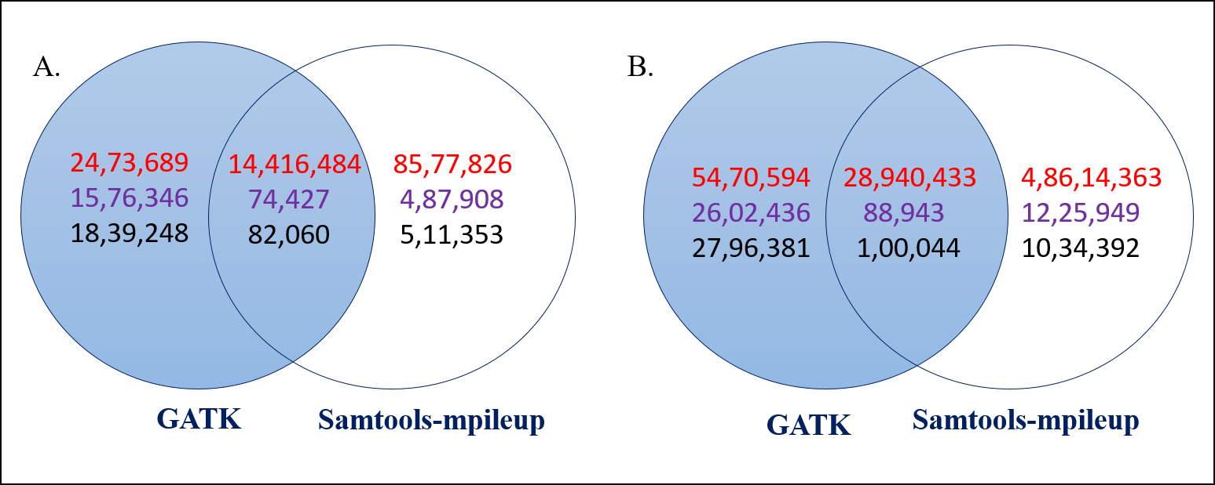
Figure S1 Venn diagram showing common and unique Variants identified by GATK and Samtools-mpileup. (A) Variants identified in Ae. Aegypti and (B) Ae. albopictus. The red colour represents number of SNPs, purple represent number of insertions and black represents number of deletions.

