Supplementary information for

Plastic sex-trait modulation by differential gene expression according to social environment in male red deer

Camilla Broggini¹*, Nieves Abril², Alberto Membrillo¹, Eva de la Peña^{1,3}, Juan Carranza¹

Supplementary Table S1. Red deer specimens used for gene expression studies. "LC" stands for Low Competition Estate, and "HC" stands for High Competition Estate. "Month=1" indicates the first month of the hunting season, which is October. All measurements are in centimeters. The columns represent the following: Sample ID, Age (years), Estate type, Month of collection, Season (year/year), Dark Ventral Patch length, Total Ventral Size, Maximum Dark Ventral Patch Size, and Dark Ventral Patch Width.

Sample ID | Age | Estate | Month | Season | Dark ventral patch | Total ventral size | Maximum dark ventral patch size | Dark ventral patch width
CA19-ALM-2 | 4 | HC | 2 | 2019/2020 | 63 | 63 | 63 | 11
JA19-VLQ-3 | 5 | LC | 2 | 2019/2020 | 36 | 64 | 64 | 17
C018-CLL-04 | 3 | LC | 5 | 2018/2019 | 14,00 | 59,00 | 59,00 | 11,00
JA19-VLQ-4 | 7 | LC | 2 | 2019/2020 | 55 | 65 | 65 | 16
CA19-ALM-1 | 2 | HC | 2 | 2019/2020 | 63 | 63 | 63 | 12
CO19-RC-9 | 3 | HC | 5 | 2019/2020 | 9 | 56 | 9 | 6
CO19-MON-13 | 3 | LC | 4 | 2019/2020 | 20 | 52 | 20 | 10
CO19-MON-03 | 3 | LC | 4 | 2019/2020 | 34 | 67 | 67 | 21
CO19-MON-41 | 1 | LC | 4 | 2019/2020 | 11,5 | 55 | 16 | 8,5
CO19-MON-14 | 4 | LC | 4 | 2019/2020 | 67 | 67 | 67 | 22
CO18-CLL-03 | 2 | LC | 5 | 2018/2019 | 14,00 | 59,00 | 14,00 | 12,50
CO19-ALD-11 | 3 | LC | 5 | 2019/2020 | 15 | 60 | 15 | 10,5
CO19-ALD-13 | 3 | LC | 5 | 2019/2020 | 17 | 61 | 17 | 18
CO19-ALD-15 | 2 | LC | 5 | 2019/2020 | 61 | 61 | 61 | 9
CO19-ALD-16 | 2 | LC | 5 | 2019/2020 | 9 | 53 | 9 | 10
CO19-RC-5 | 3 | HC | 5 | 2019/2020 | 12 | 56 | 12 | 12
CO19-RC-8 | 2 | HC | 5 | 2019/2020 | 10 | 50 | 10 | 6
CO19-RC-1 | 4 | HC | 5 | 2019/2020 | 16 | 63 | 16 | 15
CO20-MEA-1 | 4 | LC | 1 | 2020/2021 | 61 | 61 | 61 | -
CO20-MEA-2 | 3 | LC | 1 | 2020/2021 | 71 | 71 | 71 | -
CO20-MEA-6 | 2 | LC | 1 | 2020/2021 | 14 | 53 | 14 | -
CO20-MEA-7 | 1 | LC | 1 | 2020/2021 | 13 | 60 | 13 | -
CO20-MEA-8 | 1 | LC | 1 | 2020/2021 | 14 | 55 | 14 | -
CO20-BON-2 | 5 | HC | 2 | 2020/2021 | 64 | 64 | 64 | 24
CO21-BON-7 | 6 | HC | 2 | 2020/2021 | 67 | 67 | 67 | 28
CO21-BON-8 | 5 | HC | 2 | 2020/2021 | 62 | 62 | 62 | 23
CO20-BON-5 | 3 | HC | 2 | 2020/2021 | 64 | 64 | 64 | 22
CO20-BON-6 | 6 | HC | 2 | 2020/2021 | 61 | 61 | 61 | 25
CO20-BON-7 | 3 | HC | 2 | 2020/2021 | 55 | 35 | 35 | 17
CO20-BON-8 | 2 | HC | 2 | 2020/2021 | 62 | 62 | 62 | 23,5
CO20-BON-9 | 2 | HC | 2 | 2020/2021 | 58 | 21 | 21 | 13
CO20-JAB-1 | - | LC | 3 | 2020/2021 | 61 | 61 | 61 | 22
CO20-JAB-2 | 3 | LC | 3 | 2020/2021 | 60 | 34 | 34 | 21
CO20-JAB-6 | 6 | LC | 3 | 2020/2021 | 63 | 63 | 63 | 21
CO20-JAB-7 | 4 | LC | 3 | 2020/2021 | 62 | 20 | 20 | 13
CO20-JAB-9 | 3 | LC | 3 | 2020/2021 | 54 | 15 | 15 | 10
CO20-JAB-10 | 3 | LC | 3 | 2020/2021 | 58 | 58 | 58 | 17
CO21-ALM-1 | 2 | LC | 2 | 2021/2022 | 15 | 57 | 28 | 16
CO21-ALM-2 | 3 | LC | 2 | 2021/2022 | 58 | 58 | 58 | 14
CO21-ALM-3 | 3 | LC | 2 | 2021/2022 | 61 | 61 | 61 | 16,5
CO21-BER-4 | 3 | HC | 2 | 2021/2022 | 57 | 57 | 57 | 14
CO21-BER-5 | 4 | HC | 2 | 2021/2022 | 63,5 | 63,5 | 63,5 | 11
CO21-BER-6 | 3 | HC | 2 | 2021/2022 | 63 | 63 | 63 | 10,5
CO21-BON-7 | 5 | HC | 2 | 2021/2022 | 65 | 65 | 65 | 21,5
CO21-BON-8 | 3 | HC | 2 | 2021/2022 | 24 | 59 | 24 | 13

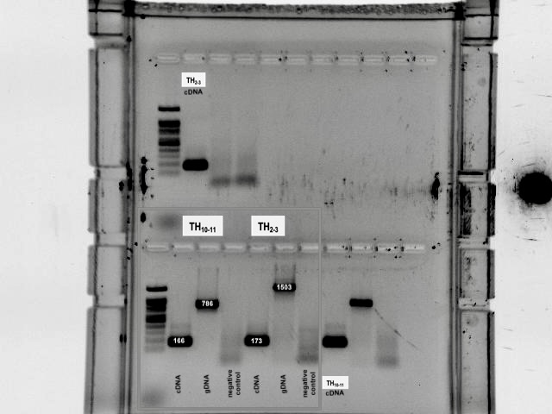
Supplementary Figure S2. Uncropped agarose gel (2%) electrophoresis depicted in Fig 3; the box points to the piece corresponding to Fig. 3b.
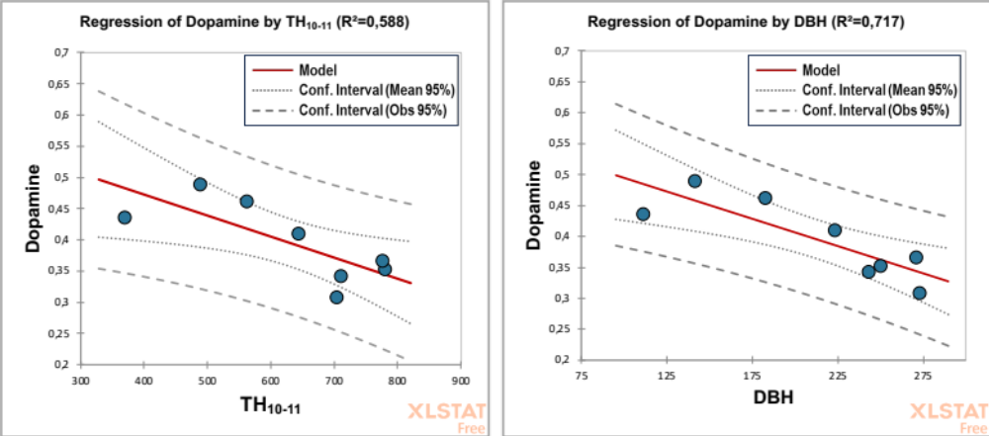
Supplementary Figure S3. Negative correlation between the TH and DBH transcript counts in the adrenal gland of male red deer under different levels of competition pressure and their dopamine levels.

