Supplemetary Table of Preoperative carbohydrate loading reduces length of hospital stay compared to fasting in patients undergoing major elective, non-cardiac surgery: A systematic Review and Meta-Analysis
Figure 1. Baseline characteristics

Forest plot of outcomes which are not included in the manuscript

Preoperative carbohydrate loading versus fasting
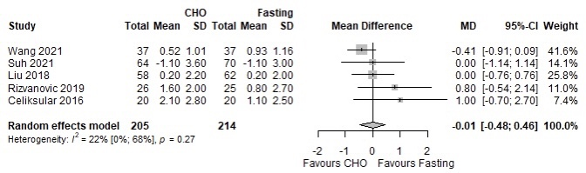
S2. Postoperative glucose levels on postoperative day 1
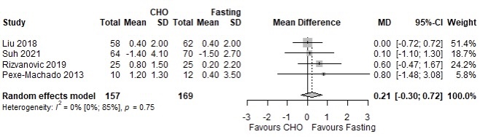
S3.Postoperative glucose levels on postoperative day 2
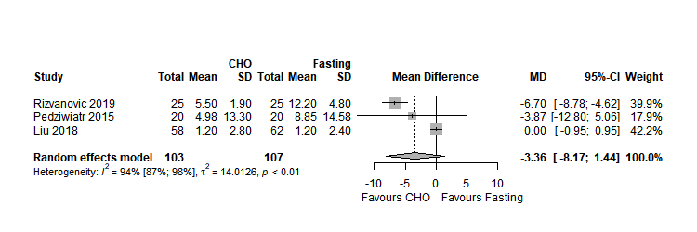
S4. Postoperative insulin levels on postoperative day 1

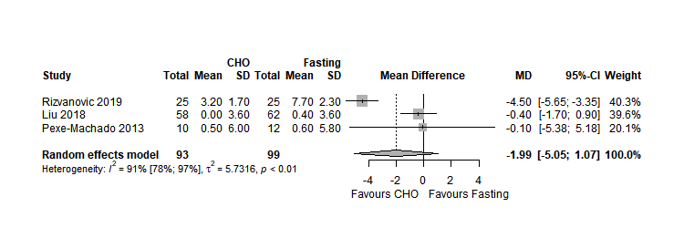
S5. Postoperative insulin levels on postoperative day 2

Preoperative carbohydrate loading versus placebo
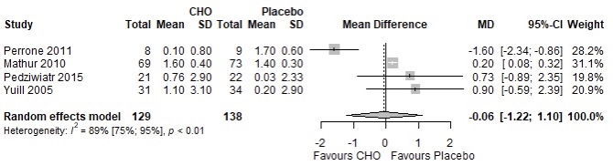
S6. Postoperative glucose levels on postoperative day 1
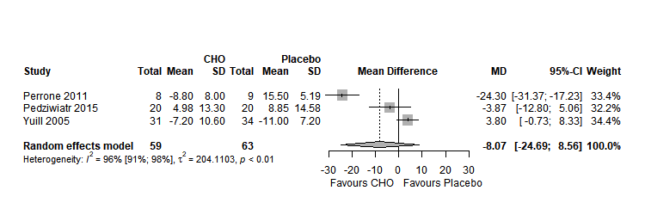
S7. Postoperative insulin levels on postoperative day 1

Risk of bias assesement

Preoperative carbohydrate loading versus fasting
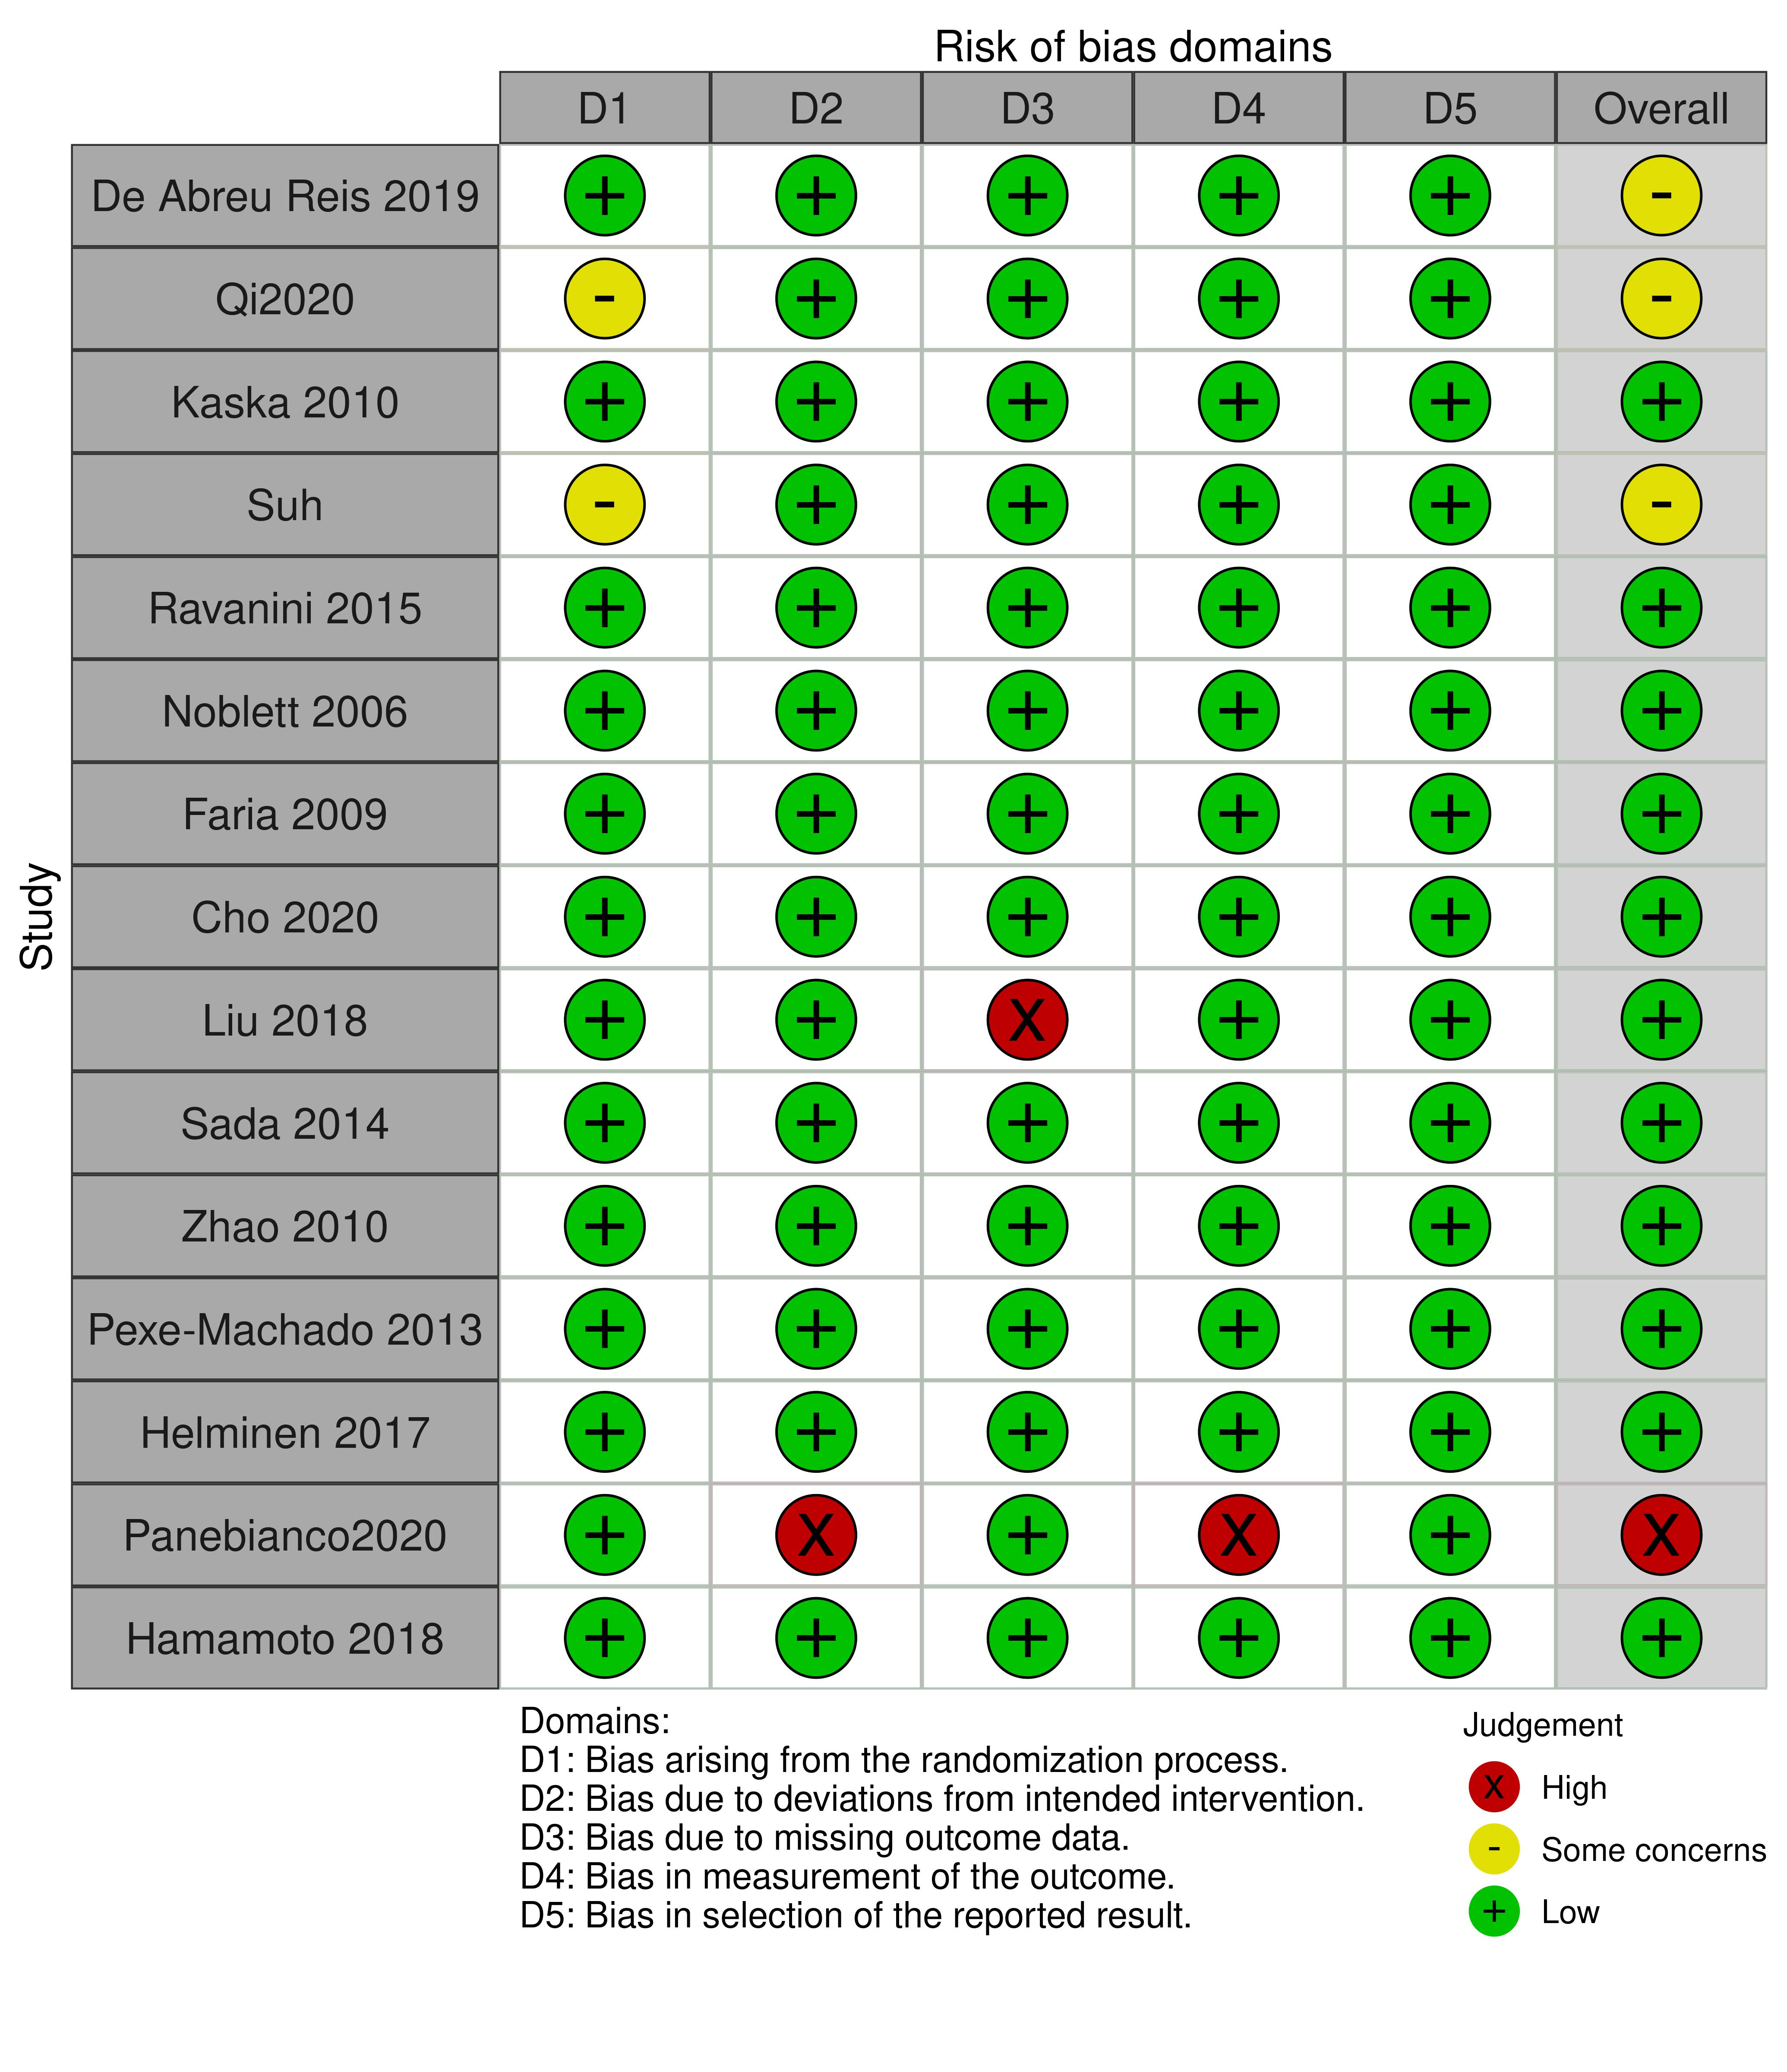
S8. Length of hospital stay
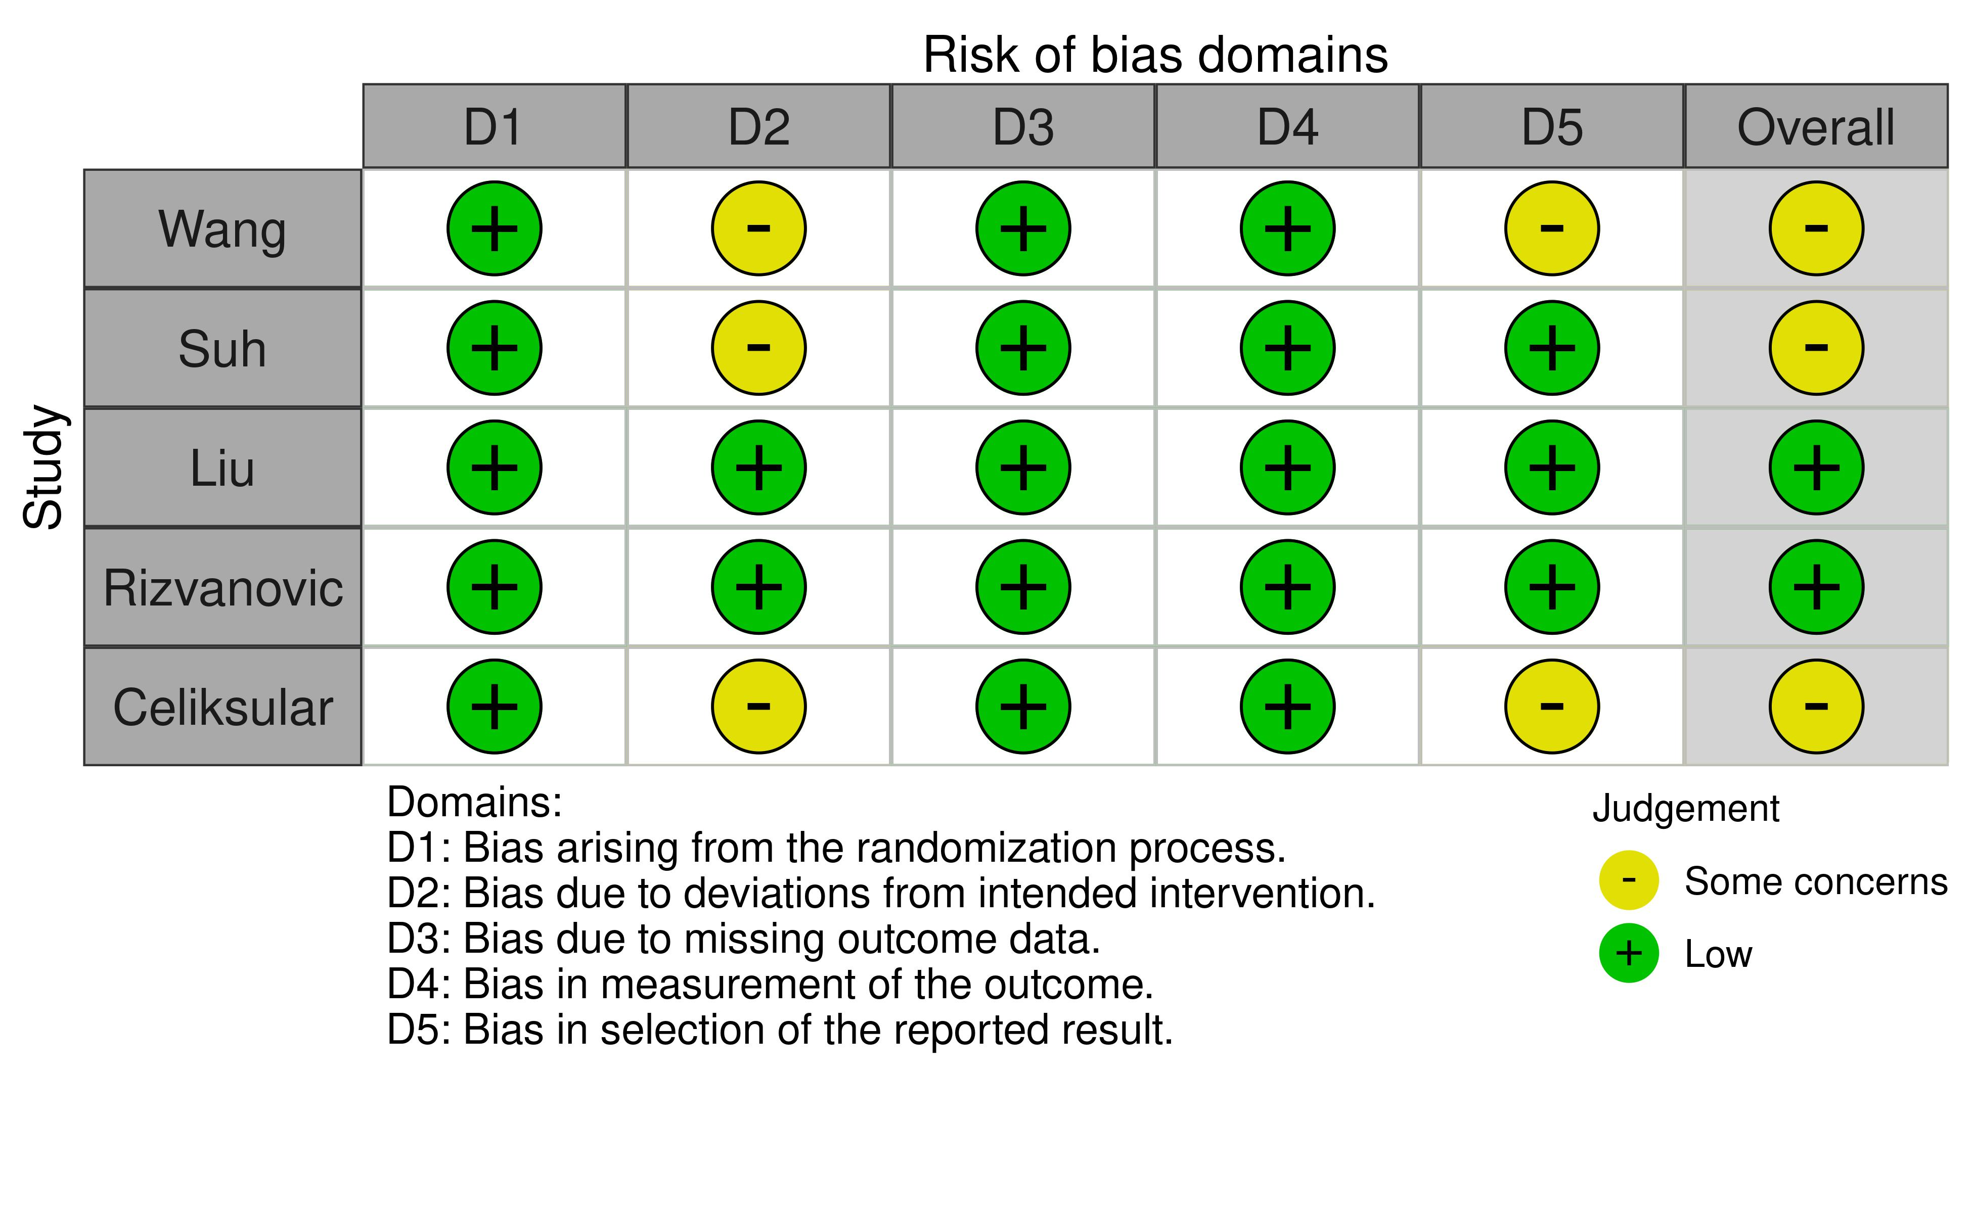
S9. Postoperative glucose levels on postoperative day 1

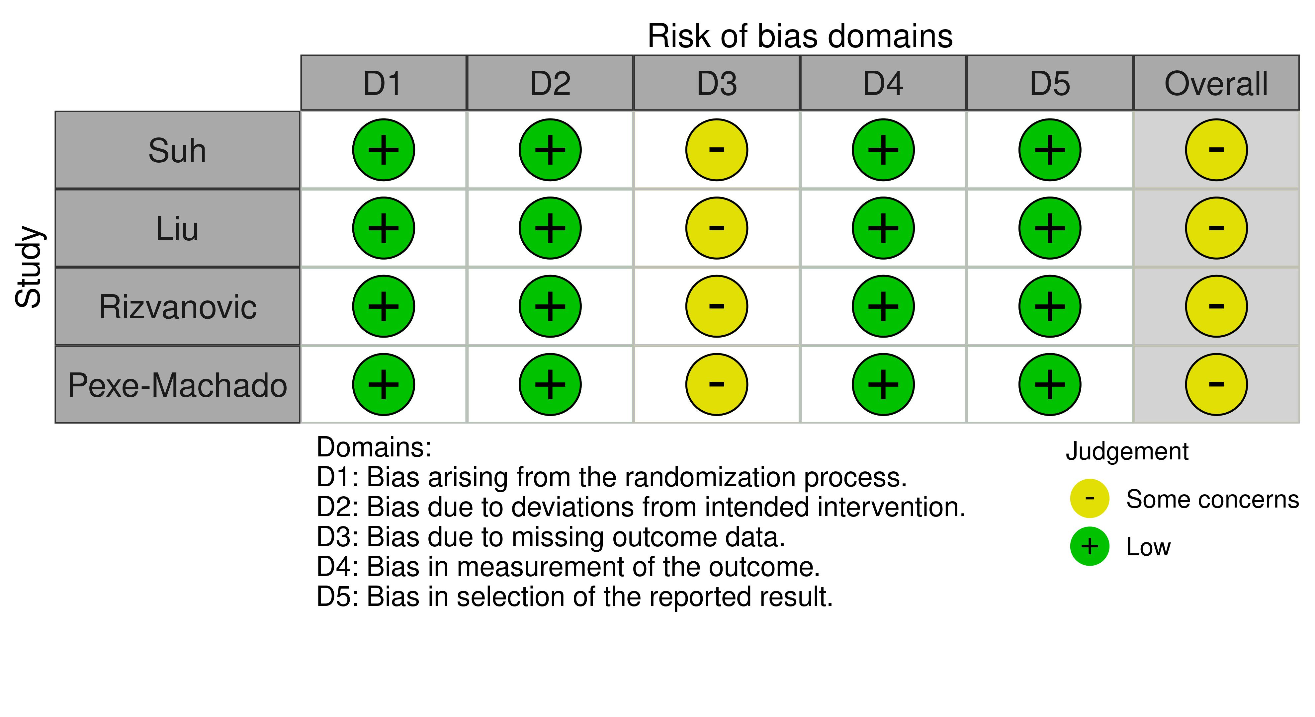
S10. Postoperative glucose levels on postoperative day 2

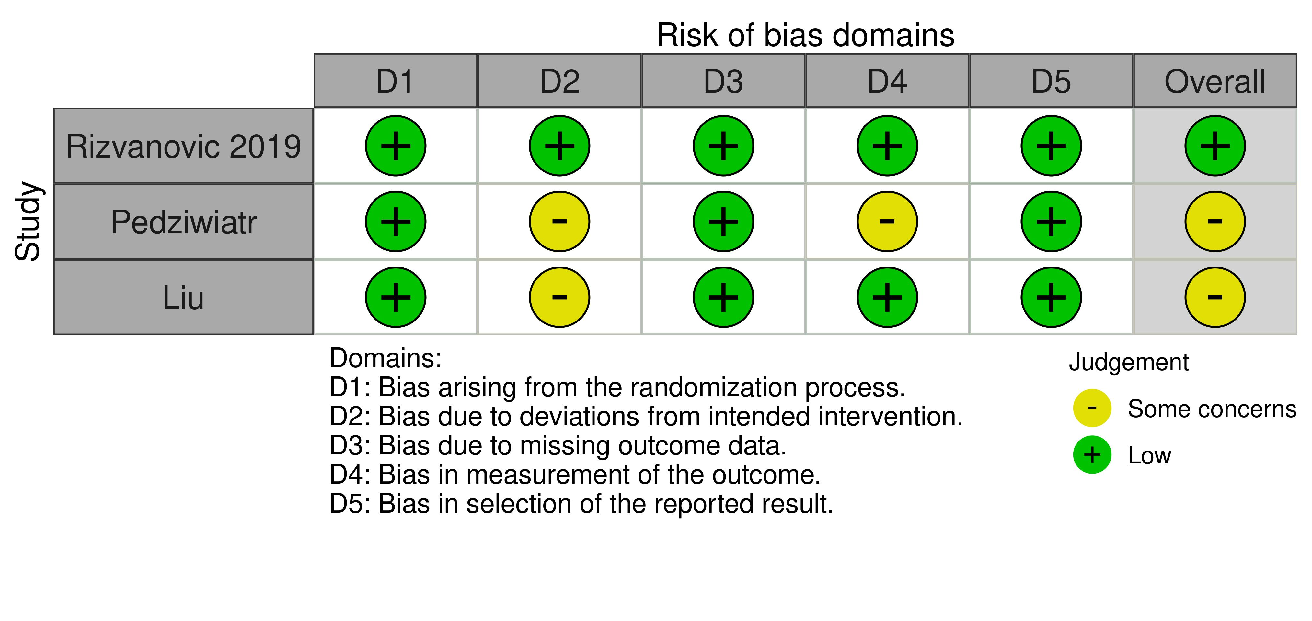
S11. Postoperative insulin levels on postoperative day 1

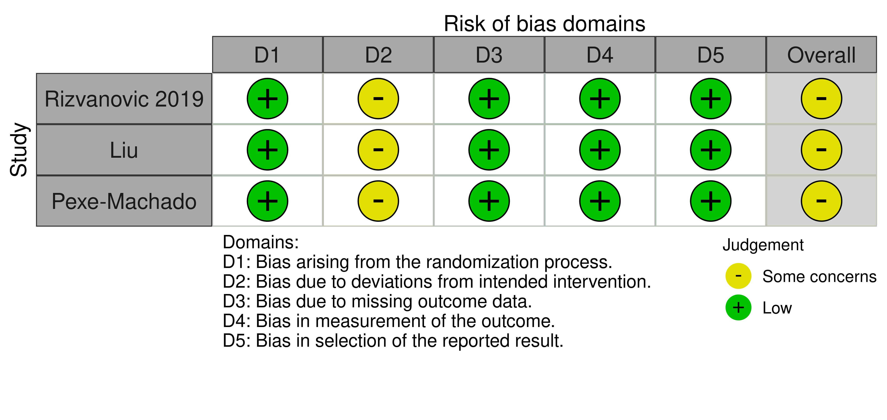
S12. Postoperative insulin levels on postoperative day 2

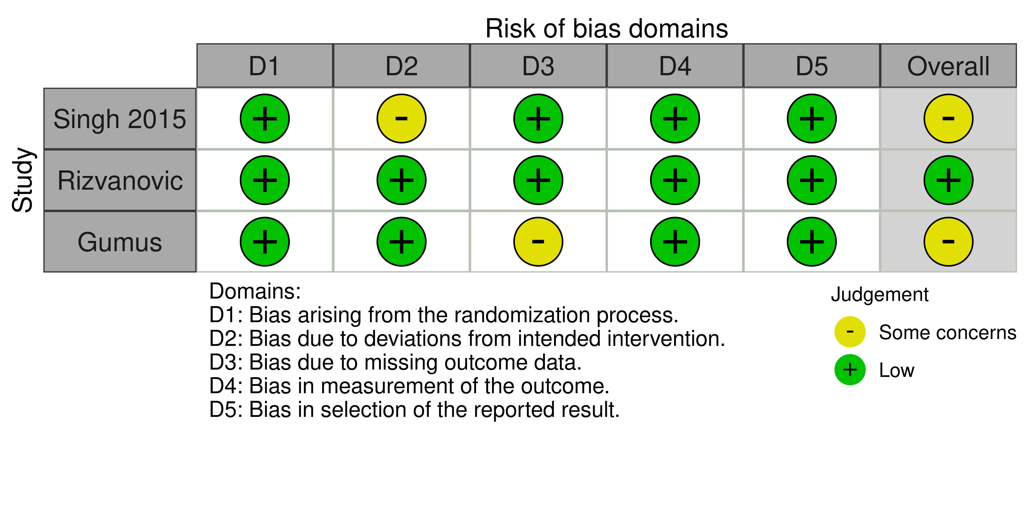
S13. Postoperative CRP levels on postoperative day 1

Preoperative carbohydrate loading versus placebo
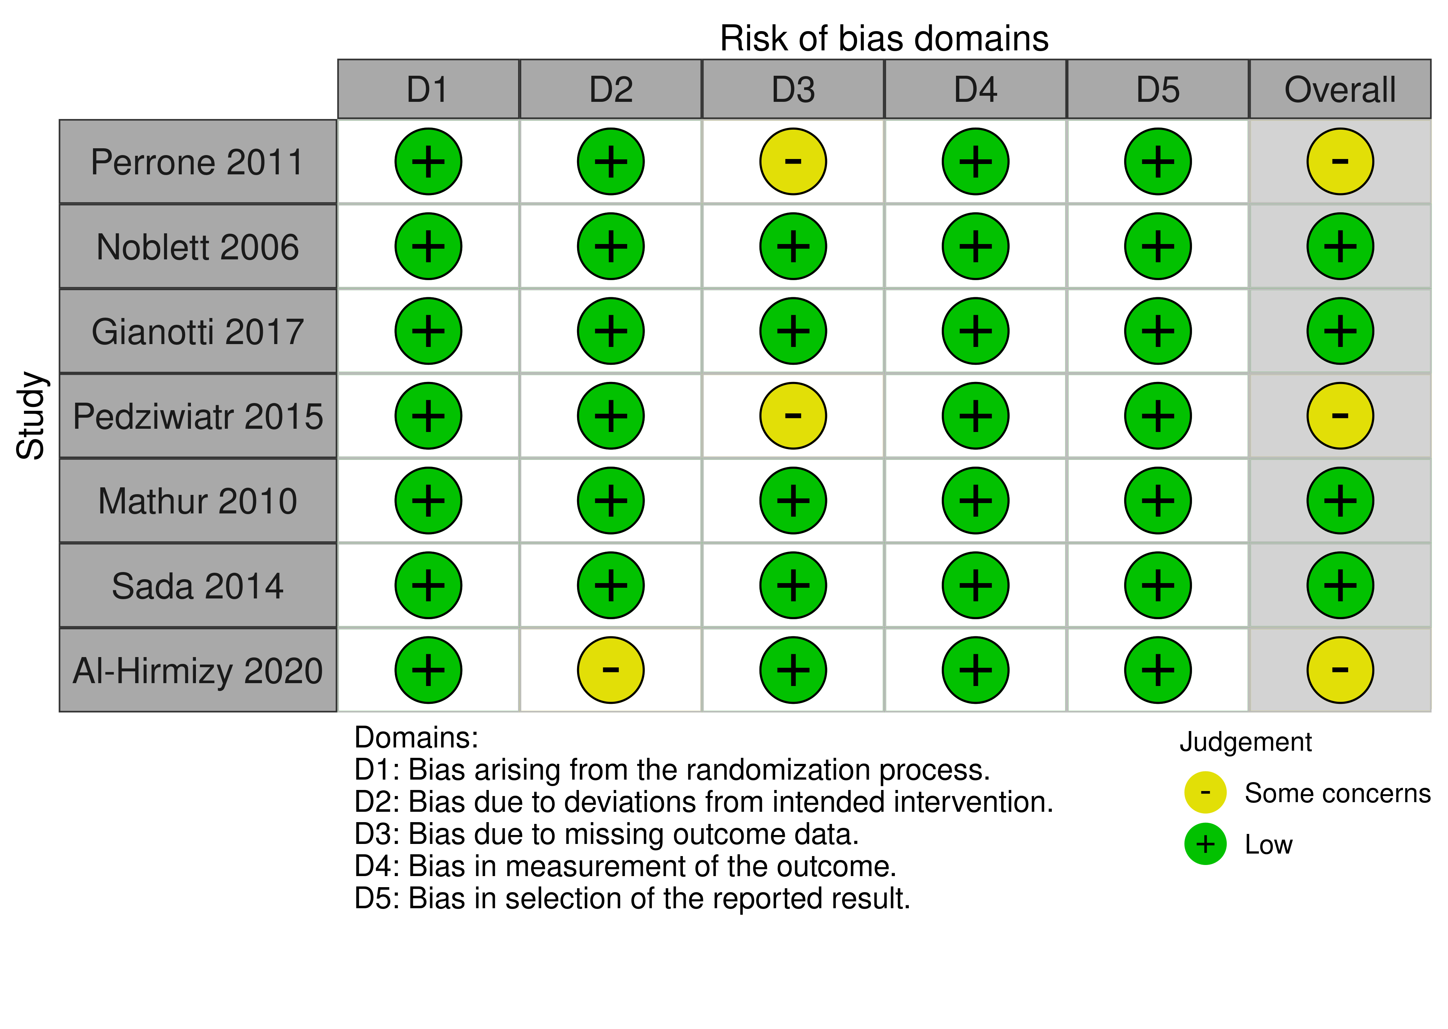S14. Length of hospital stay
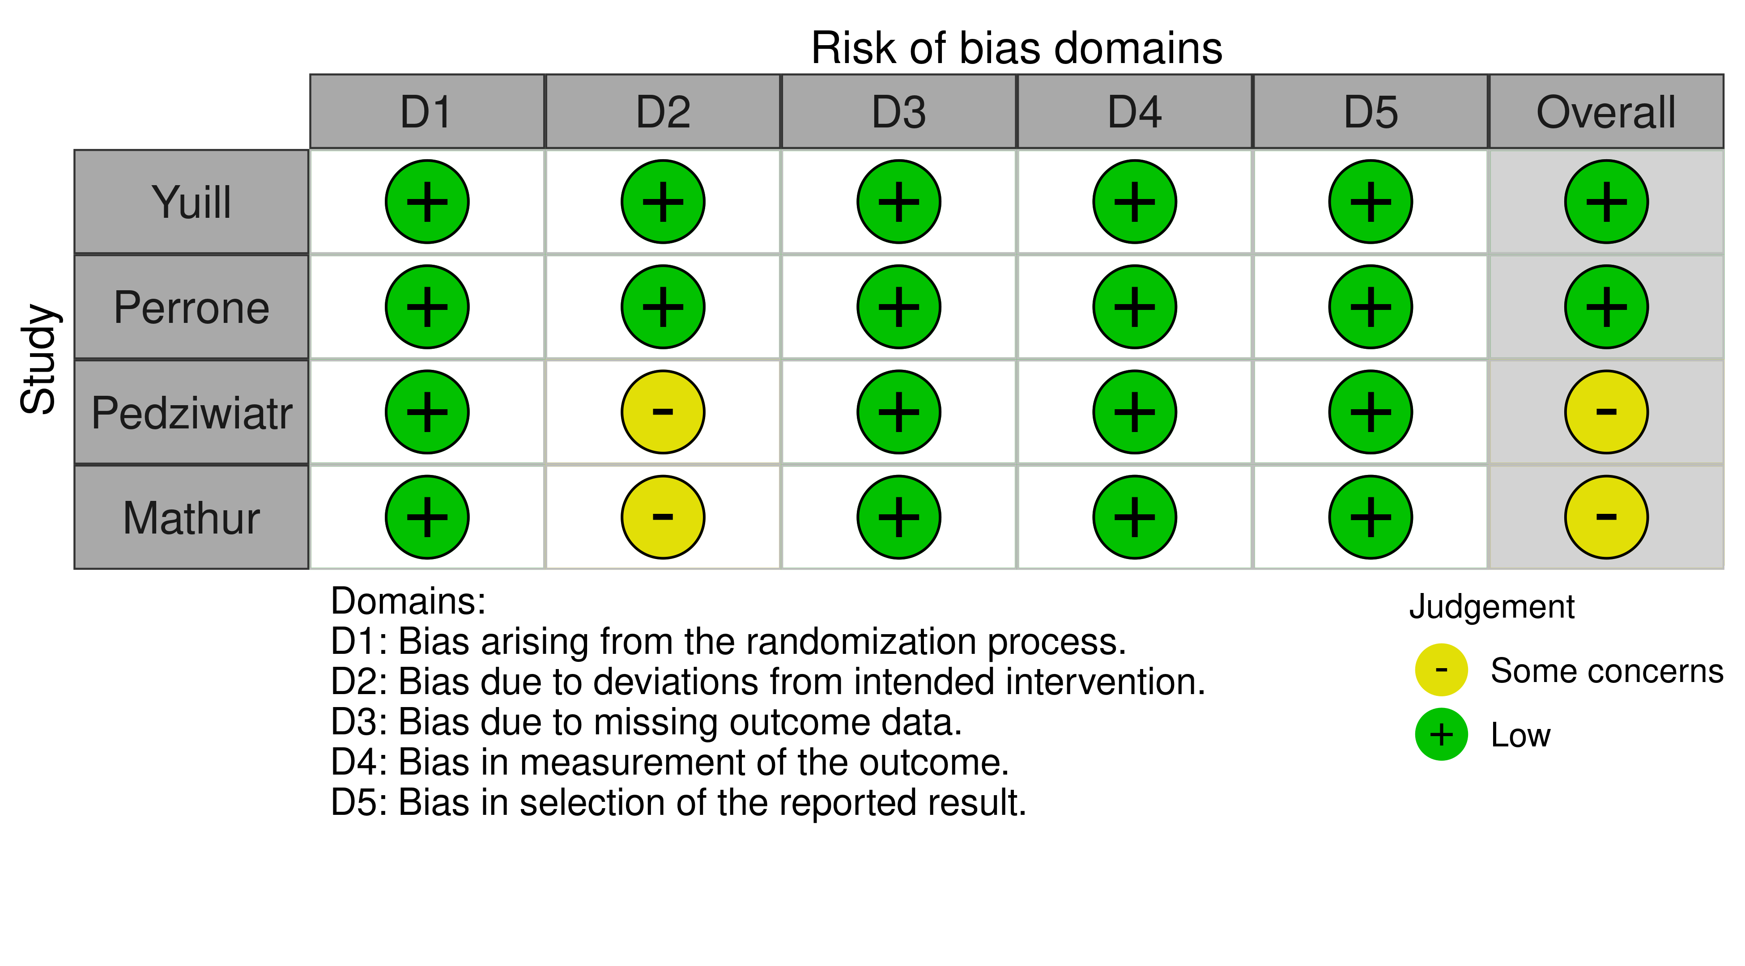

S15. Postoperative glucose levels on postoperative day 1
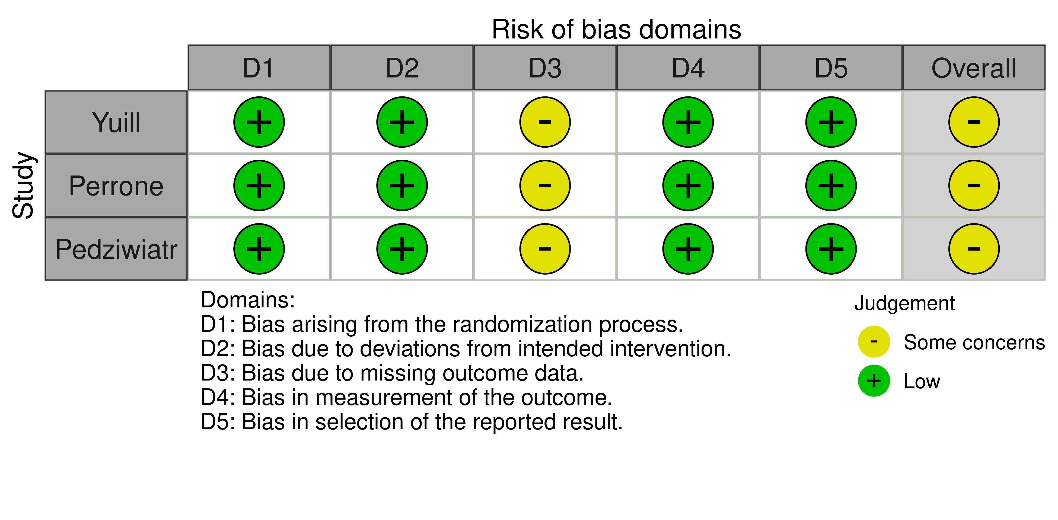
S16. Postoperative insulin levels in postoperative day 1
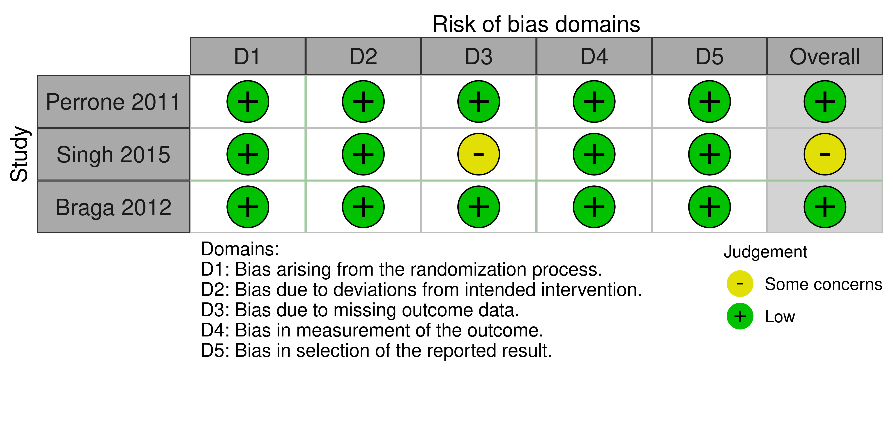
S17. Postoperative CRP levels on postoperative day 1

GRADE assesement
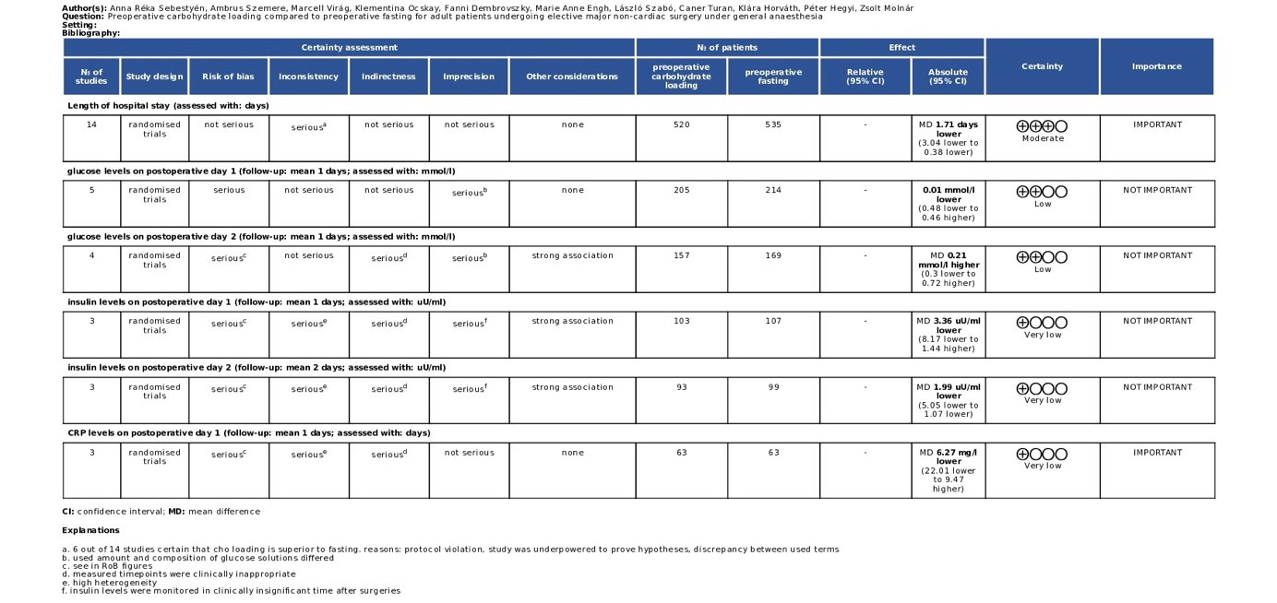
S18. GRADE assesement of preoperative carbohydrate loading versus fasting
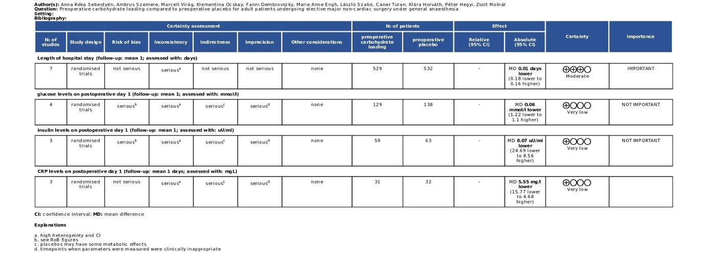
S19. GRADE assesement of preoperative carbohydrate loading versus fasting

