Supplemental Data
Supplementary methods
Detailed procedure of UCBT
HLA typing of cord blood and patient blood was performed using using real-time PCR with a minimum antigen split-level resolution for HLA-A and HLA-B and allele-level resolution for HLA-DRB1. All patients received single-unit cord blood, and each unit was matched with a recipient at ≥4/6 HLA-A and HLA-B antigens and HLA-DRB1 at high resolution. Myeloablative conditioning regimens consisting of busulfan (BU, total 12.8 mg/kg, 0.8 mg/kg every 6 hours for 4 days), cyclophosphamide (CY, 60 mg/kg daily for 2 days) plus fludarabine (FLU, 30 mg/m² daily for 4 days), and total body irradiation or total marrow irradiation (TBI, total 12 Gy in 4 fractions or TMI, total 15 Gy in 3 fractions), CY (60 mg/kg daily for 2 days) plus fludarabine (FLU, 30 mg/m² daily for 4 days) or cytarabine (Ara-C, 2 g/m² twice for 2 days) were applied to all recipients. A combination of cyclosporin A (CsA, Novartis, Stein, Switzerland) and mycophenolate mofetil (MMF, Roche, Basel, Switzerland) was used to prevent GVHD.
Methods for monitoring and diagnosis of Infection
Real-time quantitative PCR for the detection of cytomegalovirus (CMV) DNA was used to detect CMV DNAemia, and CMV was monitored twice a week during aGVHD therapy. Chest computed tomography was performed when patients were suspected of pulmonary infection, and C-reactive protein, 1,3-β-D-glucan assay and galactomannan test were measured. Samples collected from sputum, blood, and bronchoalveolar lavage fluid were used for microbial culture or next-generation sequencing if necessary. Invasive fungal disease was diagnosed as possible, probable or proven according to the EORTC criteria.
Supplementary Table
Supplemental Table 1. Patient characteristics between basiliximab and combined therapy
Characteristics | Basiliximab  group (n=112) | Combined therapy group (n=86) | P
Age (years), Median (Range) | 10(2-61) | 21(1-58) | < 0.001
Male sex, n (%) | 63(56.2) | 47(54.7) | 0.886
Disease |  |  | 0.440
AML, n (%) | 53(47.3) | 49(57.0)
ALL, n (%) | 43(38.4) | 24(27.9)
MDS, n (%) | 8(7.1) | 9(10.5)
CML, n (%) | 3(2.7) | 1(1.2)
Others*, n (%) | 5(4.5) | 3(3.5)
Disease status before HSCT# |  |  | 0.334
CR1 | 66(58.9) | 57(66.3)
≥CR2 | 22(19.6) | 13(15.1)
NR | 24(21.4) | 16(18.6)
HLA matching (/6), n (%) |  |  | 0.453
4 | 57(50.9) | 46(53.5)
5 | 45(40.2) | 35(40.7)
6 | 10(8.9) | 5(5.8)
Conditioning regimen, n (%) |  |  | 0.012
Bu-based | 97(86.6) | 84(97.7)
Irradiation-based | 15(13.4) | 2(2.3)
CD34⁺ cell infused (10⁵/kg) | 2.20(0.25-8.92) | 2.36(0.20-21.36) | 0.420
TNCs infused (10⁷/kg) | 3.60(0.41-12.90) | 3.04(0.49-30.80) | 0.262
Transplantation time |  |  | <0.001
2014-2017 | 76(67.9) | 0
2018-2022 | 36(32.1) | 86(100.0)
Median follow-up time among survivors (m) | 77.2(20.2-117.8) | 31.1(20.9-72.9) | <0.001
*MPAL, mixed phenotype acute leukemia; NHL, non-Hodgkin's lymphoma; PCL, plasma cell leukemia; HLH, hemophagocytic lymphohistiocytosis.
#MDS without excess blasts was categorized as CR1. MDS with excess blasts and CML in accelerated phase or blastic phase without prior treatment was categorized as NR.
Abbreviations: ALL, acute lymphoblastic leukemia; AML, acute myelocytic leukemia;
CML, chronic myeloid leukemia; CR, complete remission; CsA, cyclosporin A; GVHD, graft-versus-host disease; HSCT, hematopoietic stem cell transplantation; MDS, myelodysplastic syndrome; MMF, mycophenolate mofetil; NR, non-remission; TNCs, total nucleate cells.

Supplementary Figures
Supplemental Figure. 1 Cumulative incidence of platelet engraftment post second-line treatment.
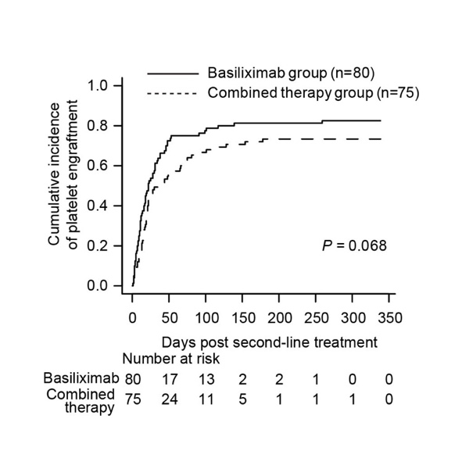

Supplemental Figure. 2 Transplant-related mortality and relapse for the basiliximab group and combined therapy group. (A) transplant-related mortality for all patients enrolled in the study; (B) transplant-related mortality for patients of standard-risk in refined Minnesota aGVHD risk score; (C) transplant-related mortality for patients of high-risk in refined Minnesota aGVHD risk score; (D) relapse for all patients enrolled in the study; (E) relapse for patients of standard-risk in refined Minnesota aGVHD risk score; (F) relapse for patients of high-risk in refined Minnesota aGVHD risk score. GVHD, graft-versus-host disease
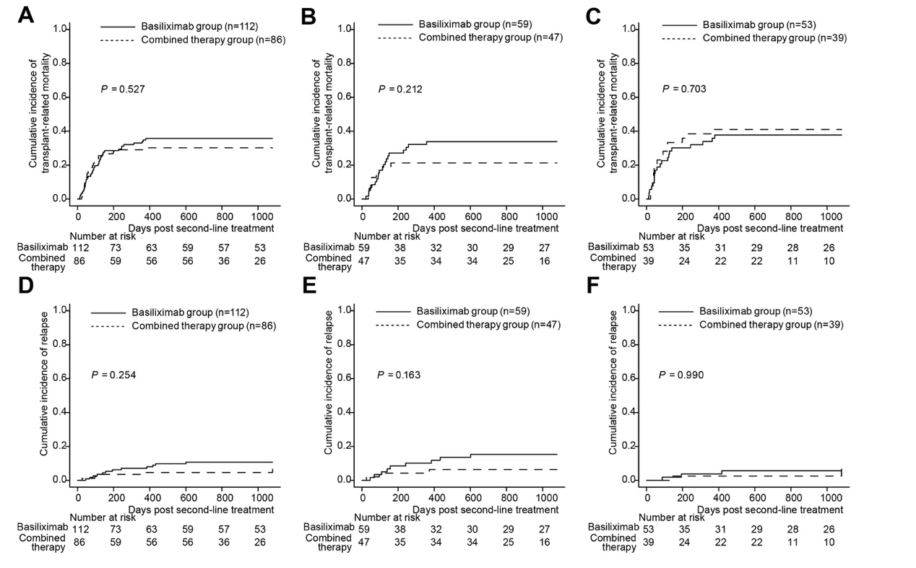

Supplemental Figure. 3 Cumulative incidence of overall chronic GVHD post transplantation. GVHD, graft-versus-host disease
