^{AMB Express}
Supplementary Information for:
Metabolic engineering of Moorella thermoacetica for thermophilic bioconversion of gaseous substrates to a volatile chemical

Junya Kato^{1,3}, Kaisei Takemura^{1,3}, Setsu Kato¹, Tatsuya Fujii², Keisuke Wada², Yuki Iwasaki², Yoshiteru Aoi,¹ Akinori Matsushika^{1,2}, Katsuji Murakami² and Yutaka Nakashimada^{1, *}
*Corresponding author at: E-mail nyutaka@hiroshima-u.ac.jp, Phone No.: +81-82-424-4443
¹Graduate School of Integrated Sciences for Life, Hiroshima University, 1-3-1 Kagamiyama, Higashihiroshima, Hiroshima, 739-8530, Japan
²National Institute of Advanced Industrial Science and Technology (AIST), 3-11-32 Kagamiyama, Higashihiroshima, Hiroshima, 739-0046, Japan
³J.K. and K.T. contributed equally to this work.

This Supplementary Information file contains Fig. S1.

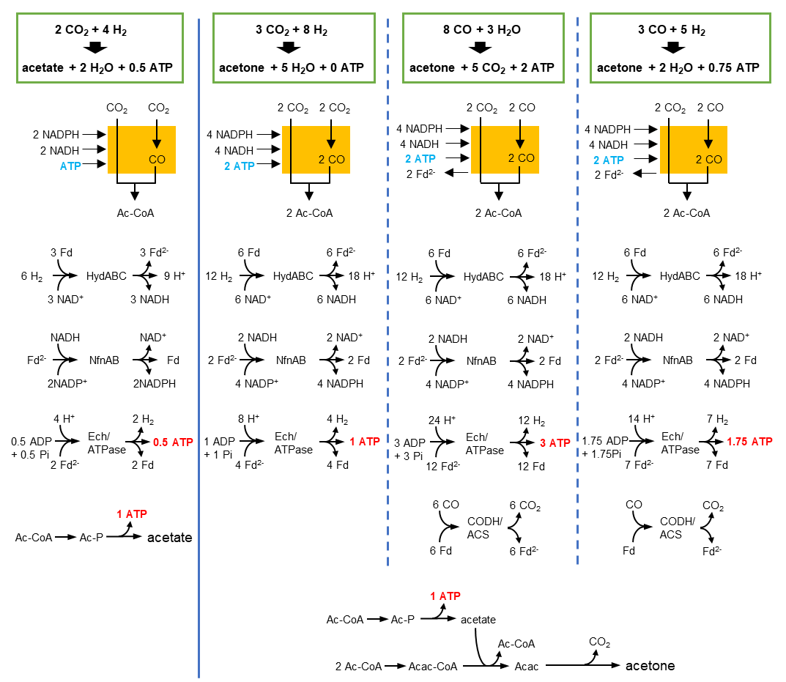
Supplementary Information Figure S1. Schematic representation of energy conservation in acetone-producing Moorella thermoacetica. ATP generation for acetate or acetone production as the sole end product is shown. The estimation and calculation were according to Schuchmann and Muller (2014) and a part of the figure was adopted from Redl et al. (2017). The orange box is a part of the WLP to convert CO₂ to Ac-CoA. HydABC and NfnAB are protein complexes to bifurcate electrons. Acac, acetoacetate; Acac-CoA, acetoacetyl–coenzyme A; Ac-P, acetyl phosphate; Ac-CoA, acetyl–coenzyme A; CODH/ACS, CO dehydrogenase/acetyl–coenzyme A synthase; Ech/ATPase, Ech complex/F₀F₁ adenosine triphosphate synthase; Fd, ferredoxin; ATP, adenosine triphosphate.

