SUPPLEMENTARY INFORMATION
For

Femtosecond laser multiple pulse-induced thermochemical copper precipitation from glyoxylic acid copper complex ink with surfactant

Nam Phuong Ha¹, Tomoji Ohishi², and Mizue Mizoshiri^{1*}

¹Nagaoka University of Technology, Department of Mechanical Engineering, Nagaoka, 940-2188, Japan
²Shibaura Institute of Technology, Department of Applied Chemistry, Tokyo, 135-8548, Japan
Corresponding author: mizoshiri@mech.nagaokaut.ac.jp

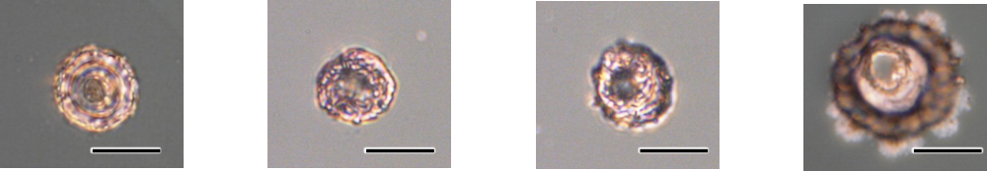
Figure S1. Fabricated Cu dot pattern with different NDSS concentrations at laser repetition rate of
5 MHz and pulse number of 8×10⁴ (a) 2 mol%, (b) 1 mol%, (c) 0.5 mol%, (d) without NDSS
(Scale bar 10 μm).
(a)
(b)
(c)
(d)
Figure S1 shows the optical microscope images of Cu dot patterns fabricated with different NDSS concentrations. There is not much difference in the size of Cu dot pattern with different NDSS concentrations indicated. Therefore, the higher concentration of 2 mol% was applied to ensure the stability of precipitated Cu at lower pulse number.

