Supplemental material
Dynamic mesophase transition induces anomalous suppressed and anisotropic phonon transport revealed by unified machine learning potential
Note S1. Equilibrium molecular dynamics solution for thermal conductivity.
As shown in Supplementary Figs. S2-4, based on the equilibrium molecular dynamics (EMD)method, it was found that the thermal conductivity decreased by an order of magnitude at 7% (x: 60.54±5.56 W/mK, y: 15.66±1.67 W/mK) strain compared to 0% (x: 125.61±3.59 W/mK, y: 119.76±3.31 W/mK) and 13% strain (x: 160.21±4.40 W/mK, y: 235.56±7.32W/mK). The thermal conductivity along the y-axis (parallel to the direction of applied strain) is more suppressed than along the x-axis (perpendicular to the direction of applied strain), indicating more anisotropy. At room temperature, the anisotropy is 0.26 for 7% strain while 0.95 and 1.47 for 0% and 13% strain, where the anisotropy is measured by the ratio of y-axis to x-axis thermal conductivity. However, the solution results from BTE indicated an opposite tendency to those of MD, i.e., the thermal conductivity of the static 0K structure on the y-axis was higher than that on the x-axis due to the applied uniaxial strain.

Note S2. Phonon Boltzmann transport equation.
The thermal conductivity is obtained by solving the phonon BTE as implemented in the ShengBTE package^{1,2}. Phonons are the primary carriers of thermal transport, which are distributed obeying the Bose-Einstein function $f_{0}\left(ω_{λ}\right)$ at thermal equilibrium due to the absence of temperature gradient （∇T） or other thermodynamical forces². At a steady state, assuming that the temperature gradient is small enough in most practical situations, the phonon distribution function $f_{λ}$ can be linearized in ∇T as:
$$\begin{aligned}f_{λ}-f_{0}\left(ω_{λ}\right)=-F_{λ}·∇T\frac{df_{0}}{dT},\#（1）\end{aligned}$$
where $F_{λ}=τ_{λ}^{0}\left(ν_{λ}+Δ_{λ}\right)$ when only three phonon scattering processes in considered^{3–5}. In this case, the linear BTE is related to the phonon relaxation time τ, phonon group velocity υ and the measure of the deviation from relaxation time approximation (RTA).
The anharmonicity mainly depends on the phonon relaxation time due to the scattering rate is inversely proportional to the relaxation time, i.e., $Γ=\frac{1}{τ}$. The scattering rate can be obtained by summing different scattering events by Matthiessen’s rule⁶:
$$\begin{aligned}\frac{1}{τ\left(\vec{q},p\right)}=\frac{1}{τ^{3nd}\left(\vec{q},p\right)}+\frac{1}{τ^{iso}\left(\vec{q},p\right)},\#\left(2\right)\end{aligned}$$
where $1/{τ^{3nd}}$ is the three-phonon scattering rate， $1/{τ^{iso}}$ is the scattering rate due to isotope impurities. The scattering rate$Γ$ can be obtained by:
$$\begin{aligned}\frac{1}{τ_{λ}^{0}}=\frac{1}{N}\left(\sum_{λ^{'}λ^{''}}^{+}{Γ_{λλ^{'}λ^{''}}^{+}}+\sum_{λ^{'}λ^{''}}^{-}{\frac{1}{2}Γ_{λλ^{'}λ^{''}}^{-}}+\sum_{λ^{'}}{Γ_{λλ^{'}}}\right)+ \\ \frac{1}{N}\left(\sum_{λ^{'}λ^{''}λ^{'''}}^{++}{Γ_{λλ^{'}λ^{''}λ^{'''}}^{+}}+\sum_{λ^{'}λ^{''}λ^{'''}}^{+-}{\frac{1}{2}Γ_{λλ^{'}λ^{''}λ^{'''}}^{-}}+\sum_{λ^{'}λ^{''}λ^{'''}}^{--}{\frac{1}{6}Γ_{λλ^{'}λ^{''}λ^{'''}}^{--}}\right),\#\left(3\right)\end{aligned}$$
where N and $Γ_{λλ^{'}}$ are the number of q points and, respectively. $Γ_{λλ^{'}λ^{''}}^{±}$ and $Γ_{λλ^{'}λ^{''}λ^{'''}}^{±}$is the three-phonon and four-phonon scattering rate, which can be further obtained by:
$$\begin{aligned}Γ_{λλ^{'}λ^{''}}^{+}=\frac{ℏπ}{4}\frac{{f_{0}^{ }}^{'}{-f_{0}^{ }}^{''}}{ω_{λ}ω_{λ^{'}}ω_{λ^{''}}}{\left|V_{{λλ}^{'}λ^{''}}^{+}\right|}^{2}δ\left(ω_{λ}+ω_{λ^{'}}-ω_{λ^{''}}\right),\#\left(4\right)\end{aligned}$$
$$\begin{aligned}Γ_{λλ^{'}λ^{''}}^{-}=\frac{ℏπ}{4}\frac{{f_{0}^{ }}^{'}{+f_{0}^{ }}^{''}+1}{ω_{λ}ω_{λ^{'}}ω_{λ^{''}}}{\left|V_{{λλ}^{'}λ^{''}}^{-}\right|}^{2}δ\left(ω_{λ}-ω_{λ^{'}}-ω_{λ^{''}}\right),\#\left(5\right)\end{aligned}$$
where the scattering rate$Γ_{λλ^{'}λ^{''}}^{±}$ mainly depends on scattering matrix elements $V_{{λλ}^{'}λ^{''}}^{±}$and the Dirac delta distributions function $δ$, respectively.
$$\begin{aligned}V_{{λλ}^{'}λ^{''}}^{±}=\sum_{ijk}{\sum_{αβγ}{Φ_{ijk}^{αβγ}\frac{e_{α}^{λ}\left(i\right)e_{β}^{±λ^{'}}\left(j\right)e_{γ}^{-λ^{''}}\left(k\right)}{\sqrt{{\overline{M}}_{i}{\overline{M}}_{j}{\overline{M}}_{k}}}e_{ }^{±iq^{'}∙r_{j}}e_{ }^{-iq^{''}∙r_{k}}}}\#\left(6\right)\end{aligned}$$
where $i$, $j$, $k$, and $l$ denote the atomic indices and $α$, $β$, $γ$, and $θ$ denote the Cartesian dimensions x, y, or z. $Φ_{ijk}^{αβγ}$ are the third-order and fourth-order force constants, respectively. $e_{α}^{λ}\left(i\right)$ is the eigenvector component for a mode. $r_{j}$ is the position vector of the unit cell where j-th atom lies, and ${\overline{M}}_{j}$ is its mass.

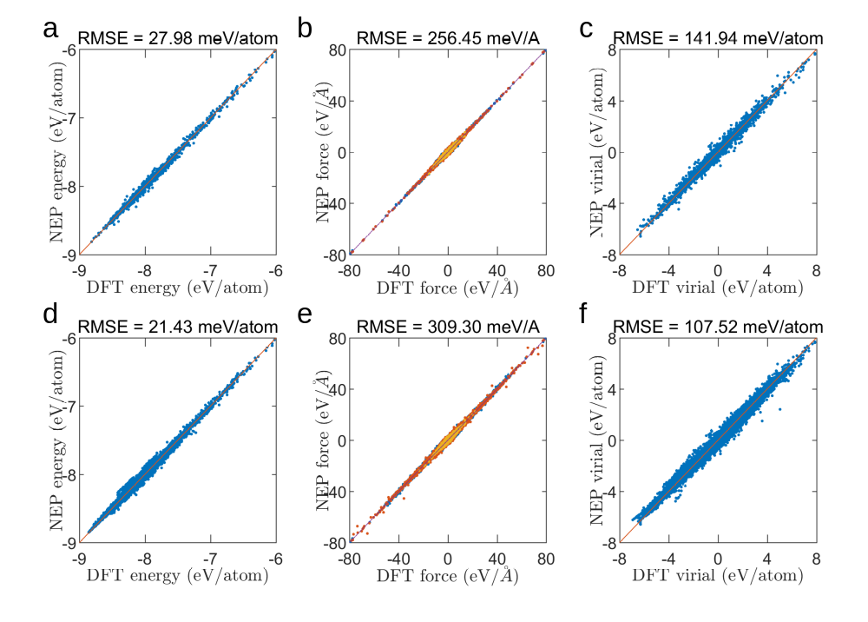
Figure S1. Training set and test set. A comparison of (a) energy, (b) force, and (c) virial force between machine learning potentials and first-principles approaches for training sets. A comparison of (d) energy, (e) force, and (f) virial force between machine learning potentials and first-principles approaches for test sets.

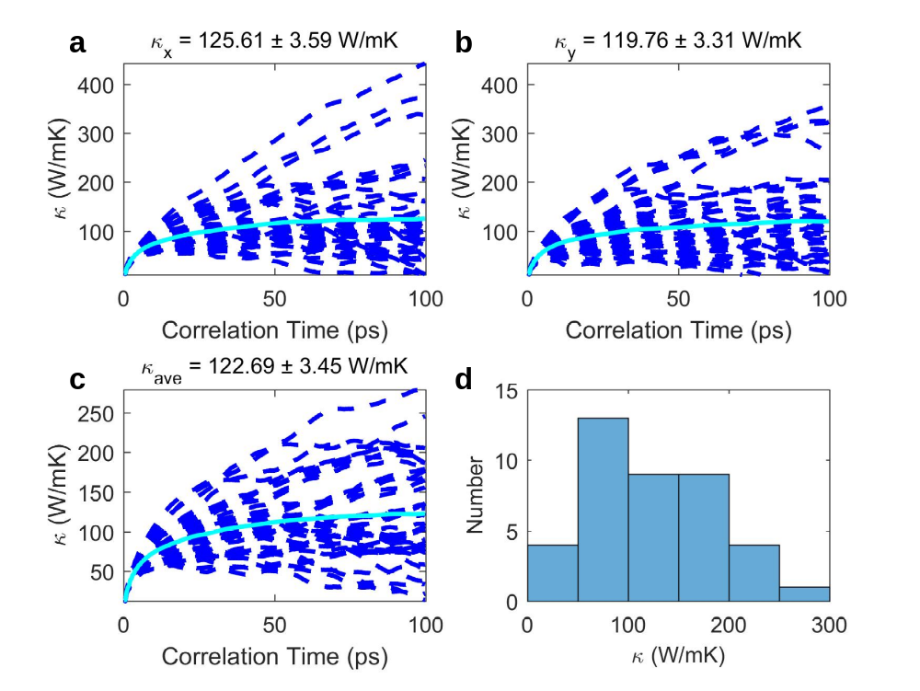
Figure S2. Thermal conductivity at 0% strain based on the Green-Kubo method. (a) x-direction, (b) y-direction, (c) average thermal conductivity, and (d) frequency distribution of thermal conductivity results.

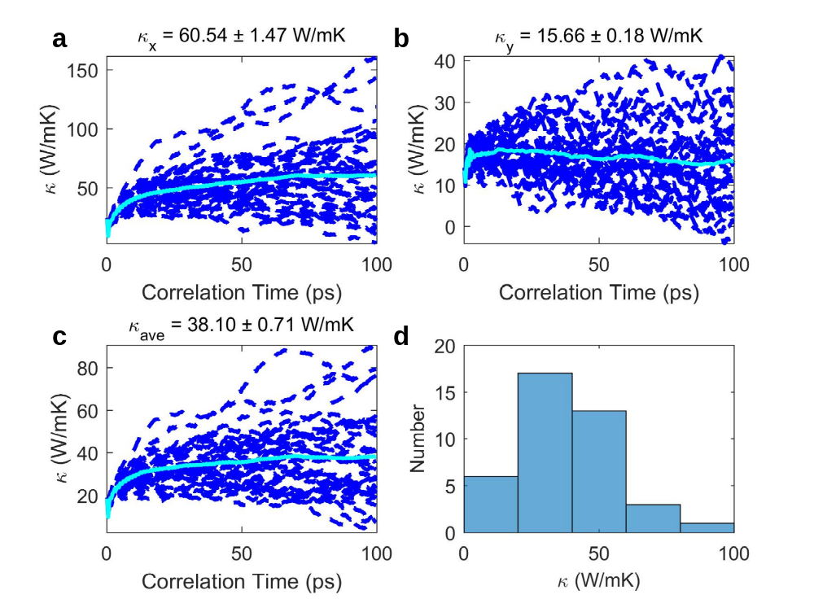
Figure S3. Thermal conductivity at 7% strain based on the Green-Kubo method. (a) x-direction, (b) y-direction, (c) average thermal conductivity, and (d) frequency distribution of thermal conductivity results.

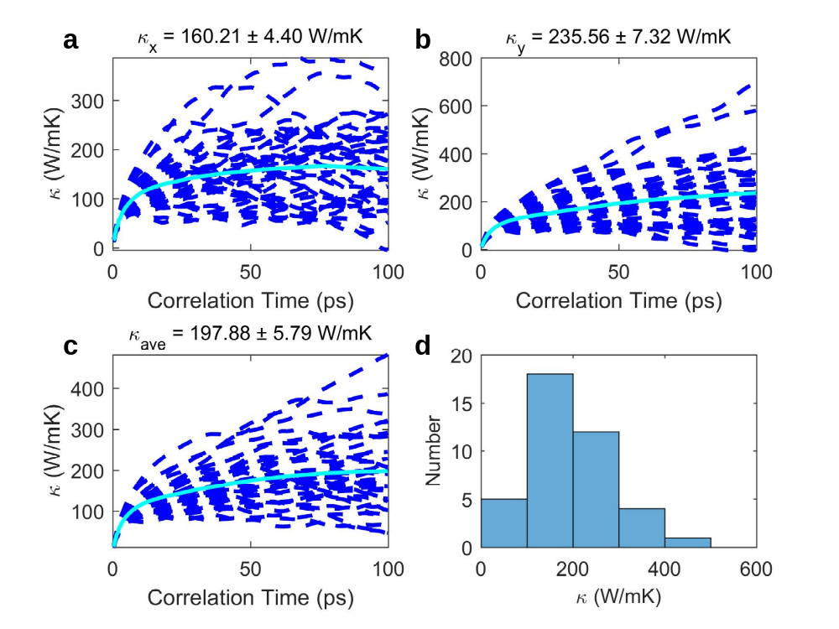
Figure S4. Thermal conductivity at 13% strain based on the Green-Kubo method. (a) x-direction, (b) y-direction, (c) average thermal conductivity, and (d) frequency distribution of thermal conductivity results.

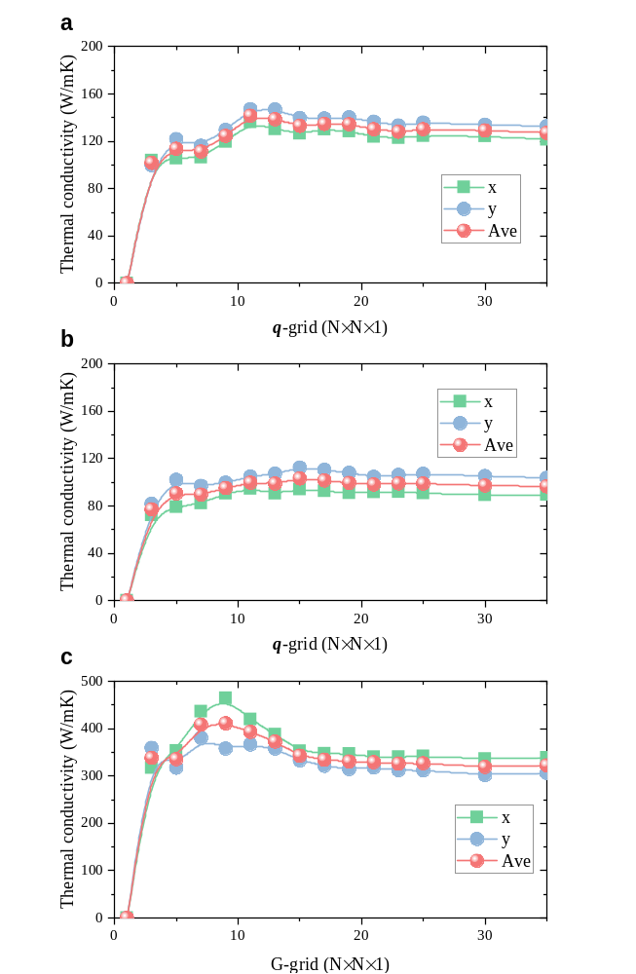
Figure S5. Phonon BTE simulations. The convergence of the Q-mesh was tested by solving the BTE method for (a) 0%, (b) 7% and (c) 13% strain.

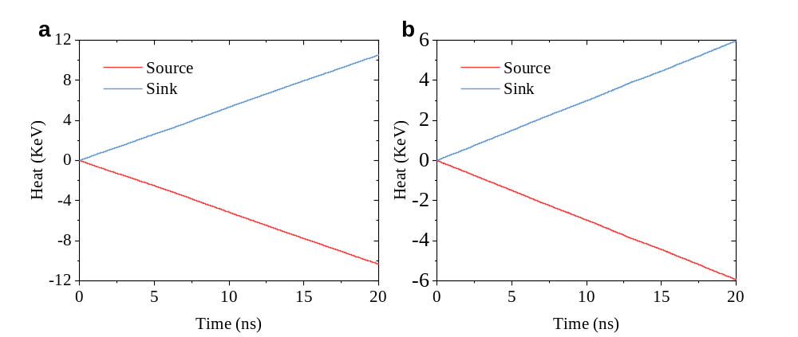
Figure S6. The NEMD simulations. The cumulative energy of the heat source domain and the heat sink domain varies with the simulation time along (a) x-direction and (b) y-direction under the Langevin thermostat with the simulation size of ~33 nm.

REFERENCES
1. Li, W., Lindsay, L., Broido, D. A., Stewart, D. A. & Mingo, N. Thermal conductivity of bulk and nanowire Mg 2 Si x Sn 1 − x alloys from first principles. Phys. Rev. B 86, 174307 (2012).
2. Li, W., Carrete, J., A. Katcho, N. & Mingo, N. ShengBTE: A solver of the Boltzmann transport equation for phonons. Computer Physics Communications 185, 1747–1758 (2014).
3. Omini, M. & Sparavigna, A. Beyond the isotropic-model approximation in the theory of thermal conductivity. Phys. Rev. B 53, 9064–9073 (1996).
4. Ward, A. & Broido, D. A. Intrinsic phonon relaxation times from first-principles studies of the thermal conductivities of Si and Ge. Phys. Rev. B 81, 085205 (2010).
5. Lindsay, L. & Broido, D. A. Three-phonon phase space and lattice thermal conductivity in semiconductors. J. Phys.: Condens. Matter 20, 165209 (2008).
6. Qin, Z., Qin, G., Zuo, X., Xiong, Z. & Hu, M. Orbitally driven low thermal conductivity of monolayer gallium nitride (GaN) with planar honeycomb structure: a comparative study. Nanoscale 9, 4295–4309 (2017).

